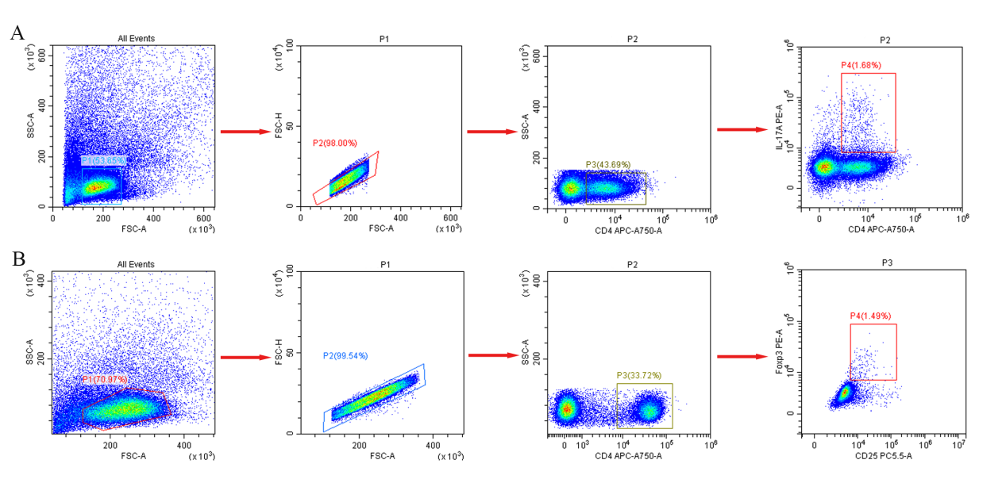
Figure S1 The gating strategy used to analyze the data. (A) The gating strategy of Th17 cells. FSC/SSC was used to circle lymphocyte population. After excluding adhesions and dead cells with FSC/FSC-H, CD4 were used to circle CD4⁺T cells, and CD4⁺IL-17A⁺ double positive cells were used to circle Th17 cells. (B) The gating strategy of Treg cells. FSC/SSC was used to circle lymphocyte population. After excluding adhesions and dead cells with FSC/FSC-H, CD4 were used to circle CD4⁺T cells, and CD25⁺Foxp3⁺ double positive cells were used to circle Treg cells.

