Appendix 1: rehabilitation program
- Neck muscle stretching

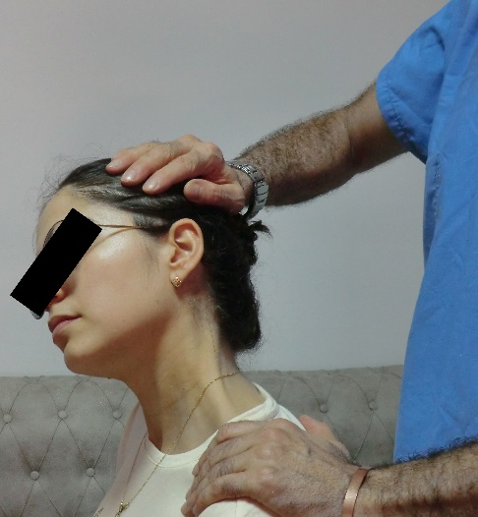
Anterior scalene muscle stretching

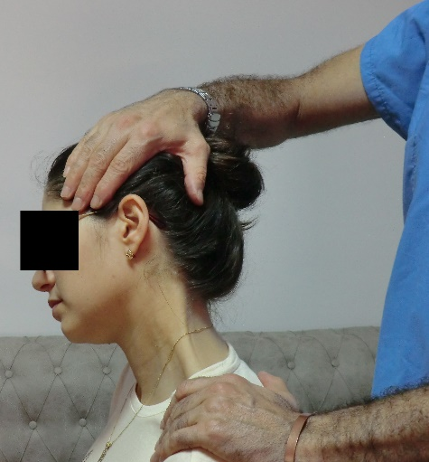
Middle scalene muscle stretching

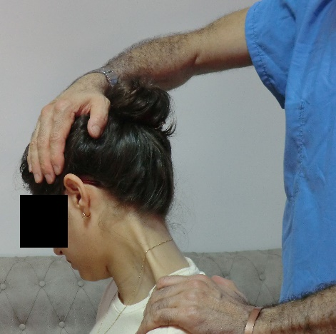
Posterior scalene muscle stretching

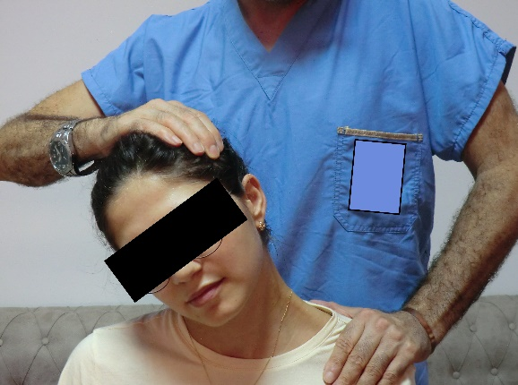
Trapezius muscle stretching


Pectoralis minor stretching

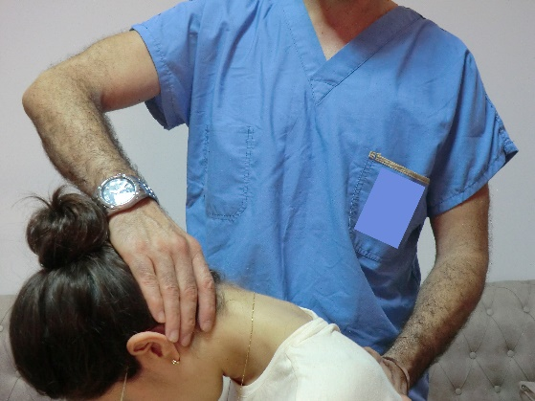
Interspinalis muscle stretching

- Neck muscle strengthening
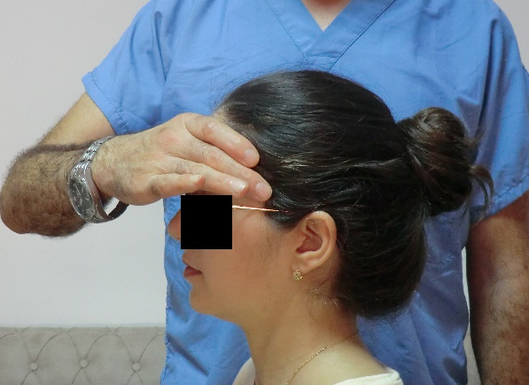
Neck flexors strengthening

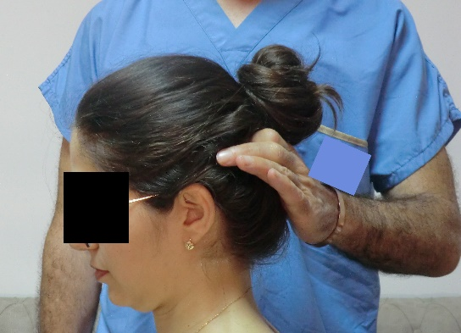
Neck extensors strengthening
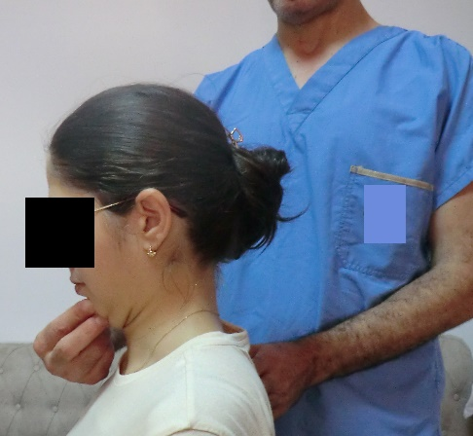
Neck retraction exercise

