Here are our surgical procedures for the treatment of “Posterior Condylar Triad”
1.The initial position is the floating position;
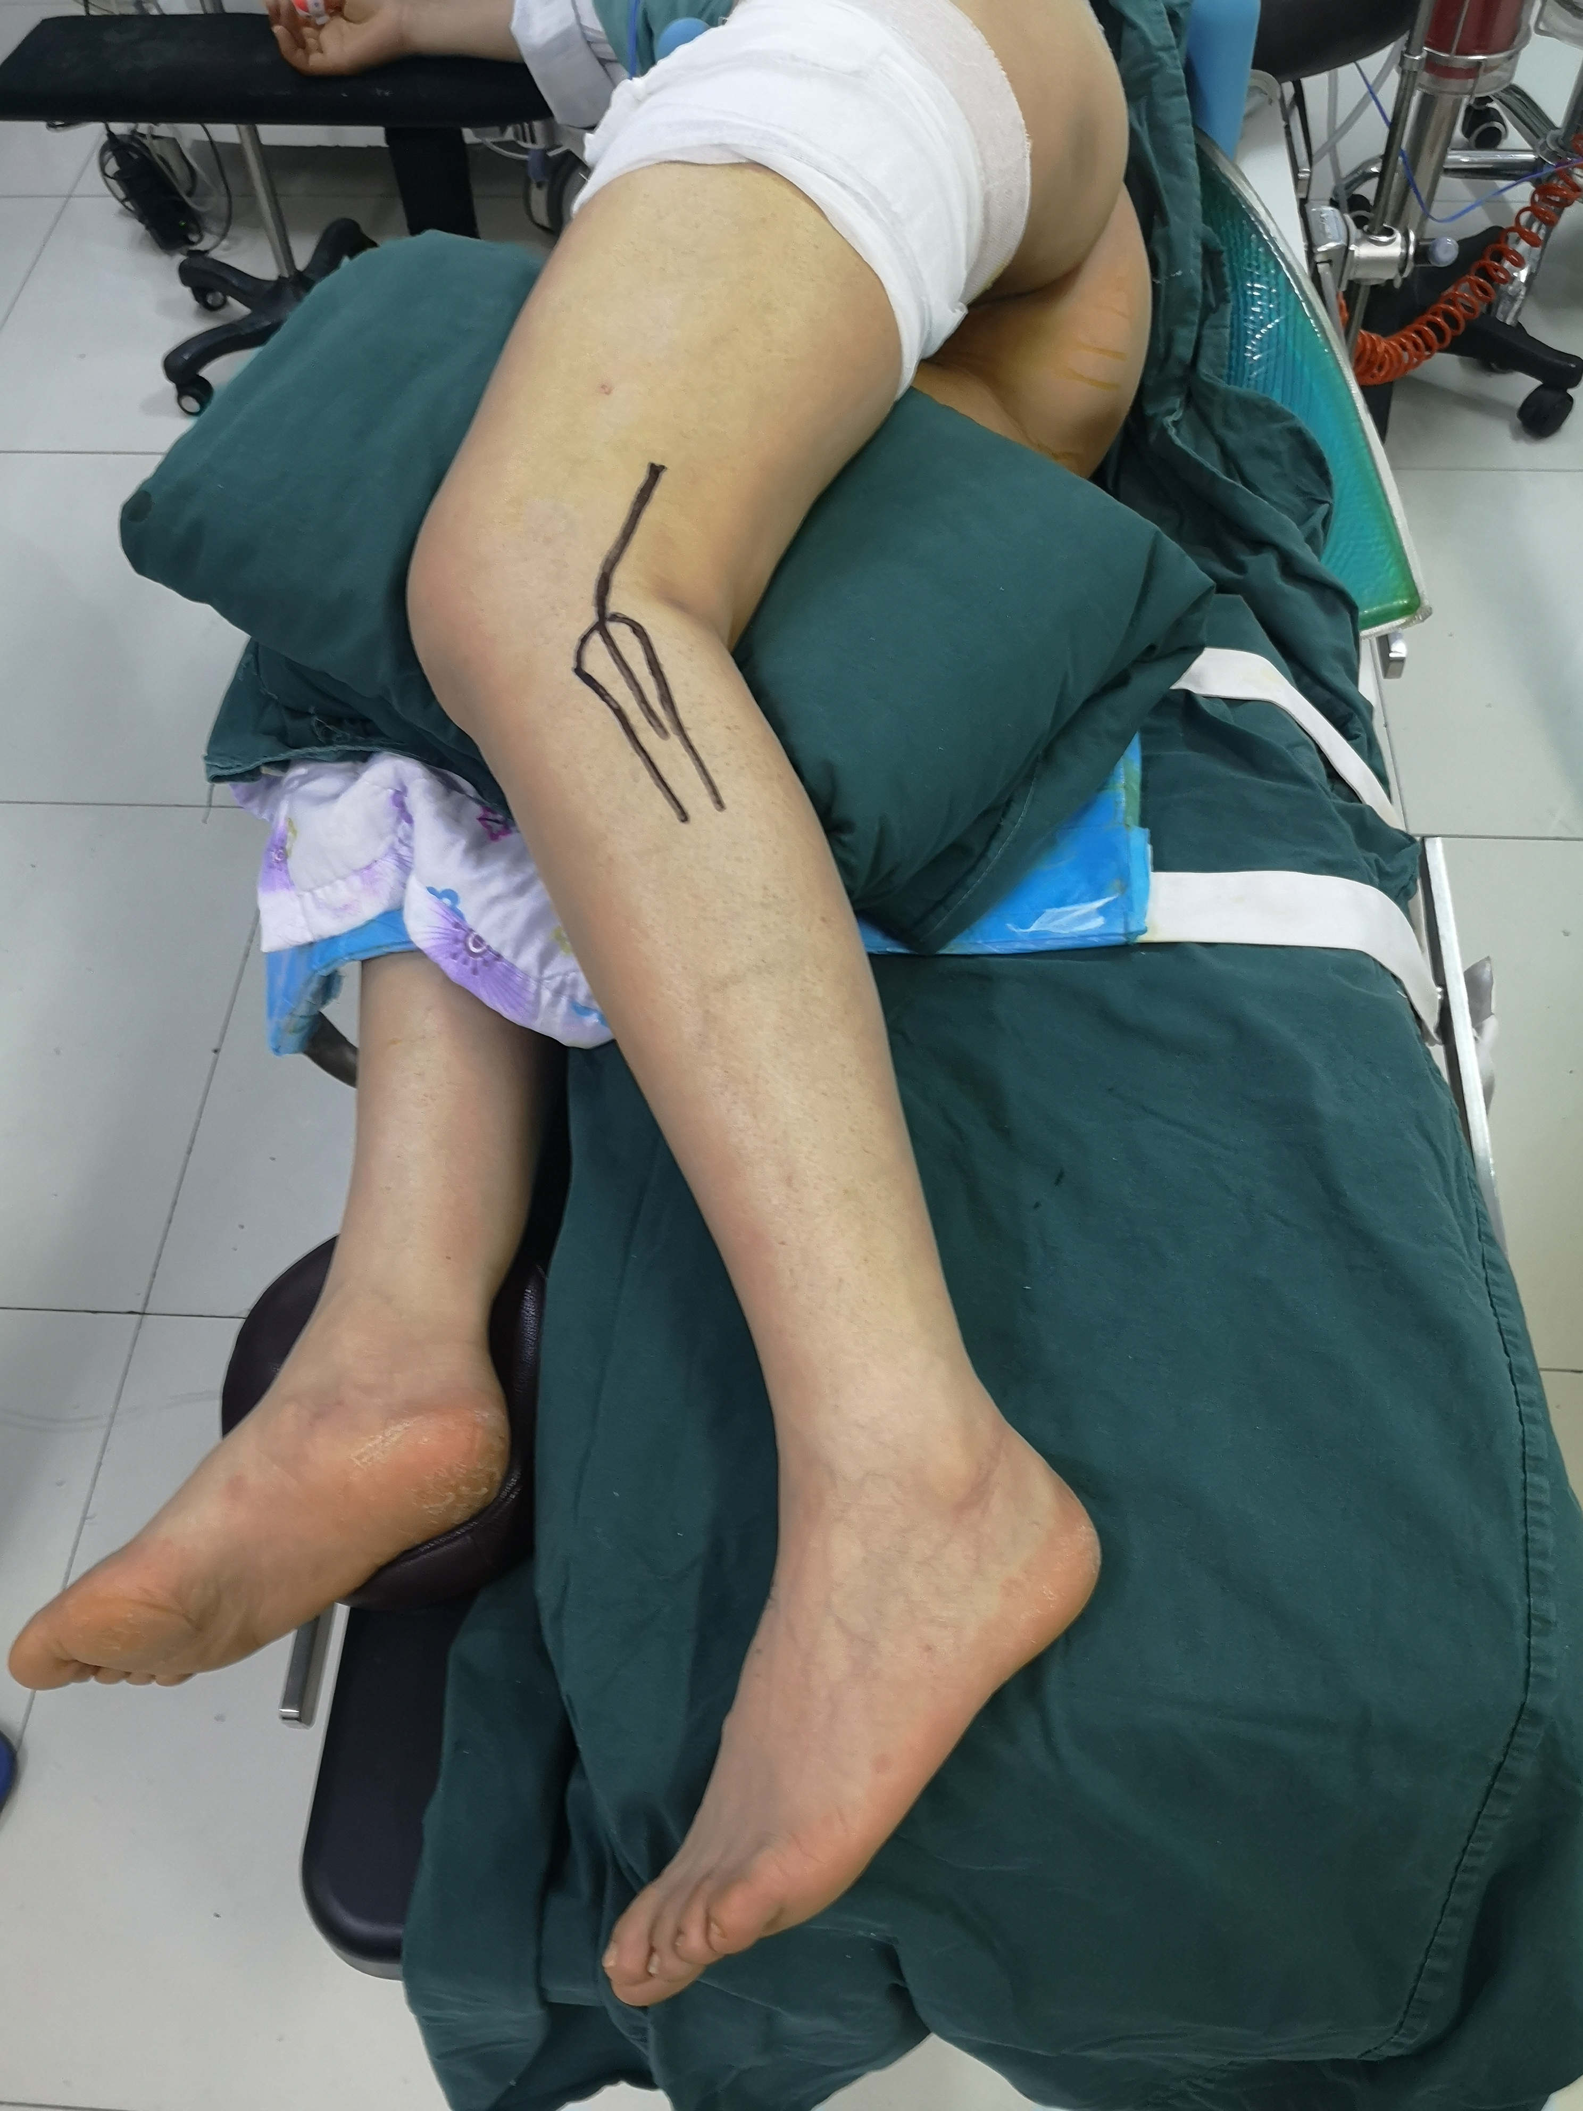
2.During the operation, an assistant raised the affected limb. First, the fracture of the posterior medial tibial plateau was fixed through the posterior medial incision; 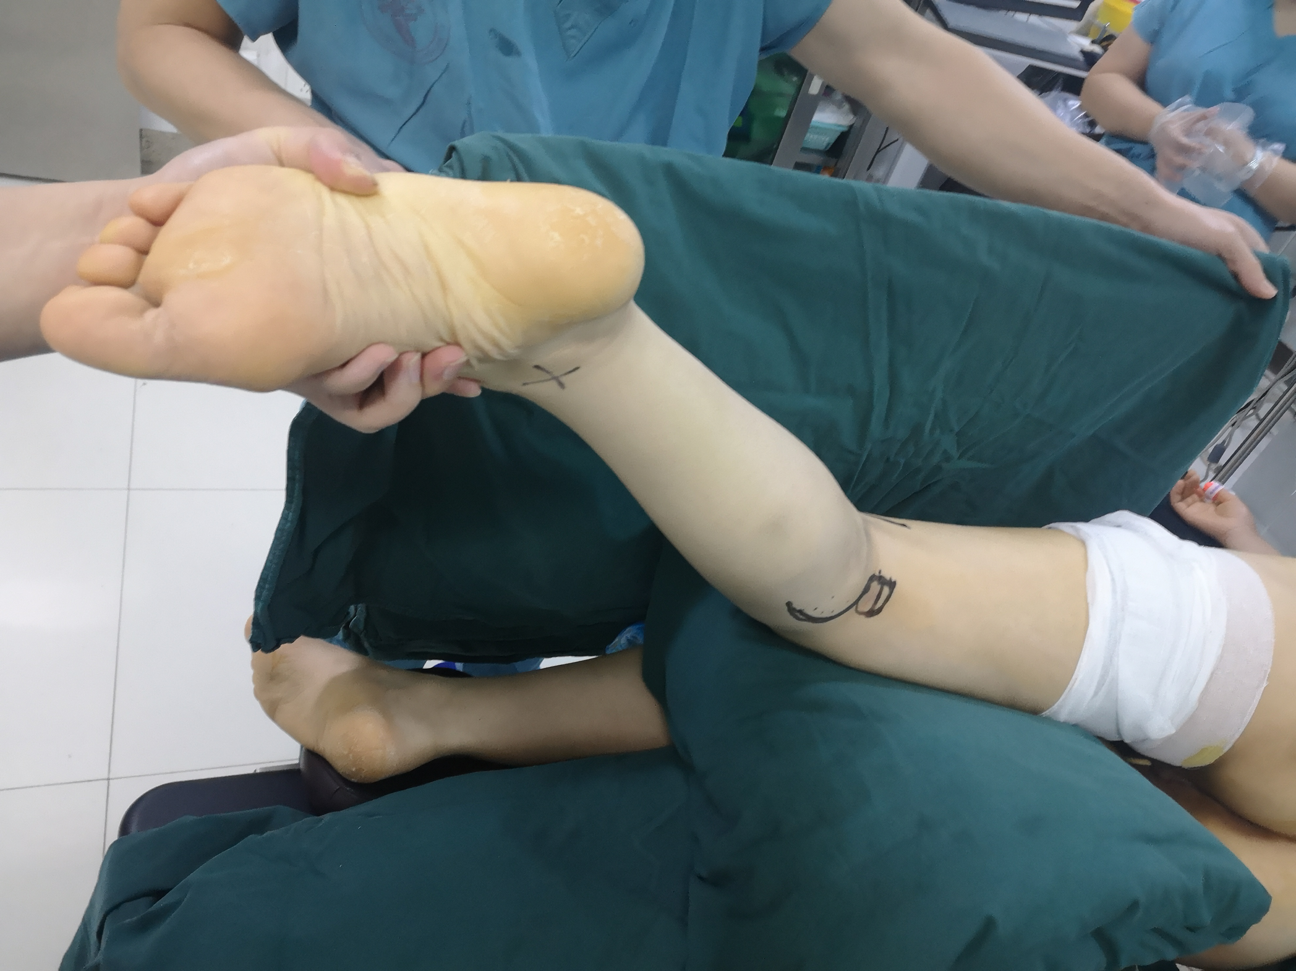
3.Then through the Frosch approach, the posterolateral tibial plateau was fractured;
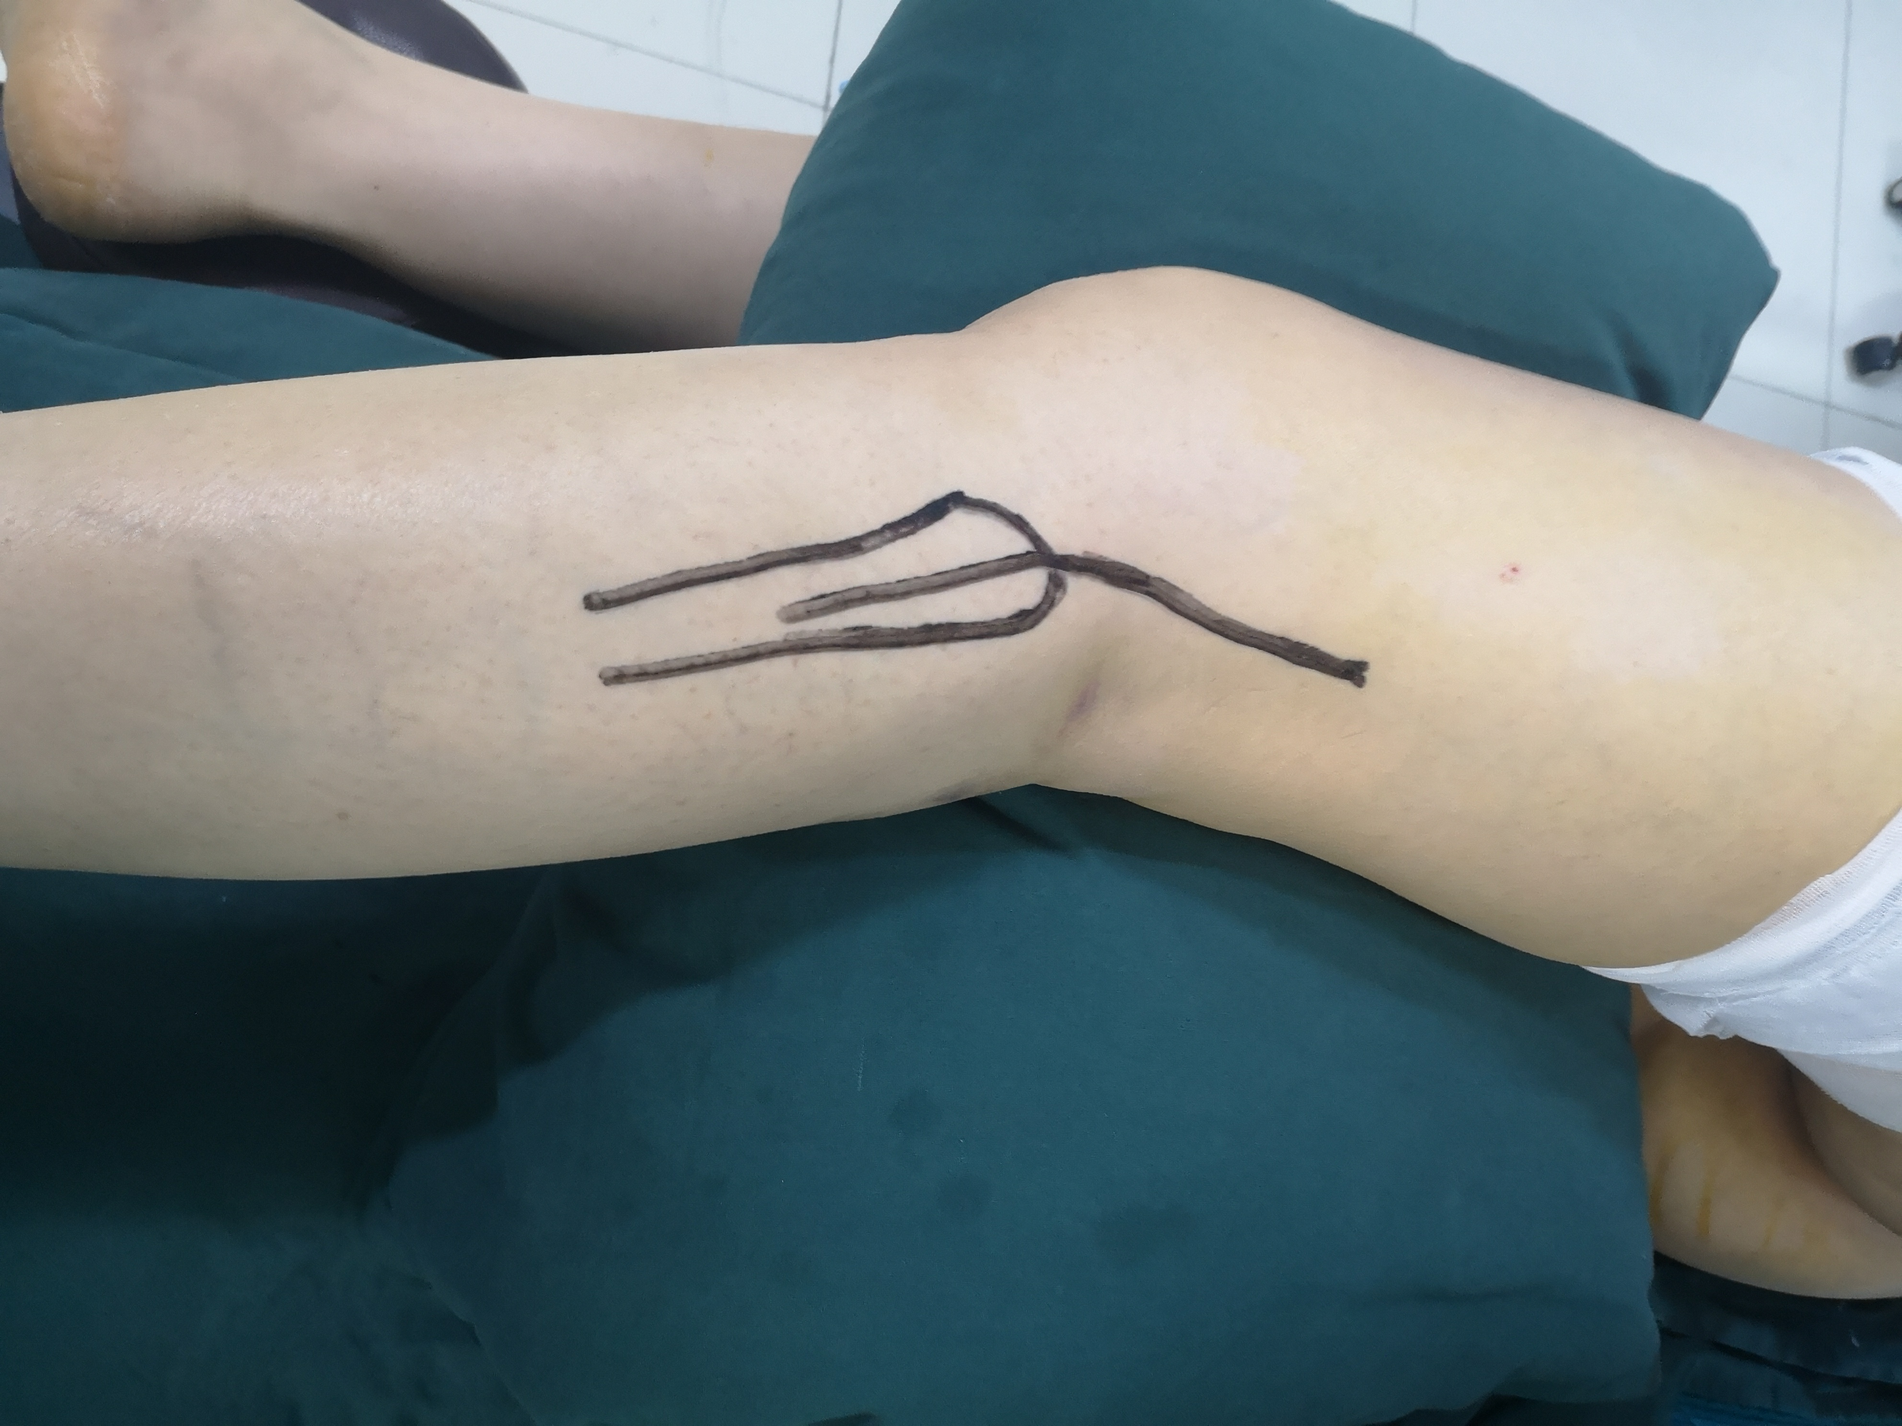
4. Finally, the avulsion fracture of the anterior inserted ligament is fixed through the anteromedial incision, and the whole process only needs one time of disinfection and sheet laying. (some data are lost, and we are trying to retrieve them)

