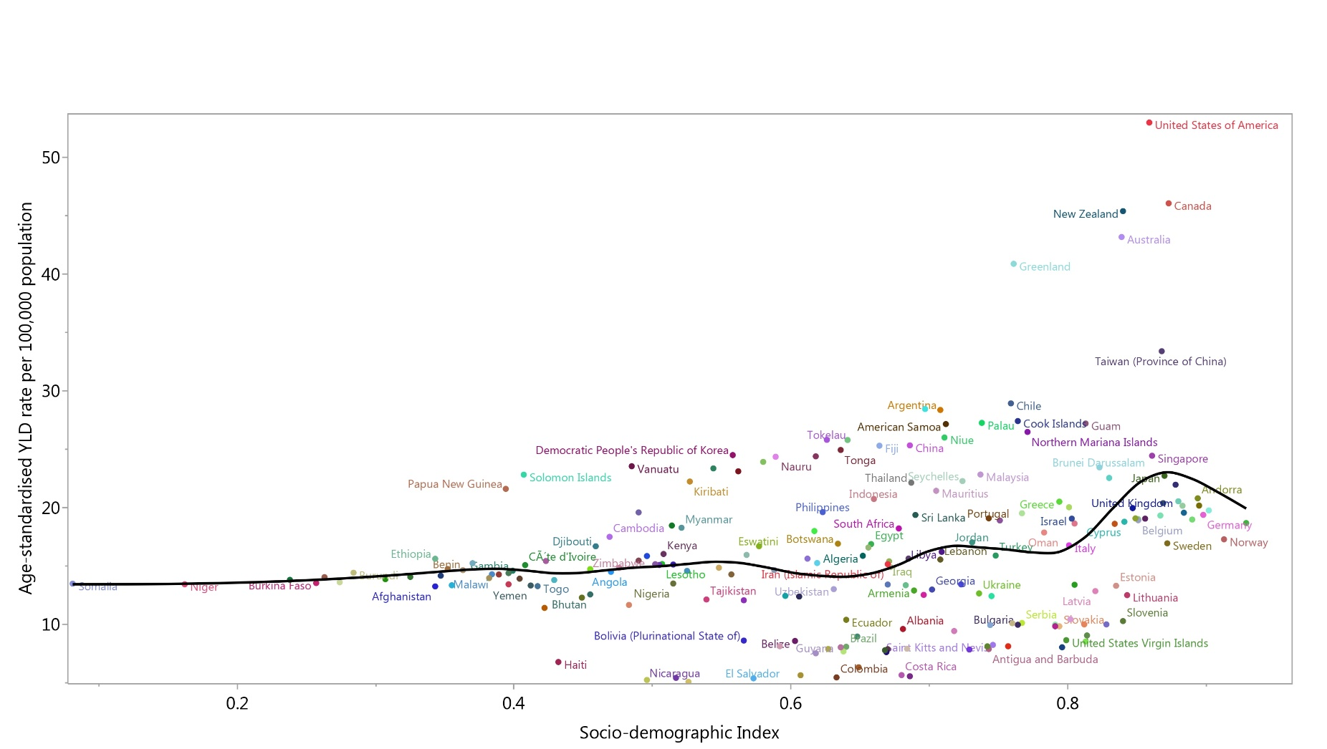
Figure S1: Age-standardised years lived with disability (YLDs) rate of gout for 204 countries and territories, by SDI in 2019; Expected values based on the Socio-demographic Index and disease rates in all locations are shown as the black line. Each point shows the observed age-standardised YLD rate for each country in 2019. (Generated from data available from http://ghdx.healthdata.org/gbd-results-tool).

