Correlation Between Low Testosterone Levels and the Risk of Osteoarthritis: A Cross-Sectional Analysis of NHANES Data (2011-2016)

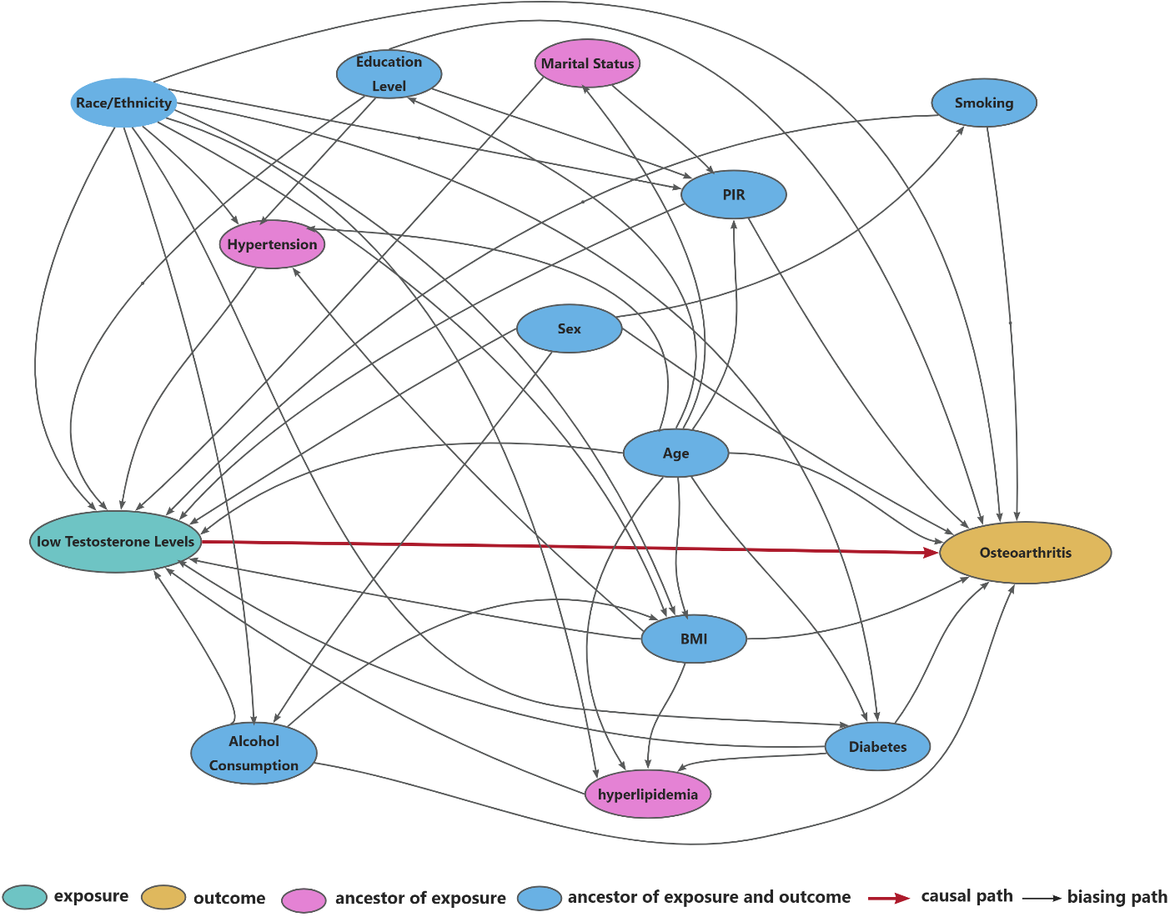
Figure S1. Diagram of Variables Affecting Testosterone Levels and OA Risk. This diagram illustrates the independent and interactive relationships among demographic, socioeconomic, lifestyle, and clinical factors, and their potential impact on testosterone levels and the risk of OA.

