Efficacy of Non-Surgical, Non-Pharmacological Treatments for Congenital Muscular Torticollis: A Systematic Review and Meta-Analysis

Additional File 8
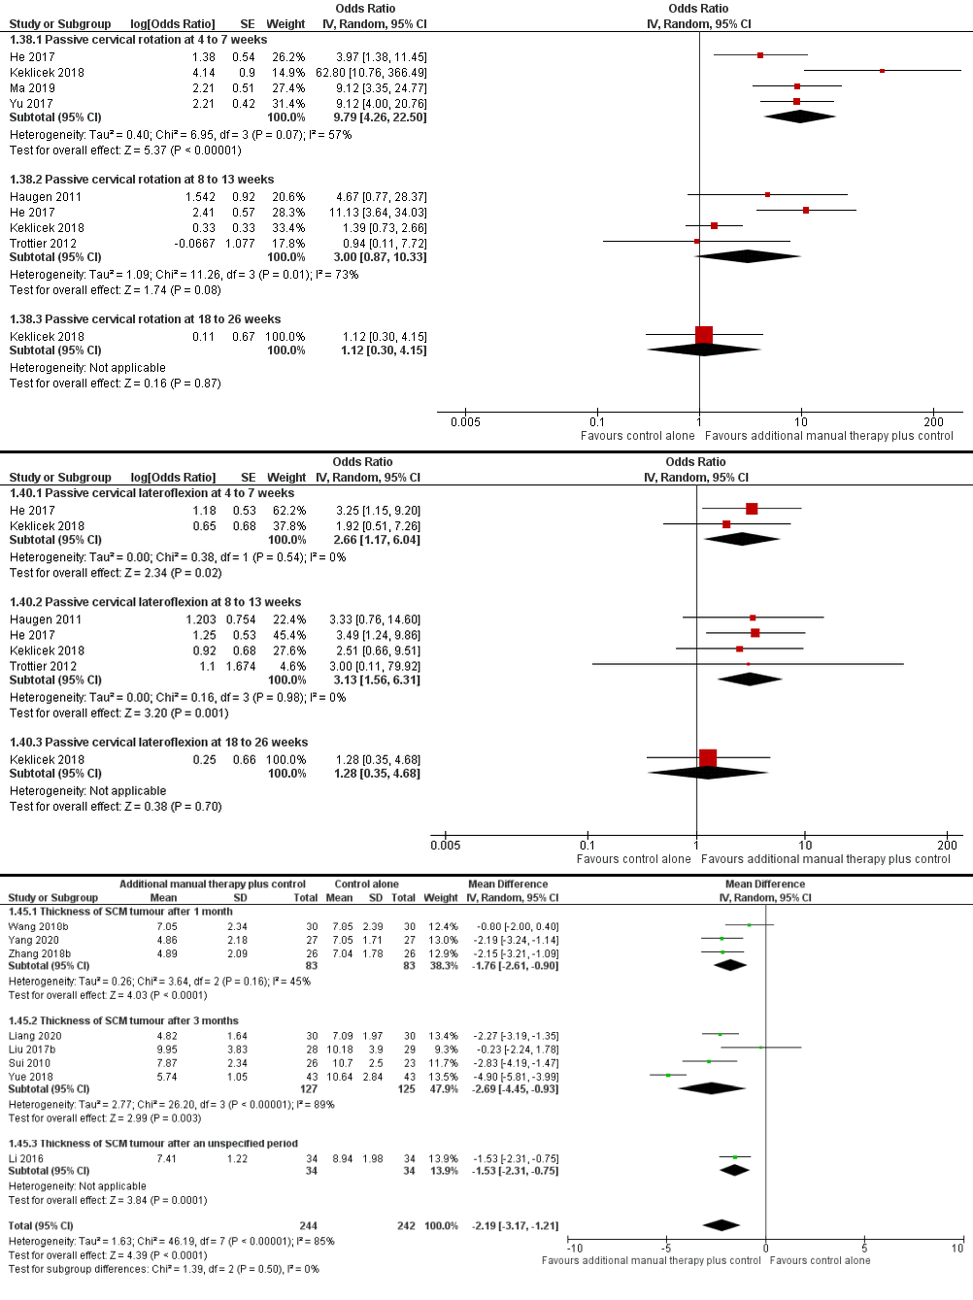
Fig. 3. Meta-analyses of studies that add manual therapy to a control intervention (quasi-RCTs excluded). H. passive cervical rotation. I. passive cervical lateroflexion. J. thickness of SCM tumour.

