Additional File

The effectiveness of instrument-assisted soft tissue mobilization on pain and function in patients with musculoskeletal disorders: A systematic review and meta-analysis

Table of Contents

Additional file 1 Search strategies……………………………………….…………..………………2
Additional file 2 Details of risk of bias…………………………………...……….………………...4
Additional file 3 Sensitivity analyses for studies with patient-reported pain………..………….….14
Additional file 4 Sensitivity analyses for studies with patient-reported function………….…........15
Additional file 5 TSA for patient-reported pain………………………………….………..……….16
Additional file 6 TSA for patient-reported function……………………………….………..……...17

Additional file 1 Search strategies

 | Pubmed | Total
#1 | (“instrument assisted soft tissue mobilization” [Title/Abstract]) OR (“soft tissue mobilization technique” [Title/Abstract]) OR (“instrument assisted soft tissue treatment technique” [Title/Abstract]) OR (“instrument assisted soft tissue technique” [Title/Abstract]) OR (“instrument assisted cross fiber massage” [Title/Abstract]) OR (“augmented soft tissue mobilization” [Title/Abstract]) OR (“IASTM” [Title/Abstract]) OR (“IASTT” [Title/Abstract]) OR (“IACFM” [Title/Abstract]) OR (“ASTM” [Title/Abstract]) OR (“ISTM” [Title/Abstract]) OR (“Graston” [Title/Abstract]) OR (“Ergon” [Title/Abstract]) OR (“ASTYM” [Title/Abstract]) OR (“Gua Sha” [Title/Abstract]) OR (“instrument assisted” [Title/Abstract]) OR (“soft tissue mobilization” [Title/Abstract]) OR (“soft tissue manipulation” [Title/Abstract]) | 3886
#2 | (randomized controlled trial[pt] OR controlled clinical trial[pt] OR clinical trials as topic[mesh:noexp] OR trial[ti] OR random*[tiab] OR placebo*[tiab]) | 2089947
#3 | #1 AND #2 | 299

 | Web of Science | Total
#1 | TS= (“instrument assisted soft tissue mobilization” OR “soft tissue mobilization technique” OR “instrument assisted soft tissue treatment technique” OR “instrument assisted soft tissue technique” OR “instrument assisted cross fiber massage” OR “augmented soft tissue mobilization” OR “IASTM” OR “IASTT” OR “IACFM” OR “ASTM” OR “ISTM” OR “Graston” OR “Ergon” OR “ASTYM” OR “Gua Sha” OR “instrument assisted” OR “soft tissue mobilization” OR “soft tissue manipulation”) | 39519
#2 | TI= (random* OR placebo* OR trial) | 972568
#3 | AB= (random* OR placebo*) | 3242015
#4 | #2 OR #3 | 3646923
#5 | #1 AND #4 | 843

 | Embase | Total
#1 | ‘instrument assisted soft tissue mobilizatio’ OR ‘soft tissue mobilization technique’ OR ‘instrument assisted soft tissue treatment technique’ OR ‘instrument assisted soft tissue technique’ OR ‘instrument assisted cross fiber massage’ OR ‘augmented soft tissue mobilization’ OR ‘IASTM’ OR ‘IASTT’ OR ‘IACFM’ OR ‘ASTM’ OR ‘ISTM’ OR ‘Graston’ OR ‘Ergon’ OR ‘ASTYM’ OR ‘Gua Sha’ OR ‘instrument assisted’ OR ‘soft tissue mobilization’ OR ‘soft tissue manipulation’ | 21239
#2 | 'controlled clinical trial'/exp | 1053197
#3 | (random* OR placebo*): ti, ab | 2297776
#4 | trial: ti | 455603
#5 | #2 or #3 OR #4 | 2679030
#6 | [embase]/lim | 33007888
#7 | #5 AND #6 | 2245021
#8 | #1 AND #7 | 668
 | Cochrane Library | Total
#1 | (“instrument assisted soft tissue mobilization” OR “soft tissue mobilization technique” OR “instrument assisted soft tissue treatment technique” OR “instrument assisted soft tissue technique” OR “instrument assisted cross fiber massage” OR “augmented soft tissue mobilization” OR “IASTM” OR “IASTT” OR “IACFM” OR “ASTM” OR “ISTM” OR “Graston” OR “Ergon” OR “ASTYM” OR “Gua Sha” OR “instrument assisted” OR “soft tissue mobilization” OR “soft tissue manipulation”): ti, ab, kw | 758

Additional file 2 Details of risk of bias
Bias in trials with subjective outcomes | Author’s judgment | Support for judgment
Abdel-Aal et al 2021
Random sequence generation | Low risk | Quote: “Computer-generated block randomization was used to assign the participants randomly to the Graston technique in addition to an exercise program group or an exercise program only group.”
Allocation concealment | Low risk | Quote: “Sealed, sequentially numbered opaque envelopes were used to ensure the concealed allocation.”
Blinding of participants and researchers | High risk | The blindness of the therapist and patients were not attainable due to the nature of the intervention.
Blinding of outcome assessment | Low risk | Quote: “The study was an assessor-blinded, parallel-groups, randomized controlled trial”; “Randomization was conducted by the second author who did not participate in the data collection. The third author opened the envelopes and hence applied the treatment according to the group allocation. The first author, who was blinded to the group allocation, collected the outcome measures.”
Incomplete outcome data | Low risk | The intervention group lost 3 participants (10.0%) and the control group lost 1 participant (3.33%), this is a reasonable attrition. In addition, the author used intention to treat analysis with the multiple imputation model for the missing data. Furthermore, adequate sample size was achieved (the minimal estimated sample size was 52, the included participants was 60).
Selective reporting | Low risk | All prespecified outcomes were reported.
Other bias | Low risk | We did not find any other bias.
Aggarwal et al 2021
Random sequence generation | Low risk | Quote: “They were randomized by simple random sampling using a lottery method.”
Allocation concealment | Unclear risk | No describe.
Blinding of participants and researchers | High risk | The blindness of the therapist and patients were not attainable due to the nature of the intervention.
(contiuned)
Additional file 2 contiuned
Bias in trials with subjective outcomes | Author’s judgment | Support for judgment
Blinding of outcome assessment | Unclear risk | No describe.
Incomplete outcome data | Unclear risk | Adequate sample size was achieved (the minimal estimated sample size was 30, the included participants was 30), but there was no describition about the attrition.
Selective reporting | Low risk | All prespecified outcomes were reported.
Other bias | Low risk | We did not find any other bias.
Bostan & Kaya 2024
Random sequence generation | Low risk | Quote: “Randomization was conducted using a random number generator (https://www.randomizer.org/).”
Allocation concealment | High risk | Quote: “Only the participants were blinded to group allocation.”
Blinding of participants and researchers | High risk | The blindness of the therapist and patients were not attainable due to the nature of the intervention.
Blinding of outcome assessment | High risk | Quote: “It was impossible for the outcome assessor and the physiotherapist providing the treatment to be blinded due to a lack of investigators. The principal investigator collected all the data and performed all the steps.”
Incomplete outcome data | Low risk | Adequate sample size was achieved (the minimal estimated sample size was 36, the included participants was 48), and the flow diagram showed no withdrawal.
Selective reporting | High risk | Nottingham Health Profile and Neck Disability Index including in the registeration were not reported in the text.
Other bias | Low risk | We did not find any other bias.
Candeniz et al 2023
Random sequence generation | Low risk | Quote: “Patients who met the inclusion criteria were randomized into 3 equal groups using the sealed envelope method.”
Allocation concealment | Low risk | Quote: “Intervention cards, including random assignment, were prepared by a researcher who was not involved in the clinical research and placed in sealed opaque envelopes. When a patient consented to participate in the trial, an
(contiuned)
Additional file 2 contiuned
Bias in trials with subjective outcomes | Author’s judgment | Support for judgment
 |  | envelope was drawn, and the patient was presented with the designated treatment regimen.”
Blinding of participants and researchers | High risk | The blindness of the therapist and patients were not attainable due to the nature of the intervention.
Blinding of outcome assessment | High risk | Quote: “This study was a 3-arm, parallel, nonblinded randomized clinical trial.”
Incomplete outcome data | Low risk | Adequate sample size was achieved (the minimal estimated sample size was 13 in each group, the included participants was 14 in each group) and “there was no withdrawal during the 3-week follow-up.”
Selective reporting | Unclear risk | The study was not registered.
Other bias | Unclear risk | The study conducted home exercises for all participants, but did not describe whether they were supervised, making it difficult to ensure consistency. In addition, the outcome was measured 3 days after the treatment, during which biases may be introduced.
Hamdy et al 2023
Random sequence generation | Low risk | Quote: “Ninety participants with NCNP were allocated randomly by a computer-generated block randomization program to the following 3 equal groups: the IASTM group, the INIT group, and the control group that received STT. The size of each block was 9, and the allocation ratio was 1:1:1 to avoid bias between the 3 groups.”
Allocation concealment | Low risk | Quote: “The first author was responsible for the step of randomization and was not involved in assessment or treatment. The codes of randomization were kept in an opaque sealed envelope to ensure the concealment of the allocation. The third author assessed the participant’s outcome measures and was blinded to the allocation and the treatment steps.” “After baseline measurement, the envelopes were opened by the fourth author, who started the treatment protocol.”
(contiuned)
Additional file 2 contiuned
Bias in trials with subjective outcomes | Author’s judgment | Support for judgment
Blinding of participants and researchers | High risk | The blindness of the therapist and patients were not attainable due to the nature of the intervention.
Blinding of outcome assessment | Low risk | Quote: “The first author was responsible for the step of randomization and was not involved in assessment or treatment. The codes of randomization were kept in an opaque sealed envelope to ensure the concealment of the allocation. The third author assessed the participant’s outcome measures and was blinded to the allocation and the treatment steps.” “After baseline measurement, the envelopes were opened by the fourth author, who started the treatment protocol.”
Incomplete outcome data | Low risk | The intervention group lost 2 participants (6.67%) and the control group lost 1 participant (3.33%), this is a reasonable attrition. In addition, the author used intention to treat analysis with the multiple imputations. Furthermore, adequate sample size was achieved (the minimal estimated sample size was 24 in each group, the included participants was 30 in each group).
Selective reporting | Low risk | All prespecified outcomes were reported.
Other bias | Low risk | We did not find any other bias.
Jones et al 2019
Random sequence generation | Low risk | Quote: “participants were randomly assigned into one of two groups via a random number generator.”
Allocation concealment | Unclear risk | No describe.
Blinding of participants and researchers | High risk | The blindness of the therapist and patients were not attainable due to the nature of the intervention.
Blinding of outcome assessment | Unclear risk | No describe.
Incomplete outcome data | High risk | There was no attrition in this study, but adequate sample size was not achieved (the minimal estimated sample size was 42, the included participants was 11).
Selective reporting | Unclear risk | The study was not registered.
(contiuned)
Additional file 2 contiuned
Bias in trials with subjective outcomes | Author’s judgment | Support for judgment
Other bias | Low risk | We did not find any other bias.
Kiran et al 2023
Random sequence generation | Low risk | Quote: “Randomization was done by the sealed enveloped method.”
Allocation concealment | Unclear risk | No describe.
Blinding of participants and researchers | High risk | The blindness of the therapist and patients were not attainable due to the nature of the intervention.
Blinding of outcome assessment | Unclear risk | No describe.
Incomplete outcome data | High risk | Adequate sample size was not achieved (the minimal estimated sample size was 42, the included participants was 30).
Selective reporting | Low risk | All prespecified outcomes were reported.
Other bias | Low risk | We did not find any other bias.
McCormack et al 2016
Random sequence generation | Low risk | Quote: “Prior to the start of subject recruitment, an individual not involved with the study used a random number generator to assign subjects to a treatment group.”
Allocation concealment | Low risk | Quote: “Group assignments were then placed in sequentially numbered and sealed opaque envelopes. An envelope was opened only once the corresponding subject agreed to enter the study.”
Blinding of participants and researchers | High risk | The blindness of the therapist and patients were not attainable due to the nature of the intervention.
Blinding of outcome assessment | Unclear risk | The registration mentioned that outcomes assessor was blinded, but there was no describition in the text.
Incomplete outcome data | Low risk | Only the control group lost 1 participant (11.11%), this is a reasonable attrition. In addition, the author used intention to treat analysis with the multiple imputation method for the missing data. Furthermore, adequate sample size was achieved (the minimal estimated sample size was 12, the included participants was 16).
(contiuned)
Additional file 2 contiuned
Bias in trials with subjective outcomes | Author’s judgment | Support for judgment
Selective reporting | Low risk | All prespecified outcomes were reported.
Other bias | High risk | Quote: “A second limitation is the difference in contact with a therapist between the 2 groups. The soft tissue treatment (Astym) group was seen in the clinic for up to 12 sessions while subjects in the exercise-only group met with a therapist 1 to 4 times.” In addition, eccentric exercise was performed for 12 weeks and IASTM was performed for 6 weeks, but the overlap time between IASTM and eccentric exercise was not specified in the text. We extracted the outcome of 12 weeks and assumed that the last IASTM treatment was at 12 weeks of treatment. If IASTM treatment was in the first 6 weeks of eccentric exercise, then this study should not be included.
Schaefer & Sandrey 2012
Random sequence generation | Unclear risk | The paper mention randomization, but there was no detail.
Allocation concealment | Unclear risk | Quote: “The allocation of group membership was concealed, as the prinicpal investigator was blinded to group assignment.” However, there was no further description.
Blinding of participants and researchers | High risk | The blindness of the therapist and patients were not attainable due to the nature of the intervention.
Blinding of outcome assessment | High risk | Quote: “The primary researcher administered and supervised all treatment, testing, and training sessions.”
Incomplete outcome data | High risk | 4 (26.67%) lost in the control group, 2 (13.33%) lost in the intervention group. This is an unreasonable attrition (the attrition in the control group was greater than 20%).
Selective reporting | Unclear risk | The study was not registered.
Other bias | Low risk | We did not find any other bias.
Sevier & Stegink-Jansen 2015
Random sequence generation | Low risk | Quote: “Randomization was performed using computer-generated random number tables.”
(contiuned)
Additional file 2 contiuned
Bias in trials with subjective outcomes | Author’s judgment | Support for judgment
Allocation concealment | Unclear risk | The text only mentioned that the rater taking the measurements was blinded to the group allocation, but there was no further description.
Blinding of participants and researchers | High risk | The blindness of the therapist and patients were not attainable due to the nature of the intervention.
Blinding of outcome assessment | Low risk | Quote: “The rater taking the measurements from the subjects was blinded to the group allocation, as well as the physicians evaluating the recovery of the subjects. The patients, office staff, treating therapists and the study coordinator were instructed not to reveal the type of physical therapy intervention to the physicians.”
Incomplete outcome data | Low risk | 11 (19.30%) lost in the intervention group, 12 (21.43%) lost in the control group. This is an unreasonable attrition, but the study used two ways for data analyize, “using only participants who had received the assigned treatment and secondly using an intent-to-treat analysis imputing the total group mean to replace missing data, and they provided the same results. Effect sizes and power calculations were completed for the performed statistical analyses based on the true participant analyses.” As a result, we thought it would not affect results. In addition, adequate sample size was achieved (the minimal estimated sample size was 64, the included participants was 90).
Selective reporting | Low risk | Quote: “registration of this trial was not required under Section 801 of the Food and Drug Administration Amendments Act.” All outcomes were reported.
Other bias | Unclear risk | Quote: “The possibility of placebo effects was present in the design: the Astym treatment group was seen in the clinic twice per week and experienced a hands-on treatment. To counteract some of the placebo effect, subjects in the EE program had unlimited access to the treating EE clinician via phone, and EE clinician also initiated contact with the subjects on a regular basis. Even though EE subjects met with a clinician initially to receive exercise
(contiuned)
Additional file 2 contiuned
Bias in trials with subjective outcomes | Author’s judgment | Support for judgment
instruction and guidance on the exercise program, the subjects were not
supervised during the actual performance of the exercise, which could have
resulted in improper performance or non-compliance, however, no such concerns were reported.”
Torlak et al 2022
Random sequence generation | Unclear risk | Quote: “Three different treatment options for randomization were created on a computer by a statistician and were numbered from largest to smallest by putting them in envelopes.” However, the study did not describe whether the envelope was sealed or transparent.
Allocation concealment | Unclear risk | Quote: “The person applying the treatment opened the envelopes in turn and applied the treatment in the envelope according to the number of the patients.” However, the study did not describe whether the envelope was sealed or transparent.
Blinding of participants and researchers | High risk | The blindness of the therapist and patients were not attainable due to the nature of the intervention.
Blinding of outcome assessment | Unclear risk | Quote: “the outcome assessor, who evaluated clinical measurements, was unaware to the type of treatment.” However, there was no further description.
Incomplete outcome data | Low risk | Adequate sample size was achieved (the minimal estimated sample size was 15 in each group, the included participants was 15 in each group), and the flow diagram showed no withdrawal.
Selective reporting | Low risk | All prespecified outcomes were reported.
Other bias | Low risk | We did not find any other bias.

Additional file 2 contiuned
Bias in trials with objective outcomes | Author’s judgment | Support for judgment
Candeniz et al 2023
Random sequence generation | Low risk | Quote: “Patients who met the inclusion criteria were randomized into 3 equal groups using the sealed envelope method.”
Allocation concealment | Low risk | Quote: “Intervention cards, including random assignment, were prepared by a researcher who was not involved in the clinical research and placed in sealed opaque envelopes. When a patient consented to participate in the trial, an envelope was drawn, and the patient was presented with the designated treatment regimen.”
Blinding of participants and researchers | High risk | We could not rule out the influence of factors such as strength on the outcome, so we still rated as high risk based on the nature of the intervention.
Blinding of outcome assessment | Low risk | We thought that blinding of outcome assessment had little impact on objective outcomes.
Incomplete outcome data | Low risk | Adequate sample size was achieved (the minimal estimated sample size was 13 in each group, the included participants was 14 in each group) and “there was no withdrawal during the 3-week follow-up.”
Selective reporting | Low risk | The outcome of interest was reported.
Other bias  Schaefer & Sandrey 2012  Random sequence generation  Allocation concealment  Blinding of participants and researchers | Unclear risk  Unclear risk  Unclear risk  High risk | The study conducted home exercises for all participants, but did not describe whether they were supervised, making it difficult to ensure consistency. In addition, the outcome was measured 3 days after the treatment, during which biases may be introduced.  The paper mention randomization, but there was no detail.  Quote: “The allocation of group membership was concealed, as the prinicpal investigator was blinded to group assignment.” However, there was no further description.  We could not rule out the influence of factors such as strength on the outcome, so we still rated as high risk based on the nature of the intervention.
(contiuned)
Additional file 2 contiuned
Bias in trials with objective outcomes | Author’s judgment | Support for judgment
Blinding of outcome assessment  Incomplete outcome data | Low risk  High risk | We thought that blinding of outcome assessment had little impact on objective outcomes  4 (26.67%) lost in the control group, 2 (13.33%) lost in the intervention group. This is an unreasonable attrition (the attrition in the control group was greater than 20%).
Selective reporting  Other bias | Low risk  Low risk | The outcome of interest was reported.  We did not find any other bias.

Additional file 3 Sensitivity analyses for studies with patient-reported pain

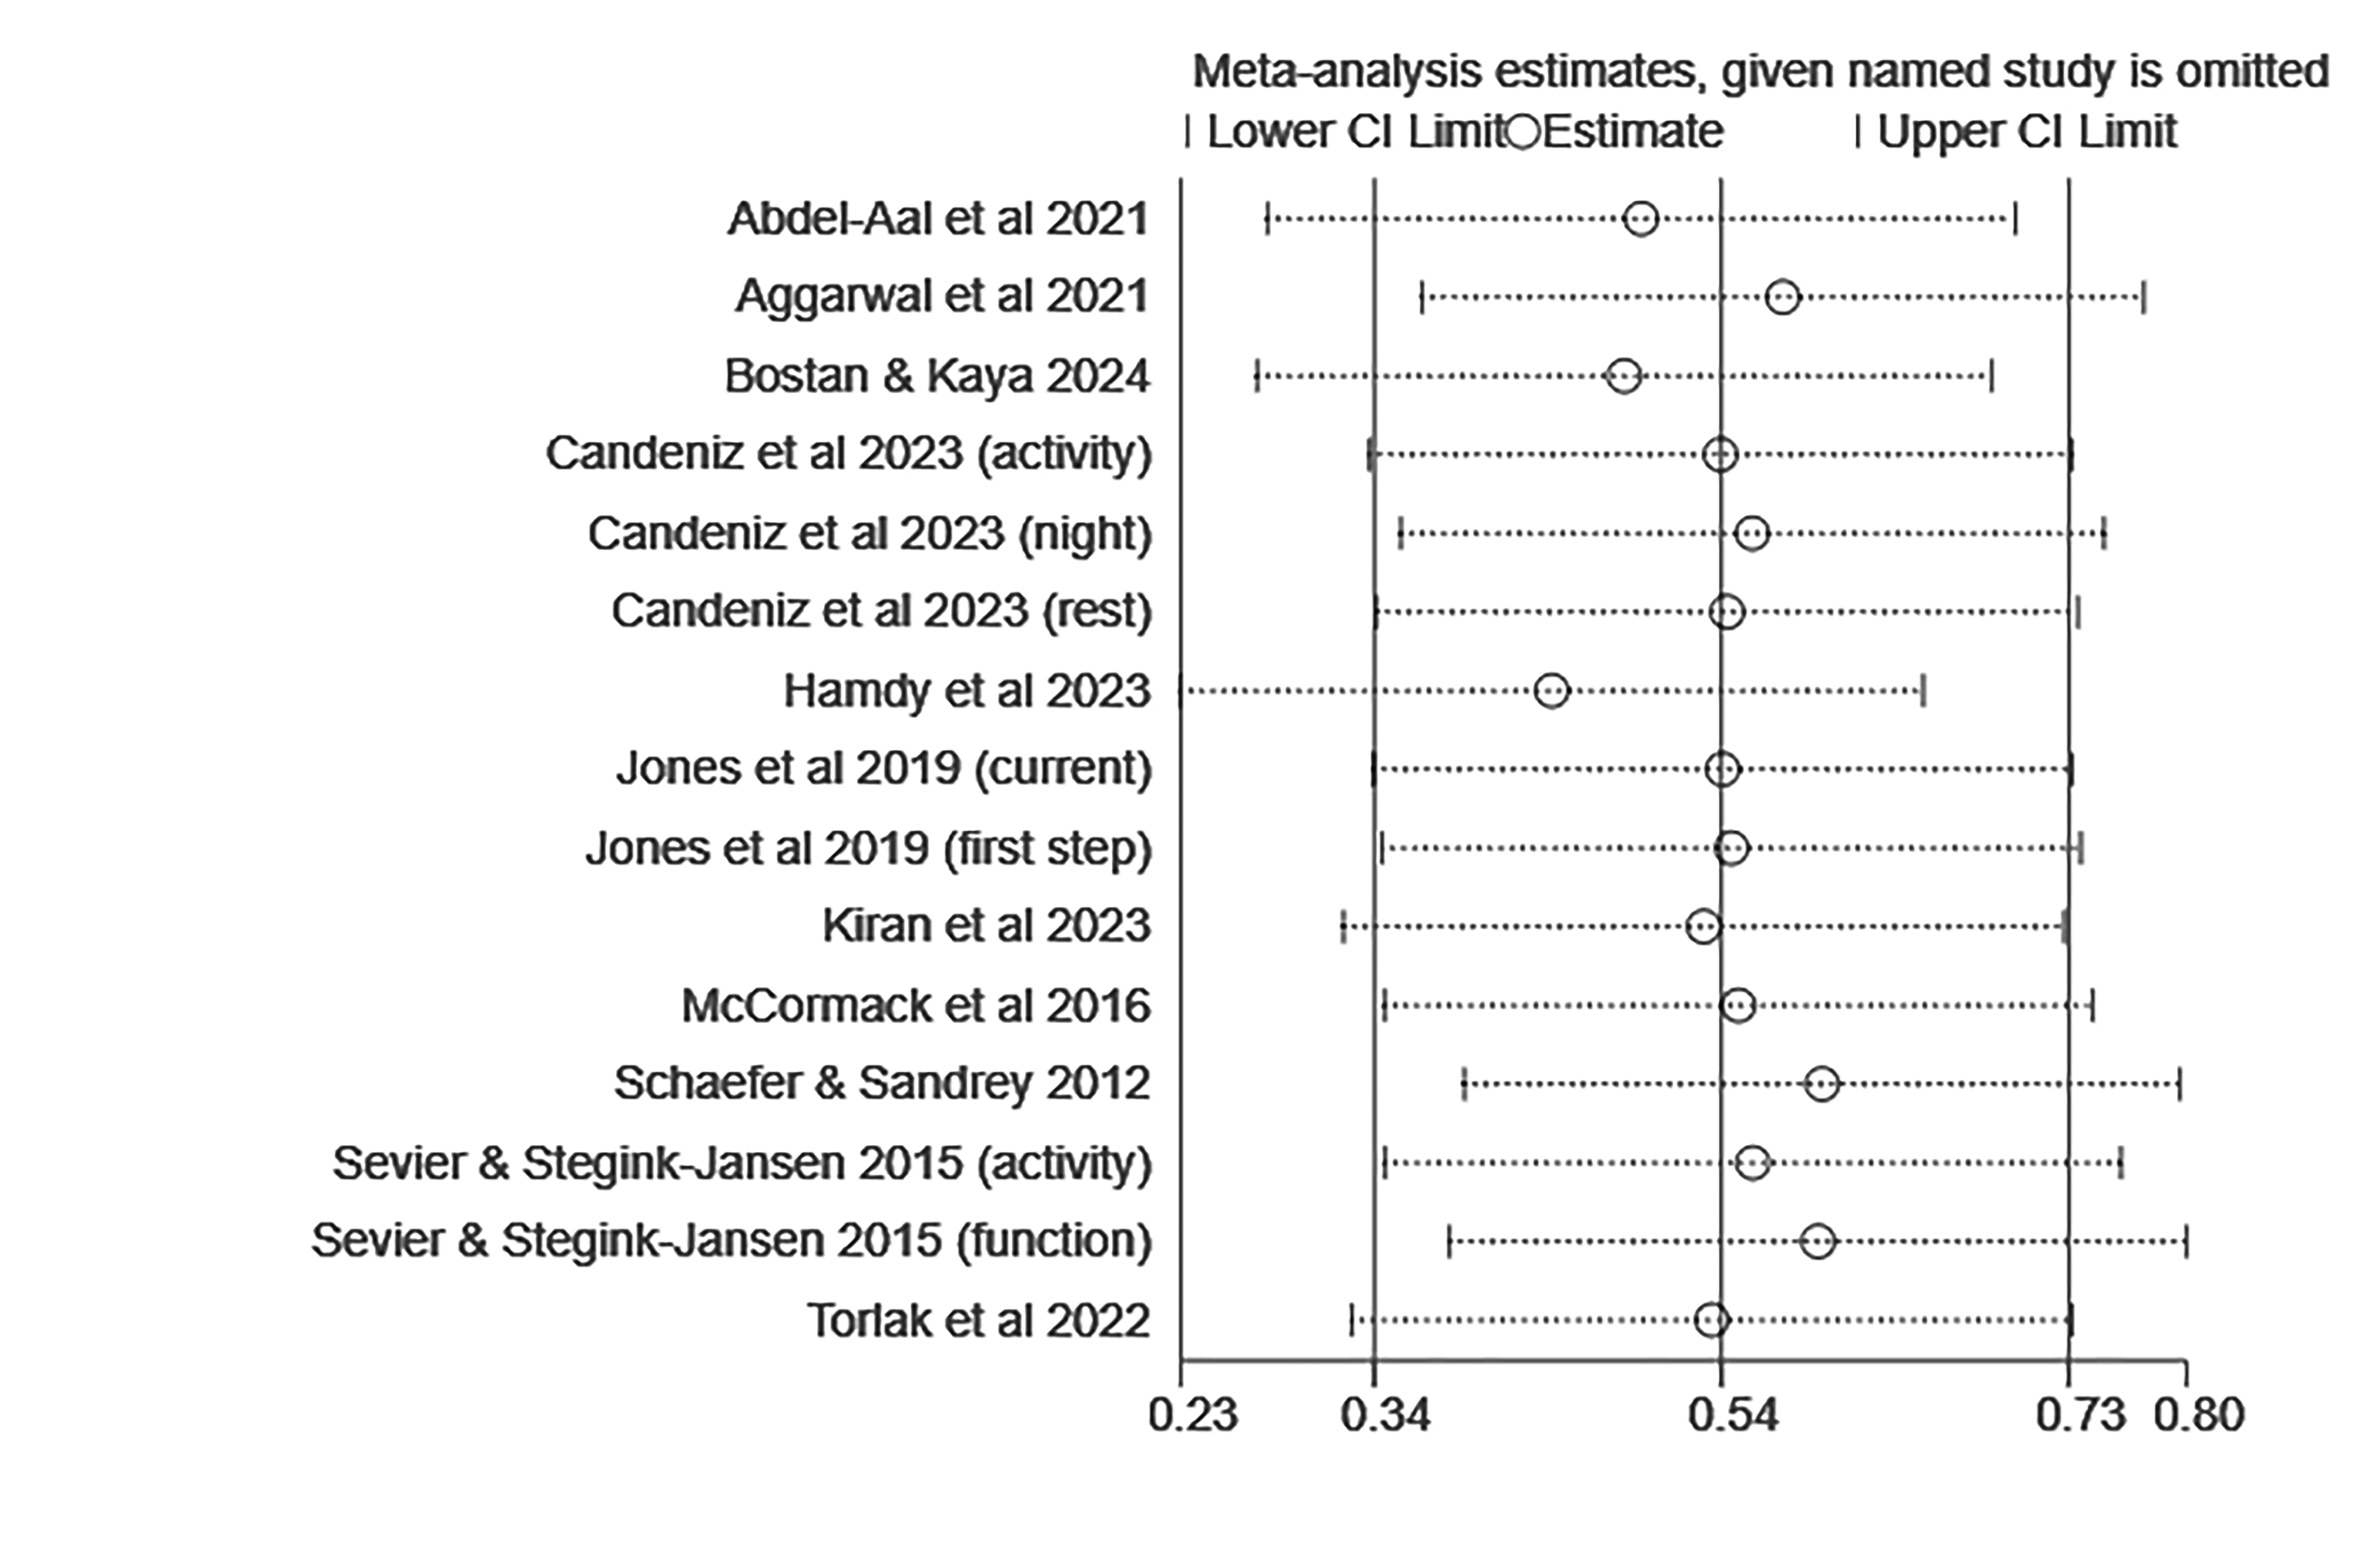
Figure Af 3 Sensitivity analyses for studies with patient-reported pain

Additional file 4 Sensitivity analyses for studies with patient-reported function

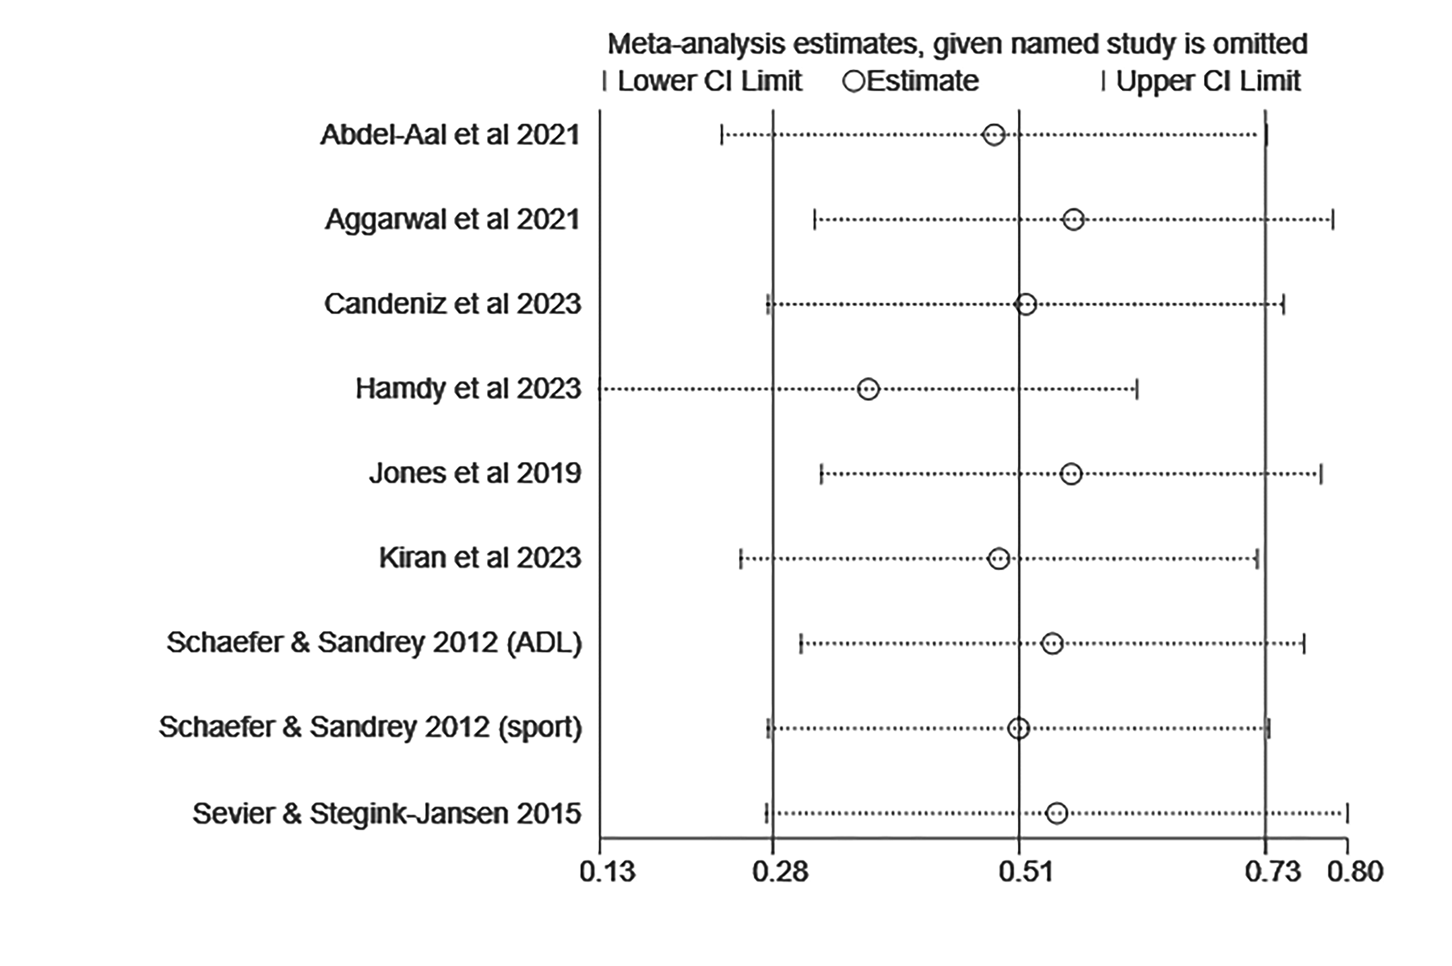
Figure Af 4 Sensitivity analyses for studies with patient-reported function

Additional file 5 TSA for patient-reported pain

Figure Af 5 TSA for patient-reported pain

Additional file 6 TSA for patient-reported function

Figure Af 6 TSA for patient-reported function

