Supplementary materials
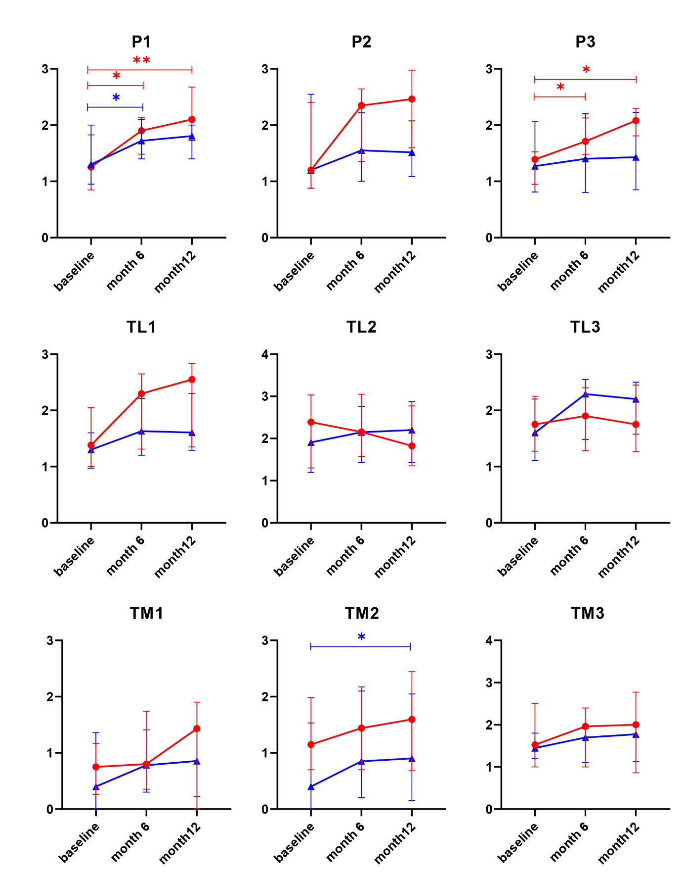
Figure S1. MRI analysis of cartilage thickness in patients with KOA at different evaluation sites (P1, P2, P3, TL1, TL2, TL3, TM1, TM2, and TM3). *, p≤0.05. The red line represents the Control group; the blue line represents the MSC group.
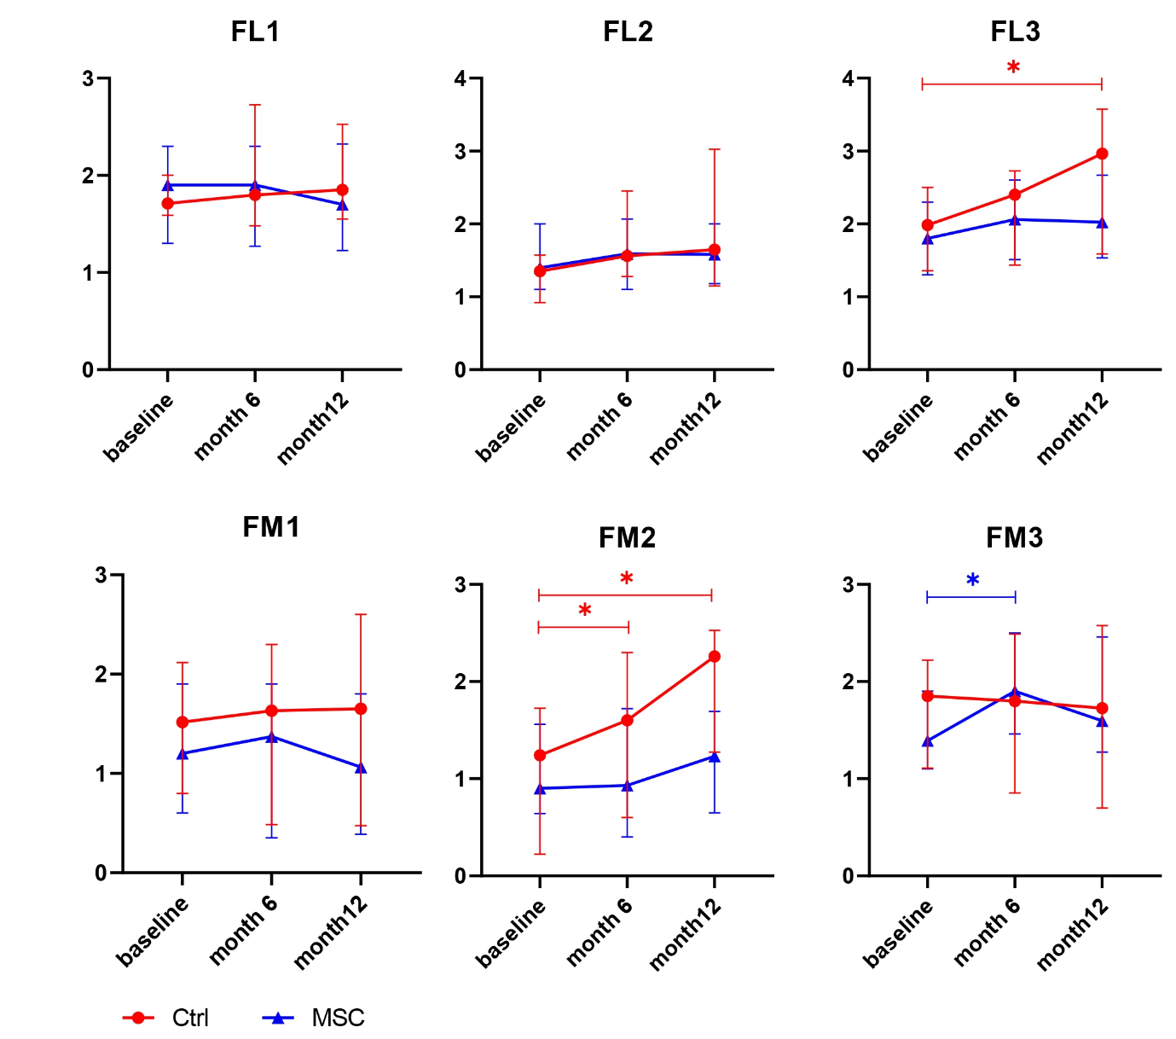
Figure S1 (continued).

