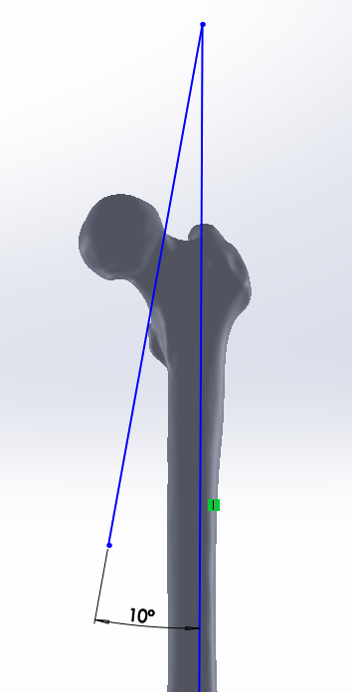
10°

Supplementary Figure 1. Vertical femoral neck fracture model with Pauwels angles of 80°.

