Relationship between cardiovascular health and osteoarthritis in middle-aged and elderly U.S. population: A cross-sectional NHANES study

Dui Mou^{a†}, Yuhang Liu^{b†}, Siyao Gao^{c}, Peng Zhao^{a*}

Author Affiliations:
ª Football Academic, Wuhan Sports University, Wuhan, 430079, P. R. China;
^{b} School of Physical Education and sports, Central China Normal University, Wuhan 430079, P. R. China;
^{c} Department of Physical Education, Central South University, Changsha, 410083, P. R. China.

E-mail:
moudui2001@163.com;
yuhangliu@mails.ccnu.edu.cn;
gaosiyao@csu.edu.cn;
1115803148@qq.com.

† These authors contributed equally to this work.

*Corresponding Author:
Siyao Gao, PhD.,
Department of Physical Education, Central South University,
No.932 Lushan South Road, Yuelu District, Changsha, China 410083.
(E-mail: gaosiyao@csu.edu.cn)
AND
Peng Zhao,
Football Academic, Wuhan Sports University,
No.461 Luoyu Road, Hongshan District, Wuhan, China 430079.
(E-mail: 1115803148@qq.com)

Table of contents
Fig S1 Flowchart of selection of participants 3
Fig S2 Age-adjusted prevalence of OA in different levels of LE8 score, health behavior score, and health factor score 4
Figure S3 Dose-response relationships between LE8 score (A), health behavior score (B), health factor score(C), and OA, stratified by age. 5
Figure S4 Dose-response relationships between LE8 score (A), health behavior score (B), health factor score(C), and OA, stratified by gender. 6
Figure S5 Dose-response relationships between LE8 score (A), health behavior score (B), health factor score(C), and OA, stratified by race/ethnicity. 7
Table S1 The details of exclusion variables information 8
Table S2 Definition and scoring algorithm for the Life’s Essential 8 9
Table S3 Healthy Eating Index-2015 components, point values, and scoring standards 13
Table S4 Baseline characteristics of U.S. adults aged ≥ 40 years by LE8-evaluated CVH levels 14
Table S5 Associations of LE8 scores and OA, moderate level groups (50-79) as the reference 16
Table S6 Associations of all 8 LE8 metrics scores with OA 17
Table S7 Associations of all 8 LE8 metrics scores with OA, moderate level groups (50-79) as the reference 19
Table S8 Associations of LE8 scores with OA for additional adjustment 21
Table S9 Associations of health behavior scores with OA for additional adjustment 22
Table S10 Associations of health factor scores with OA for additional adjustment 23
Table S11 Associations of LE8 scores and OA, high level CVH groups (80-100) as the reference 24

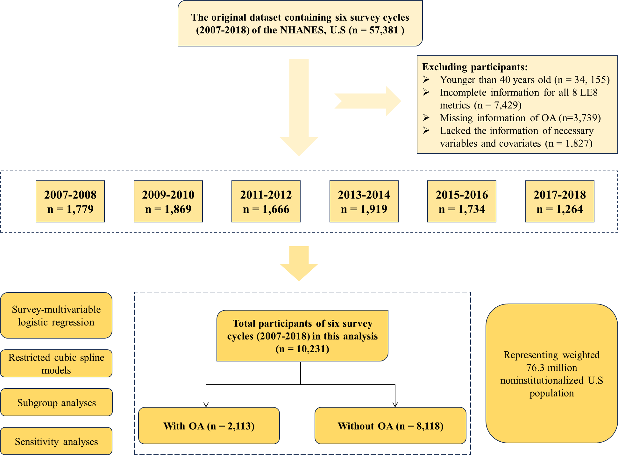

Fig S1 Flowchart of selection of participants
Abbreviations: OA, Osteoarthritis; LE8, Life’s Essential 8; NHANES, National Health and Nutrition Examination Survey.

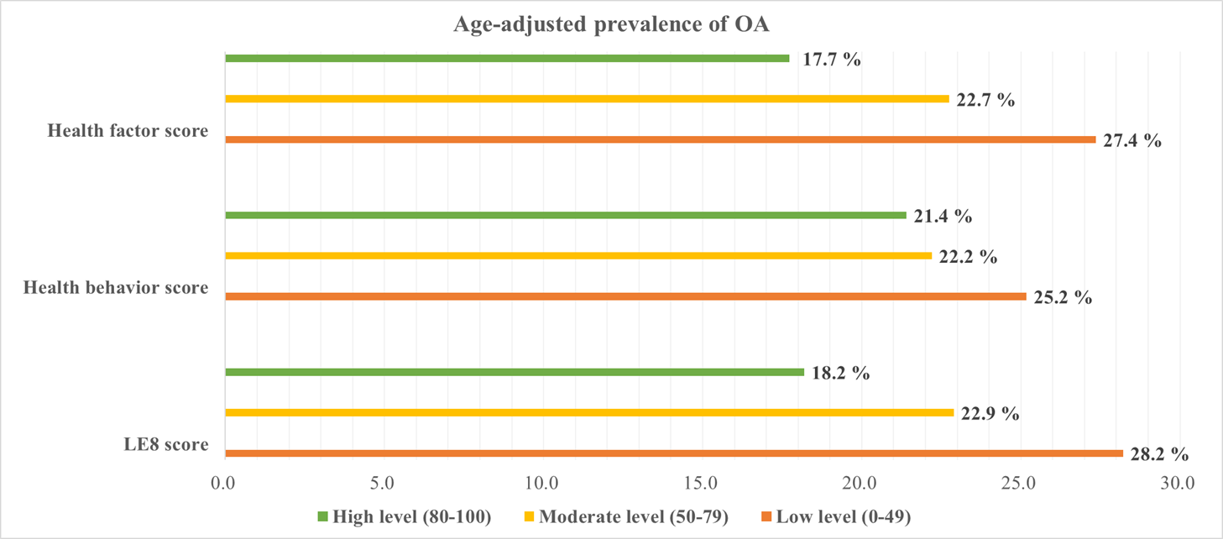

Fig S2 Age-adjusted prevalence of OA in different levels of LE8 score, health behavior score, and health factor score
The numbers at the right of the bars represent the weighted percentage.
Abbreviations: LE8, Life’s Essential 8; OA, Osteoarthritis.

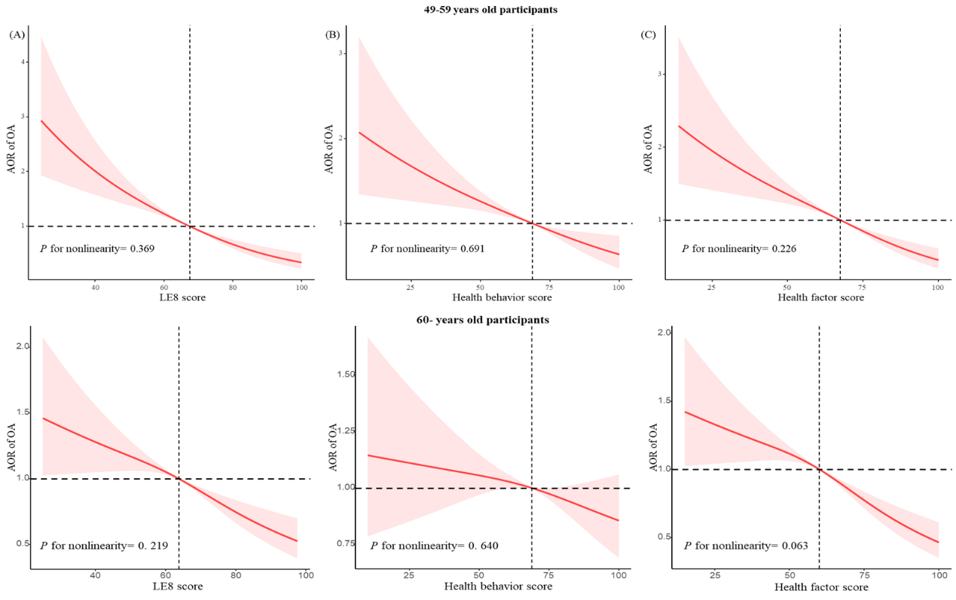

Figure S3 Dose-response relationships between LE8 score (A), health behavior score (B), health factor score(C), and OA, stratified by age.
Abbreviations: AOR = Adjusted Odd ratios; LE8 = Life’s Essential8; OA = Osteoarthritis.

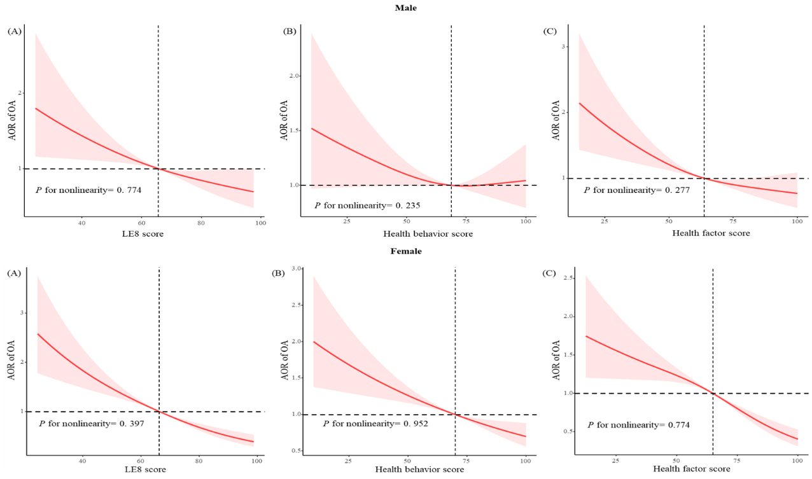

Figure S4 Dose-response relationships between LE8 score (A), health behavior score (B), health factor score(C), and OA, stratified by gender.
Abbreviations: AOR = Adjusted Odd ratios; LE8 = Life’s Essential8; OA = Osteoarthritis.

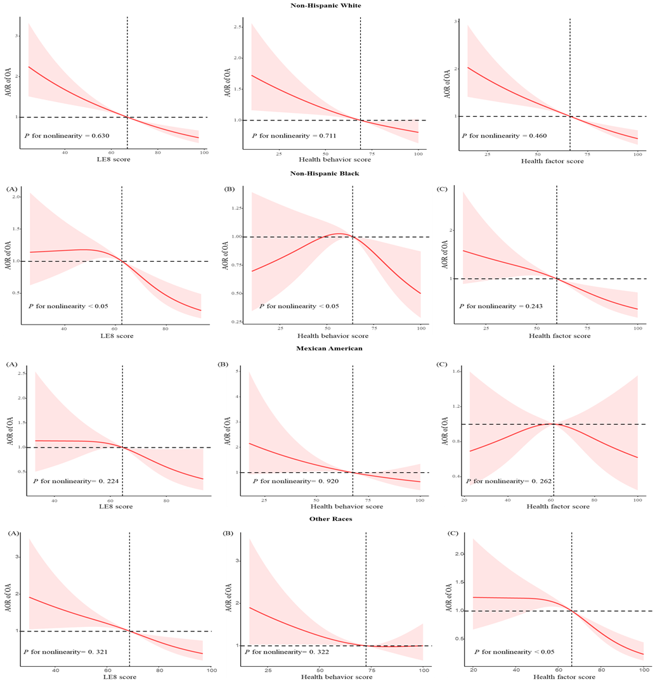

Figure S5 Dose-response relationships between LE8 score (A), health behavior score (B), health factor score(C), and OA, stratified by race/ethnicity.
Abbreviations: AOR = Adjusted Odd ratios; LE8 = Life’s Essential8; OA = Osteoarthritis.

Table S1 The details of exclusion variables information
Variable | Original (n) | Drop (n) | Drop (%) | Left (n)
Age ª | 57,381 | 34,155 | 59.5% | 23,226
LE8 | 23,226 | 7,513 | 13.1% | 16,031
OA | 13,828 | 3,655 | 6.4% | 12,058
PIR | 12,058 | 1,032 | 1.8% | 11,026
Marital status | 11,026 | 2 | 0.0% | 11,024
Education level | 11,024 | 6 | 0.0% | 11,018
Alcohol consumption | 11,018 | 787 | 1.4% | 10,231
ª excluded participants aged under 40 years old.

Table S2 Definition and scoring algorithm for the Life’s Essential 8
Domain | CVH metric | Method of measurement | Quantification and scoring of CVH metric: adults (≥ 20 years of age)
Health behaviors | Diet | Healthy Eating Index-2015 diet score percentile | Quantiles of DASH-style diet adherence HEI-2015 (population)  Scoring (Population):  Points Quantile  100 ≥ 95th percentile (top/ideal diet)  80 75th-94th percentile  50 50th-74th percentile  25 25th-49th percentile  0 1st-24th percentile (bottom/least ideal quartile)
Health behaviors | Physical activity | Self-reported minutes of moderate or vigorous physical activity per week | Metric: Minutes of moderate (or greater) intensity activity per week  Scoring:  Points Minutes  100 ≥ 150  90 120-149  80 90-119  60 60-89  40 30-59  20 1-29  0 0
Health behaviors | Nicotine exposure | Self-reported use of cigarettes or inhaled NDS | Metric: Combustible tobacco use and/or inhaled NDS use; or secondhand smoke exposure  Scoring:  Points Status  100 Never smoker  75 Former smoker, quit ≥5 years  50 Former smoker, quit 1-< 5 years  25 Former smoker, quit < 1 year, or currently using inhaled NDS  0 Current smoker  Subtract 20 points (unless score is 0) for living with active indoor smoker in home
Health behaviors | Sleep health | Self-reported average hours of sleep per night | Metric: Average hours of sleep per night  Scoring:  Points Level  100 7-< 9  90 9-< 10  70 6-< 7  40 5-< 6 or ≥ 10  20 4-< 5  0 < 4
Health factors | Body mass index | Body weight (kg) divided by height squared (m²) | Metric: Body mass index (kg/m²)  Scoring:  Points Level  100 < 25  70 25.0-29.9  30 30.0-34.9  15 35.0-39.9  0 ≥ 40.0
Health factors | Blood lipids | Plasma total and HDL-cholesterol with calculation of non-HDL-cholesterol | Metric: Non-HDL-cholesterol (mg/dL)  Scoring:  Points Level  100 < 130  60 130-159  40 160-189  20 190-219  0 ≥ 220  If drug-treated level, subtract 20 points
Health factors | Blood glucose | Fasting blood glucose or casual hemoglobin A1c | Metric: Fasting blood glucose (mg/dL) or hemoglobin A1c (%)  Scoring:  Points Level  100 No history of diabetes and FBG < 100 (or HbA1c < 5.7)  60 No diabetes and FBG 100 – 125 (or HbA1c 5.7-6.4) (Pre-diabetes)  40 Diabetes with HbA1c < 7.0  30 Diabetes with HbA1c 7.0-7.9  20 Diabetes with HbA1c 8.0-8.9  10 Diabetes with Hb A1c 9.0-9.9  0 Diabetes with HbA1c ≥ 10.0
Health factors | Blood pressure | Appropriately measured systolic and diastolic blood pressure | Metric: Systolic and diastolic blood pressure (mm Hg)  Scoring:  Points Level  100 < 120/< 80 (Optimal)  75 120-129/< 80 (Elevated)  50 130-139 or 80-89 (Stage 1 hypertension)  25 140-159 or 90-99  0 ≥ 160 or ≥ 100  Subtract 20 points if treated level
References:
[1] Lloyd-Jones DM, Hong Y, Labarthe D, et al. Defining and setting national goals for cardiovascular health promotion and disease reduction: the American Heart Association's strategic Impact Goal through 2020 and beyond. Circulation. 2010;121(4):586-613. doi:10.1161/CIRCULATIONAHA.109.192703
[2] Lloyd-Jones DM, Allen NB, Anderson CAM, et al. Life's Essential 8: Updating and Enhancing the American Heart Association's Construct of Cardiovascular Health: A Presidential Advisory From the American Heart Association. Circulation. 2022;146(5):e18-e43. doi:10.1161/CIR.0000000000001078
Abbreviations: CVH, Cardiovascular health; FBG, Fasting blood glucose; HbA1c: Hemoglobin A1c; HDL, High-density lipoprotein; NDS, Nicotine-delivery system; HEI, Healthy Eating Index.

Table S3 Healthy Eating Index-2015 components, point values, and scoring standards
Component | Maximum points | Standard for maximum score | Standard for minimum score of zero
Adequacy
Total Fruitsª | 5 | ≥ 0.8 c equivalents/1,000 kcal | No fruit
Whole Fruits | 5 | ≥ 0.4 c equivalents/1,000 kcal | No whole fruit
Total Vegetables | 5 | ≥ 1.1 c equivalents/1,000 kcal | No vegetables
Greens and Beans | 5 | ≥ 0.2 c equivalents/1,000 kcal | No dark green vegetables or beans and peas
Whole Grains | 10 | ≥ 1.5 oz equivalents/1,000 kcal | No whole grains
Dairy | 10 | ≥ 1.3 c equivalents/1,000 kcal | No dairy
Total Protein Foods | 5 | ≥ 2.5 oz equivalents/1,000 kcal | No protein foods
Seafood and Plant Proteins | 5 | ≥ 0.8 c equivalents/1,000 kcal | No seafood or plant proteins
Fatty Acids | 10 | (PUFAs+MUFAs)/SFAs ≥ 2.5 | (PUFAs+MUFAs)/SFAs ≤ 1.2
Moderation
Refined Grains | 10 | ≤ 1.8 oz equivalents/1,000 kcal | ≥ 4.3 oz equivalents/1,000 kcal
Sodium | 10 | ≤ 1.1 g/1,000 kcal | ≥ 2.0 g/1,000 kcal
Added Sugars | 10 | ≤ 6.5% of energy | ≥ 26% of energy
Saturated Fats | 10 | ≤ 8% of energy | ≥ 16% of energy
Reference:
[1] Krebs-Smith SM, Pannucci TE, Subar AF, et al. Update of the Healthy Eating Index: HEI-2015 [published correction appears in J Acad Nutr Diet. 2019 Aug 20;:]. J Acad Nutr Diet. 2018;118(9):1591-1602.
Abbreviations: MUFAs, Monounsaturated fatty acids; PUFAs, Polyunsaturated fatty acids; SFAs, saturated fatty acids.

Table S4 Baseline characteristics of U.S. adults aged ≥ 40 years by LE8-evaluated CVH levels
Demographic/health variables | Total | LE8 score |  |  | P-valueª
Demographic/health variables | Total | Low CVH (0-49) | Moderate CVH (50-79) | High CVH (80-100) | P-valueª
Age | 56.99 ± 0.20 | 58.62 ± 0.39 | 57.43 ± 0.21 | 54.78 ± 0.38 | < 0.001
40-59 | 5,520 (61.5) | 651 (54.7) | 3,761 (60.2) | 1,108 (69.1) | < 0.001
60- | 4,711 (38.5) | 718 (45.3) | 3,389 (39.8) | 604 (30.9) | < 0.001
Sex
Male | 5,061 (47.7) | 681 (48.4) | 3,703 (50.5) | 677 (38.3) | < 0.001
Female | 5,170 (52.3) | 688 (51.6) | 3,447 (49.5) | 1,035 (61.7) | < 0.001
Education level
Less than high school | 2,170 (12.5) | 456 (24.6) | 1,527 (12.7) | 187 (5.9) | < 0.001
High school | 2296 (22.5) | 376 (30.2) | 1,708 (24.9) | 212 (10.9) | < 0.001
More than high school | 5,765 (65.0) | 537 (45.2) | 3,915 (62.3) | 1,313 (83.2) | < 0.001
PIR | 3.39 ± 0.04 | 2.58 ± 0.07 | 3.33 ± 0.05 | 4.00 ± 0.06 | < 0.001
<1.3 | 2,512 (14.0) | 526 (27.6) | 1,764 (14.3) | 222 (6.2) | < 0.001
1.3-3.5 | 3,895 (33.8) | 577 (42.7) | 2,799 (35.6) | 519 (23.7) | < 0.001
>3.5 | 3,824 (52.3) | 266 (29.7) | 2,587 (50.1) | 971 (70.1) | < 0.001
Race
Non-Hispanic White | 4,984 (76.6) | 615 (70.1) | 3,425 (75.7) | 944 (82.7) | < 0.001
Non-Hispanic Black | 1,910 (8.2) | 375 (14.3) | 1,361 (8.7) | 174 (3.6) | < 0.001
Mexican American | 1,345 (5.5) | 186 (6.3) | 999 (6.0) | 160 (3.6) | < 0.001
Other races | 1,992 (9.7) | 193 (9.3) | 1,365 (9.6) | 434 (10.1) | < 0.001
Marital status
Married/Living with partner | 6,672 (70.6) | 779 (61.3) | 4,620 (69.3) | 1,273 (79.1) | < 0.001
Living alone | 3,559 (29.4) | 590 (38.7) | 2,530 (30.7) | 439 (20.9) | < 0.001
Alcohol consumption
Never | 1,382 (10.1) | 159 (9.5) | 968 (10.2) | 255 (10.0) | < 0.001
Former | 1,897 (15.0) | 389 (26.2) | 1,326 (15.1) | 182 (8.9) | < 0.001
Current | 6,952 (75.0) | 821 (64.2) | 4,856 (74.7) | 1,275 (81.1) | < 0.001
Total LE8 score | 67.51 ± 0.27 | 41.62 ± 0.22 | 65.57 ± 0.13 | 86.34 ± 0.16 | < 0.001
Health behavior score | 68.88 ± 0.37 | 39.85 ± 0.58 | 67.55 ± 0.28 | 87.28 ± 0.29 | < 0.001
Diet | 44.18 ± 0.62 | 20.42 ± 0.81 | 40.63 ± 0.63 | 67.08 ± 0.98 | < 0.001
PA | 71.76 ± 0.62 | 24.41 ± 1.52 | 71.35 ± 0.74 | 96.18 ± 0.36 | < 0.001
Nicotine exposure | 74.57 ±0.61 | 45.41 ± 1.60 | 73.49 ± 0.65 | 92.27 ± 0.55 | < 0.001
Sleep health | 85.00 ± 0.33 | 69.15 ± 1.11 | 84.74 ± 0.32 | 93.57 ± 0.44 | < 0.001
Health factor score | 66.14 ± 0.30 | 43.40 ± 0.61 | 63.58 ± 0.28 | 85.41 ± 0.29 | < 0.001
BMI | 59.88 ± 0.51 | 32.76 ± 1.16 | 56.41 ± 0.54 | 84.17 ± 0.74 | < 0.001
Blood lipids | 59.56 ± 0.40 | 41.42 ± 1.12 | 57.03 ± 0.49 | 76.47 ± 0.71 | < 0.001
Blood glucose | 81.77 ± 0.41 | 57.02 ± 0.87 | 81.11 ± 0.48 | 95.95 ± 0.43 | < 0.001
Blood pressure | 63.37 ± 0.52 | 42.41 ± 1.01 | 59.78 ± 0.52 | 85.05 ± 0.71 | < 0.001
Osteoarthritis
No | 8,118 (77.6) | 990 (70.4) | 5,661 (76.8) | 1467 (83.6) | < 0.001
Yes | 2,113 (22.4) | 379 (29.6) | 1,489 (23.2) | 245 (16.4) | < 0.001
Survey cycle
2007-2008 | 1,779 (14.9) | 238 (15.4) | 1,270 (15.3) | 271 (13.5) | 0.51
2009-2010 | 1,869 (16.0) | 251 (15.3) | 1,310 (15.9) | 308 (16.4) | 0.51
2011-2012 | 1,666 (18.0) | 231 (19.7) | 1,156 (18.1) | 279 (16.8) | 0.51
2013-2014 | 1,919 (18.8) | 256 (20.2) | 1,276 (17.8) | 387 (21.3) | 0.51
2015-2016 | 1,734 (18.0) | 244 (16.9) | 1,220 (18.0) | 270 (18.3) | 0.51
2017-2018 | 1,264 (14.3) | 149 (12.5) | 918 (14.8) | 197 (13.6) | 0.51
Footnotes: Continuous variables are presented as mean ± SE, and categorical variables are presented as n (%).
ª P-values were assessed by T-test (continuous variables) or by Chi-square test (categorical variables). P-values shown in bold were statistically significant.
Abbreviations: BMI, Body mass index; CVH, Cardiovascular health; LE8, Life’s Essential 8; NHANES, National Health and Nutrition Examination Survey; PA, Physical activity; PIR, Poverty income ratio; SE, Standard error.

Table S5 Associations of LE8 scores and OA, moderate level groups (50-79) as the reference
 | Crude model |  |  | Model 1 |  |  | Model 2
 | COR (95% CI) | P-value |  | AOR (95% CI) | P-value |  | AOR (95% CI) | P-value
LE8 score
Moderate CVH (80-100) | Reference | - |  | Reference | - |  | Reference | -
Low CVH (50-79) | 1.391 (1.107, 1.747) | < 0.05 |  | 1.482 (1.149, 1.912) | < 0.05 |  | 1.455 (1.125, 1.883) | < 0.05
High CVH (0-49) | 0.649 (0.528, 0.796) | < 0.001 |  | 0.622 (0.497, 0.779) | < 0.001 |  | 0.626 (0.500, 0.784) | < 0.001
P for trend |  | < 0.05 |  |  | < 0.05 |  |  | < 0.05
Health behavior score
Moderate level (0-49) | Reference | - |  | Reference | - |  | Reference | -
Low level (50-79) | 1.202 (0.996, 1.451) | 0.054 |  | 1.235 (1.005, 1.517) | 0.044 |  | 1.243 (1.007, 1.535) | 0.043
High level (80-100) | 1.000 (0.850, 1.176) | 0.997 |  | 0.916 (0.768, 1.092) | 0.322 |  | 0.893 (0.743, 1.073) | 0.222
P for trend |  | 0.918 |  |  | 0.385 |  |  | 0.319
Health factor score
Moderate level (0-49) | Reference | - |  | Reference | - |  | Reference | -
Low level (50-79) | 1.401 (1.170, 1.678) | < 0.001 |  | 1.345 (1.121, 1.614) | < 0.05 |  | 1.374 (1.144, 1.651) | < 0.001
High level (80-100) | 0.583 (0.493, 0.689) | < 0.001 |  | 0.677 (0.569, 0.804) | < 0.001 |  | 0.662 (0.557, 0.787) | < 0.001
P for trend |  | < 0.001 |  |  | < 0.001 |  |  | < 0.001
Footnotes: The crude model was unadjusted. Model 1 was adjusted for age, sex and race/ethnicity. Model 2 was additionally adjusted for education level, marital status, PIR and alcohol consumption. Results of COR (95% CI), AOR (95% CI), P for tend, and P-value presented with bold values were statistically significant with P-value < 0.05 or P-value < 0.001.
Abbreviations: AOR, Adjusted odds ratio; CI, Confidence interval; COR, Crude odds ratio; CVH, Cardiovascular health; OA, Osteoarthritis; LE8, Life’s Essential 8; NHANES, National Health and Nutrition Examination Survey; PIR, Poverty income ratio.

Table S6 Associations of all 8 LE8 metrics scores with OA
LE8 components | Crude model |  |  | Model 1 |  |  | Model 2
LE8 components | COR (95% CI) | P-value |  | AOR (95% CI) | P-value |  | AOR (95% CI) | P-value
Diet score
Low (0-49) | Reference | - |  | Reference | - |  | Reference | -
Moderate (50-79) | 1.224 (1.040, 1.442) | < 0.05 |  | 1.020 (0.851, 1.223) | 0.828 |  | 1.038 (0.852, 1.264) | 0.710
High (80-100) | 1.187 (1.006, 1.402) | < 0.05 |  | 0.889 (0.739, 1.069) | 0.207 |  | 1.008 (0.819, 1.241) | 0.937
P for trend |  | < 0.05 |  |  | 0.222 |  |  | 0.917
PA score
Low (0-49) | Reference | - |  | Reference | - |  | Reference | -
Moderate (50-79) | 0.722 (0.489, 1.067) | 0.101 |  | 0.840 (0.555, 1.271) | 0.404 |  | 0.920 (0.589, 1.438) | 0.711
High (80-100) | 0.600 (0.529, 0.682) | < 0.001 |  | 0.782 (0.684, 0.895) | < 0.001 |  | 0.890 (0.759, 1.042) | 0.145
P for trend |  | < 0.001 |  |  | < 0.001 |  |  | 0.148
Nicotine exposure score
Low (0-49) | Reference | - |  | Reference | - |  | Reference | -
Moderate (50-79) | 1.498 (1.238, 1.812) | < 0.001 |  | 1.039 (0.850, 1.270) | 0.706 |  | 0.912 (0.744, 1.120) | 0.375
High (80-100) | 0.954 (0.814, 1.119) | 0.559 |  | 0.703 (0.588, 0.840) | < 0.001 |  | 0.665 (0.537, 0.822) | < 0.001
P for trend |  | < 0.05 |  |  | < 0.001 |  |  | < 0.001
Sleep health score
Low (0-49) | Reference | - |  | Reference | - |  | Reference | -
Moderate (50-79) | 0.771 (0.618, 0.962) | < 0.05 |  | 0.895 (0.704, 1.139) | 0.363 |  | 0.944 (0.730, 1.220) | 0.656
High (80-100) | 0.965 (0.788, 1.181) | 0.724 |  | 0.891 (0.723, 1.098) | 0.276 |  | 0.950 (0.762, 1.185) | 0.645
P for trend |  | 0.491 |  |  | 0.367 |  |  | 0.729
BMI score
Low (0-49) | Reference | - |  | Reference | - |  | Reference | -
Moderate (50-79) | 0.619 (0.524, 0.731) | < 0.001 |  | 0.573 (0.480, 0.684) | < 0.001 |  | 0.614 (0.504, 0.749) | < 0.001
High (80-100) | 0.548 (0.467, 0.644) | < 0.001 |  | 0.435 (0.367, 0.516) | < 0.001 |  | 0.464 (0.381, 0.566) | < 0.001
P for trend |  | < 0.001 |  |  | < 0.001 |  |  | < 0.001
Blood lipids score
Low (0-49) | Reference | - |  | Reference | - |  | Reference | -
Moderate (50-79) | 0.822 (0.700, 0.967) | < 0.05 |  | 0.911 (0.762, 1.089) | 0.303 |  | 0.953 (0.790, 1.150) | 0.612
High (80-100) | 1.167 (1.008, 1.351) | < 0.05 |  | 1.079 (0.911, 1.277) | 0.374 |  | 1.098 (0.914, 1.320) | 0.312
P for trend |  | < 0.05 |  |  | 0.381 |  |  | 0.321
Blood glucose score
Low (0-49) | Reference | - |  | Reference | - |  | Reference | -
Moderate (50-79) | 0.773 (0.632, 0.946) | < 0.05 |  | 0.718 (0.572, 0.902) | < 0.05 |  | 0.790 (0.611, 1.023) | 0.073
High (80-100) | 0.544 (0.454, 0.651) | < 0.001 |  | 0.648 (0.532, 0.789) | < 0.001 |  | 0.793 (0.626, 1.005) | 0.055
P for trend |  | < 0.001 |  |  | < 0.001 |  |  | 0.121
Blood pressure score
Low (0-49) | Reference | - |  | Reference | - |  | Reference | -
Moderate (50-79) | 0.681 (0.577, 0.803) | < 0.001 |  | 0.868 (0.725, 1.039) | 0.122 |  | 0.897 (0.745, 1.079) | 0.245
High (80-100) | 0.628 (0.519, 0.761) | < 0.001 |  | 0.864 (0.699, 1.069) | 0.177 |  | 0.916 (0.735, 1.141) | 0.427
P for trend |  | < 0.001 |  |  | 0.239 |  |  | 0.517
Footnotes: The crude model was unadjusted. Model 1 was adjusted for age, sex, and race/ethnicity. Model 2 was additionally adjusted for education level, marital status, PIR, alcohol consumption and the remaining 7 LE8 components. The results of COR (95% CI), AOR (95% CI), and P-value shown in bold were statistically significant. P-value < 0.05 or P-value < 0.001.
Abbreviations: AOR, Adjusted odds ratio; BMI, Body mass index; CI, Confidence interval; COR, Crude odds ratio; OA, Osteoarthritis; PA, Physical activity; LE8, Life’s Essential 8; NHANES, National Health and Nutrition Examination Survey; PIR, Poverty income ratio.

Table S7 Associations of all 8 LE8 metrics scores with OA, moderate level groups (50-79) as the reference
LE8 components | Crude model |  |  | Model 1 |  |  | Model 2
LE8 components | COR (95% CI) | P-value |  | AOR (95% CI) | P-value |  | AOR (95% CI) | P-value
Diet score
Moderate (50-79) | Reference | - |  | Reference | - |  | Reference | -
Low (0-49) | 0.817 (0.693, 0.962) | < 0.05 |  | 0.980 (0.818, 1.175) | 0.828 |  | 0.964 (0.791, 1.174) | 0.710
High (80-100) | 0.969 (0.807, 1.165) | 0.739 |  | 0.871 (0.714, 1.064) | 0.173 |  | 0.972 (0.792, 1.193) | 0.780
P for trend |  | 0.823 |  |  | 0.164 |  |  | 0.781
PA score
Moderate (50-79) | Reference | - |  | Reference | - |  | Reference | -
Low (0-49) | 1.384 (0.937, 2.044) | 0.101 |  | 1.191 (0.787, 1.802) | 0.404 |  | 1.087 (0.695, 1.699) | 0.711
High (80-100) | 0.831 (0.567, 1.219) | 0.340 |  | 0.932 (0.623, 1.394) | 0.728 |  | 0.967 (0.625, 1.496) | 0.878
P for trend |  | < 0.001 |  |  | < 0.05 |  |  | 0.307
Nicotine exposure score
Moderate (50-79) | Reference | - |  | Reference | - |  | Reference | -
Low (0-49) | 0.668 (0.552, 0.808) | < 0.001 |  | 0.963 (0.787, 1.177) | 0.706 |  | 1.096 (0.893, 1.345) | 0.375
High (80-100) | 0.637 (0.538, 0.754) | < 0.001 |  | 0.676 (0.559, 0.818) | < 0.001 |  | 0.728 (0.590, 0.900) | < 0.05
P for trend |  | < 0.001 |  |  | < 0.001 |  |  | < 0.05
Sleep health score
Moderate (50-79) | Reference | - |  | Reference | - |  | Reference | -
Low (0-49) | 1.297 (1.039, 1.619) | < 0.05 |  | 1.117 (0.878, 1.421) | 0.363 |  | 1.059 (0.819, 1.370) | 0.656
High (80-100) | 1.251 (1.059, 1.478) | < 0.05 |  | 0.995 (0.824, 1.203) | 0.962 |  | 1.006 (0.826, 1.226) | 0.949
P for trend |  | < 0.05 |  |  | 0.778 |  |  | 0.974
BMI score
Moderate (50-79) | Reference | - |  | Reference | - |  | Reference | -
Low (0-49) | 1.615 (1.368, 1.907) | < 0.001 |  | 1.745 (1.463, 2.081) | < 0.001 |  | 1.628 (1.335, 1.984) | < 0.001
High (80-100) | 0.886 (0.727, 1.078) | 0.223 |  | 0.759 (0.615, 0.937) | < 0.05 |  | 0.755 (0.608, 0.939) | < 0.05
P for trend |  | 0.64 |  |  | < 0.001 |  |  | 0.085
Blood lipids score
Moderate (50-79) | Reference | - |  | Reference | - |  | Reference | -
Low (0-49) | 1.216 (1.034, 1.429) | < 0.05 |  | 1.097 (0.918, 1.312) | 0.303 |  | 1.049 (0.869, 1.266) | 0.612
High (80-100) | 1.419 (1.196, 1.683) | < 0.001 |  | 1.184 (0.975, 1.437) | 0.088 |  | 1.153 (0.933, 1.424) | 0.185
P for trend |  | < 0.001 |  |  | 0.094 |  |  | 0.175
Blood glucose score
Moderate (50-79) | Reference | - |  | Reference | - |  | Reference | -
Low (0-49) | 1.293 (1.057, 1.582) | < 0.05 |  | 1.392 (1.109, 1.748) | < 0.05 |  | 1.265 (0.978, 1.638) | 0.073
High (80-100) | 0.703 (0.599, 0.825) | < 0.001 |  | 0.902 (0.754, 1.078) | 0.254 |  | 1.004 (0.821, 1.227) | 0.970
P for trend |  | < 0.001 |  |  | 0.104 |  |  | 0.89
Blood pressure score
Moderate (50-79) | Reference | - |  | Reference | - |  | Reference | -
Low (0-49) | 1.468 (1.245, 1.732) | < 0.001 |  | 1.152 (0.962, 1.379) | 0.122 |  | 1.115 (0.927, 1.342) | 0.245
High (80-100) | 0.923 (0.788, 1.080) | 0.312 |  | 0.996 (0.832, 1.191) | 0.961 |  | 1.021 (0.847, 1.231) | 0.826
P for trend |  | 0.249 |  |  | 0.965 |  |  | 0.818
Footnotes: The crude model was unadjusted. Model 1 was adjusted for age, sex, and race/ethnicity. Model 2 was additionally adjusted for education level, marital status, PIR, alcohol consumption and the remaining 7 LE8 components. The results of COR (95% CI), AOR (95% CI), and P-value shown in bold were statistically significant. P-value < 0.05 or P-value < 0.001.
Abbreviations: AOR, Adjusted odds ratio; BMI, Body mass index; CI, Confidence interval; COR, Crude odds ratio; OA, Osteoarthritis; PA, Physical activity; LE8, Life’s Essential 8; NHANES, National Health and Nutrition Examination Survey; PIR, Poverty income ratio.

Table S8 Associations of LE8 scores with OA for additional adjustment
 | LE8 score
 | Low CVH (0-49) |  | Moderate CVH (50-79) |  |  | High CVH (80-100)
 | Low CVH (0-49) |  | AOR (95% CI) | P-value |  | AOR (95% CI) | P-value
Original | Reference |  | 0.687 (0.531, 0.889) | < 0.05 |  | 0.430 (0.326, 0.567) | < 0.001
Adding
Survey cycle | Reference |  | 0.690 (0.533, 0.894) | < 0.05 |  | 0.428 (0.323, 0.567) | < 0.001
DM | Reference |  | 0.741 (0.569, 0.964) | < 0.05 |  | 0.485 (0.359, 0.655) | < 0.001
Hypertension | Reference |  | 0.736 (0.569, 0.953) | < 0.05 |  | 0.524 (0.397, 0.691) | < 0.001
CVD | Reference |  | 0.713 (0.549, 0.926) | < 0.05 |  | 0.450 (0.340, 0.597) | < 0.001
Total calorie | Reference |  | 0.687 (0.531, 0.889) | < 0.05 |  | 0.431 (0.327, 0.568) | < 0.001
History of fracture | Reference |  | 0.698 (0.520, 0.937) | < 0.001 |  | 0.417 (0.302, 0.575) | < 0.001
Footnotes: The multivariable logistic regression model was adjusted for age, sex, race/ethnicity, education level, marital status, PIR, and alcohol consumption. Survey cycle, DM (yes or no), hypertension (yes or no), CVD (yes or no), total calorie and history of fracture (yes or no) were added into the multivariable logistic regression model for additional adjustment, respectively. Results of AOR (95% CI), and P-value presented with bold values were statistically significant with P-value < 0.05 or P-value < 0.001.
Abbreviations: AOR, Adjusted odds ratio; CI, Confidence interval; CVD, Cardiovascular disease; CVH, Cardiovascular health; DM, Diabetes mellitus; OA, Osteoarthritis; LE8, Life’s Essential 8; NHANES, National Health and Nutrition Examination Survey; PIR, Poverty income ratio.

Table S9 Associations of health behavior scores with OA for additional adjustment
 | Health behavior score
 | Low level (0-49) |  | Moderate level (50-79) |  |  | High level (80-100)
 | Low level (0-49) |  | AOR (95% CI) | P-value |  | AOR (95% CI) | P-value
Original | Reference |  | 0.805 (0.652, 0.993) | < 0.05 |  | 0.718 (0.577, 0.895) | < 0.05
Adding
Survey cycle | Reference |  | 0.789 (0.641, 0.971) | < 0.05 |  | 0.714 (0.572, 0.891) | < 0.05
DM | Reference |  | 0.814 (0.657, 1.008) | 0.058 |  | 0.745 (0.597, 0.931) | < 0.05
Hypertension | Reference |  | 0.818 (0.662, 1.010) | 0.062 |  | 0.761 (0.613, 0.945) | < 0.05
CVD | Reference |  | 0.824 (0.666, 1.020) | 0.072 |  | 0.743 (0.597, 0.924) | < 0.05
Total calorie | Reference |  | 0.805 (0.652, 0.994) | < 0.05 |  | 0.720 (0.578, 0.896) | < 0.05
History of fracture | Reference |  | 0.734 (0.573, 0.940) | < 0.05 |  | 0.757 (0.593, 0.966) | < 0.05
Footnotes: The multivariable logistic regression model was adjusted for age, sex, race/ethnicity, education level, marital status, PIR, and alcohol consumption. Survey cycle, DM (yes or no), hypertension (yes or no), CVD (yes or no), total calorie and history of fracture (yes or no) were added into the multivariable logistic regression model for additional adjustment, respectively. Results of AOR (95% CI), and P-value presented with bold values were statistically significant with P-value < 0.05 or P-value < 0.001.
Abbreviations: AOR, Adjusted odds ratio; CI, Confidence interval; CVD, Cardiovascular disease; CVH, Cardiovascular health; DM, Diabetes mellitus; OA, Osteoarthritis; LE8, Life’s Essential 8; NHANES, National Health and Nutrition Examination Survey; PIR, Poverty income ratio.

Table S10 Associations of health factor scores with OA for additional adjustment
 | Health factor score
 | Low level (0-49) |  | Moderate level (50-79) |  |  | High level (80-100)
 | Low level (0-49) |  | AOR (95% CI) | P-value |  | AOR (95% CI) | P-value
Original | Reference |  | 0.728 (0.606, 0.874) | < 0.001 |  | 0.482 (0.381, 0.610) | < 0.001
Adding
Survey cycle | Reference |  | 0.733 (0.609, 0.883) | < 0.05 |  | 0.474 (0.372, 0.603) | < 0.001
DM | Reference |  | 0.787 (0.645, 0.959) | < 0.05 |  | 0.538 (0.410, 0.707) | < 0.001
Hypertension | Reference |  | 0.800 (0.669, 0.957) | < 0.05 |  | 0.593 (0.469, 0.750) | < 0.001
CVD | Reference |  | 0.743 (0.618, 0.893) | < 0.05 |  | 0.493 (0.388, 0.625) | < 0.001
Total calorie | Reference |  | 0.728 (0.606, 0.874) | < 0.001 |  | 0.481 (0.380, 0.610) | < 0.001
History of fracture | Reference |  | 0.698 (0.549, 0.888) | < 0.05 |  | 0.453 (0.336, 0.611) | < 0.001
Footnotes: The multivariable logistic regression model was adjusted for age, sex, race/ethnicity, education level, marital status, PIR, and alcohol consumption. Survey cycle, DM (yes or no), hypertension (yes or no), CVD (yes or no), total calorie and history of fracture (yes or no) were added into the multivariable logistic regression model for additional adjustment, respectively. Results of AOR (95% CI), and P-value presented with bold values were statistically significant with P-value < 0.05 or P-value < 0.001.
Abbreviations: AOR, Adjusted odds ratio; CI, Confidence interval; CVD, Cardiovascular disease; CVH, Cardiovascular health; DM, Diabetes mellitus; OA, Osteoarthritis; LE8, Life’s Essential 8; NHANES, National Health and Nutrition Examination Survey; PIR, Poverty income ratio.

Table S11 Associations of LE8 scores and OA, high level CVH groups (80-100) as the reference
 | Crude model |  |  | Model 1 |  |  | Model 2
 | COR (95% CI) | P-value |  | AOR (95% CI) | P-value |  | AOR (95% CI) | P-value
LE8 score
High CVH (80-100) | Reference | - |  | Reference | - |  | Reference | -
Moderate CVH (50-79) | 1.542 (1.256, 1.892) | < 0.001 |  | 1.608 (1.283, 2.014) | < 0.001 |  | 1.597 (1.275, 2.000) | < 0.001
Low CVH (0-49) | 2.144 (1.674, 2.745) | < 0.05 |  | 2.383 (1.818, 3.123) | < 0.001 |  | 2.324 (1.763, 3.064) | < 0.001
P for trend |  | < 0.05 |  |  | < 0.05 |  |  | < 0.05
Footnotes: The crude model was unadjusted. Model 1 was adjusted for age, sex and race/ethnicity. Model 2 was additionally adjusted for education level, marital status, PIR and alcohol consumption. Results of COR (95% CI), AOR (95% CI), P for tend, and P-value presented with bold values were statistically significant with P-value < 0.05 or P-value < 0.001.
Abbreviations: AOR, Adjusted odds ratio; CI, Confidence interval; COR, Crude odds ratio; CVH, Cardiovascular health; OA, Osteoarthritis; LE8, Life’s Essential 8; NHANES, National Health and Nutrition Examination Survey; PIR, Poverty income ratio.

