Supplement 1
Impingement of the Ankle Joint - A Systematic Review on the Expected Outcome.
Maximilian A. Hamberger, Maximilian M. Saller, Wolfgang Böcker, Hans Polzer, Sebastian F. Baumbach

Search strategy

PubMed 1532 hits

(Impingement[Title/Abstract] OR Imping*[Title/Abstract] OR „Os trigonum"[Title/Abstract] OR „entrapment"[Title/Abstract] OR „entrap*"[Title/Abstract] OR Arthrofibrosis[Title/Abstract] OR scar[Title/Abstract]) AND ("Ankle Joint"[Mesh] OR "Ankle"[Mesh] OR "Ankle joint"[Title/Abstract] OR ankle[Title/Abstract])

Scopus 2555 hits

TITLE-ABS-KEY(Impingement OR Imping* OR „Os trigonum" OR „entrapment" OR „entrap*" OR Arthrofibrosis OR scar) AND TITLE-ABS-KEY("Ankle Joint" OR "Ankle" OR "Ankle joint" OR ankle)

Central 87 hits

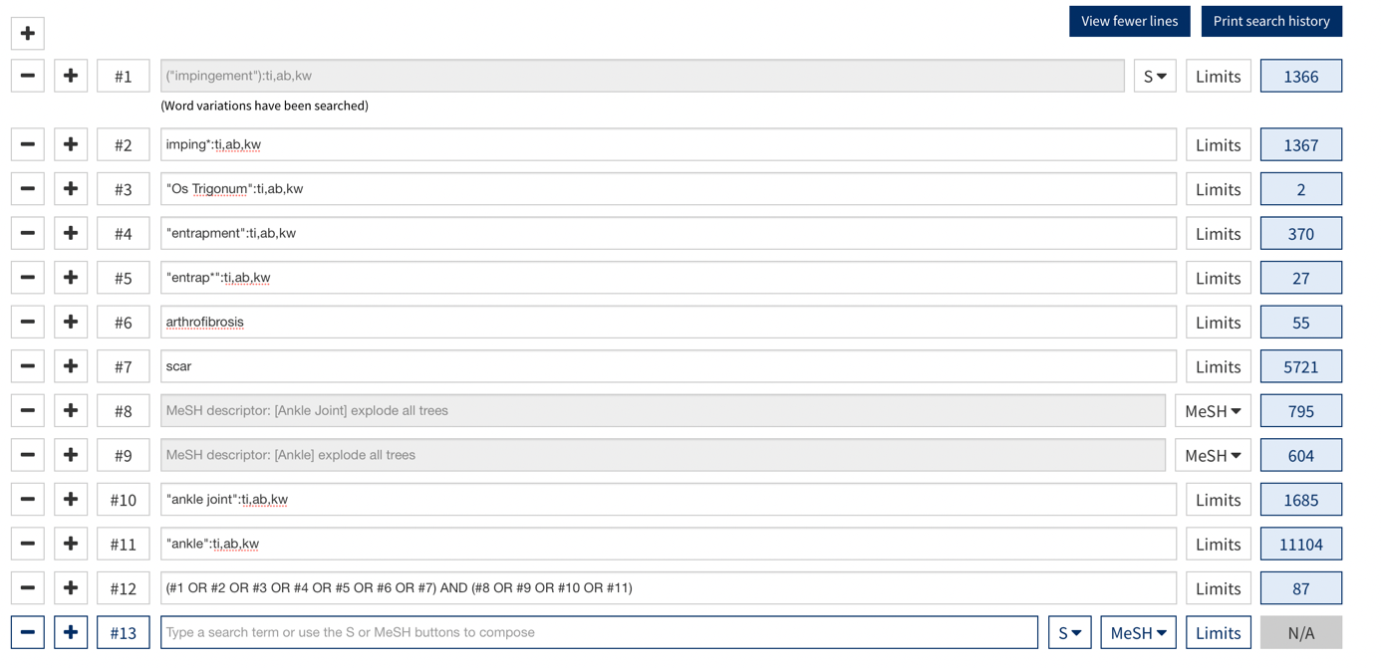

Embase 1966 hits

(impingement.mp
OR
(imping*.ab,kf,ti
OR
(os trigonum.ab,kf,ti
OR
(entrapment.ab,kf,ti
OR
(entrap*.ab,kf,ti
OR
(arthrofibrosis.ab,kf,ti
OR
(scar.ab,kf,ti)))))))
AND
(ankle joint.mp
OR
(ankle joint.ab,kf,ti
OR
(ankle.ab,kf,ti
OR
(ankle.ab,kf,ti))))

