Attachments
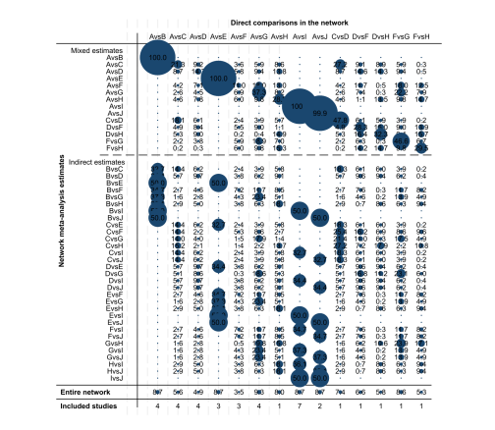
Quadriceps Network Contribution Diagram

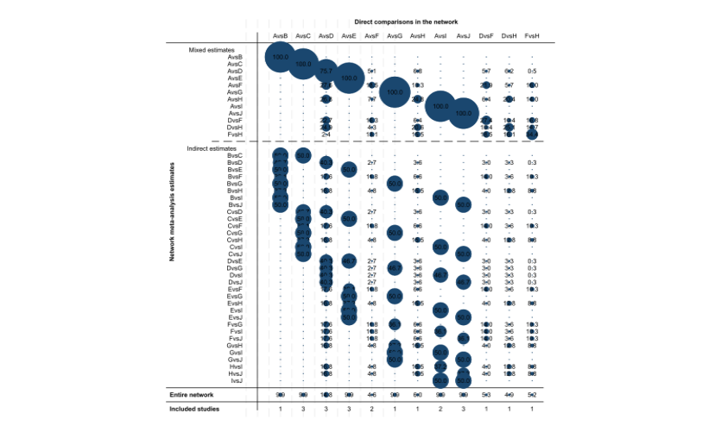

Hamstrings Network Contribution Diagram

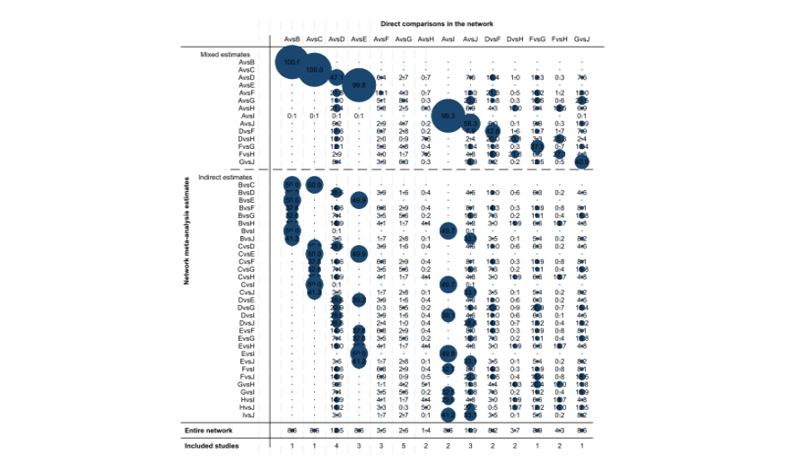

Knee Joint Network Contribution Diagram
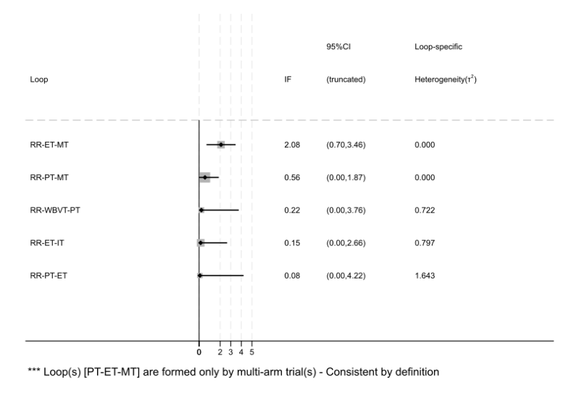

Quadriceps IFPlot Diagram Drawing

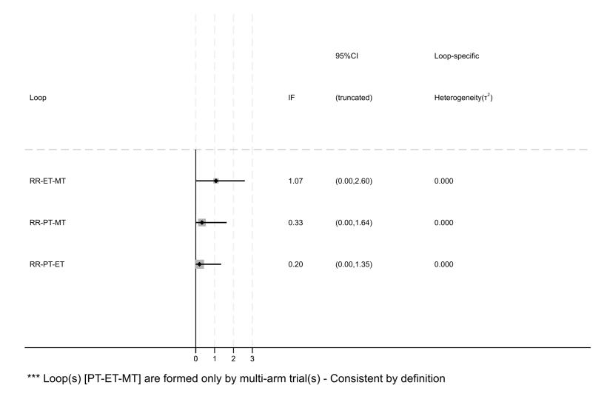
Hamstrings IFPlot Diagram Drawing

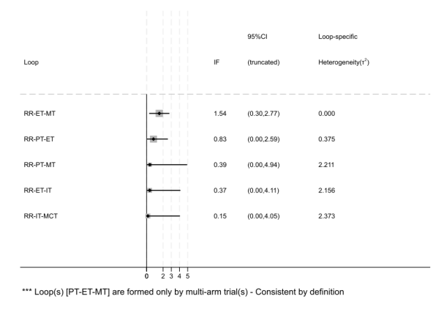
Knee Joint IFPlot Diagram Drawing

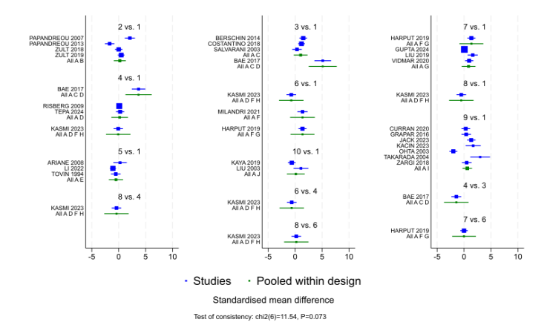
Quadriceps Forest Plot

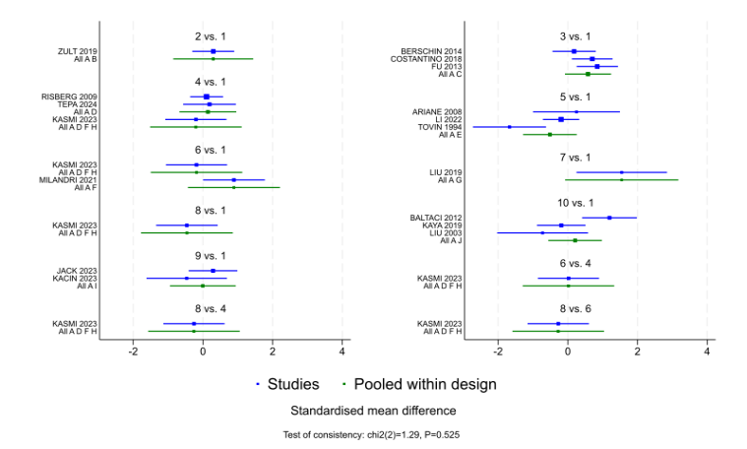
Hamstrings Forest Plot

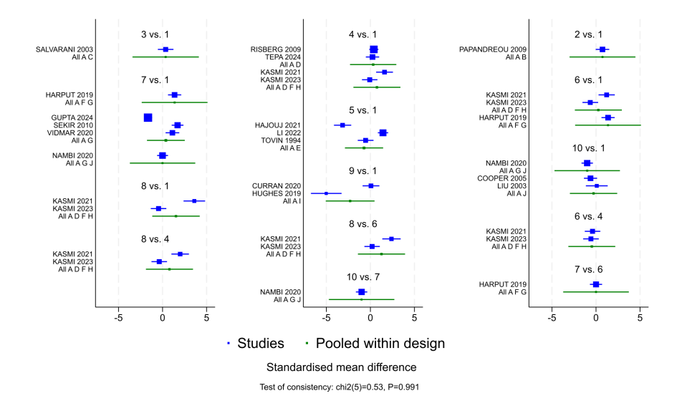
Knee Joint Forest Plot
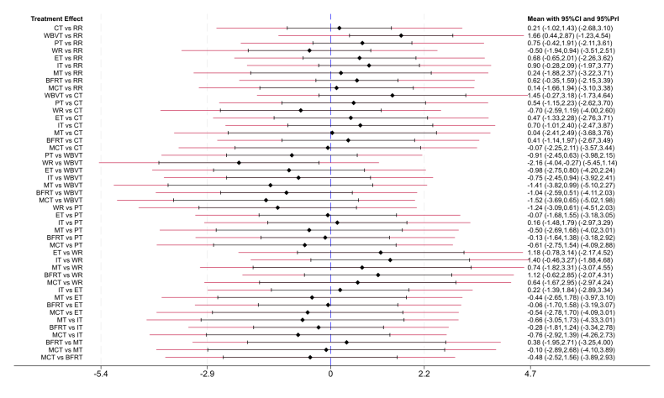

Quadriceps Pairwise Comparison Forest Plot

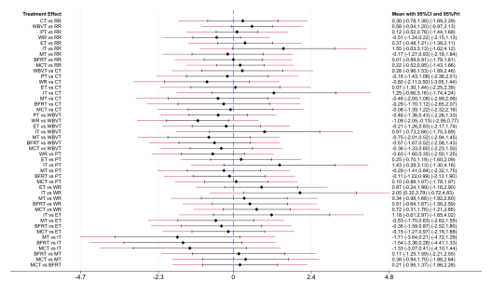

Hamstrings Pairwise Comparison Forest Plot

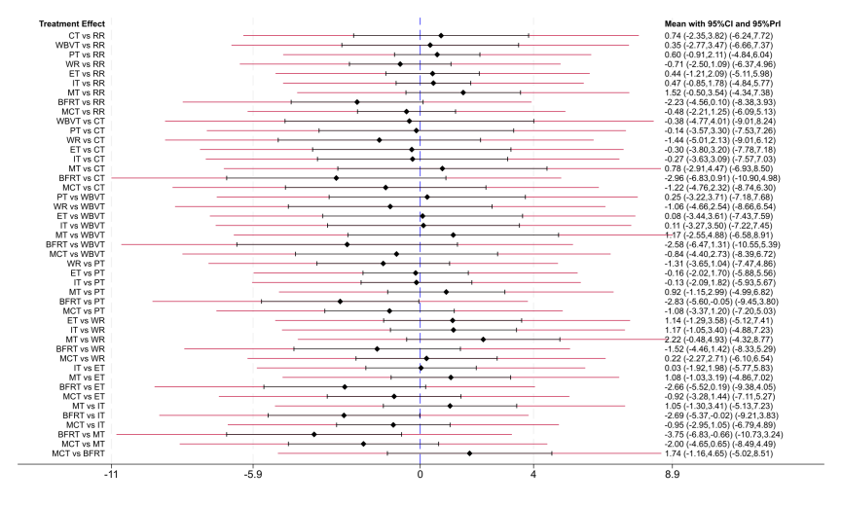
Knee Joint Pairwise Comparison Forest Plot

