Supplementary Appendix
Implants for fixation of intertrochanteric femoral fracture: a systematic review and network meta-analysis of randomized controlled trials
Table of contents

Appendix 1: Search strategy 2
Appendix 2: Characteristics of included studies 6
Appendix 3: List of data extracted from the included randomized clinical trials 14
Appendix 4: Risk of bias of randomized clinical trials 15
Appendix 5: Evaluation of inconsistency 25
Appendix 6: League table 40
Appendix 7: SUCRA 54
Appendix 8: CINeMA Assessment 68
Appendix 9: Regression analysis 90
Appendix 10: Complications 95
Appendix 11: Analysis of unstable intertrochanteric fractures 118
Appendix 12: Network maps 155
Appendix 13: Funnel plots 169
Appendix 14: Comparison of different implants with SHS 183
Appendix 15: Cumulative probability plots 197

Appendix 1: Search strategy
Table S1. Search strategy of PubMed
# | Searches
1 | hip fractures [MeSH Major Topic]
2 | hip fracture [Title/Abstract]
3 | extracapsular fracture* [Title/Abstract]
4 | intertrochanteric fracture* [Title/Abstract]
5 | (hip [Title/Abstract] OR hips [Title/Abstract] OR trochant*[Title/Abstract] OR pertrochant*[Title/Abstract] OR intertrochant*[Title/Abstract] OR extracapsular*[Title/Abstract]) AND fracture [Title/Abstract]
6 | #1 OR #2 OR #3 OR #4 OR #5
7 | Randomized controlled trial [Publication Type] OR Controlled clinical trial [Publication Type] OR Randomized [Title/Abstract] OR Clinical Trials as Topic [Mesh] OR Randomly [Title/Abstract] OR Trials [Title]
8 | "Internal Fixators"[Mesh]
9 | "Bone Plates"[Mesh]
10 | "Fracture Fixation, Internal"[Mesh]
11 | "Bone Nails"[Mesh]
12 | "Bone Screws"[Mesh]
13 | internal fixation device*[Title/Abstract]
14 | internal fixator*[Title/Abstract]
15 | bone plate*[Title/Abstract]
16 | internal fracture fixation*[Title/Abstract]
17 | fracture osteosynthes* [Title/Abstract]
18 | bone nail* [Title/Abstract]
19 | bone screw*[Title/Abstract]
20 | Pin [Title/Abstract] OR pins [Title/Abstract]
21 | Nail [Title/Abstract] OR nails [Title/Abstract] OR nailing* [Title/Abstract]
22 | Plate [Title/Abstract] OR plates [Title/Abstract]
23 | Rod [Title/Abstract] OR rods [Title/Abstract]
24 | Screw [Title/Abstract] OR screws [Title/Abstract]
25 | #8 OR #9 OR #10 OR #11 OR #12 OR #13 OR #14 OR #15 OR #16 OR #17 OR #18 OR #19 OR #20 OR #21 OR #22 OR #23 OR #24
26 | #6 AND #7 AND #25

Table S2. Search strategy of Web of Science
# |  | Searches
1 | ((((((TS=(hip)) OR TS=(hips)) OR TS=(trochant*)) OR TS=(pertrochant*)) OR TS=(intertrochant*)) OR TS=(extracapsular*)) AND TS=(fracture)
2 | ((((((((((((TS=(internal fixation device*)) OR TS=(internal fixator*)) OR TS=(bone plate*)) OR TS=(internal fracture fixation*)) OR TS=(fracture osteosynthes*)) OR TS=(bone nail*)) OR TS=(bone screw*)) OR TS=(Pin)) OR TS=(pins)) OR TS=(nail*)) OR TS=(plate*)) OR TS=(rod*)) OR TS=(screw*)
3 | (((((TS= (randomized controlled trial)) OR TS= (controlled clinical trial)) OR TS=(randomly)) OR TS= (randomized)) OR TS= (randomized trial)) OR TS= (trial)
4 | #1 AND #2 AND #3

Table S3. Embase
# |  | Searches
1 | exp hip fractures/
2 | (hip fracture$ or intertrochanteric fracture$ or extracapsular fracture$).tw.
3 | (hip or hips or trochant$ or pertrochant$ or intertrochant$ or extracapsular$).tw.
4 | fractur$tw.
5 | 3 and 4
6 | 1 or 2 or 5
7 | exp internal fixator/
8 | exp bone plate/
9 | exp fracture fixation/
10 | exp bone nail/
11 | exp bone screw/
12 | (internal fixation device$ or internal fixator$ or internal fixation system$ or internal fracture fixation$).tw.
13 | (bone plate$ or fixation plate$ or bone nail$ or bone screw$ or pin? or nail? or nailing$ or plate? or rod? or screw?).tw.
14 | 7 or 8 or 9 or 10 or 11 or 12 or 13
15 | ‘Randomized controlled trial’ OR ‘Controlled clinical trial’ OR ‘randomly’ OR ‘randomized’ OR ‘randomized trial’ OR ‘trial’
16 | #6 AND #14 AND #15

Table S4. Cochrane library
# |  | Searches
1 | [mh "Hip Fractures"]
2 | (hip fracture OR hip fractures): ti,ab,kw
3 | (extracapsular fracture*): ti,ab,kw
4 | (intertrochanteric fracture*): ti,ab,kw
5 | (hip OR hips OR trochant* OR pertrochant* OR intertrochant* OR extracapsular*): ti,ab,kw AND (fracture):ti,ab,kw
6 | #1 OR #2 OR #3 OR #4 OR #5
7 | [mh "Internal Fixators"]
8 | [mh "Bone Plates"]
9 | [mh "Fracture Fixation, Internal"]
10 | [mh "Bone Nails"]
11 | [mh "Bone Screws"]
12 | (internal fixation device* OR internal fixator* OR bone plate* OR internal fracture fixation* OR fracture osteosynthesis OR bone nail* OR bone screw* OR pin OR pins OR nail OR nails OR nailing OR plate OR plates OR rod OR rods OR screw OR screws): ti,ab,kw
13 | #8 OR #9 OR #10 OR #11 OR #12 OR #7
14 | (randomized OR randomly OR trial OR trials):ti,ab,kw
15 | #6 AND #13 AND #14

Appendix 2: Characteristics of included studies
Year | Country | Follow-up period | Journal | Funding | Randomised treatments | Number of dropouts | Age (mean ± SD), years | Male % | Outcomes | Surgical time (mean ± SD), min
Schemitsch  2023¹ | Canada | 1 year | JAMA Netw Open | Stryker | GN:423 | 56 | 78.2 | 36.6 | (1); (2); (3); (4); (5); | 59±27
 |  |  |  |  | SHS:427 | 49 | 78.8 | 33.3 |  | 64±23
Parker2012² | UK | 1 year | J Bone Joint Surg Br | No | SHS:300 | 4 | 81.4 | 23 | (1); (2); (3); (4); (5); | 46±12.3
 |  |  |  |  | Targon PF:300 | 2 | 82.4 | 17 |  | 49±12.7
Schipper  2004³ | Netherlands | 1 year | J Bone Joint Surg | Stryker Howmedica  Mathys Medical Nederland | PFN:211 | 7 | 82.2 | 16 | (1); (2); (3); (4); (5); (6); | 60±2
 |  |  |  |  | GN:213 | 1 | 82.6 | 15.4 |  | 60±2
Papasimos  2005⁴ | Greece | 1 year | Arch Orthop Trauma Surg | NA | SHS:40 |  | 81.4 | 35 | (1); (2); (3); (4); (5); | 59.2
 |  |  |  |  | GN:40 |  | 82.8 | 40 |  | 51.3
 |  |  |  |  | PFN:40 |  | 79.4 | 42.5 |  | 71.2
Adams2001⁵ | Scotland | 1 year | J Orthop Trauma | the Scottish Orthopaedic Research Trust - into Trauma | GN:203 | 18 | 81.2 | 19.2 | (1); (2); (4); (5); | 55.4
 |  |  |  |  | SHS:197 | 15 | 80.7 | 24.9 |  | 61.3
Chenchik  2014⁶ | Israe | 1 year | J Orthop | NA | DHS:31 | 0 | 83.1 ± 6.7 | 26 | (2); (3); (4); (5); | 64 ± 26
 |  |  |  |  | PFN:29 | 0 | 83.1 ± 5.7 | 21 |  | 54.5 ± 22.5
Verettas  2010⁷ | Greece | 10d | Injure | NA | GN:59 | 0 | 79.22±7.99 | 33.9 | (4); (6) | 42
 |  |  |  |  | DHS:59 | 0 | 81.03±6.38 | 25.4 |  | 45
Utrilla2005⁸ | Spain | 12–30 months | J Orthop Trauma | None | GN:104 | 3 | 80.6±7.5 | 36.5 | (1); (2); (4); (5); | 46±11
 |  |  |  |  | SHS:106 | 4 | 79.8±7.3 | 26.4 |  | 44±15
ZOU2009⁹ | China | 1 year | J Int Med Res | NA | PFNA:58 |  | 65 | 21 | (1); (2); (4);  (5); | 52±10
 |  |  |  |  | SHS:63 |  | 65 | 24 |  | 93±13
Efstathopoulos2007¹⁰ | Greece | 6 –12 months | Int Orthop | NA | GN:56 | 5 | 79.5 | 33.9 | (4); | 51±11
 |  |  |  |  | ACE TN:56 | 5 | 78.1 | 23.2 |  | 54±15
Zehir2014¹¹ | Turkey | 6 months | Eur J Trauma Emerg Surg | NA | SHS:102 | 0 | 76.86±6.74 | 0.382 | (1); (2); (4);  (5); | 56.95±5.20
 |  |  |  |  | PFNA:96 | 0 | 77.22±6.82 | 0.385 |  | 44.41±5.17
Pajarinen  2004¹² | Finland | 4 months | J Bone Joint Surg | None | SHS:41 |  | 79.0±11.5 | 26.8 | (4); | 45
 |  |  |  |  | PFN:42 |  | 80.2±9.4 | 19 |  | 55
Miedel  2004¹³ | Sweden | 12 months | J Bone Joint Surg | Stryker Howmedica, Sweden (SGN), and Swemac, Sweden (MSP), the Trygg-Hansa Insurance Company, the Swedish Orthopaedic Association | GN:109 | 3 | 84.6 | 16 | (1); (2); (3); (4); (5); | 61
 |  |  |  |  | MSP:108 | 3 | 82.7 | 22 |  | 65
Ahrengart  2002¹⁴ | Sweden | 6 months | Clin Orthop Relat Res | the The Karolinska Institute Foundation, Lund University, Skane County Council and Stryker-Howmedica | GN:210 | 0 |  | 29 | (1); (2); (3); (4); (5); | 60
 |  |  |  |  | SHS:216 | 0 |  | 28 |  | 45
Xu2010¹⁵ | China | 1 year | J Int Med Res | NA | PFNA:51 | 0 | 78.5 ± 7.97 | 29 | (1); (2); (3); (4); (5); | 68.5 ± 9.9
 |  |  |  |  | DHS:55 | 0 | 77.9 ± 7.82 | 29 |  | 56.5 ± 11.8
Sharma  2018¹⁶ | India | 1 year | Rev Bras Ortop | NA | SHS:29 | 0 | 62.27 | 39.4 | (1); (2); (3); (4); (5); (6); | 69.7
 |  |  |  |  | PFN:31 | 0 | 60.67 | 37.9 |  | 56.9
Parker2017¹⁷ | UK | 1 year | Injury | Peterborough Hospitals Hip Fracture Research Fund | SHS:500 | 6 | 82.1 | 23.2 | (2); (4); (5); | 44±11.9
 |  |  |  |  | Targon PF intramedullary nail:500 | 6 | 82.2 | 22.4 |  | 45±12.8
SADOWSKI2002¹⁸ | Switzerland | 1 year | J Bone Joint Surg | None | 95° fixed-angle screw-plate (Dynamic Condylar Screw):19 | 1 | 77±14 | 26.3 | (1); (2); (4);  (5); | 166±48
 |  |  |  |  | PFN:20 | 0 | 80±13 | 35 |  | 82±53
Barton  2010¹⁹ | UK | 1 year | J Bone Joint Surg | None | GN:100 | 3 | 83.3 | 22.7 | (1); (2); (4);
 |  |  |  |  | SHS:110 | 0 | 83.1 | 19
Kumar  2012²⁰ | India | at least 1 year | J Clin Orthop Trauma | None | PFN:25 | 0 |  |  | (1); (2); (3); (4); (5); (6); | 55±18
 |  |  |  |  | SHS:25 | 0 |  |  |  | 87±3.2
Xu2010²¹ | China | 17.5  months | Injury | NA | PFNA:55 | 5 | 76.8±9.6 | 41.8 | (1); (2); (3); (4); (5); | 66.6±15.4
 |  |  |  |  | GN:52 | 6 | 76.6±8.2 | 28.8 |  | 73.1±20.8
Guerra  2014²² | Brazil | 1 year | Injury | Nonene | SHS:19 | 0 |  | 26.3 | (1); (4);
 |  |  |  |  | PFN:12 | 0 |  | 8.3
Cheng2014²³ | China | 6-26 months | Chin J Traumatol | NA | PCCP:65 | 0 | 72.4±4.18 | 43.1 | (1); (2); (4);  (5); (6) | 55.2±8.4
 |  |  |  |  | SHS:56 | 0 | 78.6±3.92 | 39.3 |  | 88.5±14.7
Jose´2009²⁴ | Spain | 1 year | Arch Orthop Trauma Surg | NA | GN:40 | 0 |  | 15 | (1); (4); (5); | 85.82
 |  |  |  |  | PCCP:40 | 0 |  | 27.5 |  | 86.51
Philip2012²⁵ | Belgium | 1 year | Acta Orthop. Belg | NA | GN:61 | 6 | 73±12.5 | 57.4 | (1); (4); (5); | 41
 |  |  |  |  | ACE TN:51 | 6 | 77±14 | 62.7 |  | 51
Parker2017²⁶ | UK | 1 year | Bone Joint J | Peterborough Hospital Hip Fracture Fund | SHS:200 | 1 | 83.2 | 23.5 | (1); (2); (3); (4); (5); | 42.1±11.1
 |  |  |  |  | Targon PFT cephalomedullary nail:200 | 1 | 82 | 30 |  | 38.3±10.2
Hopp2016²⁷ | Germany | 6 months | Acta Orthop. Belg | None | GN:39 | 1 | 80.73±8.44 | 33.3 | (1); (2); (4); (5); (6) | 64.6±29.22
 |  |  |  |  | the InterTAN nail  (ITN):39 | 1 | 82.70±7.06 | 17.9 |  | 78.03±34.07
Janzing  2001²⁸ | Belgium | 1 year | J Trauma | NA | SHS:44 |  | 83 | 23 | (2); (3); (4); | 65±30
 |  |  |  |  | PCCP:39 |  | 82 | 10 |  | 49±18
Carulli  2017²⁹ | Italy | 1 year | Clin Cases Miner Bone Metab | NA | PFNA：71 | 3 | 81.62±7.82 | 40.9 | (1); (2); (4); (5); | 46.06±10.10
 |  |  |  |  | SHS:69 | 3 | 83.41±7.90 | 36.2 |  | 61.21±15.01
Guo2013³⁰ | China | 12-24 months | J Orthop | NA | PCCP:45 | 0 | 71.6±7.5 | 35.6 | (1); (4); (6); | 53.0±9.4
 |  |  |  |  | PFNA:45 | 0 | 74.2±8.8 | 42.2 |  | 66.5±18.1
Ioannis  2014³¹ | Greece | 12 months | Int Orthop | NA | SHS:35 | 0 | 83.1±6.5 | 20 | (4); (5); | 75.5±21.9
 |  |  |  |  | GN:36 | 0 | 82.9±5.8 | 22.2 |  | 45.7±22.7
Makridis  2010³² | Greece | 12 months | J Orthop Surg Res | NA | intramedullary hip screw (IMHS):110 | 0 | 83.5 | 30.9 | (1); (3); (4);  (5); | 25.4
 |  |  |  |  | ENDOVIS nail:105 | 0 | 83.9 | 31.4 |  | 24.8
Kouvidis  2012³³ | Greece | 24–56 months | Strat Traum Limb Recon | NA | SHS:79 | 3 | 82.53±6.79 | 34.6 | (1); (2); (3); (4); (5); | 55.18±11.50
 |  |  |  |  | Endovis:86 | 5 | 81.95±7.21 | 20 |  | 51.22±12.94
Peyser  2007³⁴ | Israel | 1 year | J Bone Joint Surg | None | PCCP:50 | 0 | 78.9 | 32 | (1); (2); (4);  (5); | 53.2
 |  |  |  |  | SHS:53 | 0 | 82.5 | 34 |  | 51.1
McCormack2013³⁵ | Canada | 6 months | Injury | NA | SHS:86 | 5 | 83 | 24.4 | (1); (2); (4); | 51
 |  |  |  |  | MSP:77 | 4 | 83.6 | 23.3 |  | 50
Vaquero  2012³⁶ | Spain | 12 months | Injury | aofoundation和Synthes, GmbH, Switzerland | GN:30 | 15 | 83.5±7.4 | 17 | (1); (2); (3); (4); (5); (6); | 37±10
 |  |  |  |  | PFNA:31 | 18 | 83.6±7.5 | 10 |  | 35±10
Matre2013³⁷ | Norway | 12 months | J Bone Joint Surg | Smith & Nephew | the InterTAN nail (ITN):341 | 53 | 84.1 | 24.3 | (1); (2); (3); (4); (5);
 |  |  |  |  | SHS:343 | 54 | 84.1 | 25.7
Zhang2013³⁸ | China | 12-30 months | Orthopedics | NA | PFNA:56 | 3 | 72.4±8.7 | 33.9 | (1); (2); (3); (4); (5); (6); | 53.7±11.3
 |  |  |  |  | the InterTAN nail (ITN):57 | 2 | 72.9±7.6 | 40.4 |  | 66.5±15.2
Seyhan  2015³⁹ | Turkey | 1 year | J Orthop | NA | PFNA:43 |  | 75.91±13.77 | 25.6 | (2); (4); (6) | 72.98±12.48
 |  |  |  |  | the InterTAN nail (ITN):32 |  | 75.34±13.52 | 25.9 |  | 73.91±8.87
Brandt  2002⁴⁰ | Netherlands | 1–8 months | Injury | NA | PCCP:33 | 0 | 80.1 |  | (1); (2); (3); (4); (5); | 46.6
 |  |  |  |  | SHS:38 | 0 | 81.6 |  |  | 69.2
Sanders  2015⁴¹ | Canada | 12 months | J Orthop Trauma | NA | SHS:126 | 13 | 81.0±0.8 | 26 | (1); (2); (4);  (5);
 |  |  |  |  | the InterTAN nail (ITN):123 | 3 | 80.6±0.8 | 29
Kosygan  2002⁴² | England | 6 months | J Bone Joint Surg | NA | PCCP:52 | 0 | 82.7±8.5 | 15.4 | (1); (4); (5); | 82.7±8.5
 |  |  |  |  | SHS:56 | 0 | 82.8±9 | 21.4 |  | 82.8±9
LI2018⁴³ | China | 18 months | Eur Rev Med Pharmacol Sci | NA | PFNA:40 | 0 | 75.6±2.5 | 50 | (4); (5); (6); | 38.5±5.7
 |  |  |  |  | SHS:40 | 0 | 75.5±2.6 | 52.5 |  | 43.6±9.0
Adeel2020⁴⁴ | Pakistan | 12 months | J Pak Med Assoc | None | SHS:34 | 0 | 60.88±12.49 | 64.71 | (1); (4); (5); | 58.71±7.84
 |  |  |  |  | PFN:34 | 0 | 59.32±2.39 | 73.53 |  | 35.35±5.48
OVESEN  2006⁴⁵ | Denmark | 12 months | Hip Int | NA | SHS:73 | 11 | 78.5±11.7 | 28.8 | (1); (2); (4);  (5); | 51±22
 |  |  |  |  | GN:73 | 8 | 79.9±10 | 27.4 |  | 65±29
Prakash  2022⁴⁶ | India | 24 weeks | Cureus | None | SHS:23 | 0 | 61.09±11.69 | 39.13 | (1); (4); (6);
 |  |  |  |  | PFN:23 | 0 | 65±14.98 | 47.83
Olsson  2001⁴⁷ | Sweden | 4 months | J Bone Joint Surg | None | MSP:54 | 8 | 84±7.5 | 25.9 | (1); (2); (4);  (5); | 58
 |  |  |  |  | SHS:60 | 8 | 84±7.3 | 33.3 |  | 55
Sameer  2017⁴⁸ | India | 12-30 months | J Clin Diagn Res | None | SHS:19 | 0 | 71.74 | 63.1 | (1); (2); (4); | 104.2±33.72
 |  |  |  |  | PFN:18 | 0 | 74 | 66.7 |  | 106.2±26.31
Harrington  2019⁴⁹ | USA | 1 year | Injure | NA | SHS:52 | 0 | 82.1±8.6 | 21.2 | (1); (3); (4);  (5); | 88±27.5
 |  |  |  |  | IMHS:50 | 0 | 83.8±8.5 | 20 |  | 108±26.8
Singh2019⁵⁰ | India | 1 year | J Clin Orthop Trauma | NA | PFNA:30 | 3 | 72.76±9.5 | 30 | (1); (2); (4); (5); (6); | 54.66±19.20
 |  |  |  |  | SHS:30 | 1 | 69.33±5.7 | 53.3 |  | 71.1±24.81
XU2020⁵¹ | China | 12 months | Orthopedics | NA | PFN:66 | 28 | 76.0±1.2 | 37.9 | (2); (3); (4);  (5); | 64.1±1.9
 |  |  |  |  | GN:70 | 28 | 75.4±1.0 | 38.6 |  | 68.6±2.4
Saudan  2002⁵² | Switzerland | 1 year | J Orthop Trauma | None | SHS:106 | 4 | 83.7±10.1 | 20.8 | (1); (2); (4);  (5); | 65±26
 |  |  |  |  | PFN:100 | 5 | 83.7±9.7 | 24 |  | 64±33
Shin2017⁵³ | South Korea | 12.3 months | Injure | None | Zimmer natural nail (ZNN):172 |  | 76.22±16.40 | 63 | (2); (6); (4);  (5); | 70.40±20.10
 |  |  |  |  | PFNA:181 |  | 77.71±16.44 | 70 |  | 57.25±12.15
Ekstro¨m2007⁵⁴ | Sweden | 12 months | J Orthop Trauma | NA | PFN:105 | 26 | 82 | 24 | (1); (2); (3); (4); (5); | 56±21
 |  |  |  |  | MSP:98 | 24 | 82 | 25 |  | 62±29
(1) mortality; (2) reoperation rate; (3) intraoperative complications;(4) postoperative complications; (5) mechanical complications;
(6) Harris hip score (HHS);
NA: not available

References
1 Schemitsch, E. H., Nowak, L. L., Schulz, A. P., Brink, O., Poolman, R. W., Mehta, S., Stengel, D., Zhang, C. Q., Martinez, S., Kinner, B., Chesser, T. J. S., Bhandari, M., & INSITE Investigators (2023). Intramedullary Nailing vs Sliding Hip Screw in Trochanteric Fracture Management: The INSITE Randomized Clinical Trial. JAMA network open, 6(6), e2317164.
2 Schipper, I. B., Steyerberg, E. W., Castelein, R. M., van der Heijden, F. H., den Hoed, P. T., Kerver, A. J., & van Vugt, A. B. (2004). Treatment of unstable trochanteric fractures. Randomised comparison of the gamma nail and the proximal femoral nail. The Journal of bone and joint surgery. British volume, 86(1), 86–94.
3 Schipper, I. B., Steyerberg, E. W., Castelein, R. M., van der Heijden, F. H., den Hoed, P. T., Kerver, A. J., & van Vugt, A. B. (2004). Treatment of unstable trochanteric fractures. Randomised comparison of the gamma nail and the proximal femoral nail. The Journal of bone and joint surgery. British volume, 86(1), 86–94.
4 Papasimos, S., Koutsojannis, C. M., Panagopoulos, A., Megas, P., & Lambiris, E. (2005). A randomised comparison of AMBI, TGN and PFN for treatment of unstable trochanteric fractures. Archives of orthopaedic and trauma surgery, 125(7), 462–468.
5. Adams, C. I., Robinson, C. M., Court-Brown, C. M., & McQueen, M. M. (2001). Prospective randomized controlled trial of an intramedullary nail versus dynamic screw and plate for intertrochanteric fractures of the femur. Journal of orthopaedic trauma, 15(6), 394–400.
6. Chechik, O., Amar, E., Khashan, M., Pritsch, T., Drexler, M., Goldstein, Y., & Steinberg, E. L. (2014). Favorable radiographic outcomes using the expandable proximal femoral nail in the treatment of hip fractures - A randomized controlled trial. Journal of orthopaedics, 11(2), 103–109.
7. Verettas, D. A., Ifantidis, P., Chatzipapas, C. N., Drosos, G. I., Xarchas, K. C., Chloropoulou, P., Kazakos, K. I., Trypsianis, G., & Ververidis, A. (2010). Systematic effects of surgical treatment of hip fractures: gliding screw-plating vs intramedullary nailing. Injury, 41(3), 279–284.
8. Utrilla, A. L., Reig, J. S., Muñoz, F. M., & Tufanisco, C. B. (2005). Trochanteric gamma nail and compression hip screw for trochanteric fractures: a randomized, prospective, comparative study in 210 elderly patients with a new design of the gamma nail. Journal of orthopaedic trauma, 19(4), 229–233.
9. Zou, J., Xu, Y., & Yang, H. (2009). A comparison of proximal femoral nail antirotation and dynamic hip screw devices in trochanteric fractures. The Journal of international medical research, 37(4), 1057–1064.
10. Efstathopoulos, N. E., Nikolaou, V. S., & Lazarettos, J. T. (2007). Intramedullary fixation of intertrochanteric hip fractures: a comparison of two implant designs. International orthopaedics, 31(1), 71–76.
11. Zehir, S., Zehir, R., Zehir, S., Azboy, İ., & Haykir, N. (2015). Proximal femoral nail antirotation against dynamic hip screw for unstable trochanteric fractures; a prospective randomized comparison. European journal of trauma and emergency surgery : official publication of the European Trauma Society, 41(4), 393–400.
12. Pajarinen, J., Lindahl, J., Michelsson, O., Savolainen, V., & Hirvensalo, E. (2005). Pertrochanteric femoral fractures treated with a dynamic hip screw or a proximal femoral nail. A randomised study comparing post-operative rehabilitation. The Journal of bone and joint surgery. British volume, 87(1), 76–81.
13. Miedel, R., Ponzer, S., Törnkvist, H., Söderqvist, A., & Tidermark, J. (2005). The standard Gamma nail or the Medoff sliding plate for unstable trochanteric and subtrochanteric fractures. A randomised, controlled trial. The Journal of bone and joint surgery. British volume, 87(1), 68–75.
14. Ahrengart, L., Törnkvist, H., Fornander, P., Thorngren, K. G., Pasanen, L., Wahlström, P., Honkonen, S., & Lindgren, U. (2002). A randomized study of the compression hip screw and Gamma nail in 426 fractures. Clinical orthopaedics and related research, (401), 209–222.
15. Xu, Y. Z., Geng, D. C., Mao, H. Q., Zhu, X. S., & Yang, H. L. (2010). A comparison of the proximal femoral nail antirotation device and dynamic hip screw in the treatment of unstable pertrochanteric fracture. The Journal of international medical research, 38(4), 1266–1275.
16. Sharma, A., Sethi, A., & Sharma, S. (2017). Treatment of stable intertrochanteric fractures of the femur with proximal femoral nail versus dynamic hip screw: a comparative study. Revista brasileira de ortopedia, 53(4), 477–481.
17. Parker M. J. (2017). Sliding hip screw versus intramedullary nail for trochanteric hip fractures; a randomised trial of 1000 patients with presentation of results related to fracture stability. Injury, 48(12), 2762–2767.
18. Sadowski, C., Lübbeke, A., Saudan, M., Riand, N., Stern, R., & Hoffmeyer, P. (2002). Treatment of reverse oblique and transverse intertrochanteric fractures with use of an intramedullary nail or a 95 degrees screw-plate: a prospective, randomized study. The Journal of bone and joint surgery. American volume, 84(3), 372–381.
19. Barton, T. M., Gleeson, R., Topliss, C., Greenwood, R., Harries, W. J., & Chesser, T. J. (2010). A comparison of the long gamma nail with the sliding hip screw for the treatment of AO/OTA 31-A2 fractures of the proximal part of the femur: a prospective randomized trial. The Journal of bone and joint surgery. American volume, 92(4), 792–798.
20. Kumar, R., Singh, R. N., & Singh, B. N. (2012). Comparative prospective study of proximal femoral nail and dynamic hip screw in treatment of intertrochanteric fracture femur. Journal of clinical orthopaedics and trauma, 3(1), 28–36.
21. Yaozeng, X., Dechun, G., Huilin, Y., Guangming, Z., & Xianbin, W. (2010). Comparative study of trochanteric fracture treated with the proximal femoral nail anti-rotation and the third generation of gamma nail. Injury, 41(12), 1234–1238.
22. Guerra, M. T., Pasqualin, S., Souza, M. P., & Lenz, R. (2014). Functional recovery of elderly patients with surgically-treated intertrochanteric fractures: preliminary results of a randomised trial comparing the dynamic hip screw and proximal femoral nail techniques. Injury, 45 Suppl 5, S26–S31.
23. Cheng, Q., Huang, W., Gong, X., Wang, C., Liang, X., & Hu, N. (2014). Minimally invasive percutaneous compression plating versus dynamic hip screw for intertrochanteric fractures: a randomized control trial. Chinese journal of traumatology = Zhonghua chuang shang za zhi, 17(5), 249–255.
24. Varela-Egocheaga, J. R., Iglesias-Colao, R., Suárez-Suárez, M. A., Fernández-Villán, M., González-Sastre, V., & Murcia-Mazón, A. (2009). Minimally invasive osteosynthesis in stable trochanteric fractures: a comparative study between Gotfried percutaneous compression plate and Gamma 3 intramedullary nail. Archives of orthopaedic and trauma surgery, 129(10), 1401–1407.
25. Winnock de Grave, P., Tampere, T., Byn, P., Van Overschelde, J., Pattyn, C., & Verdonk, R. (2012). Intramedullary fixation of intertrochanteric hip fractures: a comparison of two implant designs. A prospective randomised clinical trial. Acta orthopaedica Belgica, 78(2), 192–198.
26. Parker, M. J., & Cawley, S. (2017). Sliding hip screw versus the Targon PFT nail for trochanteric hip fractures: a randomised trial of 400 patients. The bone & joint journal, 99-B(9), 1210–1215.
27. Hopp, S., Wirbel, R., Ojodu, I., Pizanis, A., Pohlemann, T., & Fleischer, J. (2016). Does the implant make the difference ? - Prospective comparison of two different proximal femur nails. Acta orthopaedica Belgica, 82(2), 319–331.
28. Janzing, H. M., Houben, B. J., Brandt, S. E., Chhoeurn, V., Lefever, S., Broos, P., Reynders, P., & Vanderschot, P. (2002). The Gotfried PerCutaneous Compression Plate versus the Dynamic Hip Screw in the treatment of pertrochanteric hip fractures: minimal invasive treatment reduces operative time and postoperative pain. The Journal of trauma, 52(2), 293–298.
29. Carulli, C., Piacentini, F., Paoli, T., Civinini, R., & Innocenti, M. (2017). A comparison of two fixation methods for femoral trochanteric fractures: a new generation intramedullary system vs sliding hip screw. Clinical cases in mineral and bone metabolism : the official journal of the Italian Society of Osteoporosis, Mineral Metabolism, and Skeletal Diseases, 14(1), 40–47.
30. Guo, Q., Shen, Y., Zong, Z., Zhao, Y., Liu, H., Hua, X., & Chen, H. (2013). Percutaneous compression plate versus proximal femoral nail anti-rotation in treating elderly patients with intertrochanteric fractures: a prospective randomized study. Journal of orthopaedic science : official journal of the Japanese Orthopaedic Association, 18(6), 977–986.
31. Aktselis, I., Kokoroghiannis, C., Fragkomichalos, E., Koundis, G., Deligeorgis, A., Daskalakis, E., Vlamis, J., & Papaioannou, N. (2014). Prospective randomised controlled trial of an intramedullary nail versus a sliding hip screw for intertrochanteric fractures of the femur. International orthopaedics, 38(1), 155–161.
32. Makridis, K. G., Georgaklis, V., Georgoussis, M., Mandalos, V., Kontogeorgakos, V., & Badras, L. (2010). Comparing two intramedullary devices for treating trochanteric fractures: a prospective study. Journal of orthopaedic surgery and research, 5, 9.
33. Kouvidis, G., Sakellariou, V. I., Mavrogenis, A. F., Stavrakakis, J., Kampas, D., Galanakis, J., Papagelopoulos, P. J., & Katonis, P. (2012). Dual lag screw cephalomedullary nail versus the classic sliding hip screw for the stabilization of intertrochanteric fractures. A prospective randomized study. Strategies in trauma and limb reconstruction, 7(3), 155–162.
34. Peyser, A., Weil, Y. A., Brocke, L., Sela, Y., Mosheiff, R., Mattan, Y., Manor, O., & Liebergall, M. (2007). A prospective, randomised study comparing the percutaneous compression plate and the compression hip screw for the treatment of intertrochanteric fractures of the hip. The Journal of bone and joint surgery. British volume, 89(9), 1210–1217.
35. McCormack, R., Panagiotopolous, K., Buckley, R., Penner, M., Perey, B., Pate, G., Goetz, T., & Piper, M. (2013). A multicentre, prospective, randomised comparison of the sliding hip screw with the Medoff sliding screw and side plate for unstable intertrochanteric hip fractures. Injury, 44(12), 1904–1909.
36. Vaquero, J., Munoz, J., Prat, S., Ramirez, C., Aguado, H. J., Moreno, E., & Perez, M. D. (2012). Proximal Femoral Nail Antirotation versus Gamma3 nail for intramedullary nailing of unstable trochanteric fractures. A randomised comparative study. Injury, 43 Suppl 2, S47–S54.
37. Matre, K., Vinje, T., Havelin, L. I., Gjertsen, J. E., Furnes, O., Espehaug, B., Kjellevold, S. H., & Fevang, J. M. (2013). TRIGEN INTERTAN intramedullary nail versus sliding hip screw: a prospective, randomized multicenter study on pain, function, and complications in 684 patients with an intertrochanteric or subtrochanteric fracture and one year of follow-up. The Journal of bone and joint surgery. American volume, 95(3), 200–208.
38. Zhang, S., Zhang, K., Jia, Y., Yu, B., & Feng, W. (2013). InterTan nail versus Proximal Femoral Nail Antirotation-Asia in the treatment of unstable trochanteric fractures. Orthopedics, 36(3), e288–e294.
39. Seyhan, M., Turkmen, I., Unay, K., & Ozkut, A. T. (2015). Do PFNA devices and Intertan nails both have the same effects in the treatment of trochanteric fractures? A prospective clinical study. Journal of orthopaedic science : official journal of the Japanese Orthopaedic Association, 20(6), 1053–1061.
40. Brandt, S. E., Lefever, S., Janzing, H. M., Broos, P. L., Pilot, P., & Houben, B. J. (2002). Percutaneous compression plating (PCCP) versus the dynamic hip screw for pertrochanteric hip fractures: preliminary results. Injury, 33(5), 413–418.
41. Sanders, D., Bryant, D., Tieszer, C., Lawendy, A. R., MacLeod, M., Papp, S., Liew, A., Viskontas, D., Coles, C., Gurr, K., Carey, T., Gofton, W., Bailey, C., Bartley, D., Trenholm, A., Stone, T., Leighton, R., Foxall, J., Zomar, M., & Trask, K. (2017). A Multicenter Randomized Control Trial Comparing a Novel Intramedullary Device (InterTAN) Versus Conventional Treatment (Sliding Hip Screw) of Geriatric Hip Fractures. Journal of orthopaedic trauma, 31(1), 1–8.
42. Kosygan, K. P., Mohan, R., & Newman, R. J. (2002). The Gotfried percutaneous compression plate compared with the conventional classic hip screw for the fixation of intertrochanteric fractures of the hip. The Journal of bone and joint surgery. British volume, 84(1), 19–22.
43. Li, H., Wang, Q., Dai, G. G., & Peng, H. (2018). PFNA vs. DHS helical blade for elderly patients with osteoporotic femoral intertrochanteric fractures. European review for medical and pharmacological sciences, 22(1 Suppl), 1–7.
44. Adeel, K., Nadeem, R. D., Akhtar, M., Sah, R. K., & Mohy-Ud-Din, I. (2020). Comparison of proximal femoral nail (PFN) and dynamic hip screw (DHS) for the treatment of AO type A2 and A3 pertrochanteric fractures of femur. JPMA. The Journal of the Pakistan Medical Association, 70(5), 815–819.
45. Ovesen, O., Andersen, M., Poulsen, T., Nymark, T., Overgaard, S., & Rock, N. D. (2006). The trochanteric gamma nail versus the dynamic hip screw: a prospective randomised study. One-year follow-up of 146 intertrochanteric fractures. Hip international : the journal of clinical and experimental research on hip pathology and therapy, 16(4), 293–298.
46. Prakash, A. K., S, N. J., Shanthappa, A. H., Venkataraman, S., & Kamath, A. (2022). A Comparative Study of Functional Outcome Following Dynamic Hip Screw and Proximal Femoral Nailing for Intertrochanteric Fractures of the Femur. Cureus, 14(4), e23803.
47. Olsson, O., Ceder, L., & Hauggaard, A. (2001). Femoral shortening in intertrochanteric fractures. A comparison between the Medoff sliding plate and the compression hip screw. The Journal of bone and joint surgery. British volume, 83(4), 572–578.
48. Mansukhani, S. A., Tuteja, S. V., Kasodekar, V. B., & Mukhi, S. R. (2017). A Comparative study of the Dynamic Hip Screw, the Cemented Bipolar Hemiarthroplasty and the Proximal Femoral Nail for the Treatment of Unstable Intertrochanteric Fractures. Journal of clinical and diagnostic research : JCDR, 11(4), RC14–RC19.
49. Harrington, P., Nihal, A., Singhania, A. K., & Howell, F. R. (2002). Intramedullary hip screw versus sliding hip screw for unstable intertrochanteric femoral fractures in the elderly. Injury, 33(1), 23–28.
50. Singh, N. K., Sharma, V., Trikha, V., Gamanagatti, S., Roy, A., Balawat, A. S., Aravindh, P., & Diwakar, A. R. (2019). Is PFNA-II a better implant for stable intertrochanteric fractures in elderly population ? A prospective randomized study. Journal of clinical orthopaedics and trauma, 10(Suppl 1), S71–S76.
51. Xu, Y., Geng, D., Yang, H., Wang, X., & Zhu, G. (2010). Treatment of unstable proximal femoral fractures: comparison of the proximal femoral nail antirotation and gamma nail 3. Orthopedics, 33(7), 473.
52. Saudan, M., Lübbeke, A., Sadowski, C., Riand, N., Stern, R., & Hoffmeyer, P. (2002). Pertrochanteric fractures: is there an advantage to an intramedullary nail?: a randomized, prospective study of 206 patients comparing the dynamic hip screw and proximal femoral nail. Journal of orthopaedic trauma, 16(6), 386–393.
53. Shin, Y. S., Chae, J. E., Kang, T. W., & Han, S. B. (2017). Prospective randomized study comparing two cephalomedullary nails for elderly intertrochanteric fractures: Zimmer natural nail versus proximal femoral nail antirotation II. Injury, 48(7), 1550–1557.
54. Ekström, W., Karlsson-Thur, C., Larsson, S., Ragnarsson, B., & Alberts, K. A. (2007). Functional outcome in treatment of unstable trochanteric and subtrochanteric fractures with the proximal femoral nail and the Medoff sliding plate. Journal of orthopaedic trauma, 21(1), 18–25.

Appendix 3: List of data extracted from the included randomized clinical trials

Data category | List of variables
Study | country, journal, author, funding, and publication year
Patients | baseline age, gender, comorbidities, fracture type and stability, medication, sample size, losses and reasons for losses
Interventions | name, follow-up duration, surgical time, ASA, and intraoperative blood loss
Efficacy outcome | mortality, reoperation rate, postoperative complications, mechanical complications, intraoperative complications, and HHS

Abbreviations: ASA, American Society of Anesthesiologists status; HHS, Harris hip score;

Appendix 4: Risk of bias of randomized clinical trials
Table S4.1: The Cochrane bias risk Tool 2.0 was used to assess the bias risk of randomized clinical trials with mortality.
ID | Random sequence generation | Allocation concealment | Blinding of participants and personnel | Blinding of outcome assessment | Incomplete outcome data | Selection of the  reported result | other bias
Schemitsch2023 | Low | Low | Low | Low | Low | Low | Low
Parker2012 | Low | Low | Low | Low | Low | Low | Low
Schipper2004 | Low | Low | Low | Low | Low | Low | Low
Papasimos2005 | Unclear | Unclear | Unclear | Unclear | Unclear | Low | Low
Adams2001 | Low | Low | Unclear | Low | Low | Low | Low
Utrilla2005 | Low | Low | Unclear | Unclear | Low | Low | Low
ZOU2009 | Unclear | Unclear | Unclear | Low | Unclear | Low | Low
Zehir2014 | Low | Low | Unclear | Unclear | Low | Low | Low
Miedel2004 | Low | Low | Low | Low | Unclear | Low | Low
Ahrengart2002 | Low | Low | Unclear | Unclear | Low | Low | Low
Xu2015 | Low | Low | Low | Unclear | Unclear | Low | Low
Sharma2018 | Unclear | Unclear | Low | Unclear | Low | Low | Low
SADOWSKI2002 | Low | High | Unclear | Unclear | Low | Low | Low
Barton2010 | Low | Low | Low | Unclear | Unclear | Low | Low
Kumar2012 | Unclear | Unclear | Unclear | Unclear | Low | Low | Low
Xu2010 | Low | Low | Low | Unclear | Low | Low | Low
Guerra2014 | Low | Low | Low | Low | Unclear | Low | Low
Cheng2014 | Low | Low | Unclear | Unclear | Low | Low | Low
Jose´2009 | Unclear | Unclear | Unclear | Unclear | Low | Low | Low
Philip2012 | Unclear | Unclear | Unclear | Low | Low | Low | Low
Parker2017 | Low | Low | Low | Low | Low | Low | Low
Hopp2016 | Low | Low | Unclear | Unclear | Low | Low | Low
Guo2013 | Low | Low | Unclear | Unclear | Low | Low | Low
Carulli2017 | Unclear | Unclear | Unclear | Unclear | Low | Low | Low
Makridis2010 | Low | Low | Unclear | Unclear | Low | Low | Low
Kouvidis2012 | Unclear | Unclear | Unclear | Unclear | Low | Low | Low
Peyser2007 | Low | Low | Low | Low | Low | Low | Low
McCormack2013 | Low | Low | Unclear | Unclear | Low | Low | Low
Vaquero2012 | Low | Low | Low | Low | High | Low | Low
Matre2013 | Low | Low | Unclear | Unclear | Low | Low | Low
Zhang2013 | Low | Low | Low | Low | Low | Low | Low
Brandt2002 | Low | Low | Unclear | Unclear | Low | Low | Low
Sanders2015 | Low | Low | Unclear | Unclear | Low | Low | Low
Kosygan2002 | Low | Low | Unclear | Unclear | Low | Low | Low
Adeel2020 | Low | Low | Unclear | Unclear | Low | Low | Low
OVESEN2006 | Low | Low | Unclear | Unclear | Low | Low | Low
Prakash2022 | Low | Low | Unclear | Unclear | Low | Low | Low
Olsson2001 | Low | Low | Unclear | Unclear | Low | Low | Low
Sameer2017 | Low | Low | Unclear | Unclear | Low | Low | Low
Harrington2019 | Low | Low | Low | Low | Unclear | Low | Low
Singh2019 | Low | Low | Low | Low | Low | Low | Low
Saudan2002 | Unclear | Unclear | Unclear | Low | Low | Low | Low
Ekstro¨m2007 | Low | Low | Unclear | Unclear | Unclear | Low | Low

Table S4.2: The Cochrane bias risk Tool 2.0 was used to assess the bias risk of randomized clinical trials with reoperation rate.
ID | Random sequence generation | Allocation concealment | Blinding of participants and personnel | Blinding of outcome assessment | Incomplete outcome data | Selection of the  reported result | other bias
Schemitsch2023 | Low | Low | Low | Low | Low | Low | Low
Parker2012 | Low | Low | Low | Low | Low | Low | Low
Schipper2004 | Low | Low | Low | Low | Low | Low | Low
Papasimos2005 | Unclear | Unclear | Unclear | Unclear | Unclear | Low | Low
Adams2001 | Low | Low | Unclear | Low | Low | Low | Low
Chenchik2014 | Low | Low | Unclear | Low | Low | Low | Low
Utrilla2005 | Low | Low | Unclear | Unclear | Low | Low | Low
ZOU2009 | Unclear | Unclear | Unclear | Low | Unclear | Low | Low
Zehir2014 | Low | Low | Unclear | Unclear | Low | Low | Low
Miedel2004 | Low | Low | Low | Low | Unclear | Low | Low
Ahrengart2002 | Low | Low | Unclear | Unclear | Low | Low | Low
Xu2015 | Low | Low | Low | Unclear | Unclear | Low | Low
Sharma2018 | Unclear | Unclear | Low | Unclear | Low | Low | Low
Parker2017 | Low | Low | Low | Low | Low | Low | Low
SADOWSKI2002 | Low | High | Unclear | Unclear | Low | Low | Low
Barton2010 | Low | Low | Low | Unclear | Unclear | Low | Low
Kumar2012 | Unclear | Unclear | Unclear | Unclear | Low | Low | Low
Xu2010 | Low | Low | Low | Unclear | Low | Low | Low
Cheng2014 | Low | Low | Unclear | Unclear | Low | Low | Low
Parker2017 | Low | Low | Low | Low | Low | Low | Low
Hopp2016 | Low | Low | Unclear | Unclear | Low | Low | Low
Janzing2001 | Low | Low | Unclear | Unclear | Low | Low | Low
Carulli2017 | Unclear | Unclear | Unclear | Unclear | Low | Low | Low
Kouvidis2012 | Unclear | Unclear | Unclear | Unclear | Low | Low | Low
Peyser2007 | Low | Low | Low | Low | Low | Low | Low
McCormack2013 | Low | Low | Unclear | Unclear | Low | Low | Low
Vaquero2012 | Low | Low | Low | Low | High | Low | Low
Matre2013 | Low | Low | Unclear | Unclear | Low | Low | Low
Zhang2013 | Low | Low | Low | Low | Low | Low | Low
Brandt2002 | Low | Low | Unclear | Unclear | Low | Low | Low
Sanders2015 | Low | Low | Unclear | Unclear | Low | Low | Low
OVESEN2006 | Low | Low | Unclear | Unclear | Low | Low | Low
Sameer2017 | Low | Low | Unclear | Unclear | Low | Low | Low
Singh2019 | Low | Low | Low | Low | Low | Low | Low
XU2020 | Low | Low | Low | Low | Low | Low | Low
Saudan2002 | Unclear | Unclear | Unclear | Low | Low | Low | Low
Shin2017 | Low | Low | Low | Low | Low | Low | Low
Ekstro¨m2007 | Low | Low | Unclear | Unclear | Unclear | Low | Low
Seyhan2015 | Low | Low | Unclear | Unclear | Low | Low | Low
Olsson2001 | Low | Low | Unclear | Unclear | Low | Low | Low

Table S4.3: The Cochrane bias risk Tool 2.0 was used to assess the bias risk of randomized clinical trials with intraoperative complications.
ID | Random sequence generation | Allocation concealment | Blinding of participants and personnel | Blinding of outcome assessment | Incomplete outcome data | Selection of the  reported result | other bias
Schemitsch2023 | Low | Low | Low | Low | Low | Low | Low
Parker2012 | Low | Low | Low | Low | Low | Low | Low
Schipper2004 | Low | Low | Low | Low | Low | Low | Low
Papasimos2005 | Unclear | Unclear | Unclear | Unclear | Unclear | Low | Low
Chenchik2014 | Low | Low | Unclear | Low | Low | Low | Low
Miedel2004 | Low | Low | Low | Low | Unclear | Low | Low
Ahrengart2002 | Low | Low | Unclear | Unclear | Low | Low | Low
Xu2015 | Low | Low | Low | Unclear | Unclear | Low | Low
Kumar2012 | Unclear | Unclear | Unclear | Unclear | Low | Low | Low
Xu2010 | Low | Low | Low | Unclear | Low | Low | Low
Parker2017 | Low | Low | Low | Low | Low | Low | Low
Janzing2001 | Low | Low | Unclear | Unclear | Low | Low | Low
Makridis2010 | Low | Low | Unclear | Unclear | Low | Low | Low
Kouvidis2012 | Unclear | Unclear | Unclear | Unclear | Low | Low | Low
Vaquero2012 | Low | Low | Low | Low | High | Low | Low
Matre2013 | Low | Low | Unclear | Unclear | Low | Low | Low
Zhang2013 | Low | Low | Low | Low | Low | Low | Low
Brandt2002 | Low | Low | Unclear | Unclear | Low | Low | Low
Harrington2019 | Low | Low | Low | Low | Unclear | Low | Low
XU2020 | Low | Low | Low | Low | Low | Low | Low
Ekstro¨m2007 | Low | Low | Unclear | Unclear | Unclear | Low | Low
Sharma2018 | Unclear | Unclear | Low | Unclear | Low | Low | Low

Table S4.4: The Cochrane bias risk Tool 2.0 was used to assess the bias risk of randomized clinical trials with non-mechanical complications.
ID | Random sequence generation | Allocation concealment | Blinding of participants and personnel | Blinding of outcome assessment | Incomplete outcome data | Selection of the  reported result | other bias
Schemitsch2023 | Low | Low | Low | Low | Low | Low | Low
Parker2012 | Low | Low | Low | Low | Low | Low | Low
Schipper2004 | Low | Low | Low | Low | Low | High | Low
Papasimos2005 | Unclear | Unclear | Unclear | Unclear | Unclear | Low | Low
Adams2001 | Low | Low | Unclear | Low | Low | Low | Low
Chenchik2014 | Low | Low | Unclear | Low | Low | Low | Low
Verettas2010 | High | Unclear | Unclear | Low | Low | Low | Low
Utrilla2005 | Low | Low | Unclear | Unclear | Low | Low | Low
ZOU2009 | Unclear | Unclear | Unclear | Low | Unclear | Low | Low
Efstathopoulos2007 | Low | Low | Unclear | Unclear | Low | Low | Low
Zehir2014 | Low | Low | Unclear | Unclear | Low | Low | Low
Pajarinen2004 | Low | Low | Unclear | Unclear | Low | Low | Low
Miedel2004 | Low | Low | Low | Low | Unclear | Low | Low
Ahrengart2002 | Low | Low | Unclear | Unclear | Low | Low | Low
Xu2015 | Low | Low | Low | Unclear | Unclear | Low | Low
Sharma2018 | Unclear | Unclear | Low | Unclear | Low | Low | Low
Parker2017 | Low | Low | Low | Low | Low | Low | Low
SADOWSKI2002 | Low | High | Unclear | Unclear | Low | Low | Low
Barton2010 | Low | Low | Low | Unclear | Unclear | Low | Low
Kumar2012 | Unclear | Unclear | Unclear | Unclear | Low | Low | Low
Xu2010 | Low | Low | Low | Unclear | Low | Low | Low
Guerra2014 | Low | Low | Low | Low | Unclear | Low | Low
Cheng2014 | Low | Low | Unclear | Unclear | Low | Low | Low
Jose´2009 | Unclear | Unclear | Unclear | Unclear | Low | Low | Low
Philip2012 | Unclear | Unclear | Unclear | Low | Low | Low | Low
Parker2017 | Low | Low | Low | Low | Low | Low | Low
Hopp2016 | Low | Low | Unclear | Unclear | Low | Low | Low
Janzing2001 | Low | Low | Unclear | Unclear | Low | Low | Low
Carulli2017 | Unclear | Unclear | Unclear | Unclear | Low | Low | Low
Guo2013 | Low | Low | Unclear | Unclear | Low | Low | Low
Ioannis2014 | Low | Low | Low | Low | Low | Low | Low
Makridis2010 | Low | Low | Unclear | Unclear | Low | Low | Low
Kouvidis2012 | Unclear | Unclear | Unclear | Unclear | Low | Low | Low
Peyser2007 | Low | Low | Low | Low | Low | Low | Low
McCormack2013 | Low | Low | Unclear | Unclear | Low | Low | Low
Vaquero2012 | Low | Low | Low | Low | High | Low | Low
Matre2013 | Low | Low | Unclear | Unclear | Low | Low | Low
Zhang2013 | Low | Low | Low | Low | Low | Low | Low
Seyhan2015 | Low | Low | Unclear | Unclear | Low | Low | Low
Brandt2002 | Low | Low | Unclear | Unclear | Low | Low | Low
Sanders2015 | Low | Low | Unclear | Unclear | Low | Low | Low
Kosygan2002 | Low | Low | Unclear | Unclear | Low | Low | Low
LI2018 | Low | Low | Unclear | Unclear | Unclear | Low | Low
Adeel2020 | Low | Low | Unclear | Unclear | Low | Low | Low
OVESEN2006 | Low | Low | Unclear | Unclear | Low | Low | Low
Prakash2022 | Low | Low | Unclear | Unclear | Low | Low | Low
Olsson2001 | Low | Low | Unclear | Unclear | Low | Low | Low
Sameer2017 | Low | Low | Unclear | Unclear | Low | Low | Low
Harrington2019 | Low | Low | Low | Low | Unclear | Low | Low
Singh2019 | Low | Low | Low | Low | Low | Low | Low
XU2020 | Low | Low | Low | Low | Low | Low | Low
Saudan2002 | Unclear | Unclear | Unclear | Low | Low | Low | Low
Shin2017 | Low | Low | Low | Low | Low | Low | Low
Ekstro¨m2007 | Low | Low | Unclear | Unclear | Unclear | Low | Low

Table S4.5: The Cochrane bias risk Tool 2.0 was used to assess the bias risk of randomized clinical trials with mechanical complications.
ID | Random sequence generation | Allocation concealment | Blinding of participants and personnel | Blinding of outcome assessment | Incomplete outcome data | Selection of the  reported result | other bias
Schemitsch2023 | Low | Low | Low | Low | Low | Low | Low
Parker2012 | Low | Low | Low | Low | Low | Low | Low
Schipper2004 | Low | Low | Low | Low | Low | Low | Low
Papasimos2005 | Unclear | Unclear | Unclear | Unclear | Unclear | Low | Low
Adams2001 | Low | Low | Unclear | Low | Low | Low | Low
Chenchik2014 | Low | Low | Unclear | Low | Low | Low | Low
Utrilla2005 | Low | Low | Unclear | Unclear | Low | Low | Low
ZOU2009 | Unclear | Unclear | Unclear | Low | Unclear | Low | Low
Zehir2014 | Low | Low | Unclear | Unclear | Low | Low | Low
Pajarinen2004 | Low | Low | Unclear | Unclear | Low | Low | Low
Miedel2004 | Low | Low | Low | Low | Unclear | Low | Low
Ahrengart2002 | Low | Low | Unclear | Unclear | Low | Low | Low
Xu2015 | Low | Low | Low | Unclear | Unclear | Low | Low
Sharma2018 | Unclear | Unclear | Low | Unclear | Low | Low | Low
Parker2017 | Low | Low | Low | Low | Low | Low | Low
SADOWSKI2002 | Low | High | Unclear | Unclear | Low | Low | Low
Kumar2012 | Unclear | Unclear | Unclear | Unclear | Low | Low | Low
Xu2010 | Low | Low | Low | Unclear | Low | Low | Low
Cheng2014 | Low | Low | Unclear | Unclear | Low | Low | Low
Jose´2009 | Unclear | Unclear | Unclear | Unclear | Low | Low | Low
Philip2012 | Unclear | Unclear | Unclear | Low | Low | Low | Low
Parker2017 | Low | Low | Low | Low | Low | Low | Low
Hopp2016 | Low | Low | Unclear | Unclear | Low | Low | Low
Carulli2017 | Unclear | Unclear | Unclear | Unclear | Low | Low | Low
Ioannis2014 | Low | Low | Low | Low | Low | Low | Low
Makridis2010 | Low | Low | Unclear | Unclear | Low | Low | Low
Kouvidis2012 | Unclear | Unclear | Unclear | Unclear | Low | Low | Low
Peyser2007 | Low | Low | Low | Low | Low | Low | Low
Vaquero2012 | Low | Low | Low | Low | High | Low | Low
Matre2013 | Low | Low | Unclear | Unclear | Low | Low | Low
Zhang2013 | Low | Low | Low | Low | Low | Low | Low
Brandt2002 | Low | Low | Unclear | Unclear | Low | Low | Low
Sanders2015 | Low | Low | Unclear | Unclear | Low | Low | Low
Kosygan2002 | Low | Low | Unclear | Unclear | Low | Low | Low
LI2018 | Low | Low | Unclear | Unclear | Unclear | Low | Low
Adeel2020 | Low | Low | Unclear | Unclear | Low | Low | Low
OVESEN2006 | Low | Low | Unclear | Unclear | Low | Low | Low
Olsson2001 | Low | Low | Unclear | Unclear | Low | Low | Low
Harrington2019 | Low | Low | Low | Low | Unclear | Low | Low
Singh2019 | Low | Low | Low | Low | Low | Low | Low
XU2020 | Low | Low | Low | Low | Low | Low | Low
Saudan2002 | Unclear | Unclear | Unclear | Low | Low | Low | Low
Shin2017 | Low | Low | Low | Low | Low | Low | Low
Ekstro¨m2007 | Low | Low | Unclear | Unclear | Unclear | Low | Low

Table S4.6: The Cochrane bias risk Tool 2.0 was used to assess the bias risk of randomized clinical trials with Harris hip score.
ID | Random sequence generation | Allocation concealment | Blinding of participants and personnel | Blinding of outcome assessment | Incomplete outcome data | Selection of the  reported result | other bias
Prakash2022 | Low | Low | Unclear | Unclear | Low | Low | Low
Shin2017 | Low | Low | Low | Low | Low | Low | Low
LI2018 | Low | Low | Unclear | Unclear | Unclear | Low | Low
Seyhan2015 | Low | Low | Unclear | Unclear | Low | Low | Low
Zhang2013 | Low | Low | Low | Low | Low | Low | Low
Schipper2004 | Low | Low | Low | Low | Low | Low | Low
Vaquero2012 | Low | Low | Low | Low | High | Low | Low
Sharma2018 | Unclear | Unclear | Low | Unclear | Low | Low | Low
Kumar2012 | Unclear | Unclear | Unclear | Unclear | Low | Low | Low
Hopp2016 | Low | Low | Unclear | Unclear | Low | Low | Low
Singh2019 | Low | Low | Low | Low | Low | Low | Low
Guo2013 | Low | Low | Unclear | Unclear | Low | Low | Low
Cheng2014 | Low | Low | Unclear | Unclear | Low | Low | Low
Chenchik2014 | Low | Low | Unclear | Low | Low | Low | Low

Appendix 5: Evaluation of inconsistency
Table S5.1: Global consistency.
Clinical outcome | Chi square | P value
mortality | 13.06 | 0.2896
reoperation rate | 9.08 | 0.3352
intraoperative complications-operative issue | 0.02 | 0.8887
non-specific intraoperative complications | 1.99 | 0.7369
non-mechanical post-surgery medical complications | 9.86 | 0.1967
non-mechanical major post-surgery complications | 7.53 | 0.4808
non-mechanical minor post-surgery complications | 8.01 | 0.5336
overall mechanical complications | 14.43 | 0.1543
mechanical complications-cut out | 7.47 | 0.4872
mechanical complications-fixation failure | 2.05 | 0.3580
mechanical complications-migration | 0.11 | 0.9459
mechanical complications-valgus deformity | 0.31 | 0.8577
non-specific mechanical complications | 3.30 | 0.5092
Harris hip score | 0.57 | 0.9038

Table S5.2: Side-splitting of mortality. Inconsistency test between direct and indirect treatment comparisons in mixed treatment comparison.
Comparison | Direct |  | Indirect |  | Difference |  |  | tau
Comparison | Coef. | Std. Err. | Coef. | Std. Err. | Coef. | Std. Err. | P>|z| | tau
SHS GN | .0975373 | .1095601 | -.5260608 | .2514525 | .6235981 | .2742474 | 0.023 | 3.66e-08
SHS TPFT | . | . | . | . | . | . | . | .
SHS PFN | .1216453 | .3081935 | .0002427 | .2322634 | .1214026 | .3859139 | 0.753 | 3.33e-08
SHS PFNA | -.1810378 | .2627261 | .2665734 | .4760028 | -.4476112 | .5436945 | 0.410 | 7.98e-07
SHS MSP | -.4740992 | .3360454 | .4195062 | .2712801 | -.8936053 | .4318789 | 0.039 | 6.93e-08
SHS PCCP | -.6813266 | .3747296 | 1.103409 | .9974904 | -1.784736 | 1.065556 | 0.094 | 4.92e-08
SHS ITN | -.1767775 | .1602595 | .0360173 | .4181068 | -.2127948 | .4477683 | 0.635 | 6.12e-09
SHS IMHS | .1466035 | .4077597 | .1557219 | .539666 | -.0091184 | .6763929 | 0.989 | 7.61e-07
SHS ENDOVIS | .1390604 | .3846132 | .1299419 | .5563992 | .0091185 | .6763929 | 0.989 | 1.09e-07
GN PFN | .0952331 | .2369038 | -.0188722 | .2724166 | .1141053 | .3605068 | 0.752 | 1.92e-07
GN PFNA | 1.752261 | .910355 | -.2209167 | .2576202 | 1.973178 | .9461049 | 0.037 | 5.94e-10
GN MSP | .3585875 | .3156475 | -.1555953 | .2777913 | .5141828 | .4204776 | 0.221 | 6.81e-08
GN PCCP | 1.466337 | 1.141674 | -.6741475 | .381942 | 2.140485 | 1.203868 | 0.075 | 4.68e-08
GN ACE | .0324353 | .4490874 | .0069058 | 1482.842 | .0255294 | 1482.842 | 1.000 | 1.76e-07
GN ITN | -3.53e-10 | .5627314 | -.1636168 | .1852676 | .1636168 | .5924447 | 0.782 | 9.37e-08
PFN MSP | .3158529 | .3945939 | -.1445613 | .2980697 | .4604142 | .4945199 | 0.352 | 6.58e-08
PFNA PCCP | -2.76e-11 | 2.010959 | -.4012043 | .4246123 | .4012043 | 2.055298 | 0.845 | 1.77e-08
PFNA ITN | .1120252 | .5575597 | -.1244934 | .2941354 | .2365186 | .6303876 | 0.708 | 3.29e-07
IMHS ENDOVIS | -.0166615 | .3785659 | -.007543 | .5605312 | -.0091185 | .6763929 | 0.989 | 1.17e-07

Table S5.3: Side-splitting of reoperation rate. Inconsistency test between direct and indirect treatment comparisons in mixed treatment comparison.
Comparison | Direct |  | Indirect |  | Difference |  |  | tau
Comparison | Coef. | Std. Err. | Coef. | Std. Err. | Coef. | Std. Err. | P>|z| | tau
SHS GN | .254267 | .2705583 | -.7712615 | .4919078 | 1.025528 | .5812797 | 0.078 | .2804637
SHS TPFT | . | . | . | . | . | . | . | .
SHS PFN | .1389024 | .4465143 | .5587988 | .4729448 | -.4198964 | .6600572 | 0.525 | .2453436
SHS PFNA | -.3948282 | .5871847 | .572321 | .6123701 | -.9671491 | .8495459 | 0.255 | .137229
SHS MSP | -1.292525 | .9359854 | .1900419 | .6233628 | -1.482567 | 1.124546 | 0.187 | .0043552
SHS PCCP | . | . | . | . | . | . | . | .
SHS ITN | .0865258 | .2718263 | .0643522 | .7848568 | .0221736 | .8296594 | 0.979 | .1486582
SHS ENDOVIS | . | . | . | . | . | . | . | .
GN PFN | .3281658 | .3323361 | .3352573 | .522048 | -.0070914 | .6258294 | 0.991 | .1900439
GN PFNA | .634858 | .8028322 | -.2021339 | .536499 | .8369919 | .9665004 | 0.386 | .1373439
GN MSP | 1.012053 | .7097704 | -1.626791 | .7261011 | 2.638844 | 1.01538 | 0.009 | 2.56e-07
GN ITN | .7282385 | 1.259239 | .0231713 | .325447 | .7050672 | 1.300614 | 0.588 | .1244372
D MSP | -2.197224 | 1.071202 | -.0772741 | .6171845 | -2.11995 | 1.236281 | 0.086 | 3.60e-06
PFNA ITN | -.3168002 | .8578914 | .1463332 | .5473127 | -.4631334 | 1.016944 | 0.649 | .1386834
PFNA ZNN | .0527982 | .5941049 | -.1219237 | 4400.835 | .1747219 | 4400.835 | 1.000 | .0888193

Table S5.4: Side-splitting of intraoperative complications-operative issue. Inconsistency test between direct and indirect treatment comparisons in mixed treatment comparison.
Comparison | Direct |  | Indirect |  | Difference |  |  | tau
Comparison | Coef. | Std. Err. | Coef. | Std. Err. | Coef. | Std. Err. | P>|z| | tau
SHS GN | .6881596 | 1.226779 | -.411916 | 1197.553 | 1.100076 | 1197.554 | 0.999 | 2.10e-06
SHS PCCP | . | . | . | . | . | . | . | .
SHS IMHS | 1.157453 | 2.05679 | .6976581 | 2.562212 | .4597947 | 3.285623 | 0.889 | 1.234694
SHS ENDOVIS | 2.160183 | 1.942005 | 2.619972 | 2.650265 | -.4597885 | 3.285618 | 0.889 | 1.234691
SHS ITN | . | . | . | . | . | . | . | .
GN PFNA | * .7056903 | .7216886 | -1.495122 | 2274.443 | 2.200812 | 2274.444 | 0.999 | .0000237
IMHS ENDOVIS | 1.462522 | 1.671393 | 1.002731 | 2.828745 | .4597909 | 3.285628 | 0.889 | 1.234698

Table S5.5: Side-splitting of non-specific intraoperative complications. Inconsistency test between direct and indirect treatment comparisons in mixed treatment comparison.
Comparison | Direct |  | Indirect |  | Difference |  |  | tau
Comparison | Coef. | Std. Err. | Coef. | Std. Err. | Coef. | Std. Err. | P>|z| | tau
SHS GN | .2316252 | .7748374 | .5930526 | .6725105 | -.3614274 | 1.012099 | 0.721 | 1.82e-07
SHS PFN | .3658348 | .5697347 | .5018264 | .8843736 | -.1359916 | 1.029801 | 0.895 | 6.20e-08
SHS PFNA | 1.723848 | 1.56148 | -.3863633 | .7424528 | 2.110212 | 1.729004 | 0.222 | 3.12e-07
GN PFN | .0268599 | .3421239 | -.6387646 | 1.0743 | .6656246 | 1.126509 | 0.555 | 2.93e-07
GN PFNA | -.6174789 | .5074352 | 1.492724 | 1.652863 | -2.110203 | 1.729002 | 0.222 | 2.64e-06
PFNA ITN | .1053605 | .503651 | .0531719 | 1644.996 | .0521886 | 1644.996 | 1.000 | 9.31e-07

Table S5.6: Side-splitting of non-mechanical post-surgery medical complications. Inconsistency test between direct and indirect treatment comparisons in mixed treatment comparison.
Comparison | Direct |  | Indirect |  | Difference |  |  | tau
Comparison | Coef. | Std. Err. | Coef. | Std. Err. | Coef. | Std. Err. | P>|z| | tau
SHS GN | .0090817 | .3145527 | -.2573019 | .3695143 | .2663836 | .4881431 | 0.585 | .2517035
SHS PFN | .4651713 | .2385632 | -.0093101 | .3238286 | .4744814 | .4029347 | 0.239 | 6.83e-08
SHS PFNA | -.2694959 | .2837312 | -.3090134 | .400995 | .0395175 | .4867172 | 0.935 | .1992676
SHS TPFT | . | . | . | . | . | . | . | .
SHS PCCP | -1.393592 | .6483268 | .1938198 | .4452921 | -1.587412 | .7865194 | 0.044 | 5.52e-06
GN PFN | .4481549 | .3256769 | .3699578 | .4384624 | .0781971 | .581857 | 0.893 | .2351996
GN ACE | * | .1125976 | .4578369 | .1034227 | 1249.417 | .0091749 | 1249.417 | .1462082
GN PFNA | -.1583336 | .4103843 | -.1901365 | .3164056 | .0318029 | .5165629 | 0.951 | .1915984
GN MSP | * | .5269118 | .7930082 | .1588014 | 3162.435 | .3681104 | 3162.435 | .1462082
GN PCCP | .4955369 | .6430584 | -.6462287 | .4648046 | 1.141766 | .7934529 | 0.150 | .0822945
GN ITN | -.2876821 | .5682087 | -.5047276 | .5282139 | .2170455 | .7758035 | 0.780 | .1843155
PFNA PCCP | .145182 | .5665201 | -.2380164 | .5182269 | .3831984 | .7677917 | 0.618 | .1732891
PFNA ITN | -.3001046 | .4560352 | -.0830615 | .62762 | -.2170431 | .775806 | 0.780 | .1843218

Table S5.7: Side-splitting of non-mechanical major post-surgery complications. Inconsistency test between direct and indirect treatment comparisons in mixed treatment comparison.
Comparison | Direct |  | Indirect |  | Difference |  |  | tau
Comparison | Coef. | Std. Err. | Coef. | Std. Err. | Coef. | Std. Err. | P>|z| | tau
SHS GN | .0584046 | .2231385 | -.527618 | .441702 | .5860226 | .4948649 | 0.236 | 5.05e-09
SHS TPFT | . | . | . | . | . | . | . | .
SHS PFN | -.6863225 | .4110371 | .1686933 | .4991151 | -.8550158 | .6422379 | 0.183 | 5.58e-08
SHS PFNA | -.7384008 | .4422706 | .230036 | .4291502 | -.9684368 | .6162574 | 0.116 | 8.83e-07
SHS IMHS | 1.771079 | 1.570012 | 3.18478 | 2.203585 | -1.4137 | 2.705684 | 0.601 | 1.24e-07
SHS ENDOVIS | 1.609438 | 1.559826 | .195735 | 2.210808 | 1.413703 | 2.705685 | 0.601 | 4.72e-07
SHS PCCP | -1.886422 | 1.092973 | -1.347347 | 1.675809 | -.5390744 | 2.000731 | 0.788 | 1.14e-07
SHS ITN | -.5024136 | .2730597 | -1.474407 | .8268299 | .9719937 | .8707521 | 0.264 | 3.39e-07
SHS MSP | 1.893542 | 1.095743 | -1.024082 | 1.280736 | 2.917624 | 1.685508 | 0.083 | 6.14e-07
GN PFN | -.0962661 | .4633308 | -.4643449 | .4612164 | .3680788 | .6497638 | 0.571 | 5.85e-09
GN PFNA | .1455483 | .4809011 | -.4439572 | .4347226 | .5895055 | .6482666 | 0.363 | 8.17e-08
PFN MSP | -.5733459 | 1.238673 | 2.344279 | 1.143078 | -2.917625 | 1.685508 | 0.083 | 3.27e-07
PFNA PCCP | -1.120836 | 1.646547 | -1.65991 | 1.136577 | .539074 | 2.000731 | 0.788 | 5.74e-08
PFNA ITN | -1.092311 | .7566346 | -.1203173 | .4309448 | -.9719936 | .8707522 | 0.264 | 3.34e-07
PFNA ZNN | -.8816054 | .8435426 | 2.058751 | 4326.012 | -2.940357 | 4326.012 | 0.999 | 3.50e-06
IMHS ENDOVIS | -1.575343 | 1.556513 | -.1616413 | 2.213142 | -1.413702 | 2.705685 | 0.601 | 1.34e-07

Table S5.8: Side-splitting of non-mechanical minor post-surgery complications. Inconsistency test between direct and indirect treatment comparisons in mixed treatment comparison.
Comparison | Direct |  | Indirect |  | Difference |  |  | tau
Comparison | Coef. | Std. Err. | Coef. | Std. Err. | Coef. | Std. Err. | P>|z| | tau
SHS GN | -.1148653 | .3216558 | .0754737 | .3448265 | -.190339 | .471417 | 0.686 | 7.93e-06
SHS TPFT | . | . | . | . | . | . | . | .
SHS PFN | .0304169 | .2986174 | -.6812709 | .445488 | .7116877 | .5360634 | 0.184 | 1.35e-08
SHS PFNA | -.6202464 | .4286382 | -.5295553 | .408441 | -.0906911 | .5920767 | 0.878 | 1.70e-06
SHS MSP | -1.609438 | 1.562446 | .7795022 | .773785 | -2.38894 | 1.743554 | 0.171 | 1.76e-08
SHS PCCP | -2.30875 | .4991242 | -.503942 | 1.461627 | -1.804808 | 1.544499 | 0.243 | 2.74e-07
SHS ENDOVIS | -1.166435 | 1.169303 | .0274455 | 2147.906 | -1.19388 | 2147.906 | 1.000 | .0000175
SHS ITN | -.420428 | .9183185 | -.2447455 | .5518988 | -.1756825 | 1.071402 | 0.870 | 1.94e-07
GN PFN | -.4556674 | .3191211 | .3592813 | .4273546 | -.8149487 | .5336785 | 0.127 | 9.34e-08
GN PFNA | -.3425101 | .3867056 | -.8105646 | .4401669 | .4680544 | .5859079 | 0.424 | 1.79e-06
GN ACE | .1640681 | .7955532 | .0393066 | 2188.519 | .1247615 | 2188.519 | 1.000 | 1.34e-07
GN MSP | 1.261131 | .8329901 | -1.43643 | 1.152318 | 2.697561 | 1.421868 | 0.058 | 1.02e-06
GN ITN | -.4418328 | .9518848 | -.2073805 | .543663 | -.2344522 | 1.0962 | 0.831 | .0000318
PFN MSP | -.981813 | 1.643202 | .8260655 | .7721328 | -1.807878 | 1.815572 | 0.319 | 8.25e-08
PFNA PCCP | 3.38e-11 | 1.430194 | -1.804808 | .5831154 | 1.804808 | 1.544499 | 0.243 | 6.44e-08
PFNA ITN | .3937837 | .5682752 | .1015281 | .7186836 | .2922555 | .9162111 | 0.750 | 2.11e-07
IMHS ENDOVIS | .0578196 | 1.011504 | -2.338435 | 4343.393 | 2.396255 | 4343.393 | 1.000 | 4.04e-07

Table S5.9: Side-splitting of overall mechanical complications. Inconsistency test between direct and indirect treatment comparisons in mixed treatment comparison.
Comparison | Direct |  | Indirect |  | Difference |  |  | tau
Comparison | Coef. | Std. Err. | Coef. | Std. Err. | Coef. | Std. Err. | P>|z| | tau
SHS GN | 0.116099 | 0.40935 | -1.50825 | 0.58093 | 1.624349 | 0.709645 | 0.022 | 0.852091
SHS TPFT | . | . | . | . | . | . | . | .
SHS PFN | -0.44639 | 0.504692 | 0.21521 | 0.943307 | -0.6616 | 1.069151 | 0.536 | 1.000799
SHS EPFNA | -1.22152 | 0.556211 | 1.218039 | 0.736415 | -2.43956 | 0.916535 | 0.008 | 0.819062
SHS MSP | -2.50466 | 1.794524 | -0.55945 | 1.105604 | -1.94521 | 2.107766 | 0.356 | 0.992478
SHS PCCP | 0.085562 | 0.776708 | -2.51353 | 1.858186 | 2.599087 | 2.015032 | 0.197 | 0.983814
SHS IMHS | -0.62646 | 1.601484 | -2.06369 | 1.624552 | 1.437236 | 2.28121 | 0.529 | 0.999005
SHS ENDOVIS | 0.287682 | 1.151831 | 1.724915 | 1.96906 | -1.43723 | 2.281208 | 0.529 | 0.999005
SHS ITN | -0.97737 | 0.776415 | -1.21051 | 1.247262 | 0.233134 | 1.469561 | 0.874 | 1.008133
GN PFN | 0.27993 | 0.812062 | 0.073213 | 0.667884 | 0.206717 | 1.052057 | 0.844 | 1.013056
GN PFNA | 1.220412 | 0.746519 | -0.76454 | 0.664314 | 1.984953 | 0.987756 | 0.044 | 0.875867
GN MSP | 2.20163 | 1.785532 | -1.72888 | 1.092031 | 3.930508 | 2.093001 | 0.06 | 0.937501
GN PCCP | -1.97369 | 1.819112 | 0.625398 | 0.866708 | -2.59909 | 2.015032 | 0.197 | 0.983814
GN ITN | 0.728239 | 1.593884 | -0.91342 | 0.788059 | 1.641662 | 1.778062 | 0.356 | 0.985022
GN ACE | 0.195745 | 1.418257 | 0.909094 | 3227.062 | -0.71335 | 3227.063 | 1 | 0.98092
PFN MSP | -1.48573 | 1.276036 | -0.01627 | 1.352839 | -1.46946 | 1.859688 | 0.429 | 0.99018
PFNA ITN | -2.72438 | 1.772926 | -0.29465 | 0.83089 | -2.42973 | 1.957969 | 0.215 | 0.97143
PFNA ZNN | 0.762943 | 1.21402 | 0.497079 | 3859.956 | 0.265864 | 3859.956 | 1 | 0.98092
H\IMHS ENDOVIS | 2.351375 | 1.145627 | 0.914138 | 1.97268 | 1.437237 | 2.281211 | 0.529 | 0.999005

Table S5.10: Side-splitting of mechanical complications-cut out. Inconsistency test between direct and indirect treatment comparisons in mixed treatment comparison.
Comparison | Direct |  | Indirect |  | Difference |  |  | tau
Comparison | Coef. | Std. Err. | Coef. | Std. Err. | Coef. | Std. Err. | P>|z| | tau
SHS GN | .5534341 | .3817925 | -.9059389 | .7152099 | 1.459373 | .810743 | 0.072 | 1.53e-08
SHS TPFT | . | . | . | . | . | . | . | .
SHS PFN | -.931654 | .8455329 | .0576316 | .5844411 | -.9892856 | 1.024228 | 0.334 | 4.02e-08
SHS PFNA | -.1492797 | .5471336 | 2.130101 | 1.153302 | -2.279381 | 1.276503 | 0.074 | 9.22e-08
SHS PCCP | -.3717806 | .7753992 | -1.418507 | 1.603934 | 1.046726 | 1.78153 | 0.557 | 3.29e-07
SHS ITN | -.431042 | .5366653 | .0677972 | 1.023587 | -.4988392 | 1.155742 | 0.666 | 3.29e-06
SHS IMHS | .0984401 | 1.437266 | -1.760611 | 1.387428 | 1.859051 | 1.997671 | 0.352 | 3.28e-08
SHS ENDOVIS | -.5810299 | .7539657 | 1.278021 | 1.849925 | -1.859051 | 1.99767 | 0.352 | 1.03e-06
GN PFN | -.3585073 | .4224736 | -1.453814 | 1.10061 | 1.095306 | 1.166906 | 0.348 | 6.13e-08
GN PFNA | 2.408533 | 1.573987 | -.3273537 | .6195722 | 2.735887 | 1.691539 | 0.106 | 2.81e-08
GN PCCP | -1.609438 | 1.566778 | -.5627121 | .8479706 | -1.046726 | 1.78153 | 0.557 | 7.67e-07
GN ITN | .7282385 | 1.253075 | -.8622811 | .6153258 | 1.59052 | 1.396002 | 0.255 | 2.43e-07
PFN MSP | -1.027153 | .8381089 | .2355159 | 2492.867 | -1.262669 | 2492.867 | 1.000 | 1.20e-07
PFNA ITN | -1.674678 | 1.563178 | -.3668748 | .7146365 | -1.307804 | 1.718787 | 0.447 | 1.94e-07
PFNA ZNN | .7629429 | .7152916 | -.7208787 | 5028.92 | 1.483822 | 5028.92 | 1.000 | 6.12e-07
IMHS ENDOVIS | 1.179581 | 1.164686 | -.67947 | 1.623021 | 1.859051 | 1.997671 | 0.352 | 2.14e-07

Table S5.11: Side-splitting of mechanical complications-fixation failure. Inconsistency test between direct and indirect treatment comparisons in mixed treatment comparison.
Comparison | Direct |  | Indirect |  | Difference |  |  | tau
Comparison | Coef. | Std. Err. | Coef. | Std. Err. | Coef. | Std. Err. | P>|z| | tau
SHS GN | -.2182456 | .539143 | -2.23893 | 1.432211 | 2.020684 | 1.529503 | 0.186 | .7928447
SHS TPFT | . | . | . | . | . | . | . | .
SHS PFNA | -.4471753 | .7766497 | 1.573512 | 1.318603 | -2.020688 | 1.529502 | 0.186 | .7928448
SHS PFN | . | . | . | . | . | . | . | .
SHS PCCP | . | . | . | . | . | . | . | .
SHS IMHS | -1.035099 | 1.889867 | -2.796707 | 2.239988 | 1.761608 | 2.930724 | 0.548 | .9172643
SHS ENDOVIS | -1.147803 | 1.881714 | .6138093 | 2.246841 | -1.761612 | 2.930723 | 0.548 | .9172642
SHS ITN | . | . | . | . | . | . | . | .
SHS MSP | . | . | . | . | . | . | . | .
GN PFNA | 1.791759 | 1.203348 | -.2289295 | .9441037 | 2.020689 | 1.529503 | 0.186 | .7928449
IMHS ENDOVIS | 1.648908 | 1.215199 | -.1127037 | 2.666917 | 1.761612 | 2.930725 | 0.548 | .9172643

Table S5.12: Side-splitting of mechanical complications-migration. Inconsistency test between direct and indirect treatment comparisons in mixed treatment comparison.
Comparison | Direct |  | Indirect |  | Difference |  |  | tau
Comparison | Coef. | Std. Err. | Coef. | Std. Err. | Coef. | Std. Err. | P>|z| | tau
SHS GN | .4509275 | .9164225 | .0464647 | .9947041 | .4044627 | 1.352504 | 0.765 | 7.74e-08
SHS PFNA | .6611954 | .9083923 | 1.098008 | .9564378 | -.4368125 | 1.319072 | 0.741 | 2.84e-08
SHS ENDOVIS | 1.962577 | 1.522843 | .7022691 | 1521.119 | 1.260308 | 1521.119 | 0.999 | 4.72e-08
SHS ITN | -1.291724 | 1.639591 | -1.454332 | 1.655979 | .1626086 | 2.330348 | 0.944 | 3.32e-09
SHS MSP | -.9322911 | .6495696 | -.6347748 | 2557.442 | -.2975163 | 2557.442 | 1.000 | 4.45e-07
GN PFNA | .6654852 | .5310952 | .261023 | 1.243867 | .4044621 | 1.352504 | 0.765 | 2.23e-08
GN PCCP | -1.071584 | 1.649464 | -.8148577 | 3943.271 | -.2567259 | 3943.271 | 1.000 | 1.02e-07
PFNA ITN | -2.30845 | 1.505591 | -2.145842 | 1.778685 | -.1626082 | 2.330348 | 0.944 | 5.45e-08
IMHS ENDOVIS | 2.848632 | 1.468619 | 5.373305 | 3063.18 | -2.524673 | 3063.18 | 0.999 | 2.06e-07
MSP PFN | .981813 | 1.643202 | 1.580155 | 5091.9 | -.5983423 | 5091.901 | 1.000 | 3.69e-06

Table S5.13: Side-splitting of mechanical complications-valgus deformity. Inconsistency test between direct and indirect treatment comparisons in mixed treatment comparison.
Comparison | Direct |  | Indirect |  | Difference |  |  | tau
Comparison | Coef. | Std. Err. | Coef. | Std. Err. | Coef. | Std. Err. | P>|z| | tau
SHS GN | -.1492798 | .5471336 | -.3841583 | 1640.154 | .2348786 | 1640.154 | 1.000 | 3.22e-07
SHS PFN | -.4255222 | .4301325 | .0207533 | 1.036568 | -.4462755 | 1.122269 | 0.691 | 1.81e-07
SHS TPFN | . | . | . | . | . | . | . | .
SHS GN | 1.290503 | .8249887 | .5108962 | 1.844441 | .7796071 | 2.020537 | 0.700 | 4.02e-07
SHS PCCP | -1.098542 | .9732273 | -.3189349 | 1.770706 | -.7796068 | 2.020538 | 0.700 | 9.85e-08
SHS IMHS | .0984401 | 1.437266 | -.7525051 | 2127.529 | .8509452 | 2127.529 | 1.000 | 1.50e-08
SHS ITN | . | . | . | . | . | . | . | .
SHS MSP | -.262822 | .4541243 | -.7090974 | 1.026284 | .4462753 | 1.122269 | 0.691 | 7.80e-08
PFNA ZNN | .7629429 | .7152916 | .2252709 | 6360.738 | .537672 | 6360.738 | 1.000 | 1.51e-06
PFN MSP | -.2835753 | .9317968 | .1627002 | .6254941 | -.4462755 | 1.122269 | 0.691 | 1.50e-07
GN PCCP | -1.609438 | 1.566778 | -2.389045 | 1.275844 | .7796073 | 2.020538 | 0.700 | 1.78e-07
IMHS ENDOVIS | 1.179581 | 1.164686 | -.4781779 | 4310.242 | 1.657759 | 4310.243 | 1.000 | 5.28e-09

Table S5.14: Side-splitting of non-specific mechanical complications. Inconsistency test between direct and indirect treatment comparisons in mixed treatment comparison.
Comparison | Direct |  | Indirect |  | Difference |  |  | tau
Comparison | Coef. | Std. Err. | Coef. | Std. Err. | Coef. | Std. Err. | P>|z| | tau
SHS GN | -.1798108 | .4635705 | -1.241409 | 1.124367 | 1.061599 | 1.212936 | 0.381 | 2.69e-08
SHS TPFT | . | . | . | . | . | . | . | .
SHS PFN | -.1944882 | .5248774 | .939106 | .9872528 | -1.133594 | 1.118108 | 0.311 | 1.92e-07
SHS PFNA | . | . | . | . | . | . | . | .
SHS ENDOVIS | 1.548443 | 1.557053 | .6691104 | 1378.827 | .879333 | 1378.828 | 0.999 | 1.97e-06
SHS PCCP | . | . | . | . | . | . | . | .
SHS ITN | . | . | . | . | . | . | . | .
GN PFN | .5102491 | .6408896 | .180697 | .8351744 | .3295521 | 1.062249 | 0.756 | 1.14e-07
GN MSP | 2.20163 | 1.51961 | -1.309031 | 1.643734 | 3.510661 | 2.238544 | 0.117 | 8.00e-08
GN ACE | .1957447 | 1.024329 | .6906536 | 2835.067 | -.4949089 | 2835.068 | 1.000 | 8.80e-08
PFN MSP | -1.508512 | 1.560032 | 2.002148 | 1.605422 | -3.51066 | 2.238544 | 0.117 | 4.27e-08
IMHS ENDOVIS | 2.353229 | 1.065462 | 4.124488 | 2792.283 | -1.771259 | 2792.283 | 0.999 | 1.84e-08

Table S5.15: Side-splitting of Harris hip score. Inconsistency test between direct and indirect treatment comparisons in mixed treatment comparison.
Comparison | Direct |  | Indirect |  | Difference |  |  | tau
Comparison | Coef. | Std. Err. | Coef. | Std. Err. | Coef. | Std. Err. | P>|z| | tau
SHS PFN | 2.792258 | 3.872708 | -6.647319 | 10.45544 | 9.439577 | 11.14986 | 0.397 | 6.193315
SHS PFNA | 3.629905 | 4.576577 | 7.99601 | 7.057907 | -4.366105 | 8.411724 | 0.604 | 6.457934
SHS PCCP | 4.900001 | 6.619544 | 5.905978 | 8.085888 | -1.005977 | 10.44988 | 0.923 | 6.595712
PFN GN | 2.699997 | 6.837127 | -6.739595 | 8.807574 | 9.439592 | 11.14987 | 0.397 | 6.193313
ZNN PFNA | 2.35 | 6.110769 | 9.843436 | 4464.47 | -7.493436 | 4464.475 | 0.999 | 6.064507
PFNA ITN | -.316646 | 4.639771 | 5.87041 | 10.1096 | -6.187055 | 11.11875 | 0.578 | 6.279677
PFNA GN | -7.499999 | 11.82734 | -3.194052 | 6.126453 | -4.305947 | 13.31989 | 0.746 | 6.245512
PFNA PCCP | .8000028 | 6.84628 | -.2060098 | 7.894867 | 1.006013 | 10.4499 | 0.923 | 6.595722
ITN GN | -7.439999 | 7.148586 | -1.252654 | 8.516173 | -6.187345 | 11.11879 | 0.578 | 6.279672

Appendix 6: League table
The columns represent the comparison of the row therapies to the column therapies. The rows represent the comparison of the row therapies to the column therapies. The effect estimates are expressed as mean difference and 95% confidence interval. significant results are in bold.
Table S6.1: League table of mortality.
PCCP

0.73 (0.35,1.55) | ITN
0.68 (0.30,1.54) | 0.93 (0.56,1.55) | PFNA
0.63 (0.31,1.29) | 0.86 (0.61,1.22) | 0.93 (0.57,1.51) | GN
0.63 (0.32,1.25) | 0.86 (0.64,1.15) | 0.93 (0.59,1.45) | 1.00 (0.82,1.22) | SHS
0.61 (0.20,1.90) | 0.84 (0.32,2.15) | 0.90 (0.33,2.46) | 0.97 (0.40,2.33) | 0.97 (0.39,2.39) | ACE
0.62 (0.29,1.29) | 0.84 (0.56,1.26) | 0.90 (0.53,1.53) | 0.97 (0.69,1.37) | 0.98 (0.74,1.29) | 1.01 (0.39,2.58) | TPFT
0.60 (0.28,1.31) | 0.82 (0.52,1.31) | 0.89 (0.50,1.58) | 0.95 (0.67,1.36) | 0.96 (0.67,1.38) | 0.99 (0.38,2.54) | 0.98 (0.62,1.55) | PFN
0.59 (0.27,1.31) | 0.81 (0.49,1.33) | 0.87 (0.47,1.59) | 0.93 (0.62,1.40) | 0.94 (0.62,1.41) | 0.96 (0.37,2.54) | 0.96 (0.58,1.58) | 0.98 (0.61,1.56) | MSP
0.55 (0.22,1.39) | 0.75 (0.38,1.49) | 0.81 (0.38,1.74) | 0.87 (0.45,1.67) | 0.87 (0.47,1.62) | 0.90 (0.30,2.69) | 0.89 (0.45,1.76) | 0.91 (0.44,1.87) | 0.93 (0.44,1.97) | ENDOVIS
0.54 (0.21,1.39) | 0.74 (0.37,1.50) | 0.80 (0.37,1.74) | 0.86 (0.44,1.67) | 0.86 (0.45,1.63) | 0.89 (0.29,2.68) | 0.88 (0.44,1.77) | 0.90 (0.43,1.87) | 0.92 (0.43,1.97) | 0.99 (0.53,1.82) | IMHS

Efficacy (OR,95%CI) Treatment

Table S6.2: League table of reoperation rate.
ENDOVIS

0.23 (0.02,2.23) | TPFT
0.24 (0.02,2.65) | 1.04 (0.30,3.55) | MSP
0.18 (0.02,1.60) | 0.79 (0.41,1.54) | 0.76 (0.27,2.14) | SHS
0.18 (0.02,1.64) | 0.78 (0.36,1.69) | 0.75 (0.27,2.09) | 0.99 (0.66,1.46) | GN
0.17 (0.02,1.74) | 0.74 (0.26,2.13) | 0.71 (0.19,2.62) | 0.93 (0.41,2.13) | 0.95 (0.40,2.25) | PFNA
0.16 (0.01,1.92) | 0.72 (0.19,2.69) | 0.69 (0.15,3.20) | 0.90 (0.29,2.84) | 0.91 (0.27,3.09) | 0.97 (0.23,3.97) | PCCP
0.17 (0.02,1.56) | 0.73 (0.32,1.66) | 0.70 (0.23,2.20) | 0.92 (0.57,1.49) | 0.94 (0.51,1.70) | 0.99 (0.41,2.41) | 1.02 (0.29,3.56) | ITN
0.16 (0.01,2.17) | 0.70 (0.15,3.39) | 0.68 (0.12,3.87) | 0.88 (0.21,3.68) | 0.90 (0.21,3.83) | 0.95 (0.30,3.04) | 0.98 (0.16,6.13) | 0.96 (0.22,4.16) | ZNN
0.13 (0.01,1.22) | 0.56 (0.24,1.34) | 0.54 (0.18,1.59) | 0.71 (0.40,1.24) | 0.72 (0.44,1.19) | 0.76 (0.29,2.00) | 0.79 (0.22,2.84) | 0.77 (0.37,1.59) | 0.80 (0.18,3.64) | PFN

Efficacy (OR,95%CI) Treatment

Table S6.3: League table of intraoperative complications-operative issue.
SHS

1.04 (0.13,8.52) | PCCP
0.50 (0.05,5.56) | 0.48 (0.02,11.83) | GN
0.38 (0.03,4.33) | 0.37 (0.01,9.17) | 0.76 (0.03,23.21) | IMHS
0.29 (0.17,0.49) | 0.28 (0.03,2.47) | 0.58 (0.05,6.84) | 0.76 (0.06,9.12) | ITN
0.25 (0.02,4.04) | 0.24 (0.01,7.88) | 0.49 (0.12,2.03) | 0.65 (0.02,26.03) | 0.85 (0.05,14.44) | PFNA
0.10 (0.01,1.02) | 0.09 (0.00,2.20) | 0.19 (0.01,5.60) | 0.25 (0.04,1.82) | 0.33 (0.03,3.69) | 0.39 (0.01,15.09) | ENDOVIS

Efficacy (OR,95%CI) Treatment

Table S6.4: League table of non-specific intraoperative complications.
SHS

1.00 (0.27,3.71) | PFNA
0.90 (0.17,4.64) | 0.90 (0.34,2.42) | ITN
0.67 (0.26,1.74) | 0.67 (0.22,2.06) | 0.74 (0.17,3.32) | PFN
0.65 (0.24,1.77) | 0.65 (0.25,1.67) | 0.72 (0.18,2.83) | 0.97 (0.51,1.83) | GN

Efficacy (OR,95%CI) Treatment

Table S6.5: League table of non-mechanical post-surgery medical complications.
ITN

0.85 (0.32,2.27) | PCCP
0.80 (0.40,1.62) | 0.94 (0.45,1.97) | PFNA
0.66 (0.32,1.39) | 0.78 (0.37,1.66) | 0.83 (0.51,1.34) | GN
0.62 (0.26,1.50) | 0.73 (0.31,1.73) | 0.78 (0.42,1.43) | 0.94 (0.51,1.73) | TPFT
0.59 (0.18,1.91) | 0.70 (0.21,2.26) | 0.74 (0.27,2.06) | 0.89 (0.36,2.19) | 0.95 (0.32,2.84) | ACE
0.61 (0.28,1.32) | 0.72 (0.34,1.52) | 0.76 (0.49,1.19) | 0.92 (0.59,1.43) | 0.98 (0.64,1.48) | 1.03 (0.37,2.83) | SHS
0.39 (0.07,2.19) | 0.46 (0.08,2.59) | 0.49 (0.10,2.49) | 0.59 (0.12,2.79) | 0.63 (0.12,3.34) | 0.66 (0.11,3.98) | 0.64 (0.13,3.24) | MSP
0.45 (0.20,1.01) | 0.53 (0.23,1.19) | 0.56 (0.32,0.97) | 0.68 (0.43,1.06) | 0.72 (0.40,1.29) | 0.76 (0.27,2.09) | 0.74 (0.49,1.11) | 1.15 (0.23,5.78) | PFN

Efficacy (OR,95%CI) Treatment

Table S6.6: League table of non-mechanical major post-surgery complications.
PCCP

0.55 (0.05,6.45) | ZNN
0.32 (0.05,2.08) | 0.59 (0.10,3.62) | ITN
0.25 (0.04,1.67) | 0.46 (0.07,2.93) | 0.77 (0.35,1.73) | PFN
0.23 (0.04,1.42) | 0.41 (0.08,2.16) | 0.70 (0.34,1.46) | 0.90 (0.39,2.09) | PFNA
0.19 (0.02,1.41) | 0.34 (0.05,2.50) | 0.58 (0.20,1.66) | 0.75 (0.24,2.28) | 0.83 (0.27,2.49) | TPFT
0.19 (0.03,1.18) | 0.35 (0.06,2.03) | 0.58 (0.31,1.10) | 0.75 (0.40,1.44) | 0.84 (0.44,1.57) | 1.01 (0.37,2.76) | GN
0.18 (0.03,1.07) | 0.33 (0.06,1.89) | 0.55 (0.33,0.91) | 0.71 (0.38,1.33) | 0.79 (0.43,1.44) | 0.95 (0.38,2.40) | 0.94 (0.64,1.39) | SHS
0.09 (0.01,1.04) | 0.17 (0.02,1.85) | 0.28 (0.05,1.57) | 0.37 (0.07,1.90) | 0.41 (0.07,2.30) | 0.49 (0.08,3.21) | 0.49 (0.09,2.56) | 0.52 (0.10,2.64) | MSP
0.06 (0.00,1.23) | 0.10 (0.00,2.21) | 0.18 (0.01,2.25) | 0.23 (0.02,2.99) | 0.25 (0.02,3.29) | 0.30 (0.02,4.37) | 0.30 (0.02,3.77) | 0.32 (0.03,3.89) | 0.62 (0.03,12.24) | ENDOVIS
0.02 (0.00,0.41) | 0.03 (0.00,0.74) | 0.06 (0.00,0.75) | 0.08 (0.01,0.99) | 0.08 (0.01,1.10) | 0.10 (0.01,1.46) | 0.10 (0.01,1.26) | 0.11 (0.01,1.30) | 0.20 (0.01,4.07) | 0.33 (0.03,4.01) | IMHS

Efficacy (OR,95%CI) Treatment

Table S6.7: League table of non-mechanical minor post-surgery complications.
PCCP

0.39 (0.03,4.56) | ENDOVIS
0.41 (0.02,9.70) | 1.06 (0.15,7.69) | IMHS
0.21 (0.07,0.61) | 0.55 (0.05,5.87) | 0.52 (0.02,11.40) | PFNA
0.16 (0.04,0.58) | 0.42 (0.04,4.94) | 0.39 (0.02,9.36) | 0.75 (0.32,1.81) | ITN
0.15 (0.05,0.41) | 0.38 (0.04,3.92) | 0.36 (0.02,7.65) | 0.68 (0.34,1.35) | 0.90 (0.33,2.45) | PFN
0.12 (0.04,0.34) | 0.32 (0.03,3.31) | 0.30 (0.01,6.47) | 0.58 (0.33,1.02) | 0.77 (0.30,1.94) | 0.85 (0.51,1.40) | GN
0.10 (0.02,0.67) | 0.27 (0.02,4.51) | 0.26 (0.01,7.98) | 0.49 (0.09,2.58) | 0.65 (0.11,3.99) | 0.72 (0.14,3.71) | 0.85 (0.18,4.04) | ACE
0.12 (0.05,0.30) | 0.31 (0.03,3.08) | 0.29 (0.01,6.09) | 0.56 (0.32,1.01) | 0.75 (0.30,1.89) | 0.83 (0.51,1.34) | 0.97 (0.61,1.54) | 1.15 (0.23,5.83) | SHS
0.11 (0.03,0.38) | 0.29 (0.02,3.26) | 0.27 (0.01,6.23) | 0.52 (0.19,1.42) | 0.69 (0.20,2.37) | 0.76 (0.29,1.98) | 0.89 (0.35,2.30) | 1.05 (0.17,6.52) | 0.92 (0.40,2.09) | TPFT
0.09 (0.02,0.45) | 0.23 (0.02,3.28) | 0.22 (0.01,5.98) | 0.41 (0.10,1.72) | 0.55 (0.11,2.71) | 0.61 (0.15,2.39) | 0.72 (0.19,2.69) | 0.84 (0.11,6.51) | 0.73 (0.19,2.86) | 0.80 (0.16,3.93) | MSP

Efficacy (OR,95%CI) Treatment

Table S6.8: League table of overall mechanical complications.
IMHS

0.74  (0.06,9.53) | ITN
0.78 (0.04,13.82) | 1.05 (0.12,9.60) | MSP
0.65 (0.05,9.27) | 0.88 (0.13,6.03) | 0.84 (0.08,8.67) | TPFT
0.41 (0.04,4.24) | 0.55 (0.14,2.21) | 0.53 (0.08,3.40) | 0.63 (0.12,3.16) | GN
0.34 (0.01,12.74) | 0.46 (0.02,10.15) | 0.43 (0.02,12.31) | 0.52 (0.02,12.86) | 0.82 (0.05,13.25) | ACE
0.35 (0.03,4.87) | 0.48 (0.07,3.13) | 0.45 (0.05,4.48) | 0.54 (0.07,4.07) | 0.86 (0.19,3.97) | 1.05 (0.04,24.98) | PCCP
0.36 (0.03,3.94) | 0.48 (0.11,2.12) | 0.46 (0.06,3.45) | 0.54 (0.10,3.09) | 0.87 (0.31,2.44) | 1.05 (0.05,20.46) | 1.01 (0.19,5.36) | PFN
0.35 (0.03,3.81) | 0.48 (0.10,2.16) | 0.45 (0.07,2.77) | 0.54 (0.10,2.91) | 0.86 (0.32,2.31) | 1.04 (0.05,19.97) | 1.00 (0.19,5.10) | 0.99 (0.29,3.43) | PFNA
0.26 (0.03,2.40) | 0.35 (0.10,1.25) | 0.33 (0.05,2.09) | 0.40 (0.09,1.71) | 0.64 (0.31,1.32) | 0.78 (0.04,13.71) | 0.74 (0.18,3.01) | 0.74 (0.29,1.89) | 0.74 (0.31,1.76) | SHS
0.17 (0.01,4.89) | 0.22 (0.01,3.70) | 0.21 (0.01,4.83) | 0.25 (0.01,4.83) | 0.40 (0.03,5.41) | 0.49 (0.01,22.02) | 0.47 (0.03,8.60) | 0.47 (0.04,5.04) | 0.47 (0.03,6.89) | 0.63 (0.05,8.20) | ZNN
0.14 (0.02,0.93) | 0.18 (0.02,1.84) | 0.17 (0.01,2.49) | 0.21 (0.02,2.33) | 0.33 (0.04,2.61) | 0.40 (0.01,12.86) | 0.39 (0.04,4.17) | 0.38 (0.05,3.26) | 0.39 (0.05,3.19) | 0.52 (0.08,3.57) | 0.82 (0.03,20.20) | ENDOVIS

Efficacy (OR,95%CI) Treatment

Table S6.9: League table of mechanical complications-cut out.
MSP

0.66 (0.08,5.70) | TPFT
0.65 (0.04,9.97) | 0.99 (0.11,8.95) | IMHS
0.49 (0.05,4.90) | 0.74 (0.13,4.04) | 0.75 (0.07,8.11) | PCCP
0.38 (0.05,3.07) | 0.57 (0.14,2.28) | 0.58 (0.07,5.09) | 0.78 (0.15,4.06) | ITN
0.38 (0.04,3.92) | 0.57 (0.10,3.14) | 0.58 (0.09,3.69) | 0.78 (0.11,5.37) | 0.99 (0.19,5.20) | ENDOVIS
0.36 (0.07,1.85) | 0.54 (0.13,2.16) | 0.55 (0.06,4.81) | 0.73 (0.15,3.71) | 0.94 (0.26,3.40) | 0.95 (0.18,4.99) | PFN
0.28 (0.04,1.84) | 0.42 (0.15,1.15) | 0.42 (0.06,2.98) | 0.57 (0.14,2.22) | 0.72 (0.29,1.84) | 0.73 (0.19,2.86) | 0.77 (0.30,1.98) | SHS
0.21 (0.03,1.74) | 0.32 (0.08,1.29) | 0.32 (0.04,2.86) | 0.43 (0.08,2.30) | 0.55 (0.15,1.98) | 0.56 (0.10,2.98) | 0.59 (0.16,2.21) | 0.76 (0.29,2.01) | PFNA
0.22 (0.04,1.35) | 0.33 (0.10,1.11) | 0.33 (0.04,2.64) | 0.45 (0.10,1.94) | 0.58 (0.19,1.70) | 0.58 (0.13,2.65) | 0.61 (0.28,1.34) | 0.79 (0.41,1.54) | 1.04 (0.34,3.22) | GN
0.10 (0.01,1.24) | 0.15 (0.02,1.08) | 0.15 (0.01,2.01) | 0.20 (0.02,1.78) | 0.26 (0.04,1.71) | 0.26 (0.03,2.31) | 0.27 (0.04,1.89) | 0.36 (0.06,1.96) | 0.47 (0.11,1.89) | 0.45 (0.07,2.71) | ZNN

Efficacy (OR,95%CI) Treatment

Table S6.10: League table of mechanical complications-fixation failure.
MSP

0.75 (0.01,92.48) | TPFT
0.48 (0.01,39.60) | 0.64 (0.01,52.77) | IMHS
0.13 (0.00,4.72) | 0.18 (0.01,6.29) | 0.28 (0.01,5.61) | GN
0.14 (0.00,7.26) | 0.18 (0.00,9.67) | 0.28 (0.01,9.17) | 1.02 (0.10,10.28) | ITN
0.12 (0.00,4.43) | 0.16 (0.00,5.90) | 0.25 (0.01,5.27) | 0.89 (0.18,4.47) | 0.88 (0.08,9.54) | PFN
0.12 (0.00,10.22) | 0.17 (0.00,13.62) | 0.26 (0.03,2.19) | 0.93 (0.05,18.50) | 0.91 (0.03,29.54) | 1.04 (0.05,22.15) | ENDOVIS
0.08 (0.00,3.05) | 0.10 (0.00,4.07) | 0.16 (0.01,3.69) | 0.58 (0.13,2.65) | 0.57 (0.05,6.77) | 0.65 (0.10,4.09) | 0.62 (0.03,14.10) | PFNA
0.08 (0.00,2.46) | 0.11 (0.00,3.28) | 0.17 (0.01,2.82) | 0.61 (0.21,1.77) | 0.60 (0.08,4.70) | 0.69 (0.20,2.32) | 0.66 (0.04,10.84) | 1.05 (0.27,4.16) | SHS
0.02 (0.00,2.46) | 0.02 (0.00,3.27) | 0.04 (0.00,3.44) | 0.14 (0.00,5.42) | 0.14 (0.00,7.94) | 0.15 (0.00,6.37) | 0.15 (0.00,13.26) | 0.24 (0.01,10.32) | 0.22 (0.01,7.57) | PCCP

Efficacy (OR,95%CI) Treatment

Table S6.11: League table of mechanical complications-migration.
ITN

0.75 (0.01,92.48) | MSP
0.48 (0.01,39.60) | 0.64 (0.01,52.77) | IMHS
0.13 (0.00,4.72) | 0.18 (0.01,6.29) | 0.28 (0.01,5.61) | PCCP
0.14 (0.00,7.26) | 0.18 (0.00,9.67) | 0.28 (0.01,9.17) | 1.02 (0.10,10.28) | SHS
0.12 (0.00,4.43) | 0.16 (0.00,5.90) | 0.25 (0.01,5.27) | 0.89 (0.18,4.47) | 0.88 (0.08,9.54) | PFN
0.12 (0.00,10.22) | 0.17 (0.00,13.62) | 0.26 (0.03,2.19) | 0.93 (0.05,18.50) | 0.91 (0.03,29.54) | 1.04 (0.05,22.15) | GN
0.08 (0.00,3.05) | 0.10 (0.00,4.07) | 0.16 (0.01,3.69) | 0.58 (0.13,2.65) | 0.57 (0.05,6.77) | 0.65 (0.10,4.09) | 0.62 (0.03,14.10) | PFNA
0.08 (0.00,2.46) | 0.11 (0.00,3.28) | 0.17 (0.01,2.82) | 0.61 (0.21,1.77) | 0.60 (0.08,4.70) | 0.69 (0.20,2.32) | 0.66 (0.04,10.84) | 1.05 (0.27,4.16) | ENDOVIS

Efficacy (OR,95%CI) Treatment

Table S6.12: League table of mechanical complications-valgus deformity.
TPFT

1.06 (0.12,9.17) | PCCP
0.61 (0.13,2.92) | 0.57 (0.09,3.62) | PFN
0.59 (0.12,2.90) | 0.56 (0.09,3.59) | 0.98 (0.35,2.70) | MSP
0.51 (0.12,2.30) | 0.48 (0.08,2.88) | 0.84 (0.31,2.30) | 0.87 (0.31,2.42) | ITN
0.49 (0.09,2.79) | 0.46 (0.06,3.38) | 0.81 (0.22,3.05) | 0.83 (0.22,3.19) | 0.96 (0.28,3.32) | PFNA
0.39 (0.02,8.79) | 0.36 (0.01,9.58) | 0.63 (0.03,11.75) | 0.65 (0.03,12.16) | 0.75 (0.04,13.42) | 0.78 (0.04,15.90) | IMHS
0.43 (0.11,1.65) | 0.40 (0.08,2.13) | 0.70 (0.32,1.52) | 0.71 (0.32,1.61) | 0.83 (0.44,1.55) | 0.86 (0.29,2.52) | 1.10 (0.07,18.46) | SHS
0.23 (0.02,2.13) | 0.22 (0.02,2.46) | 0.38 (0.05,2.60) | 0.39 (0.06,2.70) | 0.45 (0.07,2.91) | 0.47 (0.11,1.89) | 0.60 (0.02,16.59) | 0.54 (0.09,3.16) | ZNN
0.12 (0.00,5.69) | 0.11 (0.00,6.03) | 0.19 (0.00,7.93) | 0.20 (0.00,8.18) | 0.23 (0.01,9.12) | 0.24 (0.01,10.52) | 0.31 (0.03,3.01) | 0.28 (0.01,10.46) | 0.51 (0.01,29.03) | ENDOVIS
0.13 (0.02,0.99) | 0.13 (0.02,0.87) | 0.22 (0.04,1.16) | 0.22 (0.04,1.21) | 0.26 (0.05,1.29) | 0.27 (0.04,1.67) | 0.35 (0.01,8.32) | 0.31 (0.07,1.37) | 0.58 (0.06,5.78) | 1.12 (0.02,56.38) | GN

Efficacy (OR,95%CI) Treatment

Table S6.13: League table of non-specific mechanical complications.
PFNA

0.19 (0.06,0.56) | ITN
0.11 (0.00,4.69) | 0.55 (0.01,23.73) | IMHS
0.09 (0.01,0.67) | 0.49 (0.07,3.28) | 0.89 (0.01,53.92) | PCCP
0.07 (0.02,0.22) | 0.34 (0.12,1.01) | 0.62 (0.01,27.65) | 0.70 (0.10,4.94) | GN
0.05 (0.01,0.56) | 0.28 (0.03,2.77) | 0.51 (0.01,37.44) | 0.57 (0.03,9.47) | 0.82 (0.11,6.12) | ACE
0.05 (0.02,0.11) | 0.25 (0.13,0.49) | 0.45 (0.01,18.05) | 0.50 (0.09,2.93) | 0.72 (0.31,1.67) | 0.87 (0.10,7.70) | SHS
0.04 (0.01,0.15) | 0.23 (0.08,0.73) | 0.42 (0.01,19.06) | 0.47 (0.06,3.46) | 0.68 (0.25,1.82) | 0.83 (0.09,7.73) | 0.95 (0.38,2.35) | PFN
0.04 (0.00,0.41) | 0.19 (0.02,2.02) | 0.35 (0.00,26.40) | 0.39 (0.02,6.81) | 0.56 (0.06,4.97) | 0.68 (0.03,13.21) | 0.78 (0.08,7.39) | 0.82 (0.09,7.36) | MSP
0.04 (0.01,0.18) | 0.21 (0.05,0.88) | 0.38 (0.01,18.77) | 0.42 (0.05,3.72) | 0.60 (0.13,2.78) | 0.73 (0.06,9.14) | 0.84 (0.23,3.01) | 0.89 (0.19,4.25) | 1.08 (0.08,14.38) | TPFT
0.01 (0.00,0.24) | 0.05 (0.00,1.20) | 0.10 (0.01,0.77) | 0.11 (0.00,3.62) | 0.15 (0.01,3.62) | 0.19 (0.00,7.88) | 0.21 (0.01,4.50) | 0.22 (0.01,5.42) | 0.27 (0.01,12.14) | 0.25 (0.01,6.92) | ENDOVIS

Efficacy (OR,95%CI) Treatment

Table S6.14: League table of Harris hip score.
PFN

0.25  (-12.40,12.90) | ZNN
1.25  (-6.85,9.34) | 1.00  (-8.73,10.72) | ITN
2.17  (-11.41,15.76) | 1.92  (-10.35,14.20) | 0.93  (-9.98,11.84) | PFNA
3.60  (-11.15,18.34) | 3.35  (-12.35,19.04) | 2.35  (-9.97,14.67) | 1.42  (-15.03,17.88) | PCCP
3.72  (-6.42,13.87) | 3.47  (-10.16,17.11) | 2.48  (-7.08,12.04) | 1.55  (-12.96,16.06) | 0.13  (-15.47,15.72) | SHS
4.97  (-6.27,16.20) | 4.72  (-4.89,14.33) | 3.72  (-4.07,11.51) | 2.79  (-4.85,10.44) | 1.37  (-13.21,15.95) | 1.24  (-11.09,13.57) | GN

Efficacy (OR,95%CI) Treatment

Appendix 7: SUCRA
Table S7.1: SUCRA of the effects of various treatments of mortality.
Treatment | SUCRA | PrBest | MeanRank
SHS | 48.0 | 0.1 | 6.2
GN | 48.6 | 0.3 | 6.1
TPFT | 43.9 | 0.8 | 6.6
PFN | 41.4 | 1.4 | 6.9
PFNA | 57.7 | 7.4 | 5.2
MSP | 39.0 | 2.2 | 7.1
PCCP | 87.4 | 59.5 | 2.3
ACE | 46.1 | 14.1 | 6.4
ITN | 70.5 | 7.6 | 3.9
IMHS | 33.0 | 3.3 | 7.7
ENDOVIS | 34.5 | 3.3 | 7.5

Table S7.2: SUCRA of the effects of various treatments of reoperation rate.
Treatment | SUCRA | PrBest | MeanRank
SHS | 48.5 | 0.1 | 5.6
GN | 47.1 | 0.1 | 5.8
TPFT | 64.7 | 4.0 | 4.2
PFN | 19.7 | 0.1 | 8.2
PFNA | 42.4 | 0.9 | 6.2
MSP | 64.2 | 7.2 | 4.2
PCCP | 40.8 | 2.6 | 6.3
ITN | 40.2 | 0.2 | 6.4
ENDOVIS | 92.5 | 80.7 | 1.7
ZNN | 40.0 | 4.3 | 6.4

Table S7.3: SUCRA of the effects of various treatments of intraoperative complications-operative issue.
Treatment | SUCRA | PrBest | MeanRank
SHS | 79.6 | 25.8 | 2.2
GN | 58.6 | 15.7 | 3.5
PFNA | 35.5 | 4.8 | 4.9
PCCP | 74.9 | 40.5 | 2.5
IMHS | 50.1 | 12.7 | 4.0
ENDOVIS | 13.9 | 0.4 | 6.2
ITN | 37.3 | 0.0 | 4.8

Table S7.4: SUCRA of the effects of various treatments of non-specific intraoperative complications.
Treatment | SUCRA | PrBest | MeanRank
SHS | 66.9 | 39.8 | 2.3
GN | 28.8 | 2.1 | 3.8
PFN | 33.4 | 4.7 | 3.7
PFNA | 66.5 | 25.8 | 2.3
ITN | 54.3 | 27.6 | 2.8

Table S7.5: SUCRA of the effects of various treatments of non-mechanical post-surgery medical complications.
Treatment | SUCRA | PrBest | MeanRank
SHS | 42.2 | 0.3 | 5.6
GN | 51.8 | 0.8 | 4.9
PFN | 15.5 | 0.0 | 7.8
ACE | 44.2 | 11.0 | 5.5
PFNA | 70.5 | 7.1 | 3.4
MSP | 26.1 | 8.8 | 6.9
TPFT | 46.3 | 3.5 | 5.3
PCCP | 71.5 | 25.8 | 3.3
ITN | 81.9 | 42.6 | 2.4

Table S7.6: SUCRA of the effects of various treatments of non-mechanical major post-surgery complications.
Treatment | SUCRA | PrBest | MeanRank
SHS | 39.0 | 0.0 | 7.1
GN | 44.1 | 0.0 | 6.6
TPFT | 45.8 | 0.7 | 6.4
PFN | 62.5 | 1.1 | 4.7
PFNA | 55.5 | 0.1 | 5.5
IMHS | 5.7 | 0.1 | 10.4
ENDOVIS | 22.1 | 1.4 | 8.8
PCCP | 92.6 | 64.8 | 1.7
ITN | 75.7 | 3.0 | 3.4
ZNN | 81.2 | 28.1 | 2.9
MSP | 25.9 | 0.6 | 8.4

Table S7.7: SUCRA of the effects of various treatments of non-mechanical minor post-surgery complications.
Treatment | SUCRA | PrBest | MeanRank
SHS | 31.7 | 0.0 | 7.8
GN | 33.7 | 0.0 | 7.6
TPFT | 29.6 | 0.0 | 8.0
PFN | 46.8 | 0.0 | 6.3
PFNA | 67.8 | 0.1 | 4.2
ACE | 32.4 | 0.5 | 7.8
MSP | 23.8 | 0.1 | 8.6
PCCP | 94.8 | 65.5 | 1.5
IMHS | 68.1 | 22.6 | 4.2
ENDOVIS | 71.2 | 11.0 | 3.9
ITN | 50.1 | 0.2 | 6.0

Table S7.8: SUCRA of the effects of various treatments of overall mechanical complications.
Treatment | SUCRA | PrBest | MeanRank
SHS | 29.0 | 0.0 | 8.8
GN | 52.8 | 0.2 | 6.2
TPFT | 68.1 | 11.6 | 4.5
PFN | 45.2 | 0.4 | 7.0
PFNA | 46.0 | 0.5 | 6.9
MSP | 71.8 | 21.3 | 4.1
PCCP | 46.1 | 2.5 | 6.9
IMHS | 75.9 | 33.9 | 3.7
ENDOVIS | 18.4 | 0.2 | 10.0
ITN | 74.0 | 13.3 | 3.9
ZNN | 26.6 | 3.6 | 9.1
ACE | 46.2 | 12.4 | 6.9

Table S7.9: SUCRA of the effects of various treatments of mechanical complications-cut out.
Treatment | SUCRA | PrBest | MeanRank
SHS | 37.5 | 0.0 | 7.3
GN | 25.1 | 0.0 | 8.5
TPFT | 76.8 | 15.4 | 3.3
PFN | 52.1 | 0.4 | 5.8
PFNA | 27.2 | 0.0 | 8.3
PCCP | 62.9 | 9.2 | 4.7
ITN | 55.2 | 2.4 | 5.5
IMHS | 69.5 | 24.9 | 4.0
ENDOVIS | 51.6 | 3.4 | 5.8
ZNN | 9.6 | 0.3 | 10.0
MSP | 82.5 | 43.9 | 2.8

Table S7.10: SUCRA of the effects of various treatments of mechanical complications-fixation failure.
Treatment | SUCRA | PrBest | MeanRank
SHS | 30.6 | 0.0 | 7.2
GN | 50.5 | 0.5 | 5.5
TPFT | 77.6 | 33.2 | 3.0
PFNA | 31.9 | 0.2 | 7.1
PFN | 45.3 | 0.2 | 5.9
PCCP | 14.9 | 1.2 | 8.7
IMHS | 74.9 | 20.0 | 3.3
ENDOVIS | 44.0 | 1.4 | 6.0
ITN | 48.5 | 1.9 | 5.6
MSP | 81.7 | 41.3 | 2.7

Table S7.11: SUCRA of the effects of various treatments of mechanical complications-migration.
Treatment | SUCRA | PrBest | MeanRank
SHS | 47.8 | 0.1 | 5.2
GN | 41.2 | 0.2 | 5.7
PFNA | 21.1 | 0.0 | 7.3
PCCP | 64.0 | 23.2 | 3.9
IMHS | 64.4 | 28.3 | 3.9
ENDOVIS | 11.5 | 0.0 | 8.1
ITN | 78.9 | 28.2 | 2.7
MSP | 73.5 | 9.2 | 3.1
PFN | 47.7 | 10.7 | 5.2

Table S7.12: SUCRA of the effects of various treatments of mechanical complications-valgus deformity.
Treatment | SUCRA | PrBest | MeanRank
SHS | 42.6 | 0.0 | 6.7
PFNA | 53.6 | 3.4 | 5.6
PFN | 63.9 | 4.5 | 4.6
TPFT | 79.0 | 29.5 | 3.1
GN | 14.1 | 0.1 | 9.6
PCCP | 78.6 | 36.2 | 3.1
IMHS | 48.5 | 14.2 | 6.2
ENDOVIS | 23.6 | 4.3 | 8.6
ITN | 55.6 | 1.4 | 5.4
MSP | 62.1 | 4.3 | 4.8
ZNN | 28.6 | 2.2 | 8.1

Table S7.13: SUCRA of the effects of various treatments of non-specific mechanical complications.
Treatment | SUCRA | PrBest | MeanRank
SHS | 38.2 | 0.0 | 7.2
GN | 52.3 | 0.0 | 5.8
TPFT | 33.2 | 0.0 | 7.7
PFN | 36.3 | 0.0 | 7.4
PFNA | 98.5 | 85.9 | 1.1
MSP | 34.2 | 0.4 | 7.6
ACE | 44.0 | 0.7 | 6.6
IMHS | 59.5 | 12.1 | 5.0
ENDOVIS | 13.2 | 0.0 | 9.7
PCCP | 59.8 | 0.8 | 5.0
ITN | 80.7 | 0.1 | 2.9

Table S7.14: SUCRA of the effects of various treatments of mechanical complications-Harris hip score.
Treatment | SUCRA | PrBest | MeanRank
SHS | 38.6 | 7.1 | 4.7
PFN | 67.2 | 27.1 | 3.0
ZNN | 64.8 | 27.7 | 3.1
PFNA | 51.4 | 17.0 | 3.9
ITN | 59.0 | 5.8 | 3.5
GN | 27.1 | 0.4 | 5.4
PCCP | 41.9 | 14.9 | 4.5

Appendix 8: CINeMA Assessment
We use the CINeMA framework to evidence certainty, assessing it for each network estimate based on the following criteria:
Within study bias: We classified the overall risk of bias for each study as low risk of bias, the risk of bias as moderate when none of the four assessed risk of bias items were rated as high risk, and the risk of bias as high when one or both items were rated as high risk.
Imprecision: We use the CINeMA website to grade the accuracy of each comparison.
Inconsistency: For inconsistency, we looked at the results for node splitting (Appendix 5).
Abbreviations: TENS, Transcutaneous Electrical Nerve Stimulation; NEXA, Neuromuscular exercise.
Heterogeneity: We assessed the degree of worry by comparing clinical reasoning based on 95% confidence intervals (CIs) while applying the same clinical reasoning framework as for inaccuracy.
Table S8.1: CINeMA results of mortality.
Comparison | Within-study bias | Reporting bias | Indirectness | Imprecision | Heterogeneity | Incoherence | Confidence rating
ACE:GN | No concerns | Low risk | No concerns | Major concerns | No concerns | No concerns | Moderate
ENDOVIS: IMHS | No concerns | Low risk | No concerns | Major concerns | No concerns | No concerns | Moderate
ENDOVIS: SHS | Some concerns | Low risk | No concerns | Major concerns | No concerns | No concerns | Low
GN: ITN | No concerns | Low risk | No concerns | Major concerns | No concerns | No concerns | Moderate
GN: MSP | No concerns | Low risk | No concerns | Major concerns | No concerns | No concerns | Moderate
GN: PCCP | No concerns | Low risk | No concerns | Major concerns | No concerns | No concerns | Moderate
GN: PFN | No concerns | Low risk | No concerns | Major concerns | No concerns | No concerns | Moderate
GN: PFNA | No concerns | Low risk | No concerns | Major concerns | No concerns | No concerns | Moderate
GN: SHS | No concerns | Low risk | No concerns | Major concerns | No concerns | Major concerns | Low
IMHS: SHS | No concerns | Low risk | No concerns | Major concerns | No concerns | No concerns | Moderate
ITN: PFNA | No concerns | Low risk | No concerns | Major concerns | No concerns | No concerns | Moderate
ITN: SHS | No concerns | Low risk | No concerns | Major concerns | No concerns | No concerns | Moderate
MSP: PFN | No concerns | Low risk | No concerns | Major concerns | No concerns | No concerns | Moderate
MSP: SHS | No concerns | Low risk | No concerns | Major concerns | No concerns | No concerns | Moderate
PCCP: PFNA | No concerns | Low risk | No concerns | Major concerns | No concerns | No concerns | Moderate
PCCP: SHS | No concerns | Low risk | No concerns | Major concerns | No concerns | No concerns | Moderate
PFN: SHS | No concerns | Low risk | No concerns | Major concerns | No concerns | No concerns | Moderate
PFNA: SHS | No concerns | Low risk | No concerns | Major concerns | No concerns | No concerns | Moderate
SHS: TPFT | No concerns | Low risk | No concerns | Major concerns | No concerns | No concerns | Moderate
ACE: ENDOVIS | No concerns | Low risk | No concerns | Major concerns | No concerns | No concerns | Moderate
ACE: IMHS | No concerns | Low risk | No concerns | Major concerns | No concerns | No concerns | Moderate
ACE: ITN | No concerns | Low risk | No concerns | Major concerns | No concerns | No concerns | Moderate
ACE: MSP | No concerns | Low risk | No concerns | Major concerns | No concerns | No concerns | Moderate
ACE: PCCP | No concerns | Low risk | No concerns | Major concerns | No concerns | No concerns | Moderate
ACE: PFN | No concerns | Low risk | No concerns | Major concerns | No concerns | No concerns | Moderate
ACE: PFNA | No concerns | Low risk | No concerns | Major concerns | No concerns | No concerns | Moderate
ACE: SHS | No concerns | Low risk | No concerns | Major concerns | No concerns | No concerns | Moderate
ACE: TPFT | No concerns | Low risk | No concerns | Major concerns | No concerns | No concerns | Moderate
ENDOVIS: GN | No concerns | Low risk | No concerns | Major concerns | No concerns | No concerns | Moderate
ENDOVIS: ITN | No concerns | Low risk | No concerns | Major concerns | No concerns | No concerns | Moderate
ENDOVIS: MSP | No concerns | Low risk | No concerns | Major concerns | No concerns | No concerns | Moderate
ENDOVIS: PCCP | No concerns | Low risk | No concerns | Major concerns | No concerns | No concerns | Moderate
ENDOVIS: PFN | No concerns | Low risk | No concerns | Major concerns | No concerns | No concerns | Moderate
ENDOVIS: PFNA | No concerns | Low risk | No concerns | Major concerns | No concerns | No concerns | Moderate
ENDOVIS: TPFT | No concerns | Low risk | No concerns | Major concerns | No concerns | No concerns | Moderate
GN: IMHS | No concerns | Low risk | No concerns | Major concerns | No concerns | No concerns | Moderate
GN: TPFT | No concerns | Low risk | No concerns | Major concerns | No concerns | No concerns | Moderate
IMHS: ITN | No concerns | Low risk | No concerns | Major concerns | No concerns | No concerns | Moderate
IMHS: MSP | No concerns | Low risk | No concerns | Major concerns | No concerns | No concerns | Moderate
IMHS: PCCP | No concerns | Low risk | No concerns | Major concerns | No concerns | No concerns | Moderate
IMHS: PFN | No concerns | Low risk | No concerns | Major concerns | No concerns | No concerns | Moderate
IMHS: PFNA | No concerns | Low risk | No concerns | Major concerns | No concerns | No concerns | Moderate
IMHS: TPFT | No concerns | Low risk | No concerns | Major concerns | No concerns | No concerns | Moderate
ITN: MSP | No concerns | Low risk | No concerns | Major concerns | No concerns | No concerns | Moderate
ITN: PCCP | No concerns | Low risk | No concerns | Major concerns | No concerns | No concerns | Moderate
ITN: PFN | No concerns | Low risk | No concerns | Major concerns | No concerns | No concerns | Moderate
ITN: TPFT | No concerns | Low risk | No concerns | Major concerns | No concerns | No concerns | Moderate
MSP: PCCP | No concerns | Low risk | No concerns | Major concerns | No concerns | No concerns | Moderate
MSP: PFNA | No concerns | Low risk | No concerns | Major concerns | No concerns | No concerns | Moderate
MSP: TPFT | No concerns | Low risk | No concerns | Major concerns | No concerns | No concerns | Moderate
PCCP: PFN | No concerns | Low risk | No concerns | Major concerns | No concerns | No concerns | Moderate
PCCP: TPFT | No concerns | Low risk | No concerns | Major concerns | No concerns | No concerns | Moderate
PFN: PFNA | No concerns | Low risk | No concerns | Major concerns | No concerns | No concerns | Moderate
PFN: TPFT | No concerns | Low risk | No concerns | Major concerns | No concerns | No concerns | Moderate
PFNA: TPFT | No concerns | Low risk | No concerns | Major concerns | No concerns | No concerns | Moderate

Table S8.2: CINeMA results of reoperation rate.
Comparison | Within-study bias | Reporting bias | Indirectness | Imprecision | Heterogeneity | Incoherence | Confidence rating
ENDOVIS: SHS | Some concerns | Low risk | No concerns | Major concerns | No concerns | No concerns | Low
GN: ITN | No concerns | Low risk | No concerns | Major concerns | No concerns | No concerns | Moderate
GN: MSP | No concerns | Low risk | No concerns | Major concerns | No concerns | Major concerns | Low
GN: PFN | No concerns | Low risk | No concerns | Major concerns | No concerns | No concerns | Moderate
GN: PFNA | No concerns | Low risk | No concerns | Major concerns | No concerns | No concerns | Moderate
GN: SHS | No concerns | Low risk | No concerns | Major concerns | No concerns | No concerns | Moderate
ITN: PFNA | No concerns | Low risk | No concerns | Major concerns | No concerns | No concerns | Moderate
ITN: SHS | No concerns | Low risk | No concerns | Major concerns | No concerns | No concerns | Moderate
MSP: PFN | No concerns | Low risk | No concerns | Major concerns | No concerns | No concerns | Moderate
MSP: SHS | No concerns | Low risk | No concerns | Major concerns | No concerns | No concerns | Moderate
PCCP: SHS | No concerns | Low risk | No concerns | Major concerns | No concerns | No concerns | Moderate
PFN: SHS | No concerns | Low risk | No concerns | Major concerns | No concerns | No concerns | Moderate
PFNA: SHS | No concerns | Low risk | No concerns | Major concerns | No concerns | No concerns | Moderate
PFNA: ZNN | No concerns | Low risk | No concerns | Major concerns | No concerns | No concerns | Moderate
SHS: TPFT | No concerns | Low risk | No concerns | Major concerns | No concerns | No concerns | Moderate
ENDOVIS: GN | Some concerns | Low risk | No concerns | Major concerns | No concerns | No concerns | Low
ENDOVIS: ITN | No concerns | Low risk | No concerns | Major concerns | No concerns | No concerns | Moderate
ENDOVIS: MSP | No concerns | Low risk | No concerns | Major concerns | No concerns | No concerns | Moderate
ENDOVIS: PCCP | Some concerns | Low risk | No concerns | Major concerns | No concerns | No concerns | Low
ENDOVIS: PFN | Some concerns | Low risk | No concerns | Major concerns | No concerns | No concerns | Low
ENDOVIS: PFNA | Some concerns | Low risk | No concerns | Major concerns | No concerns | No concerns | Low
ENDOVIS: TPFT | Some concerns | Low risk | No concerns | Major concerns | No concerns | No concerns | Low
ENDOVIS: ZNN | No concerns | Low risk | No concerns | Major concerns | No concerns | No concerns | Moderate
GN: PCCP | No concerns | Low risk | No concerns | Major concerns | No concerns | No concerns | Moderate
GN: TPFT | No concerns | Low risk | No concerns | Major concerns | No concerns | No concerns | Moderate
GN: ZNN | No concerns | Low risk | No concerns | Major concerns | No concerns | No concerns | Moderate
ITN: MSP | No concerns | Low risk | No concerns | Major concerns | No concerns | No concerns | Moderate
ITN: PCCP | No concerns | Low risk | No concerns | Major concerns | No concerns | No concerns | Moderate
ITN: PFN | No concerns | Low risk | No concerns | Major concerns | No concerns | No concerns | Moderate
ITN: TPFT | No concerns | Low risk | No concerns | Major concerns | No concerns | No concerns | Moderate
ITN: ZNN | No concerns | Low risk | No concerns | Major concerns | No concerns | No concerns | Moderate
MSP: PCCP | No concerns | Low risk | No concerns | Major concerns | No concerns | No concerns | Moderate
MSP: PFNA | No concerns | Low risk | No concerns | Major concerns | No concerns | No concerns | Moderate
MSP: TPFT | No concerns | Low risk | No concerns | Major concerns | No concerns | No concerns | Moderate
MSP: ZNN | No concerns | Low risk | No concerns | Major concerns | No concerns | No concerns | Moderate
PCCP: PFN | No concerns | Low risk | No concerns | Major concerns | No concerns | No concerns | Moderate
PCCP: PFNA | No concerns | Low risk | No concerns | Major concerns | No concerns | No concerns | Moderate
PCCP: TPFT | No concerns | Low risk | No concerns | Major concerns | No concerns | No concerns | Moderate
PCCP: ZNN | No concerns | Low risk | No concerns | Major concerns | No concerns | No concerns | Moderate
PFN: PFNA | No concerns | Low risk | No concerns | Major concerns | No concerns | No concerns | Moderate
PFN: TPFT | No concerns | Low risk | No concerns | Major concerns | No concerns | No concerns | Moderate
PFN: ZNN | No concerns | Low risk | No concerns | Major concerns | No concerns | No concerns | Moderate
PFNA: TPFT | No concerns | Low risk | No concerns | Major concerns | No concerns | No concerns | Moderate
SHS: ZNN | No concerns | Low risk | No concerns | Major concerns | No concerns | No concerns | Moderate
TPFT: ZNN | No concerns | Low risk | No concerns | Major concerns | No concerns | No concerns | Moderate

Table S8.3: CINeMA results of intraoperative complications-operative issue.
Comparison | Within-study bias | Reporting bias | Indirectness | Imprecision | Heterogeneity | Incoherence | Confidence rating
GN: PFN | No concerns | Low risk | No concerns | Major concerns | No concerns | No concerns | Moderate
GN: PFNA | No concerns | Low risk | No concerns | Major concerns | No concerns | No concerns | Moderate
GN: SHS | No concerns | Low risk | No concerns | Major concerns | No concerns | No concerns | Moderate
ITN: PFNA | No concerns | Low risk | No concerns | Major concerns | No concerns | No concerns | Moderate
PFN: SHS | Some concerns | Low risk | No concerns | Major concerns | No concerns | No concerns | Low
PFNA: SHS | No concerns | Low risk | No concerns | Major concerns | No concerns | No concerns | Moderate
GN: ITN | No concerns | Low risk | No concerns | Major concerns | No concerns | No concerns | Moderate
ITN: PFN | No concerns | Low risk | No concerns | Major concerns | No concerns | No concerns | Moderate
ITN: SHS | No concerns | Low risk | No concerns | Major concerns | No concerns | No concerns | Moderate
PFN: PFNA | No concerns | Low risk | No concerns | Major concerns | No concerns | No concerns | Moderate

Table S8.4: CINeMA results of non-specific intraoperative complications.
Comparison | Within-study bias | Reporting bias | Indirectness | Imprecision | Heterogeneity | Incoherence | Confidence rating
ENDOVIS: IMHS | No concerns | Low risk | No concerns | Major concerns | No concerns | No concerns | Moderate
ENDOVIS: SHS | Some concerns | Low risk | No concerns | Major concerns | No concerns | No concerns | Low
GN: PFNA | No concerns | Low risk | No concerns | Major concerns | No concerns | No concerns | Moderate
GN: SHS | No concerns | Low risk | No concerns | Major concerns | No concerns | No concerns | Moderate
IMHS: SHS | No concerns | Low risk | No concerns | Major concerns | No concerns | No concerns | Moderate
ITN: SHS | No concerns | Low risk | No concerns | Major concerns | No concerns | No concerns | Moderate
PCCP: SHS | No concerns | Low risk | No concerns | Major concerns | No concerns | No concerns | Moderate
ENDOVIS: GN | No concerns | Low risk | No concerns | Major concerns | No concerns | No concerns | Moderate
ENDOVIS: ITN | No concerns | Low risk | No concerns | Major concerns | No concerns | No concerns | Moderate
ENDOVIS: PCCP | No concerns | Low risk | No concerns | Major concerns | No concerns | No concerns | Moderate
ENDOVIS: PFNA | No concerns | Low risk | No concerns | Major concerns | No concerns | No concerns | Moderate
GN: IMHS | No concerns | Low risk | No concerns | Major concerns | No concerns | No concerns | Moderate
GN: ITN | No concerns | Low risk | No concerns | Major concerns | No concerns | No concerns | Moderate
GN: PCCP | No concerns | Low risk | No concerns | Major concerns | No concerns | No concerns | Moderate
IMHS: ITN | No concerns | Low risk | No concerns | Major concerns | No concerns | No concerns | Moderate
IMHS: PCCP | No concerns | Low risk | No concerns | Major concerns | No concerns | No concerns | Moderate
IMHS: PFNA | No concerns | Low risk | No concerns | Major concerns | No concerns | No concerns | Moderate
ITN: PCCP | No concerns | Low risk | No concerns | Major concerns | No concerns | No concerns | Moderate
ITN: PFNA | No concerns | Low risk | No concerns | Major concerns | No concerns | No concerns | Moderate
PCCP: PFNA | No concerns | Low risk | No concerns | Major concerns | No concerns | No concerns | Moderate
PFNA: SHS | No concerns | Low risk | No concerns | Major concerns | No concerns | No concerns | Moderate

Table S8.5: CINeMA results of non-mechanical post-surgery medical complications.
Comparison | Within-study bias | Reporting bias | Indirectness | Imprecision | Heterogeneity | Incoherence | Confidence rating
ACE: GN | No concerns | Low risk | No concerns | Major concerns | No concerns | No concerns | Moderate
GN: ITN | No concerns | Low risk | No concerns | Major concerns | No concerns | No concerns | Moderate
GN: MSP | No concerns | Low risk | No concerns | Major concerns | No concerns | No concerns | Moderate
GN: PCCP | No concerns | Low risk | No concerns | Major concerns | No concerns | No concerns | Moderate
GN: PFN | Some concerns | Low risk | No concerns | No concerns | No concerns | No concerns | Moderate
GN: PFNA | No concerns | Low risk | No concerns | Major concerns | No concerns | No concerns | Moderate
GN: SHS | No concerns | Low risk | No concerns | Major concerns | No concerns | No concerns | Moderate
ITN: PFNA | No concerns | Low risk | No concerns | Major concerns | No concerns | No concerns | Moderate
PCCP: PFNA | No concerns | Low risk | No concerns | Major concerns | No concerns | No concerns | Moderate
PCCP: SHS | No concerns | Low risk | No concerns | Major concerns | No concerns | Major concerns | Low
PFN: SHS | No concerns | Low risk | No concerns | Major concerns | No concerns | No concerns | Moderate
PFNA: SHS | No concerns | Low risk | No concerns | Major concerns | No concerns | No concerns | Moderate
SHS: TPFT | No concerns | Low risk | No concerns | Major concerns | No concerns | No concerns | Moderate
ACE: ITN | No concerns | Low risk | No concerns | Major concerns | No concerns | No concerns | Moderate
ACE: MSP | No concerns | Low risk | No concerns | Major concerns | No concerns | No concerns | Moderate
ACE: PCCP | No concerns | Low risk | No concerns | Major concerns | No concerns | No concerns | Moderate
ACE: PFN | No concerns | Low risk | No concerns | Major concerns | No concerns | No concerns | Moderate
ACE: PFNA | No concerns | Low risk | No concerns | Major concerns | No concerns | No concerns | Moderate
ACE: SHS | No concerns | Low risk | No concerns | Major concerns | No concerns | No concerns | Moderate
ACE: TPFT | No concerns | Low risk | No concerns | Major concerns | No concerns | No concerns | Moderate
GN: TPFT | No concerns | Low risk | No concerns | Major concerns | No concerns | No concerns | Moderate
ITN: MSP | No concerns | Low risk | No concerns | Major concerns | No concerns | No concerns | Moderate
ITN: PCCP | No concerns | Low risk | No concerns | Major concerns | No concerns | No concerns | Moderate
ITN: PFN | No concerns | Low risk | No concerns | No concerns | Major concerns | No concerns | Moderate
ITN: SHS | No concerns | Low risk | No concerns | Major concerns | No concerns | No concerns | Moderate
ITN: TPFT | No concerns | Low risk | No concerns | Major concerns | No concerns | No concerns | Moderate
MSP: PCCP | No concerns | Low risk | No concerns | Major concerns | No concerns | No concerns | Moderate
MSP: PFN | No concerns | Low risk | No concerns | Major concerns | No concerns | No concerns | Moderate
MSP: PFNA | No concerns | Low risk | No concerns | Major concerns | No concerns | No concerns | Moderate
MSP: SHS | No concerns | Low risk | No concerns | Major concerns | No concerns | No concerns | Moderate
MSP: TPFT | No concerns | Low risk | No concerns | Major concerns | No concerns | No concerns | Moderate
PCCP: PFN | No concerns | Low risk | No concerns | Major concerns | No concerns | No concerns | Moderate
PCCP: TPFT | No concerns | Low risk | No concerns | Major concerns | No concerns | No concerns | Moderate
PFN: PFNA | No concerns | Low risk | No concerns | No concerns | No concerns | No concerns | High
PFN: TPFT | No concerns | Low risk | No concerns | Major concerns | No concerns | No concerns | Moderate
PFNA: TPFT | No concerns | Low risk | No concerns | Major concerns | No concerns | No concerns | Moderate

Table S8.6: CINeMA results of non-mechanical major post-surgery complications.
Comparison | Within-study bias | Reporting bias | Indirectness | Imprecision | Heterogeneity | Incoherence | Confidence rating
ENDOVIS: IMHS | No concerns | Low risk | No concerns | Major concerns | No concerns | No concerns | Moderate
ENDOVIS: SHS | Some concerns | Low risk | No concerns | Major concerns | No concerns | No concerns | Low
GN: PFN | Some concerns | Low risk | No concerns | Major concerns | No concerns | No concerns | Low
GN: PFNA | No concerns | Low risk | No concerns | Major concerns | No concerns | No concerns | Moderate
GN: SHS | No concerns | Low risk | No concerns | Major concerns | No concerns | No concerns | Moderate
IMHS: SHS | No concerns | Low risk | No concerns | Major concerns | No concerns | No concerns | Moderate
ITN: PFNA | No concerns | Low risk | No concerns | Major concerns | No concerns | No concerns | Moderate
ITN: SHS | No concerns | Low risk | No concerns | No concerns | No concerns | No concerns | High
MSP: PFN | No concerns | Low risk | No concerns | Major concerns | No concerns | Major concerns | Low
MSP: SHS | No concerns | Low risk | No concerns | Major concerns | No concerns | No concerns | Moderate
PCCP: PFNA | No concerns | Low risk | No concerns | Major concerns | No concerns | No concerns | Moderate
PCCP: SHS | No concerns | Low risk | No concerns | Major concerns | No concerns | No concerns | Moderate
PFN: SHS | No concerns | Low risk | No concerns | Major concerns | No concerns | No concerns | Moderate
PFNA: SHS | No concerns | Low risk | No concerns | Major concerns | No concerns | No concerns | Moderate
PFNA: ZNN | No concerns | Low risk | No concerns | Major concerns | No concerns | No concerns | Moderate
SHS: TPFT | No concerns | Low risk | No concerns | Major concerns | No concerns | No concerns | Moderate
ENDOVIS: GN | No concerns | Low risk | No concerns | Major concerns | No concerns | No concerns | Moderate
ENDOVIS: ITN | No concerns | Low risk | No concerns | Major concerns | No concerns | No concerns | Moderate
ENDOVIS: MSP | No concerns | Low risk | No concerns | Major concerns | No concerns | No concerns | Moderate
ENDOVIS: PCCP | No concerns | Low risk | No concerns | Major concerns | No concerns | No concerns | Moderate
ENDOVIS: PFN | No concerns | Low risk | No concerns | Major concerns | No concerns | No concerns | Moderate
ENDOVIS: PFNA | No concerns | Low risk | No concerns | Major concerns | No concerns | No concerns | Moderate
ENDOVIS: TPFT | No concerns | Low risk | No concerns | Major concerns | No concerns | No concerns | Moderate
ENDOVIS: ZNN | No concerns | Low risk | No concerns | Major concerns | No concerns | No concerns | Moderate
GN: IMHS | No concerns | Low risk | No concerns | Major concerns | No concerns | No concerns | Moderate
GN: ITN | No concerns | Low risk | No concerns | Major concerns | No concerns | No concerns | Moderate
GN: MSP | No concerns | Low risk | No concerns | Major concerns | No concerns | No concerns | Moderate
GN: PCCP | No concerns | Low risk | No concerns | Major concerns | No concerns | No concerns | Moderate
GN: TPFT | No concerns | Low risk | No concerns | Major concerns | No concerns | No concerns | Moderate
GN: ZNN | No concerns | Low risk | No concerns | Major concerns | No concerns | No concerns | Moderate
IMHS: ITN | No concerns | Low risk | No concerns | No concerns | No concerns | No concerns | High
IMHS: MSP | No concerns | Low risk | No concerns | Major concerns | No concerns | No concerns | Moderate
IMHS: PCCP | No concerns | Low risk | No concerns | No concerns | No concerns | No concerns | High
IMHS: PFN | No concerns | Low risk | No concerns | No concerns | Major concerns | No concerns | Moderate
IMHS: PFNA | No concerns | Low risk | No concerns | Major concerns | No concerns | No concerns | Moderate
IMHS: TPFT | No concerns | Low risk | No concerns | Major concerns | No concerns | No concerns | Moderate
IMHS: ZNN | No concerns | Low risk | No concerns | No concerns | No concerns | No concerns | High
ITN: MSP | No concerns | Low risk | No concerns | Major concerns | No concerns | No concerns | Moderate
ITN: PCCP | No concerns | Low risk | No concerns | Major concerns | No concerns | No concerns | Moderate
ITN: PFN | No concerns | Low risk | No concerns | Major concerns | No concerns | No concerns | Moderate
ITN: TPFT | No concerns | Low risk | No concerns | Major concerns | No concerns | No concerns | Moderate
ITN: ZNN | No concerns | Low risk | No concerns | Major concerns | No concerns | No concerns | Moderate
MSP: PCCP | No concerns | Low risk | No concerns | Major concerns | No concerns | No concerns | Moderate
MSP: PFNA | No concerns | Low risk | No concerns | Major concerns | No concerns | No concerns | Moderate
MSP: TPFT | No concerns | Low risk | No concerns | Major concerns | No concerns | No concerns | Moderate
MSP: ZNN | No concerns | Low risk | No concerns | Major concerns | No concerns | No concerns | Moderate
PCCP: PFN | No concerns | Low risk | No concerns | Major concerns | No concerns | No concerns | Moderate
PCCP: TPFT | No concerns | Low risk | No concerns | Major concerns | No concerns | No concerns | Moderate
PCCP: ZNN | No concerns | Low risk | No concerns | Major concerns | No concerns | No concerns | Moderate
PFN: PFNA | No concerns | Low risk | No concerns | Major concerns | No concerns | No concerns | Moderate
PFN: TPFT | No concerns | Low risk | No concerns | Major concerns | No concerns | No concerns | Moderate
PFN: ZNN | No concerns | Low risk | No concerns | Major concerns | No concerns | No concerns | Moderate
PFNA: TPFT | No concerns | Low risk | No concerns | Major concerns | No concerns | No concerns | Moderate
SHS: ZNN | No concerns | Low risk | No concerns | Major concerns | No concerns | No concerns | Moderate
TPFT: ZNN | No concerns | Low risk | No concerns | Major concerns | No concerns | No concerns | Moderate

Table S8.7: CINeMA results of non-mechanical minor post-surgery complications.
Comparison | Within-study bias | Reporting bias | Indirectness | Imprecision | Heterogeneity | Incoherence | Confidence rating
ACE: GN | No concerns | Low risk | No concerns | Major concerns | No concerns | No concerns | Moderate
ENDOVIS: IMHS | No concerns | Low risk | No concerns | Major concerns | No concerns | No concerns | Moderate
ENDOVIS: SHS | Some concerns | Low risk | No concerns | Major concerns | No concerns | No concerns | Low
GN: ITN | No concerns | Low risk | No concerns | Major concerns | No concerns | No concerns | Moderate
GN: MSP | No concerns | Low risk | No concerns | Major concerns | No concerns | No concerns | Moderate
GN: PFN | Some concerns | Low risk | No concerns | Major concerns | No concerns | No concerns | Low
GN: PFNA | No concerns | Low risk | No concerns | Major concerns | No concerns | No concerns | Moderate
GN: SHS | No concerns | Low risk | No concerns | Major concerns | No concerns | No concerns | Moderate
ITN: PFNA | No concerns | Low risk | No concerns | Major concerns | No concerns | No concerns | Moderate
ITN: SHS | No concerns | Low risk | No concerns | Major concerns | No concerns | No concerns | Moderate
MSP: PFN | No concerns | Low risk | No concerns | Major concerns | No concerns | No concerns | Moderate
MSP: SHS | No concerns | Low risk | No concerns | Major concerns | No concerns | No concerns | Moderate
PCCP: PFNA | No concerns | Low risk | No concerns | No concerns | No concerns | No concerns | High
PCCP: SHS | No concerns | Low risk | No concerns | No concerns | No concerns | No concerns | High
PFN: SHS | No concerns | Low risk | No concerns | Major concerns | No concerns | No concerns | Moderate
PFNA: SHS | No concerns | Low risk | No concerns | Major concerns | No concerns | No concerns | Moderate
SHS: TPFT | No concerns | Low risk | No concerns | Major concerns | No concerns | No concerns | Moderate
ACE: ENDOVIS | No concerns | Low risk | No concerns | Major concerns | No concerns | No concerns | Moderate
ACE: IMHS | No concerns | Low risk | No concerns | Major concerns | No concerns | No concerns | Moderate
ACE: ITN | No concerns | Low risk | No concerns | Major concerns | No concerns | No concerns | Moderate
ACE: MSP | No concerns | Low risk | No concerns | Major concerns | No concerns | No concerns | Moderate
ACE: PCCP | No concerns | Low risk | No concerns | No concerns | No concerns | No concerns | High
ACE: PFN | No concerns | Low risk | No concerns | Major concerns | No concerns | No concerns | Moderate
ACE: PFNA | No concerns | Low risk | No concerns | Major concerns | No concerns | No concerns | Moderate
ACE: SHS | No concerns | Low risk | No concerns | Major concerns | No concerns | No concerns | Moderate
ACE: TPFT | No concerns | Low risk | No concerns | Major concerns | No concerns | No concerns | Moderate
ENDOVIS: GN | Some concerns | Low risk | No concerns | Major concerns | No concerns | No concerns | Low
ENDOVIS: ITN | No concerns | Low risk | No concerns | Major concerns | No concerns | No concerns | Moderate
ENDOVIS: MSP | No concerns | Low risk | No concerns | Major concerns | No concerns | No concerns | Moderate
ENDOVIS: PCCP | No concerns | Low risk | No concerns | Major concerns | No concerns | No concerns | Moderate
ENDOVIS: PFN | Some concerns | Low risk | No concerns | Major concerns | No concerns | No concerns | Low
ENDOVIS: PFNA | Some concerns | Low risk | No concerns | Major concerns | No concerns | No concerns | Low
ENDOVIS: TPFT | Some concerns | Low risk | No concerns | Major concerns | No concerns | No concerns | Low
GN: IMHS | No concerns | Low risk | No concerns | Major concerns | No concerns | No concerns | Moderate
GN: PCCP | No concerns | Low risk | No concerns | No concerns | No concerns | No concerns | High
GN: TPFT | No concerns | Low risk | No concerns | Major concerns | No concerns | No concerns | Moderate
IMHS: ITN | No concerns | Low risk | No concerns | Major concerns | No concerns | No concerns | Moderate
IMHS: MSP | No concerns | Low risk | No concerns | Major concerns | No concerns | No concerns | Moderate
IMHS: PCCP | No concerns | Low risk | No concerns | Major concerns | No concerns | No concerns | Moderate
IMHS: PFN | No concerns | Low risk | No concerns | Major concerns | No concerns | No concerns | Moderate
IMHS: PFNA | No concerns | Low risk | No concerns | Major concerns | No concerns | No concerns | Moderate
IMHS: SHS | Some concerns | Low risk | No concerns | Major concerns | No concerns | No concerns | Low
IMHS: TPFT | No concerns | Low risk | No concerns | Major concerns | No concerns | No concerns | Moderate
ITN: MSP | No concerns | Low risk | No concerns | Major concerns | No concerns | No concerns | Moderate
ITN: PCCP | No concerns | Low risk | No concerns | No concerns | No concerns | No concerns | High
ITN: PFN | No concerns | Low risk | No concerns | Major concerns | No concerns | No concerns | Moderate
ITN: TPFT | No concerns | Low risk | No concerns | Major concerns | No concerns | No concerns | Moderate
MSP: PCCP | No concerns | Low risk | No concerns | No concerns | No concerns | No concerns | High
MSP: PFNA | No concerns | Low risk | No concerns | Major concerns | No concerns | No concerns | Moderate
MSP: TPFT | No concerns | Low risk | No concerns | Major concerns | No concerns | No concerns | Moderate
PCCP: PFN | No concerns | Low risk | No concerns | No concerns | No concerns | No concerns | High
PCCP: TPFT | No concerns | Low risk | No concerns | No concerns | No concerns | No concerns | High
PFN: PFNA | No concerns | Low risk | No concerns | Major concerns | No concerns | No concerns | Moderate
PFN: TPFT | No concerns | Low risk | No concerns | Major concerns | No concerns | No concerns | Moderate
PFNA: TPFT | No concerns | Low risk | No concerns | Major concerns | No concerns | No concerns | Moderate

Table S8.8: CINeMA results of overall mechanical complications.
Comparison | Within-study bias | Reporting bias | Indirectness | Imprecision | Heterogeneity | Incoherence | Confidence rating
ACE: GN | Some concerns | Low risk | No concerns | Major concerns | No concerns | No concerns | Low
ENDOVIS: IMHS | No concerns | Low risk | No concerns | No concerns | Major concerns | No concerns | Moderate
ENDOVIS: SHS | Some concerns | Low risk | No concerns | Major concerns | No concerns | No concerns | Low
GN: ITN | No concerns | Low risk | No concerns | Major concerns | No concerns | No concerns | Moderate
GN: MSP | No concerns | Low risk | No concerns | Major concerns | No concerns | No concerns | Moderate
GN: PCCP | No concerns | Low risk | No concerns | Major concerns | No concerns | No concerns | Moderate
GN: PFN | No concerns | Low risk | No concerns | Major concerns | No concerns | No concerns | Moderate
GN: PFNA | No concerns | Low risk | No concerns | Major concerns | No concerns | No concerns | Moderate
GN: SHS | No concerns | Low risk | No concerns | Major concerns | No concerns | Major concerns | Low
IMHS: SHS | No concerns | Low risk | No concerns | Major concerns | No concerns | No concerns | Moderate
ITN: PFNA | No concerns | Low risk | No concerns | Major concerns | No concerns | No concerns | Moderate
ITN: SHS | No concerns | Low risk | No concerns | Major concerns | No concerns | No concerns | Moderate
MSP: PFN | Some concerns | Low risk | No concerns | Major concerns | No concerns | No concerns | Low
MSP: SHS | No concerns | Low risk | No concerns | Major concerns | No concerns | No concerns | Moderate
PCCP: SHS | No concerns | Low risk | No concerns | Major concerns | No concerns | No concerns | Moderate
PFN: SHS | Some concerns | Low risk | No concerns | Major concerns | No concerns | No concerns | Low
PFNA: SHS | No concerns | Low risk | No concerns | Major concerns | No concerns | Major concerns | Low
PFNA: ZNN | No concerns | Low risk | No concerns | Major concerns | No concerns | No concerns | Moderate
SHS: TPFT | No concerns | Low risk | No concerns | Major concerns | No concerns | No concerns | Moderate
ACE: ENDOVIS | Some concerns | Low risk | No concerns | Major concerns | No concerns | No concerns | Low
ACE: IMHS | No concerns | Low risk | No concerns | Major concerns | No concerns | No concerns | Moderate
ACE: ITN | No concerns | Low risk | No concerns | Major concerns | No concerns | No concerns | Moderate
ACE: MSP | Some concerns | Low risk | No concerns | Major concerns | No concerns | No concerns | Low
ACE: PCCP | No concerns | Low risk | No concerns | Major concerns | No concerns | No concerns | Moderate
ACE: PFN | Some concerns | Low risk | No concerns | Major concerns | No concerns | No concerns | Low
ACE: PFNA | Some concerns | Low risk | No concerns | Major concerns | No concerns | No concerns | Low
ACE: SHS | Some concerns | Low risk | No concerns | Major concerns | No concerns | No concerns | Low
ACE: TPFT | No concerns | Low risk | No concerns | Major concerns | No concerns | No concerns | Moderate
ACE: ZNN | No concerns | Low risk | No concerns | Major concerns | No concerns | No concerns | Moderate
ENDOVIS: GN | No concerns | Low risk | No concerns | Major concerns | No concerns | No concerns | Moderate
ENDOVIS: ITN | No concerns | Low risk | No concerns | Major concerns | No concerns | No concerns | Moderate
ENDOVIS: MSP | Some concerns | Low risk | No concerns | Major concerns | No concerns | No concerns | Low
ENDOVIS: PCCP | No concerns | Low risk | No concerns | Major concerns | No concerns | No concerns | Moderate
ENDOVIS: PFN | Some concerns | Low risk | No concerns | Major concerns | No concerns | No concerns | Low
ENDOVIS: PFNA | Some concerns | Low risk | No concerns | Major concerns | No concerns | No concerns | Low
ENDOVIS: TPFT | No concerns | Low risk | No concerns | Major concerns | No concerns | No concerns | Moderate
ENDOVIS: ZNN | No concerns | Low risk | No concerns | Major concerns | No concerns | No concerns | Moderate
GN: IMHS | No concerns | Low risk | No concerns | Major concerns | No concerns | No concerns | Moderate
GN: TPFT | No concerns | Low risk | No concerns | Major concerns | No concerns | No concerns | Moderate
GN: ZNN | No concerns | Low risk | No concerns | Major concerns | No concerns | No concerns | Moderate
IMHS: ITN | No concerns | Low risk | No concerns | Major concerns | No concerns | No concerns | Moderate
IMHS: MSP | No concerns | Low risk | No concerns | Major concerns | No concerns | No concerns | Moderate
IMHS: PCCP | No concerns | Low risk | No concerns | Major concerns | No concerns | No concerns | Moderate
IMHS: PFN | No concerns | Low risk | No concerns | Major concerns | No concerns | No concerns | Moderate
IMHS: PFNA | No concerns | Low risk | No concerns | Major concerns | No concerns | No concerns | Moderate
IMHS: TPFT | No concerns | Low risk | No concerns | Major concerns | No concerns | No concerns | Moderate
IMHS: ZNN | No concerns | Low risk | No concerns | Major concerns | No concerns | No concerns | Moderate
ITN: MSP | No concerns | Low risk | No concerns | Major concerns | No concerns | No concerns | Moderate
ITN: PCCP | No concerns | Low risk | No concerns | Major concerns | No concerns | No concerns | Moderate
ITN: PFN | No concerns | Low risk | No concerns | Major concerns | No concerns | No concerns | Moderate
ITN: TPFT | No concerns | Low risk | No concerns | Major concerns | No concerns | No concerns | Moderate
ITN: ZNN | No concerns | Low risk | No concerns | Major concerns | No concerns | No concerns | Moderate
MSP: PCCP | No concerns | Low risk | No concerns | Major concerns | No concerns | No concerns | Moderate
MSP: PFNA | No concerns | Low risk | No concerns | Major concerns | No concerns | No concerns | Moderate
MSP: TPFT | No concerns | Low risk | No concerns | Major concerns | No concerns | No concerns | Moderate
MSP: ZNN | No concerns | Low risk | No concerns | Major concerns | No concerns | No concerns | Moderate
PCCP: PFN | No concerns | Low risk | No concerns | Major concerns | No concerns | No concerns | Moderate
PCCP: PFNA | No concerns | Low risk | No concerns | Major concerns | No concerns | No concerns | Moderate
PCCP: TPFT | No concerns | Low risk | No concerns | Major concerns | No concerns | No concerns | Moderate
PCCP: ZNN | No concerns | Low risk | No concerns | Major concerns | No concerns | No concerns | Moderate
PFN: PFNA | No concerns | Low risk | No concerns | Major concerns | No concerns | No concerns | Moderate
PFN: TPFT | No concerns | Low risk | No concerns | Major concerns | No concerns | No concerns | Moderate
PFN: ZNN | No concerns | Low risk | No concerns | Major concerns | No concerns | No concerns | Moderate
PFNA: TPFT | No concerns | Low risk | No concerns | Major concerns | No concerns | No concerns | Moderate
SHS: ZNN | No concerns | Low risk | No concerns | Major concerns | No concerns | No concerns | Moderate
TPFT: ZNN | No concerns | Low risk | No concerns | Major concerns | No concerns | No concerns | Moderate

Table S8.9: CINeMA results of mechanical complications-cut out.
Comparison | Within-study bias | Reporting bias | Indirectness | Imprecision | Heterogeneity | Incoherence | Confidence rating
ENDOVIS: IMHS | No concerns | Low risk | No concerns | Major concerns | No concerns | No concerns | Moderate
ENDOVIS: SHS | Some concerns | Low risk | No concerns | Major concerns | No concerns | No concerns | Low
GN: ITN | No concerns | Low risk | No concerns | Major concerns | No concerns | No concerns | Moderate
GN: PCCP | No concerns | Low risk | No concerns | Major concerns | No concerns | No concerns | Moderate
GN: PFN | No concerns | Low risk | No concerns | Major concerns | No concerns | No concerns | Moderate
GN: PFNA | No concerns | Low risk | No concerns | Major concerns | No concerns | No concerns | Moderate
GN: SHS | No concerns | Low risk | No concerns | Major concerns | No concerns | No concerns | Moderate
IMHS: SHS | No concerns | Low risk | No concerns | Major concerns | No concerns | No concerns | Moderate
ITN: PFNA | No concerns | Low risk | No concerns | Major concerns | No concerns | No concerns | Moderate
ITN: SHS | No concerns | Low risk | No concerns | Major concerns | No concerns | No concerns | Moderate
MSP: PFN | No concerns | Low risk | No concerns | Major concerns | No concerns | No concerns | Moderate
PCCP: SHS | No concerns | Low risk | No concerns | Major concerns | No concerns | No concerns | Moderate
PFN: SHS | No concerns | Low risk | No concerns | Major concerns | No concerns | No concerns | Moderate
PFNA: SHS | No concerns | Low risk | No concerns | Major concerns | No concerns | No concerns | Moderate
PFNA: ZNN | No concerns | Low risk | No concerns | Major concerns | No concerns | No concerns | Moderate
SHS: TPFT | No concerns | Low risk | No concerns | Major concerns | No concerns | No concerns | Moderate
ENDOVIS: GN | No concerns | Low risk | No concerns | Major concerns | No concerns | No concerns | Moderate
ENDOVIS: ITN | No concerns | Low risk | No concerns | Major concerns | No concerns | No concerns | Moderate
ENDOVIS: MSP | No concerns | Low risk | No concerns | Major concerns | No concerns | No concerns | Moderate
ENDOVIS: PCCP | No concerns | Low risk | No concerns | Major concerns | No concerns | No concerns | Moderate
ENDOVIS: PFN | No concerns | Low risk | No concerns | Major concerns | No concerns | No concerns | Moderate
ENDOVIS: PFNA | No concerns | Low risk | No concerns | Major concerns | No concerns | No concerns | Moderate
ENDOVIS: TPFT | No concerns | Low risk | No concerns | Major concerns | No concerns | No concerns | Moderate
ENDOVIS: ZNN | No concerns | Low risk | No concerns | Major concerns | No concerns | No concerns | Moderate
GN: IMHS | No concerns | Low risk | No concerns | Major concerns | No concerns | No concerns | Moderate
GN: MSP | No concerns | Low risk | No concerns | Major concerns | No concerns | No concerns | Moderate
GN: TPFT | No concerns | Low risk | No concerns | Major concerns | No concerns | No concerns | Moderate
GN: ZNN | No concerns | Low risk | No concerns | Major concerns | No concerns | No concerns | Moderate
IMHS: ITN | No concerns | Low risk | No concerns | Major concerns | No concerns | No concerns | Moderate
IMHS: MSP | No concerns | Low risk | No concerns | Major concerns | No concerns | No concerns | Moderate
IMHS: PCCP | No concerns | Low risk | No concerns | Major concerns | No concerns | No concerns | Moderate
IMHS: PFN | No concerns | Low risk | No concerns | Major concerns | No concerns | No concerns | Moderate
IMHS: PFNA | No concerns | Low risk | No concerns | Major concerns | No concerns | No concerns | Moderate
IMHS: TPFT | No concerns | Low risk | No concerns | Major concerns | No concerns | No concerns | Moderate
IMHS: ZNN | No concerns | Low risk | No concerns | Major concerns | No concerns | No concerns | Moderate
ITN: MSP | No concerns | Low risk | No concerns | Major concerns | No concerns | No concerns | Moderate
ITN: PCCP | No concerns | Low risk | No concerns | Major concerns | No concerns | No concerns | Moderate
ITN: PFN | No concerns | Low risk | No concerns | Major concerns | No concerns | No concerns | Moderate
ITN: TPFT | No concerns | Low risk | No concerns | Major concerns | No concerns | No concerns | Moderate
ITN: ZNN | No concerns | Low risk | No concerns | Major concerns | No concerns | No concerns | Moderate
MSP: PCCP | No concerns | Low risk | No concerns | Major concerns | No concerns | No concerns | Moderate
MSP: PFNA | No concerns | Low risk | No concerns | Major concerns | No concerns | No concerns | Moderate
MSP: SHS | No concerns | Low risk | No concerns | Major concerns | No concerns | No concerns | Moderate
MSP: TPFT | No concerns | Low risk | No concerns | Major concerns | No concerns | No concerns | Moderate
MSP: ZNN | No concerns | Low risk | No concerns | Major concerns | No concerns | No concerns | Moderate
PCCP: PFN | No concerns | Low risk | No concerns | Major concerns | No concerns | No concerns | Moderate
PCCP: PFNA | No concerns | Low risk | No concerns | Major concerns | No concerns | No concerns | Moderate
PCCP: TPFT | No concerns | Low risk | No concerns | Major concerns | No concerns | No concerns | Moderate
PCCP: ZNN | No concerns | Low risk | No concerns | Major concerns | No concerns | No concerns | Moderate
PFN: PFNA | No concerns | Low risk | No concerns | Major concerns | No concerns | No concerns | Moderate
PFN: TPFT | No concerns | Low risk | No concerns | Major concerns | No concerns | No concerns | Moderate
PFN: ZNN | No concerns | Low risk | No concerns | Major concerns | No concerns | No concerns | Moderate
PFNA: TPFT | No concerns | Low risk | No concerns | Major concerns | No concerns | No concerns | Moderate
SHS: ZNN | No concerns | Low risk | No concerns | Major concerns | No concerns | No concerns | Moderate
TPFT: ZNN | No concerns | Low risk | No concerns | Major concerns | No concerns | No concerns | Moderate

Table S8.10: CINeMA results of mechanical complications-fixation failure.
Comparison | Within-study bias | Reporting bias | Indirectness | Imprecision | Heterogeneity | Incoherence | Confidence rating
AMBI: GN | No concerns | Low risk | No concerns | Major concerns | No concerns | No concerns | Moderate
ENDOVIS: IMHS | No concerns | Low risk | No concerns | Major concerns | No concerns | No concerns | Moderate
ENDOVIS: SHS | Some concerns | Low risk | No concerns | Major concerns | No concerns | No concerns | Low
GN: PFNA | Some concerns | Low risk | No concerns | Major concerns | No concerns | No concerns | Low
GN: SHS | No concerns | Low risk | No concerns | Major concerns | No concerns | No concerns | Moderate
IMHS: SHS | No concerns | Low risk | No concerns | Major concerns | No concerns | No concerns | Moderate
ITN: SHS | No concerns | Low risk | No concerns | Major concerns | No concerns | No concerns | Moderate
MSP: SHS | No concerns | Low risk | No concerns | Major concerns | No concerns | No concerns | Moderate
PCCP: SHS | No concerns | Low risk | No concerns | Major concerns | No concerns | No concerns | Moderate
PFN: SHS | No concerns | Low risk | No concerns | Major concerns | No concerns | No concerns | Moderate
PFNA: SHS | No concerns | Low risk | No concerns | Major concerns | No concerns | No concerns | Moderate
SHS: TPFT | No concerns | Low risk | No concerns | Major concerns | No concerns | No concerns | Moderate
AMBI: ENDOVIS | No concerns | Low risk | No concerns | Major concerns | No concerns | No concerns | Moderate
AMBI: IMHS | No concerns | Low risk | No concerns | Major concerns | No concerns | No concerns | Moderate
AMBI: ITN | No concerns | Low risk | No concerns | Major concerns | No concerns | No concerns | Moderate
AMBI: MSP | No concerns | Low risk | No concerns | Major concerns | No concerns | No concerns | Moderate
AMBI: PCCP | No concerns | Low risk | No concerns | Major concerns | No concerns | No concerns | Moderate
AMBI: PFN | No concerns | Low risk | No concerns | Major concerns | No concerns | No concerns | Moderate
AMBI: PFNA | No concerns | Low risk | No concerns | Major concerns | No concerns | No concerns | Moderate
AMBI: SHS | No concerns | Low risk | No concerns | Major concerns | No concerns | No concerns | Moderate
AMBI: TPFT | No concerns | Low risk | No concerns | Major concerns | No concerns | No concerns | Moderate
ENDOVIS: GN | No concerns | Low risk | No concerns | Major concerns | No concerns | No concerns | Moderate
ENDOVIS: ITN | No concerns | Low risk | No concerns | Major concerns | No concerns | No concerns | Moderate
ENDOVIS: MSP | No concerns | Low risk | No concerns | Major concerns | No concerns | No concerns | Moderate
ENDOVIS: PCCP | No concerns | Low risk | No concerns | Major concerns | No concerns | No concerns | Moderate
ENDOVIS: PFN | No concerns | Low risk | No concerns | Major concerns | No concerns | No concerns | Moderate
ENDOVIS: PFNA | Some concerns | Low risk | No concerns | Major concerns | No concerns | No concerns | Low
ENDOVIS: TPFT | No concerns | Low risk | No concerns | Major concerns | No concerns | No concerns | Moderate
GN: IMHS | No concerns | Low risk | No concerns | Major concerns | No concerns | No concerns | Moderate
GN: ITN | No concerns | Low risk | No concerns | Major concerns | No concerns | No concerns | Moderate
GN: MSP | No concerns | Low risk | No concerns | Major concerns | No concerns | No concerns | Moderate
GN: PCCP | No concerns | Low risk | No concerns | Major concerns | No concerns | No concerns | Moderate
GN: PFN | No concerns | Low risk | No concerns | Major concerns | No concerns | No concerns | Moderate
GN: TPFT | No concerns | Low risk | No concerns | Major concerns | No concerns | No concerns | Moderate
IMHS: ITN | No concerns | Low risk | No concerns | Major concerns | No concerns | No concerns | Moderate
IMHS: MSP | No concerns | Low risk | No concerns | Major concerns | No concerns | No concerns | Moderate
IMHS: PCCP | No concerns | Low risk | No concerns | Major concerns | No concerns | No concerns | Moderate
IMHS: PFN | No concerns | Low risk | No concerns | Major concerns | No concerns | No concerns | Moderate
IMHS: PFNA | No concerns | Low risk | No concerns | Major concerns | No concerns | No concerns | Moderate
IMHS: TPFT | No concerns | Low risk | No concerns | Major concerns | No concerns | No concerns | Moderate
ITN: MSP | No concerns | Low risk | No concerns | Major concerns | No concerns | No concerns | Moderate
ITN: PCCP | No concerns | Low risk | No concerns | Major concerns | No concerns | No concerns | Moderate
ITN: PFN | No concerns | Low risk | No concerns | Major concerns | No concerns | No concerns | Moderate
ITN: PFNA | No concerns | Low risk | No concerns | Major concerns | No concerns | No concerns | Moderate
ITN: TPFT | No concerns | Low risk | No concerns | Major concerns | No concerns | No concerns | Moderate
MSP: PCCP | No concerns | Low risk | No concerns | Major concerns | No concerns | No concerns | Moderate
MSP: PFN | No concerns | Low risk | No concerns | Major concerns | No concerns | No concerns | Moderate
MSP: PFNA | No concerns | Low risk | No concerns | Major concerns | No concerns | No concerns | Moderate
MSP: TPFT | No concerns | Low risk | No concerns | Major concerns | No concerns | No concerns | Moderate
PCCP: PFN | No concerns | Low risk | No concerns | Major concerns | No concerns | No concerns | Moderate
PCCP: PFNA | No concerns | Low risk | No concerns | Major concerns | No concerns | No concerns | Moderate
PCCP: TPFT | No concerns | Low risk | No concerns | Major concerns | No concerns | No concerns | Moderate
PFN: PFNA | No concerns | Low risk | No concerns | Major concerns | No concerns | No concerns | Moderate
PFN: TPFT | No concerns | Low risk | No concerns | Major concerns | No concerns | No concerns | Moderate
PFNA: TPFT | No concerns | Low risk | No concerns | Major concerns | No concerns | No concerns | Moderate

Table S8.11: CINeMA results of mechanical complications-migration.
Comparison | Within-study bias | Reporting bias | Indirectness | Imprecision | Heterogeneity | Incoherence | Confidence rating
PFNA:GN | No concerns | Low risk | No concerns | Major concerns | No concerns | No concerns | Moderate
ENDOVIS: IMHS | No concerns | Low risk | No concerns | Major concerns | No concerns | No concerns | Moderate
ENDOVIS: SHS | Some concerns | Low risk | No concerns | Major concerns | No concerns | No concerns | Low
GN: PCCP | Some concerns | Low risk | No concerns | Major concerns | No concerns | No concerns | Low
GN: PFNA | No concerns | Low risk | No concerns | Major concerns | No concerns | No concerns | Moderate
GN: SHS | No concerns | Low risk | No concerns | Major concerns | No concerns | No concerns | Moderate
ITN: PFNA | No concerns | Low risk | No concerns | Major concerns | No concerns | No concerns | Moderate
ITN: SHS | No concerns | Low risk | No concerns | Major concerns | No concerns | No concerns | Moderate
MSP: PFN | No concerns | Low risk | No concerns | Major concerns | No concerns | No concerns | Moderate
MSP: SHS | No concerns | Low risk | No concerns | Major concerns | No concerns | No concerns | Moderate
PFNA: SHS | No concerns | Low risk | No concerns | Major concerns | No concerns | No concerns | Moderate
PFNA: ENDOVIS | No concerns | Low risk | No concerns | Major concerns | No concerns | No concerns | Moderate
PFNA: IMHS | No concerns | Low risk | No concerns | Major concerns | No concerns | No concerns | Moderate
PFNA: ITN | No concerns | Low risk | No concerns | Major concerns | No concerns | No concerns | Moderate
PFNA: MSP | No concerns | Low risk | No concerns | Major concerns | No concerns | No concerns | Moderate
PFNA: PCCP | Some concerns | Low risk | No concerns | Major concerns | No concerns | No concerns | Low
PFNA: PFN | No concerns | Low risk | No concerns | Major concerns | No concerns | No concerns | Moderate
PFNA: PFNA | No concerns | Low risk | No concerns | Major concerns | No concerns | No concerns | Moderate
PFNA: SHS | No concerns | Low risk | No concerns | Major concerns | No concerns | No concerns | Moderate
ENDOVIS: GN | No concerns | Low risk | No concerns | Major concerns | No concerns | No concerns | Moderate
ENDOVIS: ITN | No concerns | Low risk | No concerns | Major concerns | No concerns | No concerns | Moderate
ENDOVIS: MSP | Some concerns | Low risk | No concerns | Major concerns | No concerns | No concerns | Low
ENDOVIS: PCCP | Some concerns | Low risk | No concerns | Major concerns | No concerns | No concerns | Low
ENDOVIS: PFN | No concerns | Low risk | No concerns | Major concerns | No concerns | No concerns | Moderate
ENDOVIS: PFNA | Some concerns | Low risk | No concerns | Major concerns | No concerns | No concerns | Low
GN: IMHS | No concerns | Low risk | No concerns | Major concerns | No concerns | No concerns | Moderate
GN: ITN | No concerns | Low risk | No concerns | Major concerns | No concerns | No concerns | Moderate
GN: MSP | No concerns | Low risk | No concerns | Major concerns | No concerns | No concerns | Moderate
GN: PFN | No concerns | Low risk | No concerns | Major concerns | No concerns | No concerns | Moderate
IMHS: ITN | No concerns | Low risk | No concerns | Major concerns | No concerns | No concerns | Moderate
IMHS: MSP | No concerns | Low risk | No concerns | Major concerns | No concerns | No concerns | Moderate
IMHS: PCCP | No concerns | Low risk | No concerns | Major concerns | No concerns | No concerns | Moderate
IMHS: PFN | No concerns | Low risk | No concerns | Major concerns | No concerns | No concerns | Moderate
IMHS: PFNA | No concerns | Low risk | No concerns | Major concerns | No concerns | No concerns | Moderate
IMHS: SHS | Some concerns | Low risk | No concerns | Major concerns | No concerns | No concerns | Low
ITN: MSP | No concerns | Low risk | No concerns | Major concerns | No concerns | No concerns | Moderate
ITN: PCCP | No concerns | Low risk | No concerns | Major concerns | No concerns | No concerns | Moderate
ITN: PFN | No concerns | Low risk | No concerns | Major concerns | No concerns | No concerns | Moderate
MSP: PCCP | No concerns | Low risk | No concerns | Major concerns | No concerns | No concerns | Moderate
MSP: PFNA | No concerns | Low risk | No concerns | Major concerns | No concerns | No concerns | Moderate
PCCP: PFN | No concerns | Low risk | No concerns | Major concerns | No concerns | No concerns | Moderate
PCCP: PFNA | No concerns | Low risk | No concerns | Major concerns | No concerns | No concerns | Moderate
PCCP: SHS | No concerns | Low risk | No concerns | Major concerns | No concerns | No concerns | Moderate
PFN: PFNA | No concerns | Low risk | No concerns | Major concerns | No concerns | No concerns | Moderate
PFN: SHS | No concerns | Low risk | No concerns | Major concerns | No concerns | No concerns | Moderate

Table S8.12: CINeMA results of mechanical complications-valgus deformity.
Comparison | Within-study bias | Reporting bias | Indirectness | Imprecision | Heterogeneity | Incoherence | Confidence rating
ENDOVIS: IMHS | No concerns | Low risk | No concerns | Major concerns | No concerns | No concerns | Moderate
GN: PCCP | No concerns | Low risk | No concerns | No concerns | Major concerns | No concerns | Moderate
GN: SHS | No concerns | Low risk | No concerns | Major concerns | No concerns | No concerns | Moderate
IMHS: SHS | No concerns | Low risk | No concerns | Major concerns | No concerns | No concerns | Moderate
ITN: SHS | No concerns | Low risk | No concerns | Major concerns | No concerns | No concerns | Moderate
MSP: PFN | No concerns | Low risk | No concerns | Major concerns | No concerns | No concerns | Moderate
MSP: SHS | No concerns | Low risk | No concerns | Major concerns | No concerns | No concerns | Moderate
PCCP: SHS | No concerns | Low risk | No concerns | Major concerns | No concerns | No concerns | Moderate
PFN: SHS | No concerns | Low risk | No concerns | Major concerns | No concerns | No concerns | Moderate
PFNA: SHS | No concerns | Low risk | No concerns | Major concerns | No concerns | No concerns | Moderate
PFNA: ZNN | No concerns | Low risk | No concerns | Major concerns | No concerns | No concerns | Moderate
SHS: TPFT | No concerns | Low risk | No concerns | Major concerns | No concerns | No concerns | Moderate
ENDOVIS: GN | No concerns | Low risk | No concerns | Major concerns | No concerns | No concerns | Moderate
ENDOVIS: ITN | No concerns | Low risk | No concerns | Major concerns | No concerns | No concerns | Moderate
ENDOVIS: MSP | No concerns | Low risk | No concerns | Major concerns | No concerns | No concerns | Moderate
ENDOVIS: PCCP | No concerns | Low risk | No concerns | Major concerns | No concerns | No concerns | Moderate
ENDOVIS: PFN | No concerns | Low risk | No concerns | Major concerns | No concerns | No concerns | Moderate
ENDOVIS: PFNA | No concerns | Low risk | No concerns | Major concerns | No concerns | No concerns | Moderate
ENDOVIS: SHS | No concerns | Low risk | No concerns | Major concerns | No concerns | No concerns | Moderate
ENDOVIS: TPFT | No concerns | Low risk | No concerns | Major concerns | No concerns | No concerns | Moderate
ENDOVIS: ZNN | No concerns | Low risk | No concerns | Major concerns | No concerns | No concerns | Moderate
GN: IMHS | No concerns | Low risk | No concerns | Major concerns | No concerns | No concerns | Moderate
GN: ITN | No concerns | Low risk | No concerns | Major concerns | No concerns | No concerns | Moderate
GN: MSP | No concerns | Low risk | No concerns | Major concerns | No concerns | No concerns | Moderate
GN: PFN | No concerns | Low risk | No concerns | Major concerns | No concerns | No concerns | Moderate
GN: PFNA | No concerns | Low risk | No concerns | Major concerns | No concerns | No concerns | Moderate
GN: TPFT | No concerns | Low risk | No concerns | No concerns | Major concerns | No concerns | Moderate
GN: ZNN | No concerns | Low risk | No concerns | Major concerns | No concerns | No concerns | Moderate
IMHS: ITN | No concerns | Low risk | No concerns | Major concerns | No concerns | No concerns | Moderate
IMHS: MSP | No concerns | Low risk | No concerns | Major concerns | No concerns | No concerns | Moderate
IMHS: PCCP | No concerns | Low risk | No concerns | Major concerns | No concerns | No concerns | Moderate
IMHS: PFN | No concerns | Low risk | No concerns | Major concerns | No concerns | No concerns | Moderate
IMHS: PFNA | No concerns | Low risk | No concerns | Major concerns | No concerns | No concerns | Moderate
IMHS: TPFT | No concerns | Low risk | No concerns | Major concerns | No concerns | No concerns | Moderate
IMHS: ZNN | No concerns | Low risk | No concerns | Major concerns | No concerns | No concerns | Moderate
ITN: MSP | No concerns | Low risk | No concerns | Major concerns | No concerns | No concerns | Moderate
ITN: PCCP | No concerns | Low risk | No concerns | Major concerns | No concerns | No concerns | Moderate
ITN: PFN | No concerns | Low risk | No concerns | Major concerns | No concerns | No concerns | Moderate
ITN: PFNA | No concerns | Low risk | No concerns | Major concerns | No concerns | No concerns | Moderate
ITN: TPFT | No concerns | Low risk | No concerns | Major concerns | No concerns | No concerns | Moderate
ITN: ZNN | No concerns | Low risk | No concerns | Major concerns | No concerns | No concerns | Moderate
MSP: PCCP | No concerns | Low risk | No concerns | Major concerns | No concerns | No concerns | Moderate
MSP: PFNA | No concerns | Low risk | No concerns | Major concerns | No concerns | No concerns | Moderate
MSP: TPFT | No concerns | Low risk | No concerns | Major concerns | No concerns | No concerns | Moderate
MSP: ZNN | No concerns | Low risk | No concerns | Major concerns | No concerns | No concerns | Moderate
PCCP: PFN | No concerns | Low risk | No concerns | Major concerns | No concerns | No concerns | Moderate
PCCP: PFNA | No concerns | Low risk | No concerns | Major concerns | No concerns | No concerns | Moderate
PCCP: TPFT | No concerns | Low risk | No concerns | Major concerns | No concerns | No concerns | Moderate
PCCP: ZNN | No concerns | Low risk | No concerns | Major concerns | No concerns | No concerns | Moderate
PFN: PFNA | No concerns | Low risk | No concerns | Major concerns | No concerns | No concerns | Moderate
PFN: TPFT | No concerns | Low risk | No concerns | Major concerns | No concerns | No concerns | Moderate
PFN: ZNN | No concerns | Low risk | No concerns | Major concerns | No concerns | No concerns | Moderate
PFNA: TPFT | No concerns | Low risk | No concerns | Major concerns | No concerns | No concerns | Moderate
SHS: ZNN | No concerns | Low risk | No concerns | Major concerns | No concerns | No concerns | Moderate
TPFT: ZNN | No concerns | Low risk | No concerns | Major concerns | No concerns | No concerns | Moderate

Table S8.13: CINeMA results of non-specific mechanical complications.
Comparison | Within-study bias | Reporting bias | Indirectness | Imprecision | Heterogeneity | Incoherence | Confidence rating
ACE: GN | No concerns | Low risk | No concerns | Major concerns | No concerns | No concerns | Moderate
ENDOVIS: IMHS | No concerns | Low risk | No concerns | No concerns | Major concerns | No concerns | Moderate
ENDOVIS: SHS | No concerns | Low risk | No concerns | Major concerns | No concerns | No concerns | Moderate
GN: MSP | No concerns | Low risk | No concerns | Major concerns | No concerns | No concerns | Moderate
GN: PFN | No concerns | Low risk | No concerns | Major concerns | No concerns | No concerns | Moderate
GN: SHS | No concerns | Low risk | No concerns | Major concerns | No concerns | No concerns | Moderate
ITN: SHS | No concerns | Low risk | No concerns | No concerns | No concerns | No concerns | High
MSP: PFN | No concerns | Low risk | No concerns | Major concerns | No concerns | No concerns | Moderate
PCCP: SHS | No concerns | Low risk | No concerns | Major concerns | No concerns | No concerns | Moderate
PFN: SHS | No concerns | Low risk | No concerns | Major concerns | No concerns | No concerns | Moderate
PFNA: SHS | No concerns | Low risk | No concerns | No concerns | No concerns | No concerns | High
SHS: TPFT | No concerns | Low risk | No concerns | Major concerns | No concerns | No concerns | Moderate
ACE: ENDOVIS | No concerns | Low risk | No concerns | Major concerns | No concerns | No concerns | Moderate
ACE: IMHS | No concerns | Low risk | No concerns | Major concerns | No concerns | No concerns | Moderate
ACE: ITN | No concerns | Low risk | No concerns | Major concerns | No concerns | No concerns | Moderate
ACE: MSP | No concerns | Low risk | No concerns | Major concerns | No concerns | No concerns | Moderate
ACE: PCCP | No concerns | Low risk | No concerns | Major concerns | No concerns | No concerns | Moderate
ACE: PFN | No concerns | Low risk | No concerns | Major concerns | No concerns | No concerns | Moderate
ACE: PFNA | No concerns | Low risk | No concerns | No concerns | No concerns | No concerns | High
ACE: SHS | No concerns | Low risk | No concerns | Major concerns | No concerns | No concerns | Moderate
ACE: TPFT | No concerns | Low risk | No concerns | Major concerns | No concerns | No concerns | Moderate
ENDOVIS: GN | No concerns | Low risk | No concerns | Major concerns | No concerns | No concerns | Moderate
ENDOVIS: ITN | No concerns | Low risk | No concerns | Major concerns | No concerns | No concerns | Moderate
ENDOVIS: MSP | No concerns | Low risk | No concerns | Major concerns | No concerns | No concerns | Moderate
ENDOVIS: PCCP | No concerns | Low risk | No concerns | Major concerns | No concerns | No concerns | Moderate
ENDOVIS: PFN | No concerns | Low risk | No concerns | Major concerns | No concerns | No concerns | Moderate
ENDOVIS: PFNA | No concerns | Low risk | No concerns | No concerns | No concerns | No concerns | High
ENDOVIS: TPFT | No concerns | Low risk | No concerns | Major concerns | No concerns | No concerns | Moderate
GN: IMHS | No concerns | Low risk | No concerns | Major concerns | No concerns | No concerns | Moderate
GN: ITN | No concerns | Low risk | No concerns | Major concerns | No concerns | No concerns | Moderate
GN: PCCP | No concerns | Low risk | No concerns | Major concerns | No concerns | No concerns | Moderate
GN: PFNA | No concerns | Low risk | No concerns | No concerns | No concerns | No concerns | High
GN: TPFT | No concerns | Low risk | No concerns | Major concerns | No concerns | No concerns | Moderate
IMHS: ITN | No concerns | Low risk | No concerns | Major concerns | No concerns | No concerns | Moderate
IMHS: MSP | No concerns | Low risk | No concerns | Major concerns | No concerns | No concerns | Moderate
IMHS: PCCP | No concerns | Low risk | No concerns | Major concerns | No concerns | No concerns | Moderate
IMHS: PFN | No concerns | Low risk | No concerns | Major concerns | No concerns | No concerns | Moderate
IMHS: PFNA | No concerns | Low risk | No concerns | Major concerns | No concerns | No concerns | Moderate
IMHS: SHS | No concerns | Low risk | No concerns | Major concerns | No concerns | No concerns | Moderate
IMHS: TPFT | No concerns | Low risk | No concerns | Major concerns | No concerns | No concerns | Moderate
ITN: MSP | No concerns | Low risk | No concerns | Major concerns | No concerns | No concerns | Moderate
ITN: PCCP | No concerns | Low risk | No concerns | Major concerns | No concerns | No concerns | Moderate
ITN: PFN | No concerns | Low risk | No concerns | No concerns | No concerns | No concerns | High
ITN: PFNA | No concerns | Low risk | No concerns | No concerns | No concerns | No concerns | High
ITN: TPFT | No concerns | Low risk | No concerns | No concerns | Major concerns | No concerns | Moderate
MSP: PCCP | No concerns | Low risk | No concerns | Major concerns | No concerns | No concerns | Moderate
MSP: PFNA | No concerns | Low risk | No concerns | No concerns | No concerns | No concerns | High
MSP: SHS | No concerns | Low risk | No concerns | Major concerns | No concerns | No concerns | Moderate
MSP: TPFT | No concerns | Low risk | No concerns | Major concerns | No concerns | No concerns | Moderate
PCCP: PFN | No concerns | Low risk | No concerns | Major concerns | No concerns | No concerns | Moderate
PCCP: PFNA | No concerns | Low risk | No concerns | No concerns | No concerns | No concerns | High
PCCP: TPFT | No concerns | Low risk | No concerns | Major concerns | No concerns | No concerns | Moderate
PFN: PFNA | No concerns | Low risk | No concerns | No concerns | No concerns | No concerns | High
PFN: TPFT | No concerns | Low risk | No concerns | Major concerns | No concerns | No concerns | Moderate
PFNA: TPFT | No concerns | Low risk | No concerns | No concerns | No concerns | No concerns | High

Table S8.14: CINeMA results of Harris hip score.
Comparison | Within-study bias | Reporting bias | Indirectness | Imprecision | Heterogeneity | Incoherence | Confidence rating
GN: ITN | No concerns | Low risk | No concerns | Major concerns | No concerns | No concerns | Moderate
GN: PFNA | No concerns | Low risk | No concerns | Major concerns | No concerns | No concerns | Moderate
ITN: PFNA | No concerns | Low risk | No concerns | Major concerns | No concerns | No concerns | Moderate
PCCP: PFNA | No concerns | Low risk | No concerns | Major concerns | No concerns | No concerns | Moderate
PCCP: SHS | No concerns | Low risk | No concerns | Major concerns | No concerns | No concerns | Moderate
PFN: SHS | No concerns | Low risk | No concerns | Major concerns | No concerns | No concerns | Moderate
PFNA: SHS | No concerns | Low risk | No concerns | Major concerns | No concerns | No concerns | Moderate
PFNA: ZNN | No concerns | Low risk | No concerns | Major concerns | No concerns | No concerns | Moderate
GN: PCCP | No concerns | Low risk | No concerns | Major concerns | No concerns | No concerns | Moderate
GN: PFN | No concerns | Low risk | No concerns | Major concerns | No concerns | No concerns | Moderate
GN: SHS | No concerns | Low risk | No concerns | Major concerns | No concerns | No concerns | Moderate
GN: ZNN | No concerns | Low risk | No concerns | Major concerns | No concerns | No concerns | Moderate
ITN: PCCP | No concerns | Low risk | No concerns | Major concerns | No concerns | No concerns | Moderate
ITN: PFN | No concerns | Low risk | No concerns | Major concerns | No concerns | No concerns | Moderate
ITN: SHS | No concerns | Low risk | No concerns | Major concerns | No concerns | No concerns | Moderate
ITN: ZNN | No concerns | Low risk | No concerns | Major concerns | No concerns | No concerns | Moderate
PCCP: PFN | No concerns | Low risk | No concerns | Major concerns | No concerns | No concerns | Moderate
PCCP: ZNN | No concerns | Low risk | No concerns | Major concerns | No concerns | No concerns | Moderate
PFN: PFNA | No concerns | Low risk | No concerns | Major concerns | No concerns | No concerns | Moderate
PFN: ZNN | No concerns | Low risk | No concerns | Major concerns | No concerns | No concerns | Moderate
SHS: ZNN | No concerns | Low risk | No concerns | Major concerns | No concerns | No concerns | Moderate

Appendix 9: Regression analysis
Table S9.1: Cochran' Q test results.
Clinical outcome | tau^2 | I^2
mortality | 0 | 0%
reoperation rate | 0.0632 | 9%
intraoperative complications-operative issue | 0 | 0%
non-specific intraoperative complications | 0.5992 | 26.2%
non-mechanical post-surgery medical complications | 0.0137 | 3.8%
non-mechanical major post-surgery complications | 0 | 0%
non-mechanical minor post-surgery complications | 0 | 0%
overall mechanical complications | 2.1988 | 77.8%
mechanical complications-cut out | 0 | 0%
mechanical complications-fixation failure | 0.7672 | 45.3%
mechanical complications-migration | 0 | 0%
mechanical complications-valgus deformity | 0 | 0%
non-specific mechanical complications | 0 | 0%
Harris hip score | 135.0457 | 99.3%

Table S9.2: Regression analysis results of non-specific intraoperative complications.
Independent variable | Multiple R-squared | Adjusted R-squared | F-statistic | p-value
age | 0.6183 | 0.5638 | 11.34 | 0.01196
gender | 0.5986 | 0.5317 | 8.948 | 0.02428
publication year | 0.006218 | -0.1358 | 0.0438 | 0.8402
surgery time | 0.03035 | -0.1313 | 0.1878 | 0.6799

Table S9.3: Regression analysis results of overall mechanical complications.
Independent variable | Multiple R-squared | Adjusted R-squared | F-statistic | p-value
age | 0.02322 | -0.000604 | 0.9746 | 0.3293
gender | 0.004085 | -0.01963 | 0.1723 | 0.6802
publication year | 0.03118 | 0.009162 | 1.416 | 0.2404
surgery time | 0.1287 | 0.1079 | 6.203 | 0.01679

Table S9.4: Regression analysis results of mechanical complications-fixation failure.
Independent variable | Multiple R-squared | Adjusted R-squared | F-statistic | p-value
age | 0.01374 | -0.04106 | 0.2507 | 0.6227
gender | 0.01635 | -0.03542 | 0.3158 | 0.5807
publication year | 0.07702 | 0.03087 | 1.669 | 0.2111
surgery time | 0.1608 | 0.1167 | 3.641 | 0.0716

Table S9.5: Regression analysis results of Harris hip score.
Independent variable | Multiple R-squared | Adjusted R-squared | F-statistic | p-value
age | 0.359 | 0.2949 | 5.601 | 0.0395
gender | 0.001518 | -0.09833 | 0.0152 | 0.9043
publication year | 0.01013 | -0.07985 | 0.1126 | 0.7435
surgery time | 0.3482 | 0.283 | 5.342 | 0.04342

Appendix 10: Complications
Table S10.1: Detailed information of intraoperative operative issues.
Study | Treatment | Total | Detailed complications (number of occurrences)
Schemitsch2023 | GN | 404 | Misdrilling (2)
 | SHS | 401 | Intraoperative intertrochanteric fracture (1)
Xu2010 | PFNA | 55 | Femoral shaft fracture (4)
 | TGN | 52 | Femoral shaft fracture (2)
Janzing2001 | DHS | 44 | Technical or implant-related (0)
 | PCCP | 39 | Technical or implant-related (3)
Makridis2010 | IMHS | 110 | Distal locking screws were missed (1)
 | ENDOVIS | 105 | Distal locking screws were missed (4)
Kouvidis2012 | DHS | 79 | intraoperative fractures of the greater trochanter (0), Distal locking screws were missed (0)
 | ENDOVIS | 86 | intraoperative fractures of the greater trochanter (2), Distal locking screws were missed (2)
Matre2013 | ITN | 341 | Technical or implant-related (62)
 | SHS | 343 | Technical or implant-related (21)
Brandt2002 | PCCP | 33 | Technical or implant-related (0)
 | DHS | 38 | Technical or implant-related (4)
Harrington2019 | CHS | 52 | fracture propagation (0)
 | IMHS | 50 | fracture propagation (1)
XU2020 | PFNA | 66 | Femoral shaft fracture (2)
 | GN | 70 | Femoral shaft fracture (1)

Table S10.2: Detailed information of non-specific intraoperative complications.
Study | Treatment | Total | Detailed complications (number of occurrences)
Schipper2004 | PFN | 221 | Fracture at the tip of the nail (0), Conversion of method of fixation (3), Proximal screw(s) occur problem (4), Distal interlocking occur problem (3), Organization/logistical problems (6)
 | GN | 213 | Fracture at the tip of the nail (2), Conversion of method of fixation (4), Proximal screw(s) occur problem (1), Distal interlocking occur problem (6), Organization, logistical problems (3)
Papasimos2005 | AMBI | 40 | Intra-operative fracture (0), Inappropriate length of screws (1)
 | GN | 40 | Intra-operative fracture (1), Inappropriate length of screws (1)
 | PFN | 40 | Intra-operative fracture (0), Inappropriate length of screws (3)
Chenchik2014 | DHS | 31 | Intra-operative fracture (3)
 | PFN | 29 | Intra-operative fracture (1)
Ahrengart2002 | GN | 210 | Intra-operative fracture (2)
 | CHS | 216 | Intra-operative fracture (2)
Xu2010 | PFNA | 51 | Intra-operative fracture (2)
 | DHS | 55 | Intra-operative fracture (0)
Kumar2012 | PFN | 25 | Fracture of lateral cortex (1), Improper insertion of compression screw (0), Failure to put derotation screw (3), Fracture displacement by nail insertion (1)
 | DHS | 25 | Fracture of lateral cortex (0), Improper insertion of compression screw (3), Failure to put derotation screw (0), Fracture displacement by nail insertion (0)
Xu2010 | PFNA | 55 | Distal interlocking occur problem (2), Inappropriate length of screws (5)
 | TGN | 52 | Distal interlocking occur problem (3), Inappropriate length of screws (7)
Vaquero2012 | PFNA | 31 | fracture of the lateral cortex of the femur at the level of the greater trochanter (0), loss of fracture reduction (1)
 | GN | 30 | fracture of the lateral cortex of the femur at the level of the greater trochanter (0), loss of fracture reduction (1)
Zhang2013 | PFNA | 56 | latrogenic femoral shaft fracture (2), Lateral greater trochanter fracture (1), Distal interlocking problem, Distal interlocking problem (2), Proximal end of nail penetrating top of trochanter (4)
 | ITN | 57 | latrogenic femoral shaft fracture (1), Lateral greater trochanter fracture (6), Distal interlocking problem, Distal interlocking problem (2), Proximal end of nail penetrating top of trochanter (1)

Table S10.3: Detailed information of non-mechanical post-surgery medical complications.
Study | Treatment | Total | Detailed complications (number of occurrences)
Schemitsch2023 | GN | 304 | Femoral mononeuropathy (0)
 | SHS | 317 | Femoral mononeuropathy (1)
Schipper2004 | PFN | 211 | Urogenital (27), Thromboembolic (4), Cardiac (30), Intestinal obstruction (1), Pulmonary (11), Neurologic (8), Psychiatric (14), Pressure ulcer (14)
 | GN | 213 | Urogenital (27), Thromboembolic (1), Cardiac (27), Intestinal obstruction (0), Pulmonary (11), Neurologic (11), Psychiatric (12), Pressure ulcer (11)
Papasimos2005 | SHS | 39 | Urinary tract infection (2), Urine retention (1), Lower limb deep vein thrombus (2), pulmonary embolism (2), Respiratory (1), Psychiatric (2)
 | GN | 38 | Urinary tract infection (2), Urine retention (0), Lower limb deep vein thrombus (1), pulmonary embolism (1), Respiratory (1), Psychiatric (3)
 | PFN | 39 | Urinary tract infection (1), Urine retention (1), Lower limb deep vein thrombus (1), pulmonary embolism (1), Respiratory (2), Psychiatric (3)
Adams2001 | GN | 126 | Lower limb deep vein thrombus (9)
 | SHS | 121 | Lower limb deep vein thrombus (10)
Chenchik2014 | SHS | 31 | cerebrovascular accident (1), Myocardial infarction (1)
 | PFN | 29 | cerebrovascular accident (1), Myocardial infarction (1)
Verettas2010 | GN | 59 | Lower limb deep vein thrombus (2), Cardiac arrhythmia (2), Pneumonia (1), Neurologic (2)
 | SHS | 59 | Lower limb deep vein thrombus (1), Cardiac arrhythmia (2), Pneumonia (0), Neurologic (1)
Utrilla2005 | GN | 82 | Lower limb deep vein thrombus (4)
 | SHS | 81 | Lower limb deep vein thrombus (3)
Efstathopoulos2007 | GN | 41 | Lower limb deep vein thrombus (1), General complications (12)
 | ACE | 47 | Lower limb deep vein thrombus (0), General complications (17)
Zehir2014 | SHS | 71 | Urinary tract infection (9), Lower limb deep vein thrombus (6), pulmonary embolism (1), Decompensated heart failure (3), Pneumonia (4), Pressure ulcer (10)
 | PFNA | 71 | Urinary tract infection (7), Lower limb deep vein thrombus (7), pulmonary embolism (1), Decompensated heart failure (3), Pneumonia (4), Pressure ulcer (9)
Miedel2004 | GN | 97 | severe complication (cardiac, pulmonary, thromboembolic or cerebrovascular) (3)
 | MSP | 78 | severe complication (cardiac, pulmonary, thromboembolic or cerebrovascular) (4)
Xu2010 | PFNA | 51 | cerebrovascular accident (1), General complications (17)
 | DHS | 55 | cerebrovascular accident (0), General complications (12)
Parker2017 | SHS | 500 | Urine retention (8), Renal failure (4), Lower limb deep vein thrombus (10), pulmonary embolism (2), Thrombophlebitis (0), Fat embolism (0), cerebrovascular accident (1), Myocardial infarction (4), Cardiac arrhythmia (10), Heart failure (7), Gastrointestinal bleed (17), Peritonitis (1), Intestinal obstruction (1), Clostridia diarrhoea (4), Pneumonia (13), Confusion/delirium (14), Pressure ulcer (11)
 | TPFT | 500 | Urine retention (18), Renal failure (5), Lower limb deep vein thrombus (11), pulmonary embolism (3), Thrombophlebitis (1), Fat embolism (1), cerebrovascular accident (1), Myocardial infarction (1), Cardiac arrhythmia (6), Heart failure (2), Gastrointestinal bleed (9), Peritonitis (2), Intestinal obstruction (0), Clostridia diarrhoea (2), Pneumonia (18), Confusion/delirium (13), Pressure ulcer (12)
SADOWSKI2002 | SHS | 19 | cerebrovascular accident (0), Decompensated heart failure (1)
 | PFN | 18 | cerebrovascular accident (1), Decompensated heart failure (1)
Kumar2012 | PFN | 24 | Lower limb deep vein thrombus (0)
 | SHS | 24 | Lower limb deep vein thrombus (1)
Xu2010 | PFNA | 46 | Urinary tract infection (6), cerebrovascular accident (2), Pneumonia (3), Decubitus ulcer (3)
 | GN | 45 | Urinary tract infection (8), cerebrovascular accident (1), Pneumonia (4), Decubitus ulcer (3)
Jose´2009 | GN | 39 | Urinary tract infection (3), cerebrovascular accident (0), Decompensated heart failure (1), Pneumonia (1)
 | PCCP | 36 | Urinary tract infection (4), cerebrovascular accident (1), Decompensated heart failure (1), Pneumonia (1)
Philip2012 | GN | 47 | Neurologic (1)
 | ACE | 39 | Neurologic (0)
Hopp2016 | GN | 30 | Pneumonia (20)
 | ITN | 30 | Pneumonia (18)
Carulli2017 | PFNA | 66 | Urinary tract infection (0), Lower limb deep vein thrombus (2), Pneumonia (1)
 | SHS | 62 | Urinary tract infection (2), Lower limb deep vein thrombus (2), Pneumonia (1)
Guo2013 | PCCP | 45 | Urinary tract infection (1), Urine retention (1), Lower limb deep vein thrombus (2), Fat embolism (0), cerebrovascular accident (2), Heart failure (2), Pneumonia (1)
 | PFNA | 45 | Urinary tract infection (0), Urine retention (0), Lower limb deep vein thrombus (1), Fat embolism (2), cerebrovascular accident (3), Heart failure (1), Pneumonia (1)
Peyser2007 | PCCP | 45 | Urinary tract infection (12), Renal (6), Lower limb deep vein thrombus (2), pulmonary embolism (1), cerebrovascular accident (0), Change to uncontrolled hypertension (9), Gastrointestinal (4), Respiratory (8), Electrolyte imbalance (11),
 | SHS | 40 | Urinary tract infection (14), Renal (7), Lower limb deep vein thrombus (6), pulmonary embolism (2), cerebrovascular accident (4), Change to uncontrolled hypertension (7), Gastrointestinal (3), Respiratory (9), Electrolyte imbalance (13),
Zhang2013 | PFNA | 46 | Urinary tract infection (6), Lower limb deep vein thrombus (6), pulmonary embolism (0), cerebrovascular accident (7), Pressure ulcer (4)
 | ITN | 47 | Urinary tract infection (4), Lower limb deep vein thrombus (7), pulmonary embolism (1), cerebrovascular accident (5), Pressure ulcer (3)
Kosygan2002 | PCCP | 45 | Lower limb deep vein thrombus (0), pulmonary embolism (1), cerebrovascular accident (0), Cardiac (1), Pressure ulcer (1)
 | SHS | 47 | Lower limb deep vein thrombus (1), pulmonary embolism (2), cerebrovascular accident (1), Cardiac (6), Pressure ulcer (2)
LI2018 | PFNA | 40 | Lower limb deep vein thrombus (1)
 | SHS | 40 | Lower limb deep vein thrombus (3)
Sameer2017 | SHS | 18 | Urinary tract infection (2), Thrombophlebitis (3), Pressure ulcer (3), Septicaemia (1)
 | PFN | 16 | Urinary tract infection (2), Thrombophlebitis (2), Pressure ulcer (0), Septicaemia (0)
Singh2019 | PFNA | 25 | Atrial fibrillation (1), Pneumonia (1), Hyponatremia (1), Pressure ulcer (1)
 | SHS | 24 | Atrial fibrillation (0), Pneumonia (0), Hyponatremia (0), Pressure ulcer (0)
XU2020 | PFNA | 46 | Urinary tract infection (2), Pressure ulcer (2)
 | GN | 47 | Urinary tract infection (2), Pressure ulcer (2)
Saudan2002 | SHS | 89 | Urinary tract infection (24), Lower limb deep vein thrombus (1), pulmonary embolism (1), Cardiac (9), Gastrointestinal (2), Respiratory (7), Neurologic (1), Pressure ulcer (4)
 | PFN | 79 | Urinary tract infection (34), Lower limb deep vein thrombus (1), pulmonary embolism (1), Cardiac (5), Gastrointestinal (1), Respiratory (7), Neurologic (2), Pressure ulcer (3)

Table S10.4: Detailed information of non-mechanical major post-surgery complications.
Study | Treatment | Total | Detailed complications (number of occurrences)
Schemitsch2023 | GN | 304 | Femoral shaft fracture (1), Nonunion (1), Pseudarthrosis (1), Collapse of fracture (1)
 | SHS | 317 | Femoral shaft fracture (1), Lateral wall fracture (1), Greater trochanter fracture (1), Avascular necrosis (3), Collapse of fracture (1), Nonunion (1)
Parker2012 | SHS | 215 | Deep wound infection (1), Nonunion (1)
 | TPFT | 215 | Nonunion (1), Avascular necrosis (1), Collapse of fracture (1)
Schipper2004 | PFN | 158 | Femoral shaft fracture (4), Deep Infection (5),
 | GN | 157 | Femoral shaft fracture (1), Deep Infection (6), Pseudarthrosis (2)
Papasimos2005 | SHS | 39 | Nonunion (1)
 | GN | 38 | Nonunion (1)
 | PFN | 39 | Nonunion (0)
Adams2001 | GN | 126 | Femoral shaft fracture (3), Deep infection with persisting discharge (3)
 | SHS | 121 | Femoral head fracture (1), Deep infection with persisting discharge (2)
Chenchik2014 | SHS | 26 | Deep infection with persisting discharge (7)
 | PFN | 26 | Deep infection with persisting discharge (4)
Utrilla2005 | GN | 82 | Periprosthetic fracture (1), Trochanter fracture (4), Pseudarthrosis (7)
 | SHS | 81 | Periprosthetic fracture (1), Trochanter fracture (2), Pseudarthrosis (6), Deep Infection (1)
ZOU2009 | PFNA | 58
 | SHS | 63 | Nonunion (1)
Zehir2014 | SHS | 71 | Femoral shaft fracture (1), Trochanter fracture (3), Deep wound infection (4)
 | PFNA | 71 | Femoral shaft fracture (1), Trochanter fracture (3)
Pajarinen2004 | SHS | 41
 | PFN | 42 | Hecerotopic ossification (1)
Ahrengart2002 | GN | 169 | Femoral neck fracture (3), Nonunion (19)
 | SHS | 179 | Nonunion (21)
Xu2010 | PFNA | 41 | Femoral shaft fracture (1)
 | SHS | 44 | Femoral shaft fracture (0)
Parker2017 | SHS | 500 | Deep wound infection (2), Nonunion (4)
 | TPFT | 500 | Nonunion (2)
SADOWSKI2002 | SHS | 17 | Nonunion (1), Pseudarthrosis (1)
 | PFN | 18 | Nonunion (1)
Kumar2012 | PFN | 24
 | SHS | 24 | Nonunion (1)
Xu2010 | PFNA | 46 | Femoral shaft fracture (1), delay union of fracture (6)
 | GN | 45 | delay union of fracture (9)
Cheng2014 | PCCP | 65
 | SHS | 56 | Nonunion (2)
Parker2017 | SHS | 139 | Deep wound infection (1), Nonunion (2)
 | TPFT | 140 | periprosthetic fracture (3), Nonunion (2)
Guo2013 | PCCP | 45
 | PFNA | 45 | Femoral shaft fracture (1)
Makridis2010 | IMHS | 91 | Femoral shaft fracture (1), periprosthetic fracture (1)
 | ENDOVIS | 86
Kouvidis2012 | SHS | 60
 | ENDOVIS | 62 | Femoral shaft fracture (1), periprosthetic fracture (1)
McCormack2013 | SHS | 63 | Nonunion (1)
 | MSP | 62 | Nonunion (6)
Vaquero2012 | PFNA | 11 | Deep wound infection (2), Nonunion (3), delay union of fracture (5)
 | GN | 13 | periprosthetic fracture (1), Nonunion (2), delay union of fracture (5)
Matre2013 | ITN | 204 | periprosthetic fracture (5), Nonunion (3)
 | SHS | 202 | periprosthetic fracture (1), Nonunion (10)
Zhang2013 | PFNA | 46 | Femoral shaft fracture (1), Deep Infection (1), delay union of fracture (3)
 | ITN | 47 | Femoral shaft fracture (0), Deep Infection (2), delay union of fracture (0)
Seyhan2015 | PFNA | 43 | Femoral fracture (2)
 | ITN | 32 | Femoral fracture (0)
Brandt2002 | PCCP | 33 | delay union of fracture (0)
 | SHS | 35 | delay union of fracture (3)
Sanders2015 | SHS | 85 | periprosthetic fracture (1), fracture in the same limb (1), Nonunion (26)
 | ITN | 102 | periprosthetic fracture (7), fracture in the same limb (0), Nonunion (15)
LI2018 | PFNA | 40 | bone ununion (1), delay union of fracture (1)
 | SHS | 40 | bone ununion (3), delay union of fracture (4)
Adeel2020 | SHS | 34 | bone ununion (6)
 | PFN | 34 | bone ununion (3)
OVESEN2006 | SHS | 56 | Femoral fracture (0)
 | GN | 59 | Femoral fracture (2)
Sameer2017 | SHS | 18 | Deep wound infection (1)
 | PFN | 16 | Deep wound infection (0)
Harrington2019 | SHS | 33 | Femoral shaft fracture (0)
 | IMHS | 30 | Femoral shaft fracture (1)
Singh2019 | PFNA | 24 | Femoral shaft fracture (1)
 | SHS | 25 | Femoral shaft fracture (0)
XU2020 | PFNA | 46 | Femoral shaft fracture (1)
 | GN | 47 | Femoral shaft fracture (0)
Shin2017 | ZNN | 172 | Avascular necrosis (2)
 | PFNA | 181 | Avascular necrosis (5)
Ekstro¨m2007 | PFN | 64 | Femoral fracture (1), Femoral neck fracture (1),
 | MSP | 56 | Nonunion (1)

Table S10.5: Detailed information of non-mechanical minor post-surgery complications.
Study | Treatment | Total | Detailed complications (number of occurrences)
Schemitsch2023 | GN | 304 | Superficial infection (1)
 | SHS | 317 | Superficial wound infection (1)
Parker2012 | SHS | 215 | Superficial wound infection (3)
 | TPFT | 215 | Superficial wound infection (4)
Schipper2004 | PFN | 158 | Superficial wound infection (8)
 | GN | 157 | Superficial wound infection (15)
Papasimos2005 | SHS | 39 | Superficial wound infection (1)
 | GN | 38 | Superficial wound infection (0)
 | PFN | 39 | Superficial wound infection (1)
Adams2001 | GN | 126 | Superficial infection (6)
 | SHS | 121 | Superficial infection (4)
Verettas2010 | GN | 59 | Superficial wound infection (0)
 | SHS | 59 | Superficial wound infection (2)
ZOU2009 | PFNA | 58 | Superficial wound infection (1)
 | SHS | 63 | Wound infection (1)
Efstathopoulos2007 | GN | 41 | Superficial wound infection (3)
 | ACE | 47 | Superficial wound infection (4)
Zehir2014 | SHS | 71 | Superficial wound infection (7)
 | PFNA | 71 | Superficial wound infection (4)
Miedel2004 | GN | 82 | Superficial wound infection (2)
 | MSP | 74 | Superficial wound infection (6)
Xu2010 | PFNA | 41 | Superficial infection (1)
 | SHS | 44 | Superficial infection (3)
Sharma2018 | SHS | 28 | Prolonged drainage (2), Superficial wound infection (1)
 | PFN | 30 | Prolonged drainage (0), Superficial wound infection (0)
Parker2017 | SHS | 500 | Superficial wound infection (5)
 | TPFT | 500 | Superficial wound infection (6)
SADOWSKI2002 | SHS | 17 | Infection (1)
 | PFN | 18 | Infection (0)
Kumar2012 | PFN | 24 | Infection (0)
 | SHS | 24 | Infection (2)
Xu2010 | PFNA | 46 | Superficial wound infection (1)
 | GN | 45 | Superficial wound infection (3)
Cheng2014 | PCCP | 65 | superficial soft tissue infections (0)
 | SHS | 56 | superficial soft tissue infections (5)
Parker2017 | SHS | 139 | Superficial wound infection (2)
 | TPFT | 140 | Superficial wound infection (2)
Carulli2017 | PFNA | 66 | Superficial infection (0)
 | SHS | 62 | Superficial infection (2)
Guo2013 | PCCP | 45 | Superficial wound infection (1)
 | PFNA | 45 | Superficial wound infection (0)
Makridis2010 | IMHS | 91 | Infection (2)
 | ENDOVIS | 86 | Infection (2)
Kouvidis2012 | SHS | 60 | superficial soft tissue infections (3)
 | ENDOVIS | 62 | superficial soft tissue infections (1)
Peyser2007 | PCCP | 45 | Superficial wound infection (0)
 | SHS | 40 | Superficial wound infection (1)
Vaquero2012 | PFNA | 11 | Superficial wound infection (1)
 | GN | 13 | Superficial wound infection (0)
Matre2013 | ITN | 204 | Infection (2)
 | SHS | 202 | Infection (3)
Zhang2013 | PFNA | 46 | Superficial wound infection (2)
 | ITN | 47 | Superficial wound infection (3)
Brandt2002 | PCCP | 33 | Infection (1)
 | SHS | 35 | Infection (2)
Kosygan2002 | PCCP | 45 | Superficial wound infection (0)
 | SHS | 47 | Superficial wound infection (1)
Adeel2020 | SHS | 34 | Superficial infection (2)
 | PFN | 34 | Superficial infection (1)
OVESEN2006 | SHS | 56 | Infection (1)
 | GN | 59 | Infection (2)
Prakash2022 | SHS | 23 | Infection (0)
 | PFN | 23 | Infection (2)
Olsson2001 | MSP | 48 | Infection (0)
 | SHS | 50 | Infection (2)
Sameer2017 | SHS | 18 | Superficial wound infection (2)
 | PFN | 16 | Superficial wound infection (2)
Singh2019 | PFNA | 24 | Infection (1)
 | SHS | 25 | Infection (0)
XU2020 | PFNA | 46 | Superficial wound infection (2)
 | GN | 47 | Superficial wound infection (1)
Saudan2002 | SHS | 89 | Infection (1)
 | PFN | 79 | Infection (3)

Table S10.6: Detailed information of mechanical complications-cut out.
Study | Treatment | Total | Detailed complications (number of occurrences)
Schemitsch2023 | GN | 304 | Screw cut out (5)
 | SHS | 317 | Screw cut out (3)
Parker2012 | SHS | 215 | Cut out (3)
 | TPFT | 215 | Cut out (2)
Schipper2004 | PFN | 73 | Cut out (11)
 | GN | 67 | Cut out (13)
Papasimos2005 | AMBI | 39 | Cut out (2)
 | GN | 38 | Cut out (2)
 | PFN | 39 | Cut out (1)
Chenchik2014 | SHS | 26 | Cut out (1)
 | GN | 26 | Cut out (0)
Adams2001 | GN | 126 | Lag screw cut out (6)
 | SHS | 121 | Lag screw cut out (3)
Utrilla2005 | GN | 82 | Lag screw cut out (1)
 | CHS | 81 | Lag screw cut out (2)
Zehir2014 | DHS | 71 | Cut out (8)
 | PFNA | 71 | Cut out (7)
Parker2017 | SHS | 500 | Cut out (7)
 | TPFT | 500 | Cut out (3)
Kumar2012 | PFN | 24 | Cut out (0)
 | DHS | 24 | Cut out (1)
Cheng2014 | PCCP | 65 | Cut out (1)
 | DHS | 56 | Cut out (0)
Jose´2009 | GN | 38 | Cut out (2)
 | PCCP | 36 | Cut out (0)
Parker2017 | SHS | 140 | Cut out (4)
 | TPFT | 139 | Cut out (0)
Hopp2016 | GN | 30 | Cut out (1)
 | ITN | 30 | Cut out (2)
Makridis2010 | IMHS | 91 | Cut out (1)
 | ENDOVIS | 86 | Cut out (3)
Kouvidis2012 | DHS | 60 | Cut out (5)
 | ENDOVIS | 62 | Cut out (3)
Peyser2007 | PCCP | 45 | Cut out (1)
 | CHS | 40 | Cut out (2)
Vaquero2012 | PFNA | 11 | Cut out (3)
 | GN | 13 | Cut out (0)
Matre2013 | ITN | 204 | Cut out (6)
 | SHS | 202 | Cut out (9)
Zhang2013 | PFNA | 46 | Cut out (2)
 | ITN | 47 | Cut out (0)
Kosygan2002 | PCCP | 45 | Cut out (1)
 | CHS | 47 | Cut out (2)
OVESEN2006 | DHS | 56 | Cut out (2)
 | GN | 59 | Cut out (7)
Harrington2019 | CHS | 33 | Cut out (1)
 | IMHS | 30 | Cut out (1)
Shin2017 | ZNN | 172 | Cut out (6)
 | PFNA | 181 | Cut out (3)
Ekstro¨m2007 | PFN | 64 | Cut out (6)
 | MSP | 56 | Cut out (2)

Table S10.7: Detailed information of mechanical complications-fixation failure.
Study | Treatment | Total | Detailed complications (number of occurrences)
Schemitsch2023 | GN | 304 | Implant dislocation (0), Implant dislocation (lag screw) (1), Lag screw positioning (1), Screw breakage (2),
 | SHS | 317 | Implant dislocation (1), Cut out and screw breakage (1), Distal locking screw dislocation (1), Implant dislocation (lag screw) (1), Screw breakage (5),
Parker2012 | SHS | 215 | Plate detachment from femur (4)
 | TPFT | 215 | Plate detachment from femur (0)
Adams2001 | GN | 126 | Plate pull-off (0)
 | SHS | 121 | Plate pull-off (2)
Utrilla2005 | GN | 82 | Fixation failures (5)
 | CHS | 81 | fixation failures (6)
ZOU2009 | PFNA | 58 | Screw breakage (0)
 | DHS | 63 | Screw breakage (2)
Ahrengart2002 | GN | 169 | Cut out and screw breakage (14)
 | CHS | 179 | Cut out and screw breakage (4)
Xu2010 | PFNA | 41 | fixation failures (2)
 | DHS | 44 | fixation failures (1)
Sharma2018 | DHS | 28 | Implant failure (1)
 | PFN | 30 | Implant failure (3)
SADOWSKI2002 | DCS | 17 | Implant failure (6)
 | PFN | 18 | Implant failure (0)
Kumar2012 | PFN | 24 | Implant failure (2)
 | DHS | 24 | Implant failure (4)
Cheng2014 | PCCP | 65 | Implant failure (2)
 | DHS | 56 | Implant failure (0)
39 | PFNA | 66 | Implant failure (1)
 | DHS | 62 | Implant failure (1)
Ioannis2014 | AMBI | 35 | Implant failure (3)
 | G3 | 36 | Implant failure (0)
Makridis2010 | IMHS | 91 | Misplaced proximal screws (1), Nail breakage (1)
 | ENDOVIS | 86 | Misplaced proximal screws (8), Nail breakage (1)
Kouvidis2012 | DHS | 60 | Plate pull-off (1)
 | ENDOVIS | 62 | Plate pull-off (0)
Vaquero2012 | PFNA | 11 | fixation failures (7), Implant loosening (1)
 | GN | 13 | fixation failures (3), Implant loosening (0)
Sanders2015 | SHS | 85 | Hardware failure (6), screw breakage or penetration (2)
 | ITN | 102 | Hardware failure (2), screw breakage or penetration (4)
LI2018 | PFNA | 40 | loose nail (1)
 | DHS | 40 | loose nail (3)
Adeel2020 | DHS | 34 | Implant failure (6)
 | PFN | 34 | Implant failure (3)
Olsson2001 | MSP | 39 | fixation failures (0)
 | CHS | 40 | fixation failures (5)
Harrington2019 | CHS | 33 | barrel-plate pulled off the femur (1)
 | IMHS | 30 | barrel-plate pulled off the femur (0)
Saudan2002 | DHS | 89 | fixation failures (1)
 | PFN | 79 | fixation failures (3)

Table S10.8: Detailed information of mechanical complications-migration.
Study | Treatment | Total | Detailed complications (number of occurrences)
Schemitsch2023 | GN | 304 | Screw protrusion (3)
 | SHS | 317 | Screw protrusion (2)
Xu2010 | PFNA | 46 | Lateral blade migration (5)
 | GN | 45 | Lateral blade migration (3)
Jose´2009 | GN | 38 | Screw protrusion (1)
 | PCCP | 36 | Screw protrusion (0)
Carulli2017 | PFNA | 66 | Lateral migration of blade (2), Lateral blade protrusion (1)
 | DHS | 62 | Migration of plate screws (1), Lateral blade protrusion (1)
Makridis2010 | IMHS | 91 | Proximal screws back-out (0), Z -phenomenon (0), Reverse Z phenomenon (0)
 | ENDOVIS | 86 | Proximal screws back-out (5), Z -phenomenon (1), Reverse Z phenomenon (1)
Kouvidis2012 | DHS | 60 | Screw back-out (0)
 | ENDOVIS | 62 | Screw back-out (3)
Zhang2013 | PFNA | 46 | Lateral migration hip screw (4)
 | ITN | 47 | Lateral migration hip screw (0)
Sanders2015 | SHS | 85 | trochanteric migration (1)
 | ITN | 102 | trochanteric migration (0)
Olsson2001 | MSP | 39 | Lag screw migration >2 mm (4)
 | CHS | 40 | Lag screw migration >2 mm (9)
Singh2019 | PFNA | 24 | Lateral migration of blade (1)
 | DHS | 25 | Lateral migration of blade (1)
XU2020 | PFNA | 46 | Lateral migration (6)
 | GN | 47 | Lateral migration (3)
Ekstro¨m2007 | PFN | 64 | Lateral displacement hip pin (1)
 | MSP | 56 | Lateral displacement hip pin (0)

Table S10.9: Detailed information of mechanical complications-valgus deformity.
Study | Treatment | Total | Detailed complications (number of occurrences)
Zehir2014 | DHS | 71 | Varus deformity above 15° (8)
 | PFNA | 71 | Varus deformity above 15° (7)
Pajarinen2004 | DHS | 41 | Femoral neck-shaft whose angle difference to contralateral side＞5° (14)
 | PFN | 42 | Femoral neck-shaft whose angle difference to contralateral side＞5° (11)
Parker2017 | SHS | 500 | Varus deformity above 15° (7)
 | TPFT | 500 | Varus deformity above 15° (3)
SADOWSKI2002 | SHS | 17 | Varus deformity above 15° (5)
 | PFN | 18 | Varus deformity above 15° (0)
Jose´2009 | GN | 38 | Varus deformity above 15° (2)
 | PCCP | 36 | Varus deformity above 15° (0)
Makridis2010 | IMHS | 91 | Varus deformity above 15° (1)
 | ENDOVIS | 86 | Varus deformity above 15° (3)
Peyser2007 | PCCP | 45 | Varus deformity above 15° (0)
 | CHS | 40 | Varus deformity above 15° (2)
Matre2013 | ITN | 204 | Varus deformity above 15° (6)
 | SHS | 202 | Varus deformity above 15° (9)
Sanders2015 | SHS | 85 | Alignment-coronal＞5°varus (14)
 | ITN | 102 | Alignment-coronal＞5°varus (16)
Kosygan2002 | PCCP | 45 | Varus deformity above 15° (1)
 | CHS | 47 | Varus deformity above 15° (2)
OVESEN2006 | DHS | 56 | Varus deformity above 15° (2)
 | GN | 59 | Varus deformity above 15° (7)
Olsson2001 | MSP | 39 | Femoral shaft medialisation >5% (16)
 | CHS | 40 | Femoral shaft medialisation >5% (19)
Harrington2019 | CHS | 33 | Varus deformity above 15° (1)
 | IMHS | 30 | Varus deformity above 15° (1)
Saudan2002 | DHS | 89 | Varus deformity above 15° (1)
 | PFN | 79 | Varus deformity above 15° (2)
Shin2017 | ZNN | 172 | Varus deformity above 15° (6)
 | PFNA | 181 | Varus deformity above 15° (3)
Ekstro¨m2007 | PFN | 64 | Varus deformity above 15° (3)
 | MSP | 56 | Varus deformity above 15° (2)

Table S10.10: Detailed information of non-specific mechanical complications.
Study | Treatment | Total | Detailed complications (number of occurrences)
Schemitsch2023 | GN | 304 | Shortening (1), Shortening and back pain (1)
 | SHS | 317 | Shortening (4)
Parker2012 | SHS | 215 | Central penetration of the lag screw (0)
 | TPFT | 215 | Central penetration of the lag screw (1)
Schipper2004 | PFN | 73 | Malrotation (3)
 | GN | 67 | Malrotation (2)
Papasimos2005 | SHS | 39 | Malrotation (2), Varus/valgus deformity (2)
 | GN | 38 | Malrotation (1), Varus/valgus deformity (1)
 | PFN | 39 | Malrotation (2), Varus/valgus deformity (2)
Chenchik2014 | SHS | 26 | Plate/screw failure (1)
 | PFN | 26 | Plate/screw failure (1)
Utrilla2005 | GN | 82 | A lag screw cutting through the femoral head occurred (1)
 | SHS | 81 | A lag screw cutting through the femoral head occurred (2)
Zehir2014 | SHS | 71 | Shorten (60)
 | PFNA | 71 | Shorten (13)
Pajarinen2004 | SHS | 41 | redisplacement of the fracture (2)
 | PFN | 42 | redisplacement of the fracture (2)
Miedel2004 | GN | 97 | Redisplacement/medialization (0)
 | MSP | 78 | Redisplacement/medialization (3)
Ahrengart2002 | GN | 169 | Other technical/surgical problems (5)
 | SHS | 179 | Other technical/surgical problems (2)
Parker2017 | SHS | 500 | Plate off the femur or fracture below implant (4)
 | TPFT | 500 | Plate off the femur or fracture below implant (4)
Kumar2012 | PFN | 24 | The greater trochanter splintering (0)
 | SHS | 24 | The greater trochanter splintering (2)
Philip2012 | GN | 47 | Failure of internal fixation (2)
 | ACE | 39 | Failure of internal fixation (2)
Makridis2010 | IMHS | 91 | Failure of distal locking (1),
 | ENDOVIS | 86 | Missing of proximal hole (2), Failure of distal locking (4), Joint penetration (3)
Kouvidis2012 | SHS | 79 | the distal locking screw missed the nail (0)
 | ENDOVIS | 86 | the distal locking screw missed the nail (2)
Brandt2002 | PCCP | 33 | implant-related complications (2)
 | SHS | 35 | implant-related complications (4)
Sanders2015 | SHS | 85 | excessive shortening (2), shorten (36)
 | ITN | 102 | Shorten (17)
Singh2019 | PFNA | 25 | Varus Collapse (0)
 | SHS | 24 | Varus Collapse (1)
Ekstro¨m2007 | PFN | 64 | Misplaced locking screw (2)
 | MSP | 56 | Misplaced locking screw (0)

Table S10.11: Detailed information of intraoperative complications of unstable intertrochanteric fractures.
Study | Treatment | Total | Detailed complications (number of occurrences)
Schipper2004 | PFN | 221 | Cardiac complications (0), Conversion of method of fixation (3), Proximal screw(s) occur problem (4), Distal interlocking occur problem (3), Fracture at the tip of the nail (0), Suboptimal position of fixation device(s) (34), Organisation/logistical problems (6)
 | GN | 213 | Cardiac complications (1), Conversion of method of fixation (4), Proximal screw(s) occur problem (1), Distal interlocking occur problem (6), Fracture at the tip of the nail (2), Suboptimal position of fixation device(s) (28), Organisation/logistical problems (3)
Papasimos2005 | AMBI | 40 | Intra-operative fracture (0), Inappropriate length of screws (1), Difficult distal locking (0)
 | GN | 40 | Intra-operative fracture (1), Inappropriate length of screws (1), Difficult distal locking (2)
 | PFN | 40 | Intra-operative fracture (0), Inappropriate length of screws (3), Difficult distal locking (6)
Miedel2004 | GN | 109 | Intra-operative fracture (3)
 | MSP | 108 | Intra-operative fracture (0)
Xu2010 | PFNA | 51 | Intra-operative fracture (2)
 | DHS | 55 | Intra-operative fracture (0)
Vaquero2012 | PFNA | 31 | Bleeding (1)
 | GN | 30 | fracture of the lateral cortex of the femur at the level of the greater trochanter (1), loss of fracture reduction (1)
Zhang2013 | PFNA | 56 | latrogenic femoral shaft fracture (2), Lateral greater trochanter fracture (1), Distal interlocking problem (2), Proximal end of nail penetrating top of trochanter (4)
 | ITN | 57 | latrogenic femoral shaft fracture (1), Lateral greater trochanter fracture (6), Distal interlocking problem (2), Proximal end of nail penetrating top of trochanter (1)
Harrington2019 | CHS | 52 | fracture propagation (0)
 | IMHS | 50 | fracture propagation (1)
XU2020 | PFNA | 66 | Femoral shaft fracture (2)
 | GN | 70 | Femoral shaft fracture (1)

Table S10.12: Detailed information of non-mechanical complications of unstable intertrochanteric fractures.
Study | Treatment | Total | Detailed complications (number of occurrences)
Schipper2004 | PFN | 158 | Deep Infection (5), Superficial wound infection (8), Hematoma (7), Pseudarthrosis (0), Femoral shaft fracture (4),
 | GN | 157 | Deep Infection (6), Superficial wound infection (15), Hematoma (10), Pseudarthrosis (2), Femoral shaft fracture (1),
Papasimos2005 | SHS | 39 | Superficial wound infection (1), Delayed wound healing (1), Hematoma (3), Nonunion (1)
 | GN | 38 | Superficial wound infection (0), Delayed wound healing (1), Hematoma (2), Nonunion (1)
 | PFN | 39 | Superficial wound infection (1), Delayed wound healing (0), Hematoma (3), Nonunion (0)
Zehir2014 | SHS | 71 | Deep wound infection (4), Superficial wound infection (7), Hematoma (4), Femoral shaft fracture (1), Trochanter fracture (3)
 | PFNA | 71 | Deep wound infection (0), Superficial wound infection (4), Hematoma (2), Femoral shaft fracture (1), Trochanter fracture (3)
Miedel2004 | GN | 82 | Deep Infection (0), Superficial wound infection (2)
 | MSP | 74 | Deep Infection (2), Superficial wound infection (6)
Xu2010 | PFNA | 41 | Superficial infection (1), Femoral shaft fracture (1)
 | DHS | 44 | Superficial infection (3)
Hopp2016 | GN | 30 | Hematoma (3)
 | ITN | 30 | Hematoma (2)
McCormack2013 | SHS | 63 | Nonunion (1)
 | MSP | 62 | Nonunion (6)
Vaquero2012 | PFNA | 11 | Deep wound infection (2), Superficial wound infection (1), Nonunion (3), delay union of fracture (5)
 | GN | 13 | Nonunion (2), delay union of fracture (5), Hematoma (1), Wound hematoma (1)
Zhang2013 | PFNA | 46 | Deep Infection (1), Superficial wound infection (2), Hematoma (2), delay union of fracture (3), Femoral shaft fracture (1)
 | ITN | 47 | Deep Infection (2), Superficial wound infection (3), Hematoma (3),
Sameer2017 | SHS | 18 | Deep wound infection (1), Superficial wound infection (2)
 | PFN | 16 | Superficial wound infection (2)
Harrington2019 | SHS | 33 | delay union of fracture (0), Femoral shaft fracture (0)
 | IMHS | 30 | delay union of fracture (1), Femoral shaft fracture (1)
XU2020 | PFNA | 46 | Superficial wound infection (2), Hematoma (5), Femoral shaft fracture (1)
 | GN | 47 | Superficial wound infection (1), Hematoma (6)
ZOU2009 | PFNA | 58 | wound infection (1)
 | DHS | 63 | wound infection (0)
Makridis2010 | IMHS | 91 | infection (1)
 | ENDOVIS | 86 | infection (1)
Table S10.13: Detailed information of mechanical complications of unstable intertrochanteric fractures.
Study | Treatment | Total | Detailed complications (number of occurrences)
Schipper2004 | PFN | 73 | cut out (11), Malrotation (3), Distal interlocking problem (1), Nail fatigue (0), Lateral migration hip screw(s) (10), Medial protrusion hip screw(s) (2)
 | GN | 67 | cut out (13), Malrotation (2), Distal interlocking problem (2), Nail fatigue (1), Lateral migration hip screw(s) (2), Medial protrusion hip screw(s) (0)
Papasimos2005 | AMBI | 39 | Cut out (2), Malrotation (2), Varus/valgus deformity (2)
 | GN | 38 | Cut out (2), Malrotation (1), Varus/valgus deformity (1)
 | PFN | 39 | Cut out (1), Malrotation (2), Varus/valgus deformity (2)
Zehir2014 | DHS | 71 | Cut out (8), Screw migration (0), shorten (60)
 | PFNA | 71 | Cut out (7), Screw migration (5), shorten (13)
Miedel2004 | GN | 97 | Redisplacement/medialization (0)
 | MSP | 78 | Redisplacement/medialization (3)
Xu2010 | PFNA | 51 | fixation failures (2)
 | DHS | 55 | fixation failures (1)
Hopp2016 | GN | 30 | cut out (1)
 | ITN | 30 | cut out (2)
Vaquero2012 | PFNA | 24 | cut out (3), fixation failures (7), Implant loosening (1)
 | GN | 27 | cut out (0), fixation failures (3), Implant loosening (0), Implant breakage (1)
Zhang2013 | PFNA | 46 | Cut out (2), Lateral migration hip screw (4)
 | ITN | 47
Harrington2019 | CHS | 33 | cut out (1), barrel-plate pulled off the femur (1)
 | IMHS | 30 | cut out (1)
XU2020 | PFNA | 46 | Lateral migration (6)
 | GN | 47 | Lateral migration (3)
ZOU2009 | PFNA | 58
 | DHS | 63 | breakage of implant (1), non-union (1)
Makridis2010 | IMHS | 91 | Misplacement of proximal (1), Failure of distal locking (1), cut out (1)
 | ENDOVIS | 86 | Missing of proximal hole (1), Misplacement of proximal (4), Failure of distal locking (1), Femoral shaft medialization (5), Cut out (2), Reverse Z phenomenon (1), Proximal screws back-out (3), Joint penetration (1)，Nail breakage (1)

Table S10.14: Detailed information of intraoperative complications of unstable intertrochanteric fractures (extramedullary versus intramedullary fixation)

Study | Treatment | Total | Detailed complications (number of occurrences)
Schipper2004 | PFN | 221 | Cardiac complications (0), Conversion of method of fixation (3), Proximal screw(s) occur problem (4), Distal interlocking occur problem (3), Fracture at the tip of the nail (0), Suboptimal position of fixation device(s) (34), Organisation/logistical problems (6)
 | GN | 213 | Cardiac complications (1), Conversion of method of fixation (4), Proximal screw(s) occur problem (1), Distal interlocking occur problem (6), Fracture at the tip of the nail (2), Suboptimal position of fixation device(s) (28), Organisation/logistical problems (3)
Papasimos2005 | AMBI | 40 | Intra-operative fracture (0), Inappropriate length of screws (1), Difficult distal locking (0)
 | GN | 40 | Intra-operative fracture (1), Inappropriate length of screws (1), Difficult distal locking (2)
 | PFN | 40 | Intra-operative fracture (0), Inappropriate length of screws (3), Difficult distal locking (6)
Xu2010 | PFNA | 51 | Intra-operative fracture (2)
 | DHS | 55 | Intra-operative fracture (0)
Vaquero2012 | PFNA | 31 | Bleeding (1)
 | GN | 30 | fracture of the lateral cortex of the femur at the level of the greater trochanter (1), loss of fracture reduction (1)
Zhang2013 | PFNA | 56 | latrogenic femoral shaft fracture (2), Lateral greater trochanter fracture (1), Distal interlocking problem (2), Proximal end of nail penetrating top of trochanter (4)
 | ITN | 57 | latrogenic femoral shaft fracture (1), Lateral greater trochanter fracture (6), Distal interlocking problem (2), Proximal end of nail penetrating top of trochanter (1)
Harrington2019 | CHS | 52 | fracture propagation (0)
 | IMHS | 50 | fracture propagation (1)
XU2020 | PFNA | 66 | Femoral shaft fracture (2)
Study | GN | 70 | Femoral shaft fracture (1)

Table S10.15: Detailed information of non-mechanical complications of unstable intertrochanteric fractures (extramedullary versus intramedullary fixation).
Study | Treatment | Total | Detailed complications (number of occurrences)
Schipper2004 | PFN | 158 | Deep Infection (5), Superficial wound infection (8), Hematoma (7), Pseudarthrosis (0), Femoral shaft fracture (4),
 | GN | 157 | Deep Infection (6), Superficial wound infection (15), Hematoma (10), Pseudarthrosis (2), Femoral shaft fracture (1),
Papasimos2005 | SHS | 39 | Superficial wound infection (1), Delayed wound healing (1), Hematoma (3), Nonunion (1)
 | GN | 38 | Superficial wound infection (0), Delayed wound healing (1), Hematoma (2), Nonunion (1)
 | PFN | 39 | Superficial wound infection (1), Delayed wound healing (0), Hematoma (3), Nonunion (0)
Zehir2014 | SHS | 71 | Deep wound infection (4), Superficial wound infection (7), Hematoma (4), Femoral shaft fracture (1), Trochanter fracture (3)
 | PFNA | 71 | Deep wound infection (0), Superficial wound infection (4), Hematoma (2), Femoral shaft fracture (1), Trochanter fracture (3)
Xu2010 | PFNA | 41 | Superficial infection (1), Femoral shaft fracture (1)
 | DHS | 44 | Superficial infection (3)
Hopp2016 | GN | 30 | Hematoma (3)
 | ITN | 30 | Hematoma (2)
Vaquero2012 | PFNA | 11 | Deep wound infection (2), Superficial wound infection (1), Nonunion (3), delay union of fracture (5)
 | GN | 13 | Nonunion (2), delay union of fracture (5), Hematoma (1), Wound hematoma (1)
Zhang2013 | PFNA | 46 | Deep Infection (1), Superficial wound infection (2), Hematoma (2), delay union of fracture (3), Femoral shaft fracture (1)
 | ITN | 47 | Deep Infection (2), Superficial wound infection (3), Hematoma (3),
Sameer2017 | SHS | 18 | Deep wound infection (1), Superficial wound infection (2)
 | PFN | 16 | Superficial wound infection (2)
Harrington2019 | SHS | 33 | delay union of fracture (0), Femoral shaft fracture (0)
 | IMHS | 30 | delay union of fracture (1), Femoral shaft fracture (1)
XU2020 | PFNA | 46 | Superficial wound infection (2), Hematoma (5), Femoral shaft fracture (1)
 | GN | 47 | Superficial wound infection (1), Hematoma (6)
ZOU2009 | PFNA | 58 | wound infection (1)
 | DHS | 63 | wound infection (0)
Makridis2010 | IMHS | 91 | infection (1)
Study | ENDOVIS | 86 | infection (1)

Table S10.16: Detailed information of mechanical complications of unstable intertrochanteric fractures (extramedullary versus intramedullary fixation).
Study | Treatment | Total | Detailed complications (number of occurrences)
Schipper2004 | PFN | 73 | cut out (11), Malrotation (3), Distal interlocking problem (1), Nail fatigue (0), Lateral migration hip screw(s) (10), Medial protrusion hip screw(s) (2)
 | GN | 67 | cut out (13), Malrotation (2), Distal interlocking problem (2), Nail fatigue (1), Lateral migration hip screw(s) (2), Medial protrusion hip screw(s) (0)
Papasimos2005 | AMBI | 39 | Cut out (2), Malrotation (2), Varus/valgus deformity (2)
 | GN | 38 | Cut out (2), Malrotation (1), Varus/valgus deformity (1)
 | PFN | 39 | Cut out (1), Malrotation (2), Varus/valgus deformity (2)
Xu2010 | DHS | 71 | Cut out (8), Screw migration (0), shorten (60)
 | PFNA | 71 | Cut out (7), Screw migration (5), shorten (13)
Zhang2013 | PFNA | 51 | fixation failures (2)
 | DHS | 55 | fixation failures (1)
Harrington2019 | GN | 30 | cut out (1)
 | ITN | 30 | cut out (2)
XU2020 | PFNA | 24 | cut out (3), fixation failures (7), Implant loosening (1)
Study | GN | 27 | cut out (0), fixation failures (3), Implant loosening (0), Implant breakage (1)
Study | PFNA | 46 | Cut out (2), Lateral migration hip screw (4)
Schipper2004 | ITN | 47
 | CHS | 33 | cut out (1), barrel-plate pulled off the femur (1)
Papasimos2005 | IMHS | 30 | cut out (1)
 | PFNA | 46 | Lateral migration (6)
 | GN | 47 | Lateral migration (3)
Xu2010 | PFNA | 58
 | DHS | 63 | breakage of implant (1), non-union (1)
Vaquero2012 | IMHS | 91 | Misplacement of proximal (1), Failure of distal locking (1), cut out (1)
 | ENDOVIS | 86 | Missing of proximal hole (1), Misplacement of proximal (4), Failure of distal locking (1), Femoral shaft medialization (5), Cut out (2), Reverse Z phenomenon (1), Proximal screws back-out (3), Joint penetration (1)，Nail breakage (1)

Appendix 11: Analysis of unstable intertrochanteric fractures
Table S11.1: Global consistency.
Clinical outcome | Chi square | P value
intraoperative complications | 1.62 | 0.4450
non-mechanical complications | 1.69 | 0.8896
mechanical complications | 1.94 | 0.5853
intraoperative complications (extramedullary versus intramedullary fixation) | 1.62 | 0.4450
non-mechanical complications (extramedullary versus intramedullary fixation) | 1.38 | 0.8484
mechanical complications (extramedullary versus intramedullary fixation) | 1.94 | 0.5853

Table S11.2: Side-splitting of intraoperative complications. Inconsistency test between direct and indirect treatment comparisons in mixed treatment comparison.
Comparison | Direct |  | Indirect |  | Difference |  |  | tau
Comparison | Coef. | Std. Err. | Coef. | Std. Err. | Coef. | Std. Err. | P>|z| | tau
SHS GN | 1.254792 | 1.094535 | 2.619907 | 1.125775 | -1.365115 | 1.248866 | 0.274 | 1.66e-06
SHS PFN | 2.604552 | 1.014239 | 1.162345 | 1.211621 | 1.442207 | 1.221417 | 0.238 | 4.53e-07
SHS PFNA | 1.723849 | 1.599565 | 1.890368 | 1.47166 | -.16652 | 2.173566 | 0.939 | .3469696
SHS IMHS | . | . | . | . | . | . | . | .
GN PFN | .3002832 | .4682552 | .6333778 | 4.299127 | -.3330946 | 4.347193 | 0.939 | .3469705
GN MSP | -1.964515 | 1.543428 | -4.921442 | 4490.684 | 2.956926 | 4490.684 | 0.999 | .2790176
GN PFNA | .012035 | .913717 | -.1545085 | 1.971893 | .1665435 | 2.173599 | 0.939 | .3469714
PFNA ITN | .1053605 | .5757748 | -3.553465 | 1664.096 | 3.658826 | 1664.096 | 0.998 | .2790203

Table S11.3: Side-splitting of non-mechanical complications. Inconsistency test between direct and indirect treatment comparisons in mixed treatment comparison.
Comparison | Direct |  | Indirect |  | Difference |  |  | tau
Comparison | Coef. | Std. Err. | Coef. | Std. Err. | Coef. | Std. Err. | P>|z| | tau
SHS GN | -.4042626 | .6878298 | -.4310465 | .4705995 | .0267839 | .8429524 | 0.975 | 3.40e-08
SHS PFN | -.4267662 | .5636898 | -1.137622 | .6109045 | .7108553 | .838677 | 0.397 | 7.67e-06
SHS PFNA | -.6187118 | .3830784 | .1475553 | .6864363 | -.7662671 | .786094 | 0.330 | 2.46e-08
SHS MSP | 1.893542 | 1.095743 | 1.092581 | .9015242 | .8009613 | 1.418943 | 0.572 | 8.56e-06
SHS IMHS | 1.771079 | 1.570012 | -.0308661 | 3008.013 | 1.801945 | 3008.014 | 1.000 | 1.35e-09
GN PFN | -.3795097 | .2738952 | .3795331 | 1.057453 | -.7590428 | 1.092375 | 0.487 | 2.04e-09
GN PFNA | .3969197 | .5316217 | -.4416945 | .5419221 | .8386143 | .759145 | 0.269 | 2.83e-07
GN MSP | 1.578666 | .8078685 | 2.379627 | 1.166511 | -.800961 | 1.418943 | 0.572 | 6.38e-09
GN ITN | -.4418328 | .9518848 | -.1495372 | .6727111 | -.2922956 | 1.165601 | 0.802 | 1.88e-07
PFNA ITN | -.1704268 | .5373818 | -.462722 | 1.034333 | .2922952 | 1.1656 | 0.802 | 1.02e-07
INHS ENDOVIS | .0571584 | 1.422278 | -3.502419 | 5344.858 | 3.559578 | 5344.858 | 0.999 | 4.21e-09

Table S11.4: Side-splitting of mechanical complications. Inconsistency test between direct and indirect treatment comparisons in mixed treatment comparison.
Comparison | Direct |  | Indirect |  | Difference |  |  | tau
Comparison | Coef. | Std. Err. | Coef. | Std. Err. | Coef. | Std. Err. | P>|z| | tau
SHS GN | -.4217976 | 1.508149 | -3.010772 | 1.331101 | 2.588974 | 2.017069 | 0.199 | 1.341048
SHS PFN | -.2042807 | 1.584734 | -2.990923 | 2.107735 | 2.786643 | 2.637115 | 0.291 | 1.44397
SHS PFNA | -1.904394 | .9780913 | 1.017238 | 1.564737 | -2.921632 | 1.832275 | 0.111 | 1.187468
SHS IMHS | -.6264558 | 1.93244 | -1.428132 | 961.5389 | .8016761 | 961.5408 | 0.999 | 1.472271
GN PFN | .2777683 | .9243466 | 6.121008 | 3.540369 | -5.843239 | 3.664563 | 0.111 | 1.187471
GN PFNA | 1.191209 | 1.204556 | .123291 | 1.642475 | 1.067918 | 2.03755 | 0.600 | 1.548547
GN MSP | 2.20163 | 2.115844 | 2.948801 | 4201.413 | -.747171 | 4201.414 | 1.000 | 1.472271
GN ITN | .7282388 | 1.930727 | -2.243659 | 2.305381 | 2.971897 | 3.007074 | 0.323 | 1.468847
PFNA ITN | -2.724377 | 2.087366 | .2475269 | 2.164575 | -2.971904 | 3.007072 | 0.323 | 1.468846
IMHS ENDOVIS | 2.118471 | 1.606185 | .5196028 | 1882.545 | 1.598868 | 1882.546 | 0.999 | 1.472269

Table S11.5: Side-splitting of intraoperative complications (extramedullary versus intramedullary fixation). Inconsistency test between direct and indirect treatment comparisons in mixed treatment comparison.
Comparison | Direct |  | Indirect |  | Difference |  |  | tau
Comparison | Coef. | Std. Err. | Coef. | Std. Err. | Coef. | Std. Err. | P>|z| | tau
SHS GN | 1.254793 | 1.094535 | 2.619907 | 1.125776 | -1.365114 | 1.248866 | 0.274 | 1.85e-07
SHS PFN | 2.604552 | 1.014239 | 1.162345 | 1.211622 | 1.442207 | 1.221417 | 0.238 | 5.93e-07
SHS PFNA | 1.723848 | 1.599566 | 1.890376 | 1.471708 | -.1665279 | 2.1736 | 0.939 | .346975
SHS IMHS | . | . | . | . | . | . | . | .
GN PFN | .3002825 | .4681651 | .6333771 | 4.299119 | -.3330945 | 4.347159 | 0.939 | .346969
GN PFNA | .012035 | .9137164 | -.1545063 | 1.971876 | .1665414 | 2.173583 | 0.939 | .346968
PFNA ITN | .1053605 | .5757734 | -3.505335 | 1499.879 | 3.610696 | 1499.879 | 0.998 | .2790174

Table S11.6: Side-splitting of non-mechanical complications (extramedullary versus intramedullary fixation). Inconsistency test between direct and indirect treatment comparisons in mixed treatment comparison.
Comparison | Direct |  | Indirect |  | Difference |  |  | tau
Comparison | Coef. | Std. Err. | Coef. | Std. Err. | Coef. | Std. Err. | P>|z| | tau
SHS GN | -.4006069 | .6878583 | -.5322787 | .5015174 | .1316718 | .8618784 | 0.879 | 1.08e-06
SHS PFN | -.4212173 | .5637311 | -1.31608 | .6491158 | .8948629 | .868658 | 0.303 | 1.69e-07
SHS PFNA | -.6187118 | .3830784 | .0818152 | .712563 | -.700527 | .8090087 | 0.387 | 3.73e-08
SHS IMHS | 1.771079 | 1.570012 | -.0315237 | 3078.863 | 1.802603 | 3078.863 | 1.000 | .0000122
GN PFN | -.3795013 | .2738952 | .6233067 | 1.102162 | -1.002808 | 1.135707 | 0.377 | 1.55e-07
GN PFNA | .3969198 | .5316217 | -.3893902 | .5603592 | .78631 | .7724145 | 0.309 | 2.38e-07
GN ITN | -.4418328 | .9518848 | -.103918 | .677253 | -.3379148 | 1.168228 | 0.772 | 1.23e-06
PFNA ITN | -.1704268 | .5373818 | -.5083413 | 1.037293 | .3379145 | 1.168228 | 0.772 | 2.20e-07
IMHS ENDOVIS | .0571562 | 1.422278 | -3.420941 | 5609.218 | 3.478097 | 5609.218 | 1.000 | 1.62e-06

Table S11.7: Side-splitting of mechanical complications (extramedullary versus intramedullary fixation). Inconsistency test between direct and indirect treatment comparisons in mixed treatment comparison.
Comparison | Direct |  | Indirect |  | Difference |  |  | tau
Comparison | Coef. | Std. Err. | Coef. | Std. Err. | Coef. | Std. Err. | P>|z| | tau
SHS GN | -.4217976 | 1.508149 | -3.010772 | 1.331101 | 2.588975 | 2.01707 | 0.199 | 1.341048
SHS PFN | -.2042805 | 1.584733 | -2.990924 | 2.107734 | 2.786644 | 2.637114 | 0.291 | 1.443969
SHS PFNA | -1.904394 | .9780936 | 1.017238 | 1.564737 | -2.921632 | 1.832276 | 0.111 | 1.187468
SHS IMHS | -.6264558 | 1.93244 | -1.427152 | 960.9051 | .8006966 | 960.907 | 0.999 | 1.472272
GN PFN | .2777672 | .924349 | 6.121 | 3.540374 | -5.843233 | 3.664568 | 0.111 | 1.187474
GN PFNA | 1.191209 | 1.204559 | .1232884 | 1.642475 | 1.067921 | 2.037552 | 0.600 | 1.548551
GN ITN | .7282388 | 1.930727 | -2.243659 | 2.305381 | 2.971897 | 3.007074 | 0.323 | 1.468847
PFNA ITN | -2.724377 | 2.087368 | .2475268 | 2.164577 | -2.971904 | 3.007074 | 0.323 | 1.468848
IMHS ENDOVIS | 2.118471 | 1.606187 | .5187221 | 1909.399 | 1.599749 | 1909.4 | 0.999 | 1.472271

Table S11.8: League table of intraoperative complications.
SHS

1.12 (0.03,39.63) | MSP
0.31 (0.01,8.27) | 0.28 (0.00,35.53) | IMHS
0.16 (0.02,1.04) | 0.14 (0.01,2.89) | 0.50 (0.01,21.82) | GN
0.16 (0.02,1.31) | 0.14 (0.00,4.40) | 0.51 (0.01,24.86) | 1.02 (0.21,5.09) | PFNA
0.14 (0.01,1.57) | 0.13 (0.00,4.75) | 0.46 (0.01,26.27) | 0.92 (0.13,6.54) | 0.90 (0.29,2.78) | ITN
0.12 (0.02,0.78) | 0.11 (0.00,2.48) | 0.38 (0.01,16.44) | 0.76 (0.32,1.80) | 0.74 (0.13,4.36) | 0.83 (0.10,6.74) | PFN

Efficacy (OR,95%CI) Treatment

Table S11.9: League table of non-mechanical complications.
PFN

0.92 (0.29,2.93) | ITN
0.73 (0.31,1.69) | 0.79 (0.31,2.02) | PFNA
0.72 (0.43,1.21) | 0.78 (0.27,2.29) | 0.99 (0.47,2.07) | GN
0.47 (0.21,1.05) | 0.51 (0.17,1.53) | 0.65 (0.34,1.24) | 0.66 (0.31,1.39) | SHS
0.08 (0.00,5.19) | 0.08 (0.00,6.03) | 0.10 (0.00,6.95) | 0.11 (0.00,7.16) | 0.16 (0.00,10.21) | ENDOVIS
0.08 (0.00,1.93) | 0.09 (0.00,2.28) | 0.11 (0.00,2.56) | 0.11 (0.00,2.65) | 0.17 (0.01,3.69) | 1.06 (0.07,17.20) | IMHS
0.11 (0.03,0.45) | 0.12 (0.02,0.64) | 0.16 (0.04,0.65) | 0.16 (0.04,0.58) | 0.24 (0.06,0.95) | 1.51 (0.02,119.45) | 1.43 (0.05,41.32) | MSP

Efficacy (OR,95%CI) Treatment

Table S11.10: League table of mechanical complications.
ITN

0.61 (0.03,11.11) | GN
0.31 (0.01,10.38) | 0.51 (0.06,4.19) | PFN
0.27 (0.01,5.27) | 0.45 (0.07,2.80) | 0.88 (0.07,11.33) | PFNA
0.17 (0.00,26.14) | 0.29 (0.00,21.62) | 0.56 (0.01,52.81) | 0.63 (0.01,42.31) | IMHS
0.07 (0.00,10.64) | 0.11 (0.00,7.00) | 0.22 (0.00,22.57) | 0.25 (0.00,22.75) | 0.39 (0.00,155.27) | MSP
0.09 (0.00,2.48) | 0.15 (0.02,1.24) | 0.30 (0.02,3.71) | 0.34 (0.05,2.09) | 0.53 (0.01,23.60) | 1.38 (0.01,143.57) | SHS
0.02 (0.00,7.78) | 0.03 (0.00,7.24) | 0.07 (0.00,16.96) | 0.08 (0.00,14.51) | 0.12 (0.01,2.80) | 0.31 (0.00,270.35) | 0.22 (0.00,30.97) | ENDOVIS

Efficacy (OR,95%CI) Treatment

Table S11.11: League table of intraoperative complications (extramedullary versus intramedullary fixation).
SHS

0.31 (0.01,8.27) | IMHS
0.16 (0.02,1.31) | 0.51 (0.01,24.86) | PFNA
0.16 (0.02,1.04) | 0.50 (0.01,21.82) | 0.98 (0.20,4.87) | GN
0.14 (0.01,1.57) | 0.46 (0.01,26.27) | 0.90 (0.29,2.78) | 0.92 (0.13,6.54) | ITN
0.12 (0.02,0.78) | 0.38 (0.01,16.44) | 0.74 (0.13,4.36) | 0.76 (0.32,1.80) | 0.83 (0.10,6.74) | PFN

Efficacy (OR,95%CI) Treatment

Table S11.12: League table of non-mechanical complications (extramedullary versus intramedullary fixation).
PFN

0.90 (0.28,2.88) | ITN
0.71 (0.30,1.65) | 0.79 (0.31,2.00) | PFNA
0.73 (0.43,1.22) | 0.80 (0.27,2.37) | 1.02 (0.48,2.18) | GN
0.45 (0.20,1.02) | 0.49 (0.16,1.49) | 0.63 (0.33,1.22) | 0.62 (0.28,1.35) | SHS
0.07 (0.00,4.94) | 0.08 (0.00,5.84) | 0.10 (0.00,6.78) | 0.10 (0.00,6.76) | 0.16 (0.00,10.21) | ENDOVIS
0.08 (0.00,1.84) | 0.08 (0.00,2.21) | 0.11 (0.00,2.50) | 0.10 (0.00,2.51) | 0.17 (0.01,3.69) | 1.06 (0.07,17.20) | IMHS

Efficacy (OR,95%CI) Treatment

Table S11.13: League table of mechanical complications (extramedullary versus intramedullary fixation).
ITN

0.61 (0.03,11.11) | GN
0.31 (0.01,10.38) | 0.51 (0.06,4.19) | PFN
0.27 (0.01,5.27) | 0.45 (0.07,2.80) | 0.88 (0.07,11.33) | PFNA
0.17 (0.00,26.14) | 0.29 (0.00,21.62) | 0.56 (0.01,52.81) | 0.63 (0.01,42.31) | IMHS
0.09 (0.00,2.48) | 0.15 (0.02,1.24) | 0.30 (0.02,3.72) | 0.34 (0.05,2.09) | 0.53 (0.01,23.60) | SHS
0.02 (0.00,7.78) | 0.03 (0.00,7.24) | 0.07 (0.00,16.96) | 0.08 (0.00,14.51) | 0.12 (0.01,2.80) | 0.22 (0.00,30.97) | ENDOVIS

Efficacy (OR,95%CI) Treatment

Table S11.14: SUCRA of the effects of various treatments of intraoperative complications.
Treatment | SUCRA | PrBest | MeanRank
SHS | 85.3 | 35.5 | 1.9
GN | 37.6 | 0.1 | 4.7
PFN | 24.7 | 0.0 | 5.5
MSP | 79.2 | 46.3 | 2.2
PFNA | 37.3 | 0.6 | 4.8
ITN | 32.9 | 1.2 | 5.0
IMHS | 53.0 | 16.3 | 3.8

Table S11.15: SUCRA of the effects of various treatments of non-mechanical complications.
Treatment | SUCRA | PrBest | MeanRank
SHS | 43.4 | 0.4 | 5.0
GN | 65.2 | 2.8 | 3.4
PFN | 86.1 | 42.8 | 2.0
PFNA | 67.7 | 7.6 | 3.3
MSP | 17.2 | 0.0 | 6.8
ITN | 78.0 | 35.5 | 2.5
IMHS | 19.1 | 2.2 | 6.7
ENDOVIS | 23.3 | 8.7 | 6.4

Table S11.16: SUCRA of the effects of various treatments of mechanical complications.
Treatment | SUCRA | PrBest | MeanRank
SHS | 29.3 | 0.2 | 5.9
GN | 76.1 | 16.1 | 2.7
PFN | 58.0 | 9.2 | 3.9
PFNA | 55.5 | 3.2 | 4.1
MSP | 33.1 | 6.8 | 5.7
ITN | 80.0 | 47.5 | 2.4
IMHS | 49.7 | 14.8 | 4.5
ENDOVIS | 18.3 | 2.4 | 6.7

Table S11.17: SUCRA of the effects of various treatments of intraoperative complications (extramedullary versus intramedullary fixation).
Treatment | SUCRA | PrBest | MeanRank
SHS | 92.4 | 69.5 | 1.4
GN | 43.0 | 1.2 | 3.8
PFN | 27.6 | 0.5 | 4.6
PFNA | 42.4 | 1.9 | 3.9
ITN | 37.6 | 3.8 | 4.1
IMHS | 57.0 | 23.1 | 3.2

Table S11.18: SUCRA of the effects of various treatments of non-mechanical complications (extramedullary versus intramedullary fixation).
Treatment | SUCRA | PrBest | MeanRank
SHS | 33.0 | 0.2 | 5.0
GN | 60.6 | 3.0 | 3.4
PFN | 84.4 | 44.5 | 1.9
PFNA | 61.5 | 6.4 | 3.3
ITN | 74.7 | 35.1 | 2.5
IMHS | 15.8 | 2.2 | 6.1
ENDOVIS | 19.9 | 8.6 | 5.8

Table S11.19: SUCRA of the effects of various treatments of mechanical complications (extramedullary versus intramedullary fixation).
Treatment | SUCRA | PrBest | MeanRank
SHS | 25.6 | 0.2 | 5.5
GN | 74.9 | 19.2 | 2.5
PFN | 55.0 | 9.9 | 3.7
PFNA | 52.6 | 3.6 | 3.8
ITN | 79.3 | 49.5 | 2.2
IMHS | 47.6 | 15.3 | 4.1
ENDOVIS | 15.0 | 2.3 | 6.1

Figure S11.20: Network map of intraoperative complications.
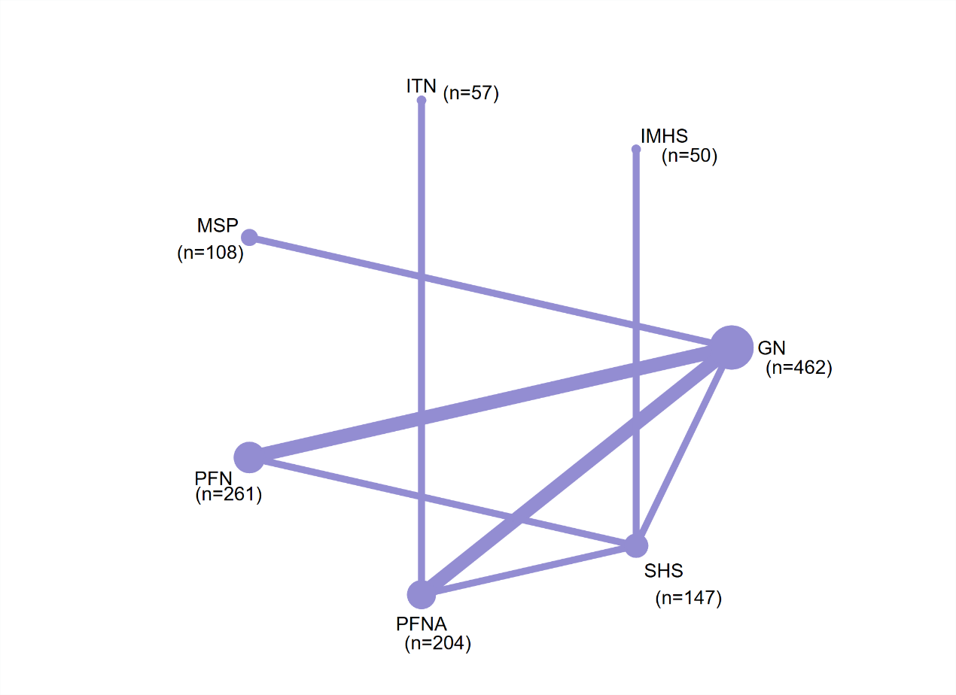

Figure S11.21: Network map of non-mechanical complications.
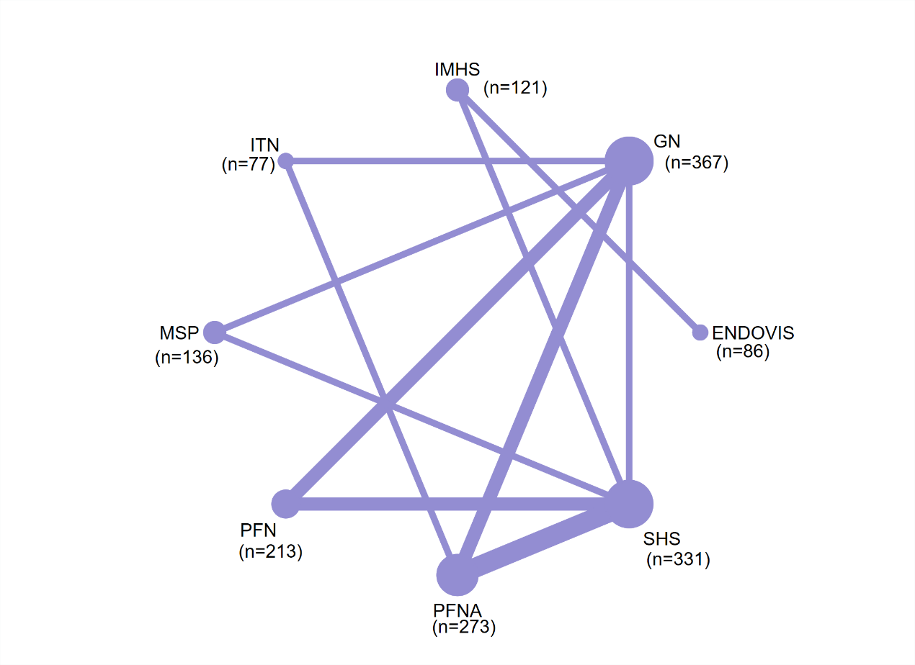

Figure S11.22: Network map of mechanical complications.
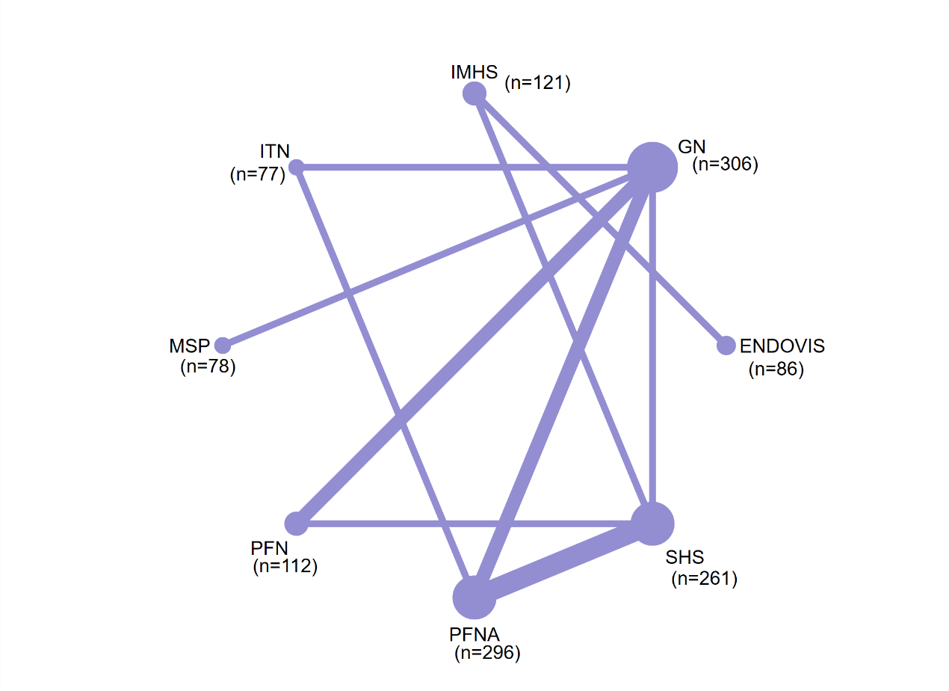

Figure S11.23: Network map of intraoperative complications (extramedullary versus intramedullary fixation).
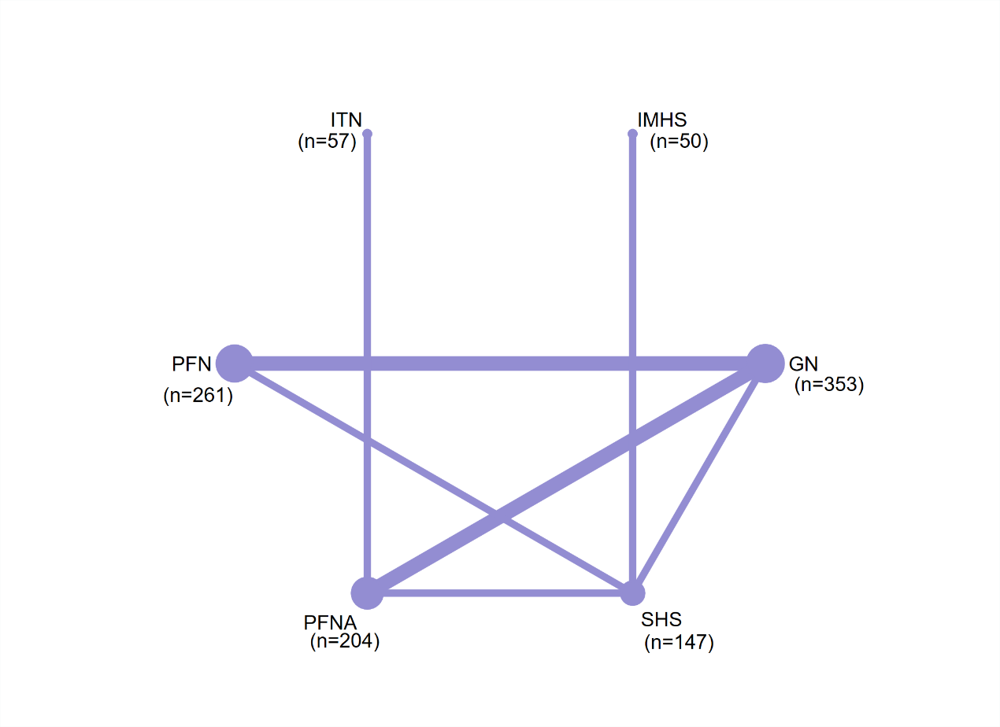

Figure S11.24: Network map of non-mechanical complications (extramedullary versus intramedullary fixation).
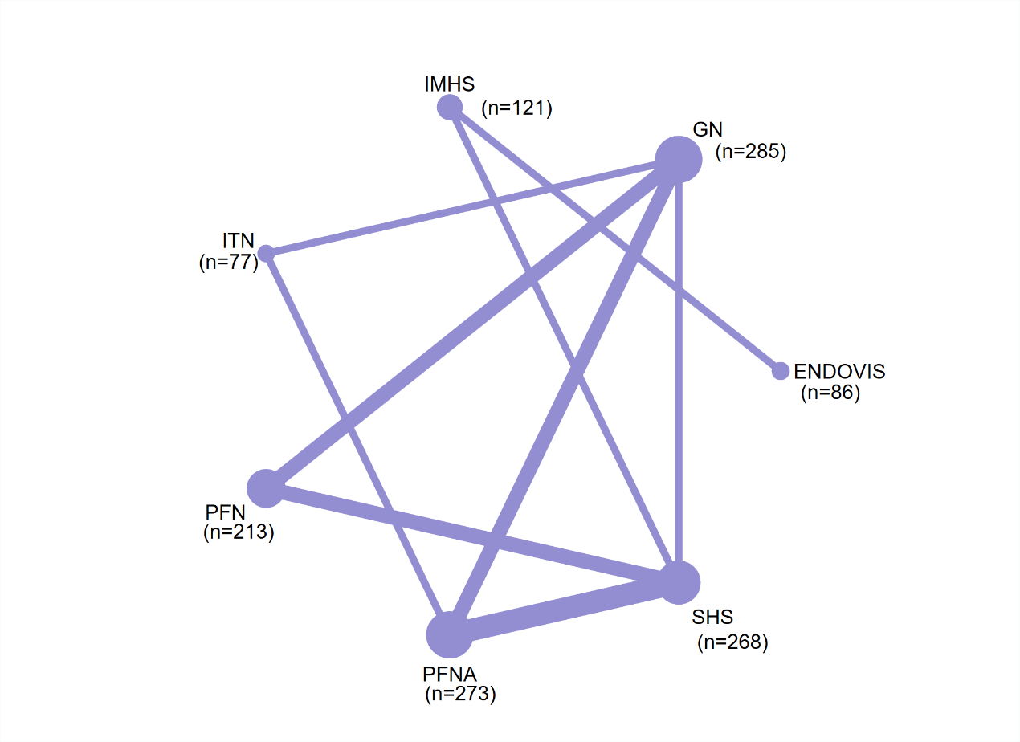

Figure S11.25: Network map of mechanical complications (extramedullary versus intramedullary fixation).
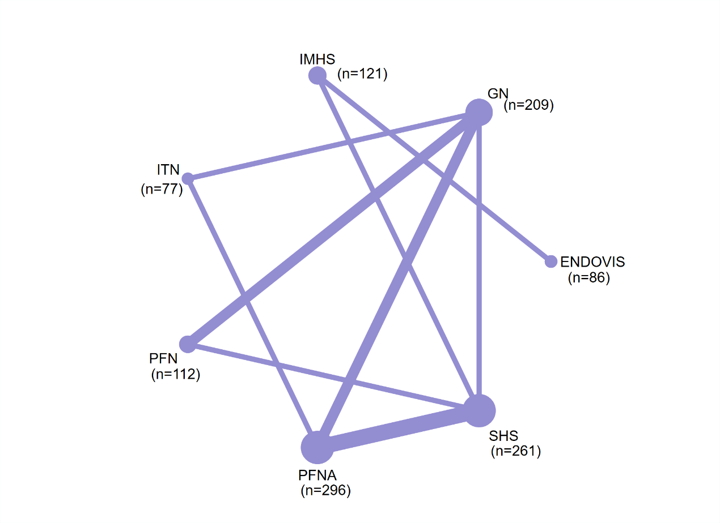
Figure S11.26: Cumulative ranking curve plots of intraoperative complications.
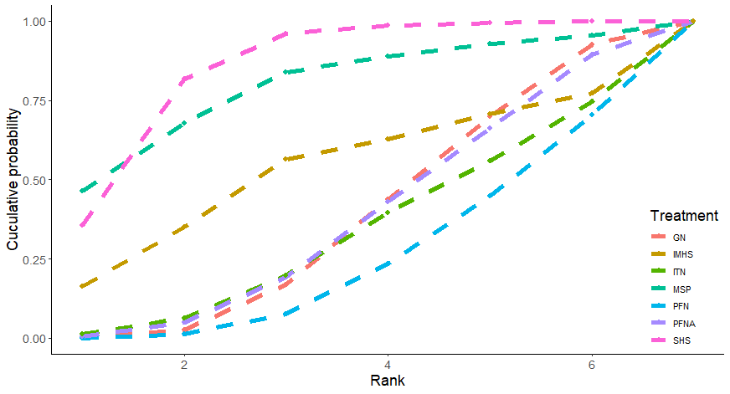
Figure S11.27: Cumulative ranking curve plots of non-mechanical complications.
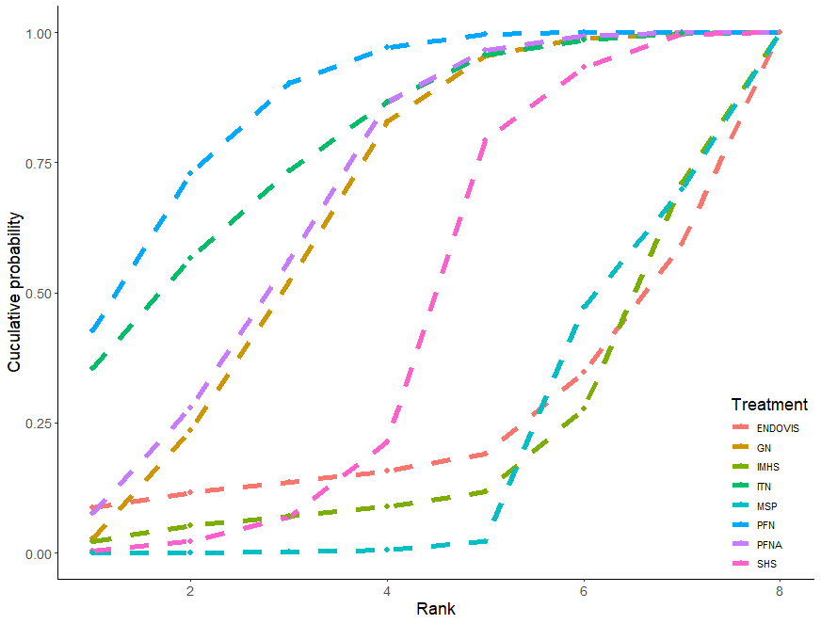

Figure S11.28: Cumulative ranking curve plots of mechanical complications.
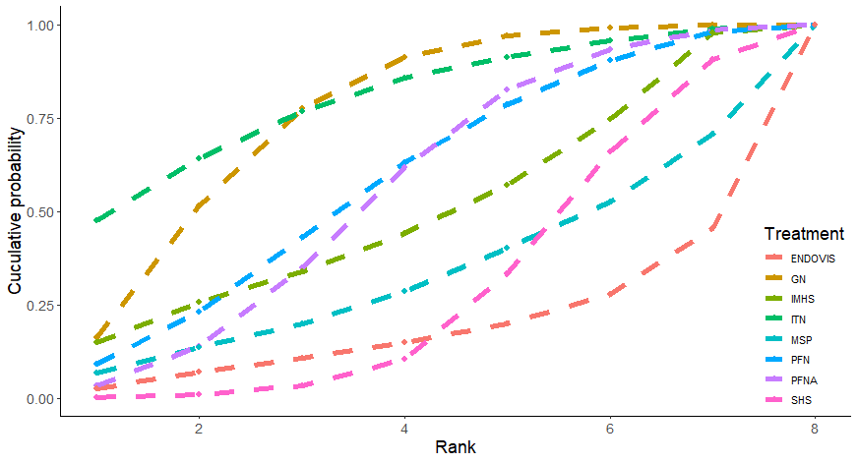

Figure S11.29: Cumulative ranking curve plots of intraoperative complications (extramedullary versus intramedullary fixation).
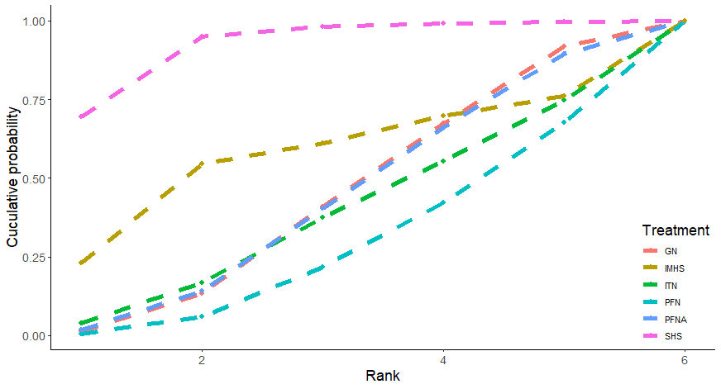

Figure S11.30: Cumulative ranking curve plots of non-mechanical complications (extramedullary versus intramedullary fixation).
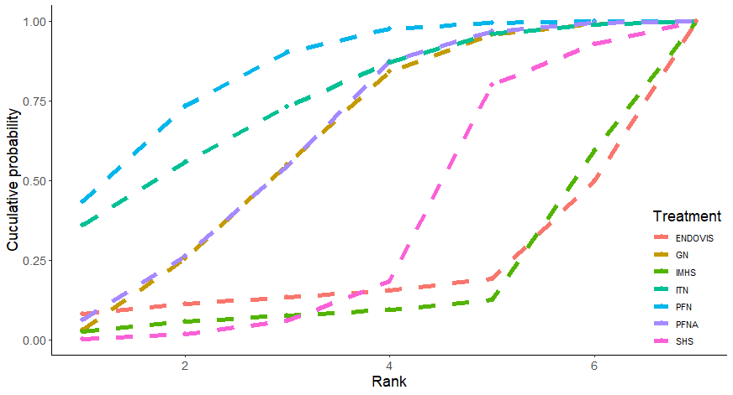

Figure S11.31: Cumulative ranking curve plots of mechanical complications (extramedullary versus intramedullary fixation).
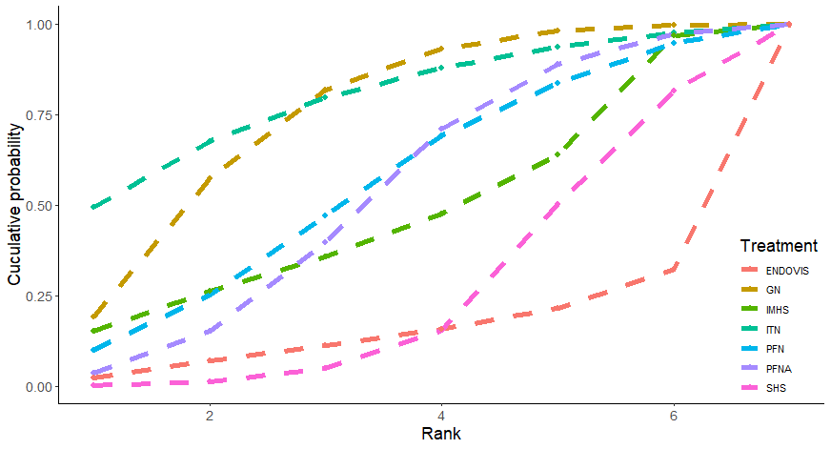

Figure S11.32: Funnel plot of mechanical intraoperative complications.
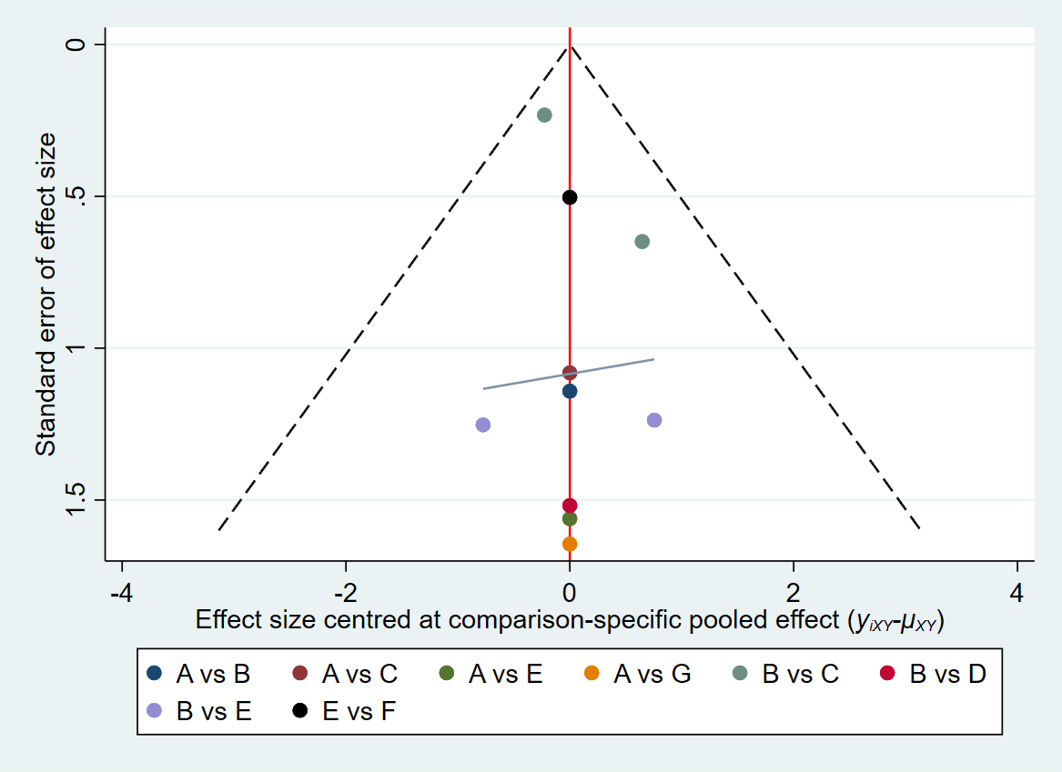
Abbreviations: A, SHS; B, GN; C, PFN; D, MSP; E, PFNA; F, ITN; G, IMHS.

Figure S11.33: Funnel plot of mechanical non-mechanical complications.
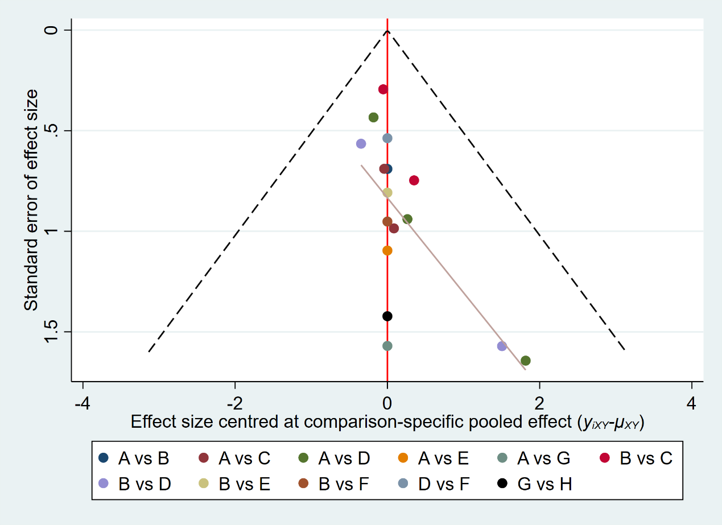
Abbreviations: A, SHS; B, GN; C, PFN; D, PFNA; E, MSP; F, ITN; G, IMHS; H, ENDOVIS.

Figure S11.34: Funnel plot of mechanical complications.
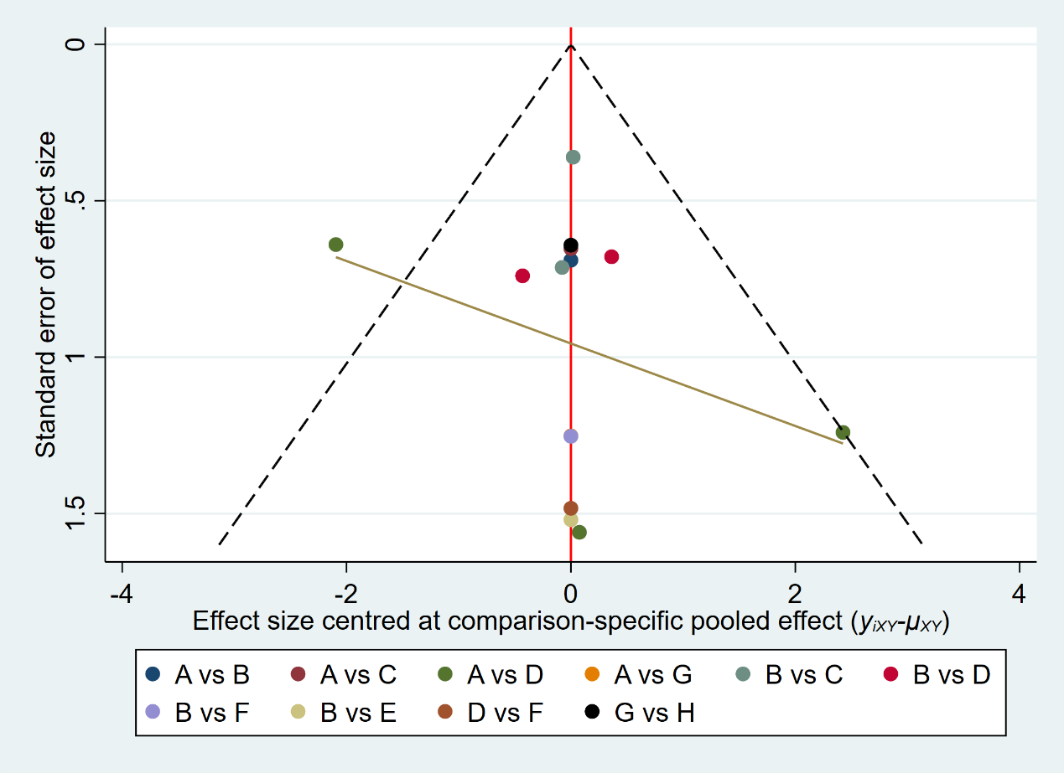
Abbreviations: A, SHS; B, GN; C, PFN; D, PFNA; E, MSP; F, ITN; G, IMHS; H, ENDOVIS.

Figure S11.35: Funnel plot of intraoperative complications (extramedullary versus intramedullary fixation).
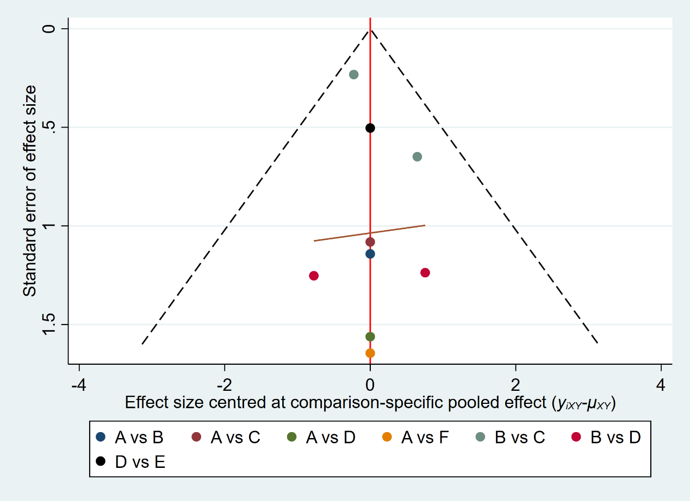
Abbreviations: A, SHS; B, GN; C, PFN; D, PFNA; E, ITN; F, IMHS.

Figure S11.36: Funnel plot of non-mechanical complications (extramedullary versus intramedullary fixation).
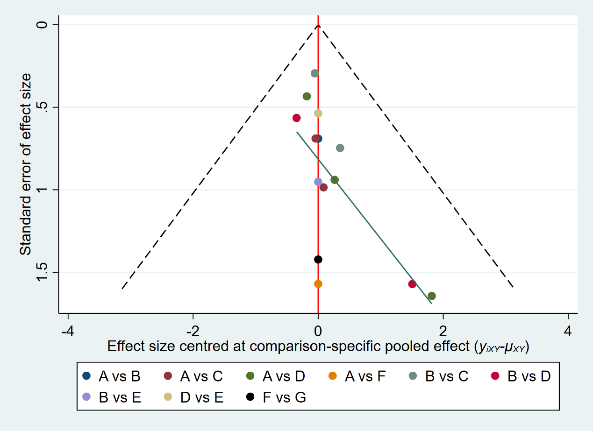
Abbreviations: A, SHS; B, GN; C, PFN; D, PFNA; E, ITN; F, IMHS; G, ENDOVIS.

Figure S11.37: Funnel plot of mechanical complications (extramedullary versus intramedullary fixation).
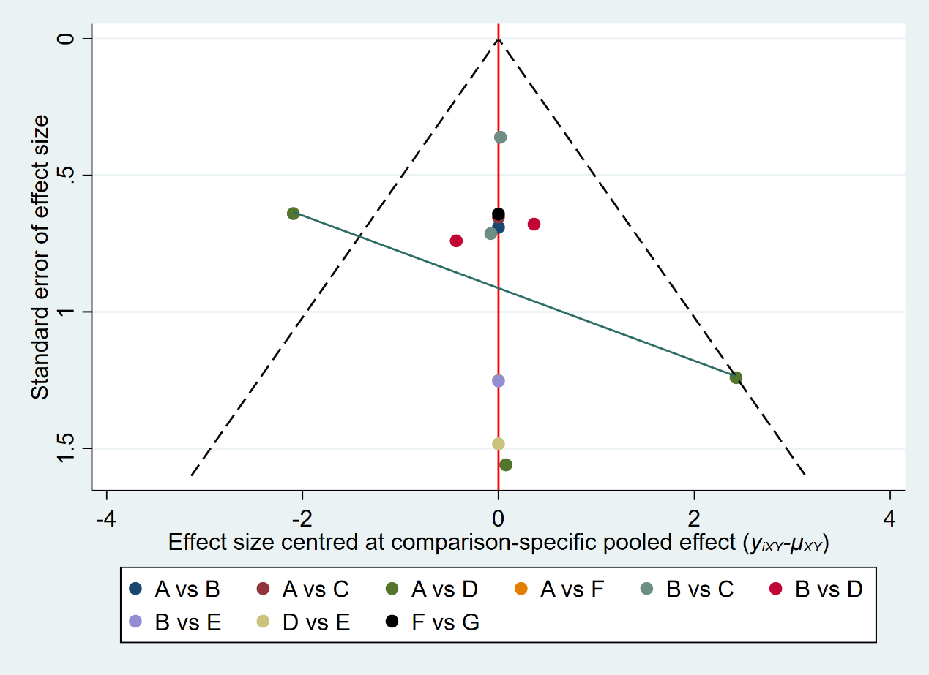
Abbreviations: A, SHS; B, GN; C, PFN; D, PFNA; E, ITN; F, IMHS; G, ENDOVIS.

Appendix 12: Network maps
The size of the nodes was proportional to the number of participants included in the trial, and the thickness of lines between the interventions relates to the number of studies for that comparison.
Figure S12.1: Network map of mortality.
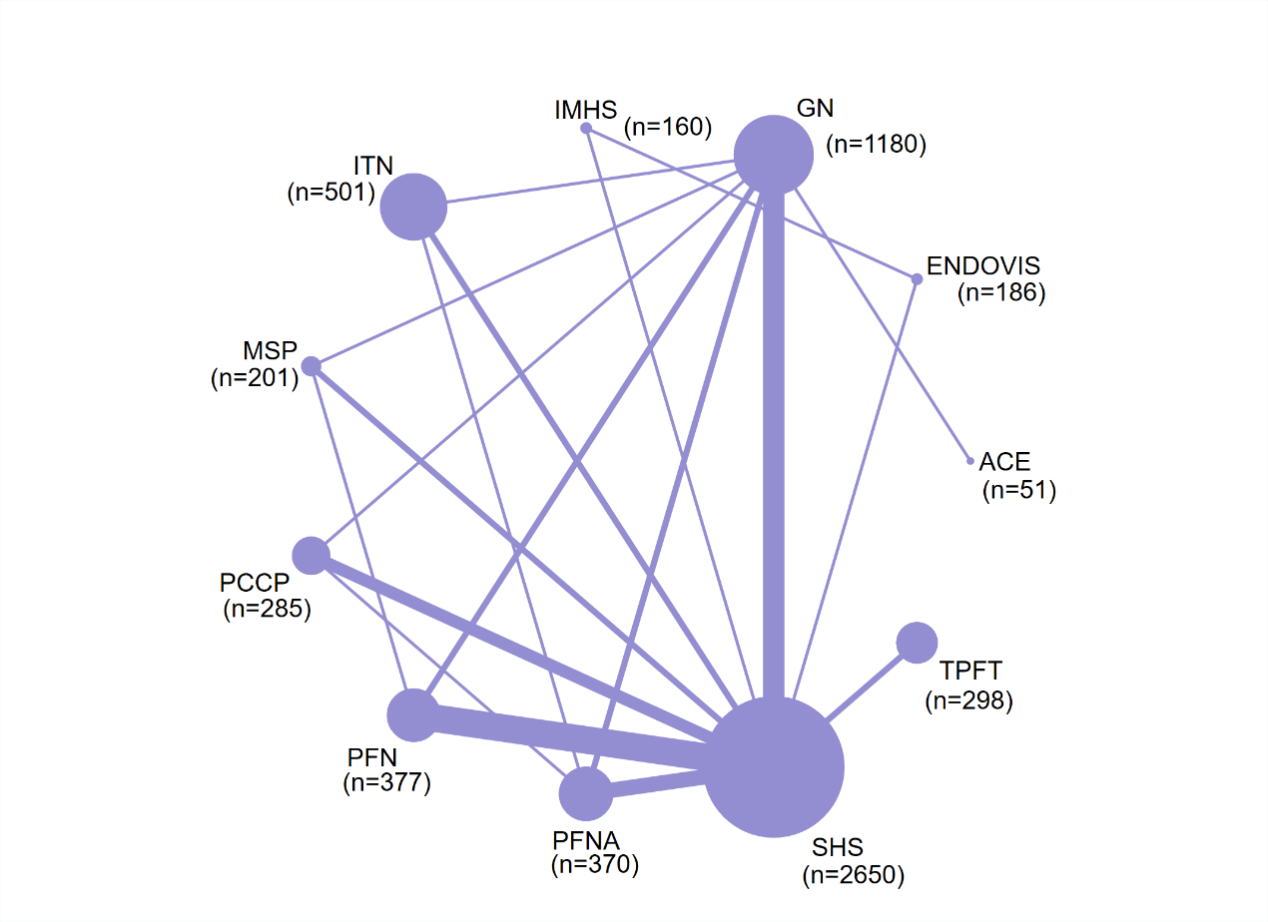

Figure S12.2: Network map of reoperation rate.
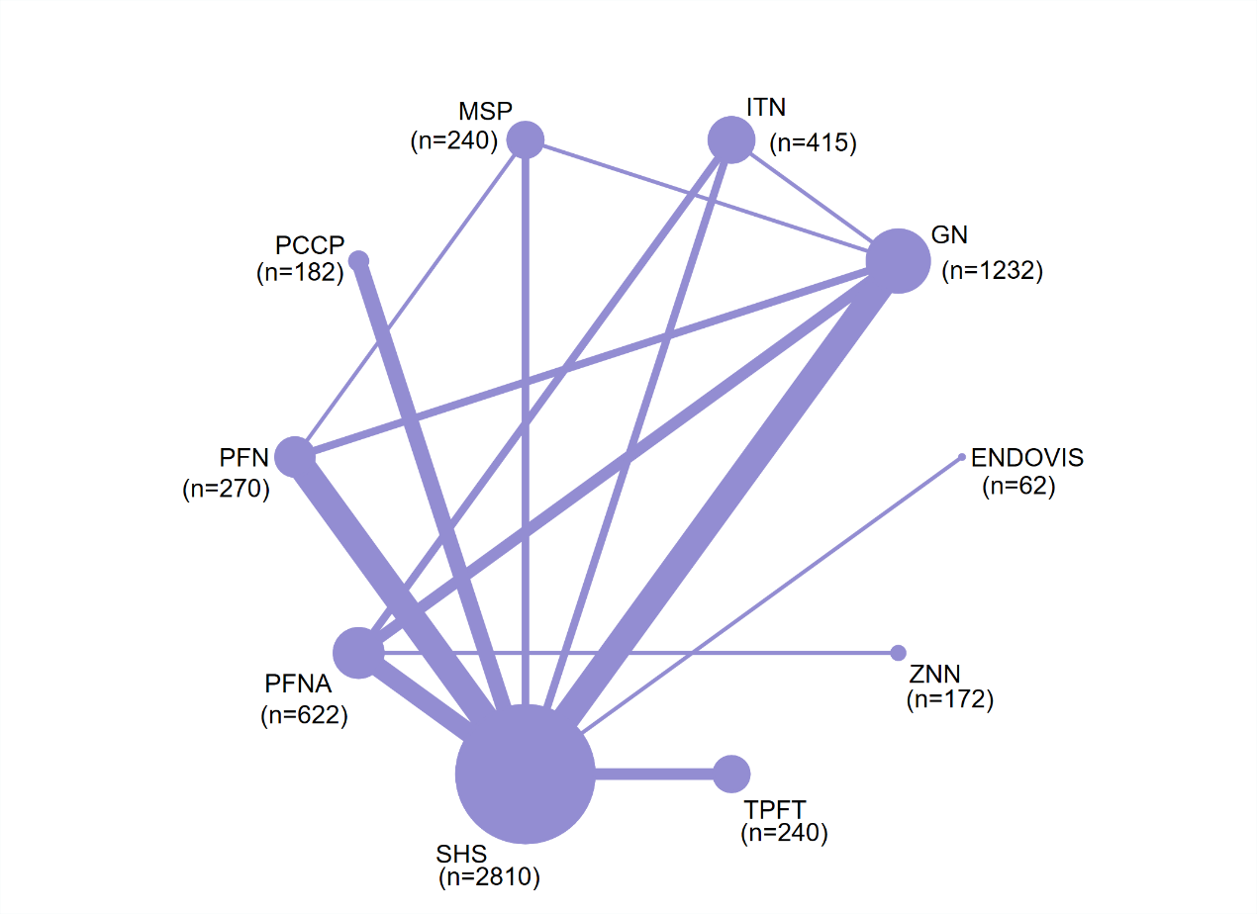

Figure S12.3: Network map of intraoperative complications-operative issue.
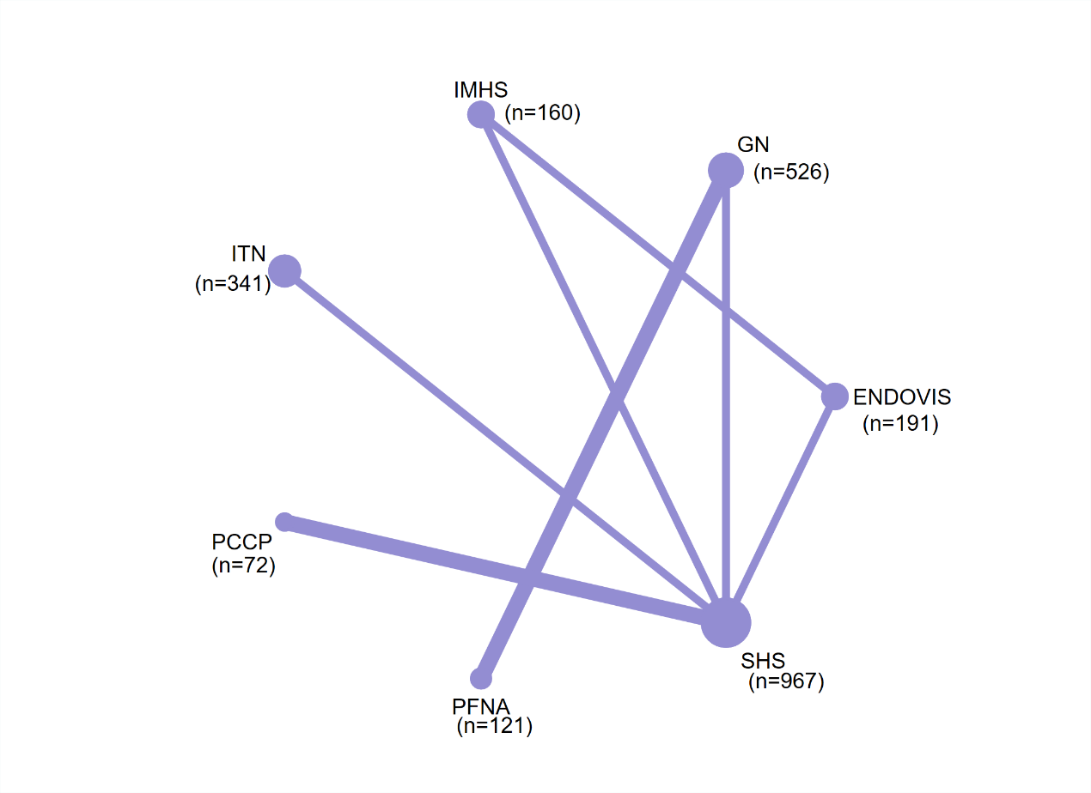

Figure S12.4: Network map of non-specific intraoperative complications.

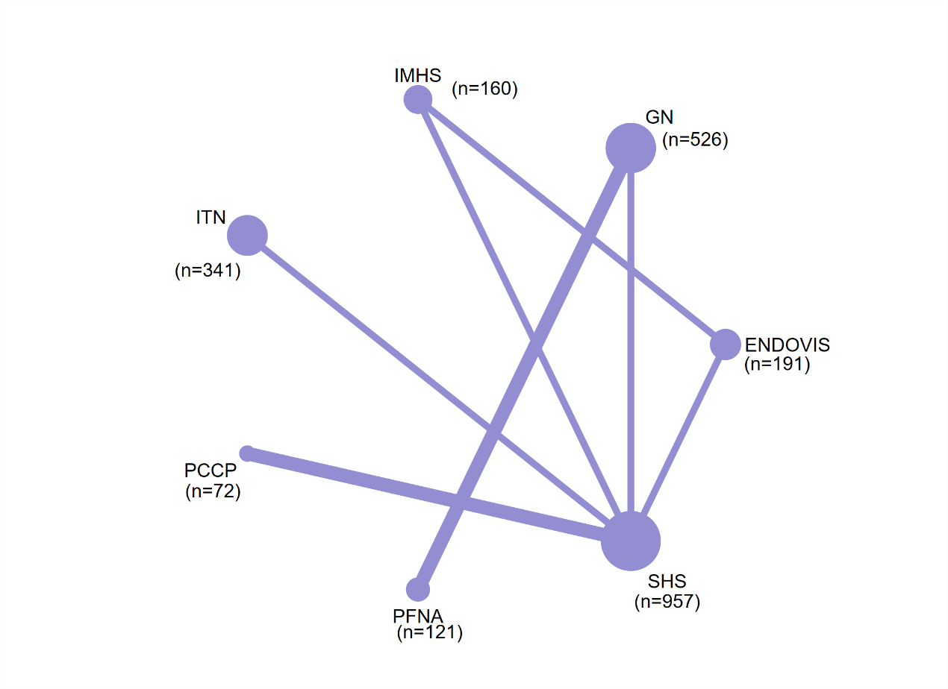

Figure S12.5: Network map of non-mechanical post-surgery medical complications.
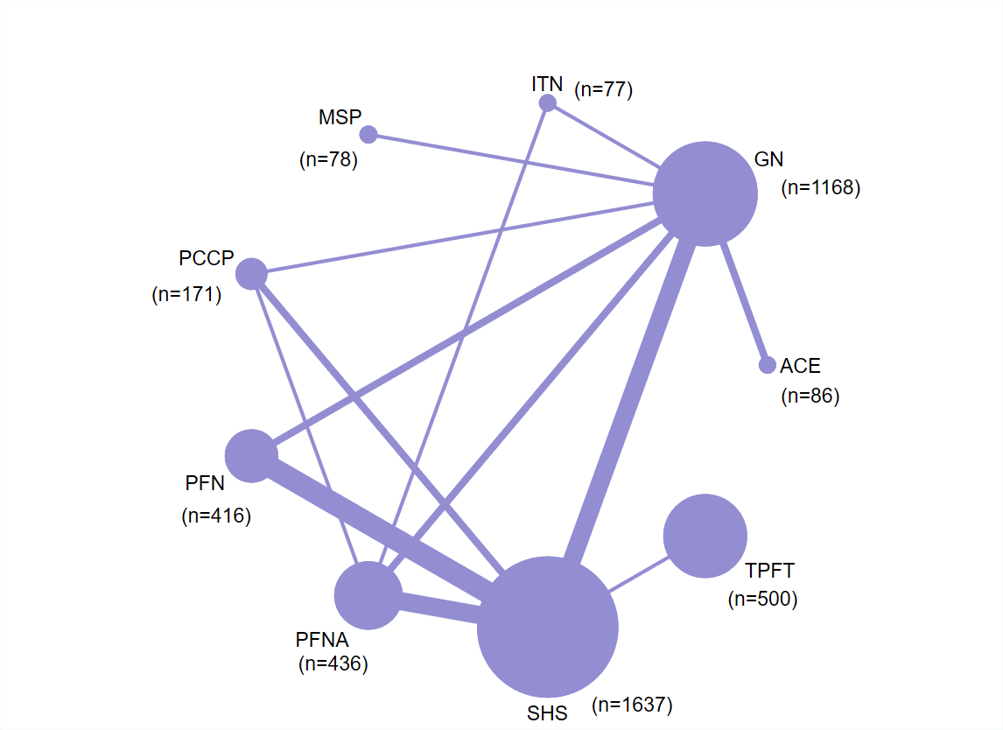

Figure S12.6: Network map of non-mechanical major post-surgery complications.
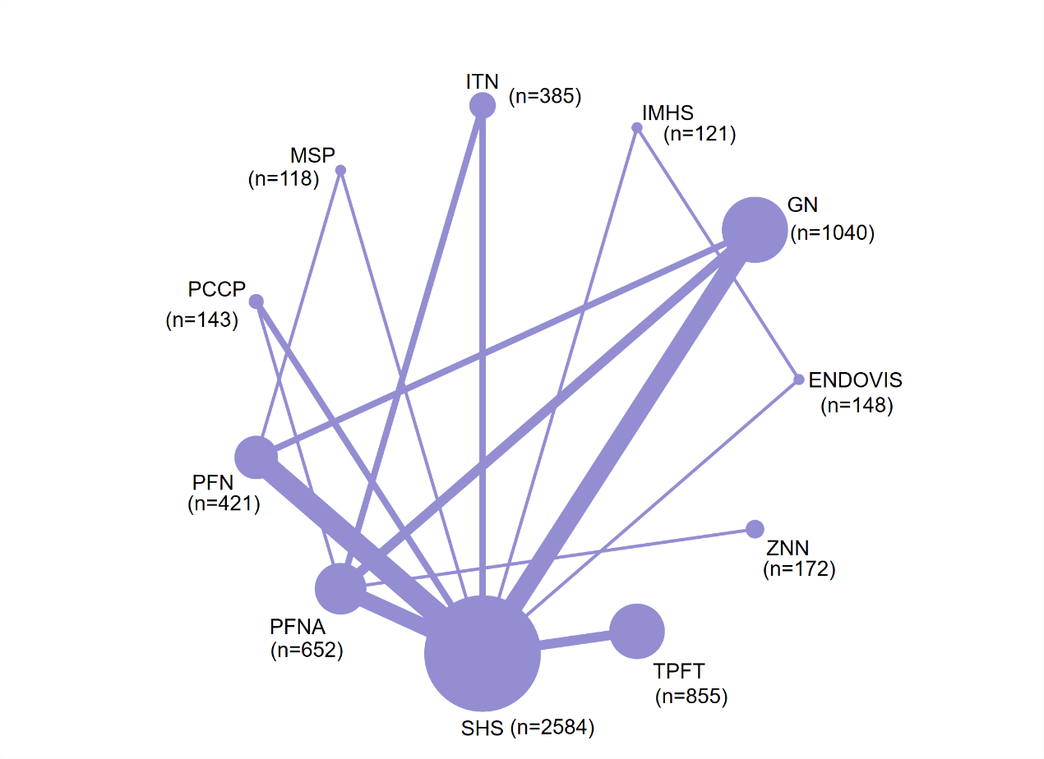

Figure S12.7: Network map of non-mechanical minor post-surgery complications.
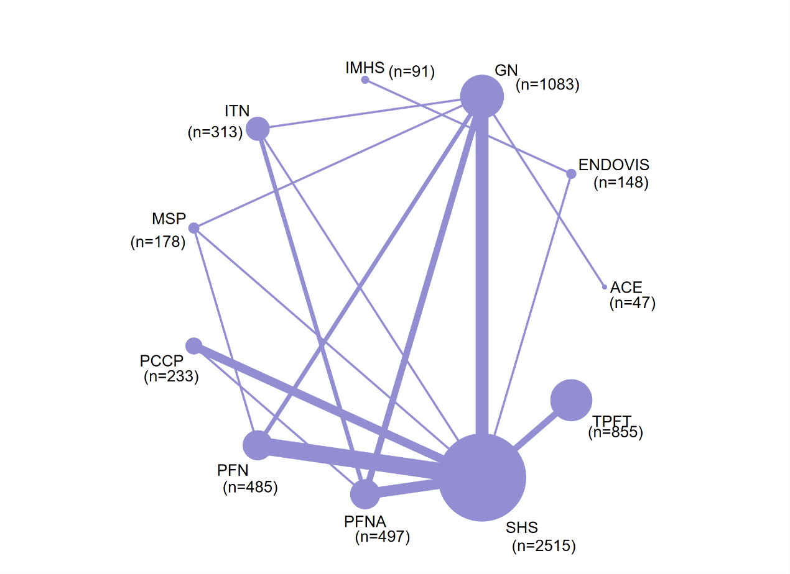

Figure S12.8: Network map of overall mechanical complications.
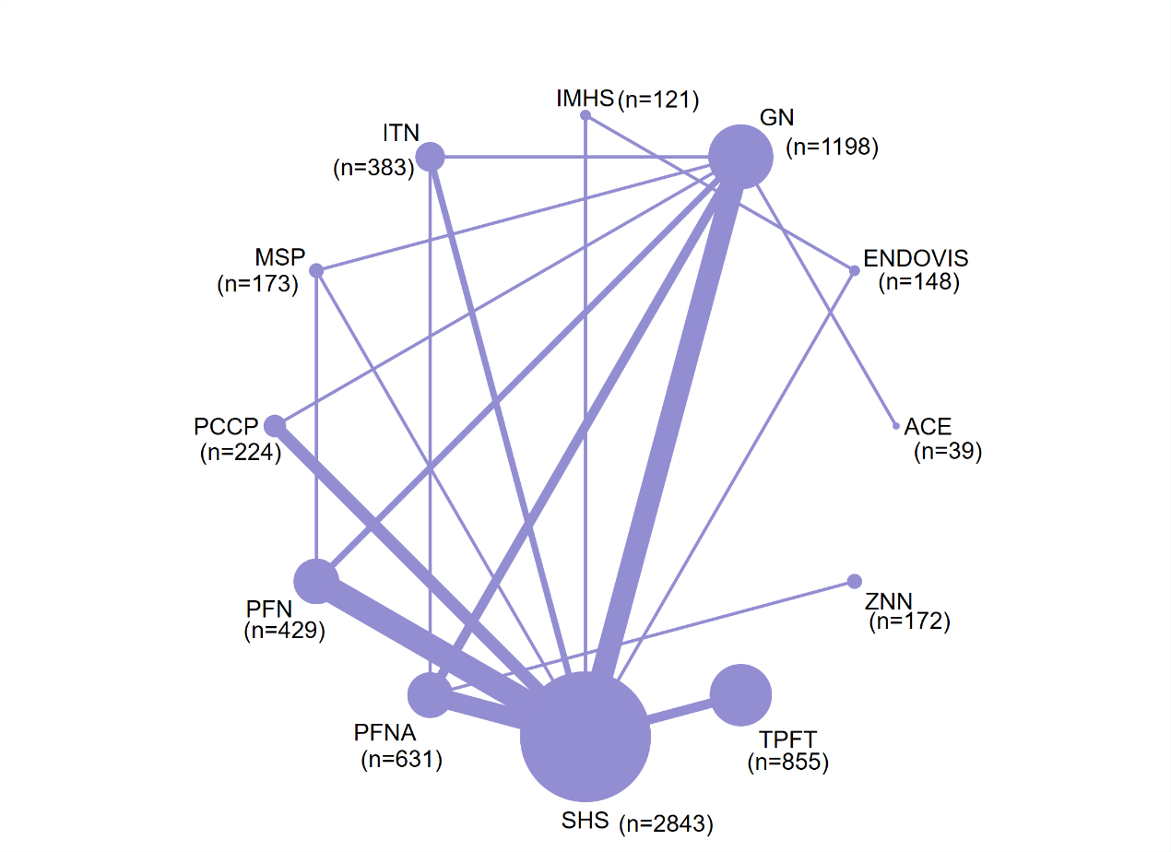

Figure S12.9: Network map of mechanical complications-cut out.
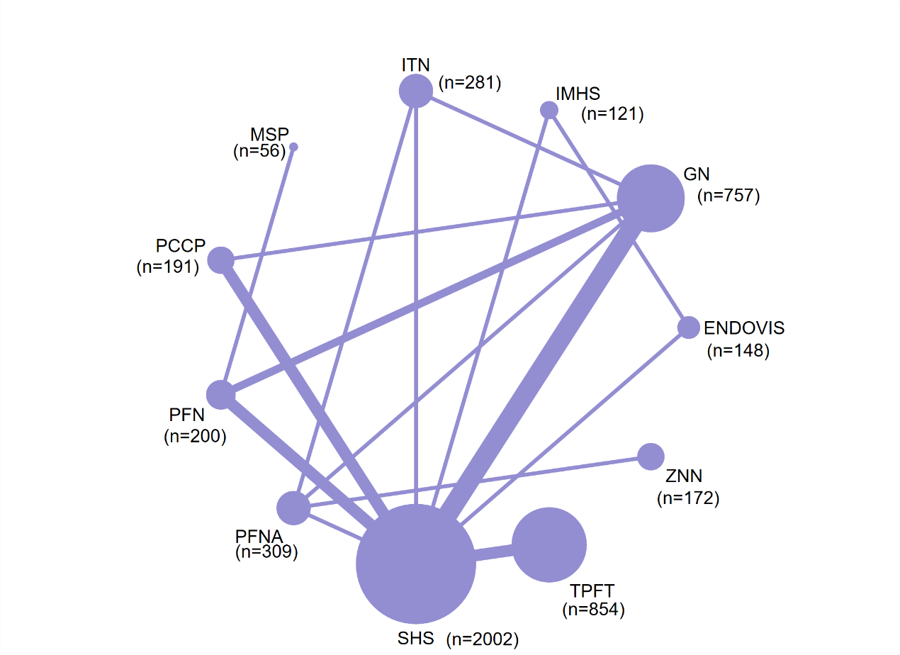

Figure S12.10: Network map of mechanical complications-fixation failure.
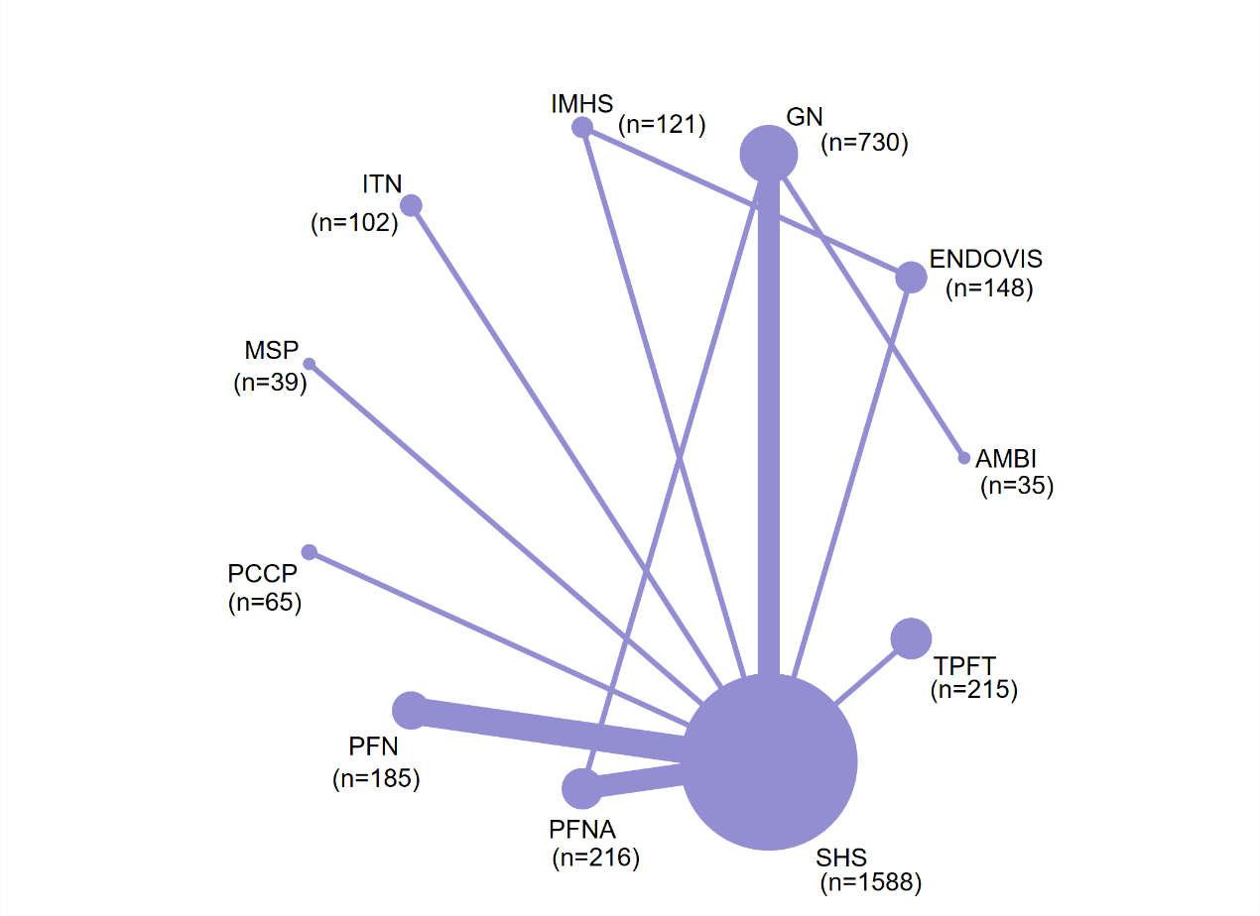

Figure S12.11: Network map of mechanical complications-migration.
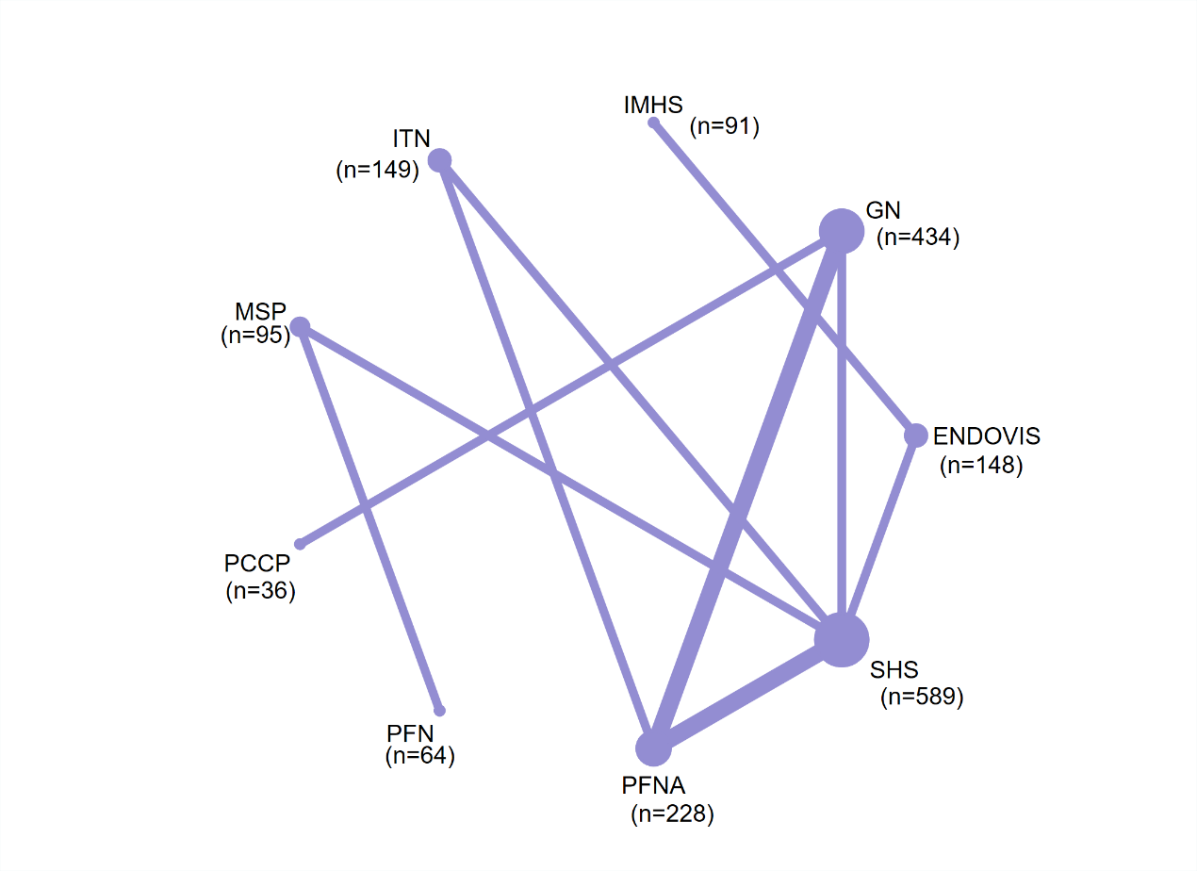

Figure S12.12: Network map of mechanical complications-valgus deformity.
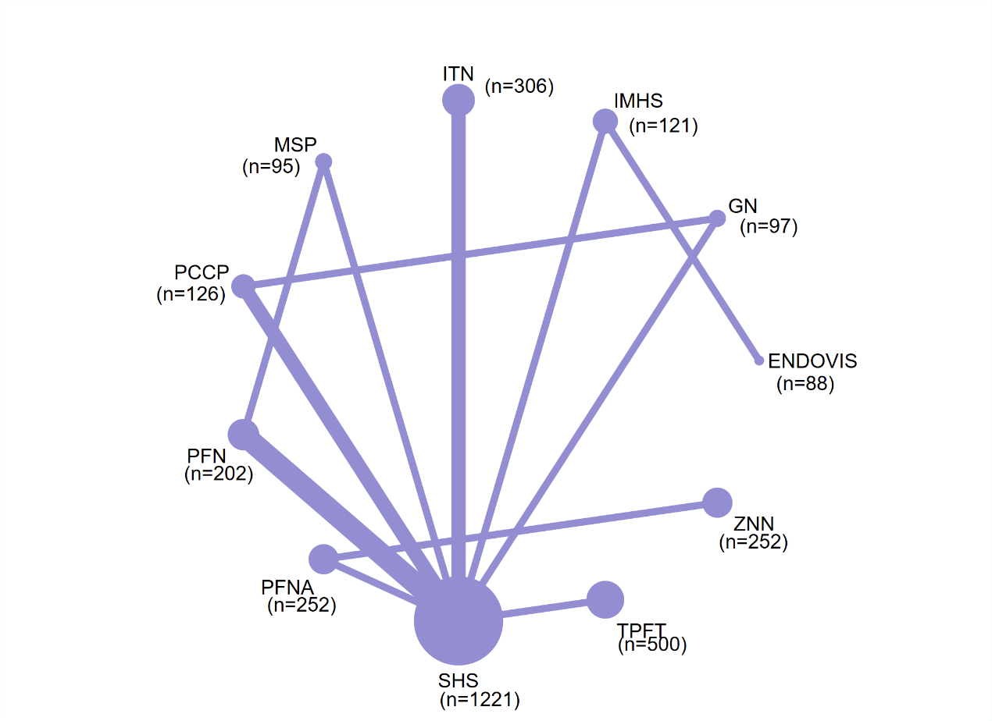

Figure S12.13: Network map of non-specific mechanical complications.
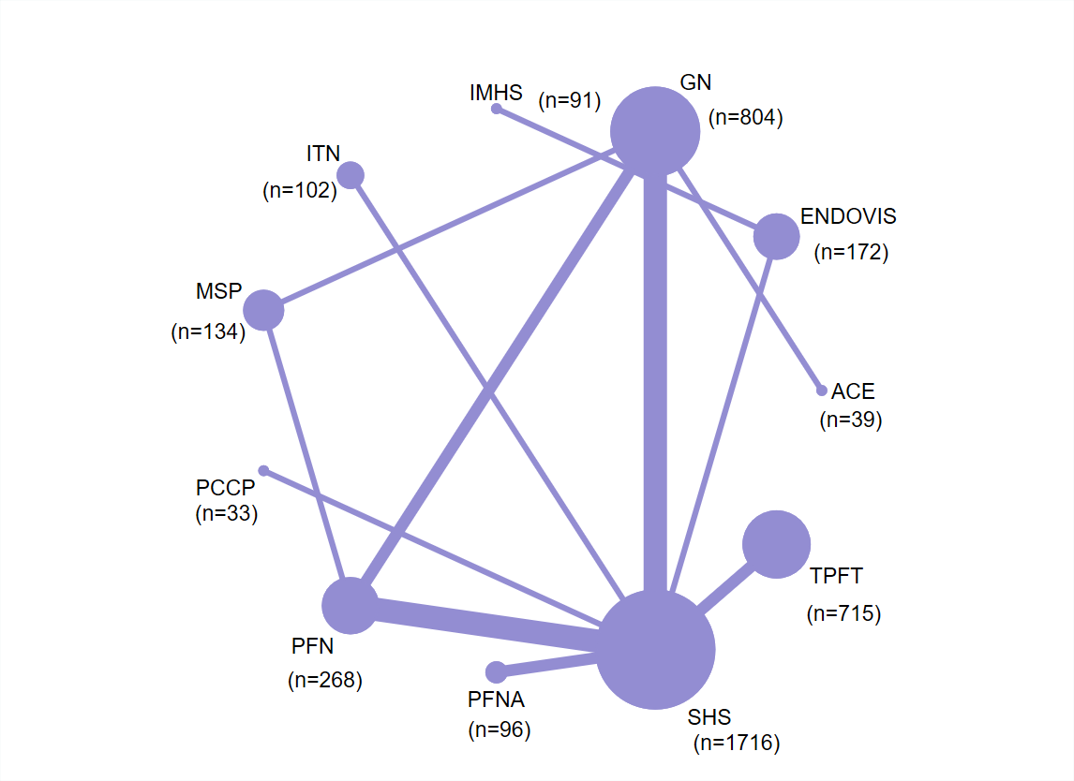

Figure S12.14: Network map of Harris hip score.
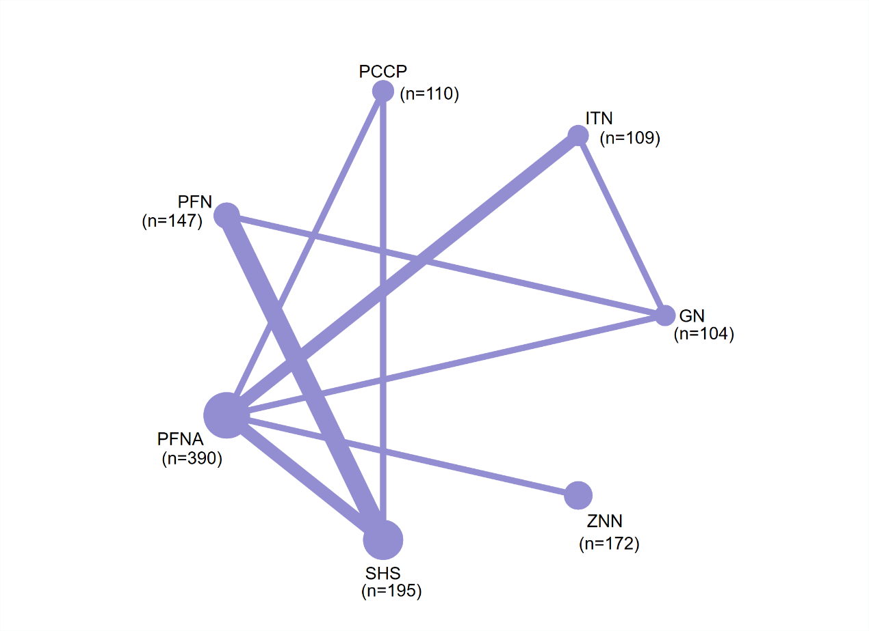

Appendix 13: Funnel plots
We used Begg's test to assess the symmetry of the funnel plot, if P > 0.05, the funnel plot is proved to be symmetrical and may not have publication bias; and if P < 0.05.
Figure S13.1: Funnel plot of mortality.
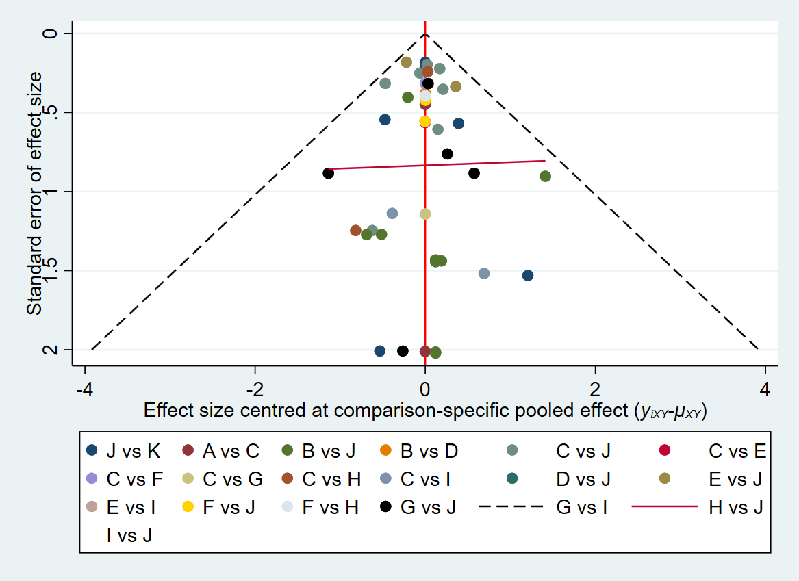
Egger's test t=-0.21 P=0.8331
Abbreviations: A, SHS; B, GN; C, TPFT; D, PFN; E, PFNA; F, MSP; G, PCCP; H, ACE; I, ITN; J, IMHS; K, ENDOVIS.

Figure S13.2: Funnel plot of reoperation rate.
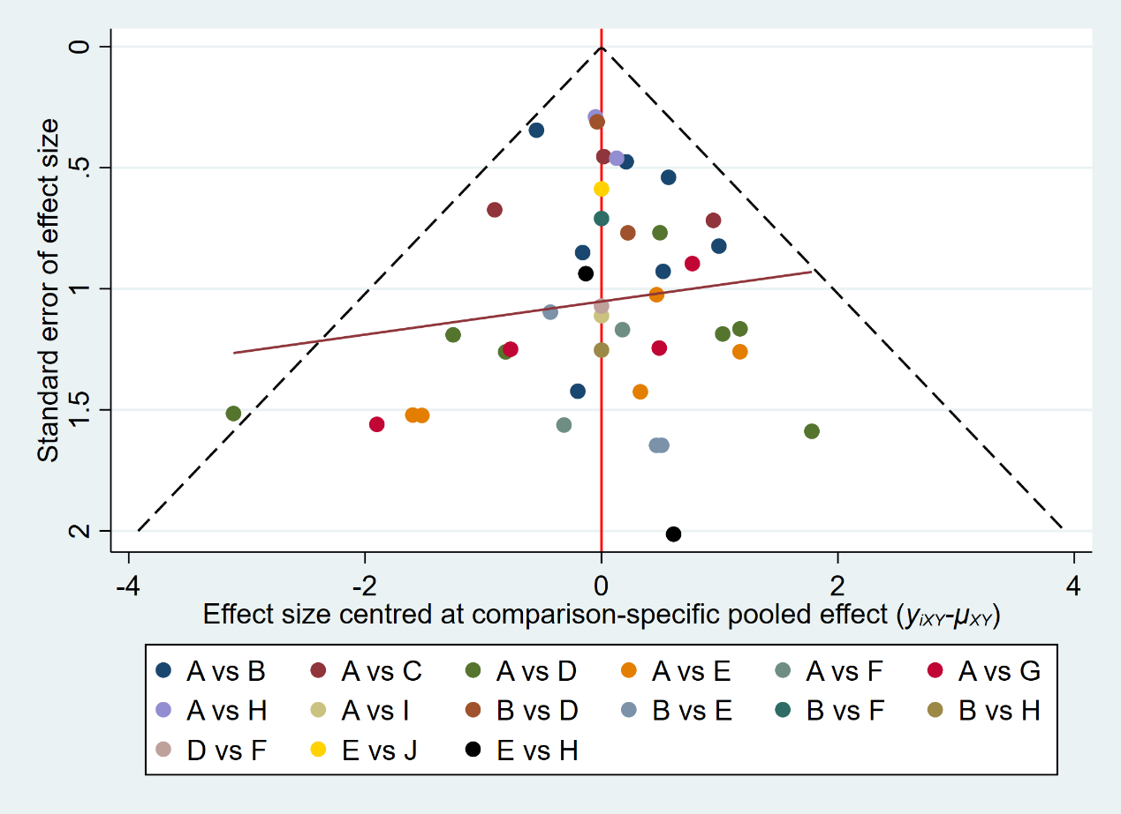
Egger's test t=-0.05 P=0.9596
Abbreviations: A, SHS; B, GN; C, TPFT; D, PFN; E, PFNA; F, MSP; G, PCCP; H, ITN; I, ENDOVIS; J, ZNN.

Figure S13.3: Funnel plot of intraoperative complications-operative issue.
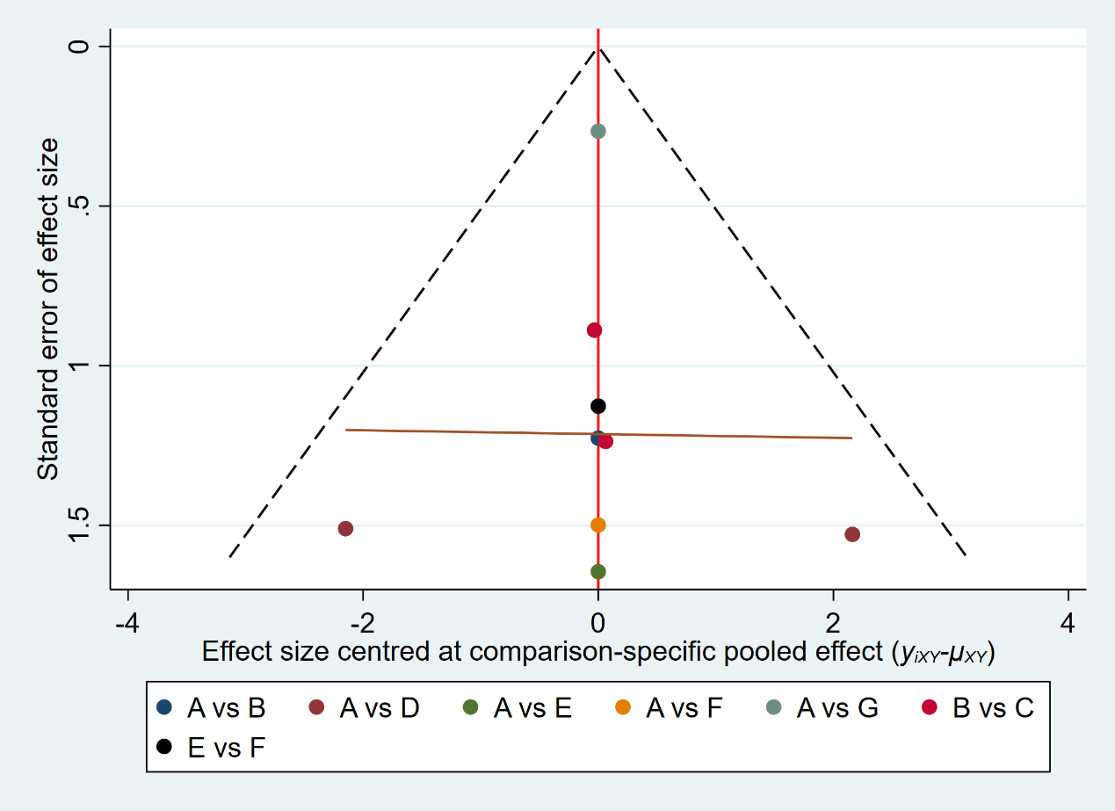
Abbreviations: A, SHS; B, GN; C, PFNA; D, PCCP; E, IMHS; F, ENDOVIS; G, ITN.

Figure S13.4: Funnel plot of non-specific intraoperative complications.
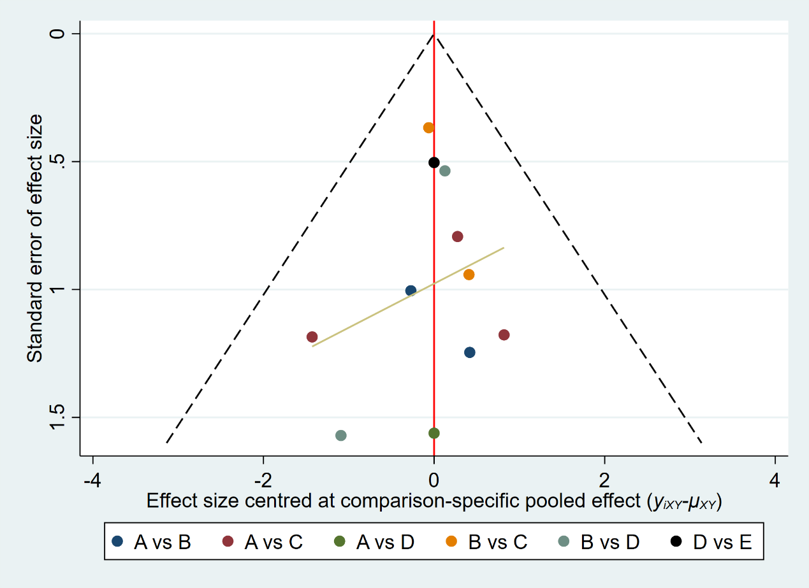
Abbreviations: A, SHS; B, GN; C, PFN; D, PFNA; E, ITN.
Figure S13.5: Funnel plot of non-mechanical post-surgery medical complications.
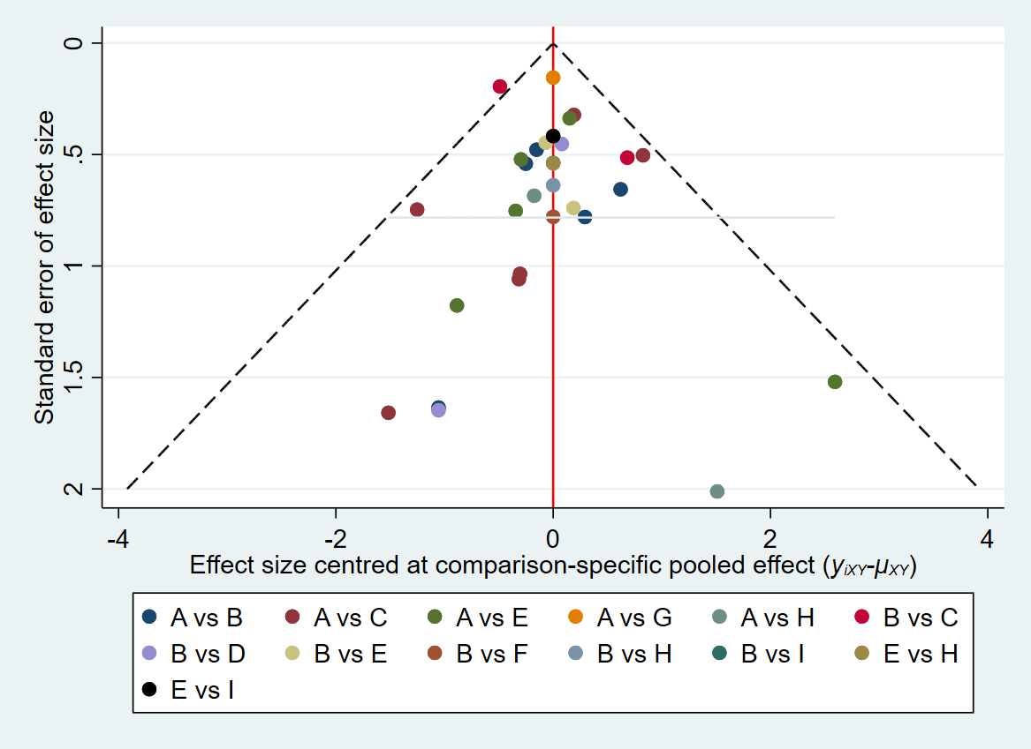
Egger's test t=-1.10 P=0.2818
Abbreviations: A, SHS; B, GN; C, PFN; D, ACE; E, PFNA; F, MSP; G, TPFT; H, PCCP; I, ITN.

Figure S13.6: Funnel plot of non-mechanical major post-surgery complications.
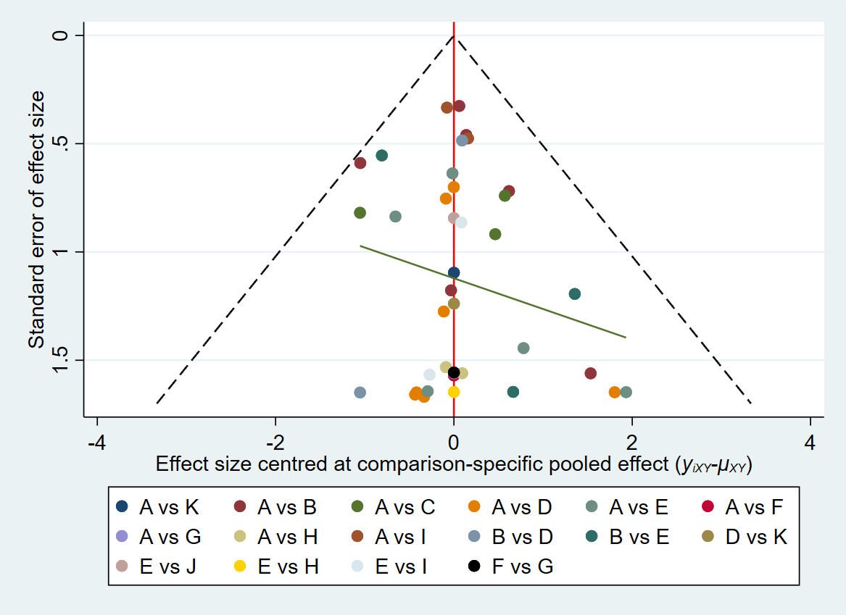
Egger's test t=0.43 P=0.6683
Abbreviations: A, SHS; B, GN; C, TPFT; D, PFN; E, PFNA; F, IMHS; G, ENDOVIS; H, PCCP; I, ITN; J, ZNN; K, MSP.

Figure S13.7: Funnel plot of non-mechanical minor post-surgery complications.
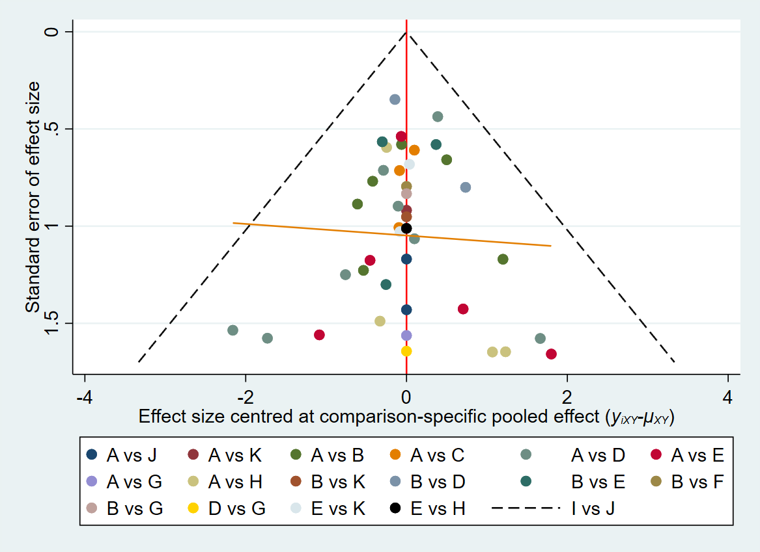
Egger's test t=-0.60 P=0.5534
Abbreviations: A, SHS; B, GN; C, TPFT; D, PFN; E, PFNA; F, ACE; G, MSP; H, PCCP; I, IMHS; J, ENDOVIS; K, ITN.

Figure S13.8: Funnel plot of overall mechanical complications.
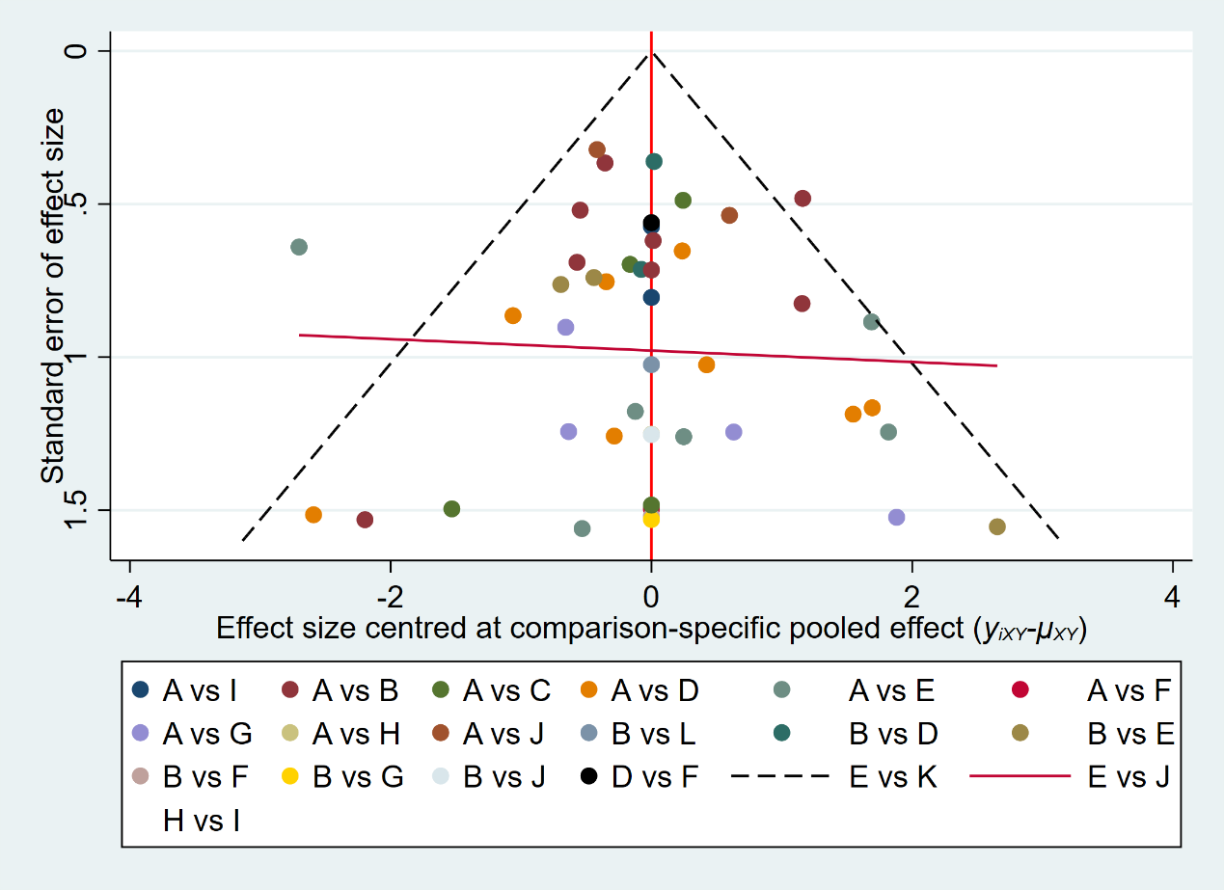
Egger's test t=0.29 P=0.7762
Abbreviations: A, SHS; B, GN; C, TPFT; D, PFN; E, PFNA; F, MSP; G, PCCP; H, IMHS; I, ENDOVIS; J, ITN; K, ZNN; L, ACE.

Figure S13.9: Funnel plot of mechanical complications-cut out.
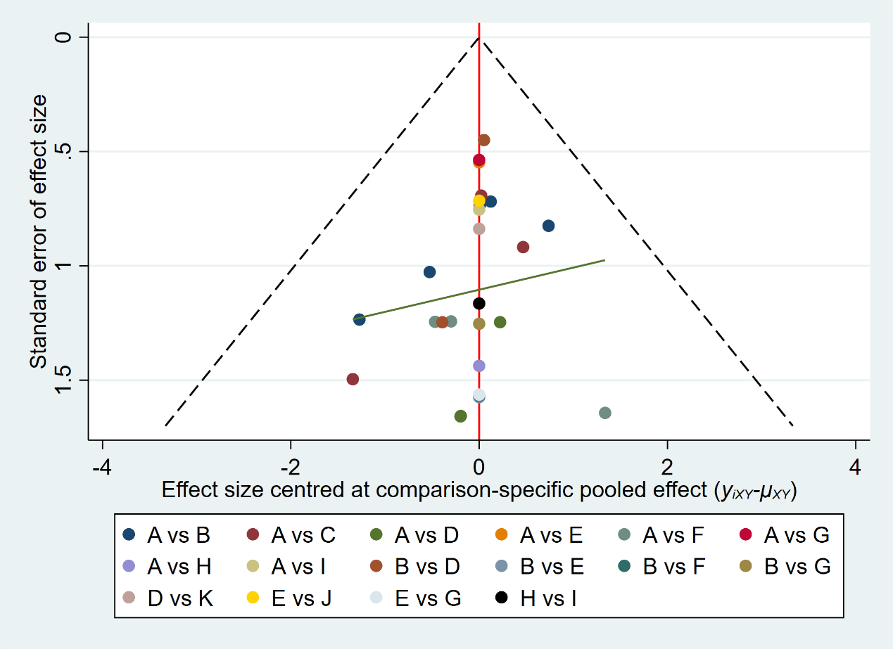
Egger's test t=-0.60 P=0.5566
Abbreviations: A, SHS; B, GN; C, TPFT; D, PFN; E, PFNA; F, PCCP; G, ITN; H, IMHS; I, ENDOVIS; J, ZNN; K, MSP.

Figure S13.10: Funnel plot of mechanical complications-fixation failure.
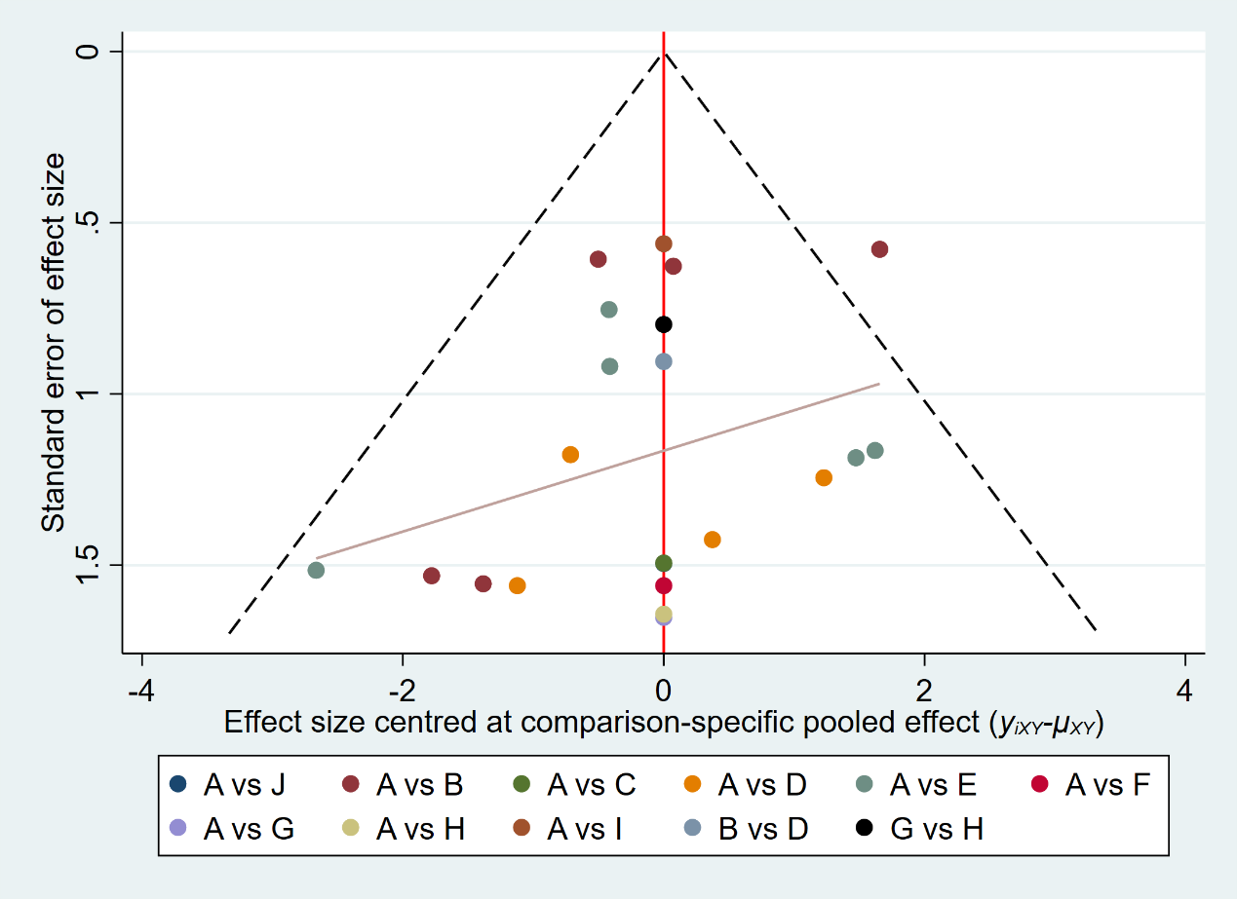
Egger's test t=-0.71 P=0.4866
Abbreviations: A, SHS; B, GN; C, TPFT; D, PFNA; E, PFN; F, PCCP; G, IMHS; H, ENDOVIS; I, ITN; J, MSP.

Figure S13.11: Funnel plot of mechanical complications-migration.
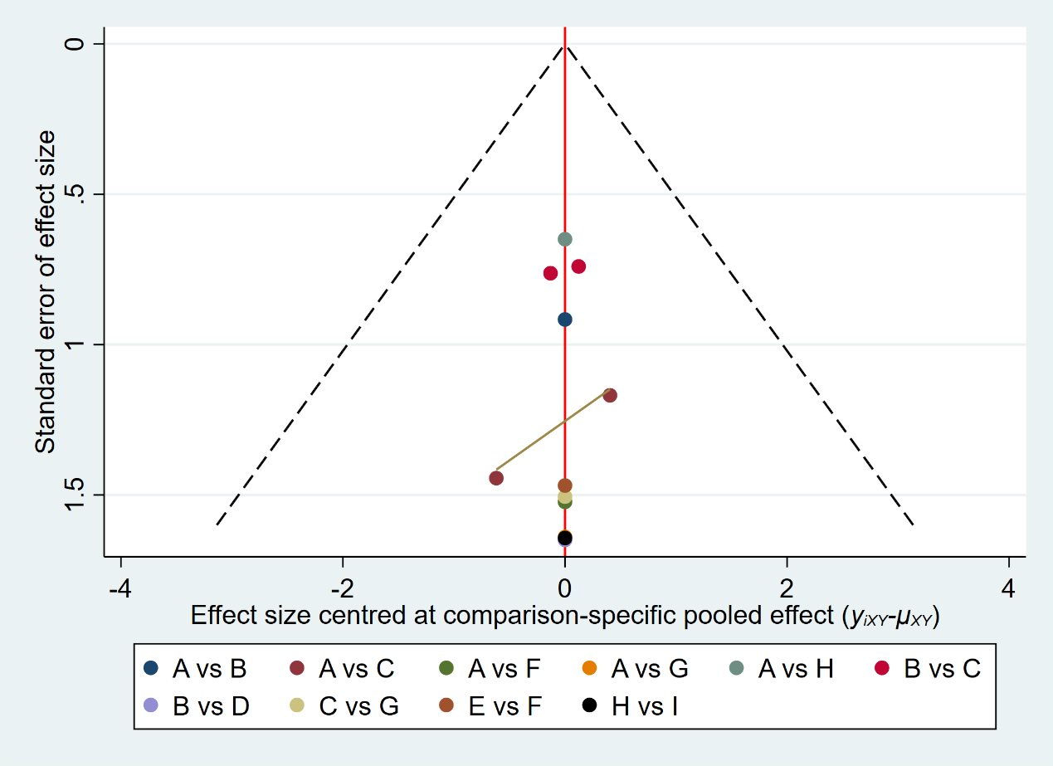
Egger's test t=-0.40 P=0.7008
Abbreviations: A, SHS; B, GN; C, PFNA; D, PCCP; E, IMHS; F, ENDOVIS; G, ITN; H, MSP; I, PFN.

Figure S13.12: Funnel plot of mechanical complications-valgus deformity.
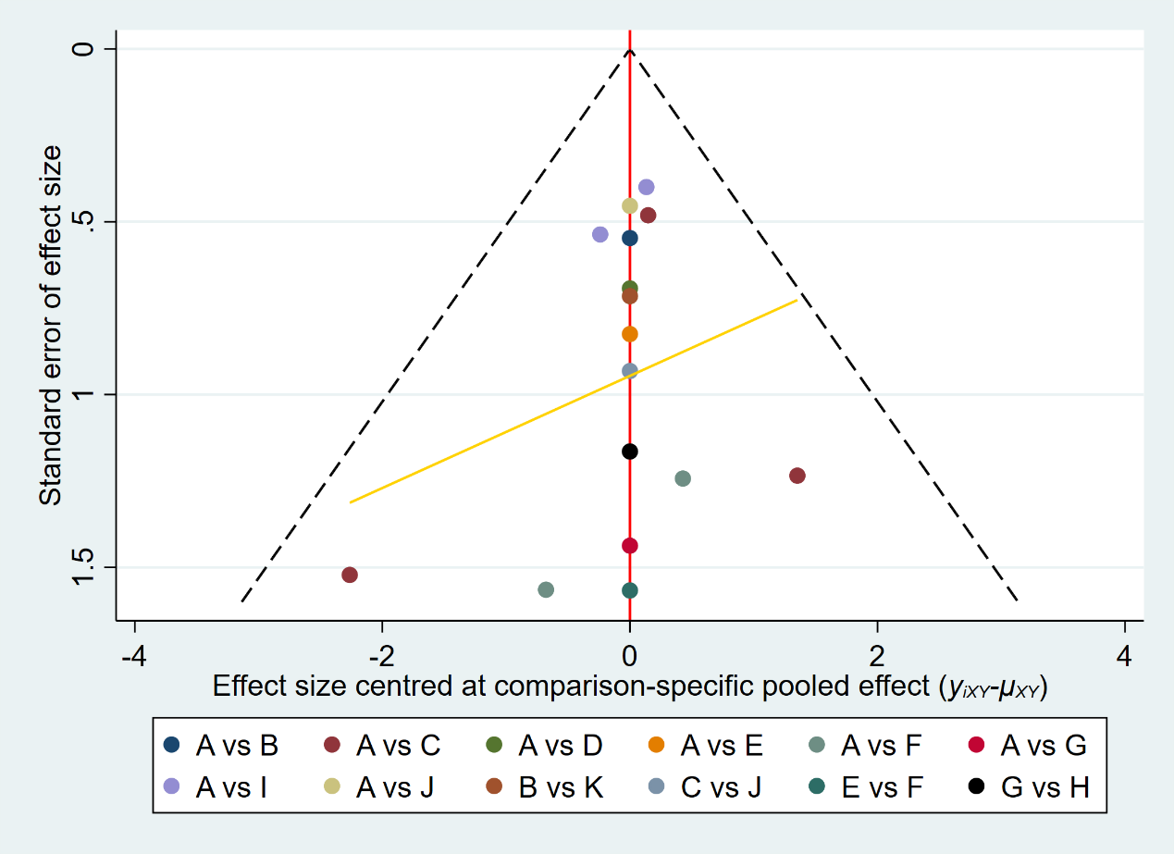
Egger's test t=-0.72 P=0.4835
Abbreviations: A, SHS; B, PFNA; C, PFN; D, TPFT; E, GN; F, PCCP; G, IMHS; H, ENDOVIS; I, ITN; J, MSP; K, ZNN.

Figure S13.13: Funnel plot of non-specific mechanical complications.
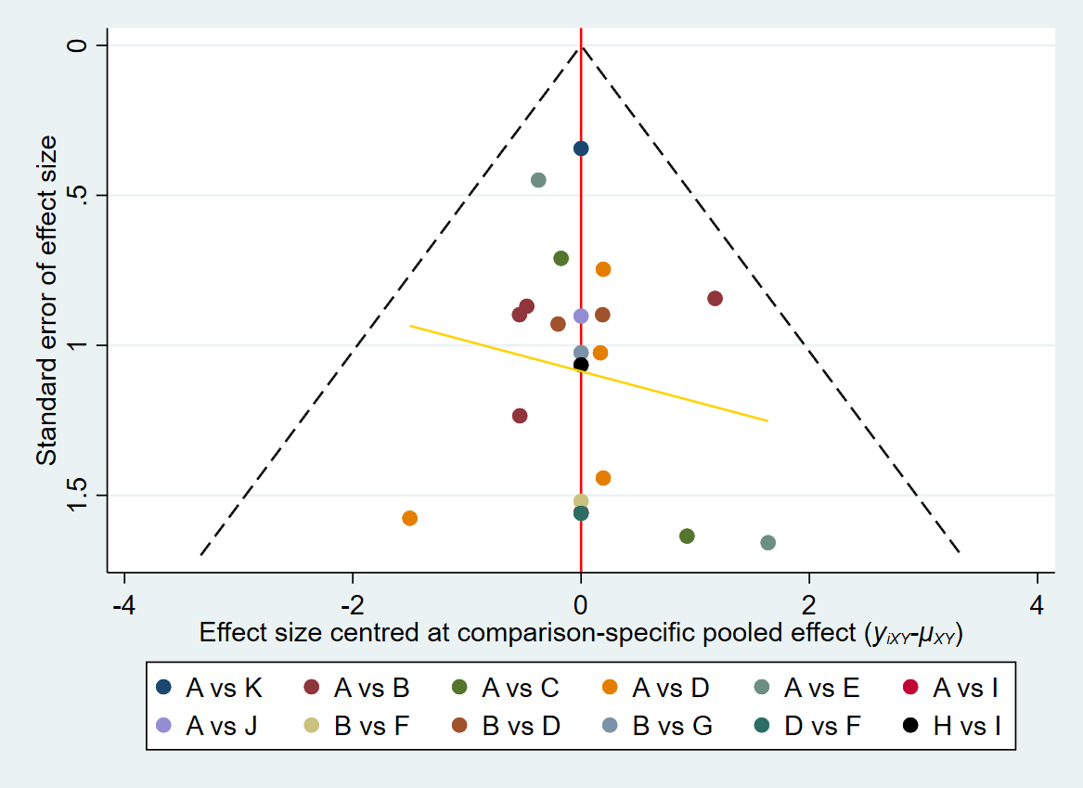
Abbreviations: A, SHS; B, GN; C, PFNA; D, PCCP; E, IMHS; F, ENDOVIS; G, ITN; H, MSP; I, PFN.

Figure S13.14: Funnel plot of Harris hip score.
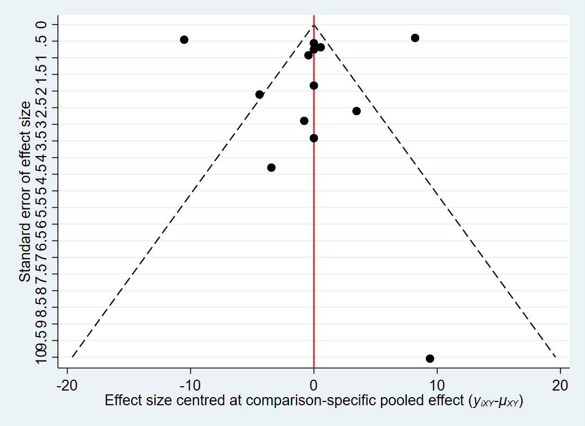
Egger's test t=0.28 P=0.7884

Appendix 14: Comparison of different implants with SHS
Figure S14.1: mortality.
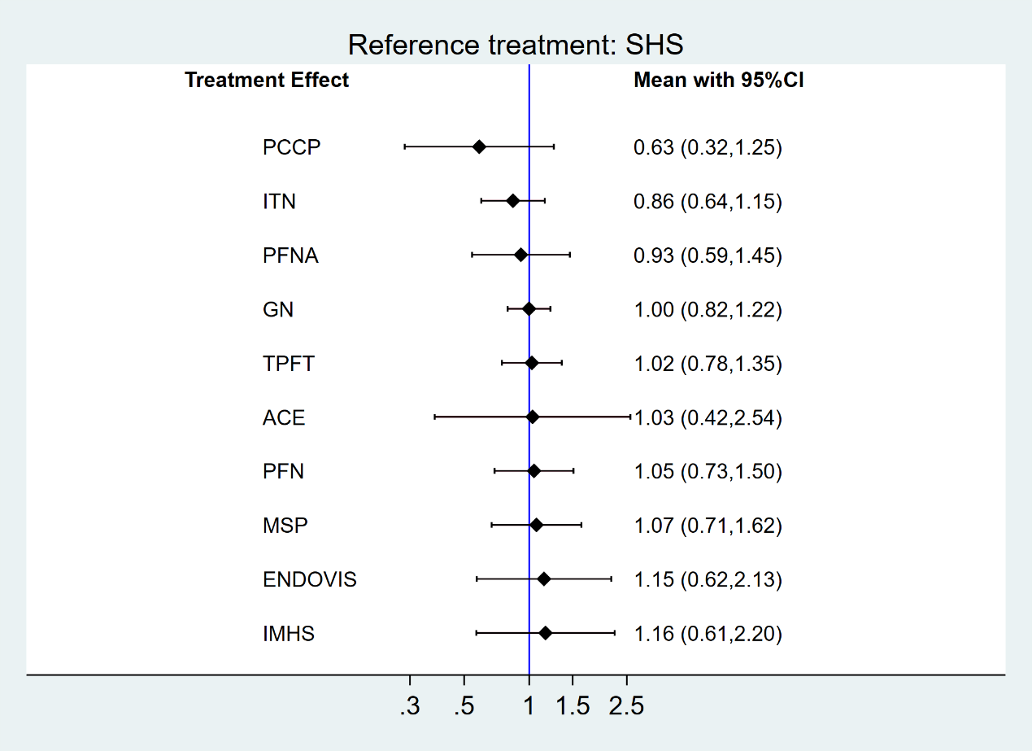

Figure S14.2: reoperation rate.
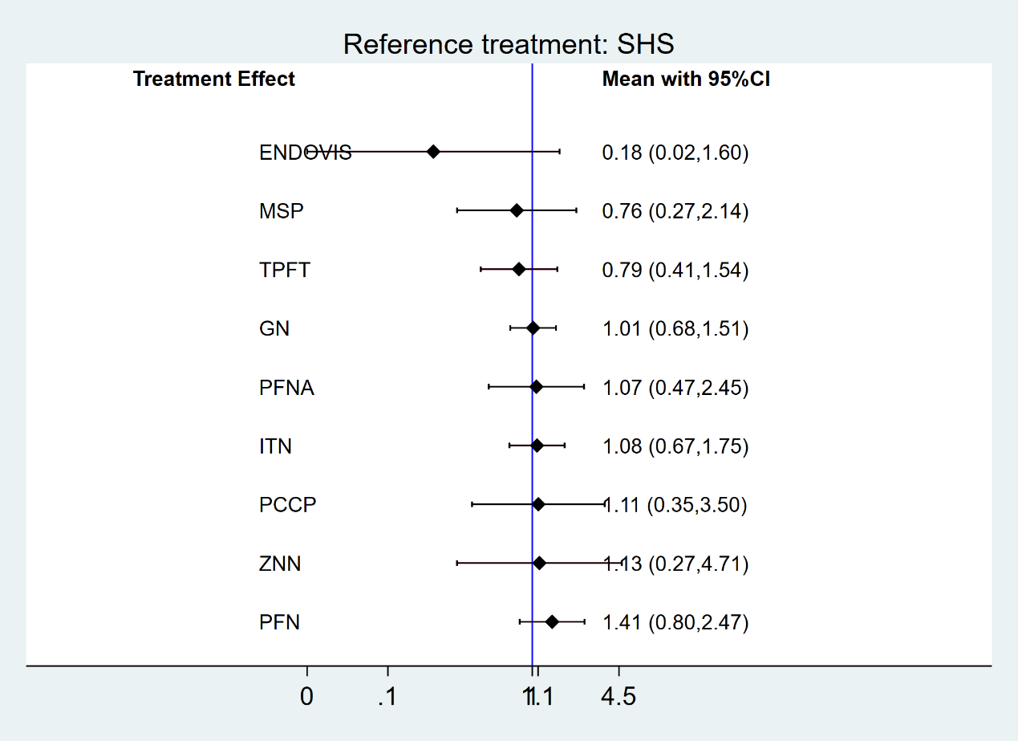

Figure S14.3: intraoperative complications-operative issue.
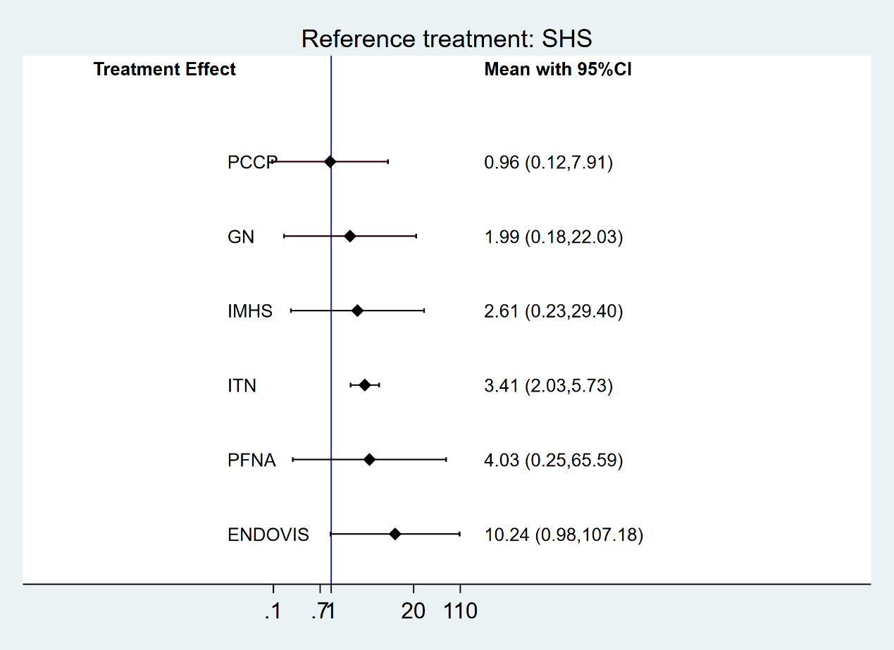

Figure S14.4: non-specific intraoperative complications.

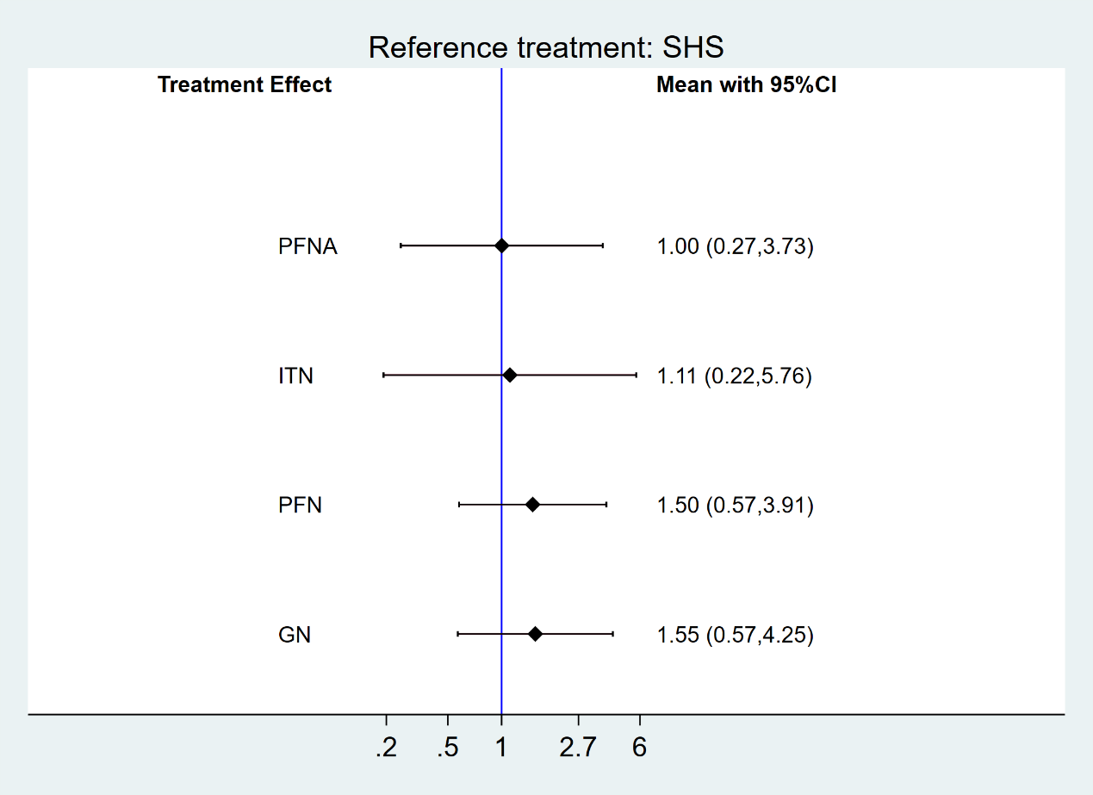

Figure S14.5: non-mechanical post-surgery medical complications.
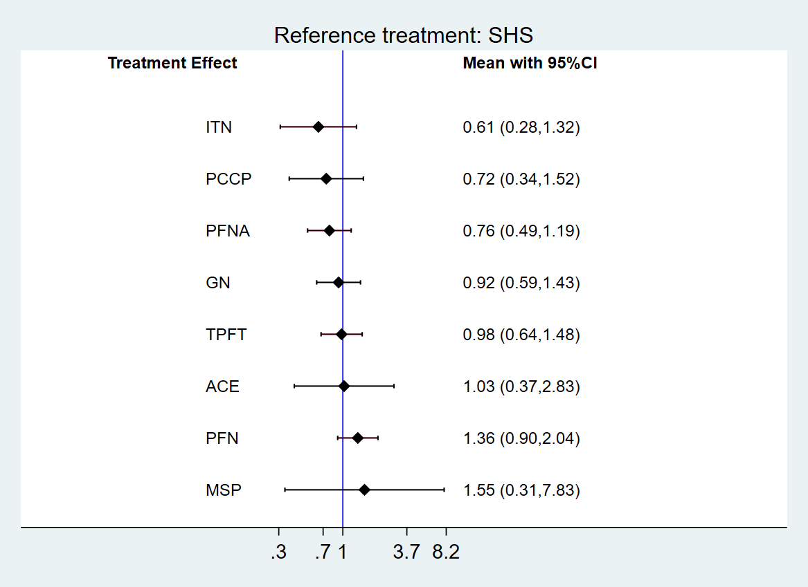

Figure S14.6: non-mechanical major post-surgery complications.
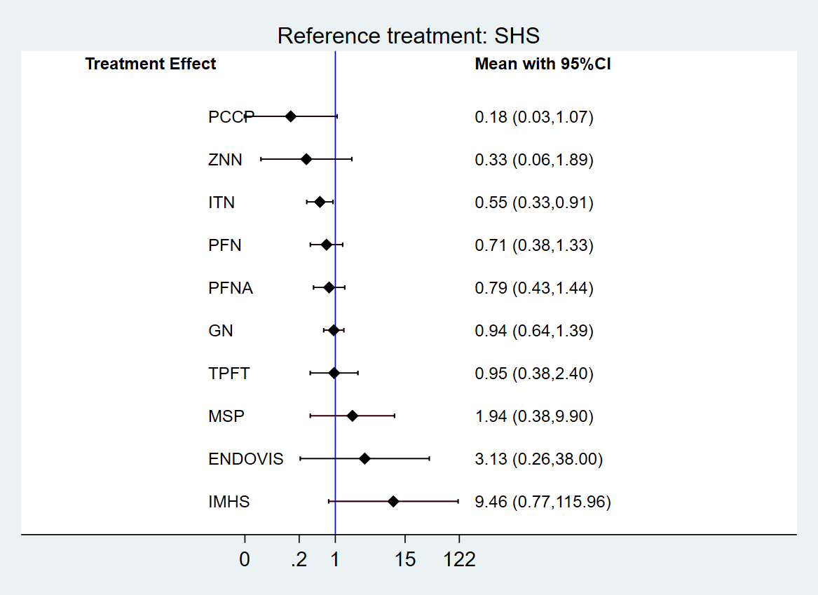

Figure S14.7: non-mechanical minor post-surgery complications.
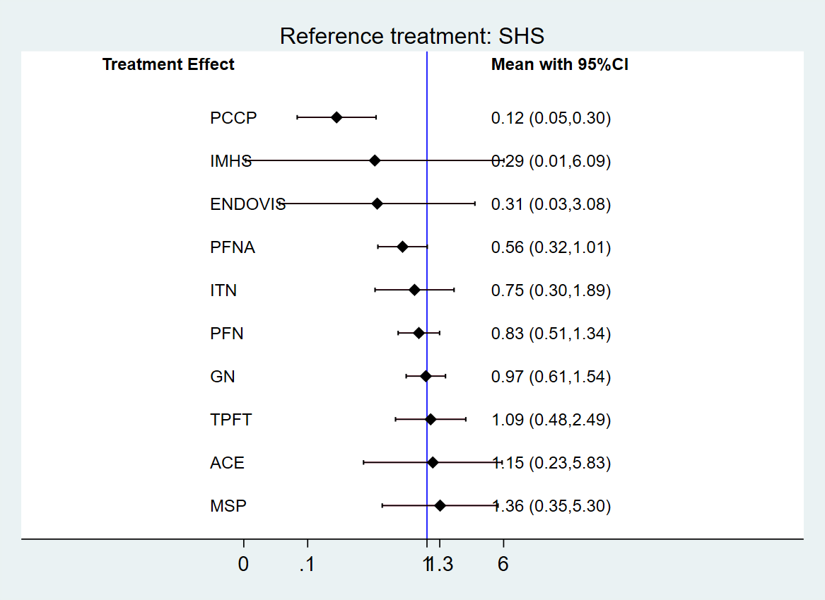

Figure S14.8: overall mechanical complications.
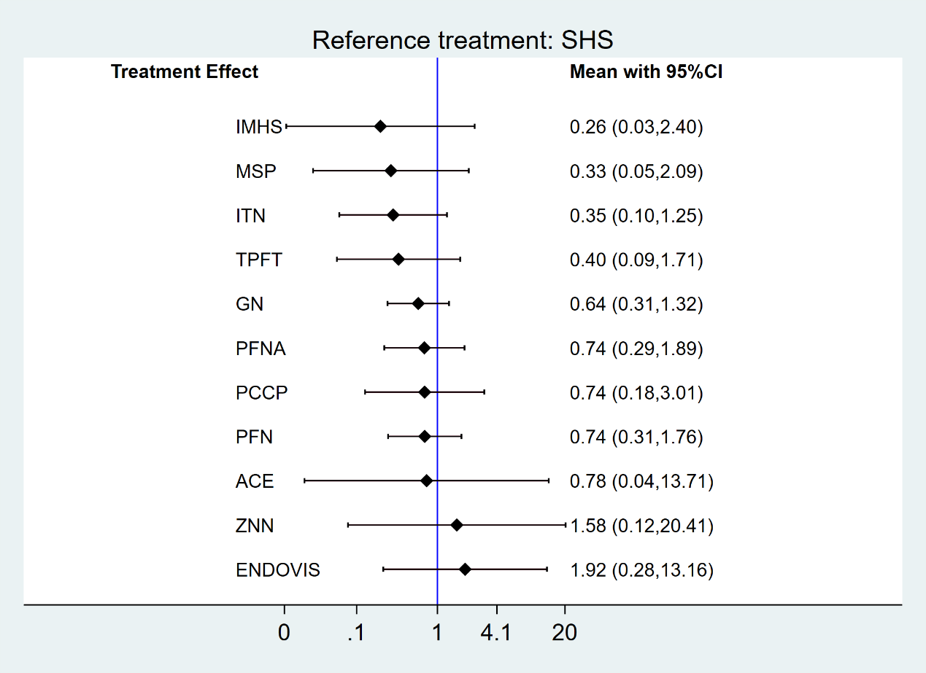

Figure S14.9: mechanical complications-cut out.
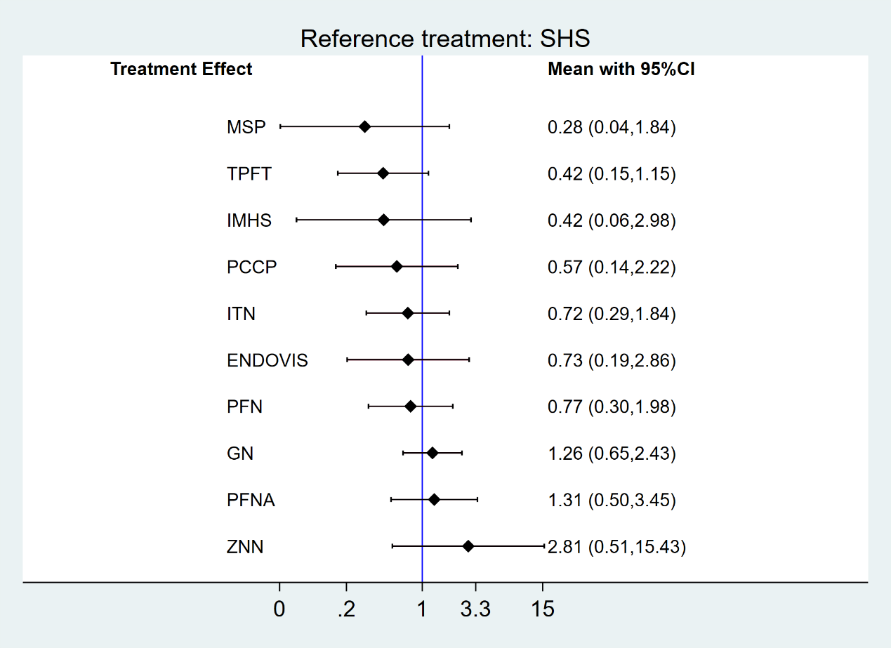

Figure S14.10: mechanical complications-fixation failure.
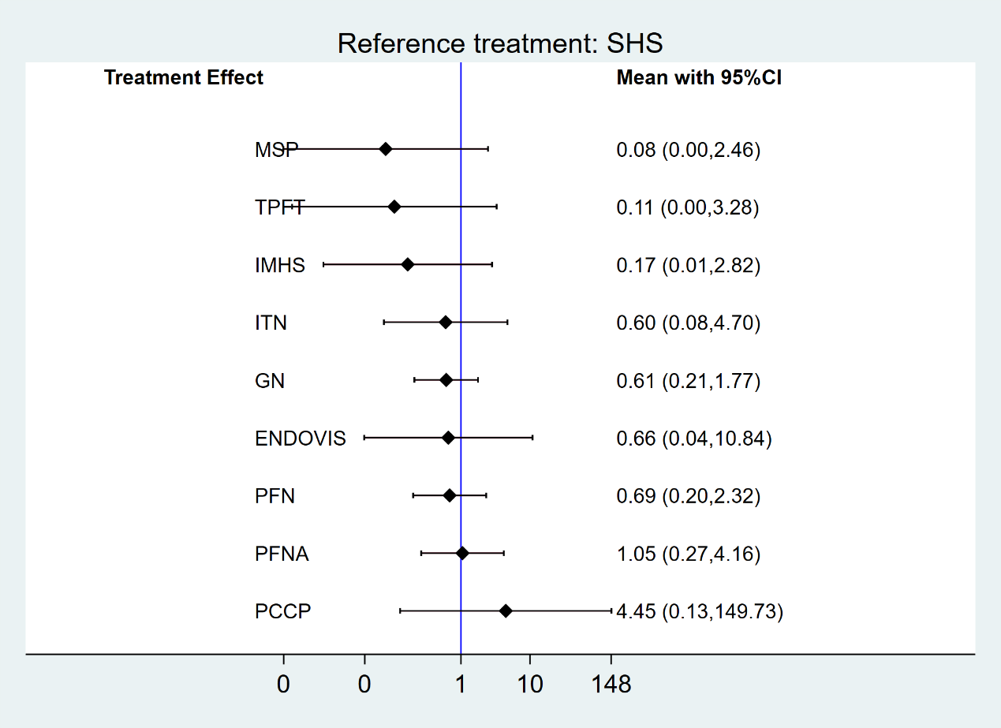

Figure S14.11: mechanical complications-migration.
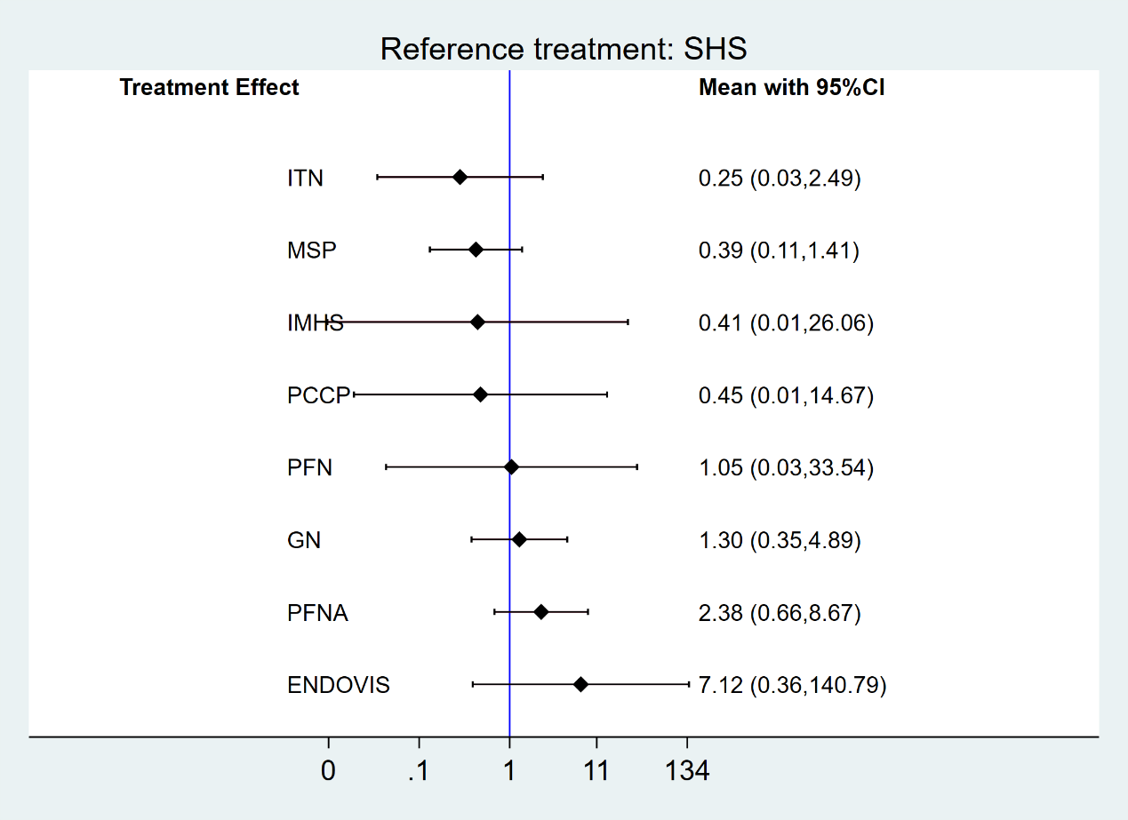

Figure S14.12: mechanical complications-valgus deformity.
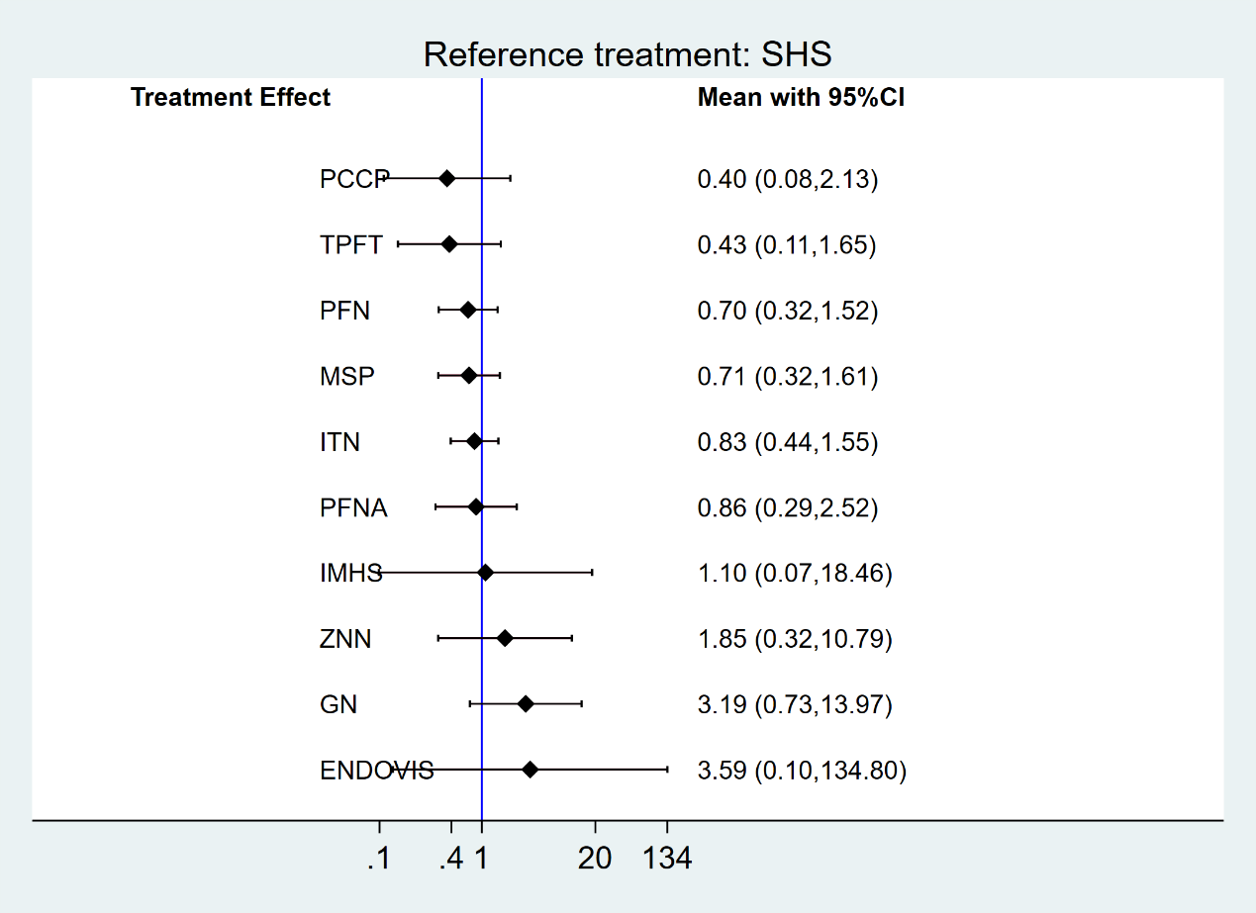

Figure S14.13: non-specific mechanical complications.
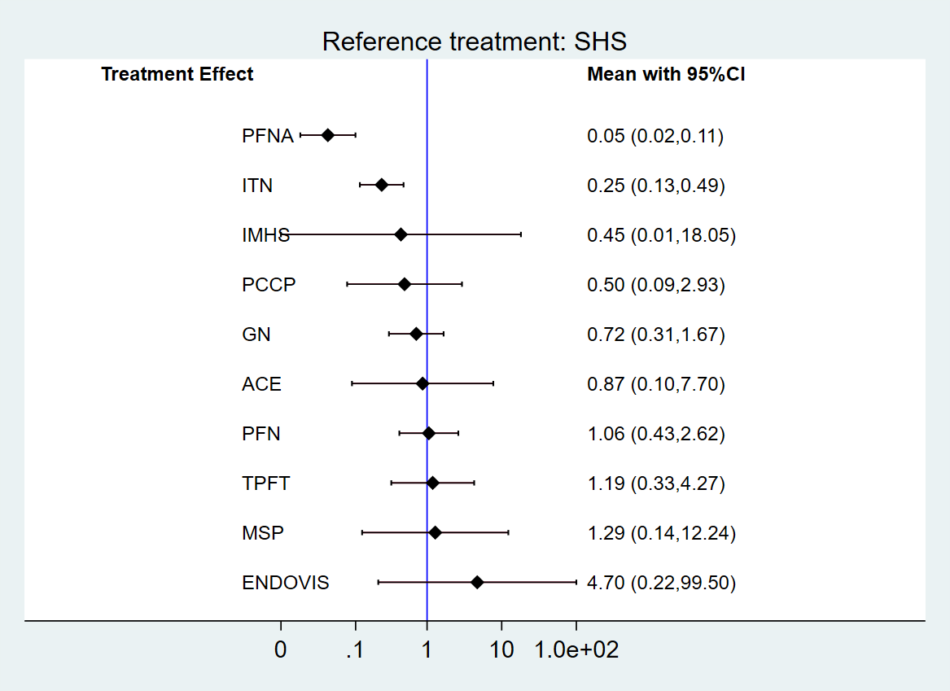

Figure S14.14: Harris hip score.
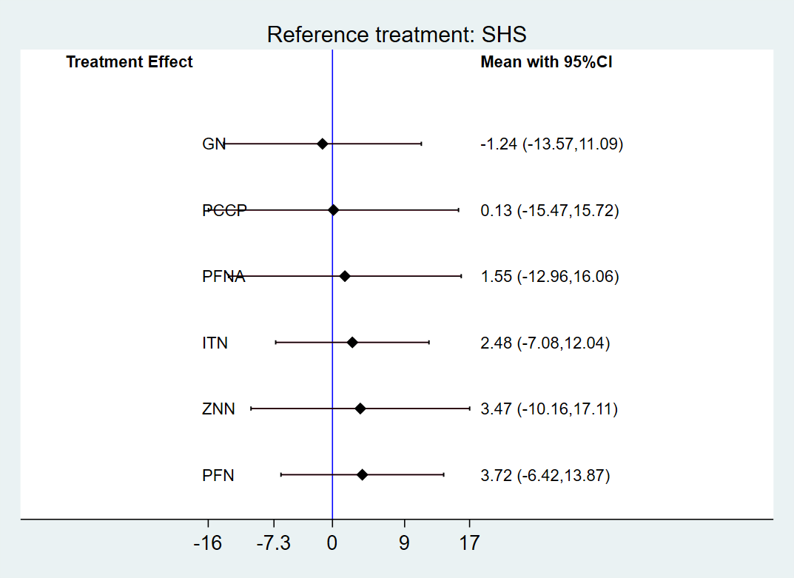

Appendix 15: Cumulative probability plots
The larger the surface under the cumulative ranking curve, the better the effect.
Abbreviations: NEXA, Neuromuscular exercise; TENS, Transcutaneous Electrical Nerve Stimulation.
Figure S15.1: Cumulative ranking curve plots of mortality.
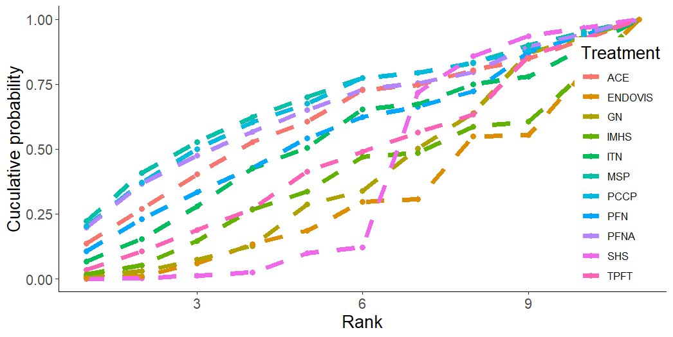

Figure S15.2: Cumulative ranking curve plots of reoperation rate.
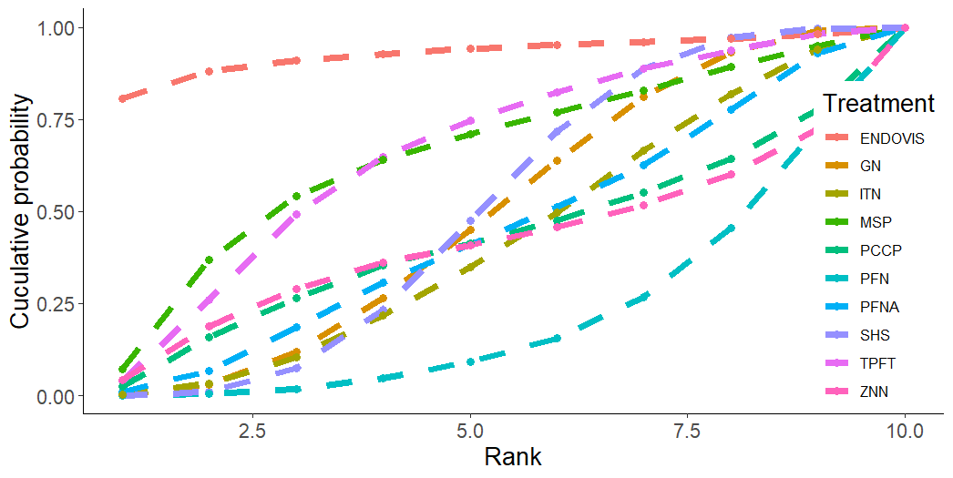

Figure S15.3: Cumulative ranking curve plots of intraoperative complications-operative issue.
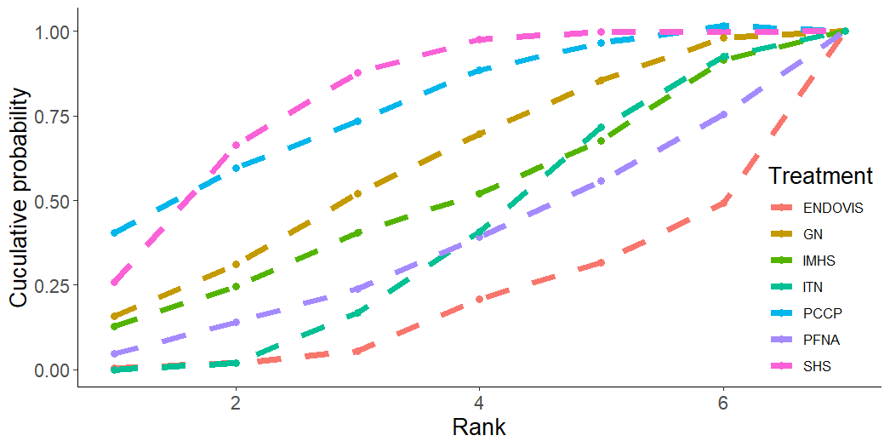

Figure S15.4: Cumulative ranking curve plots of non-specific intraoperative complications.
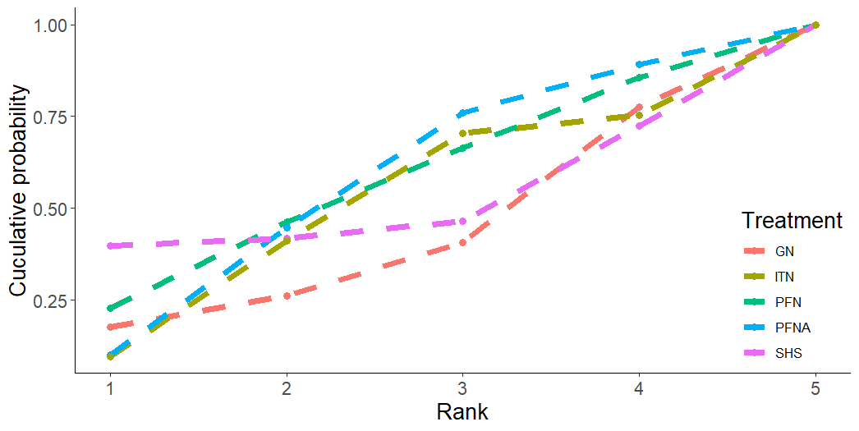

Figure S15.5: Cumulative ranking curve plots of non-mechanical post-surgery medical complications.
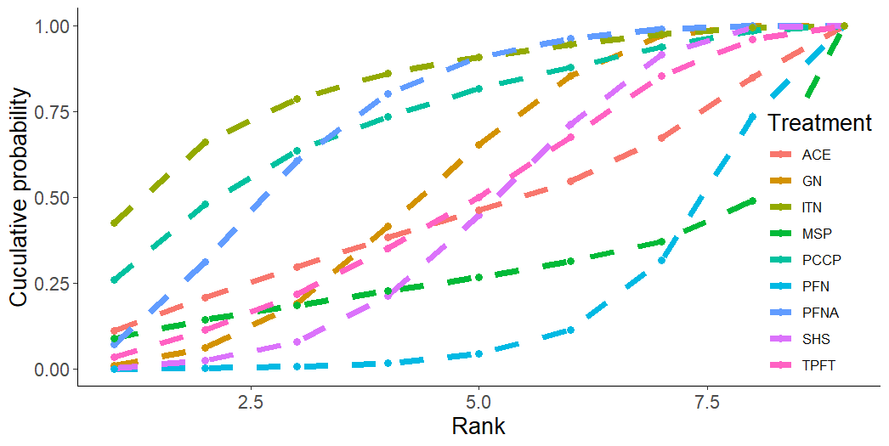

Figure S15.6: Cumulative ranking curve plots of non-mechanical major post-surgery complications.
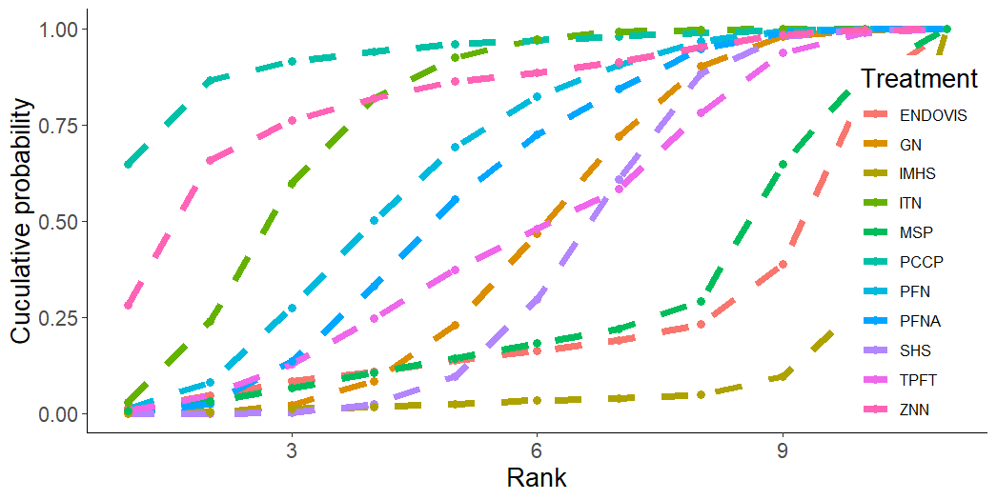

Figure S15.7: Cumulative ranking curve plots of non-mechanical minor post-surgery complications.
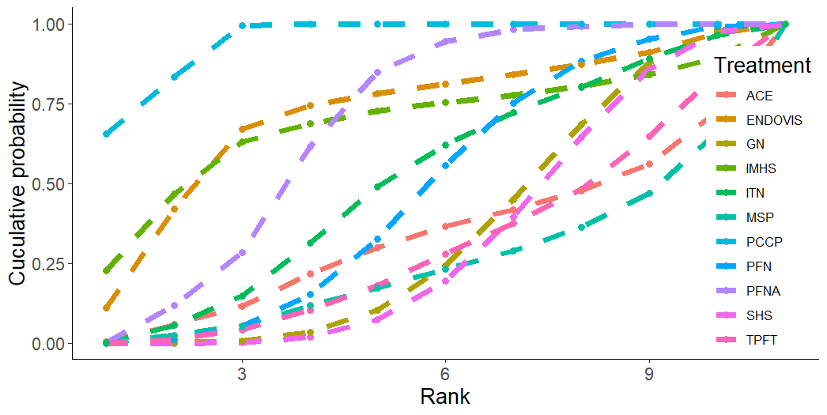

Figure S15.8: Cumulative ranking curve plots of overall mechanical complications.
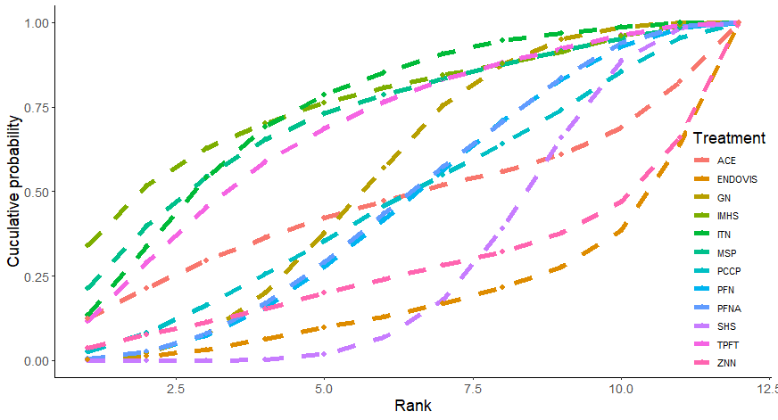

Figure S15.9: Cumulative ranking curve plots of mechanical complications-cut out.
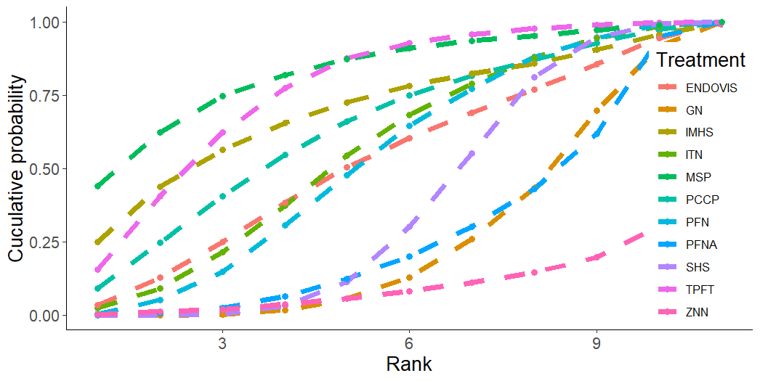

Figure S15.10: Cumulative ranking curve plots of mechanical complications-fixation failure.
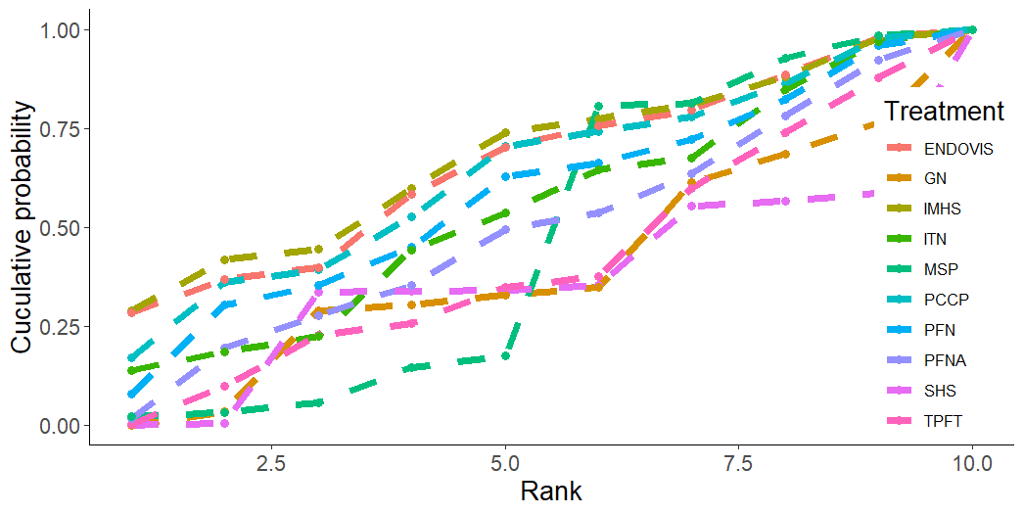

Figure S15.11: Cumulative ranking curve plots of mechanical complications-migration.
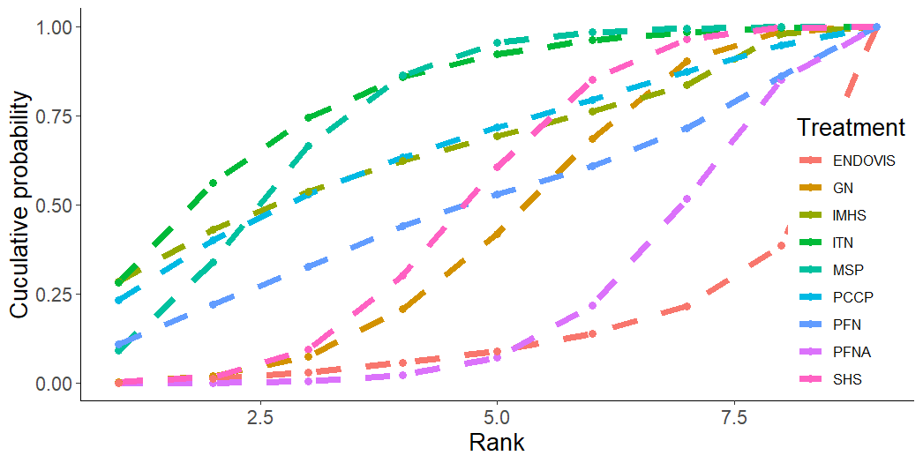

Figure S15.12: Cumulative ranking curve plots of mechanical complications-valgus deformity.
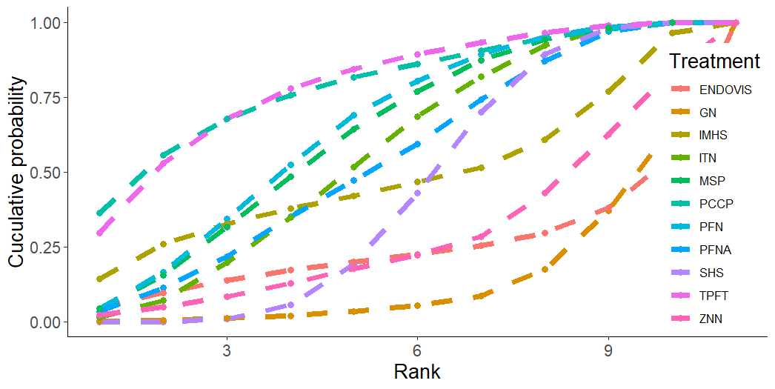

Figure S15.13: Cumulative ranking curve plots of non-specific mechanical complications.
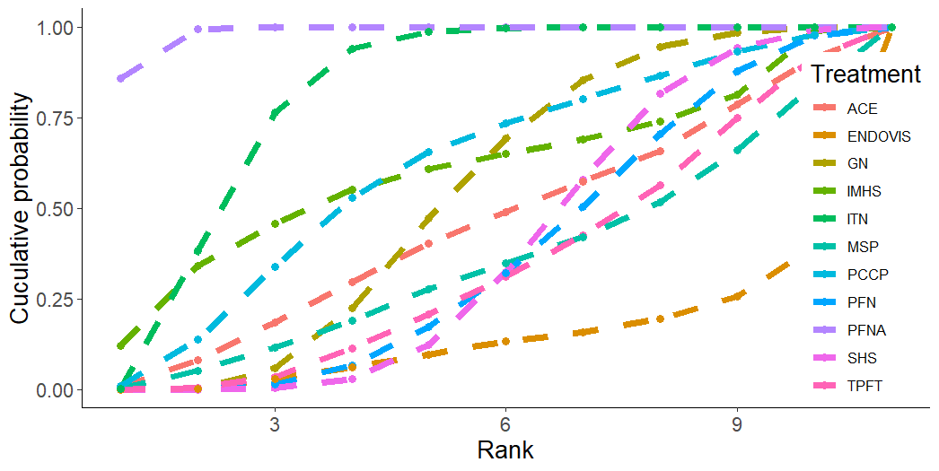

Figure S15.14: Cumulative ranking curve plots of Harris hip scores.
