Supplementary

Appendix A. MRI Protocol Parameters and Preprocession
Since sagittal intermediate-weighted three-dimensional dual-echo in steady-state (3D DESS) with fat-suppressed can more clearly display the structures around the knee joint, especially cartilage, this sequence was selected for segmentation and further analysis of the regions of interest in this study. Futher sequence parameters are as follows: acquisition time, 10.6 minutes; repetition time (TR), 16.3msec; echo time (TE), 4.7msec; bandwidth (BW), 183Hz; field of view (FOV), 140mm; matrix, 307×384; layer thickness, 0.7mm; layer number, 160; turning Angle (FA), 25°; excitation times, 1; echo chain length, 1. In order to reduce the difference of image signal intensity, using Radiomics Intelligent Analysis Software (RIAS, https://github.com/lisherlock/RMIT) to standardize MRI image.
Appendix B. Hyperparameter Selection and Rationale
The hyperparameters for our nnUNet model were determined through nnUNet's automated configuration system, which systematically adapts parameters based on dataset characteristics and established medical segmentation best practices.
Key Parameters: Patch size (80×160×160): Automatically determined based on our dataset's median image dimensions and GPU memory constraints to ensure optimal anatomical coverage. Batch size (2): Set according to memory limitations while maintaining training stability. Learning rate (0.01) with SGD optimizer (momentum=0.99, weight decay=3×10⁻⁵): Selected based on nnUNet's empirically validated defaults for medical image segmentation. Data augmentation: Conservative rotation (±30°), scaling (0.7-1.4), and gamma correction (0.7-1.5) to preserve anatomical plausibility while increasing data diversity.
Appendix C. VOIs segmentation details and workflows
Cartilage: Three three-dimensional volumes of interest (VOIs) from the cartilage regions of femur, tibia and patella, based on 3D DESS MRI images, were semi-automatically segmented. Firstly, about 1/3 of the data (150 cases) were randomly selected and manually sketched along the outline of the cartilage layer by layer using ITK-SNAP (version 3.8.0,www.itksnap.org) by two junior radiologists with 5 and 7 years of musculoskeletal diagnostic experience respectively, blinded to subject clinical information and image evaluation. Senior radiologists (10 and 15 years' musculoskeletal diagnostic experience) independently reviewed annotations to establish gold-standard labels. Then, the remaining data were processed using an nnU-Net framework trained on gold-standard data. Finally, the senior radiologists reviewed and confirmed the segmentation results again.
Subchondral bone: Subchondral bone was defined as cortical bone within 1 cm beneath the cartilage interface. First, the area of the cartilage at each level in the sagittal plane is calculated and ranked to determine the maximum (Xmax) and minimum (Xmin) values. Then, a linear transformation is applied to the cartilage area to obtain the corresponding subchondral bone width. Subchondral bone width of the layer between maximum and minimum area was calculated using L=10* (X /(Xmax-Xmin)), ensuring that the width in this region is between 1 mm and 10 mm. Finally, based on the X values, binary image corrosion expansion and multi-label constraint algorithm were applied to expand only the medial part of the cartilage to the corresponding width and intersect it with the joint bone to obtain the subchondral bone label. The subchondral bone labels corresponding to the three cartilage regions are obtained using the above method, and then re-checked and confirmed by senior radiologists.
Appendix D. Details of Extracted Radiomics Features
A total of 1427 radiomic features were extracted from each VOI by pyradiomics (V3.0.1), including first-order statistics (n = 19), high-order statistics (n = 75), shape-based features (n = 17), and filter-based features (n =1316).
1. First-order statistics (N=19)
- Interquartile Range
- Skewness
- Uniformity
- Median
- Energy
- Robust Mean Absolute Deviation
- Mean Absolute Deviation
- Total Energy
- Maximum
- Root Mean Squared
- 90Percentile
- Minimum
- Entropy
- Range
- Variance
- 10Percentile
- Kurtosis
- Mean
- StandardDeviation
2. High-order features
(1) Gray Level Cooccurrence Matrix (GLCM) (N=24)
- Joint Average
- Joint Entropy
- Cluster Shade
- Maximum Probability
- Idmn
- Joint Energy
- Contrast
- Difference Entropy
- Inverse Variance
- Difference Variance
- Idn
- Idm
- MCC
- Correlation
- Autocorrelation
- Sum Entropy
- Sum Squares
- SumAverage
- Cluster Prominence
- Imc2
- Imc1
- Difference Average
- Id
- Cluster Tendency
(2) Gray Level Size Zone Matrix (GLSZM) (N=16)
- GrayLevelVariance
- ZoneVariance
- GrayLevelNonUniformityNormalized
- SizeZoneNonUniformityNormalized
- SizeZoneNonUniformity
- GrayLevelNonUniformity
- LargeAreaEmphasis
- SmallAreaHighGrayLevelEmphasis
- ZonePercentage
- LargeAreaLowGrayLevelEmphasis
- LargeAreaHighGrayLevelEmphasis
- HighGrayLevelZoneEmphasis
- SmallAreaEmphasis
- LowGrayLevelZoneEmphasis
- ZoneEntropy
- SmallAreaLowGrayLevelEmphasis
(3) Gray Level Run Length Matrix (GLRLM) (N=16)
- ShortRunLowGrayLevelEmphasis
- GrayLevelVariance
- LowGrayLevelRunEmphasis
- GrayLevelNonUniformityNormalized
- RunVariance
- GrayLevelNonUniformity
- LongRunEmphasis
- ShortRunHighGrayLevelEmphasis
- RunLengthNonUniformity
- ShortRunEmphasis
- LongRunHighGrayLevelEmphasis
- RunPercentage
- LongRunLowGrayLevelEmphasis
- RunEntropy
- HighGrayLevelRunEmphasis
- RunLengthNonUniformityNormalized
(4) Neighboring Gray Tone Difference Matrix (NGTDM) (N=5)
- Coarseness
- Complexity
- Strength
- Contrast
- Busyness
(5) Gray Level Dependence Matrix (GLDM) (N=14)
- Gray Level Variance
- High Gray Level Emphasis
- Dependence Entropy
- Dependence Non-Uniformity
- Gray Level Non-Uniformity
- Small Dependence Emphasis
- Small Dependence High Gray Level Emphasis
- Dependence Non-Uniformity Normalized
- Large Dependence Emphasis
- Large Dependence Low Gray Level Emphasis
- Dependence Variance
- Large Dependence High Gray Level Emphasis
- Small Dependence Low Gray Level Emphasis
- Low Gray Level Emphasis
3. Shape-based features (N=17)
- Spherical Disproportion
- Compactness2
- Maximum 2D Diameter Slice
- Sphericity
- Minor Axis Length
- Compactness1
- Elongation
- Surface Volume Ratio
- Mesh Volume
- VoxelVolume
- Maximum 3D Diameter
- Major Axis Length
- Surface Area
- Flatness
- Least Axis Length
- Maximum 2D Diameter Column
- Maximum 2D Diameter Row
3. Filter-based features (N=1316)
(1) Laplacian of Gaussian (LoG) (94*2)
- Log-sigma-1.0-mm-3D
- Log-sigma-3.0-mm-3D
(2) Wavelet (94*8)
- Wavelet -HLL
- Wavelet -LHL
- Wavelet -LHH
- Wavelet -LLH
- Wavelet -HLH
- Wavelet -HHL
- Wavelet -LLL
- Wavelet -HHH
(3) Square (94*1)
(4) Square Root (94*1)
(5) Logarithm (94*1)
(6) Exponential (94*1)

Appendix E. Stability evaluation of radiomics features
Inter-observer and Intra-observer correlation coefficient (ICCs) were calculated to evaluate the stability of the radiomics features. Eighty subjects were randomly selected to evaluate reliability. Two radiologists (A: 7 years of diagnosis experience of the musculoskeletal system; B: 15 years of diagnosis experience of the musculoskeletal system) segment ROI of 80 randomly selected images under blind method to calculate the interclass correlation coefficient between observers. Radiologist A divided the same data again after one month and calculated the intraclass correlation coefficient. ICC ≥ 0.75 is considered to have good consistency of the radiomics features, with good reproducibility and repeatability. For model predicting KOA onset, 3925 and 3795 features were retained from 4281 features of cartilage and subchondral bone after ICC, respectively. Similarly, after ICC, for models predicting KOA progression, 3958 and 3688 were retained from cartilage and subchondral bone, respectively.
Appendix F. Radiomics features selection
In this study, Students T test, Least Absolute Shrinkage and Selection Operator (LASSO) and Principal Component Analysis (PCA) were used for feature selection and contraction.
LASSO focuses on reducing the variable set. By introducing L1 regularization (i.e. LASSO penalty function), the variable coefficients are compressed to make the regression coefficients of some unimportant variables become 0, so as to achieve feature selection and model sparsity. We select the optimal α value by 10-fold cross-validation of the penalty coefficient (α value). For the model predicting the onset of KOA, 167 and 72 radiomic features from cartilage and subchondral bone VOIs were further screened by using the students t-test and LASSO algorithm after ICC, respectively. For the model predicting the progression of KOA, after pre-dimensionality reduction by student t-test, 66 and 145 radiomic features from cartilage and subchondral bone VOIs were obtained respectively. After further screening by LASSO, 28 and 26 radiomic features were retained, respectively.
However, the core of PCA is to transform a set of possibly linearly correlated variables into a new set of linearly uncorrelated variables by orthogonal transformation, so that the data has the maximum variance in the new coordinate system. The key features of data are retained by retaining the most important variance to achieve data dimensionality reduction. In order to preserve the most relevant features and prevent overfitting, 74 and 38 radiological features were retained by PCA cartilage and subchondral bone VOIs in the model predicting KOA onset, respectively.
Appendix G. Clinical selection
Propensity score matching (PSM) was used in the first-stage model to minimize the influence of clinical factors, so no meaningful clinical features for disease occurrence were screened after PSM. However, in the second-stage model, only contralateral knee status was significant for KOA progression after screening. Meanwhile, we also established LR clinical model, and results showed that the AUC of the clinical model was 0.575 (95%CI : 0.390-0.760) in the testing cohort (Figure S3), with sensitivity of 0.417 (95%CI:0.165-0.714) and specificity of 0.676 (95%CI:0.494-0.820). Moreover, we also found that the combined clinical and radiomics features of the model (AUC:0.718, 95%CI:0.537-0.900) did not perform well as the radiomics features of the model only (AUC:0.738, 95%CI:0.565-0.911). This suggests that imaging features may provide more potential information about disease progression than clinical variables.
Table SⅠ Summary of characteristic in training and testing cohorts for predicting KOA onset
Characteristic | Training cohort |  |  | Testing cohort |  |  | p’ value
Characteristic | KOA  （n=106） | Control  （n=212） | P value | KOA  （n=46） | Control  （n=92） | P value | p’ value
Female, no.(%) | 75（70.8%） | 157（74.1%） | 0.532 | 26（56.5%） | 66（71.7%） | 0.433 | 0.459
Age（years,mean±SD） | 62.08±8.25 | 62.51±9.45 | 0.630 | 58.46±7.63 | 62.36±9.92 | 0.027* | 0.176
BMI（kg/m²,mean±SD） | 28.48±4.38 | 28.35±4.89 | 0.699 | 29.20±5.43 | 28.51±4.86 | 0.487 | 0.466
Race, no.(%) |  |  | 0.184 |  |  | 0.118 | 0.332
Other Non-white | 1  （0.9%） | 5  （2.4%） |  | 1  （0.7%） | 5  （1.6%）
White or Caucasian | 84（79.2%） | 166（78.3%） |  | 41（89.1%） | 70（76.1%）
Black or African American | 19（17.9%） | 41（19.3%） |  | 4  （8.7%） | 21（22.8%）
Asian | 2  （1.9%） | 0  （0%） |  | 1  （2.2%） | 1  （1.1%）
L-KL, no.(%) |  |  | 0.085 |  |  | 0.786 | 0.243
0 | 33（31.1%） | 85（40.1%） |  | 14（30.4%） | 35（38.0%）
1 | 16（15.1%） | 39（18.4%） |  | 11（23.9%） | 21（22.8%）
2 | 40（37.7%） | 48（22.6%） |  | 14（30.4%） | 28（30.4%）
3 | 13（12.3%） | 32（15.1%） |  | 6  （13.0%） | 7  （7.6%）
4 | 4  （3.8%） | 8  （3.8%） |  | 1  （2.2%） | 1  （1.1%）
Knee injury, no.(%) | 34（32.1%） | 74（34.9%） | 0.615 | 16（34.8%） | 29（31.5%） | 0.700 | 0.779
Knee alignment, no.(%) |  |  | 0.568 |  |  | 0.149 | 0.656
Normal | 30（28.3%） | 60（28.3%） |  | 10（21.7%） | 33（35.9%）
Varus | 25（23.6%） | 61（28.8%） |  | 10（21.7%） | 22（23.9%）
Valgus | 51（48.1%） | 91（42.9%） |  | 26（56.5%） | 37（40.2%）
WOMAC-total, mean±SD | 10.60±12.85 | 11.01±13.62 | 0.930 | 14.93±15.76 | 11.85±14.36 | 0.262 | 0.271
WOMAC-pain, mean±SD | 1.96±2.68 | 2.24±2.97 | 0.730 | 3.39±3.64 | 2.33±3.13 | 0.114 | 0.122

Table SⅠ (Continued)
Characteristic | Training cohort |  |  | Testing cohort |  |  | p’ value
Characteristic | KOA  （n=106） | Control  （n=212） | P value | KOA  （n=46） | Control  （n=92） | P value | p’ value
WOMAC-stiffness,  mean±SD | 1.75±1.41 | 1.56±1.56 | 0.150 | 1.85±1.58 | 1.43±1.30 | 0.180 | 0.911
WOMAC-disability,  mean±SD | 6.95±9.59 | 7.26±9.94 | 0.810 | 9.69±11.13 | 8.20±10.67 | 0.474 | 0.335
Note.Quantitative data satisfy the normal distribution were expressed as mean ± standard deviation. Qualitative data is expressed as a composition ratio (%); p’ means the difference analysis between the training and testing cohorts, * statistically significant(p<0.05).

Table SⅡ Summary of characteristic in training cohort and testing cohorts for predicting KOA progression
Characteristic |  |  | Training cohort |  |  |  |  |  |  |  | Testing cohort |  |  |  |  |  |  |  | p’ value
 |  |  | early progression（n=62） |  |  | late progression（n=44） |  | P value |  |  | early progression（n=34） |  |  | late progression（n=12） |  |  | P value
Female, no.(%) |  |  | 41（66.1%） |  |  | 30（68.2%） |  | 0.825 |  |  | 25（73.5%） |  |  | 9  （75.0%） |  |  | 0.921 |  | 0.909
Age（years,mean±SD） |  |  | 60.32±7.67 |  |  | 59.55±8.88 |  | 0.517 |  |  | 63.12±8.29 |  |  | 63.58±7.28 |  |  | 0.802 |  | 0.176
BMI（kg/m²,mean±SD） |  | 29.76±4.67 |  | 27.91±4.96 |  |  | 0.030* |  |  |  |  | 28.81±4.63 | 25.84±2.76 |  |  | 0.072 |  | 0.008*
Race, no.(%) |  |  |  |  |  |  |  | 0.314 |  |  |  |  |  |  |  |  | 0.233 |  | 0.159
Other Non-white |  |  | 1  （1.6%） |  |  | 0  （0%） |  |  |  |  | 0  （0%） |  |  | 0  （0%）
White or Caucasian |  |  | 47（75.8%） |  |  | 39（88.6%） |  |  |  |  | 27（79.4%） |  |  | 12（100%）
Black or African American |  |  | 13（21.0%） |  |  | 4  （9.1%） |  |  |  |  | 6（17.6%） |  |  | 0  （0%）
Asian |  |  | 1  （1.6%） |  |  | 1  （2.3%） |  |  |  |  | 1  （2.9%） |  |  | 0  （0%）
L-KL, no.(%) |  |  |  |  |  |  |  | 0.069 |  |  |  |  |  |  |  |  | 0.407 |  | 0.070
0 |  |  | 16（25.8%） |  |  | 21（47.7%） |  |  |  |  | 7（20.6%） |  |  | 3  （25.0%）
1 |  |  | 12（19.4%） |  |  | 11（25.0%） |  |  |  |  | 4（11.8%） |  |  | 0  （0%）
2 |  |  | 23（37.1%） |  |  | 7（15.9%） |  |  |  |  | 18（52.9%） |  |  | 6  （50.0%）
3 |  |  | 9  （14.5%） |  |  | 4  （9.1%） |  |  |  |  | 3  （8.8%） |  |  | 3  （25.0%）
4 |  |  | 2  （3.2%） |  |  | 1  （2.3%） |  |  |  |  | 2  （5.9%） |  |  | 0  （0%）
Knee injury, no.(%) |  |  | 20（32.3%） |  |  | 16（36.4%） |  | 0.660 |  |  | 10（29.4%） |  |  | 4  （33.3%） |  |  | 0.800 |  | 0.572
Knee alignment, no.(%) |  |  |  |  |  |  |  | 0.707 |  |  |  |  |  |  |  |  | 0.365 |  | 0.871
Normal |  |  | 19（30.6%） |  |  | 12（27.3%） |  |  |  |  | 5（14.7%） |  |  | 4  （33.3%）
Varus |  |  | 17（27.4%） |  |  | 10（22.7%） |  |  |  |  | 6（17.6%） |  |  | 2  （16.7%）
Valgus |  |  | 26（41.9%） |  |  | 22（50.0%） |  |  |  |  | 23（67.6%） |  |  | 6  （50.0%）
WOMAC-total, mean±SD | 13.11±13.05 |  |  |  | 10.72±14.50 |  |  |  | 0.100 | 12.19±14.65 |  |  |  |  | 9.28±14.65 |  | 0.364 |  |  | 0.078
WOMAC-pain, mean±SD |  |  | 2.48±2.83 |  |  | 2.32±3.15 |  | 0.377 |  |  | 2.50±3.52 |  |  | 1.92±2.84 |  |  | 0.774 |  | 0.390

Table SⅡ (Continued)
Characteristic | Training cohort |  |  | Testing cohort |  |  | p’ value
Characteristic | early progression（n=62） | late progression（n=44） | P value | early progression（n=34） | late progression（n=12） | P value | p’ value
WOMAC-stiffness, mean±SD | 1.87±1.42 | 1.73±1.42 | 0.586 | 1.94±1.65 | 1.00±1.04 | 0.084 | 0.201
WOMAC-disability, mean±SD | 8.77±9.71 | 6.81±10.58 | 0.042* | 7.74±10.16 | 6.36±11.15 | 0.366 | 0.041*
Note.Quantitative data satisfy the normal distribution were expressed as mean ± standard deviation. Qualitative data is expressed as a composition ratio (%); p’ means the difference analysis between the training and testing cohorts, *statistically significant(p<0.05).

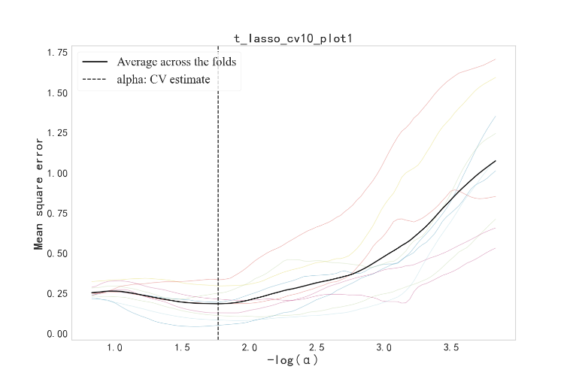
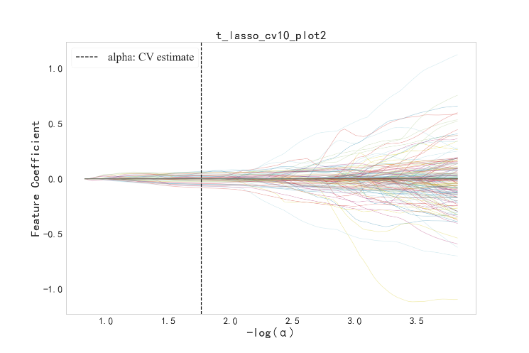
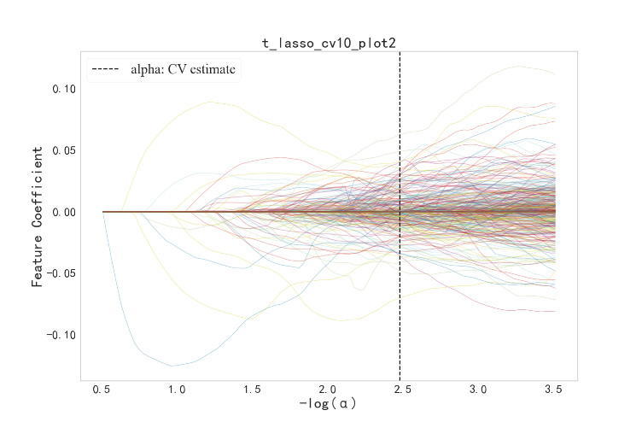
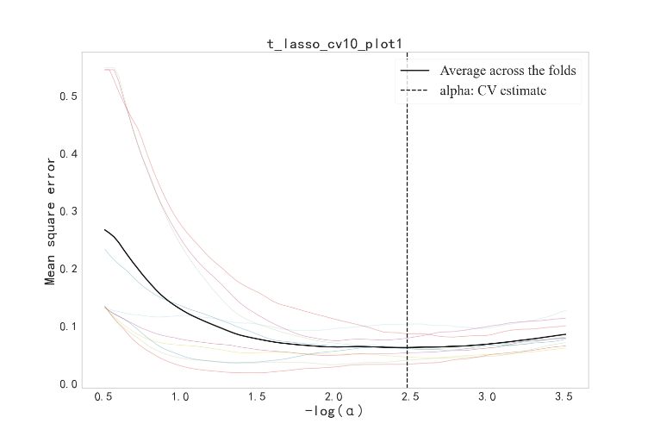
Figure S1 LASSO logistic regression correlation graphs based on combined cartilage and subchondral bone radiomics feature selection for predicting KOA onset(A) and progression(B).
B
A
B
A
The right plot is 10-fold cross-validation curve for Lasso regression. The horizontal coordinate is the logarithm of the penalty coefficient α, which is -log(α), and the vertical coordinate is the mean square error. The colored thin line represents the curve of each fold cross-validation, and the black solid line represents the mean curve of Lasso10 fold cross-validation. The vertical dashed line represents the optimal α value corresponding to the minimum mean square error, which is α=0.0033(A), 0.0170(B), respectively. The left plot is regression coefficient path map. The horizontal coordinate is -log(α) and the vertical coordinate is the value of the coefficient. Each curve represents the change trajectory of each independent variable coefficient. The vertical dashed lines represent the features whose coefficients are non-zero at the optimal α value.

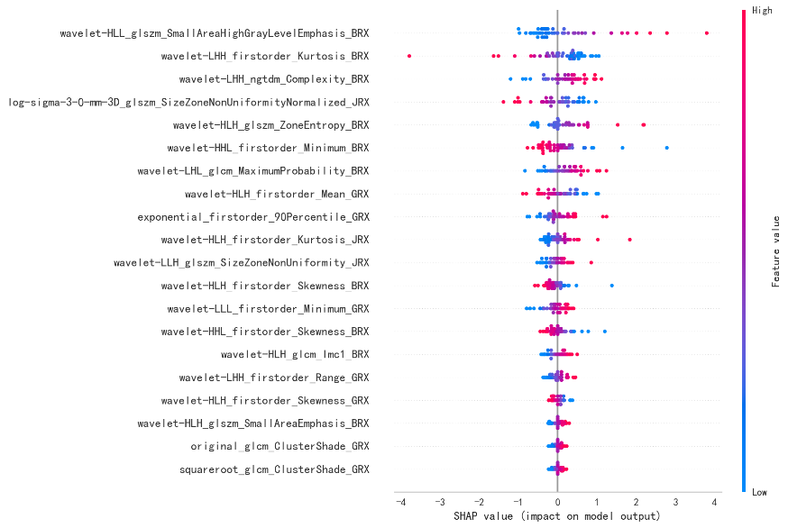
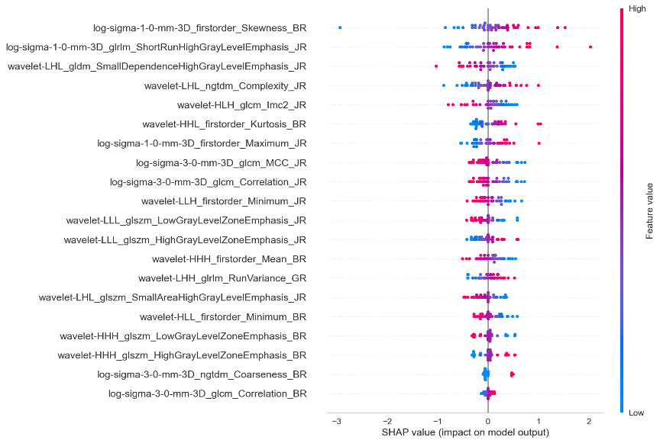
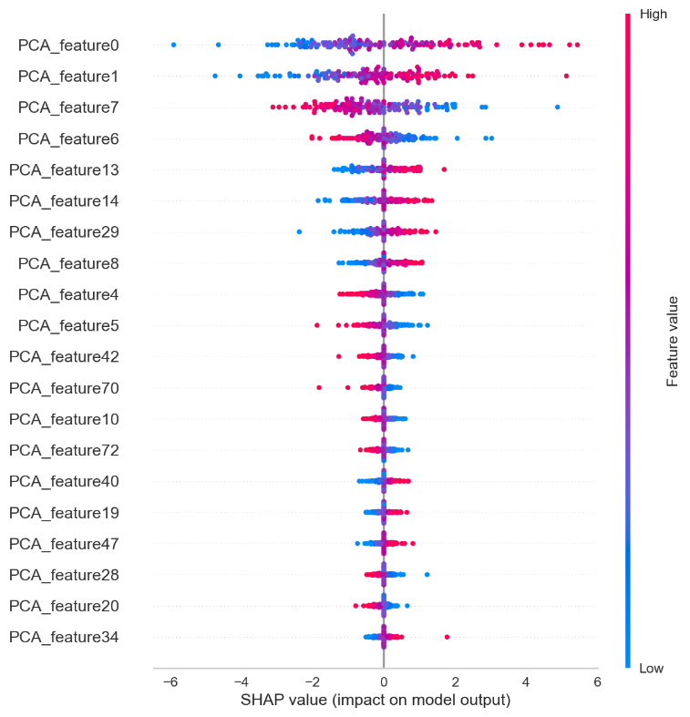
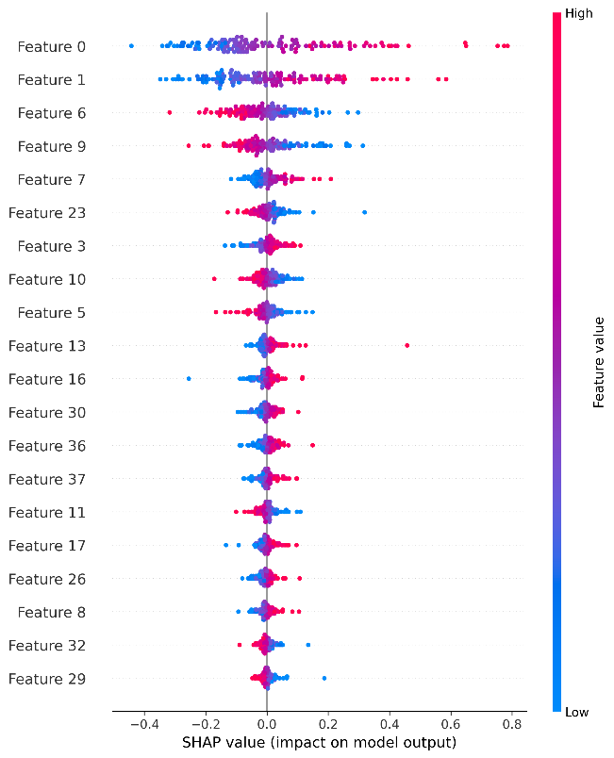
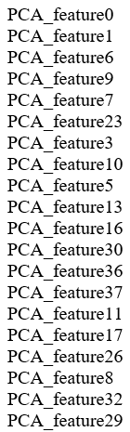
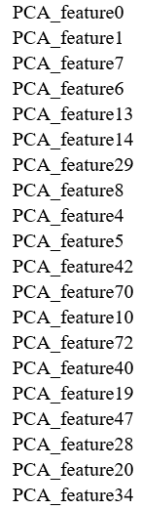
Figure S2 The SHAP figures of the cartilage(right) and subchondral bone(left) in testing cohorts for predicting KOA onset(A) and progression(B), respectively.
A
B
B

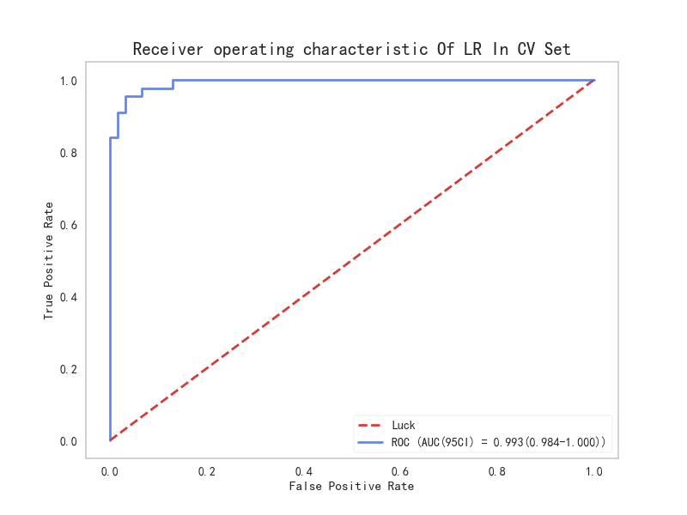
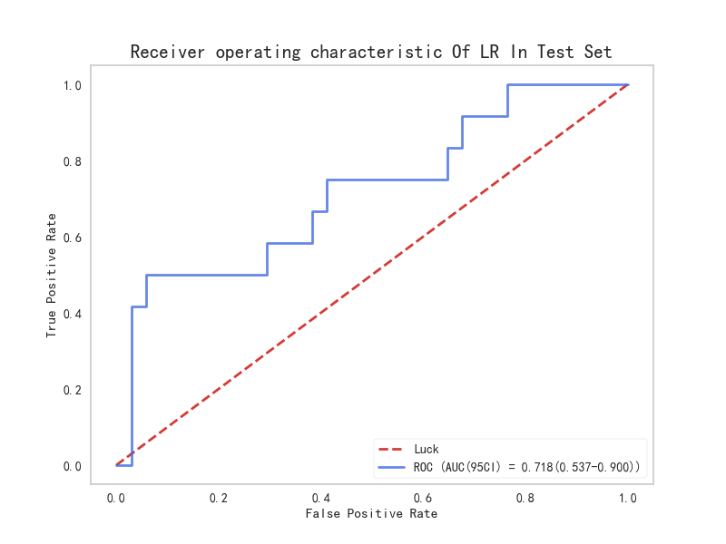
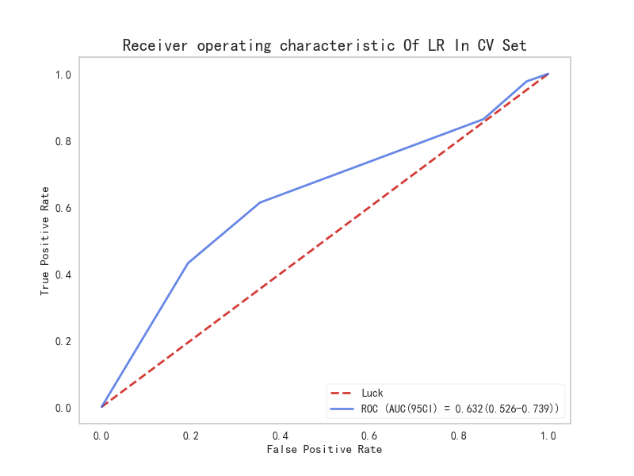
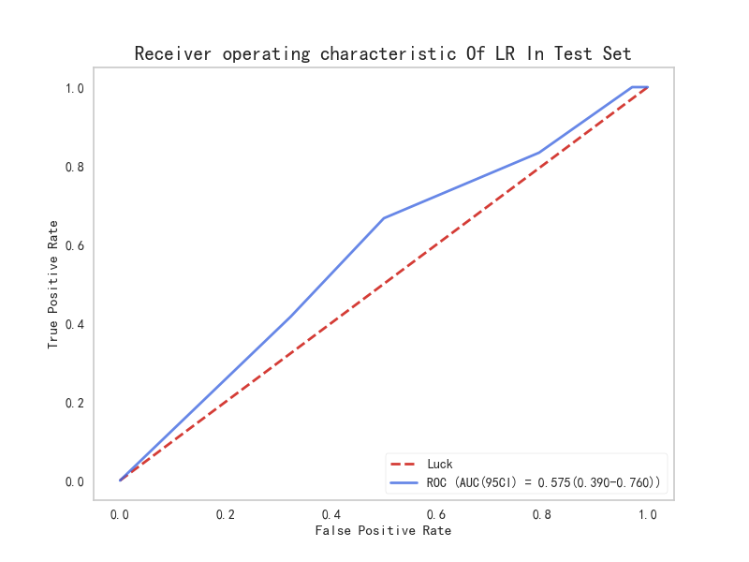
Figure S3 The ROC curves of clinical model (A) and combined clinical and radiomics(B) in the cross-validation(right) and testing cohort(left).
A
B
A
B

Table SⅢ Features and coefficients of cartilage extracted of LR model
Feature name | Coefficent
PCA_feature0 | 0.7080
PCA_feature1 | 0.6233
PCA_feature2 | 0.1426
PCA_feature3 | -0.1731
PCA_feature4 | -0.4026
PCA_feature5 | -0.4314
PCA_feature6 | -0.7141
PCA_feature7 | -1.2231
PCA_feature8 | 0.6258
PCA_feature9 | -0.2797
PCA_feature10 | -0.2762
PCA_feature11 | 0.2203
PCA_feature12 | -0.0220
PCA_feature13 | 1.0522
PCA_feature14 | 0.9291
PCA_feature15 | -0.2517
PCA_feature16 | 0.0756
PCA_feature17 | -0.2420
PCA_feature18 | -0.2111
PCA_feature19 | 0.3702
PCA_feature20 | -0.3588
PCA_feature21 | -0.2708
PCA_feature22 | -0.3018
PCA_feature23 | -0.2488
PCA_feature24 | 0.1605
PCA_feature25 | -0.1137
PCA_feature26 | 0.0114
PCA_feature27 | -0.2969
PCA_feature28 | -0.3389
PCA_feature29 | 0.9718
PCA_feature30 | -0.2044
PCA_feature31 | -0.1834
PCA_feature32 | 0.1986
PCA_feature33 | -0.4035
PCA_feature34 | 0.4437
PCA_feature35 | 0.0434
PCA_feature36 | -0.0382
PCA_feature37 | -0.0037
PCA_feature38 | 0.1611
PCA_feature39 | -0.0608
PCA_feature40 | 0.5485
PCA_feature41 | -0.4468
PCA_feature42 | -0.6464
PCA_feature43 | -0.2220
PCA_feature44 | -0.3683
PCA_feature45 | 0.2916

Table SⅢ (Continued)
Feature name | Coefficent
PCA_feature46 | 0.0328
PCA_feature47 | 0.4827
PCA_feature48 | -0.0382
PCA_feature49 | 0.2221
PCA_feature50 | 0.0631
PCA_feature51 | -0.4267
PCA_feature52 | -0.2046
PCA_feature53 | 0.0489
PCA_feature54 | 0.3886
PCA_feature55 | 0.0883
PCA_feature56 | -0.0486
PCA_feature57 | 0.2342
PCA_feature58 | -0.0010
PCA_feature59 | 0.1218
PCA_feature60 | -0.0241
PCA_feature61 | -0.1060
PCA_feature62 | -0.4694
PCA_feature63 | 0.2646
PCA_feature64 | -0.1520
PCA_feature65 | -0.1818
PCA_feature66 | -0.4236
PCA_feature67 | 0.2004
PCA_feature68 | 0.3683
PCA_feature69 | 0.3408
PCA_feature70 | -0.5264
PCA_feature71 | -0.0821
PCA_feature72 | -0.6508
PCA_feature73 | 0.1660

Table SⅣ Principal Component loadings
Original Feature | Loading Value
Original Feature | PCA_feature0 | PCA_feature1 | PCA_feature7
wavelet-LLL_firstorder_Minimum_BR | -0.1479 | -0.0716 | -0.0161
original_glszm_GrayLevelNonUniformity_JR | 0.1478 | -0.0333 | -0.0110
squareroot_glszm_GrayLevelNonUniformity_JR | 0.1476 | -0.0333 | -0.0109
original_firstorder_Median_BR | -0.1459 | 0.0226 | -0.1530
wavelet-LLL_firstorder_Median_BR | -0.1448 | 0.0196 | -0.1581
wavelet-LLL_glrlm_GrayLevelVariance_BR | 0.1448 | 0.0785 | 0.0671
squareroot_glcm_Imc1_BR | -0.1429 | -0.0692 | 0.0223
original_glcm_Imc1_BR | -0.1428 | -0.0693 | 0.0222
wavelet-LLL_firstorder_Minimum_JR | -0.1363 | -0.0620 | 0.1382
wavelet-LHL_glrlm_RunVariance_GR | -0.1360 | -0.0040 | -0.0727
Note. This table shows the loadings of the top 10 original features in the PCA for the first three principal components, reflecting the contribution of each feature to different principal components. GR, BR and JR: the abbreviations for features extracted from the cartilage of the femur, patella, and tibia, respectively.
Table SⅤ Features and coefficients of subchondral bone extracted of LR model
Feature name | Coefficent
PCA_feature0 | 1.2627
PCA_feature1 | 1.1396
PCA_feature2 | -0.0595
PCA_feature3 | 0.4285
PCA_feature4 | 0.0397
PCA_feature5 | 1.3093
PCA_feature6 | 0.2281
PCA_feature7 | 0.7973
PCA_feature8 | 0.1242
PCA_feature9 | -1.4299
PCA_feature10 | -0.6578
PCA_feature11 | -0.3994
PCA_feature12 | -0.0326
PCA_feature13 | 0.4864
PCA_feature14 | -0.1812
PCA_feature15 | -0.2579
PCA_feature16 | 0.4235
PCA_feature17 | 0.4284
PCA_feature18 | 0.3834
PCA_feature19 | 0.3776
PCA_feature20 | -0.0994
PCA_feature21 | -0.1884
PCA_feature22 | 0.0091
PCA_feature23 | -0.8806
PCA_feature24 | -0.3275
PCA_feature25 | 0.0134
PCA_feature26 | 0.5337
PCA_feature27 | 0.4008
PCA_feature28 | 0.1730
PCA_feature29 | -0.3966
PCA_feature30 | 0.5654
PCA_feature31 | 0.2867
PCA_feature32 | -0.5896
PCA_feature33 | -0.2149
PCA_feature34 | -0.1052
PCA_feature35 | -0.2469
PCA_feature36 | 0.7459
PCA_feature37 | 0.7188

Table SⅥ Principal Component loadings
Original Feature | Loading Value
Original Feature | PCA0 | PCA1 | PCA6
exponential_glrlm_ShortRunHighGrayLevelEmphasis_GRX | 0.2468 | 0.0652 | -0.0309
square_glrlm_ShortRunLowGrayLevelEmphasis_JRX | 0.2428 | 0.0225 | -0.0047
wavelet-LHH_glszm_ZonePercentage_GRX | 0.1733 | 0.0212 | 0.0318
wavelet-HHL_glszm_ZonePercentage_JRX | 0.1705 | -0.0019 | 0.1599
Wavelet-HLL_glszm_GrayLevelNonUniformityNormalized_JRX | -0.1506 | -0.0447 | -0.0431
wavelet-HLL_glszm_GrayLevelVariance_JRX | 0.1505 | 0.0447 | 0.0430
wavelet-HHL_glrlm_RunVariance_JRX | -0.1387 | 0.1588 | 0.0077
wavelet-HLL_gldm_DependenceNonUniformityNormalized_JRX | -0.1276 | 0.0578 | -0.1279
wavelet-LLH_glszm_LargeAreaHighGrayLevelEmphasis_GRX | -0.1225 | 0.2117 | 0.0191
wavelet-LHL_glszm_SizeZoneNonUniformity_GRX | -0.1069 | -0.0279 | 0.1295
Note. This table shows the loadings of the top 10 original features in the PCA for the first three principal components, reflecting the contribution of each feature to different principal components. GRX, BRX and JRX: the abbreviations for features extracted from the subchondral bone of the femur, patella, and tibia, respectively.

Table SⅦ Features and coefficients of combined cartilage and subchondral bone extracted of LR model
Feature name | Coefficent
PCA_feature0 | 1.0218
PCA_feature1 | 0.0969
PCA_feature2 | 0.6766
PCA_feature3 | 0.1700
PCA_feature4 | 0.0220
PCA_feature5 | 0.1872
PCA_feature6 | 0.3096
PCA_feature7 | -0.0945
PCA_feature8 | -0.5046
PCA_feature9 | -0.1277
PCA_feature10 | -0.4030
PCA_feature11 | -0.3812
PCA_feature12 | 0.3930
PCA_feature13 | -0.4239
PCA_feature14 | -0.4253
PCA_feature15 | -0.1785
PCA_feature16 | 0.4761
PCA_feature17 | -0.5521
PCA_feature18 | -0.3016
PCA_feature19 | 0.4208
PCA_feature20 | -0.1839
PCA_feature21 | 0.0508
PCA_feature22 | -0.2546
PCA_feature23 | 0.3084
PCA_feature24 | -0.1698
PCA_feature25 | -0.0698
PCA_feature26 | -0.2540
PCA_feature27 | 0.7497
PCA_feature28 | -0.1318
PCA_feature29 | -0.0060
PCA_feature30 | 0.4066
PCA_feature31 | 0.3823
PCA_feature32 | 0.1744
PCA_feature33 | 0.1628
PCA_feature34 | 0.0417
PCA_feature35 | 0.0409
PCA_feature36 | 0.0897
PCA_feature37 | -0.1122
PCA_feature38 | 0.2140
PCA_feature39 | 0.2807
PCA_feature40 | -0.2454
PCA_feature41 | -0.2182
PCA_feature42 | -0.1353
PCA_feature43 | -0.1426
PCA_feature44 | -0.1824
PCA_feature45 | 0.0855
PCA_feature46 | 0.2374
Table SⅦ (Continued)
Feature name | Coefficent
PCA_feature47 | -0.0436
PCA_feature48 | 0.1103
PCA_feature49 | 0.4757
PCA_feature50 | 0.0080
PCA_feature51 | -0.0955
PCA_feature52 | 0.3900
PCA_feature53 | 0.1863
PCA_feature54 | 0.2206
PCA_feature55 | -0.1588
PCA_feature56 | 0.1153
PCA_feature57 | 0.0265
PCA_feature58 | -0.1996
PCA_feature59 | 0.1199
PCA_feature60 | -0.0376
PCA_feature61 | 0.2510
PCA_feature62 | -0.0905
PCA_feature63 | -0.0717
PCA_feature64 | -0.0559
PCA_feature65 | -0.0413
PCA_feature66 | -0.0233
PCA_feature67 | -0.3685
PCA_feature68 | -0.0093
PCA_feature69 | -0.0131
PCA_feature70 | -0.1382
PCA_feature71 | 0.1695
PCA_feature72 | 0.0069
PCA_feature73 | -0.0689
PCA_feature74 | 0.1527
PCA_feature75 | 0.2806
PCA_feature76 | 0.0441
PCA_feature77 | -0.0142
PCA_feature78 | 0.1607
PCA_feature79 | 0.0453
PCA_feature80 | 0.2704
PCA_feature81 | 0.0628
PCA_feature82 | -0.0739
PCA_feature83 | -0.0320
PCA_feature84 | -0.1912
PCA_feature85 | 0.2597
PCA_feature86 | 0.1078
PCA_feature87 | -0.2400
PCA_feature88 | 0.0284
PCA_feature89 | 0.0994
PCA_feature90 | -0.0125
PCA_feature91 | 0.0849
PCA_feature92 | -0.0967
Table SⅦ (Continued)
Feature name |  | Coefficent
PCA_feature93 |  | 0.0777
PCA_feature94 |  | -0.2189
PCA_feature95 |  | 0.1221
PCA_feature96 |  | -0.0645
PCA_feature97 |  | 0.0575
PCA_feature98 |  | -0.0532
PCA_feature99 |  | 0.0910
PCA_feature100 |  | -0.1212
PCA_feature101 |  | -0.0424

Table SⅧ Principal Component loadings
Original Feature | Loading Value
Original Feature | PCA0 | PCA2 | PCA13
square_glrlm_ShortRunLowGrayLevelEmphasis_GRX | 0.1505 | 0.0447 | 0.0285
square_glrlm_ShortRunLowGrayLevelEmphasis_JRX | 0.1495 | 0.0512 | 0.0324
squareroot_glcm_Imc1_BR | -0.1412 | -0.0648 | 0.0417
original_glcm_Imc1_BR | -0.1411 | -0.0647 | 0.0416
wavelet-LLL_glrlm_GrayLevelVariance_BR | 0.1403 | 0.0483 | 0.0055
Wavelet-LLL_glrlm_GrayLevelNonUniformityNormalized_BR | -0.1402 | -0.0483 | -0.0055
wavelet-LLL_firstorder_Minimum_BR | -0.1322 | -0.0522 | 0.0049
wavelet-LLL_glcm_ClusterProminence_BR | 0.1312 | 0.0513 | 0.0073
wavelet-LLL_glrlm_ShortRunEmphasis_BR | 0.1304 | 0.0889 | 0.0191
wavelet-HLL_glszm_SizeZoneNonUniformity_GRX | -0.1082 | -0.0057 | 0.0725
Note. This table shows the loadings of each original feature on the different principal components, reflecting how much each feature contributes to each principal component. GR, BR and JR: the abbreviations for features extracted from the cartilage of the femur, patella, and tibia, respectively. GRX, BRX and JRX: the abbreviations for features extracted from the subchondral bone of the femur, patella, and tibia, respectively.

Table SⅨ Features and coefficients of cartilage extracted of LR model
Feature name | Coefficent
wavelet-LHH_glrlm_RunVariance_GR |  | 0.2880
log-sigma-3-0-mm-3D_glcm_Correlation_JR |  | -0.3173
wavelet-LLL_glszm_LowGrayLevelZoneEmphasis_JR |  | -0.3473
wavelet-LHL_glszm_GrayLevelNonUniformityNormalized_JR |  | -0.0329
wavelet-LHL_ngtdm_Complexity_JR |  | 0.3809
wavelet-HLH_glcm_Imc2_JR |  | -0.4896
log-sigma-1-0-mm-3D_firstorder_Maximum_JR |  | 0.3869
wavelet-LLL_glszm_HighGrayLevelZoneEmphasis_JR |  | 0.3473
wavelet-LHL_ngtdm_Contrast_JR |  | 0.0694
log-sigma-3-0-mm-3D_firstorder_Skewness_JR |  | -0.0648
wavelet-LHL_glszm_SmallAreaHighGrayLevelEmphasis_JR |  | -0.3291
log-sigma-1-0-mm-3D_glrlm_ShortRunHighGrayLevelEmphasis_JR |  | 0.5318
wavelet-LHL_gldm_SmallDependenceHighGrayLevelEmphasis_JR |  | -0.3815
log-sigma-3-0-mm-3D_glcm_MCC_JR |  | -0.3197
wavelet-LLH_firstorder_Minimum_JR |  | -0.2720
log-sigma-3-0-mm-3D_glszm_GrayLevelNonUniformityNormalized_BR |  | 0.0520
wavelet-HLL_firstorder_Minimum_BR |  | -0.2472
log-sigma-3-0-mm-3D_glcm_MCC_BR |  | 0.0691
wavelet-HHL_glcm_MCC_BR |  | -0.0608
wavelet-HHH_glszm_LowGrayLevelZoneEmphasis_BR |  | -0.2864
wavelet-HLH_glrlm_LowGrayLevelRunEmphasis_BR |  | -0.0270
log-sigma-3-0-mm-3D_ngtdm_Coarseness_BR |  | 0.2291
log-sigma-1-0-mm-3D_firstorder_Skewness_BR |  | 0.8151
log-sigma-3-0-mm-3D_glcm_Correlation_BR |  | 0.0881
wavelet-HHH_firstorder_Mean_BR |  | -0.2946
wavelet-HHL_firstorder_Kurtosis_BR |  | 0.4205
wavelet-HHH_glszm_HighGrayLevelZoneEmphasis_BR |  | 0.2864
wavelet-HLH_glrlm_HighGrayLevelRunEmphasis_BR |  | 0.0270
wavelet-LHH_glrlm_RunVariance_GR |  | 0.2880
log-sigma-3-0-mm-3D_glcm_Correlation_JR |  | -0.3173
wavelet-LLL_glszm_LowGrayLevelZoneEmphasis_JR |  | -0.3473
wavelet-LHL_glszm_GrayLevelNonUniformityNormalized_JR |  | -0.0329
wavelet-LHL_ngtdm_Complexity_JR |  | 0.3809
wavelet-HLH_glcm_Imc2_JR |  | -0.4896
log-sigma-1-0-mm-3D_firstorder_Maximum_JR |  | 0.3869
wavelet-LLL_glszm_HighGrayLevelZoneEmphasis_JR |  | 0.3473
wavelet-LHL_ngtdm_Contrast_JR |  | 0.0694
log-sigma-3-0-mm-3D_firstorder_Skewness_JR |  | -0.0648
wavelet-LHL_glszm_SmallAreaHighGrayLevelEmphasis_JR |  | -0.3291
log-sigma-1-0-mm-3D_glrlm_ShortRunHighGrayLevelEmphasis_JR |  | 0.5318
wavelet-LHL_gldm_SmallDependenceHighGrayLevelEmphasis_JR |  | -0.3815
log-sigma-3-0-mm-3D_glcm_MCC_JR |  | -0.3197
wavelet-LLH_firstorder_Minimum_JR |  | -0.2720
log-sigma-3-0-mm-3D_glszm_GrayLevelNonUniformityNormalized_BR |  | 0.0520
wavelet-HLL_firstorder_Minimum_BR |  | -0.2472

Table SⅨ (Continued)
Feature name | Coefficent
log-sigma-3-0-mm-3D_glcm_MCC_BR |  | 0.0691
wavelet-HHL_glcm_MCC_BR |  | -0.0608
wavelet-HHH_glszm_LowGrayLevelZoneEmphasis_BR |  | -0.2864
wavelet-HLH_glrlm_LowGrayLevelRunEmphasis_BR |  | -0.0270
log-sigma-3-0-mm-3D_ngtdm_Coarseness_BR |  | 0.2291
log-sigma-1-0-mm-3D_firstorder_Skewness_BR |  | 0.8151
log-sigma-3-0-mm-3D_glcm_Correlation_BR |  | 0.0881
wavelet-HHH_firstorder_Mean_BR |  | -0.2946
wavelet-HHL_firstorder_Kurtosis_BR |  | 0.4205
wavelet-HHH_glszm_HighGrayLevelZoneEmphasis_BR |  | 0.2864
wavelet-HLH_glrlm_HighGrayLevelRunEmphasis_BR |  | 0.0270
Note. wavelet: wavelet transform; LHH, LLL, LHL, HLH, LLH, HLL, HHL, HHH: particular subband after wavelet transform; log: laplacian of gaussian; sigma-3-0-mm, sigma-1-0-mm: standard deviation (σ) and size of the gaussian filter; 3D: three-dimensional; glrlm: gray levelrun length matrix; glcm: gray level cooccurence matrix; glszm: gray levelsize zone matrix; ngtdm: neigbouring gray tonedifference matrix; gldm: gray leveldependence matrix; Imc2: informational measure of correlation2; MCC: maximal correlation coefficient; GR, BR and JR: the abbreviations for features extracted from the cartilage of the femur, patella, and tibia, respectively.

Table SⅩ Features and coefficients of subchondral bone extracted of LR model
Feature name | Coefficent
exponential_firstorder_90Percentile_GRX |  | 0.5296
wavelet-LHH_firstorder_Range_GRX |  | 0.3877
squareroot_glcm_ClusterShade_GRX |  | 0.1575
wavelet-LLL_firstorder_Minimum_GRX |  | 0.2738
wavelet-HLH_firstorder_Mean_GRX |  | -0.5744
original_glcm_ClusterShade_GRX |  | 0.1575
wavelet-LLH_firstorder_Maximum_GRX |  | 0.0813
original_gldm_SmallDependenceEmphasis_GRX |  | 0.1473
wavelet-HLH_firstorder_Skewness_GRX |  | -0.1888
squareroot_gldm_SmallDependenceEmphasis_GRX |  | 0.1473
wavelet-LHH_ngtdm_Complexity_BRX |  | 0.7774
wavelet-HLL_glszm_SmallAreaHighGrayLevelEmphasis_BRX |  | 0.8567
wavelet-HLH_glszm_SmallAreaEmphasis_BRX |  | 0.2264
wavelet-HLH_glcm_Imc1_BRX |  | 0.2529
wavelet-HLH_glszm_ZoneEntropy_BRX |  | 0.5991
wavelet-LHL_glcm_MaximumProbability_BRX |  | 0.6019
wavelet-HHL_firstorder_Minimum_BRX |  | -0.5785
wavelet-LHL_glcm_MCC_BRX |  | 0.1738
wavelet-HHL_firstorder_Skewness_BRX |  | -0.4105
wavelet-HLH_firstorder_Skewness_BRX |  | -0.3470
wavelet-LHH_firstorder_Kurtosis_BRX |  | -1.1035
log-sigma-3-0-mm-3D_glszm_SizeZoneNonUniformityNormalized_JRX |  | -0.7462
wavelet-HLL_firstorder_Kurtosis_JRX |  | 0.0641
wavelet-LLH_glszm_SizeZoneNonUniformity_JRX |  | 0.3735
wavelet-LLL_firstorder_10Percentile_JRX |  | 0.0897
wavelet-HLH_firstorder_Kurtosis_JRX |  | 0.4496
Note. exponential: exponential transform; wavelet: wavelet transform; LHH, LLL, LHL, HLH, LLH, HLL, HHL, HHH: particular subband after wavelet transform; squareroot: square root transform; original:features are calculated directly on the original image without preprocessing or transformation; log: laplacian of gaussian; glcm: gray level cooccurence matrix; gldm: gray leveldependence matrix; ngtdm: neigbouring gray tonedifference matrix; glszm: gray levelsize zone matrix; Imc1: informational measure of correlation1; MCC: maximal correlation coefficient; G GRX, BRX and JRX: the abbreviations for features extracted from the subchondral bone of the femur, patella, and tibia, respectively.

Table SⅪ Features and coefficients of combined cartilage and subchondral bone extracted of LR model
Feature name | Coefficent
exponential_firstorder_90Percentile_GRX | 0.3308
squareroot_glszm_SmallAreaEmphasis_GRX | -0.1947
wavelet-HLH_firstorder_Mean_GRX | -0.8234
original_gldm_SmallDependenceLowGrayLevelEmphasis_GRX | 0.1527
original_glszm_LargeAreaHighGrayLevelEmphasis_GRX | -0.0241
wavelet-LLL_glcm_ClusterShade_GRX | 0.1686
original_glszm_SmallAreaEmphasis_GRX | -0.1947
squareroot_gldm_SmallDependenceLowGrayLevelEmphasis_GRX | 0.1527
wavelet-LLL_glcm_MCC_GRX | 0.1852
wavelet-HLH_firstorder_Skewness_GRX | -0.2781
wavelet-LHH_firstorder_Minimum_GRX | -0.5696
squareroot_glszm_LargeAreaHighGrayLevelEmphasis_GRX | -0.0241
wavelet-LHH_ngtdm_Complexity_BRX | 0.3219
wavelet-HLL_glszm_SmallAreaHighGrayLevelEmphasis_BRX | 0.4057
wavelet-HLH_glszm_SmallAreaEmphasis_BRX | 0.3580
wavelet-HLH_glszm_ZoneEntropy_BRX | 0.3645
wavelet-LHL_glcm_MaximumProbability_BRX | 0.6709
wavelet-HHL_firstorder_Minimum_BRX | -0.8666
wavelet-LHL_glcm_MCC_BRX | 0.3436
wavelet-LHH_ngtdm_Contrast_BRX | 0.3663
wavelet-HHL_firstorder_Skewness_BRX | -0.3169
wavelet-HLH_firstorder_Skewness_BRX | -0.4384
wavelet-LHH_firstorder_Kurtosis_BRX | -1.1486
log-sigma-3-0-mm-3D_glszm_SizeZoneNonUniformityNormalized_JRX | -0.9390
wavelet-LLH_glszm_SizeZoneNonUniformity_JRX | 0.7183
wavelet-HLH_firstorder_Kurtosis_JRX | 0.6234
wavelet-LHH_glrlm_RunVariance_GR | 0.4995
wavelet-LLL_glszm_LowGrayLevelZoneEmphasis_JR | -0.1989
wavelet-LHL_firstorder_Median_JR | 0.6054
wavelet-LHL_ngtdm_Complexity_JR | 0.6405
wavelet-HLH_glcm_Imc2_JR | -0.6850
wavelet-LLH_firstorder_Kurtosis_JR | -0.0480
log-sigma-1-0-mm-3D_firstorder_Maximum_JR | 0.0529
wavelet-LLL_glszm_HighGrayLevelZoneEmphasis_JR | 0.1989
log-sigma-1-0-mm-3D_glrlm_ShortRunHighGrayLevelEmphasis_JR | 0.3043
wavelet-LHL_glszm_SizeZoneNonUniformity_JR | -0.1934
log-sigma-3-0-mm-3D_glcm_MCC_JR | -0.1905
wavelet-LLH_firstorder_Minimum_JR | -0.2921
wavelet-HHH_glszm_LowGrayLevelZoneEmphasis_BR | -0.3811
wavelet-HLH_glrlm_LowGrayLevelRunEmphasis_BR | 0.0060
log-sigma-3-0-mm-3D_ngtdm_Coarseness_BR | 0.0679
log-sigma-1-0-mm-3D_firstorder_Skewness_BR | 0.6591
log-sigma-3-0-mm-3D_glcm_Correlation_BR | 0.7451
wavelet-HHH_firstorder_Mean_BR | -0.5803
wavelet-HHH_glszm_HighGrayLevelZoneEmphasis_BR | 0.3811
wavelet-HLH_glrlm_HighGrayLevelRunEmphasis_BR | -0.0060
Note. exponential: exponential transform; wavelet: wavelet transform; LHH, LLL, LHL, HLH, LLH, HLL, HHL, HHH: particular subband after wavelet transform; squareroot: square root transform; original:features are calculated directly on the original image without preprocessing or transformation; log: Laplacian of Gaussian; glszm: gray levelsize zone matrix; gldm: gray leveldependence matrix; glcm: gray level cooccurence matrix; ngtdm: neigbouring gray tonedifference matrix; glrlm: gray levelrun length matrix; Imc2: informational measure of correlation 2; MCC: maximal correlation coefficient; GR, BR and JR: the abbreviations for features extracted from the cartilage of the femur, patella, and tibia, respectively. GRX, BRX and JRX: the abbreviations for features extracted from the subchondral bone of the femur, patella, and tibia, respectively.

Table SⅫ Performance evaluation of models predicting the onset of KOA in testing cohort
LR model | AUC | Accuracy | Specificity | Sensitivity | F1 score | Precision
Cartilage | 0.974 | 0.942 | 0.946 | 0.935 | 0.915 | 0.896
Subchondral bone | 0.941 | 0.877 | 0.902 | 0.826 | 0.817 | 0.809
Combine cartilage and subchondral bone | 0.985 | 0.949 | 0.935 | 0.978 | 0.928 | 0.882

Table SXIII Performance evaluation of models predicting the progression of KOA in testing cohort
LR model | AUC | Accuracy | Specificity | Sensitivity | F1 score | Precision
Cartilage | 0.676 | 0.565 | 0.529 | 0.667 | 0.444 | 0.333
Subchondral bone | 0.721 | 0.652 | 0.588 | 0.833 | 0.555 | 0.417
Combine cartilage and subchondral bone | 0.738 | 0.522 | 0.412 | 0.833 | 0.476 | 0.333

Table SXIV Performance evaluation of models predicting the progression of KOA in testing cohort
Category | AUC | F1 score | Recall | Precision
Class 0 | 0.974 | 0.956 | 0.946 | 0.967
Class 1 | 0.835 | 0.324 | 0.500 | 0.240
Class 2 | 0.926 | 0.597 | 0.500 | 0.739
Note.Class 0=without KOA; Class 1=late KOA progression; Class 2=early KOA progression

