Table S1. Sensitivity analysis of subdistribution hazard models for KR following OA using PASE quartiles
 | Total |  | KL grade 2 | KL grade >2
PASE (categorized by quartiles) | Adjusted HR (95% CI) | P for interaction | Adjusted HR (95% CI) | Adjusted HR (95% CI)
Q1(<95) | Reference |  | Reference | Reference
Q2(95-145) | 0.49 (0.25,0.97) |  | 0.49 (0.24,0.99) | 1.12 (0.78,1.61)
Q3(146-206) | 0.58 (0.31,1.09) |  | 0.57 (0.30,1.10) | 1.55 (1.08,2.23)
Q4(>207) | 0.85 (0.47,1.52) |  | 0.86 (0.45,1.64) | 1.29 (0.85,1.94)
Q2 * KL>2 # | 2.34 (1.08,5.08) | 0.031 | ─ | ─
Q3 * KL>2 # | 2.68 (1.32,5.47) | <.001 | ─ | ─
Q4 * KL>2 # | 1.53 (0.78,3.00) | 0.220 | ─ | ─
Models are adjusted for age, sex, race, education level, BMI, economic status, WOMAC pain (<5, >=5), knee alignment (malignment or not), KL grade (2,>2), numbers of involved joints (two-side or one-side), history of knee injury and history of knee surgery.
# reference to subjects with PASE score below 95 in KL grade 2

Table S2. Sensitivity analysis of subdistribution hazard models for KR following OA after adjusting for season
 | Total |  | KL grade 2 | KL grade >2
PASE (categorized by tertiles) | Adjusted HR (95% CI) | P for interaction | Adjusted HR (95% CI) | Adjusted HR (95% CI)
Low | Reference |  | Reference | Reference
Moderate | 0.36 (0.19,0.68) |  | 0.37 (0.19,0.72) | 1.41 (1.04,1.91)
High | 0.84 (0.50,1.39) |  | 0.84 (0.47,1.48) | 1.27 (0.90, 1.80)
Moderate PASE * KL>2 # | 3.95 (1.95,7.99) | <.001 | ─ | ─
High PASE * KL>2 # | 1.53 (0.86, 2.75) | 0.15 | ─ | ─
Models are adjusted for age, sex, race, education level, BMI, economic status, season (spring, summer, autumn or winter), WOMAC pain (<5, >=5), knee alignment (malignment or not), KL grade (2,>2), numbers of involved joints (two-side or one-side), history of knee injury and history of knee surgery.
# reference to subjects with PASE score below 112 (tertiles1) in KL grade 2

Table S3. Sensitivity analysis of subdistribution hazard models for KR following OA using bilateral knees in individuals with baseline KL grade ≥2 (either knee)
 | Total |  | KL grade 2 | KL grade >2
PASE (categorized by tertiles) | Adjusted HR (95% CI) | P for interaction | Adjusted HR (95% CI) | Adjusted HR (95% CI)
Low | Reference |  | Reference | Reference
Moderate | 0.42 (0.21,0.83) |  | 0.44 (0.22,0.87) | 1.43 (1.04,1.95)
High | 1.02 (0.60,1.73) |  | 1.04 (0.60,1.81) | 1.27 (0.89, 1.81)
Moderate PASE * KL>2 # | 3.41 (1.61,7.19) | 0.001 | ─ | ─
High PASE * KL>2 # | 1.27 (0.68, 2.36) | 0.45 | ─ | ─
Among 2534 participants, 2496 individuals have an available baseline KL grade for both knees. Number of knees included in three groups: total group (n = 4992), KL grade 2 group (n = 2672), KL grade >2 group (n = 2320). A marginal Cox model with a cluster term was used to account for within-subject correlations. Models are adjusted for age, sex, race, education level, BMI, economic status, WOMAC pain (<5, >=5), knee alignment (malalignment or not), KL grade, history of knee injury, and history of knee surgery.
# reference to subjects with PASE score below 112 (tertiles1) in the KL grade 2 group.

Table S4. Sensitivity analysis of subdistribution hazard models for KR following OA after imputation
 | Total |  | KL grade 2 | KL grade 3
PASE (categorized by tertiles) | Adjusted HR (95% CI) | P for interaction | Adjusted HR (95% CI) | Adjusted HR (95% CI)
Low | Reference |  | Reference | Reference
Moderate | 0.43 (0.23,0.79) |  | 0.44 (0.24,0.81) | 1.52 (1.13,2.03)
High | 0.90 (0.54,1.48) |  | 0.88 (0.51,1.52) | 1.36 (0.97,1.90)
Moderate PASE * KL>2 # | 3.55 (1.82,6.93) | <.001 | ─ | ─
High PASE * KL>2 # | 1.52 (0.86,2.69) | 0.15 | ─ | ─
Models are adjusted for age, sex, race, education level, BMI, economic status, WOMAC pain (<5, >=5), knee alignment (malignment or not), KL grade (2,>2), numbers of involved joints (two-side or one-side), history of knee injury and history of knee surgery.
# reference to subjects with PASE score below 112 (tertiles1) in KL grade 2

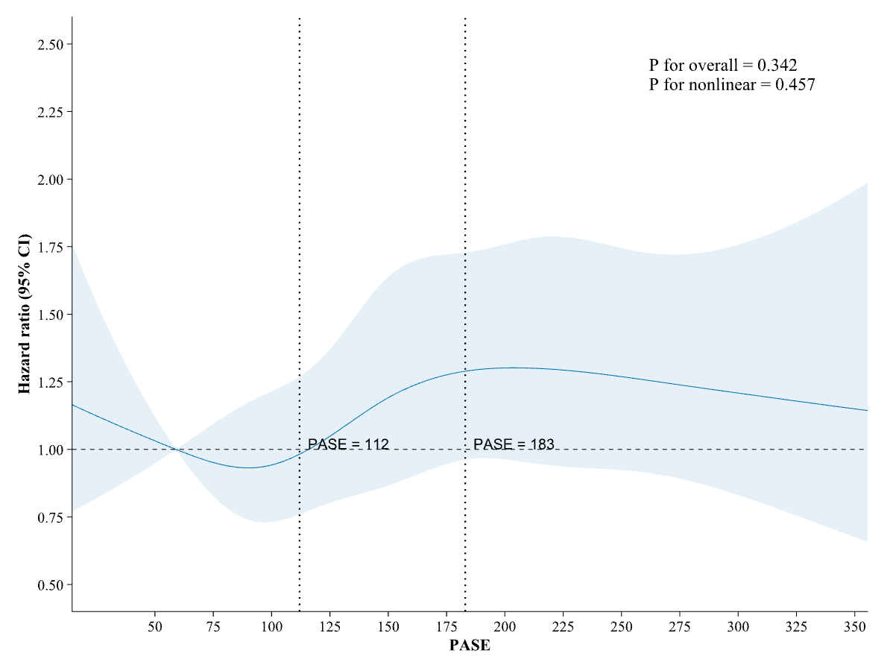
Figure S1. Association Between PASE and KROA using restricted cubic spline Cox proportional hazards regression.
HR, hazard ratio; CI, confidence interval.
Adjusted for age, sex, race, education level, BMI, economic status, WOMAC pain (<5, >=5), knee alignment (malalignment or not), KL grade (2,>2), number of involved joints (two-sided or one-sided), history of knee injury, and history of knee surgery.
Data were fitted using a restricted cubic spline Cox proportional hazards regression model, with 5 knots at the 10th, 25th, 50th, 75th, and 90th percentiles of PASE (reference is the 10th percentile). Solid lines indicate HRs, and shadow shapes indicate 95% CIs.

