S1 Search strategy
- Medline
 | Search line | Results
1 | ((((Postmenopause[MeSH Terms]) OR (postmenopausal women[Title/Abstract])) OR (postmenopausal[Title/Abstract])) OR (Postmenopausal Period[Title/Abstract])) OR (Post menopausal Period[Title/Abstract]) | 74074
2 | (((((osteoporosis[MeSH Terms]) OR (Osteoporosis, Postmenopausal[MeSH Terms])) OR (bone loss[Title/Abstract])) OR (Bone Mineral Density[Title/Abstract])) OR (BMD[Title/Abstract])) OR (bone metabolism[Title/Abstract]) | 135,966
3 | machine learning OR Transfer Learning OR Deep learning OR Prediction model OR artificial intelligence OR random forest OR artificial neural network OR ANN OR Support vector machine OR SVM OR Gradient Boosting Machine OR GBM OR Nomogram OR XGboost OR Logistic OR Decision tree OR External validation OR Cox | 4,325,483
4 | (validat$ OR predict$.ti. OR rules) OR (predict$ AND (outcomes$ OR risk$ OR model$)) OR ((history OR variable$ OR criteria OR scor$ OR characteristic$ OR finding$ OR factor$) AND (predict$ OR model$ OR decision$ OR identif$ OR prognos$)) OR (decision$ AND (model$ OR clinical$ OR logistic models/)) OR (prognostic AND (history OR variable$ OR criteria OR scor$ OR characteristic$ OR finding$ OR factor$ OR model$)) | 5,009,473
5 | #3 OR #4 | 7,739,191
6 | #1 AND #2 AND #5 AND #Filters: in the last 10 years | 2179

- Web of science
 | Search line | Results
1 | ((((TS=(Postmenopause)) OR TS=(postmenopausal women)) OR TS=(postmenopausal)) OR TS=(Postmenopausal Period)) OR TS=(Post menopausal Period) | 104,260
2 | ((((((TS=(Osteoporosis)) OR TS=(Osteoporoses)) OR TS=(Bone Loss)) OR TS=(Age-Related Bone Loss)) OR TS=(Bone Mineral Density)) OR TS=(BMD)) OR TS=(bone metabolism) | 258,153
3 | (((((((((((((((((TS=(machine learning)) OR TS=(Transfer Learning)) OR TS=( Deep learning)) OR TS=(Prediction model)) OR TS=(artificial intelligence)) OR TS=( random forest)) OR TS=(artificial neural network)) OR TS=(ANN)) OR TS=( Support vector machine)) OR TS=(SVM)) OR TS=( Gradient Boosting Machine)) OR TS=(GBM)) OR TS=(Nomogram )) OR TS=(XGboost )) OR TS=(Logistic)) OR TS=(Decision tree)) OR TS=( External validation)) OR TS=(Cox) | 2.820,773
4 | #1 AND #2 AND #3 AND #Filters: in the last 10 years | 1290
- CINAHL
 | Search line | Results
1 | SU Postmenopause OR SU postmenopausal women OR SU postmenopausal OR SU Postmenopausal Period OR SU Post menopausal Period | 12,248
2 | SU Osteoporosis OR SU Osteoporosis OR SU Bone Loss OR SU Age-Related Bone Loss OR SU Bone Mineral Density OR SU BMD OR SU bone metabolism | 31,448
3 | machine learning OR Transfer Learning OR Deep learning OR Prediction model OR artificial intelligence OR random forest OR artificial neural network OR ANN OR Support vector machine OR SVM OR Gradient Boosting Machine OR GBM OR Nomogram OR XGboost OR Logistic OR Decision tree OR External validation OR Cox | 855,231
4 | (validat$ OR predict$.ti. OR rules) OR (predict$ AND (outcomes$ OR risk$ OR model$)) OR ((history OR variable$ OR criteria OR scor$ OR characteristic$ OR finding$ OR factor$) AND (predict$ OR model$ OR decision$ OR identif$ OR prognos$)) OR (decision$ AND (model$ OR clinical$ OR logistic models/)) OR (prognostic AND (history OR variable$ OR criteria OR scor$ OR characteristic$ OR finding$ OR factor$ OR model$)) | 1,722,167
5 | S3 OR S4 | 2,299,412
6 | S1 AND S2 AND S5 AND last 10 years | 350
- Cochrane
 | Search line | Results
1 | （Postmenopause OR postmenopausal women OR postmenopausal OR Postmenopausal Period OR Post menopausal Period）ti.ab.kw | 24,641
2 | (Osteoporosis OR Osteoporoses OR Bone Loss OR Age-Related Bone Loss OR Bone Mineral Density OR BMD OR bone metabolism)ti.ab.kw | 30,247
3 | (machine learning OR Transfer Learning OR Deep learning OR Prediction model OR artificial intelligence OR random forest OR artificial neural network OR ANN OR Support vector machine OR SVM OR Gradient Boosting Machine OR GBM OR Nomogram OR XGboost OR Logistic OR Decision tree OR External validation OR Cox)ti.ab.kw | 89,499
4 | S1 AND S2 AND S3 AND last 10 years | 178
- Embase
 | Search line | Results
1 | 'postmenopause'/exp OR 'postmenopause' OR 'postmenopausal women'/exp OR 'postmenopausal women' OR 'postmenopausal' OR 'postmenopausal period'/exp OR 'postmenopausal period' OR 'post menopausal period' | 126,365
2 | 'osteoporosis' OR 'osteoporoses' OR 'bone loss' OR 'age-related bone loss' OR 'bone mineral density' OR 'bmd' OR 'bone metabolism' | 289,529
3 | 'machine learning' OR 'Transfer Learning' OR 'Deep learning' OR 'Prediction model' OR 'artificial intelligence' OR 'random forest' OR 'artificial neural network' OR 'ANN' OR 'Support vector machine' OR 'SVM' OR 'Gradient Boosting Machine' OR 'GBM' OR 'Nomogram' OR 'XGboost' OR 'Logistic' OR 'Decision tree' OR 'External validation' OR 'Cox' | 2,931,901
4 | S1 AND S2 AND S5 AND last 10 years | 1684

- CNKI：
 | Search line | Results
1 | SU=("绝经后妇女" +"绝经后" +"绝经" +"老年妇女") and SU=("骨质疏松症"+"骨量减少"+"骨量减少" +"骨密度" +"骨代谢") and SU=("深度学习"+"机器学习"+"人工智能"+"骨折风险评估工具"+"预测模型"+"列线图"+"模型"+"风险预测"+"风险评分"+"算法") | 751

7.Wanfang:
 | Search line | Results
1 | 主题:("绝经后妇女" or "绝经后" or "绝经" or "老年妇女") and 主题:("骨质疏松症" or "骨量减少" or "骨量减少" or "骨密度" or "骨代谢") and 主题:("深度学习" or "机器学习" or "人工智能"or "骨折风险评估工具" or "预测模型" or "列线图" or "模型" or "风险预测" or "风险评分" or "算法") | 1214

8.VIP:
 | Search line | Results
1 | M=(绝经后妇女 OR 绝经后 OR 绝经 OR 老年妇女) AND M=(骨质疏松症 OR 骨量减少 OR 骨量减少 OR 骨密度 OR 骨代谢) AND M=(深度学习 OR 机器学习 OR 人工智能 OR 骨折风险评估工具 OR 预测模型 OR 列线图 OR 模型 OR 风险预测 OR 风险评分 OR 算法) | 85
9.CBM
 | Search line | Results
1 | ((深度学习 OR 机器学习 OR 人工智能 OR 骨折风险评估工具 OR 预测模型 OR 列线图 OR 模型 OR 风险预测 OR 风险评分 OR 算法) AND ("骨质疏松"[常用字段:智能] OR "骨量减少"[常用字段:智能] OR "骨密度"[常用字段:智能] OR "骨代谢"[常用字段:智能]) AND ("绝经后妇女"[常用字段:智能] OR "绝经后"[常用字段:智能] OR "绝经"[常用字段:智能] OR "老年妇女"[常用字段:智能])) AND 2014-2024[日期] | 795

S2 Study Selection Criteria
Inclusion Criteria
P (Population): postmenopausal women
I (Index Models): development, validation, or updating of prediction models for postmenopausal osteoporosis
C (Comparator):Not applicable
O (outcome):osteoporosis
S (Study Design):cohort study or case-control study
Exclusion Criteria
(1) the content of the study only referred to predictors or risk factors, but no predictive model had been established;
(2) used qualitative methods to construct prediction models;
(3) reported repeatedly, abstracts, conference papers, cases, and reviews;
(4) Non-Chinese and English.

Figure S3 included predictors of each study
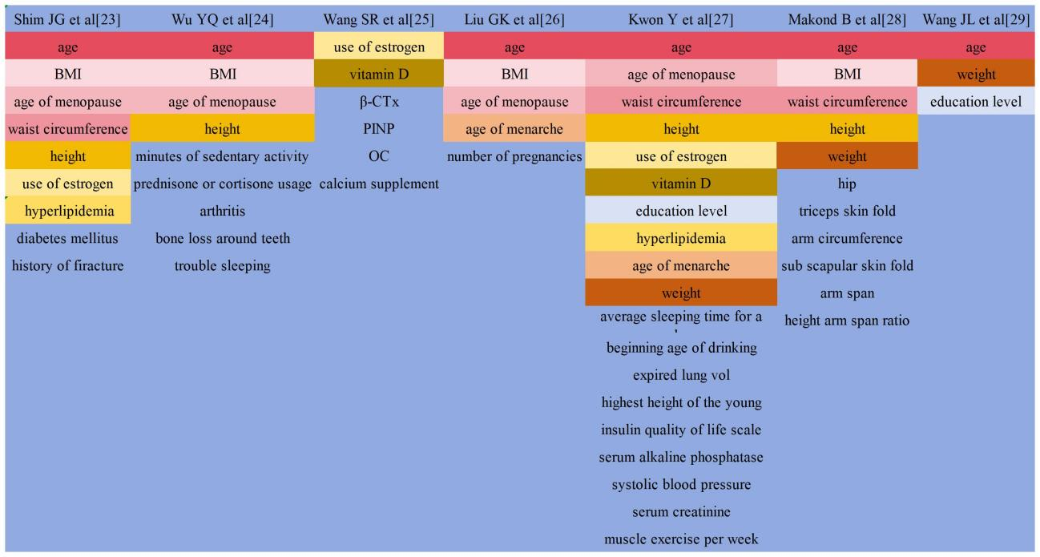

Table S4 meta regression analysis of subgroup
Subgroup | Coef | SE | t | P value
Data source | 0.004 | 0.014 | 0.275 | 0.783
ML methods | -0.010 | 0.015 | -0.636 | 0.525
Type of predictors
demographics and other indicators | 0.030 | 0.018 | 1.644 | 0.100
demographics, laboratory and others | 0.193 | 0.015 | 13.051 | ＜0.0001
Table S5 subgroup analysis
Subgroup | Number of predictive model | AUC（95%CI） | I² value(%) | P value
Data source
database | 12 | 0.78(0.73-0.83) | 98.4 | <0.0001
electronic medical record | 7 | 0.75(0.70-0.81) | 92.6 | <0.0001
ML methods
LR | 5 | 0.78(0.71-0.85) | 94.0 | <0.0001
others | 14 | 0.77(0.72-0.81) | 98.2 | <0.0001
Type of predictors
demographics | 13 | 0.72(0.70-0.74) | 59.3 | 0.003
demographics and other indicators | 2 | 0.76(0.75-0.77) | 0.00 | 0.321
demographics, laboratory and others | 4 | 0.92(0.91-0.92) | 0.00 | 0.625
Figure S6 sensitive analysis results
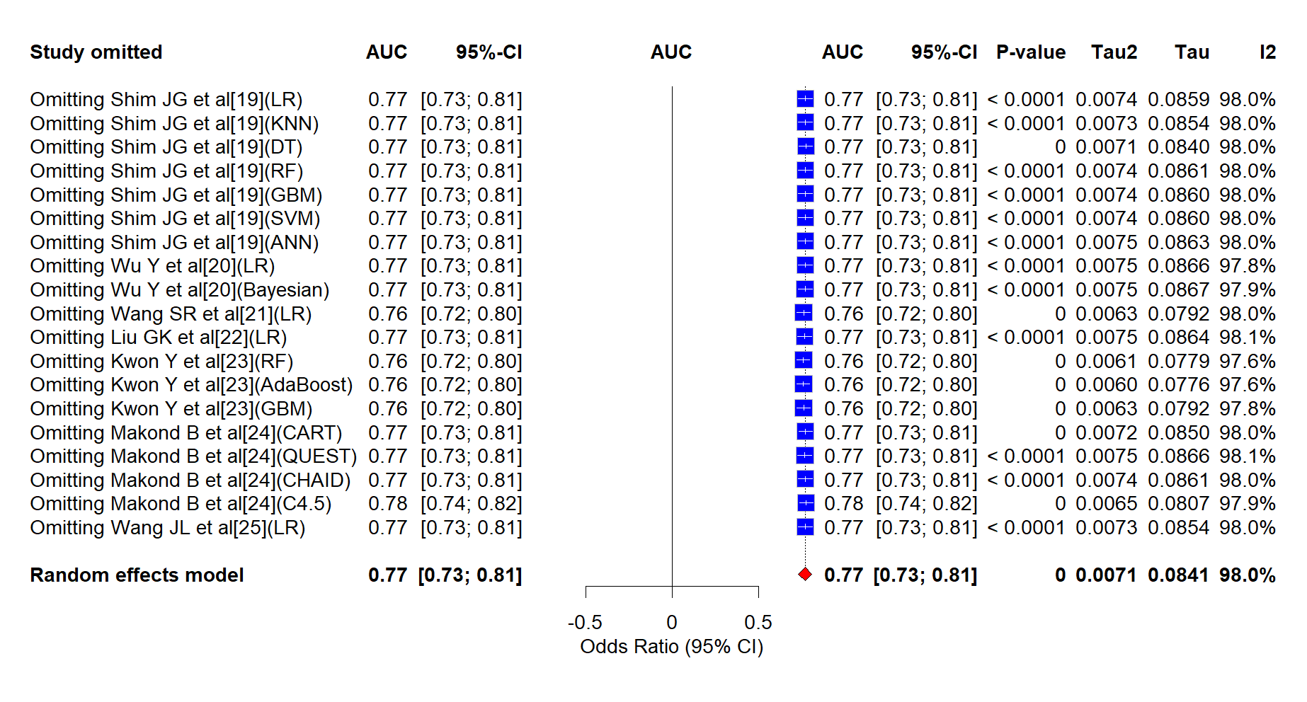
Figure S7 Funnel plot and egger's regression test
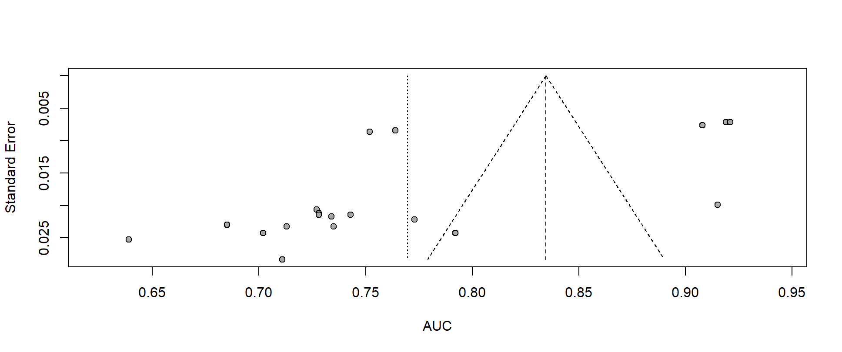
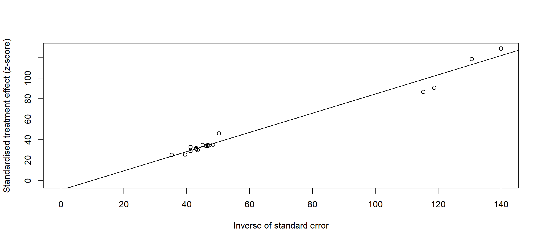
Figure S8 trim-and-fill adjustment
