Supplementary table 1. Summary of group characteristics and detailed information on questionnaire items used to develop the previously determined four latent classes (22).
Latent class label | The Positive (39%) |  | The Fearful (7%) |  | The Distressed (8%) | The Hopeful (46%)
Summary of characteristics | The overall lowest score for reported pain intensity, disability, comorbidities, symptoms of depression, and pain catastrophising. |  | The highest score on fear avoidance behaviour and comorbidity, with the second highest score on reported pain intensity, disability, catastrophising, and symptoms of depression. |  | The highest score on pain intensity, disability, symptoms of depression, and pain catastrophising. They also had the second highest score on both reported comorbidities and fear avoidance behaviour. | The second lowest overall score on all measurements. Unlike The Positive they had somewhat higher scores on pain intensity, disability, fear avoidance behaviour, symptoms of depression, and pain catastrophising.
Questionnaire |  | Range |  | Score interpretation
Back pain intensity (NRS) |  | 0-10 |  | Higher number indicate higher pain intensity
Duration of back pain |  | 0-14 days, 15-90 days, 91-365 days or ≥366 days |  | -
Widespread pain |  | 0-15 |  | Higher score indicates higher number of pain sites
Medication use |  | Yes or no |  | -
Number of comorbidities (SCQ) |  | 0-7 |  | Higher number indicate higher number of comorbidities
Disability (RMDQ) |  | 0-24 |  | Higher score indicates more back-related disability
Kinesiophobia (FABQ-PA) |  | 0-24 |  | Higher score indicates higher level of kinesiophobia
Catastrophising (PCS) |  | 0-52 |  | Higher score indicates more pain catastrophising
Back pain beliefs (BBQ) |  | 9-45 |  | Higher score indicates more pessimistic beliefs regarding the consequences of back pain
Symptoms of depression (CES-D) |  | 0-60 |  | Higher scores indicate the presence of more symptomatology
Expectation |  | Better/much better or no change/worse |  | -
Characteristics were based on the following measurements:
NRS - Numeric rating scale for pain intensity, Widespread pain - pain location (categorized McGill pain drawing), SCQ - Self-Administered Comorbidity Questionnaire, RMDQ - Roland Morris Disability Questionnaire, FABQ -PA - Fear Avoidance Belief Questionnaire-Physical activity subscale, PCS - Pain Catastrophising scale, BBQ - Back Belief Questionnaire, CES-D - Centre for Epidemiologic Studies Depression Scale and Expectation - expectations of back after 3 months.

Supplementary table 2. Patient Characteristics at baseline and at 24 months stratified by LCA classes
 | Baseline (n* = 435) |  |  |  | 24-month follow-up (n* = 234)
 | Class 1  “The Positive”  n* = 169 | Class 2  “The Fearful”  n* = 31 | Class 3  “The Distressed”  n* = 33 | Class 4  “The Hopeful”  n* = 202 | Class 1  “The  Positive”  n* = 92 | Class 2  “The Fearful”  n* = 16 | Class 3  “The Distressed”  n* = 18 | Class 4  “The Hopeful”  n* = 102
Age (mean (SD)) | 65.9 (7.7) | 72.2 (9.5) | 65.7 (8.3) | 66.5 (8.2) | 68.1 (7.8) | 73.6 (9.6) | 66.7 (7.5) | 68.3 (8.1)
Female (n (%)) | 84 (49.7) | 22 (70.9) | 23 (69.9) | 102 (50.4) | 66 (51.9) | 15 (71.4) | 16 (69.5) | 78 (56.1)
Education (n (%))  Less than High School  High School  Higher education <4 years  Higher education >4 years | 11 (6.5)  76 (44.9)  43 (25.4)  39 (23.0) | 2 (9.6)  11 (35.4)  11 (35.4)  6 (19.3) | 7 (21.8)  15 (46.8)  4 (12.5)  6 (18.7) | 24 (12.0)  97 (48.5)  48 (24.0)  31 (15.5) | 8 (6.3)  55 (43.3)  35 (27.5)  29 (22.8) | 3 (14.2)  8 (38.1)  6 (28.5)  4 (19.0) | 5 (21.7)  11 (47.8)  3 (13.0)  4 (17.3) | 17 (12.3)  66 (47.8)  35 (25.6)  20 (14.4)
Paid work, yes (n (%)) | 73 (48.3) | 13 (54.1) | 14 (56.0) | 103 (59.2) | 47 (39.1) | 4 (23.5) | 5 (25.0) | 46 (36.2)
First health care provider (n (%))  General practitioner  Physiotherapist  Chiropractor | 32 (19.1)  45 (26.9)  90 (53.8) | 14 (45.1)  9 (29.0)  8 (25.8) | 14 (42.4)  11 (33.3)  8 (24.2) | 63 (31.2)  61 (30.2)  78 (38.6) | 24 (19.2)  35 (28.0)  66 (52.8) | 8 (38.1)  6 (28.6)  7 (33.3) | 12 (52.2)  5 (21.7)  6 (26.1) | 40 (27.2)  43 (29.0)  56 (43.8)
Pain intensity (NRS)  (mean (SD)) | 4.1 (2.2) | 6.5 (1.9) | 6.5 (1.9) | 6.0 (2.0) | 2.39 (2.7) | 2.9 (2.7) | 3.8 (2.9) | 2.7 (2.6)
Symptom satisfaction (PASS) (mean (SD)) | 3.3 (1.2) | 4.4 (1.0) | 4.6 (0.7) | 4.2 (1.0) | 2.6 (1.4) | 2.7 (1.4) | 2.9 (1.5) | 2.6 (1.3)
SD – standard deviation, n – number, n* - total number without any missing variables, NRS – Numeric Rating Scale, PASS – Patient Acceptable Symptom State

Supplementary table 3. Estimates of fixed effects parameters from linear mixed models. Showing the association between LCA class, pain intensity (NRS) and symptom satisfaction (PASS) over 24 months.
 | NRS score |  |  | PASS score
 | B | 95% CI | P | B | 95% CI | P
Unadjusted model
Follow-up time points  Baseline (ref)  3 months  6 months  12 months  24 months | -2.019  -2.148  -2.341  -1.649 | -2.491 to -1.547  -2.622 to -1.673  -2.827 to -1.855  -2.154 to -1.144 | <0.001  <0.001  <0.001  0.001 | -0.734  -0.963  -1.214  -0.672 | -0.955 to -0.475  -1.228 to -0.698  -1.481 to -0.946  -0.955 to -0.390 | <0.001  <0.001  <0.001  <0.001
LCA class  The Positive (ref)  The Fearful  The Distressed  The Hopeful | 2.420  2.522  1.894 | 1.478 to 3.363  1.594 to 3.449  1.392 to 2.396 | <0.001  <0.001  <0.001 | 1.066  1.321  0.862 | 0.557 to 1.575  0.825 to 1.817  0.593 to 1.132 | <0.001  <0.001  <0.001
Interaction Time x LCA  Baseline x The Positive (ref)  3 months x The Fearful  3 months x The Distressed  3 months x The Hopeful  6 months x The Fearful  6 months x The Distressed  6 months x The Hopeful  12 months x The Fearful  12 months x The Distressed  12 months x The Hopeful  24 months x The Fearful  24 months x The Distressed  24 months x The Hopeful | -0.888  -0.445  -0.788  -0.374  -0.516  -1.054  -0.503  0.247  -0.349  -1.894  -1.255  -1.618 | -2.052 to 0.275  -1.620 to 0.729  -1.431 to -0.145  -1.601 to 0.852  -1.692 to 0.659  -1.703 to -0.405  -1.764 to 0.757  -0.953 to 1.448  -1.009 to 0.310  -3.107 to -0.682  -2.491 to -0.019  -2.306 to -0.930 | 0.135  0.457  0.016  0.550  0.389  0.001  0.434  0.686  0.299  0.002  0.047  <0.001 | -0.174  -0.139  -0.486  0.157  -0.124  -0.179  0.414  0.041  -0.105  -1.038  1.083  -0.816 | -0.814 to 0.466  -0.778 to 0.499  -0.841 to -0.130  -0.517 to 0.832  -0.766 to 0.518  -0.539 to 0.180  -0.239 to 1.097  -0.612 to 0.695  -0.469 to 0.258  -1.735 to -0.340  -1.764 to -0.402  -1.199 to -0.432 | 0.594  0.669  0.007  0.648  0.705  0.329  0.235  0.901  0.570  0.004  0.002  <0.001
Full model
Follow-up time points  Baseline (ref)  3 months  6 months  12 months  24 months | -1.874  -2.105  -2.238  -1.446 | -2.382 to -1.367  -2.618 to -1.592  -2.763 to -1.713  -1.989 to -0.903 | <0.001  <0.001  <0.001  <0.001 | -0.712  -0.950  -1.190  -0.589 | -0.990 to -0.434  -1.236 to -0.664  -1.477 to -0.903  -0.893 to -0.284 | <0.001  <0.001  <0.001  <0.001
LCA class  The Positive (ref)  The Fearful  The Distressed  The Hopeful | 2.140  2.134  1.924 | 1.070 to 3.209  1.075 to 3.194  1.386 to 2.463 | <0.001  <0.001  <0.001 | 0.977  1.206  0.844 | 0.395 to 1.560  0.637 to 1.774  0.552 to 1.135 | 0.001  <0.001  <0.001
Interaction Time x LCA  Baseline x The Positive (ref)  3 months x The Fearful  3 months x The Distressed  3 months x The Hopeful  6 months x The Fearful  6 months x The Distressed  6 months x The Hopeful  12 months x The Fearful  12 months x The Distressed  12 months x The Hopeful  24 months x The Fearful  24 months x The Distressed  24 months x The Hopeful | -0.958  -0.772  -0.962  -0.553  -0.646  -1.247  -0.445  0.486  -0.537  -2.334  -1.373  -1.975 | -2.295 to 0.377  -2.129 to 0.585  -1.662 to -0.261  -1.929 to 0.823  -2.005 to 0.713  -1.957 to -0.537  -1.865 to 0.974  -0.877 to 1.851  -1.256 to 0.182  -3.721 to -0.947  -2.800 to 0.053  -2.726 to -1.223 | 0.160  0.265  0.007  0.431  0.352  0.001  0.539  0.484  0.144  0.001  0.059  <0.001 | 0.068  -0.246  -0.445  0.215  -0.158  -0.236  0.294  0.081  -0.146  -1.336  -0.892  -0.925 | -0.662 to 0.800  -0.979 to 0.486  -0.830 to -0.059  -0.536 to 0.968  -0.894 to 0.577  -0.628 to 0.156  -0.468 to 1.057  -0.655 to 0.817  -0.541 to 0.249  -2.143 to -0.529  -1.666 to -0.119  -1.344 to -0.506 | 0.854  0.510  0.024  0.574  0.673  0.238  0.450  0.829  0.468  0.001  0.024  <0.001
B – regression coefficient, P – p-value, CI – confidence interval, NRS – Numeric Rating Scale, PASS – Patient Acceptable Symptom State, bold numbers indicate statistical significance. Full model was adjusted for age, gender, education level, employment, and visit to chosen primary health care practitioner.

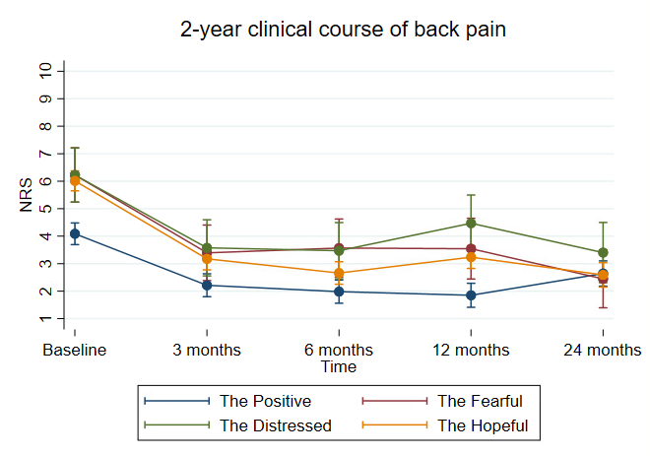
Supplementary figure 1a. Margins plot: Clinical course of back pain intensity from baseline to 24 months follow-up. NRS – Numeric Rating Scale.
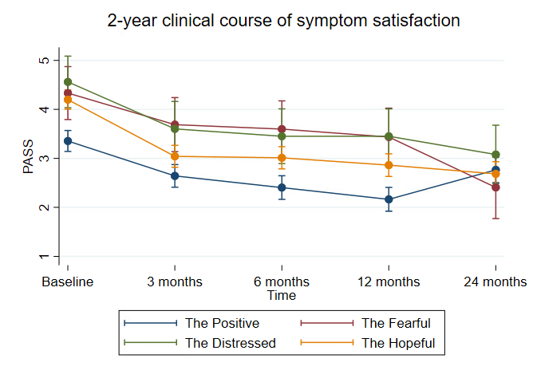
Supplementary figure 1b. Margins plot: Clinical course of symptom satisfaction from baseline to 24 months follow-up. PASS – Patient Acceptable Symptom State: 1) ”very satisfied”, 2) “somewhat satisfied”, 3) “neither satisfied nor dissatisfied”, 4) “somewhat dissatisfied” and 5) “very dissatisfied”.

Supplementary figure 4. Comparison between groups at all time points for NRS
Group vs group | Contrast | Delta-method std err. | p-value
Baseline
2 vs 1 | 2.14 | 0.41 | 0.000
3 vs 1 | 1.92 | 0.27 | 0.000
3 vs 2 | -0.21 | 0.40 | 0.588
3 months
2 vs 1 | 1.27 | 0.42 | 0.003
3 vs 1 | 0.96 | 0.29 | 0.001
3 vs 2 | -0.31 | 0.41 | 0.459
6 months
2 vs 1 | 1.53 | 0.43 | 0.000
3 vs 1 | 0.67 | 0.30 | 0.025
3 vs 2 | -0.85 | 0.42 | 0.045
12 months
2 vs 1 | 2.19 | 0.44 | 0.000
3 vs 1 | 1.38 | 0.30 | 0.000
3 vs 2 | -0.80 | 0.43 | 0.065
24 months
2 vs 1 | 0.26 | 0.45 | 0.559
3 vs 1 | -0.04 | 0.32 | 0.879
3 vs 2 | -0.31 | 0.44 | 0.483
1 = The Positive, 2 = The Fearful & Distressed, 3 = The Hopeful

Supplementary figure 5. Comparison between groups at all time points for PASS
Group vs group | Contrast | Delta-method std err. | p-value
Baseline
2 vs 1 | 1.09 | 0.22 | 0.000
3 vs 1 | 0.84 | 0.14 | 0.000
3 vs 2 | -0.25 | 0.21 | 0.247
3 months
2 vs 1 | 1.00 | 0.23 | 0.000
3 vs 1 | 0.39 | 0.16 | 0.015
3 vs 2 | -0.60 | 0.23 | 0.009
6 months
2 vs 1 | 1.12 | 0.23 | 0.000
3 vs 1 | 0.60 | 0.16 | 0.000
3 vs 2 | -0.51 | 0.23 | 0.029
12 months
2 vs 1 | 1.28 | 0.24 | 0.000
3 vs 1 | 0.69 | 0.17 | 0.000
3 vs 2 | -0.58 | 0.23 | 0.014
24 months
2 vs 1 | -0.00 | 0.26 | 0.999
3 vs 1 | -0.08 | 0.18 | 0.660
3 vs 2 | -0.08 | 0.25 | 0.753
1 = The Positive, 2 = The Fearful & Distressed, 3 = The Hopeful

