Supplementary Table 1. Association between metabolic-obesity phenotypes and the risk of knee and hand osteoarthritis after multiple imputation for missing covariates.
Group | Model 1 |  |  | Model 2
Group | Time Ratio (95% CI) | P value |  | Time Ratio (95% CI) | P value
Knee osteoarthritis
MHN | Ref |  |  | Ref
MHO | 0.59 (0.56, 0.62) | <0.001 |  | 0.59 (0.56, 0.63) | <0.001
MUN | 0.92(0.89, 0.94) | <0.001 |  | 0.92 (0.89, 0.94) | <0.001
MUO | 0.60 (0.58, 0.61) | <0.001 |  | 0.60 (0.58, 0.61) | <0.001
Hand osteoarthritis
MHN | Ref |  |  | Ref
MHO | 0.89 (0.70, 1.13) | 0.354 |  | 0.90 (0.60, 1.34) | 0.602
MUN | 0.93 (0.86, 1.01) | 0.088 |  | 0.91 (0.80, 1.03) | 0.126
MUO | 0.87 (0.80, 0.95) | 0.002 |  | 0.83 (0.72, 0.96) | 0.013
Note: Bold denotes statistically significant results. CI, confidence interval; OA, osteoarthritis; Ref, reference; MHN, metabolically healthy non-obesity; MHO, metabolically healthy obesity; MUN, metabolically unhealthy non-obesity; MUO, metabolically unhealthy obesity. Time Ratio of<l indicates a detrimental effect of metabolic-obesity phenotypes on the risk of osteoarthritis.
Model 1: adjusted for age, sex. Mode 2: further adjusted for race, TDI, smoking status, drinking status, and physical activity.

Supplementary Table 2. Association between metabolic-obesity phenotypes and the risk of knee and hand osteoarthritis after excluding patients who developed osteoarthritis within the first 4 years.
Group | Model 1 |  |  | Model 2
Group | Time Ratio (95% CI) | P value |  | Time Ratio (95% CI) | P value
Knee osteoarthritis
MHN | Ref |  |  | Ref
MHO | 0.36 (0.33, 0.40) | <0.001 |  | 0.37 (0.33, 0.40) | <0.001
MUN | 0.87(0.83, 0.90) | <0.001 |  | 0.87 (0.83, 0.90) | <0.001
MUO | 0.37 (0.35, 0.38) | <0.001 |  | 0.37 (0.35, 0.38) | <0.001
Hand osteoarthritis
MHN | Ref |  |  | Ref
MHO | 0.82 (0.57, 1.19) | 0.302 |  | 0.83 (0.57, 1.20) | 0.326
MUN | 0.89 (0.79, 1.01) | 0.064 |  | 0.89 (0.78, 1.00) | 0.059
MUO | 0.78 (0.68, 0.89) | <0.001 |  | 0.80 (0.69, 0.92) | 0.001
Note: Bold denotes statistically significant results. CI, confidence interval; OA, osteoarthritis; Ref, reference; MHN, metabolically healthy non-obesity; MHO, metabolically healthy obesity; MUN, metabolically unhealthy non-obesity; MUO, metabolically unhealthy obesity. Time Ratio of<l indicates a detrimental effect of metabolic-obesity phenotypes on the risk of osteoarthritis.
Model 1: adjusted for age, sex. Mode 2: further adjusted for race, TDI, smoking status, drinking status, and physical activity.

Supplementary Table 3. Association between metabolic-obesity phenotypes and the risk of knee and hand osteoarthritis under a less stringent definition of metabolic abnormality.
Group | Model 1 |  |  | Model 2
Group | Time Ratio (95% CI) | P value |  | Time Ratio (95% CI) | P value
Knee osteoarthritis
MHN | Ref |  |  | Ref
MHO | 0.60 (0.57, 0.62) | <0.001 |  | 0.38 (0.35, 0.40) | <0.001
MUN | 0.91(0.89, 0.93) | <0.001 |  | 0.84 (0.81, 0.87) | <0.001
MUO | 0.59 (0.58, 0.61) | <0.001 |  | 0.36 (0.35, 0.38) | <0.001
Hand osteoarthritis
MHN | Ref |  |  | Ref
MHO | 0.84 (0.72, 1.00) | 0.044 |  | 0.76(0.58, 0.98) | 0.033
MUN | 0.95 (0.89, 1.02) | 0.172 |  | 0.95(0.85, 1.05) | 0.315
MUO | 0.90 (0.83, 0.97) | 0.008 |  | 0.85 (0.75, 0.96) | 0.009
Note: Bold denotes statistically significant results. CI, confidence interval; OA, osteoarthritis; Ref, reference; MHN, metabolically healthy non-obesity; MHO, metabolically healthy obesity; MUN, metabolically unhealthy non-obesity; MUO, metabolically unhealthy obesity. Time Ratio of<l indicates a detrimental effect of metabolic-obesity phenotypes on the risk of osteoarthritis.
Model 1: adjusted for age, sex. Mode 2: further adjusted for race, TDI, smoking status, drinking status, and physical activity.

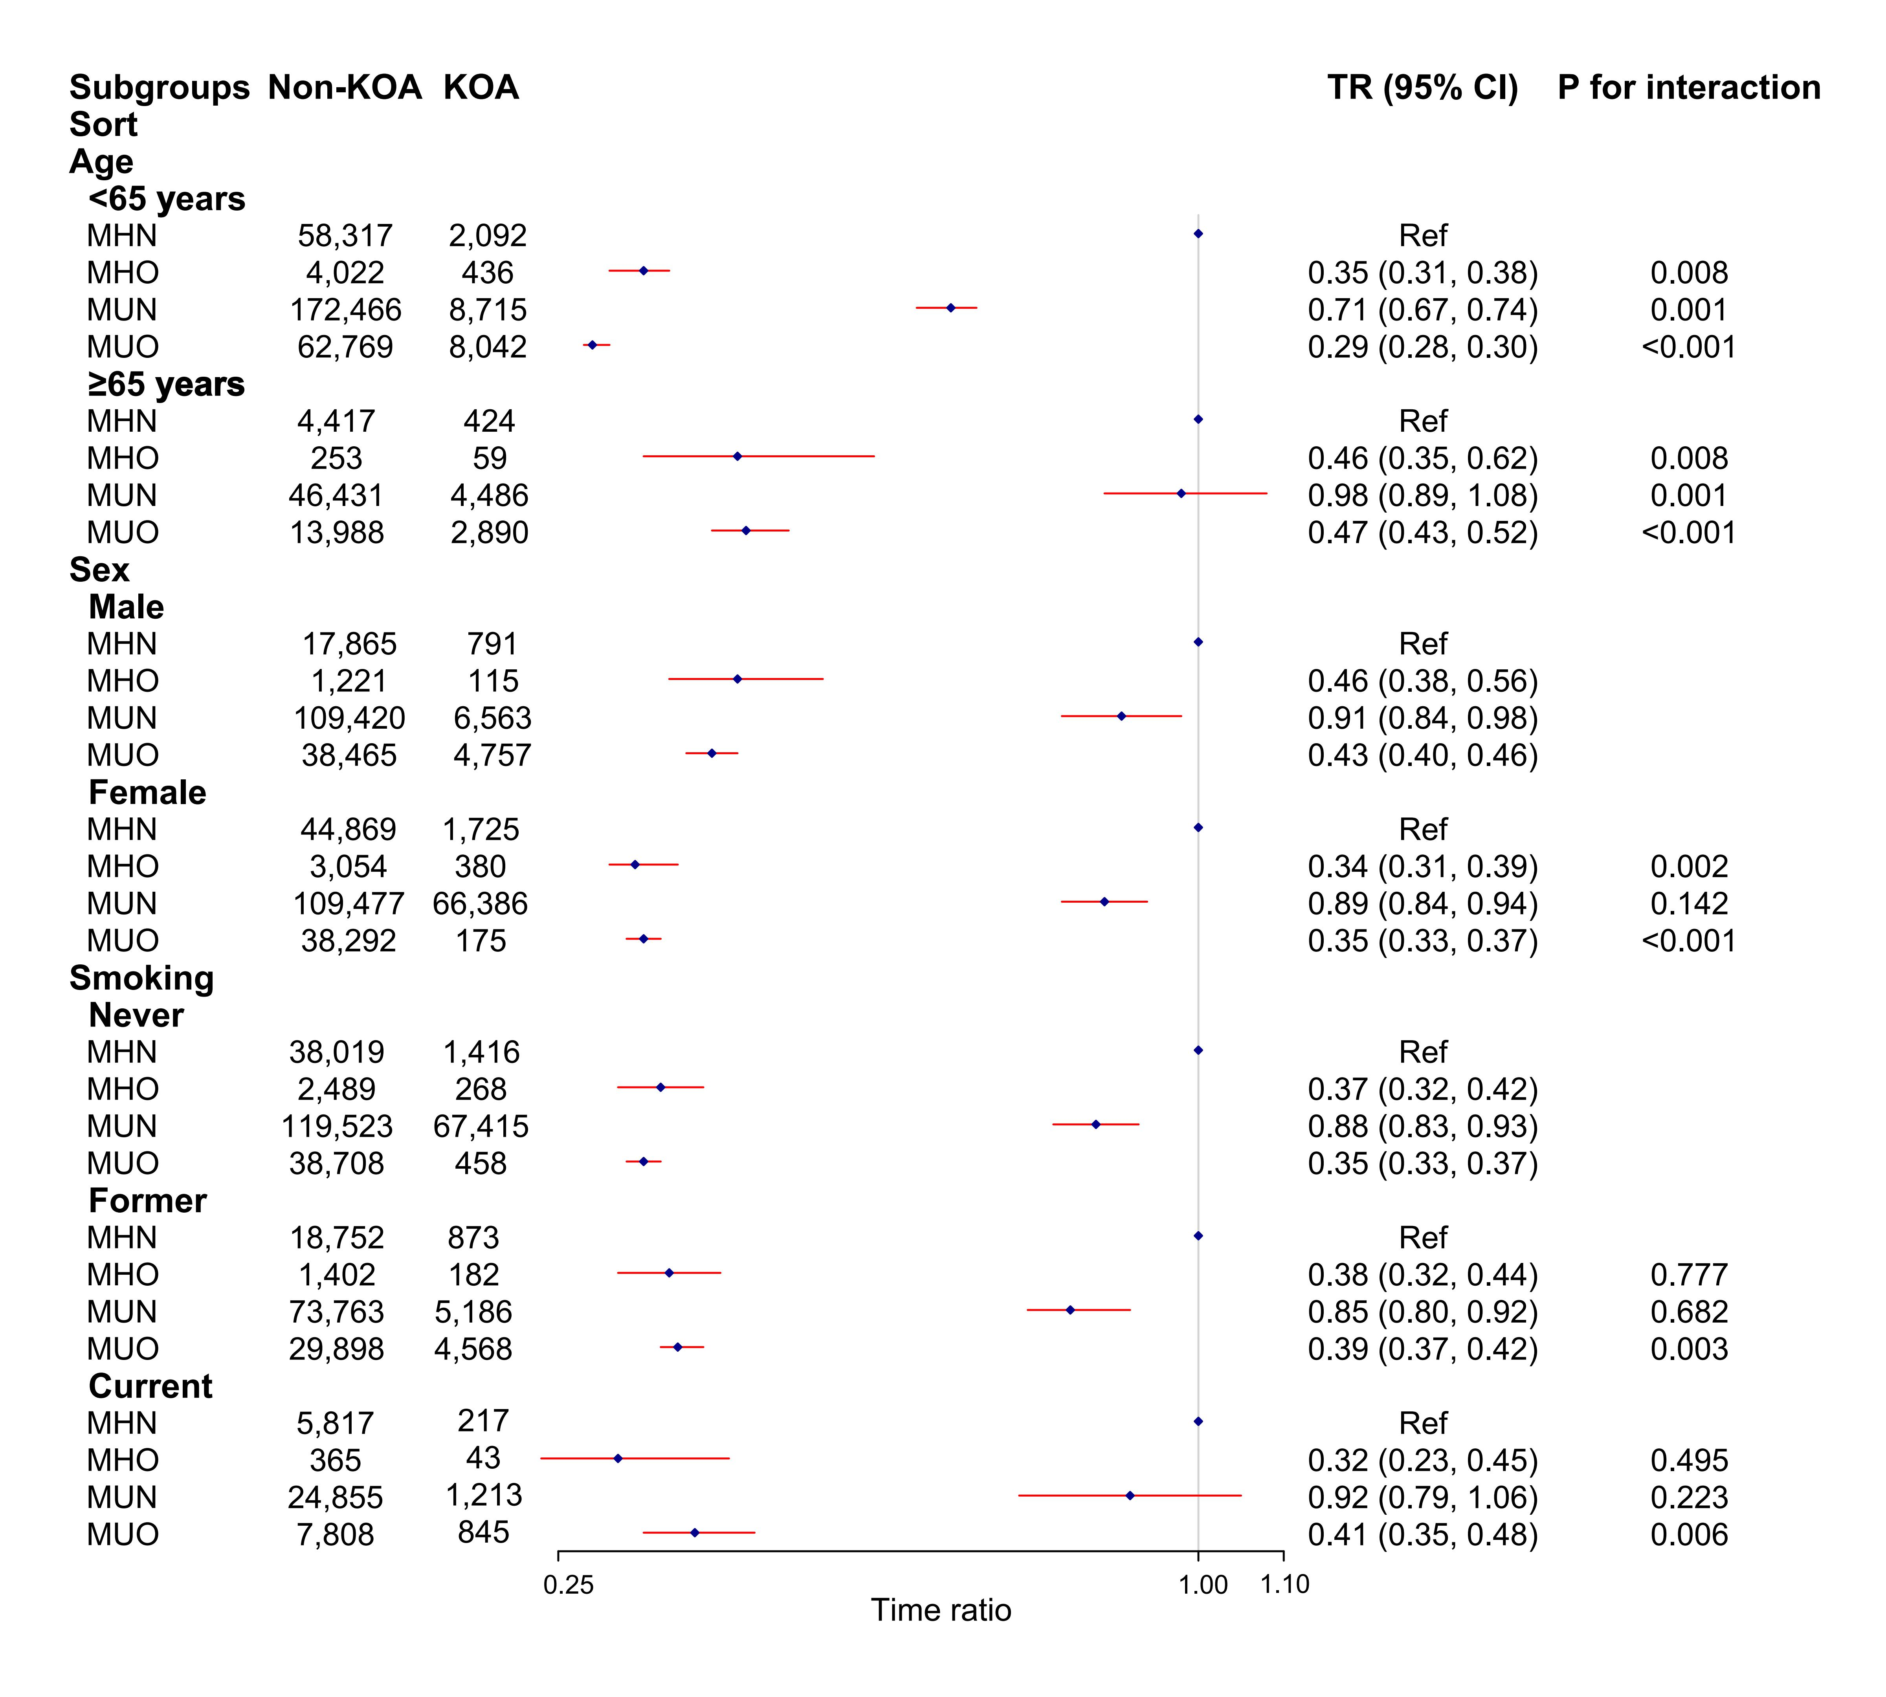
Supplementary Figure 1. Subgroup analysis for the association between metabolic-obesity phenotypes and the risk of knee osteoarthritis. OA, osteoarthritis; TR, Time ratio; TR of<l indicates a detrimental effect of metabolic-obesity phenotypes on the risk of osteoarthritis.

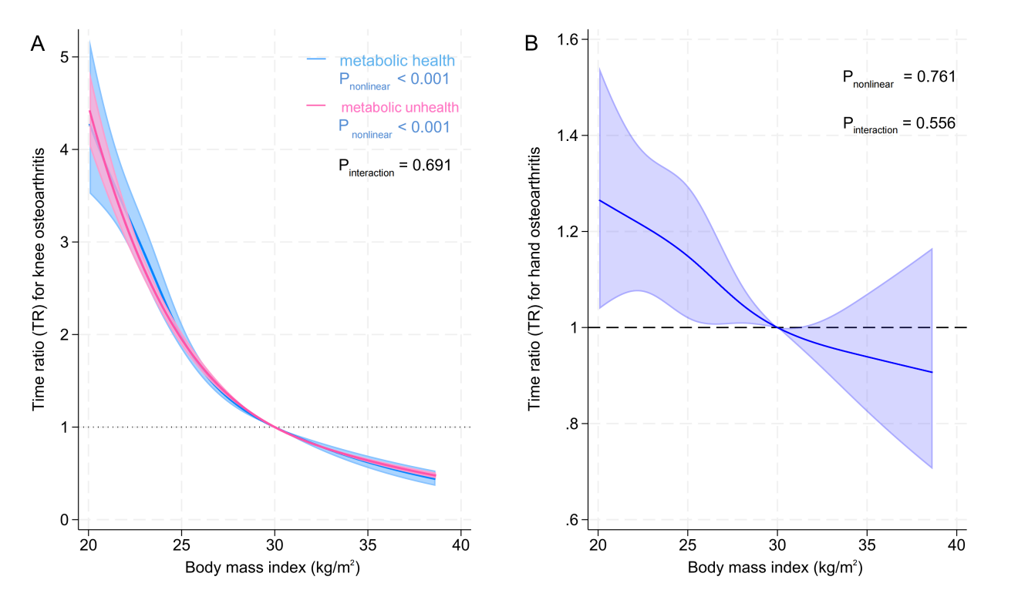

Supplementary Figure 2. The nonlinear association between body mass index (BMI) and the risk of (A) knee and (B) hand osteoarthritis. Red and blue lines are estimated effects from restricted cubic spline and accelerated failure time models, and shadows indicates 95% confidence interval.

