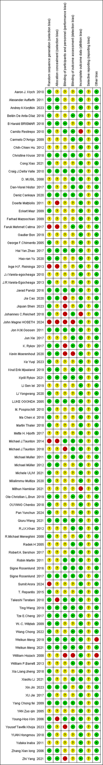
Supplementary Fig 1: Summary of Risk of Bias.
Supplementary Table 1 PRISMA NMA checklist.

PRISMA NMA Checklist of Items to Include When Reporting A Systematic Review Involving a Network Meta-analysis

Section/Topic | Item # | Checklist Item | Reported on Page #
TITLE
Title | 1 | Identify the report as a systematic review incorporating a network meta-analysis (or related form of meta-analysis). | 1
ABSTRACT
Structured summary | 2 | Provide a structured summary including, as applicable:  Background: main objectives  Methods: data sources; study eligibility criteria, participants, and interventions; study appraisal; and synthesis methods, such as network meta-analysis.  Results: number of studies and participants identified; summary estimates with corresponding confidence/credible intervals; treatment rankings may also be discussed. Authors may choose to summarize pairwise comparisons against a chosen treatment included in their analyses for brevity.  Discussion/Conclusions: limitations; conclusions and implications of findings.  Other: primary source of funding; systematic review registration number with registry name. | 2-3
INTRODUCTION
Rationale | 3 | Describe the rationale for the review in the context of what is already known, including mention of why a network meta-analysis has been conducted. | 4-6
Objectives | 4 | Provide an explicit statement of questions being addressed, with reference to participants, interventions, comparisons, outcomes, and study design (PICOS). | 5-6
METHODS
Protocol and registration | 5 | Indicate whether a review protocol exists and if and where it can be accessed (e.g., Web address); and, if available, provide registration information, including registration number. | 6
Eligibility criteria | 6 | Specify study characteristics (e.g., PICOS, length of follow-up) and report characteristics (e.g., years considered, language, publication status) used as criteria for eligibility, giving rationale. Clearly describe eligible treatments included in the treatment network, and note whether any have been clustered or merged into the same node (with justification). | 7
Information sources | 7 | Describe all information sources (e.g., databases with dates of coverage, contact with study authors to identify additional studies) in the search and date last searched. | 6-7
Search | 8 | Present full electronic search strategy for at least one database, including any limits used, such that it could be repeated. | 6-7
Study selection | 9 | State the process for selecting studies (i.e., screening, eligibility, included in systematic review, and, if applicable, included in the meta-analysis). | 7
Data collection process | 10 | Describe method of data extraction from reports (e.g., piloted forms, independently, in duplicate) and any processes for obtaining and confirming data from investigators. | 8
Data items | 11 | List and define all variables for which data were sought (e.g., PICOS, funding sources) and any assumptions and simplifications made. | 8
Geometry of the network | S1 | Describe methods used to explore the geometry of the treatment network under study and potential biases related to it. This should include how the evidence base has been graphically summarized for presentation, and what characteristics were compiled and used to describe the evidence base to readers. | 9-10
Risk of bias within individual studies | 12 | Describe methods used for assessing risk of bias of individual studies (including specification of whether this was done at the study or outcome level), and how this information is to be used in any data synthesis. | 9-10
Summary measures | 13 | State the principal summary measures (e.g., risk ratio, difference in means). Also describe the use of additional summary measures assessed, such as treatment rankings and surface under the cumulative ranking curve (SUCRA) values, as well as modified approaches used to present summary findings from meta-analyses. | 7,10-11
Planned methods of analysis | 14 | Describe the methods of handling data and combining results of studies for each network meta-analysis. This should include, but not be limited to:  - Handling of multi-arm trials;  - Selection of variance structure;  - Selection of prior distributions in Bayesian analyses; and  - Assessment of model fit. | 9-10
Assessment of Inconsistency | S2 | Describe the statistical methods used to evaluate the agreement of direct and indirect evidence in the treatment network(s) studied. Describe efforts taken to address its presence when found. | 9-10
Risk of bias across studies | 15 | Specify any assessment of risk of bias that may affect the cumulative evidence (e.g., publication bias, selective reporting within studies). | 9-10
Additional analyses | 16 | Describe methods of additional analyses if done, indicating which were pre-specified. This may include, but not be limited to, the following:  - Sensitivity or subgroup analyses;  - Meta-regression analyses;  - Alternative formulations of the treatment network; and  - Use of alternative prior distributions for Bayesian analyses (if applicable). | 9-10
RESULTS†
Study selection | 17 | Give numbers of studies screened, assessed for eligibility, and included in the review, with reasons for exclusions at each stage, ideally with a flow diagram. | 10
Presentation of network structure | S3 | Provide a network graph of the included studies to enable visualization of the geometry of the treatment network. | 17-28
Summary of network geometry | S4 | Provide a brief overview of characteristics of the treatment network. This may include commentary on the abundance of trials and randomized patients for the different interventions and pairwise comparisons in the network, gaps of evidence in the treatment network, and potential biases reflected by the network structure. | 17-28
Study characteristics | 18 | For each study, present characteristics for which data were extracted (e.g., study size, PICOS, follow-up period) and provide the citations. | 11-16
Risk of bias within studies | 19 | Present data on risk of bias of each study and, if available, any outcome level assessment. | 16-17
Results of individual studies | 20 | For all outcomes considered (benefits or harms), present, for each study: 1) simple summary data for each intervention group, and 2) effect estimates and confidence intervals. Modified approaches may be needed to deal with information from larger networks. | 17-28
Synthesis of results | 21 | Present results of each meta-analysis done, including confidence/credible intervals. In larger networks, authors may focus on comparisons versus a particular comparator (e.g. placebo or standard care), with full findings presented in an appendix. League tables and forest plots may be considered to summarize pairwise comparisons. If additional summary measures were explored (such as treatment rankings), these should also be presented. | 17-28
Exploration for inconsistency | S5 | Describe results from investigations of inconsistency. This may include such information as measures of model fit to compare consistency and inconsistency models, P values from statistical tests, or summary of inconsistency estimates from different parts of the treatment network. | 17-28
Risk of bias across studies | 22 | Present results of any assessment of risk of bias across studies for the evidence base being studied. | 17-28
Results of additional analyses | 23 | Give results of additional analyses, if done (e.g., sensitivity or subgroup analyses, meta-regression analyses, alternative network geometries studied, alternative choice of prior distributions for Bayesian analyses, and so forth). | 17-28
DISCUSSION
Summary of evidence | 24 | Summarize the main findings, including the strength of evidence for each main outcome; consider their relevance to key groups (e.g., healthcare providers, users, and policy-makers). | 17-28
Limitations | 25 | Discuss limitations at study and outcome level (e.g., risk of bias), and at review level (e.g., incomplete retrieval of identified research, reporting bias). Comment on the validity of the assumptions, such as transitivity and consistency. Comment on any concerns regarding network geometry (e.g., avoidance of certain comparisons). | 31-32
Conclusions | 26 | Provide a general interpretation of the results in the context of other evidence, and implications for future research. | 29-32
FUNDING
Funding | 27 | Describe sources of funding for the systematic review and other support (e.g., supply of data); role of funders for the systematic review. This should also include information regarding whether funding has been received from manufacturers of treatments in the network and/or whether some of the authors are content experts with professional conflicts of interest that could affect use of treatments in the network. | 33

PICOS = population, intervention, comparators, outcomes, study design.
* Text in italics indicateS wording specific to reporting of network meta-analyses that has been added to guidance from the PRISMA statement.
† Authors may wish to plan for use of appendices to present all relevant information in full detail for items in this section.

Supplementary Table 2 Literature search strategy.
PubMed Search Strategy
Step Search Query
#1 "Arthroplasty, Replacement, Hip"[Mesh] Most Recent"arthroplasty, replacement, hip"[MeSH Terms] 37,389
#2 Hip Replacement Arthroplasty[Title/Abstract] OR Replacement Arthroplasties, Hip[Title/Abstract] OR Replacement Arthroplasty, Hip[Title/Abstract] OR Hip Prosthesis Implantation[Title/Abstract] OR Hip Prosthesis Implantations[Title/Abstract] OR Implantation, Hip Prosthesis[Title/Abstract] OR Prosthesis Implantation, Hip[Title/Abstract] OR Arthroplasties, Hip Replacement[Title/Abstract] OR Arthroplasties, Replacement, Hip[Title/Abstract] OR Hip Replacement Arthroplasties[Title/Abstract] OR Arthroplasty, Hip Replacement[Title/Abstract] OR Hip Replacement, Total[Title/Abstract] OR Total Hip Arthroplasty[Title/Abstract] OR Arthroplasty, Total Hip[Title/Abstract] OR Hip Arthroplasty, Total[Title/Abstract] OR Total Hip Arthroplasties[Title/Abstract] OR Replacement, Total Hip[Title/Abstract] OR Total Hip Replacements[Title/Abstract] OR Total Hip Replacement[Title/Abstract] "hip replacement arthroplasty"[Title/Abstract] OR (("replace"[All Fields] OR "replaceable"[All Fields] OR "replaced"[All Fields] OR "replaces"[All Fields] OR "replacing"[All Fields] OR "replacment"[All Fields] OR "replantation"[MeSH Terms] OR "replantation"[All Fields] OR "Replacement"[All Fields] OR "Replacements"[All Fields]) AND "arthroplasties hip"[Title/Abstract]) OR "replacement arthroplasty hip"[Title/Abstract] OR "hip prosthesis implantation"[Title/Abstract] OR "hip prosthesis implantations"[Title/Abstract] OR (("drug implants"[MeSH Terms] OR ("drug"[All Fields] AND "implants"[All Fields]) OR "drug implants"[All Fields] OR "implant"[All Fields] OR "embryo implantation"[MeSH Terms] OR ("embryo"[All Fields] AND "Implantation"[All Fields]) OR "embryo implantation"[All Fields] OR "Implantation"[All Fields] OR "implant s"[All Fields] OR "implantability"[All Fields] OR "implantable"[All Fields] OR "implantables"[All Fields] OR "implantate"[All Fields] OR "implantated"[All Fields] OR "implantates"[All Fields] OR "Implantations"[All Fields] OR "implanted"[All Fields] OR "implanter"[All Fields] OR "implanters"[All Fields] OR "implanting"[All Fields] OR "implantion"[All Fields] OR "implantitis"[All Fields] OR "implants"[All Fields]) AND "hip prosthesis"[Title/Abstract]) OR (("prostheses and implants"[MeSH Terms] OR ("prostheses"[All Fields] AND "implants"[All Fields]) OR "prostheses and implants"[All Fields] OR "Prosthesis"[All Fields]) AND "implantation hip"[Title/Abstract]) OR "arthroplasties hip replacement"[Title/Abstract] OR (("Arthroplasty"[MeSH Terms] OR "Arthroplasty"[All Fields] OR "Arthroplasties"[All Fields]) AND "replacement hip"[Title/Abstract]) OR "hip replacement arthroplasties"[Title/Abstract] OR "arthroplasty hip replacement"[Title/Abstract] OR "hip replacement total"[Title/Abstract] OR "total hip arthroplasty"[Title/Abstract] OR "arthroplasty total hip"[Title/Abstract] OR "hip arthroplasty total"[Title/Abstract] OR "total hip arthroplasties"[Title/Abstract] OR "replacement total hip"[Title/Abstract] OR "total hip replacements"[Title/Abstract] OR "total hip replacement"[Title/Abstract] 38,176
#3 ("Arthroplasty, Replacement, Hip"[Mesh]) OR (Hip Replacement Arthroplasty[Title/Abstract] OR Replacement Arthroplasties, Hip[Title/Abstract] OR Replacement Arthroplasty, Hip[Title/Abstract] OR Hip Prosthesis Implantation[Title/Abstract] OR Hip Prosthesis Implantations[Title/Abstract] OR Implantation, Hip Prosthesis[Title/Abstract] OR Prosthesis Implantation, Hip[Title/Abstract] OR Arthroplasties, Hip Replacement[Title/Abstract] OR Arthroplasties, Replacement, Hip[Title/Abstract] OR Hip Replacement Arthroplasties[Title/Abstract] OR Arthroplasty, Hip Replacement[Title/Abstract] OR Hip Replacement, Total[Title/Abstract] OR Total Hip Arthroplasty[Title/Abstract] OR Arthroplasty, Total Hip[Title/Abstract] OR Hip Arthroplasty, Total[Title/Abstract] OR Total Hip Arthroplasties[Title/Abstract] OR Replacement, Total Hip[Title/Abstract] OR Total Hip Replacements[Title/Abstract] OR Total Hip Replacement[Title/Abstract]) "arthroplasty, replacement, hip"[MeSH Terms] OR ("hip replacement arthroplasty"[Title/Abstract] OR (("replace"[All Fields] OR "replaceable"[All Fields] OR "replaced"[All Fields] OR "replaces"[All Fields] OR "replacing"[All Fields] OR "replacment"[All Fields] OR "replantation"[MeSH Terms] OR "replantation"[All Fields] OR "Replacement"[All Fields] OR "Replacements"[All Fields]) AND "arthroplasties hip"[Title/Abstract]) OR "replacement arthroplasty hip"[Title/Abstract] OR "hip prosthesis implantation"[Title/Abstract] OR "hip prosthesis implantations"[Title/Abstract] OR (("drug implants"[MeSH Terms] OR ("drug"[All Fields] AND "implants"[All Fields]) OR "drug implants"[All Fields] OR "implant"[All Fields] OR "embryo implantation"[MeSH Terms] OR ("embryo"[All Fields] AND "Implantation"[All Fields]) OR "embryo implantation"[All Fields] OR "Implantation"[All Fields] OR "implant s"[All Fields] OR "implantability"[All Fields] OR "implantable"[All Fields] OR "implantables"[All Fields] OR "implantate"[All Fields] OR "implantated"[All Fields] OR "implantates"[All Fields] OR "Implantations"[All Fields] OR "implanted"[All Fields] OR "implanter"[All Fields] OR "implanters"[All Fields] OR "implanting"[All Fields] OR "implantion"[All Fields] OR "implantitis"[All Fields] OR "implants"[All Fields]) AND "hip prosthesis"[Title/Abstract]) OR (("prostheses and implants"[MeSH Terms] OR ("prostheses"[All Fields] AND "implants"[All Fields]) OR "prostheses and implants"[All Fields] OR "Prosthesis"[All Fields]) AND "implantation hip"[Title/Abstract]) OR "arthroplasties hip replacement"[Title/Abstract] OR (("Arthroplasty"[MeSH Terms] OR "Arthroplasty"[All Fields] OR "Arthroplasties"[All Fields]) AND "replacement hip"[Title/Abstract]) OR "hip replacement arthroplasties"[Title/Abstract] OR "arthroplasty hip replacement"[Title/Abstract] OR "hip replacement total"[Title/Abstract] OR "total hip arthroplasty"[Title/Abstract] OR "arthroplasty total hip"[Title/Abstract] OR "hip arthroplasty total"[Title/Abstract] OR "total hip arthroplasties"[Title/Abstract] OR "replacement total hip"[Title/Abstract] OR "total hip replacements"[Title/Abstract] OR "total hip replacement"[Title/Abstract]) 52,699
#4 (Anterior Approach[Title/Abstract]) OR (Direct Anterior Approach[Title/Abstract]) OR (Anterior Lateral Approach[Title/Abstract]) OR (Anterior Lateral Approach[Title/Abstract]) OR (Posterior Approach[Title/Abstract]) OR (Posteroanterior Approach[Title/Abstract]) OR (Posterolateral Approach[Title/Abstract]) OR (Posterolateral Approach[Title/Abstract]) OR (Direct Superior Approach[Title/Abstract]) OR (Direct Superior Approach[Title/Abstract]) OR (Direct Lateral Approach[Title/Abstract]) OR (Direct Lateral Approach[Title/Abstract]) OR (Two-incision approach[Title/Abstract]) OR (Two-incision approach[Title/Abstract]) OR (SuperPATH Approach[Title/Abstract]) OR (Percutaneous Assisted Retention of Joint Capsule[Title/Abstract]) OR (Superficial Peroneal Artery Approach[Title/Abstract]) OR (Two-incision approach[Title/Abstract]) "anterior approach"[Title/Abstract] OR "direct anterior approach"[Title/Abstract] OR "anterior lateral approach"[Title/Abstract] OR "anterior lateral approach"[Title/Abstract] OR "posterior approach"[Title/Abstract] OR "posteroanterior approach"[Title/Abstract] OR "posterolateral approach"[Title/Abstract] OR "posterolateral approach"[Title/Abstract] OR "direct superior approach"[Title/Abstract] OR "direct superior approach"[Title/Abstract] OR "direct lateral approach"[Title/Abstract] OR "direct lateral approach"[Title/Abstract] OR "two incision approach"[Title/Abstract] OR "two incision approach"[Title/Abstract] OR "superpath approach"[Title/Abstract] OR ((("percutaneous"[All Fields] OR "percutaneously"[All Fields] OR "percutanous"[All Fields]) AND ("assistances"[All Fields] OR "assistant s"[All Fields] OR "assistants"[All Fields] OR "assisted"[All Fields] OR "assisting"[All Fields] OR "assistive"[All Fields] OR "dental assistants"[MeSH Terms] OR ("dental"[All Fields] AND "assistants"[All Fields]) OR "dental assistants"[All Fields] OR "assistant"[All Fields] OR "helping behavior"[MeSH Terms] OR ("helping"[All Fields] AND "behavior"[All Fields]) OR "helping behavior"[All Fields] OR "assist"[All Fields] OR "assistance"[All Fields] OR "assists"[All Fields]) AND ("retention, psychology"[MeSH Terms] OR ("retention"[All Fields] AND "psychology"[All Fields]) OR "psychology retention"[All Fields] OR "retention"[All Fields] OR "retentions"[All Fields] OR "retentive"[All Fields] OR "retentiveness"[All Fields])) AND "joint capsule"[Title/Abstract]) OR ((("superficial"[All Fields] OR "superficially"[All Fields] OR "superficials"[All Fields]) AND ("peroneal"[All Fields] OR "peroneals"[All Fields] OR "peroneous"[All Fields])) AND "artery approach"[Title/Abstract]) OR "two incision approach"[Title/Abstract] 11,859
#5 "Conversion to Open Surgery"[Mesh]Most Recent "Conversion to Open Surgery"[MeSH Terms] 1,479
#6 ("Conversion to Open Surgery"[Mesh]) OR ((Anterior Approach[Title/Abstract]) OR (Direct Anterior Approach[Title/Abstract]) OR (Anterior Lateral Approach[Title/Abstract]) OR (Anterior Lateral Approach[Title/Abstract]) OR (Posterior Approach[Title/Abstract]) OR (Posteroanterior Approach[Title/Abstract]) OR (Posterolateral Approach[Title/Abstract]) OR (Posterolateral Approach[Title/Abstract]) OR (Direct Superior Approach[Title/Abstract]) OR (Direct Superior Approach[Title/Abstract]) OR (Direct Lateral Approach[Title/Abstract]) OR (Direct Lateral Approach[Title/Abstract]) OR (Two-incision approach[Title/Abstract]) OR (Two-incision approach[Title/Abstract]) OR (SuperPATH Approach[Title/Abstract]) OR (Percutaneous Assisted Retention of Joint Capsule[Title/Abstract]) OR (Superficial Peroneal Artery Approach[Title/Abstract]) OR (Two-incision approach[Title/Abstract])) "Conversion to Open Surgery"[MeSH Terms] OR ("anterior approach"[Title/Abstract] OR "direct anterior approach"[Title/Abstract] OR "anterior lateral approach"[Title/Abstract] OR "anterior lateral approach"[Title/Abstract] OR "posterior approach"[Title/Abstract] OR "posteroanterior approach"[Title/Abstract] OR "posterolateral approach"[Title/Abstract] OR "posterolateral approach"[Title/Abstract] OR "direct superior approach"[Title/Abstract] OR "direct superior approach"[Title/Abstract] OR "direct lateral approach"[Title/Abstract] OR "direct lateral approach"[Title/Abstract] OR "two incision approach"[Title/Abstract] OR "two incision approach"[Title/Abstract] OR "superpath approach"[Title/Abstract] OR ((("percutaneous"[All Fields] OR "percutaneously"[All Fields] OR "percutanous"[All Fields]) AND ("assistances"[All Fields] OR "assistant s"[All Fields] OR "assistants"[All Fields] OR "assisted"[All Fields] OR "assisting"[All Fields] OR "assistive"[All Fields] OR "dental assistants"[MeSH Terms] OR ("dental"[All Fields] AND "assistants"[All Fields]) OR "dental assistants"[All Fields] OR "assistant"[All Fields] OR "helping behavior"[MeSH Terms] OR ("helping"[All Fields] AND "behavior"[All Fields]) OR "helping behavior"[All Fields] OR "assist"[All Fields] OR "assistance"[All Fields] OR "assists"[All Fields]) AND ("retention, psychology"[MeSH Terms] OR ("retention"[All Fields] AND "psychology"[All Fields]) OR "psychology retention"[All Fields] OR "retention"[All Fields] OR "retentions"[All Fields] OR "retentive"[All Fields] OR "retentiveness"[All Fields])) AND "joint capsule"[Title/Abstract]) OR ((("superficial"[All Fields] OR "superficially"[All Fields] OR "superficials"[All Fields]) AND ("peroneal"[All Fields] OR "peroneals"[All Fields] OR "peroneous"[All Fields])) AND "artery approach"[Title/Abstract]) OR "two incision approach"[Title/Abstract]) 13,331
#7 randomized controlled trial[Publication Type] OR randomized[Title/Abstract] OR placebo[Title/Abstract] "randomized controlled trial"[Publication Type] OR "randomized"[Title/Abstract] OR "placebo"[Title/Abstract] 1,099,312
#8 ((("Arthroplasty, Replacement, Hip"[Mesh]) OR (Hip Replacement Arthroplasty[Title/Abstract] OR Replacement Arthroplasties, Hip[Title/Abstract] OR Replacement Arthroplasty, Hip[Title/Abstract] OR Hip Prosthesis Implantation[Title/Abstract] OR Hip Prosthesis Implantations[Title/Abstract] OR Implantation, Hip Prosthesis[Title/Abstract] OR Prosthesis Implantation, Hip[Title/Abstract] OR Arthroplasties, Hip Replacement[Title/Abstract] OR Arthroplasties, Replacement, Hip[Title/Abstract] OR Hip Replacement Arthroplasties[Title/Abstract] OR Arthroplasty, Hip Replacement[Title/Abstract] OR Hip Replacement, Total[Title/Abstract] OR Total Hip Arthroplasty[Title/Abstract] OR Arthroplasty, Total Hip[Title/Abstract] OR Hip Arthroplasty, Total[Title/Abstract] OR Total Hip Arthroplasties[Title/Abstract] OR Replacement, Total Hip[Title/Abstract] OR Total Hip Replacements[Title/Abstract] OR Total Hip Replacement[Title/Abstract])) AND (("Conversion to Open Surgery"[Mesh]) OR ((Anterior Approach[Title/Abstract]) OR (Direct Anterior Approach[Title/Abstract]) OR (Anterior Lateral Approach[Title/Abstract]) OR (Anterior Lateral Approach[Title/Abstract]) OR (Posterior Approach[Title/Abstract]) OR (Posteroanterior Approach[Title/Abstract]) OR (Posterolateral Approach[Title/Abstract]) OR (Posterolateral Approach[Title/Abstract]) OR (Direct Superior Approach[Title/Abstract]) OR (Direct Superior Approach[Title/Abstract]) OR (Direct Lateral Approach[Title/Abstract]) OR (Direct Lateral Approach[Title/Abstract]) OR (Two-incision approach[Title/Abstract]) OR (Two-incision approach[Title/Abstract]) OR (SuperPATH Approach[Title/Abstract]) OR (Percutaneous Assisted Retention of Joint Capsule[Title/Abstract]) OR (Superficial Peroneal Artery Approach[Title/Abstract]) OR (Two-incision approach[Title/Abstract])))) AND (randomized controlled trial[Publication Type] OR randomized[Title/Abstract] OR placebo[Title/Abstract]) ("arthroplasty, replacement, hip"[MeSH Terms] OR ("hip replacement arthroplasty"[Title/Abstract] OR (("replace"[All Fields] OR "replaceable"[All Fields] OR "replaced"[All Fields] OR "replaces"[All Fields] OR "replacing"[All Fields] OR "replacment"[All Fields] OR "replantation"[MeSH Terms] OR "replantation"[All Fields] OR "Replacement"[All Fields] OR "Replacements"[All Fields]) AND "arthroplasties hip"[Title/Abstract]) OR "replacement arthroplasty hip"[Title/Abstract] OR "hip prosthesis implantation"[Title/Abstract] OR "hip prosthesis implantations"[Title/Abstract] OR (("drug implants"[MeSH Terms] OR ("drug"[All Fields] AND "implants"[All Fields]) OR "drug implants"[All Fields] OR "implant"[All Fields] OR "embryo implantation"[MeSH Terms] OR ("embryo"[All Fields] AND "Implantation"[All Fields]) OR "embryo implantation"[All Fields] OR "Implantation"[All Fields] OR "implant s"[All Fields] OR "implantability"[All Fields] OR "implantable"[All Fields] OR "implantables"[All Fields] OR "implantate"[All Fields] OR "implantated"[All Fields] OR "implantates"[All Fields] OR "Implantations"[All Fields] OR "implanted"[All Fields] OR "implanter"[All Fields] OR "implanters"[All Fields] OR "implanting"[All Fields] OR "implantion"[All Fields] OR "implantitis"[All Fields] OR "implants"[All Fields]) AND "hip prosthesis"[Title/Abstract]) OR (("prostheses and implants"[MeSH Terms] OR ("prostheses"[All Fields] AND "implants"[All Fields]) OR "prostheses and implants"[All Fields] OR "Prosthesis"[All Fields]) AND "implantation hip"[Title/Abstract]) OR "arthroplasties hip replacement"[Title/Abstract] OR (("Arthroplasty"[MeSH Terms] OR "Arthroplasty"[All Fields] OR "Arthroplasties"[All Fields]) AND "replacement hip"[Title/Abstract]) OR "hip replacement arthroplasties"[Title/Abstract] OR "arthroplasty hip replacement"[Title/Abstract] OR "hip replacement total"[Title/Abstract] OR "total hip arthroplasty"[Title/Abstract] OR "arthroplasty total hip"[Title/Abstract] OR "hip arthroplasty total"[Title/Abstract] OR "total hip arthroplasties"[Title/Abstract] OR "replacement total hip"[Title/Abstract] OR "total hip replacements"[Title/Abstract] OR "total hip replacement"[Title/Abstract])) AND ("Conversion to Open Surgery"[MeSH Terms] OR ("anterior approach"[Title/Abstract] OR "direct anterior approach"[Title/Abstract] OR "anterior lateral approach"[Title/Abstract] OR "anterior lateral approach"[Title/Abstract] OR "posterior approach"[Title/Abstract] OR "posteroanterior approach"[Title/Abstract] OR "posterolateral approach"[Title/Abstract] OR "posterolateral approach"[Title/Abstract] OR "direct superior approach"[Title/Abstract] OR "direct superior approach"[Title/Abstract] OR "direct lateral approach"[Title/Abstract] OR "direct lateral approach"[Title/Abstract] OR "two incision approach"[Title/Abstract] OR "two incision approach"[Title/Abstract] OR "superpath approach"[Title/Abstract] OR ((("percutaneous"[All Fields] OR "percutaneously"[All Fields] OR "percutanous"[All Fields]) AND ("assistances"[All Fields] OR "assistant s"[All Fields] OR "assistants"[All Fields] OR "assisted"[All Fields] OR "assisting"[All Fields] OR "assistive"[All Fields] OR "dental assistants"[MeSH Terms] OR ("dental"[All Fields] AND "assistants"[All Fields]) OR "dental assistants"[All Fields] OR "assistant"[All Fields] OR "helping behavior"[MeSH Terms] OR ("helping"[All Fields] AND "behavior"[All Fields]) OR "helping behavior"[All Fields] OR "assist"[All Fields] OR "assistance"[All Fields] OR "assists"[All Fields]) AND ("retention, psychology"[MeSH Terms] OR ("retention"[All Fields] AND "psychology"[All Fields]) OR "psychology retention"[All Fields] OR "retention"[All Fields] OR "retentions"[All Fields] OR "retentive"[All Fields] OR "retentiveness"[All Fields])) AND "joint capsule"[Title/Abstract]) OR ((("superficial"[All Fields] OR "superficially"[All Fields] OR "superficials"[All Fields]) AND ("peroneal"[All Fields] OR "peroneals"[All Fields] OR "peroneous"[All Fields])) AND "artery approach"[Title/Abstract]) OR "two incision approach"[Title/Abstract])) AND ("randomized controlled trial"[Publication Type] OR "randomized"[Title/Abstract] OR "placebo"[Title/Abstract]) 263

EMbase Search Strategy
Step Search Query
#1. ('total hip replacement'/exp OR 'total hip replacement') AND [embase]/lim 22,267
#2. ('hip total arthroplasty':ti,ab,kw OR 'hip total joint replacement':ti,ab,kw OR 'hip total replacement':ti,ab,kw OR 'hip total replacement arthroplasty':ti,ab,kw OR 'total hip arthroplasty':ti,ab,kw OR 'total replacement hip arthroplasty':ti,ab,kw OR 'total hip replacement':ti,ab,kw) AND [embase]/lim 35,459
#3. #1 OR #2 38,694
#4. ('surgical approach'/exp OR 'surgical approach') AND [embase]/lim 305,926
#5. ('surgical approach route':ti,ab,kw OR 'surgical approach':ti,ab,kw) AND [embase]/lim 46,056
#6. ('anterior approach':ti,ab,kw OR 'direct anterior approach':ti,ab,kw OR 'anterior lateral approach':ti,ab,kw OR 'posterior approach':ti,ab,kw OR 'posteroanterior approach':ti,ab,kw OR 'posterolateral approach':ti,ab,kw OR 'direct superior approach':ti,ab,kw OR 'direct lateral approach':ti,ab,kw OR 'two-incision approach':ti,ab,kw OR 'super path approach':ti,ab,kw OR 'percutaneous assisted retention of joint capsule':ti,ab,kw OR 'superficial peroneal artery approach':ti,ab,kw) AND [embase]/lim 12,911
#7. #4 OR #5 OR #6 313,925
#8. ('randomized controlled trial':it OR randomized:ti,ab,kw OR placebo:ti,ab,kw) AND [embase]/lim 1,102,773
#9. #3 AND #7 AND #8 272

Web of Science Search Strategy
Step Search Query
1: (TI=(Total Hip Replacement OR Total Hip Arthroplasty)) OR AB=(Hip Replacement Arthroplasty OR Replacement Arthroplasties, Hip OR Replacement Arthroplasty, Hip OR Hip Prosthesis Implantation OR Hip Prosthesis Implantations OR Implantation, Hip Prosthesis OR Prosthesis Implantation, Hip OR Arthroplasties, Hip Replacement OR Arthroplasties, Replacement, Hip OR Hip Replacement Arthroplasties OR Arthroplasty, Hip Replacement OR Hip Replacement, Total OR Total Hip Arthroplasty OR Arthroplasty, Total Hip OR Hip Arthroplasty, Total OR Total Hip Arthroplasties OR Replacement, Total Hip OR Total Hip Replacements OR Total Hip Replacement) and Preprint Citation Index (Exclude – Database) Results: 52898
2: (TI=(Anterior Approach OR Direct Anterior Approach OR Anterior Lateral Approach OR Posterior Approach OR Posteroanterior Approach OR Posterolateral Approach OR Direct Superior Approach OR Direct Lateral Approach OR Two-incision approach OR Super PATH Approach OR Percutaneous Assisted Retention of Joint Capsule OR Superficial Peroneal Artery Approach)) OR AB=(Anterior Approach OR Direct Anterior Approach OR Anterior Lateral Approach OR Posterior Approach OR Posteroanterior Approach OR Posterolateral Approach OR Direct Superior Approach OR Direct Lateral Approach OR Two-incision approach OR Super PATH Approach OR Percutaneous Assisted Retention of Joint Capsule OR Superficial Peroneal Artery Approach) and Preprint Citation Index (Exclude – Database) Results: 117156
3: (TI=(randomized controlled trial OR randomized OR placebo)) OR AB=(randomized controlled trial OR randomized OR placebo) and Preprint Citation Index (Exclude – Database)
Results: 1331648
4: #1 AND #2 AND #3 and Preprint Citation Index (Exclude – Database) Results: 292

Supplementary Table 3 Comparison of Surgical Steps for 13 Total Hip Arthroplasty Approaches
Surgical Approach Name  (Abbreviation) | Detailed Description of Surgical Steps
Direct Anterior Approach  (DAA) | 1. The patient is placed in the supine position with the symphysis pubis aligned with the break in the operating table.  2. A skin incision is made starting 2 cm distal and 2 cm lateral to the anterior superior iliac spine (ASIS), extending approximately 10 cm towards the fibular head.  3. Layers are incised sequentially to expose the Hueter interval (between the tensor fasciae latae and sartorius muscles).  4. The lateral femoral circumflex vascular bundle is ligated and divided.  5. The joint capsule is opened in an inverted "T" fashion, and a Cobber retractor is placed to expose the femoral neck.  6. Osteotomy is performed as planned, the femoral head is removed, and the acetabulum is prepared.  7. The affected limb is adducted and externally rotated, with the hip hyperextended 30°, releasing the saddle area of the greater trochanter and the joint capsule.  8. The femoral canal is reamed, a trial implant is placed, and stability and leg length are assessed.  9. The final prosthesis is implanted, followed by closure of the joint capsule, tensor fasciae latae, subcutaneous tissue, and skin.
Supercapsular Percutaneously-Assisted Total Hip  (SuperPath) | 1.The patient is placed in the lateral decubitus position with the affected hip flexed 45°–60° and internally rotated 20°–30°.  2. An incision is made from the tip of the greater trochanter extending proximally for 5–7 cm.  3. The fibers of the gluteus maximus are split to expose the interval between the posterior border of the gluteus medius and the piriformis muscle.  4. A Hohmann retractor is inserted anterior and posterior to the joint capsule.  5. The joint capsule is incised longitudinally to expose the femoral neck.  6. The femoral canal is entered at the piriformis fossa to determine its orientation.  7. A round-headed impactor is used to remove part of the femoral head bone to ensure correct femoral component anteversion.  8. Sequential reaming is performed, and a trial stem is inserted.  9. A 1 cm posterior accessory incision is made to introduce the acetabular reamer for acetabular preparation.  10. The acetabular cup is implanted, with percutaneous screw fixation added if necessary.  11. The liner and femoral head are placed, followed by closure of the joint capsule and layered tissue.
Minimally Invasive Posterior Approach  (MIS-PA) | 1. The patient is placed in the lateral decubitus position.  2. An 8–10 cm incision is made along the posterior border of the greater trochanter.  3. The fascia is incised, and the gluteus maximus is bluntly dissected.  4. The sciatic nerve is identified and protected.  5. The short external rotators (piriformis, obturator internus, etc.) are transected, preserving their tendinous portions for repair.  6. The joint capsule is opened in a T-shaped or cruciate fashion, and the hip is dislocated.  7. The femoral head is osteotomized and removed, and the acetabulum and femur are prepared.  8. The prosthesis is implanted, and the joint capsule and external rotators are repaired.
Posterior Approach(PA) | 1. The patient is placed in the lateral decubitus position.  2. A curved incision approximately 12–15 cm long is centered over the greater trochanter.  3. The gluteal fascia is incised, and the gluteus maximus is split.  4. The short external rotators are identified, transected, and reflected posteriorly to protect the sciatic nerve.  5. The joint capsule is incised, and the hip is dislocated.  6. Osteotomy is performed, and the acetabulum and femur are prepared.  7. The prosthesis is implanted, and the external rotators and joint capsule are repaired.
Two-Incision Approach | 1. Anterior incision: The DAA approach is used to access and prepare the acetabulum.  2. Posterior incision: A small incision is made posterior to the greater trochanter to access the femoral side.  3. The acetabular cup is placed through the anterior incision, and femoral reaming and stem insertion are performed through the posterior incision.  4. Extensive soft tissue dissection is avoided to preserve muscle attachments.
Minimally Invasive Posterolateral Approach  (MIS-PLA) | 1. The patient is placed in the lateral decubitus position.  2. An 8–10 cm incision is made, and the gluteus maximus is split along its fibers.  3. The integrity of the external rotators is preserved, or a tendinous repair is performed.  4. The joint capsule is incised similarly to the traditional posterior approach but with a smaller extent.  5. Special retractors and long-handled instruments are used to facilitate the procedure.
Posterolateral Approach  (PLA) | 1. The patient is placed in the lateral decubitus position.  2. A curved incision 10–14 cm long is made along the posterior border of the greater trochanter.  3. The gluteus maximus is split, and the sciatic nerve is identified and protected.  4. The short external rotators are transected, and the joint capsule is incised.  5. The hip is dislocated, osteotomy is performed, and the acetabulum and femur are prepared.  6. The prosthesis is implanted, and the external rotators and joint capsule are repaired.
MIS Direct Lateral Approach  (MIS-DLA) | 1. The patient is placed in the lateral decubitus position.  2. An 8–10 cm incision is made over the midpoint of the greater trochanter.  3. The tensor fasciae latae is split, the anterior one-third of the gluteus medius is elevated, and the gluteus minimus is partially released.  4. The joint capsule is incised to expose the hip joint.  5. After the procedure, the gluteus medius and tensor fasciae latae are repaired.
Direct Lateral Approach  (DLA / Hardinge) | 1. The patient is placed in the lateral decubitus position.  2. A longitudinal incision 12–15 cm long is made over the midpoint of the greater trochanter.  3. The tensor fasciae latae is split, and the anterior one-third of the gluteus medius along with the insertion of the gluteus minimus is transected.  4. The muscle flap is reflected anteriorly, the joint capsule is incised, and the hip joint is exposed.  5. After the procedure, the muscle flap is sutured back to the greater trochanter.
MIS Anterolateral Approach  (MIS-ALA) | 1. The patient is placed in the lateral or supine position.  2. An 8–10 cm incision is made anterosuperior to the greater trochanter.  3. The tensor fasciae latae is split, and the gluteus medius is retracted posteriorly.  4. The joint capsule is incised to expose the hip joint.  5. Care is taken to avoid injury to the superior gluteal neurovascular bundle.
Anterolateral Approach  (ALA / Watson-Jones) | 1. The patient is placed in the lateral decubitus position.  2. An incision is made starting 2.5 cm inferior and lateral to the ASIS, extending distally to the greater trochanter.  3. The interval between the tensor fasciae latae and gluteus medius is developed.  4. The joint capsule is incised, and the hip is dislocated anteriorly.  5. The superior gluteal nerve must be protected.
Bikini Direct Anterior Approach  (DAA-Bikini) | 1. The patient is placed in the supine position.  2. A curved incision is made along the inguinal skin crease ("bikini line"), approximately 8–10 cm long.  3. Subcutaneous tissue is dissected, and the lateral femoral cutaneous nerve is identified and protected.  4. The Hueter interval is entered, and subsequent steps follow the standard DAA procedure.  5. The skin is closed with a cosmetic suture.
Modified Direct Anterior Approach  (DAA-Modified) | 1. The patient is placed in the supine position.  2. The standard DAA incision is extended proximally by 3 cm.  3. The origin of the tensor fasciae latae on the iliac crest is released for 3–5 cm in depth, with careful hemostasis.  4. Subsequent steps are similar to the standard DAA, but exposure is improved with reduced muscle tension.  5. During closure, the hip is flexed to 45° to reduce tension, and only the tendinous portion is sutured.

Supplementary Table 4 Cochrane Risk of Bias Tool for Randomized Controlled Trials (RCTs)
No. | Included in the study | Sequence generation for randomization (Selection bias) | Allocation concealment (Selection bias) | Blinding of participants and personnel (Performance bias) | Blinding of outcome assessment (Detection bias) | Incomplete outcome data (Attrition bias) | Selective reporting (Reporting bias) | Other bias
1 | George F. Chimento  (2005) | Random assignment method card lottery | Unclear | Unclear | Unclear | Low | Unclear | Low
2 | Radek H  (2005) | Mentioned random, no specific description | Unclear | Unclear | Low | Low | Unclear | Low
3 | LUKE OGONDA  (2005) | Sealed envelope | Low | Low | Low | Low | Unclear | Low
4 | YAN Zuo qin(2005) | Mentioned random, no specific description | Unclear | Unclear | Unclear | Low | Unclear | Low
5 | Young-Hoo Kim  (2006) | Random number table | High risk | Low | Low | Low | Unclear | Low
6 | Zhang xian long  (2006) | Random number table | Low | Unclear | Unclear | Low | Unclear | Low
7 | William Hozack  (2008) | Mentioned random, no specific description | Unclear | High risk | High risk | Low | Unclear | High Risk
8 | R.Michael Meneghini  (2008) | Computer random | Unclear | Unclear | Unclear | Low | Unclear | Low
9 | D. MUSIL  (2008) | Mentioned random, no specific description | Unclear | Unclear | Low | Low | Unclear | Low
10 | Carmelo D’Arrigo  (2009) | Mentioned random, no specific description | Unclear | Unclear | Low | Low | Unclear | Low
11 | Eckart Mayr(2009) | Computer random list | Unclear | Unclear | Unclear | Low | Unclear | Low
12 | Farhad Mazoochian(2009) | Mentioned random, no specific description | Unclear | Unclear | Unclear | Low | Unclear | Low
13 | W.-C. Witzleb  (2009) | Computer algorithm generated random numbers | Low | Unclear | Unclear | Low | Unclear | Low
14 | Yang Chong fei(2009) | Random number table | Low | Low | Low | Low | Unclear | Low
15 | Craig J.Della Valle(2010) | Sealed envelope | Low | Low | Low | Low | Unclear | Low
16 | Aaron J. Krych  (2010) | Computer random | Unclear | Unclear | Unclear | Low | Unclear | Low
17 | M. Pospischill  (2010) | Computer random | Unclear | Unclear | Unclear | Low | Unclear | Low
18 | Camilo Restrepo  (2010) | Computer generated card random | Unclear | Low | Low | High risk | Unclear | Low
19 | Takeshi Teratani  (2010) | Random number table | High risk | Low | Low | Low | Unclear | Low
20 | J.r.Varela-egocheaga  (2010) | Mentioned random, no specific description | Unclear | Unclear | Unclear | Low | Unclear | Low
21 | Alexander Auffarth  (2011) | Online generated random list | Low | Unclear | Unclear | Low | Unclear | Low
22 | Jon H.M.Goosen(2011) | Sealed opaque envelope | Low | Low | Low | Low | Unclear | Low
23 | Yutaka Inaba(2011) | Mentioned random, no specific description | Unclear | Unclear | Unclear | Low | Unclear | Low
24 | Robin Martin  (2011) | Mentioned random, no specific description | Unclear | Low | Low | Low | Unclear | Low
25 | Doerte Matziolis  (2011) | Mentioned random, no specific description | High risk | Unclear | Unclear | Low | Unclear | Low
26 | Michael Muller  (2011) | Dice + envelope | Low | Unclear | Low | Low | Unclear | Low
27 | Chih-Chien Hu(2012) | Mentioned random, no specific description | Unclear | Unclear | Unclear | Low | Unclear | Low
28 | R.J.K.Khan  (2012) | Mentioned random, no specific description | Unclear | Unclear | Low | Low | Unclear | Low
29 | Michael Müller(2012) | Dice | Low | Unclear | Unclear | Low | Unclear | Low
30 | William P.Barrett  (2013) | Mentioned random, no specific description | Unclear | Unclear | Low | Low | Unclear | Low
31 | Inge H.F. Reininga  (2013) | Did not mention the random method | High risk | Unclear | Unclear | Low | Unclear | Low
32 | J.R.Varela-Egocheaga  (2013) | Random number table | Unclear | Unclear | Unclear | Low | Unclear | Low
33 | Michael J.Taunton  (2014) | Did not mention the random method | High risk | Low | Low | Low | Unclear | Low
34 | T. Repantis (2015) | Computer generated random | Unclear | Unclear | Unclear | Low | Unclear | Low
35 | Belén De Anta-Díaz (2016) | Random number table | Unclear | Unclear | Low | Low | Unclear | Low
36 | Javad Parvizi (2016) | Random number generator | Low | Low | Low | Low | Unclear | Low
37 | Signe Rosenlund (2016) | Mentioned random, no specific description | Unclear | Low | Low | Low | Unclear | Low
38 | Faruk Mehmet Catma (2017) | Did not mention the random method | High risk | Unclear | Low | Low | Unclear | Low
39 | Tze E.Cheng (2017) | Sealed envelope | Low | Low | Low | Low | Unclear | Low
40 | Mette H. Hjorth (2017) | Mentioned random, no specific description | Unclear | Unclear | Unclear | Low | Unclear | Low
41 | Dan-Viorel Nistor (2017) | Computer | Unclear | Unclear | Low | Low | Unclear | Low
42 | Signe Rosenlund (2017) | Sealed opaque envelope | Low | Low | Low | Low | Unclear | Low
43 | K. Rykov (2017) | Sealed opaque envelope | Low | High risk | Low | Low | Unclear | Low
44 | Robert A. Sershon (2017) | Mentioned random, no specific description | Unclear | Unclear | Low | Low | Unclear | Low
45 | Jun Xie (2017) | Mentioned random, no specific description | Unclear | Unclear | Low | Low | Unclear | Low
46 | XU Jie (2017) | Random number method | Unclear | Unclear | Unclear | Low | Unclear | Low
47 | Hai Yan Zhao (2017) | Sealed opaque envelope | Low | Low | Low | Low | Unclear | Low
48 | B Harald BRISMAR (2018) | Computer + sealed envelope | Low | Low | Unclear | Low | Unclear | Low
49 | Christine Kruse (2018) | Computer + sealed envelope | Low | Low | Low | Low | Unclear | Low
50 | Xia Liang zheng (2018) | Random number table method | Unclear | Unclear | Unclear | Low | Unclear | Low
51 | Ma Chen xi (2018) | Random number table method | Unclear | Unclear | Unclear | Low | Unclear | Low
52 | OUYANG Chenbo (2018) | Random number table method | Unclear | Unclear | Unclear | Low | Unclear | Low
53 | Johannes C.Reichert (2018) | Computer | Unclear | High | Low | High risk | Unclear | Low
54 | Michael J.Taunton (2018) | Mentioned random, no specific description | Unclear | High | Low | Low | Unclear | Low
55 | Martin Thaler (2018) | Computer | Unclear | Unclear | Unclear | Low | Unclear | Low
56 | YUAN Hongmou (2018) | Random number table method | Unclear | Unclear | Unclear | Low | Unclear | Low
57 | Gautier Bon (2019) | Mentioned random, no specific description | Unclear | Unclear | Unclear | Low | Unclear | Low
58 | Ole-Christian L.Brun (2019) | Sealed envelope | Low | Unclear | Low | Low | Unclear | Low
59 | LI Sen lei (2019) | Mentioned randomness, no specific description | Unclear | Unclear | Unclear | Low | Unclear | Low
60 | Weikun Meng (2019) | Playing cards | Low | Low | Low | Low | Unclear | High Risk
61 | Knut Erik Mjaaland (2019) | Opaque, sealed envelope | Low | Unclear | Low | Low | Unclear | Low
62 | Ting Wang (2019) | Opaque envelope method | Low | Low | Low | Low | Unclear | Low
63 | Jia Cao (2020) | Sealed envelope | Low | High risk | Unclear | Low | Unclear | Low
64 | Li Yongwang (2020) | Random number table method | Unclear | Unclear | Unclear | Low | Unclear | Low
65 | Milalimmu·Multiza (2020) | Random number table method | Unclear | Unclear | Unclear | Low | Unclear | Low
66 | Kevin Moerenhout (2020) | Sealed envelope | Low | High risk | High risk | Low | Unclear | Low
67 | Deniz Cankaya (2020) | Computer random | Low | Low | Low | Low | Unclear | Low
68 | Hao-ran Yu(2020) | Computer generated random | Low | Unclear | Unclear | Low | Unclear | Low
69 | Xiaoliu Li(2021) | Computer generated random | Unclear | Unclear | Low | Low | Unclear | Low
70 | Weikun Meng(2021) | Playing cards | Low | Low | Low | Low | Unclear | Low
71 | Mithun Nambiar  (2021) | Mentioned randomness, no specific description | Unclear | Unclear | Unclear | High risk | Unclear | Low
72 | Kyrill Rykov  (2021) | Computer + opaque envelope | Low | Low | Low | Low | Unclear | Low
73 | Michele ULIVI  (2021) | Computer | Unclear | Unclear | Unclear | Low | Unclear | Low
74 | Qiuru Wang(2021) | Computer + opaque envelope | Low | Low | Low | Low | Unclear | Low
75 | Cong Xiao(2021) | Random number table | Unclear | Unclear | Unclear | Low | Unclear | Low
76 | Zhi Yang(2021) | Sealed opaque envelope | Low | High risk | Unclear | Low | Unclear | Low
77 | Wang Chong  (2022) | Random number table method | Unclear | Unclear | Low | Low | Unclear | Low
78 | Xin Jin(2023) | Opaque envelope | Low | Low | Unclear | Low | Unclear | Low
79 | Yousef Tawfik Khoja  (2023) | Random number generator | Unclear | High risk | Low | Low | Unclear | Low
80 | Andrey A Korytkin  (2023) | Computer + opaque envelope | Low | Unclear | Unclear | Low | Unclear | Low
81 | Jiquan Shen(2023) | Computer | Unclear | High risk | Unclear | Low | Unclear | Low
82 | Ke Yuqi(2023) | Random number table method | Unclear | Unclear | Unclear | Low | Unclear | Low
83 | Sumit Arora(2024) | No mention of random method | Unclear | Unclear | Unclear | Low | Unclear | Low
84 | John Magne HOSETH  (2024) | No mention of random method | High risk | High risk | High risk | Low | Unclear | Low
85 | Pan Yunchun  (2024) | Random number table method | Unclear | Unclear | Unclear | Low | Unclear | Low

Supplementary file 1 Results of the node-splitting analysis
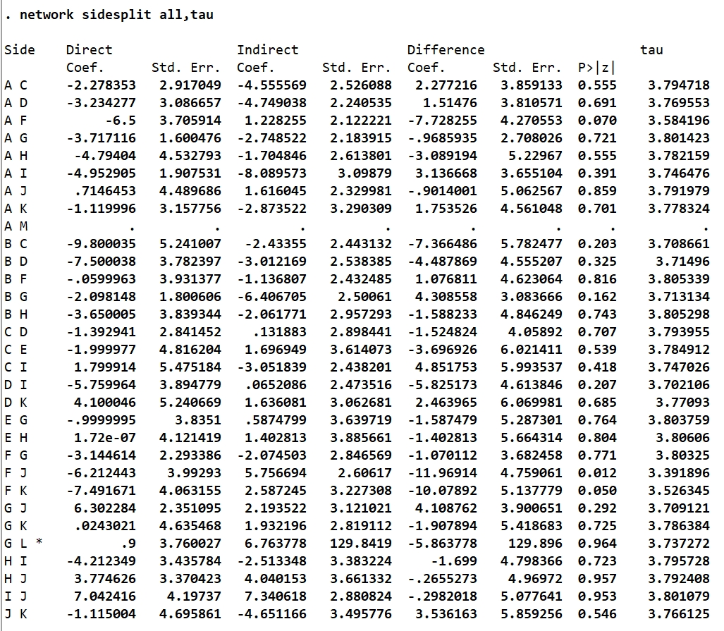
Node-splitting analysis for early postoperative (≤3 months) HHS.

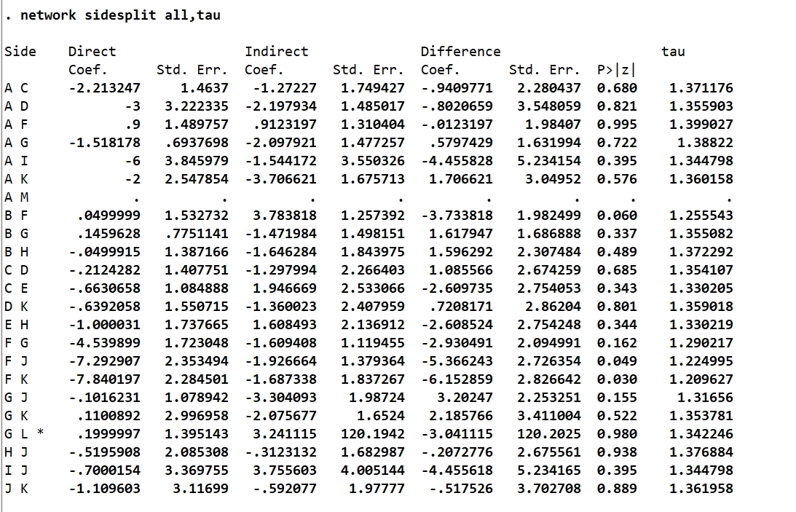
Node-splitting analysis for medium- to long-term (3 months to 1 year) HHS.
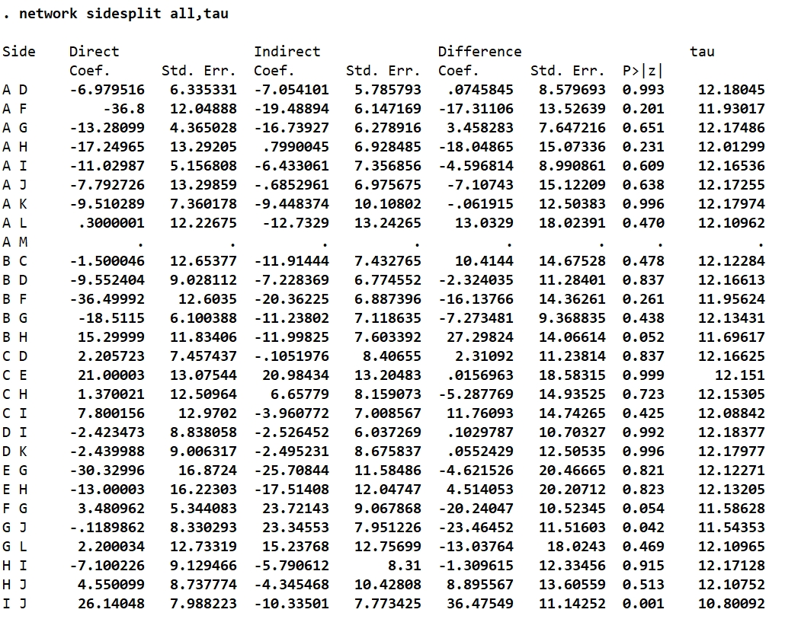
Node-splitting analysis for operative time.

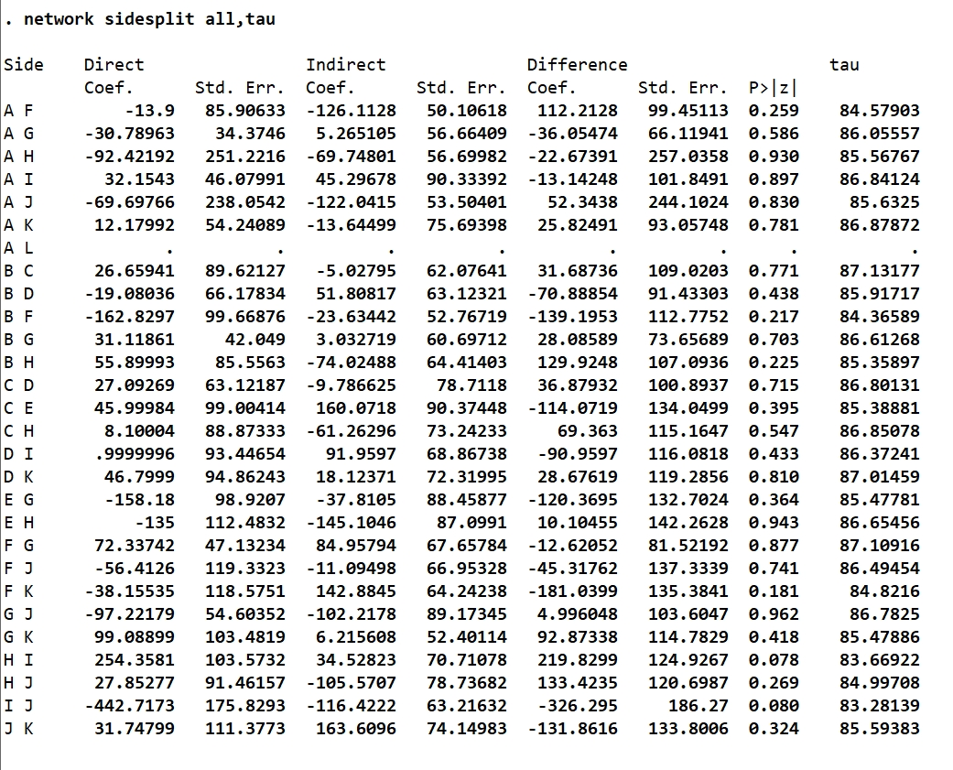

Node-splitting analysis for intraoperative blood loss.

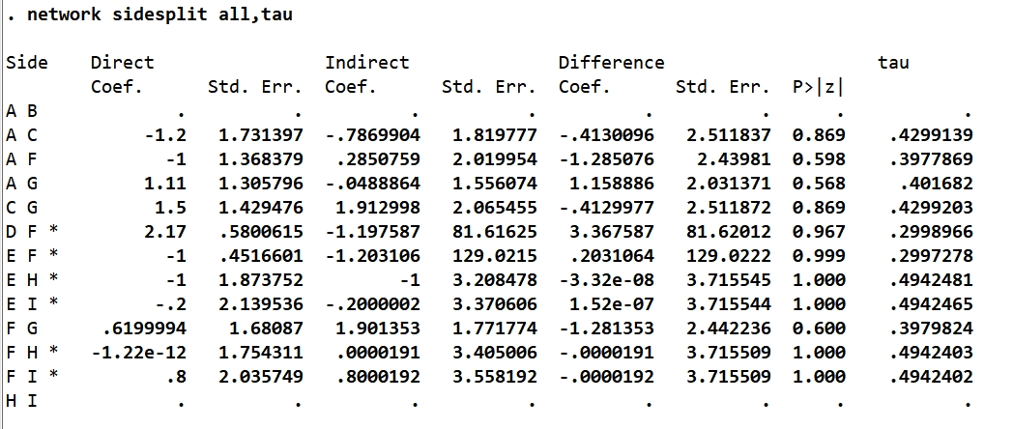
Node-splitting analysis for postoperative limb length discrepancy.
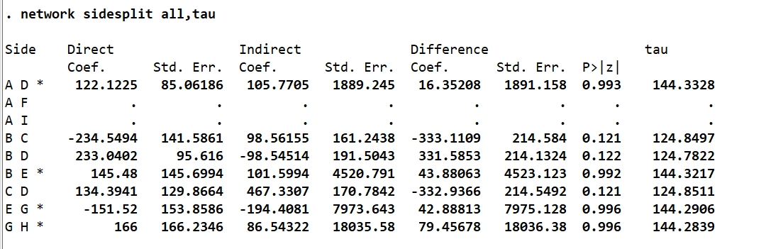
Node-splitting analysis for CK levels within 3 days postoperatively.

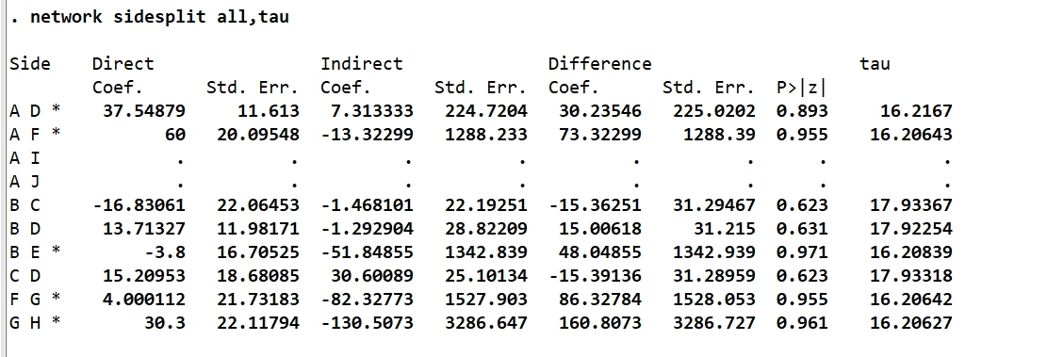
Node-splitting analysis for change in CRP within 3 days

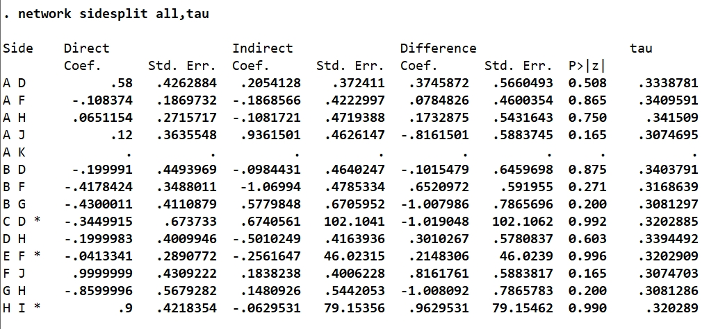
Node-splitting analysis for change in hemoglobin (Hb) within 2 days postoperatively.

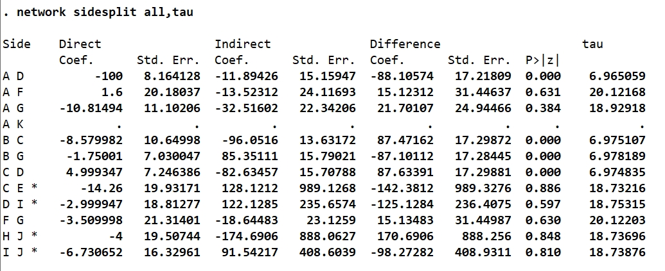
Node-splitting analysis for early postoperative (≤3 months) gait speed.

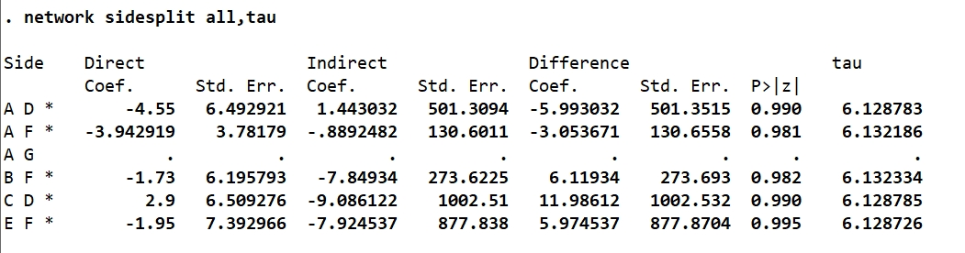
Node-splitting analysis for early postoperative (≤3 months) cadence.

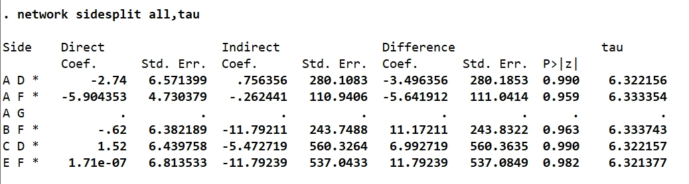
Node-splitting analysis for early postoperative (≤3 months) step length.

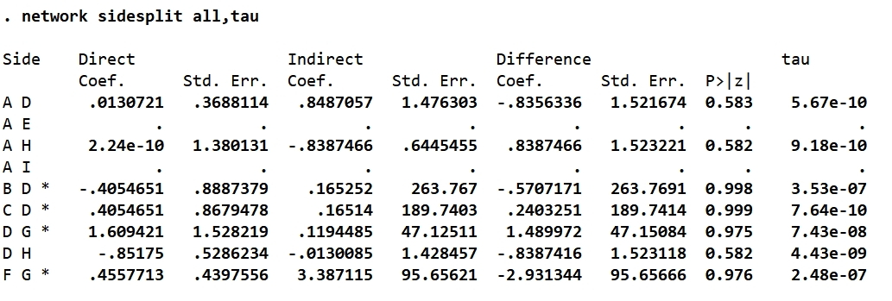
Node-splitting analysis for femoral stem malalignment.

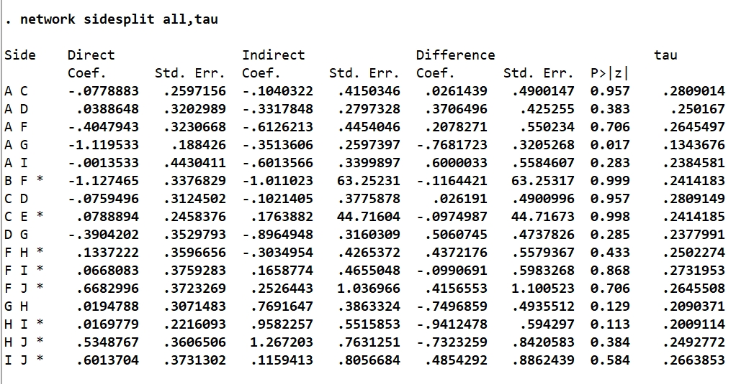
Node-splitting analysis for early postoperative (≤3 months) (PCS) score.

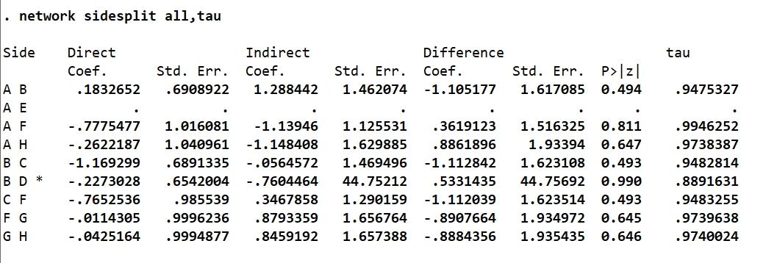
Node-splitting analysis for early postoperative (≤3 months) (MCS) score.

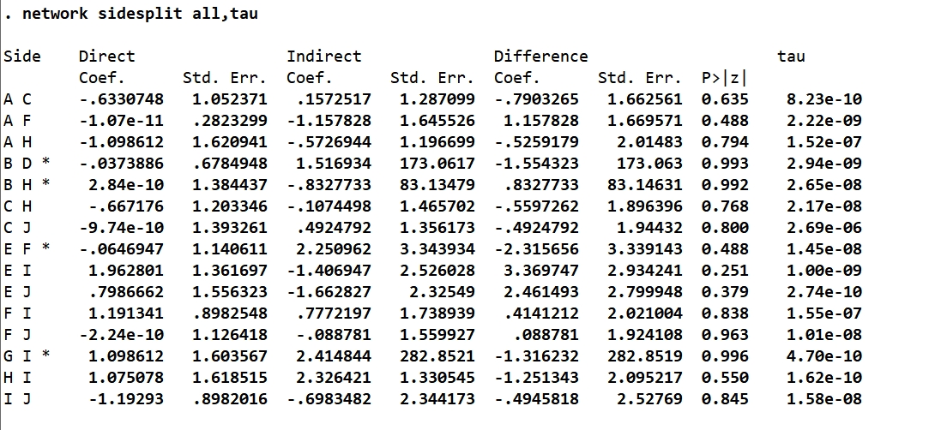
Node-splitting analysis for all-cause revision rate.

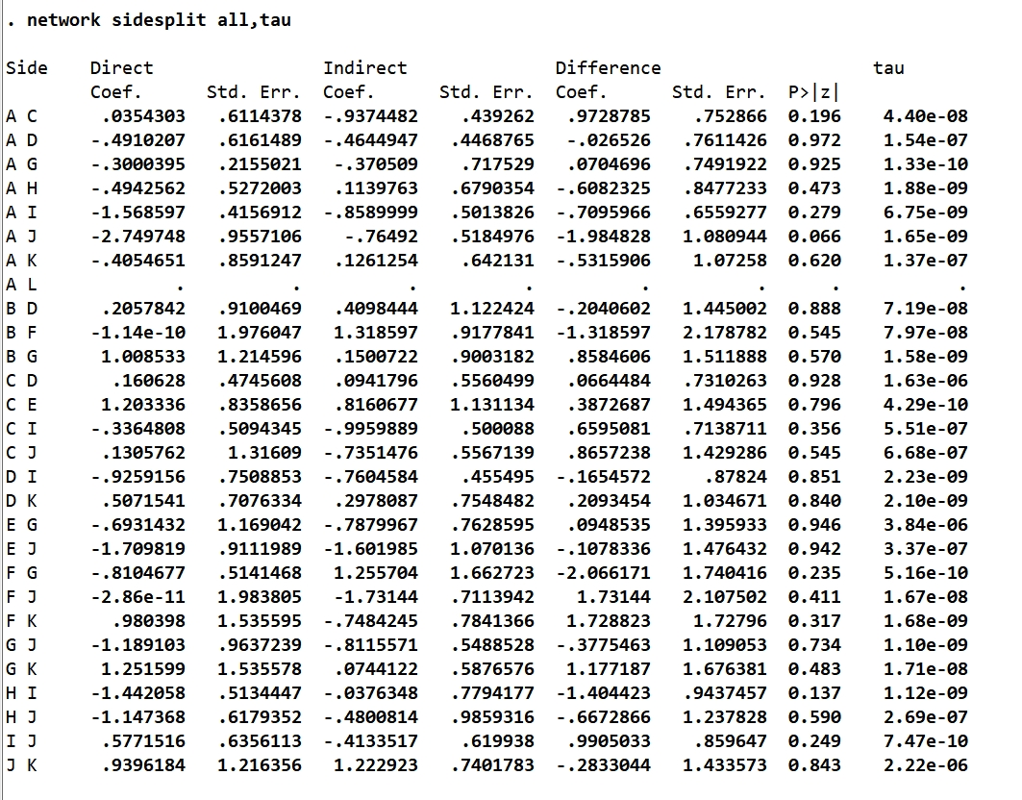
Node-splitting analysis for postoperative complications.

Supplementary file 2 Detailed SUCRA Values.
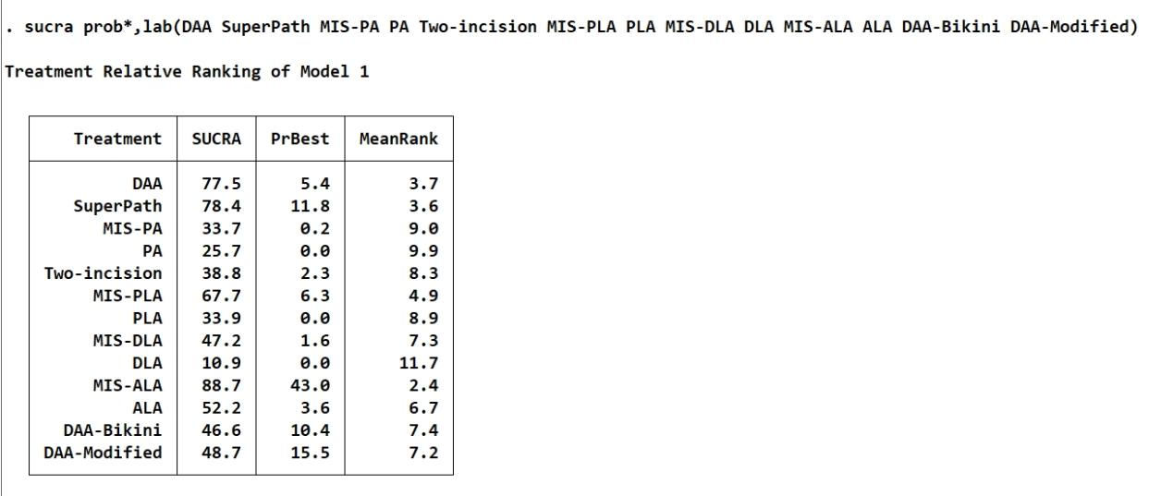
SUCRA values and rankings for early postoperative (≤3 months) HHS.

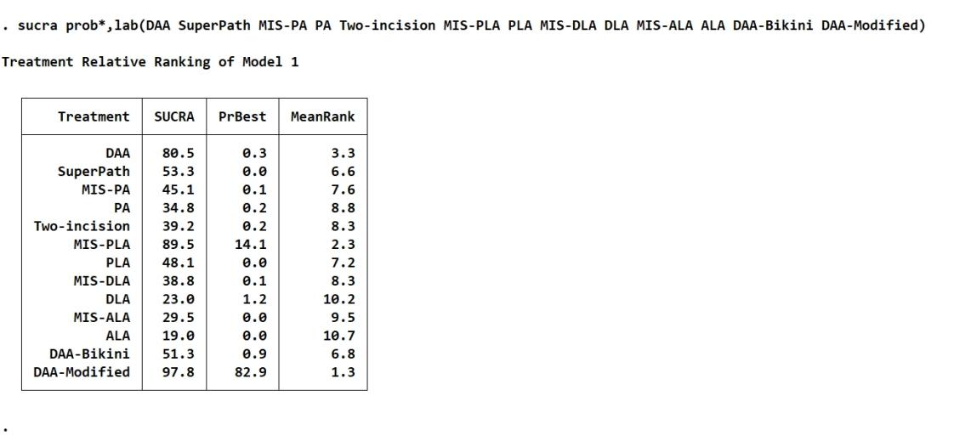
SUCRA values and rankings for medium- to long-term (3 months to 1 year) HHS.

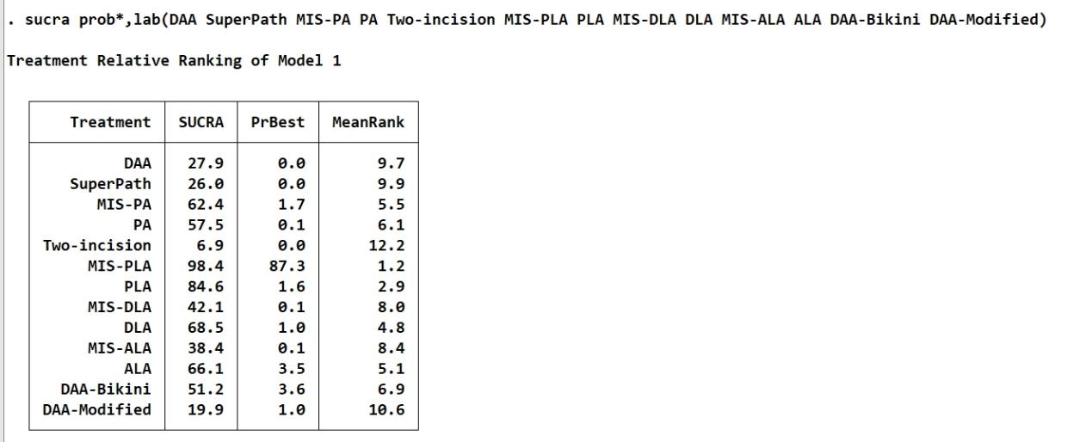
SUCRA values and rankings for operative time.

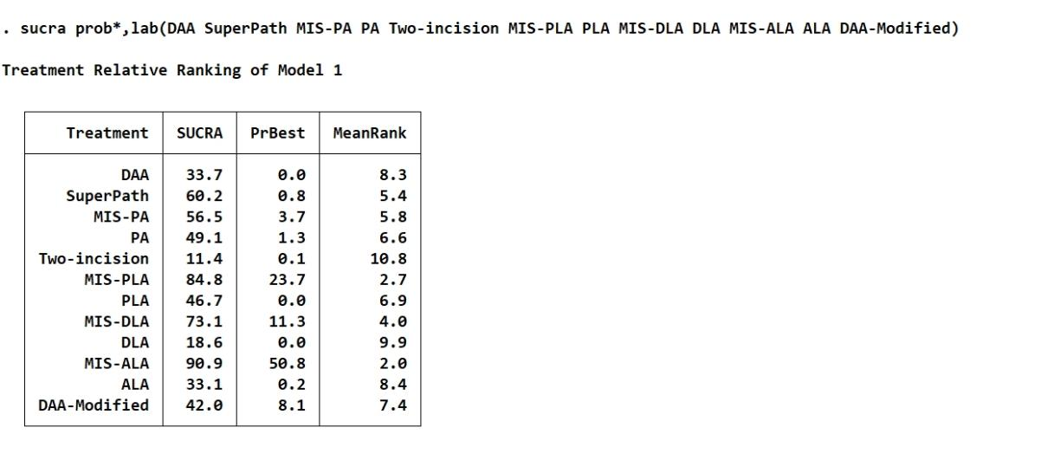
SUCRA values and rankings for intraoperative blood loss.

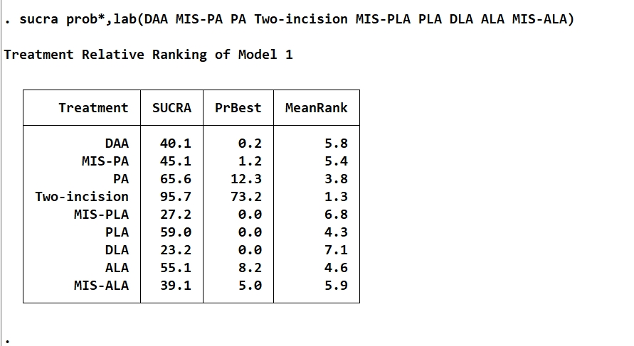
SUCRA values and rankings for postoperative limb length discrepancy.

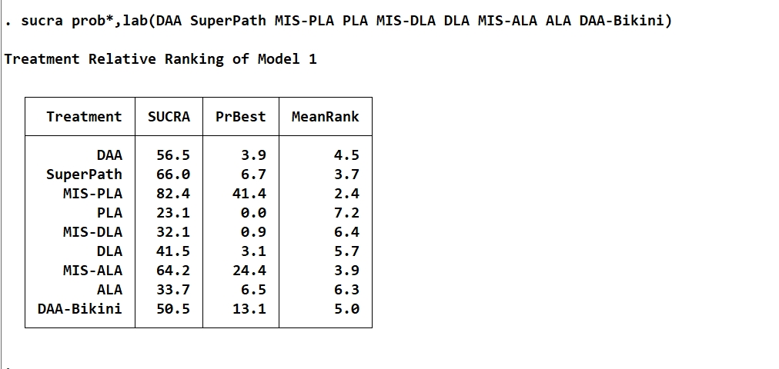
SUCRA values and rankings for CK levels within 3 days postoperatively.

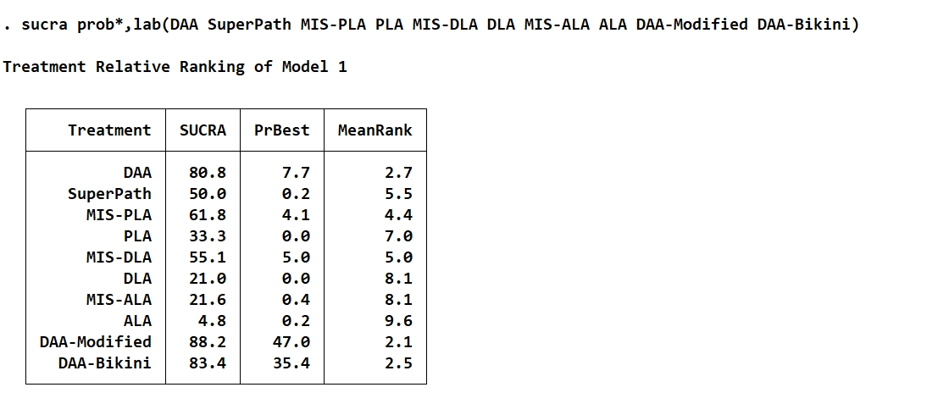
SUCRA values and rankings for change in CRP within 3 days

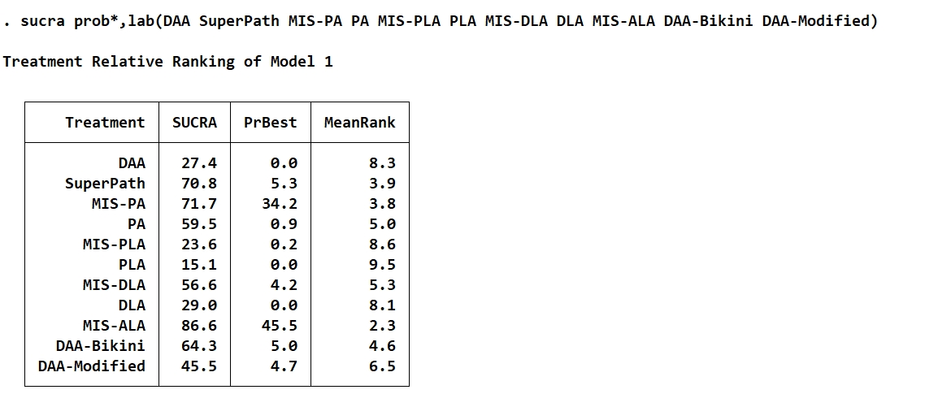
SUCRA values and rankings for change in hemoglobin (Hb) within 2 days postoperatively.

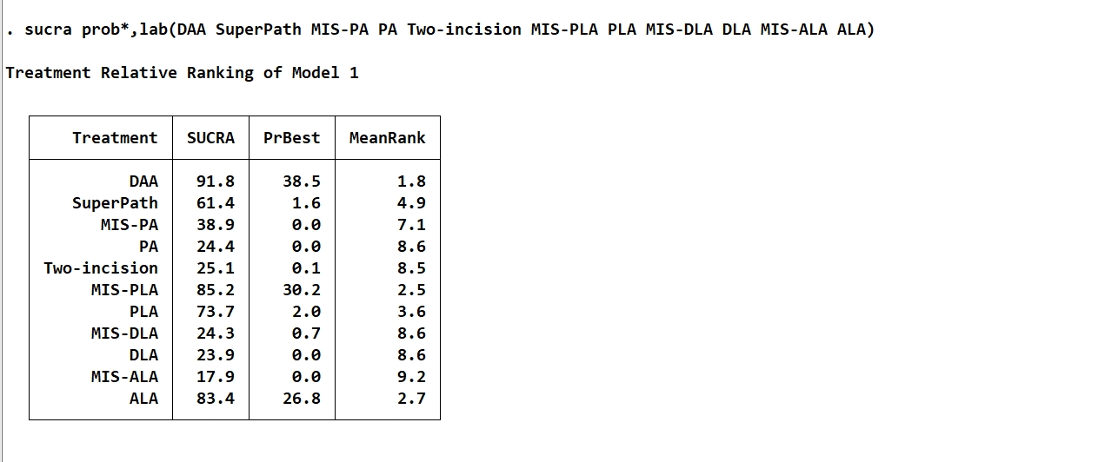
SUCRA values and rankings for early postoperative (≤3 months) gait speed.

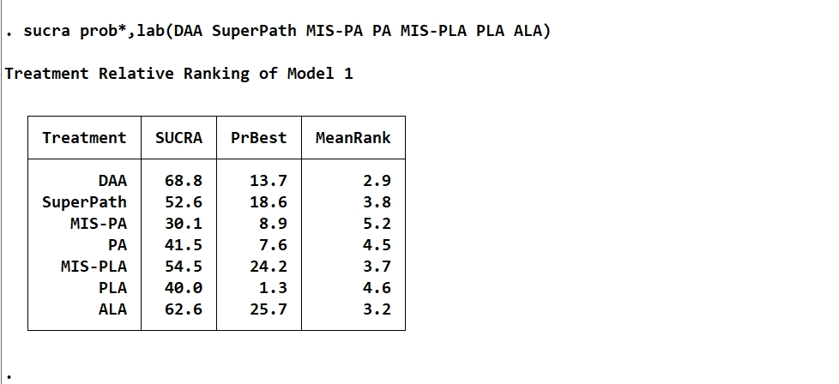
SUCRA values and rankings for early postoperative (≤3 months) cadence.

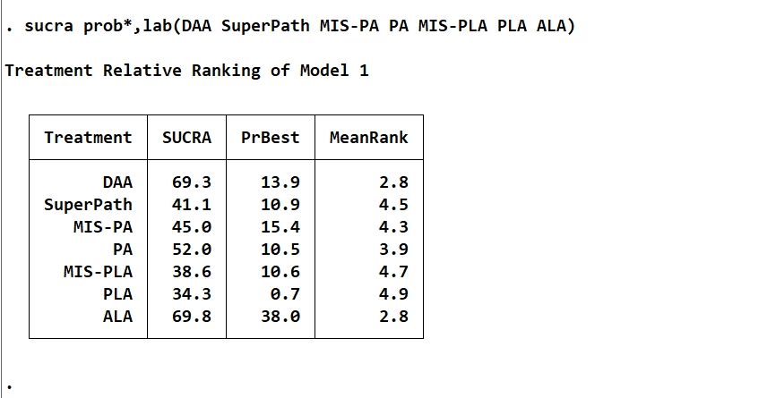
SUCRA values and rankings for early postoperative (≤3 months) step length.

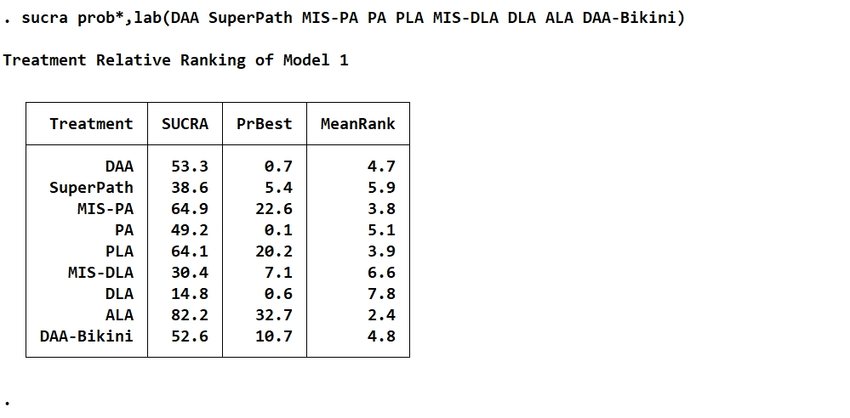
SUCRA values and rankings for femoral stem malalignment(Varus/Valgus).

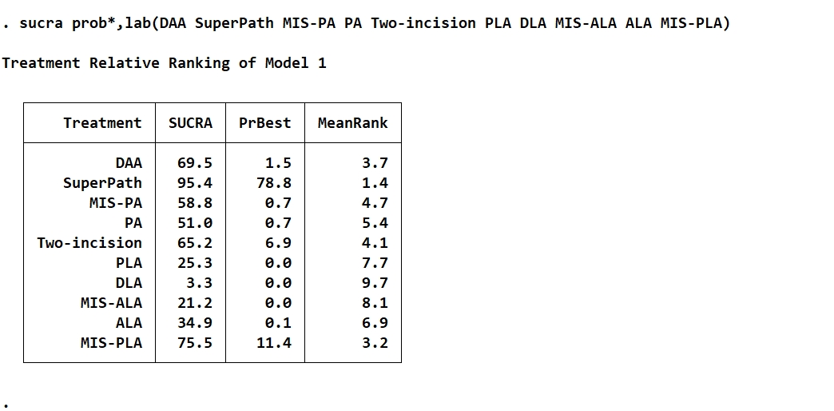
SUCRA values and rankings for early postoperative (≤3 months) (PCS) score.

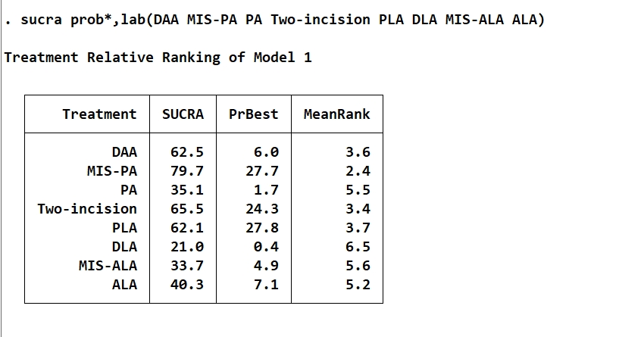
SUCRA values and rankings for early postoperative (≤3 months) (MCS) score.

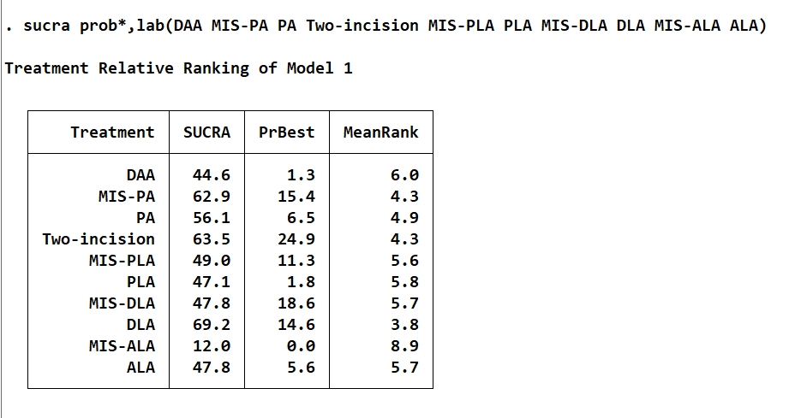
SUCRA values and rankings for all-cause revision rate.

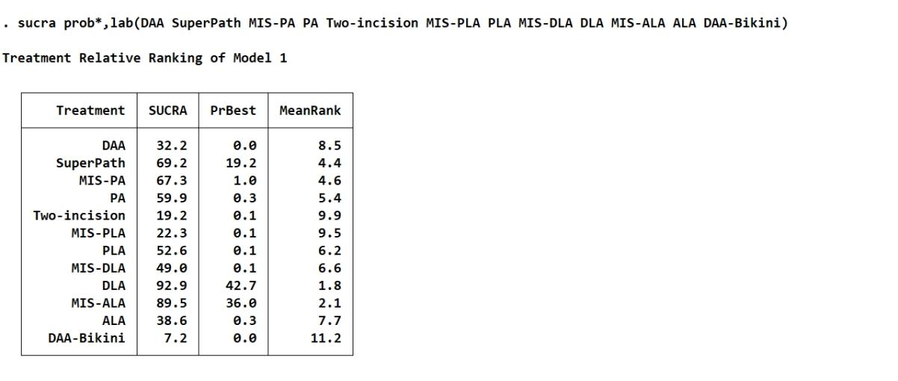
SUCRA values and rankings for postoperative complications.

Supplementary file 3 SUCRA Cumulative Ranking Probability Plot.
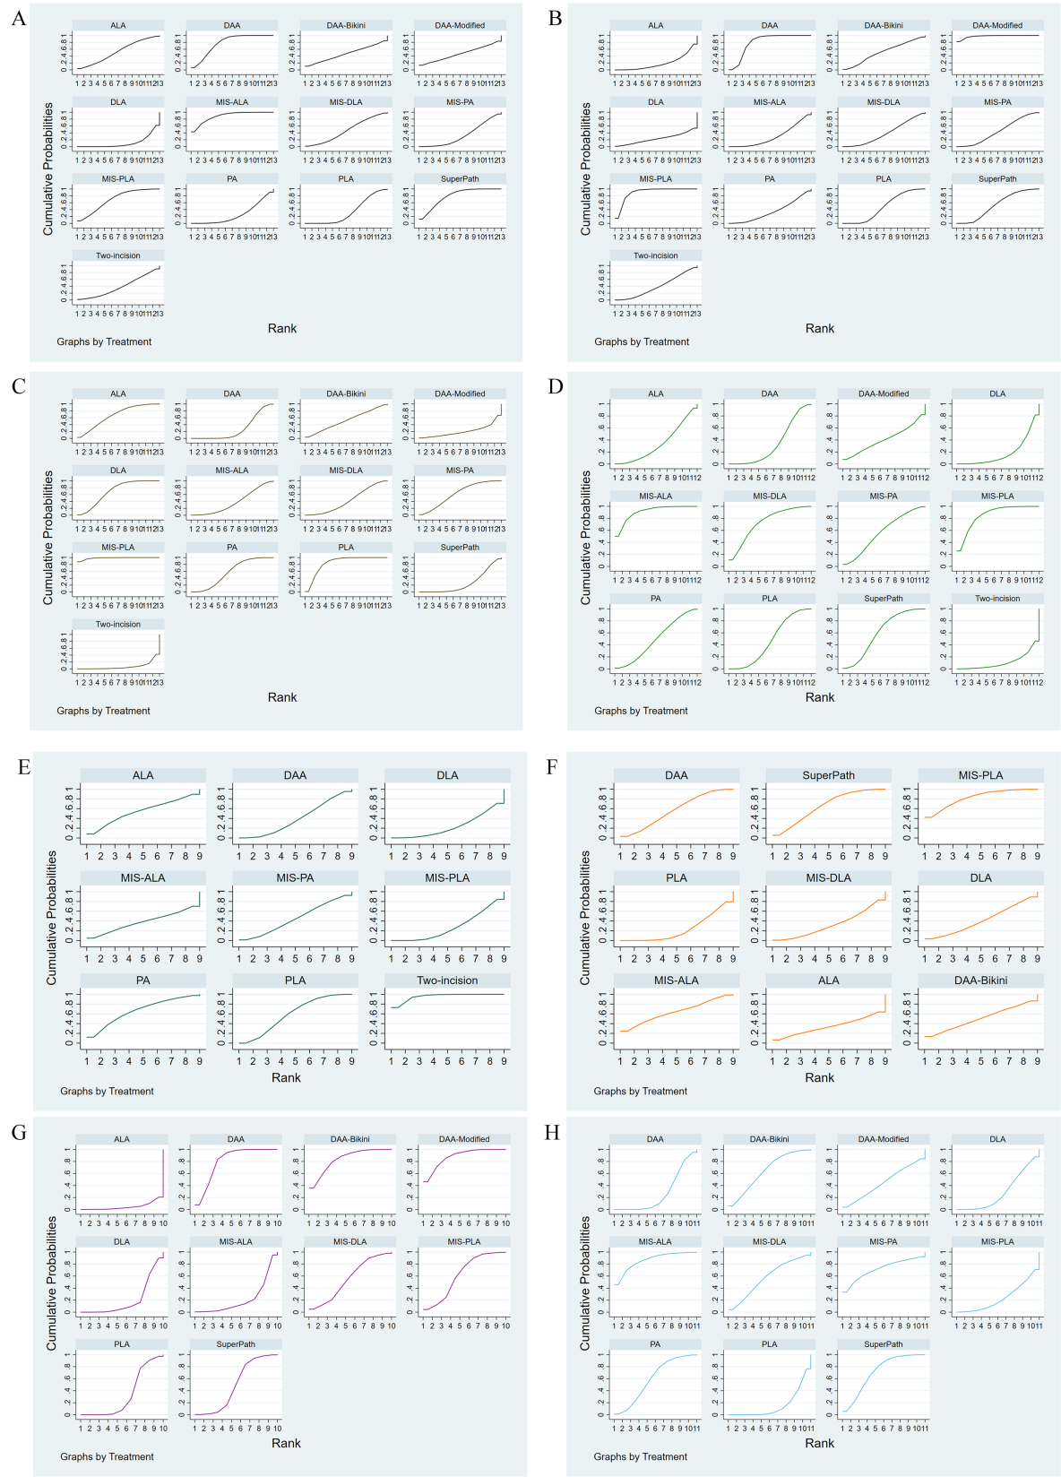
SUCRA Cumulative Ranking Probability Plot
A: Early Postoperative HHS (≤3 months)
B: Mid- to Long-Term Postoperative HHS (3 Months to 1 Year)
C: Operative Time (min)
D: Intraoperative Blood Loss (ml)
E: Postoperative Limb Length Discrepancy (mm)
F: CK Within 3 Days Postoperatively (ukat/L)
G: Change in CRP Within 3 Days Postoperatively (mg/L)
H: Change in Hb Within 2 Days Postoperatively (g/dL)

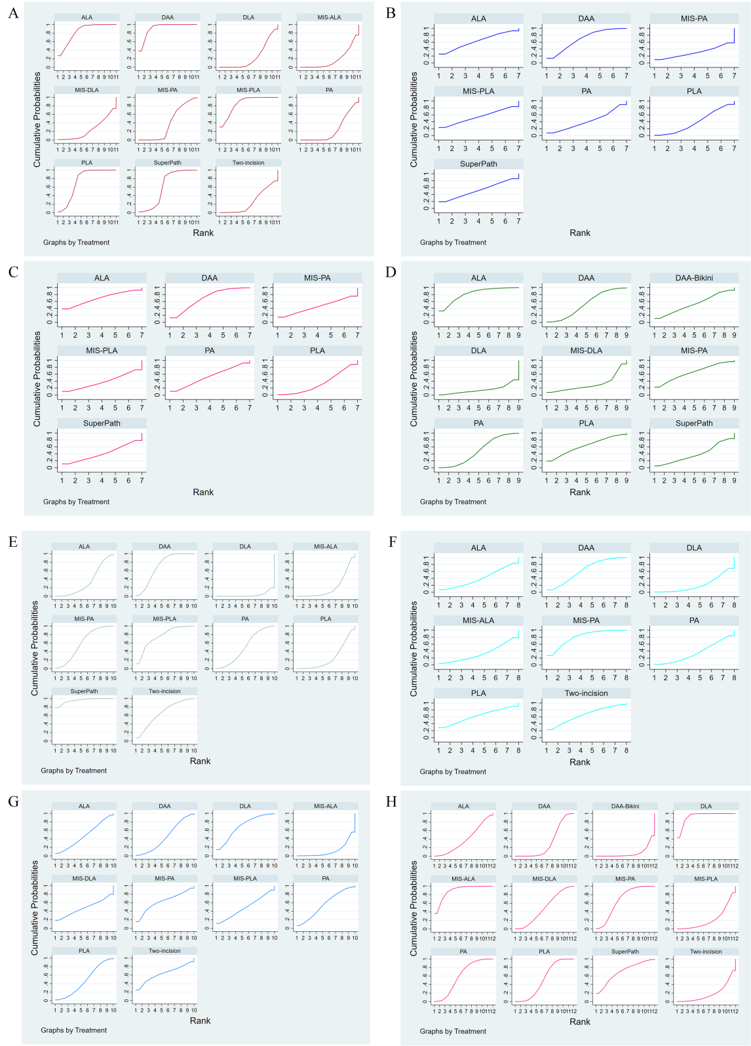
SUCRA Cumulative Ranking Probability Plot
A: Early Postoperative (≤3 Months) Gait Speed (cm/s)
B: Early Postoperative (≤3 Months) Cadence (steps/min)
C: Early Postoperative (≤3 Months) Step Length (cm)
D: Femoral Stem Malalignment (Varus/Valgus)
E: Early Postoperative (≤3 Months) PCS Score
F: Early Postoperative (≤3 Months) MCS Score
G: All-Cause Revision Rate
H: Complications

Supplementary file 4 Funnel plots.
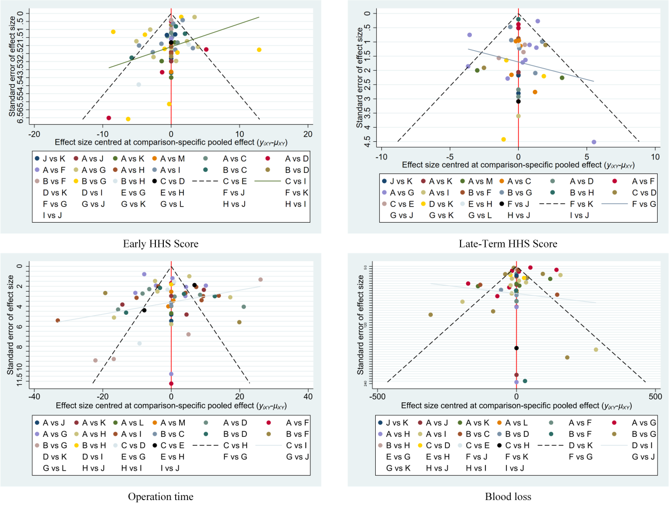
Funnel plots assessing publication bias for early HHS (≤3 months), medium-to-long-term HHS (3 months-1 year), operative time, and intraoperative blood loss.

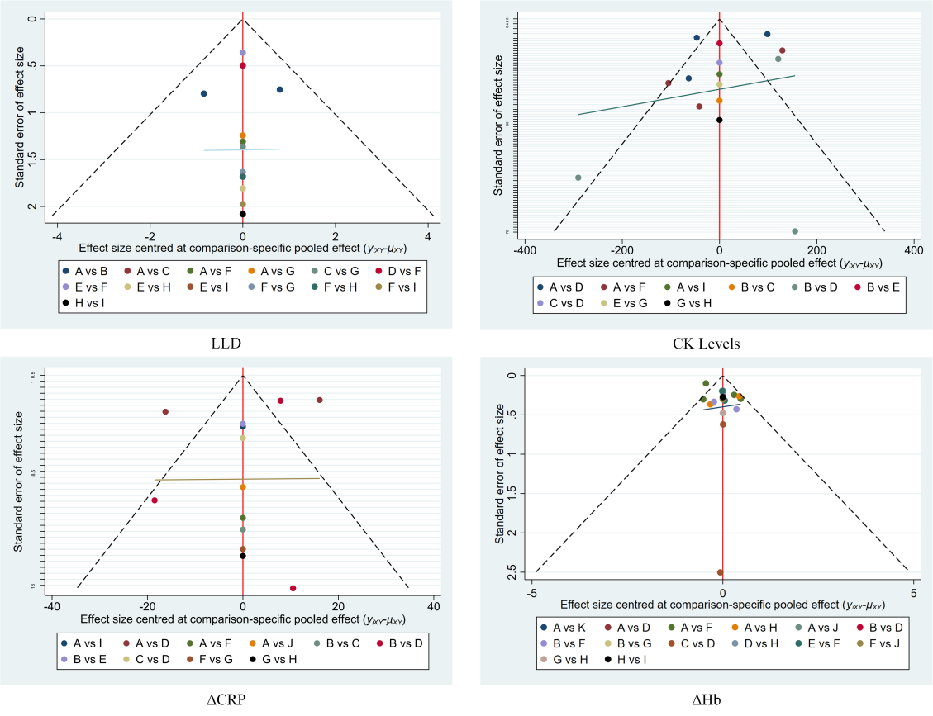
Funnel plots assessing publication bias for limb length discrepancy, postoperative CK, postoperative CRP change, and postoperative Hb change.

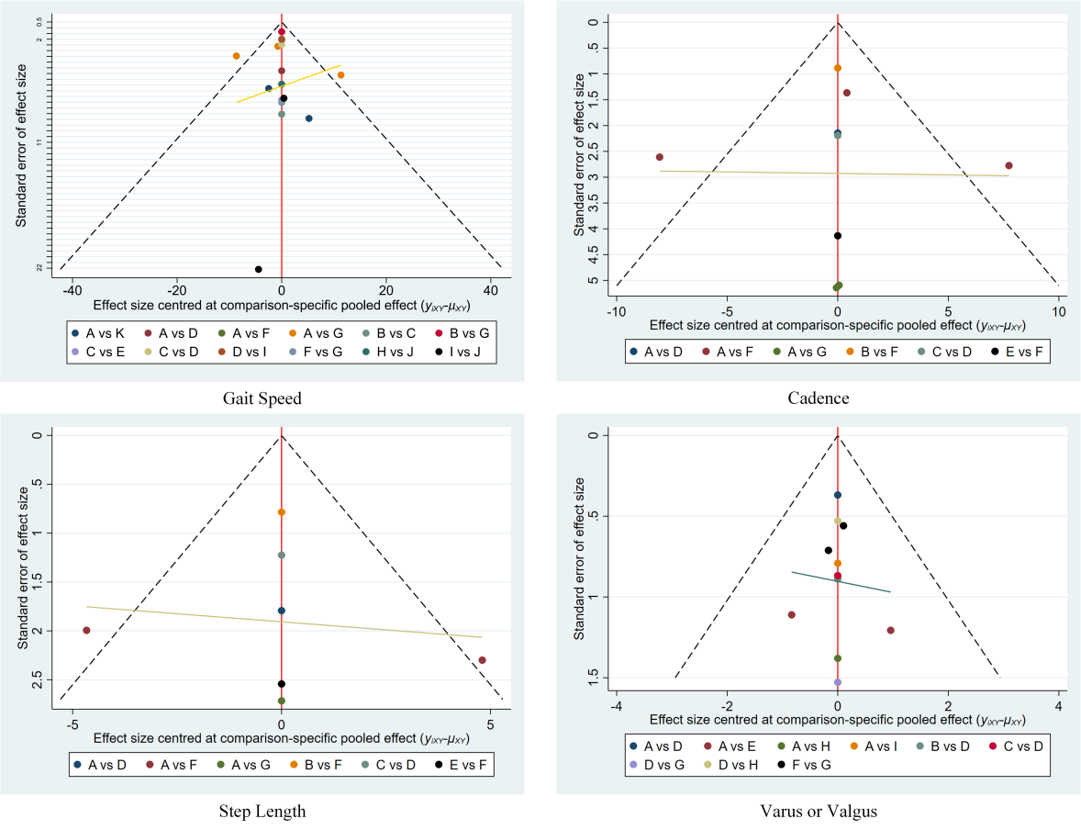
Supplementary Figures 3 Funnel plots assessing publication bias for early postoperative (≤3 months) gait parameters: gait speed, cadence, step length, and femoral stem malalignment.
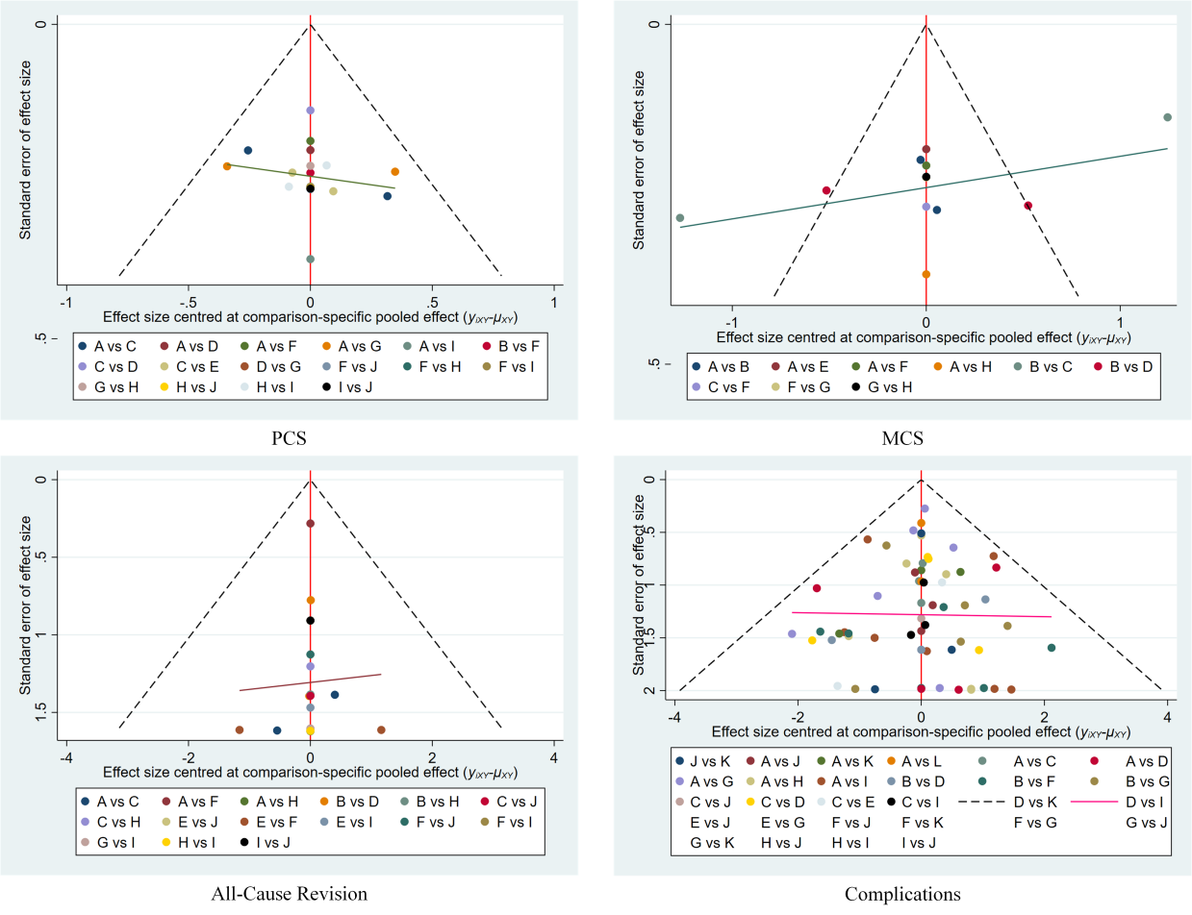
Supplementary Figures 4 Funnel plots assessing publication bias for PCS, MCS, all-cause revision rate, and postoperative complications.

