The MCID threshold was determined using two complementary methods: (1) Using the Global Rating of Change (GRC) scale as the patient-reported anchor, ROC curve analysis identified an optimal ΔLysholm score cutoff of 8.5 points (AUC = 0.796, sensitivity = 0.70, specificity = 0.78) (Figure S1). This threshold was prioritized because it directly reflects patients’ perceived meaningful improvement and demonstrated acceptable discriminative ability in our cohort. (2) Using 0.5 standard deviation (SD) of the ΔLysholm score in our cohort (SD = 10.8), the calculated threshold was 5.4 points. This method provides a statistical estimate but lacks direct clinical interpretation, as it does not account for patients’ subjective perception of change.
To assess the robustness of our primary outcome definition, we performed a sensitivity analysis using the effect size-based MCID of 5.4 points as the threshold for insufficient improvement. In this analysis, the proportion of patients classified as insufficient improvement increased from 20.7% to 32.1%, which was inconsistent with the clinical reality of our cohort (where most patients reported satisfactory outcomes based on GRC). The ExtraTrees model achieved an AUC of 0.762 (95% CI: 0.721–0.801), which was lower than the primary analysis (AUC = 0.887) (Figure S2).
These findings support the choice of the anchor-based MCID of 8.5 points as the more clinically meaningful threshold.
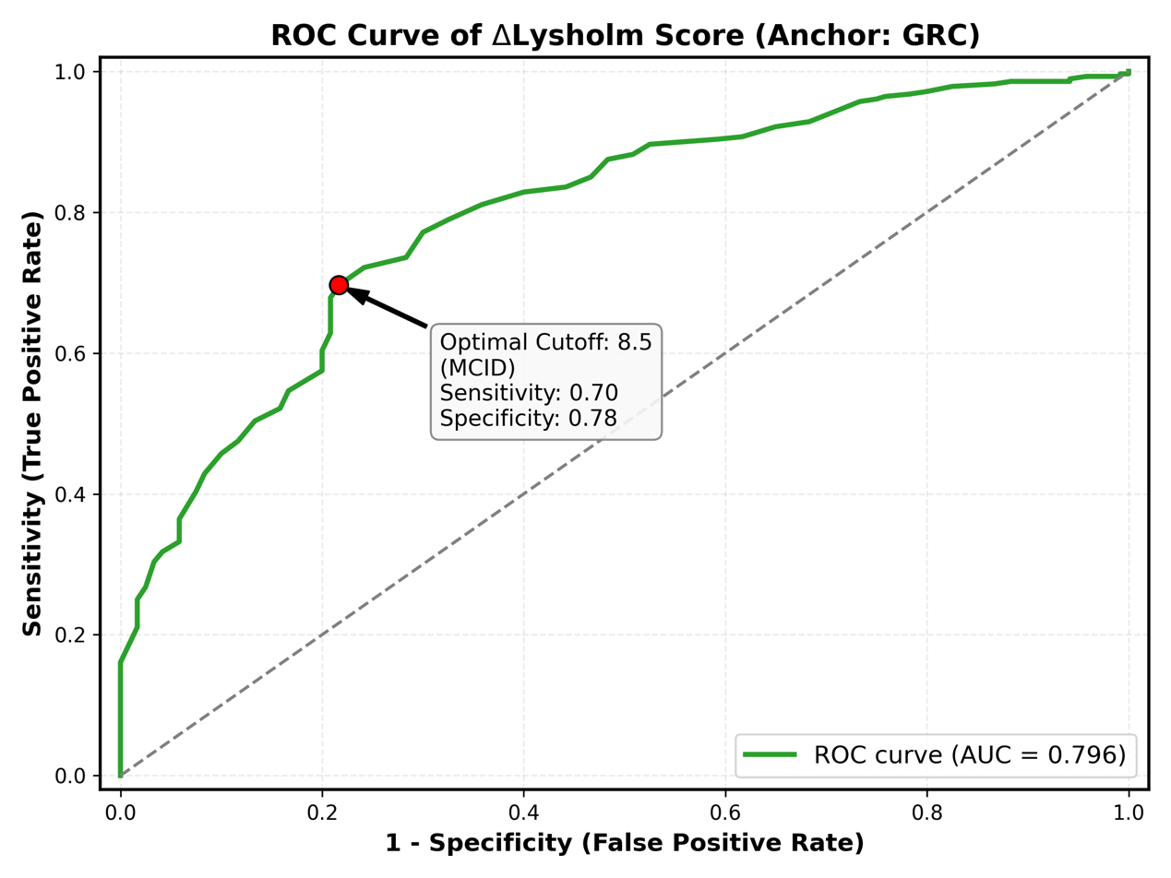
S1. ROC Curve for MCID Determination of Lysholm Score
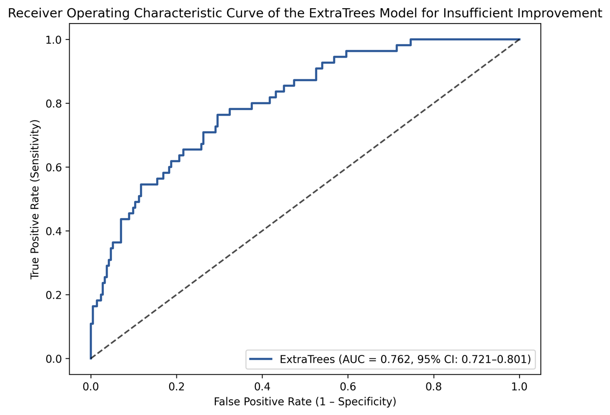
S2. ROC Curve for Sensitivity Analysis Using MCID = 5.4

S3. Final Hyperparameters of the Optimized Machine Learning Models
Model | Optimized Hyperparameters | Tuning Strategy
ExtraTrees | n_estimators = 300  max_depth = 15  min_samples_split = 4  min_samples_leaf = 2 | RandomizedSearchCV
Random Forest | n_estimators = 200  max_depth = 12  min_samples_split = 5  bootstrap = True | GridSearchCV
XGBoost | n_estimators = 250  learning_rate = 0.05  max_depth = 6  subsample = 0.8 | GridSearchCV
Logistic Regression | C = 1.0  penalty = 'l2'  solver = 'liblinear' | Default
KNN | n_neighbors = 7  weights = 'distance'  p = 2 (Minkowski metric) | GridSearchCV

