SUPPLEMENTARY MATERIAL
Full search string
Pubmed/Cochrane search
("ankle fracture*" OR "fractured ankle" OR "malleolar fracture" OR "lateral malleolar fracture" OR "medial malleolar fracture" OR "posterior malleolar fracture" OR unimalleolar OR bimalleolar OR trimalleolar OR "distal fibula fracture" OR "distal tibia fracture" OR "ankle injury with fracture" OR weber*) AND ( fixation OR "operative treatment" OR "open reduction internal fixation" OR ORIF) AND ("weight-bearing" OR "early weight-bear*" OR "immediate weight-bear*" OR "early mobilisation" OR "early mobilization" OR "functional weight-bear*" OR "unprotected weight-bear*") AND ("non-weight-bear*" OR "nonweightbear*" OR "delayed weight-bear*" OR "prolonged non-weight-bear*" OR NWB OR immobilization OR immobilisation)
Embase search
(ankle fracture/ or ankle fracture* or fractured ankle or malleolar fracture* or lateral malleolar fracture* or medial malleolar fracture* or posterior malleolar fracture* or unimalleolar or bimalleolar or trimalleolar or distal fibula fracture* or distal tibia fracture* or ankle injur* with fracture* or weber*)
(surgical fixation or operative treatment or open reduction internal fixation or ORIF or "open reduction (procedure)"/)
(weight-bearing or early weight-bear* or immediate weight-bear* or early mobili?ation or functional weight-bear* or unprotected weight-bear*)
(non-weight-bear* or nonweightbear* or non-weight bear or delayed weight-bear* or prolonged non-weight-bear* or NWB or immobili?ation)
Risk of Bias Assessment

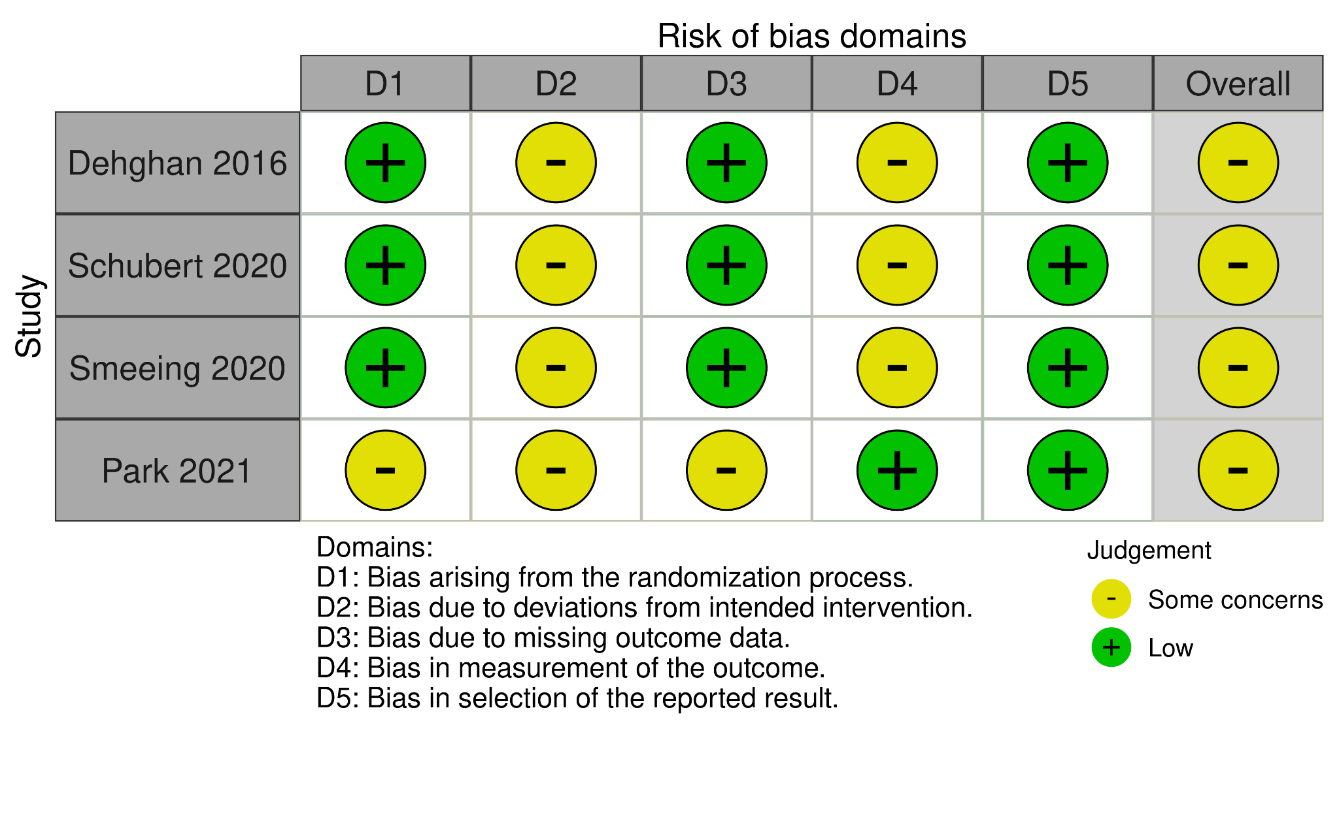
Supplementary Figure 1. Risk of Bias Assessment for Randomized Controlled Trials Using the Cochrane RoB 2 Tool
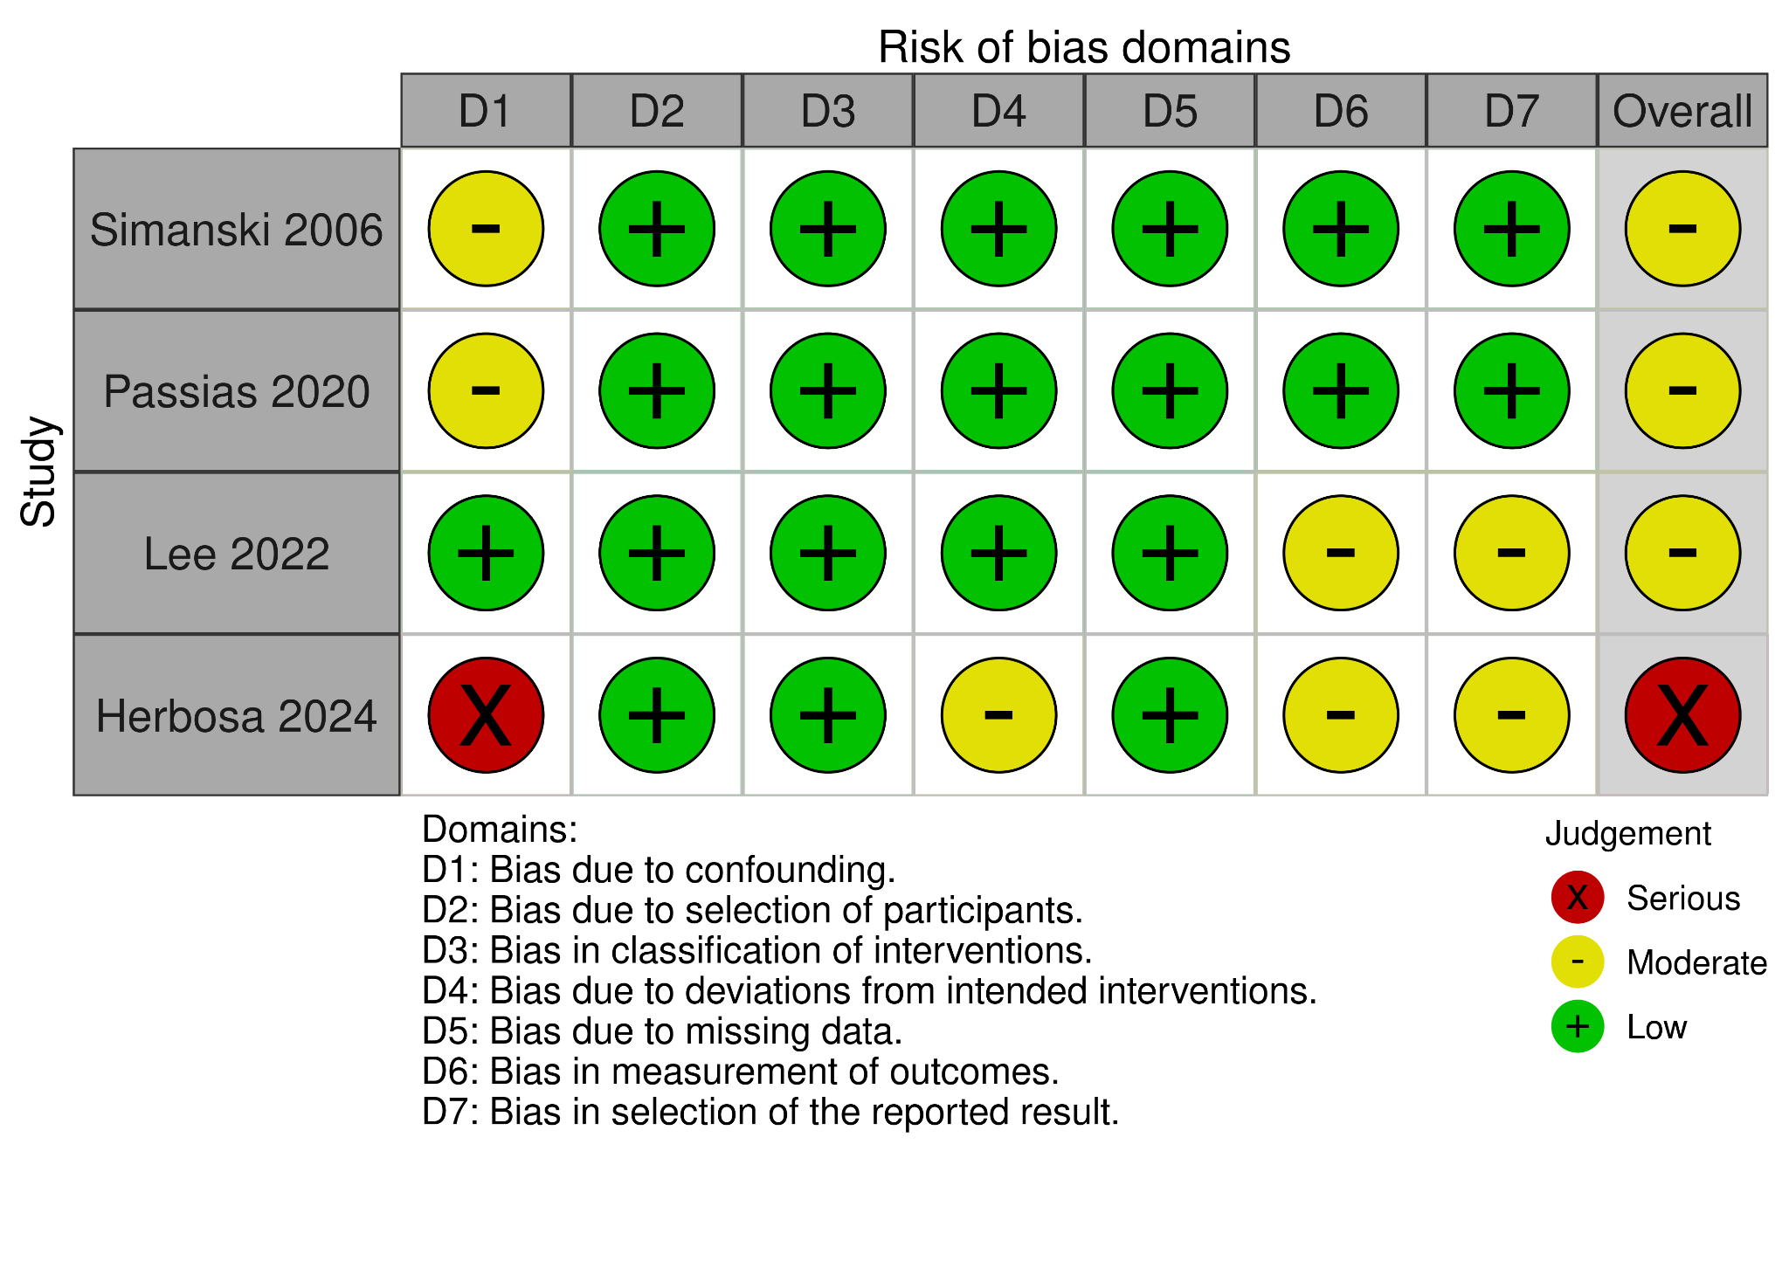
Supplementary Figure 2. Risk of Bias Assessment for Non-Randomized Studies Using the ROBINS-I Tool
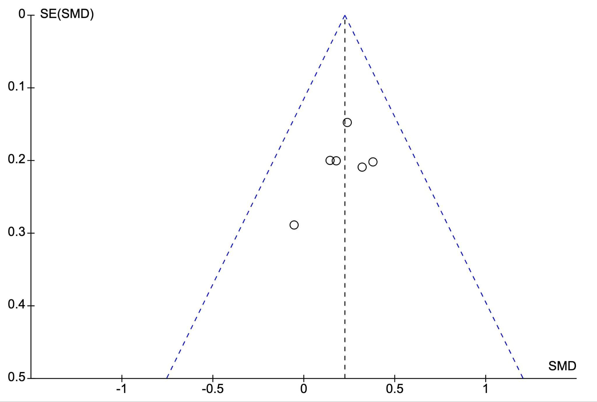
Supplementary Figure 3. Funnel plot evaluating potential publication bias for studies reporting 12-week functional outcomes. The 12-week funnel plot appeared broadly symmetric, with smaller studies more dispersed and larger studies clustered near the pooled effect; however, interpretation is limited by the small number of included studies.

Forrest Plots - Exploratory Outcomes (Supplementary Material)
Subgroup Analysis at 12 Weeks
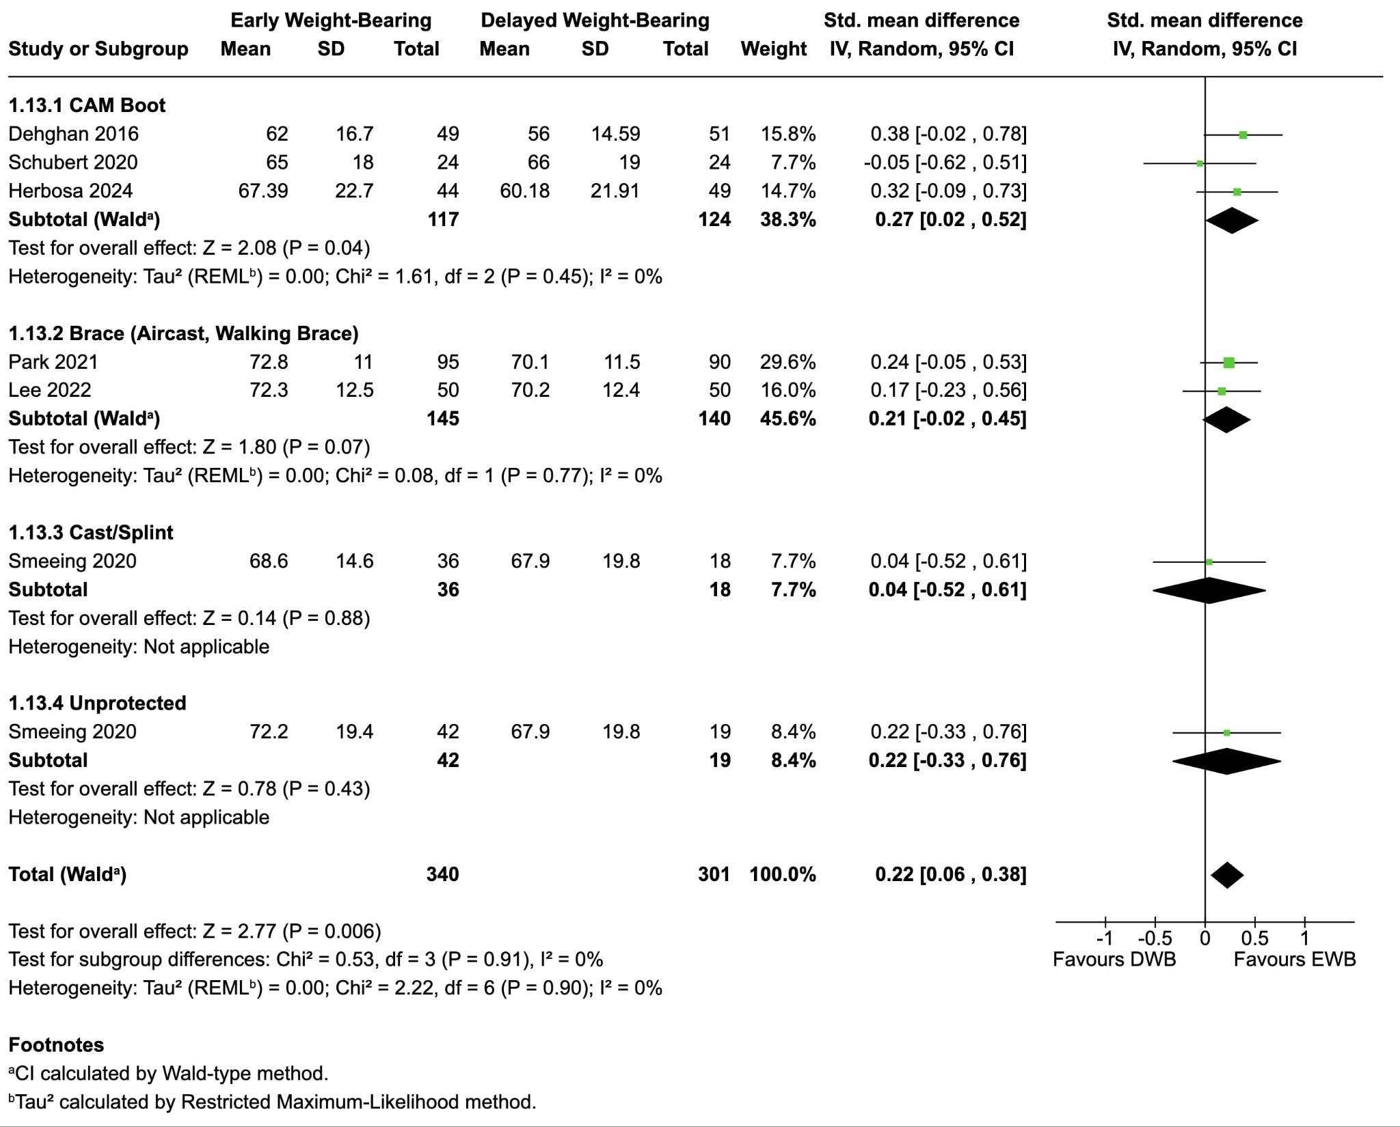
Supplementary Figure 4. Subgroup Analysis at 12 Weeks - Immobilisation Device
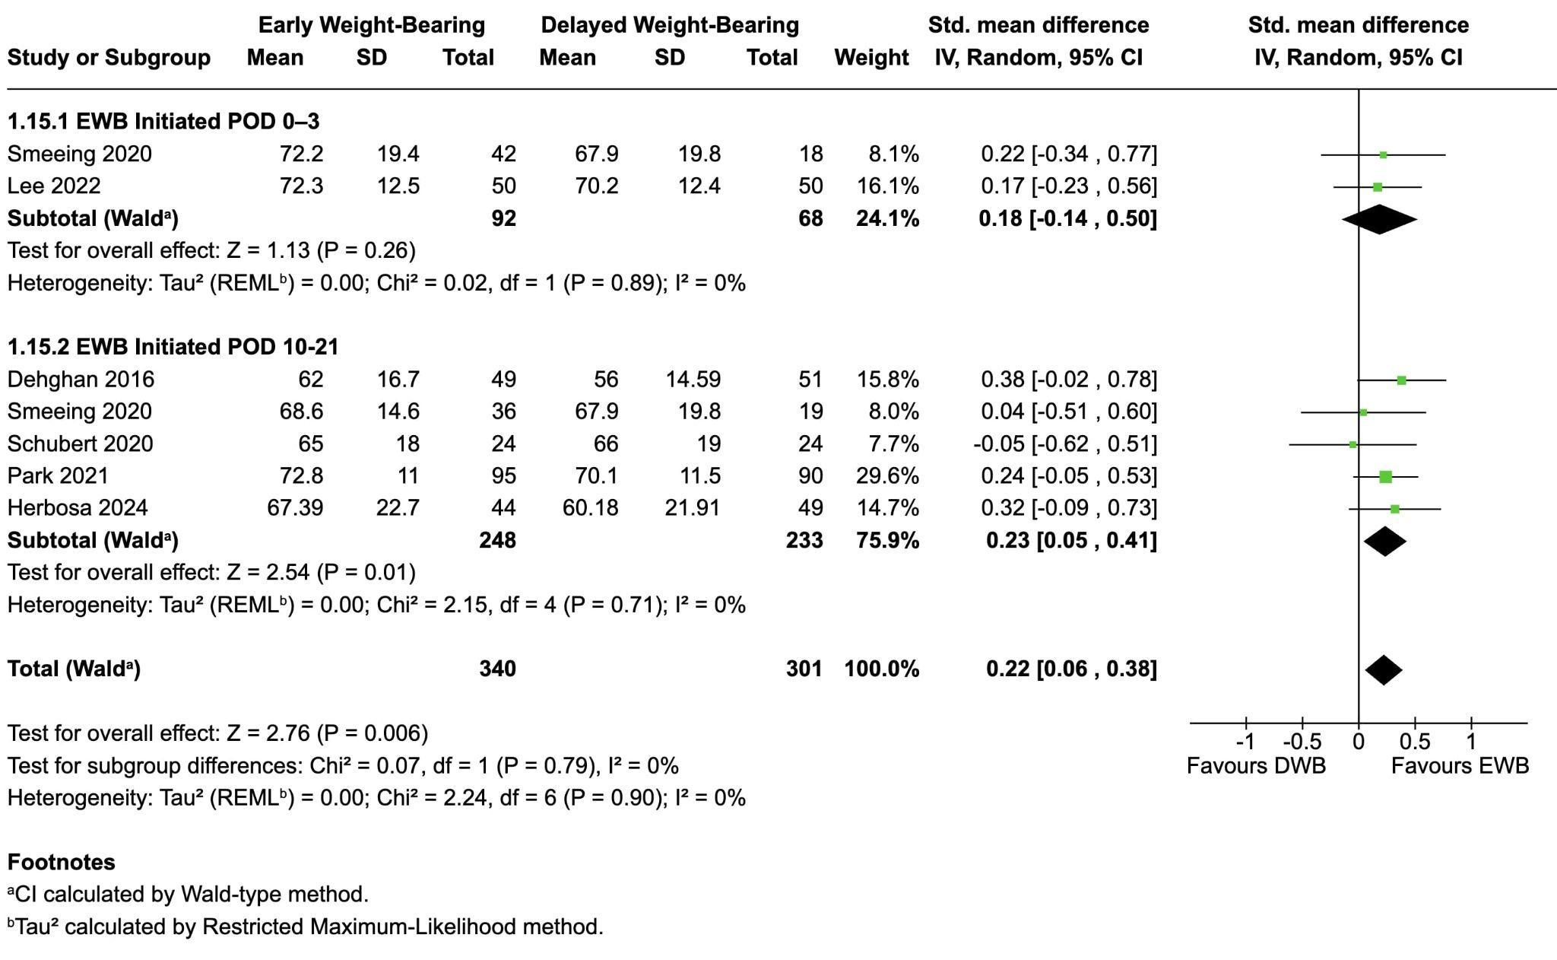
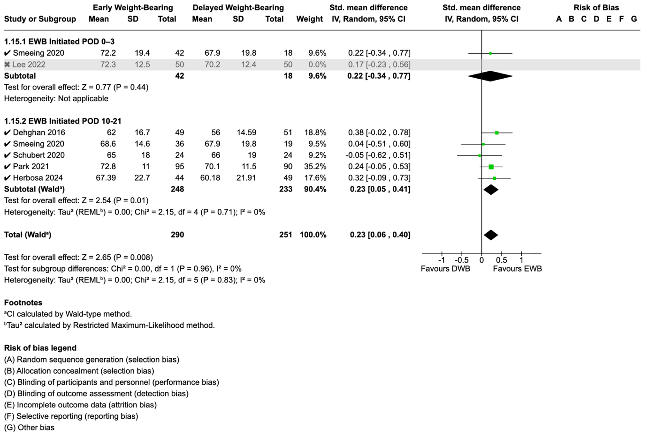

Supplementary Figure 5. Subgroup Analysis at 12 Weeks - POD Weightbearing initiation & Sensitivity Analysis
Functional Recovery at 6 Weeks Post-Surgery
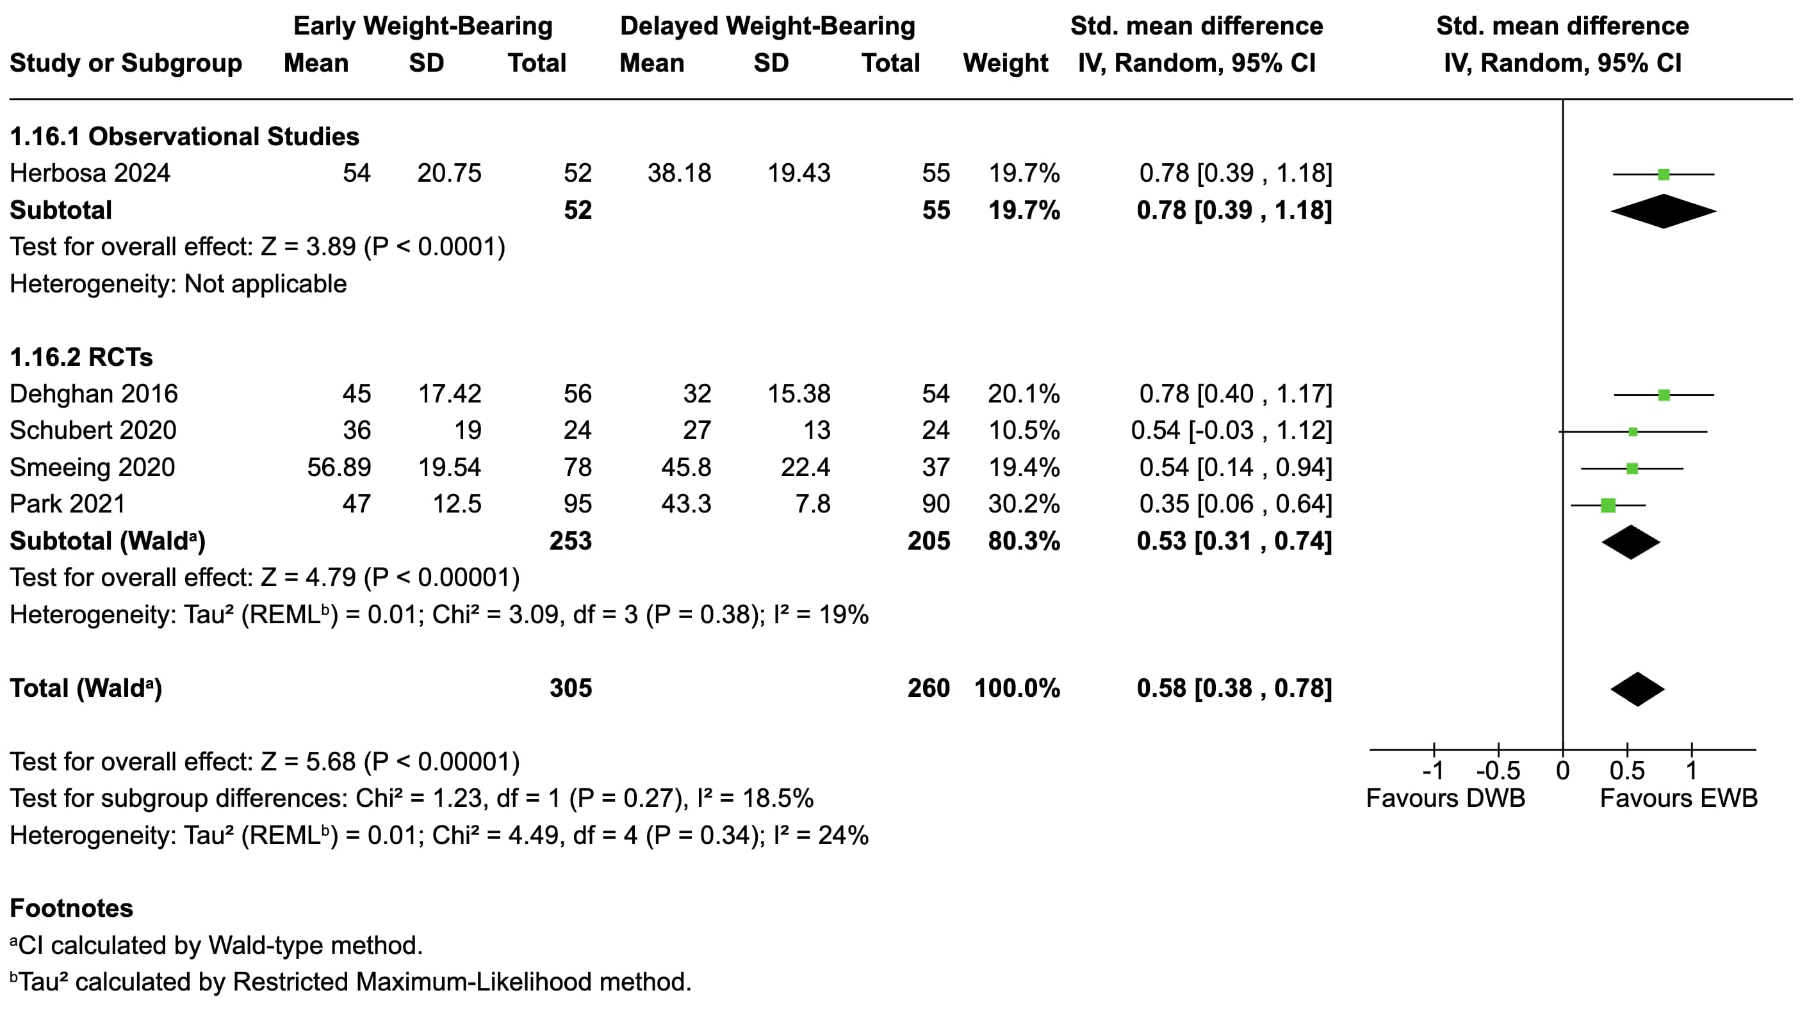
Supplementary Figure 6. Functional Recovery at 6 Weeks Post-Surgery
Functional Recovery at 6 Months Post-Surgery
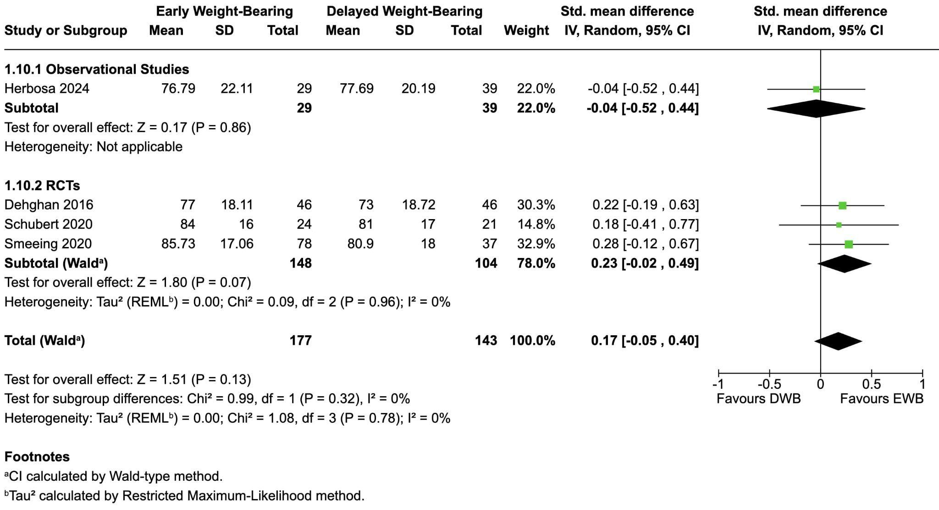
Supplementary Figure 7. Functional Recovery at 6 Months Post-Surgery

Return to Work/Normal daily activities After Ankle Fracture Surgery
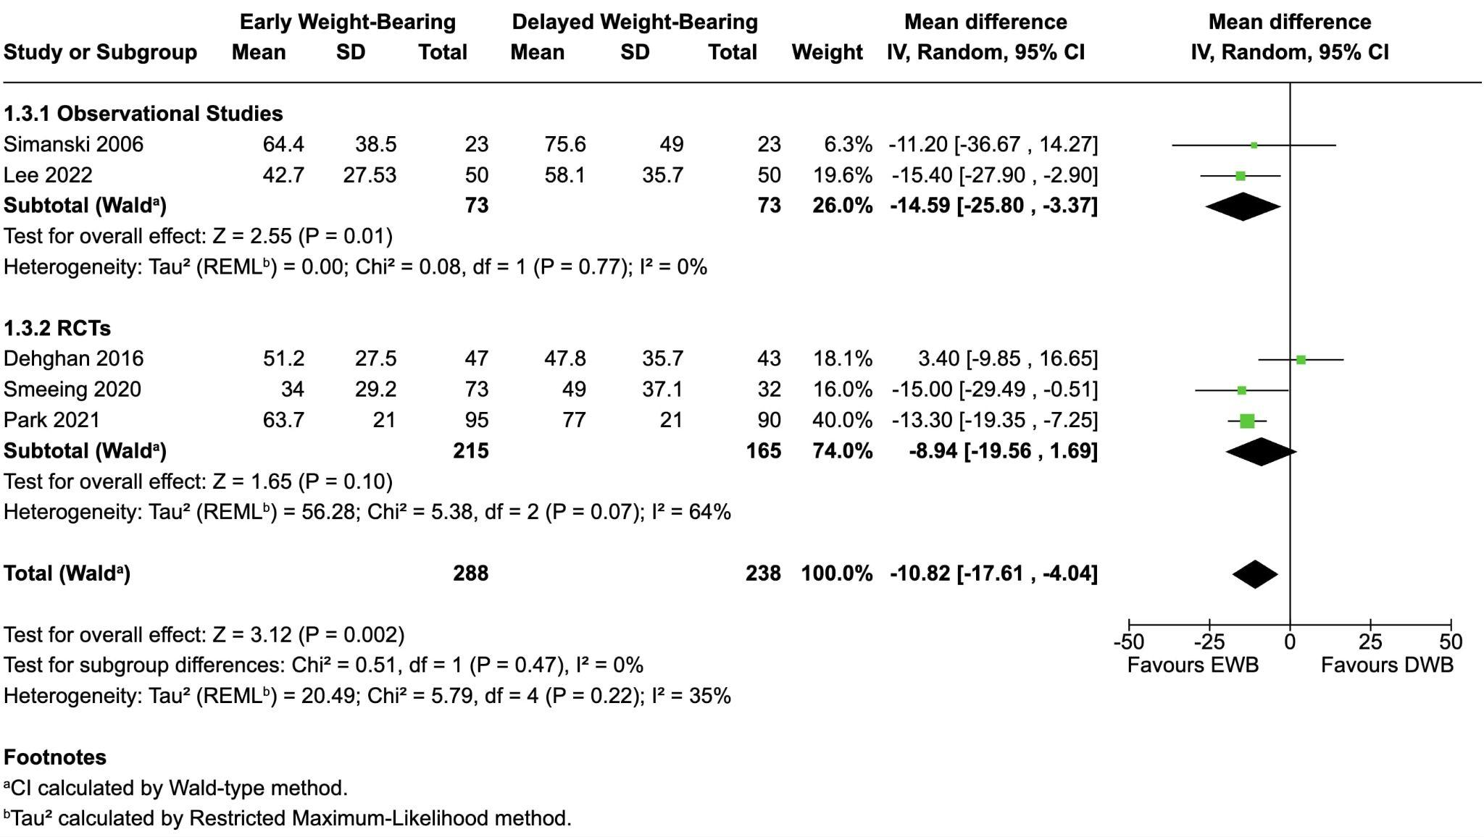
Supplementary Figure 8. Return to Work/Normal Daily Activities After Ankle Fracture Surgery

Health-Related Quality of Life (HRQoL)
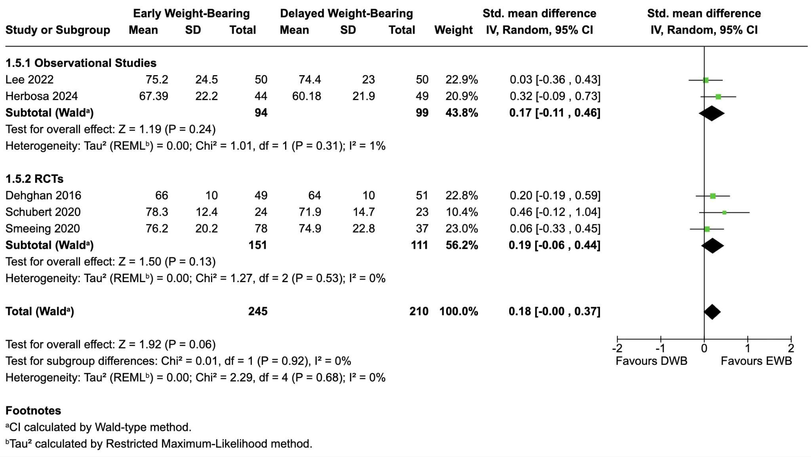
Supplementary Figure 9. Health-Related Quality of Life (HRQoL)
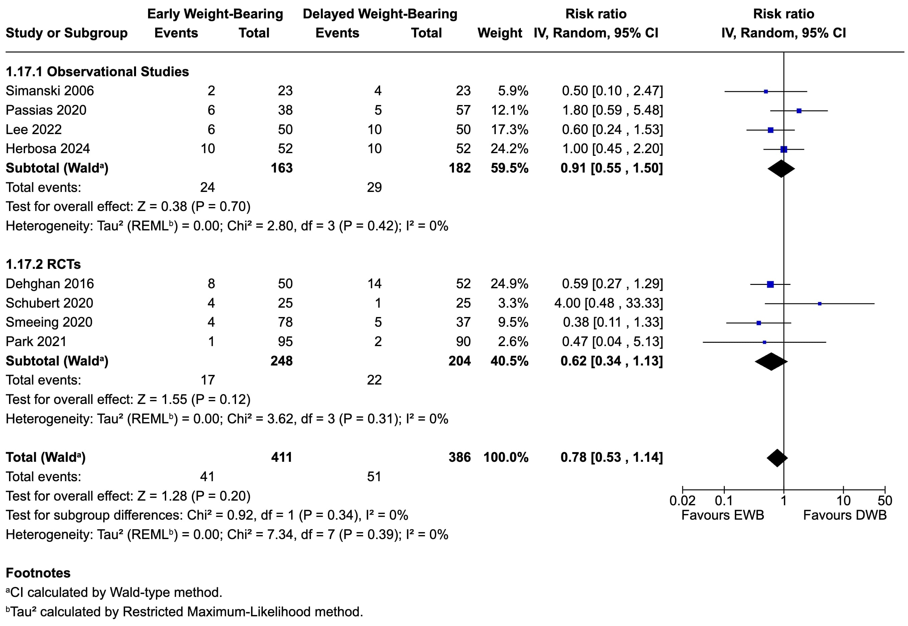
Supplementary Figure 10. Post-operative Complications (design stratified analysis)

Table S1. Radiographic follow-up schedules and definitions of loss of reduction in included studies (attached separately)
Study (Author, Year) | Design | Radiographic follow-up schedule | Definition of loss of reduction (and related) | Reported events related to displacement/union
Simanski, 2006 | Prospective cohort | 1, 3, 6 weeks; >12 months (AP/mortise, lateral) | NR (healing/alignment assessed by two blinded physicians) | Nonunion: 1 (DWB)
Dehghan, 2016 | RCT | 2, 6, 12 weeks; 3, 6, 12 months | >2 mm change vs prior films | None
Schubert, 2020 | RCT | 2, 6, 12, 26 weeks | Not reported | None
Passias, 2020 | Retrospective cohort | 3, 6, 12 weeks; 6 months; 1 year (mortise focus) | Not explicitly defined; alignment via medial clear space (normal <5 mm). Hardware loosening = lucency/back-out. Union = bridging callus at 3/4 cortices or disappearance of fracture lines; nonunion = absence of healing by 6 months | Nonunion: 2 (DWB)
Smeeing, 2020 | RCT | 6 weeks; 12 weeks; 6 months; 1 year | Not reported | None
Park, 2021 | RCT | 4, 6, 8, 12 weeks; 12 months | Loss of reduction = >2-mm displacement of the initial reduction (events counted only if not due to inappropriate activity). Implant failure = breakage or backing-out of screws/K-wires | None
Lee, 2022 | Retrospective matched cohort | 2 weeks; 3, 6, 12 months (AP, lateral, mortise) | >2 mm vs immediate post-op in ≥2/3 planes (AP/lateral/mortise) at 3 & 12 months; union = bridging trabeculae/osseous bone in ≥2/3 planes | None
Herbosa, 2024 | Prospective case–control | 2 weeks; 3, 6, 12 months | Not reported | Malunion: 1 (DWB)

Results and sensitivity analysis (leave-one-out method)
Functional Recovery at 6 Weeks Post-Surgery - Sensitivity analysis confirmed heterogeneity remaining below 38% across exclusions.
Functional Recovery at 12 Weeks Post-Surgery - Sensitivity analysis confirmed heterogeneity remained at 0% across exclusions
Functional Recovery at 6 Months Post-Surgery - Sensitivity analysis was 0% across exclusions
Functional Recovery at 12 months Post-Surgery - Sensitivity analysis remained under 2% across exclusions.
Return to Work/Normal daily activities After Ankle Fracture Surgery - Sensitivity analyses demonstrated 51% heterogeneity across all exclusions.
Post-operative Complications - Sensitivity analysis confirmed heterogeneity remaining below 10% across exclusions.
HRQoL - Sensitivity analyses confirmed heterogeneity remaining below 0% across exclusions.

