Supplementary material

Supplemental Table 1. PRISMA 2020 checklist of items to include when reporting a systematic review involving a meta-analysis.
Section and Topic | Item # | Checklist item | Location where item is reported
TITLE
Title | 1 | Identify the report as a systematic review. | 1
ABSTRACT
Abstract | 2 | See the PRISMA 2020 for Abstracts checklist. | 1
INTRODUCTION
Rationale | 3 | Describe the rationale for the review in the context of existing knowledge. | 2
Objectives | 4 | Provide an explicit statement of the objective(s) or question(s) the review addresses. | 2-3
METHODS
Eligibility criteria | 5 | Specify the inclusion and exclusion criteria for the review and how studies were grouped for the syntheses. | 3
Information sources | 6 | Specify all databases, registers, websites, organisations, reference lists and other sources searched or consulted to identify studies. Specify the date when each source was last searched or consulted. | 3
Search strategy | 7 | Present the full search strategies for all databases, registers and websites, including any filters and limits used. | 4
Selection process | 8 | Specify the methods used to decide whether a study met the inclusion criteria of the review, including how many reviewers screened each record and each report retrieved, whether they worked independently, and if applicable, details of automation tools used in the process. | 4
Data collection process | 9 | Specify the methods used to collect data from reports, including how many reviewers collected data from each report, whether they worked independently, any processes for obtaining or confirming data from study investigators, and if applicable, details of automation tools used in the process. | 5
Data items | 10a | List and define all outcomes for which data were sought. Specify whether all results that were compatible with each outcome domain in each study were sought (e.g. for all measures, time points, analyses), and if not, the methods used to decide which results to collect. | 5
Data items | 10b | List and define all other variables for which data were sought (e.g. participant and intervention characteristics, funding sources). Describe any assumptions made about any missing or unclear information. | 5
Study risk of bias assessment | 11 | Specify the methods used to assess risk of bias in the included studies, including details of the tool(s) used, how many reviewers assessed each study and whether they worked independently, and if applicable, details of automation tools used in the process. | 5
Effect measures | 12 | Specify for each outcome the effect measure(s) (e.g. risk ratio, mean difference) used in the synthesis or presentation of results. | 5
Synthesis methods | 13a | Describe the processes used to decide which studies were eligible for each synthesis (e.g. tabulating the study intervention characteristics and comparing against the planned groups for each synthesis (item #5)). | 5-6
Synthesis methods | 13b | Describe any methods required to prepare the data for presentation or synthesis, such as handling of missing summary statistics, or data conversions. | 5-6
Synthesis methods | 13c | Describe any methods used to tabulate or visually display results of individual studies and syntheses. | 5-6
Synthesis methods | 13d | Describe any methods used to synthesize results and provide a rationale for the choice(s). If meta-analysis was performed, describe the model(s), method(s) to identify the presence and extent of statistical heterogeneity, and software package(s) used. | 5-6
Synthesis methods | 13e | Describe any methods used to explore possible causes of heterogeneity among study results (e.g. subgroup analysis, meta-regression). | 5-6
Synthesis methods | 13f | Describe any sensitivity analyses conducted to assess robustness of the synthesized results. | 5-6
Reporting bias assessment | 14 | Describe any methods used to assess risk of bias due to missing results in a synthesis (arising from reporting biases). | 5-6
Certainty assessment | 15 | Describe any methods used to assess certainty (or confidence) in the body of evidence for an outcome. | 6
RESULTS
Study selection | 16a | Describe the results of the search and selection process, from the number of records identified in the search to the number of studies included in the review, ideally using a flow diagram. | 7
Study selection | 16b | Cite studies that might appear to meet the inclusion criteria, but which were excluded, and explain why they were excluded. | 7
Study characteristics | 17 | Cite each included study and present its characteristics. | 7
Risk of bias in studies | 18 | Present assessments of risk of bias for each included study. | 7-8
Results of individual studies | 19 | For all outcomes, present, for each study: (a) summary statistics for each group (where appropriate) and (b) an effect estimate and its precision (e.g. confidence/credible interval), ideally using structured tables or plots. | 7-8
Results of syntheses | 20a | For each synthesis, briefly summarise the characteristics and risk of bias among contributing studies. | 8-12
Results of syntheses | 20b | Present results of all statistical syntheses conducted. If meta-analysis was done, present for each the summary estimate and its precision (e.g. confidence/credible interval) and measures of statistical heterogeneity. If comparing groups, describe the direction of the effect. | 8-12
Results of syntheses | 20c | Present results of all investigations of possible causes of heterogeneity among study results. | 8-12
Results of syntheses | 20d | Present results of all sensitivity analyses conducted to assess the robustness of the synthesized results. | 8-12
Reporting biases | 21 | Present assessments of risk of bias due to missing results (arising from reporting biases) for each synthesis assessed. | 8-12
Certainty of evidence | 22 | Present assessments of certainty (or confidence) in the body of evidence for each outcome assessed. | 12
DISCUSSION
Discussion | 23a | Provide a general interpretation of the results in the context of other evidence. | 13
Discussion | 23b | Discuss any limitations of the evidence included in the review. | 13
Discussion | 23c | Discuss any limitations of the review processes used. | 13-14
Discussion | 23d | Discuss implications of the results for practice, policy, and future research. | 13-14
OTHER INFORMATION
Registration and protocol | 24a | Provide registration information for the review, including register name and registration number, or state that the review was not registered. | 5
Registration and protocol | 24b | Indicate where the review protocol can be accessed, or state that a protocol was not prepared. | 5
Registration and protocol | 24c | Describe and explain any amendments to information provided at registration or in the protocol. | 5
Support | 25 | Describe sources of financial or non-financial support for the review, and the role of the funders or sponsors in the review. | 5
Competing interests | 26 | Declare any competing interests of review authors. | Declaration of Interest Statement
Availability of data, code and other materials | 27 | Report which of the following are publicly available and where they can be found: template data collection forms; data extracted from included studies; data used for all analyses; analytic code; any other materials used in the review. | Supplementary material

PICOS = population, intervention, comparators, outcomes, study design.
* Text in italics indicate wording specific to reporting of network meta-analyses that has been added to guidance from the PRISMA statement.
† Authors may wish to plan for use of appendices to present all relevant information in full detail for items in this section.

Author | year | Intervention  Supplemental Table 2 Characteristics of the included studies | Control | Sample  (I/C) | Age  (I/C) | Sex（M/F） | Follow up (weeks) | Outcome Indicators
Contreras-Hernandez, I. | 2025 | EE:  4x15 eccentric plantarflexion contractions at 50% MVC (determined at 0° of plantarflexion) with a range of motion from 0° to 30° of plantarflexion. | CE:  complete the same protocol, but with concentric contractions. | （12/12） | 28.83±6.85  /  29.67±10.20 | I:(7/5)  C:(6/6) | 0,3,6w | FAAM
Karamat, M. S. | 2024 | EE:  One end of an eccentric resistance band was fastened to the table, and the other end was tied around the individual's midfoot. The eccentric resistance band was adjusted to have no slack and offered smooth eccentric resistance across the dorsiflexion range | Massage:  approximately ten deep longitudinal strokes were applied on the calf muscle | （29/43） | 35.77 ± 6.07  /  35.47 ± 7.54 | I:(13/16)  C:(23/20) | 0,2,4w | NRS、FADI
Demir Benli, M. | 2022 | EE:  the Alfredson protocol: 3 sets x 15 repetitions, twice per day for three months at home. | ESWT:  applied to the midportion Achilles tendon using the R15 applicator with an energy of 2.0 bar, a pulse rate of 1,500 pulses, and a frequency of 12 Hz (Masterpuls MP200; Storz Medical, Tagerwilen, Switzerland). | （32/31） | 34.8±13.3  /  40.0±10.5 | I:(14/18)  C:(9/22) | 0,12w | VAS、VISA-A
O. Owoeye | 2022 | EE:  The eccentric loading program was previously described and it included 3 sets of 15 slow repetitions. The gastrocnemius muscle was eccentrically loaded (standing on the toes) with both knees in full exten sion, to maximize the activation of the soleus muscle. Assessment of the outcome parameters were done post-intervention at the end of 8 weeks of treatment. | 1.IT: (Novasonic Sonic Wave SK2 device, from  USA) 3 times a week for 8 weeks.  2.TU: (Ultrason 101-ML device, from India) (1 MHz probe,3  times a week for 8 weeks) | （9/9/10） | / | / | pre-treatment, post-treatment | VAS、VISA-A、FAAM
Radovanović | 2022 | EE：  the Alfredson protocol:eccentric exercises in an upright standing position with only the forefoot of the injured leg on the edge of a stair lowering the heel with an eccentric phase of three seconds. We ensured eccentric-only contractions of the plantar flexors by using the healthy leg to return to the start position. Moreover, the use of a full ankle angle of motion in the eccentric phase was encouraged. One session was defined as three sets of 15 repetitions with extended knees followed by another three sets of 15 repetitions with bended knees and 1-min rest in between sets. | 1.Manual treatment: a maximum of 12 passive therapeutic and manual treatment sessions, while refraining from any explicit plantar flexor strength training or Alfredson eccentric exercise protocol for the time of intervention.  2.IE: five isometric MVCs of the plantar flexors were executed. The individual training load was then calculated based on 90% of the mean of the five MVCs. After 10 min of rest, the first high-loading intervention exercise was conducted under supervision with five sets of four repetitions of 90% isometric MVC plantar flexor contractions with 3 s under tension followed by 3s rest between repetitions and 1min rest between sets. Four times per week for 12 weeks. | （15/14/15） | 40 ± 8  /  42 ± 11  /  39 ± 9 | I:(15/0)  C1:(14/0)  C2:(15/0) | pre-treatment, post-treatment | NRS、VISA-A、US(Stress, Vascularity, length)
Habets, B. | 2021 | EE:  performed 12 weeks of home-based, heavy-load, eccentric heel-lowering exercises on the edge of a stair, using the noninjured limb to concentrically return to the starting position. Exercises were performed twice daily, for 3 sets of 15 repetitions with a straight knee, and 3 sets of 15 repetitions with a bent knee. | CE:  12 weeks of home-based, concentric-eccentric loading. Various heel-raising exercises were performed once daily, with 3 sets of 15 repetitions for each exercise. | （18/22） | 44.7±9.0  /  49.9±10.1 | I:(10/8)  C:(12/10) | 0,12,26,52w | VAS、VISA-A
Rabusin, C. L | 2021 | EE:  eccentric exercise：participants  in the eccentric exercise group were asked to report the number  of days per week they had performed the exercise programme in  each week of the preceding period. | CE:  heel lifts:Participants in the heel lifts group were asked to report the number of days and hours per day they had worn the heel lifts in the preceding period | （50/50） | 45.6±9.8  /  46.1±9.0 | I:(24/26)  C:(24/26) | 0,2,6,12w | VAS、VISA-A、US（AP thickness）
Kanniappan, V | 2020 | EE:  Hakan Alfredson’s heel drop protocol. The participant be  gins by standing with one foot on a step and the heel raised  up. Then the heel is slowly lowered down keeping the leg  straight until the foot is parallel to the ground but no  further. Then its pushed up to the starting position using  the other leg to assist and repeat. The participant performed  3 sets of 15 repetitions each with one min interval between  each set, twice a day for 4 weeks | IE:  the participant was asked to perform  the isometric gastrocnemius exercise with the ankle in max  imum plantar flexion and knee in full extension. The patient  has to hold the position for 45 seconds, each repetition  would be painless. The participant performed 3 sets of 5  repetition of isometric contraction with one minute rest in  terval between each set, twice a day for 4 weeks | （20/20） | / | I:(20/0)  C:(20/0) | pre-treatment, post-treatment | VAS、VISA-A
Stefansson, S. H. | 2019 | EE：  patients stood on a step, lifted up onto their toes, put their weight on their injured leg, and slowly lowered their heel as far as possible until a maximal stretch was felt,for 12 weeks. | Massage:：  twice a week (2 or 3 days between treatments) for 6 weeks and once a week for 6 weeks. | （19/21） | 46.0±12.9  /  42.3±11.1 | / | 0,4,8,12,24w | US（AP thickness、Vascularity）
Balius, R. | 2016 | EE:  the Alfredson protocol, The gastrocnemius muscle was eccentrically loaded both with the knee straight and, to maximize the activation of the soleus muscle, also with the knee bent. Each of the 2 exercises included 15 repetitions done in 3 sets. This protocol was repeated twice per day, 7 days a week, for 12 weeks. Compliance with the exercise protocol was recorded weekly by the physiotherapist. The minimum compliance to allow inclusion in the final analyses was 70%. | PS:  PS routines were included in the program to guarantee the same weekly monitoring in all the study groups. A standard protocol was applied, including 2 exercises to stretch the gastrocnemius muscle and 2 for the soleus muscle. Each exercise was performed for 30 seconds. Patients performed the stretching exercises consecutively, switching between the muscle groups without rest. | （18/20） | 38.9±6.6  /  40.2±10.6 | / | 12,24,48w | VAS、VISA-A
Beyer, R. | 2015 | EE:  3 sets of 15 slow repetitions of eccentric unilateral loading while standing on the step of a staircase. One exercise is performed with straight knees and one with bent knees, twice a day (morning andevening), 7 days a week, for 12 consecutive weeks. Patients were instructed to spend approximately 3 seconds completing each repetition and to mhave a 2-minute rest period between sets and a 5-minute rest period between the 2 exercises. | HSR:  3 times per week using resistance equipment in a fitness center. Each session consisted of three 2-legged exercises: heel rises with bended knee in the seated calf raise machine. The patients completed 3 or 4 sets in each exercise with a 2- to 3-minute rest between sets and a 5-minute rest period between the 3 exercises.There petitions and loads were as follows: 3times,15-repetition maximum (15RM), in week 1; 3 times, 12RM, in weeks 2 to 3; 4 times, 10RM, in weeks 4 to 5; 4 times, 8RM, in weeks 6 to 8; and 4 times, 6RM, in weeks 9 to 12 . | （25/22） | 48 ±2  /  48 ±2 | I:(18/7)  C:(14/8) | 0,12,52w | VAS、VISA-A、US（AP thickness）
Kedia, M. | 2014 | PRP:  In the first exercise, the patient stood bearing weight on the involved foot in plantarflexion with the knee slightly bent; the patient then slowly lowered the heel into dorsiflexion to a count of five. The other leg could be used to assist the patient in returning to plantarflexion. In the second exercise, the patient stood bearing weight on the involved foot in plantarflexion but with the knee straight on the stance leg. Again, the patient lowered the heel to a count of five into dorsiflexion .Patients were instructed to perform both exercises in two sets of 15 repetitions, twice daily. | PS：  The control protocol consisted of gastrocnemius, soleus, and hamstring stretches, ice massage on the Achilles tendon twice a day (5‐10 minutes), use of bilateral heel lifts, and a resting night splint. Patients were instructed to perform each stretch for three repetitions (30 seconds) twice daily | （16/20） | 51.5±7.5  /  55.3±10.2 | I:(5/11)  C:(5/15) | 0,6,12w | VAS
Horstmann, T. | 2013 | EE:  stood up-right (knee extended), with their entirebody weight on the ball of 1 foot andtheir ankle in plantar flexion at the edgeof the step. From this starting position,they slowly lowered their ankle until they reached full dorsiflexion (3-5 seconds).Subsequently, they used their contralat-eral limb and their arms to return to thestarting position (1-2 seconds). Partici-pants performed 3 sets of 15 repetitionson each leg.To increase training inten-sity between training periods and to en-sure a training effect, participants whocompleted the 3 sets without any signsof fatigue performed a fourth set, and, ifnecessary, the load was increased by plac-ing additional weights in a backpack at-tached to the participant’s back. | 1.VT: increased from 4 to 5 minutes in the first4 weeks to 5 to 6 minutes in the second 4weeks to 6 to 7 minutes in the last 4 weeks,and the vibration frequency and ampli-tude were increased to 16 to 21 Hz and 0.5to 0.8 mm, respectively.  2.CON: filled out an activityor training log to ensure that they main-tained their recreational activities | （19/23/16） | 49.9  /  47.8 | I:(10/9)  C1:(13/10)  C2:(9/7) | 0,12w | VAS
Kearney, R. S. | 2013 | EE：  the Alfredson protocol,The patient then lowered their heels beyond the level of the step. The second exercise followed the same sequence but with the knee slightly bent, to maximise activation of the soleus muscle. These exercises were performed twice a day, seven days a week for 12 weeks and then progressed as pain allowed by advancing from double-leg exercises to single-leg exercises and finally single-leg exercises with added weight via a backpack. At each session the patient completed three sets of 15 repetitions of the two exercises (i.e., 180 repetitions/day). | PRP：  After centrifugation the platelet layer (approximately 3 ml to 5 ml) was extracted using a syringe and then injected into the Achilles tendon using a peppering technique.This technique involved a single-skin portal followed by five penetrations of the tendon. | （10/10） | 49.9  /  47.8 | I:(3/7)  C:(4/6) | 0,6,12,24w | VAS、VISA-A
Yu, J. | 2013 | EE:  the Alfredson protocol,Eccentric contraction using both feet；Use both feet to achieve eccentric contraction or increaseweight bearing on the injured side；Use the injured-side foot to achieve eccentric contraction；Use only the injured-side foot and apply 10% of weight；Use only the injured-side foot and additionally apply 5-10 lbsStarof load to the resistance of the previous week.All movements in this exercise were performed for 10 secs. Three sets were completed (each set comprised 15 repeated movements), with a 30-sec break between each set. | CE：Plantarflexion using theraband while sitting on the floor withstraightened knees. Sit on a chair and lift the heels with partialweight bearing. Hold onto the wall and lift the heels of both feet.Hamstring and calf muscle stretching.Plantarflexion using theraband while sitting on the foor withstraightened knees. Plantarflexion while lifting the injured-sidefoot on a chair. Hold onto the wall and lift the heel of one foot.Hamstring and calf muscle stretching.Plantarflexion using theraband while sitting on the foor withstraightened knees. Hold onto the wall and lift the heel of onefoot. Side jump. Hamstring and calf muscle stretching.All movements in this exercise were performed for 10 secs. Three sets were completed (each set comprised 15 repeated movements), with a 30-sec break between each set. | （16/16） | 20.14±1.84  /  20.40±1.27 | I:(32/0)  C:(23/20) | pre-treatment, post-treatment | VAS
Zhang, B. | 2013 | EE:  stand with straight legs on a small step, lift up on the toes, hereafter put the weight on the injured leg and slowly lower the heel as far as possible until they felt a maximal stretch of the calf muscles and/or the Achilles tendon. The exercises were repeated 15 times.  Then the patients were told to repeat the exercises  with semi-flexed knee. | Acupuncture:  4 stainless fi liform needles with diameter of 0.35 mm  and in length of 40 mm were quickly inserted around  the area for 20 mm at an angle of 15°between the  needle and the skin. These needles were withdrawn  after retained for 30 min. The treatment was done  three times per week. All patients received 24  treatments in 8 weeks | （32/32） | 51.20±6.54  /  51.40 ± 5.80 | I:(13/19)  C:(11/21) | 0,8,16,24w | VISA-A
Rompe, J. D | 2008 | EE:  stood on a step with all of his or her body weight on the injured leg. From an upright body position and standing with all body weight on the forefoot, with the ankle joint in plantar flexion, the calf-muscle was loaded by having the patient lower the affected limb by dorsiflexing the ankle until the heel was well below the level of the step with the ankle in maximum dorsiflexion. The exercises were performed with the knee straight to load the gastrocnemius eccentrically and with the knee flexed to load the soleus eccentrically. Patients only loaded the calf-muscle eccentrically; no concentric loading was performed, as the patients were instructed to use the uninjured leg and/or their arms to get back to the start position. Patients started with one set of ten repetitions on the first day of exercises and gradually progressed to three sets of fifteen repetitions by the seventh day, aiming to complete three sets of fifteen repetitions twice a day by the second week of treatment. | ESWT:  three times spaced one week apart. At each of the three sessions, 2000 pulses were applied with a pressure of 2.5 bars (equal to an energy flux density of 0.12 mJ/mm2). | （25/25） | 39.2±10.7  /  40.4±11.3 | I:(11/14)  C:(9/16) | 0,12w | NRS、VISA-A
Knobloch, K. | 2007 | EE:  eccentric training of 3 sets of 15repetitions daily over at least 12 weeks.For the eccentric training, subjects wereinstructed to stand on the forefoot ofboth the involved and uninvolved lowerextremity at the edge of a step with theankle in full plantar flexion. They werethen asked to slowly lower their body byprogressively lowering their heel as faras possible below the edge of the stepto full ankle dorsiflexion. Both eccentricand concentric parts of the exercise hadto last over 2 seconds. The patients wereinstructed to perform the eccentric train-ing in socks or bare feet to maximize footand ankle flexibility and available rangeof motion. | Cryotherapy：conven-tional repetitive cryotherapy (crushed icefor 10 minutes) and relative rest in caseof pain to relieve symptoms over the 12-week study period. Both patients in thecontrol and the eccentric-training groupswere instructed not to change their usualand regular physical activities throughoutthe study period | （15/5） | 33 ± 12  /  32 ± 10 | I:(8/7)  C:(3/2) | 0,12w | VAS
Petersen, W. | 2007 | EE:  In the beginning, the loading consisted of the body weight. From an upright body position and standing with the whole body weight on the forefoot, with the ankle joint in plantar flexion, the calf muscles were loaded by lowering the heel. Two types of exercises were used. The calf muscle was eccentrically loaded both with the knee straight and, to maximize the activation of the soleus muscle, with the knee slightly bent.The patients were instructed to perform the eccentric exercises 3 times daily, 7 days per week, for 12 weeks. | AirHeel Treatment: The AirHeel is a specifically designed brace for the treatment of Achilles tendinopathy. Patients were instructed to wear the AirHeel during the daytime. | （37/35） | 42.1 ± 11  /  42.6 ± 10.7 | I:(23/14)  C:(20/15) | 0,6,12w | SF-36
Rompe, J. D. | 2007 | EE:  Patients aimed to complete  3 sets of 15 repetitions with 1 minute rest between the sets twice a day,7 days per week for 12 weeks.Patients started with 1 set of 10 repetitions in the first day of exercises and gradually progressed to 3 sets of 15 repetitions by the seventh day,aiming to complete 3 sets of 15 repetitions twice a day by the second week of treatment. | 1.ESWT: At each session,2000 pulses were applied with a pressure of 3 bars (equals an energy flux density of 0.1 mJ/mm²).The treatment frequency was 8 pulses/sec. Using the principle of clinical focusing,we treated the area of maximal tenderness in a circumferential pattern,start  ing at the point of maximum pain level.  2.CON: visited their orthopaedic physician once again during the intervention period of 12 weeks. | （25/25/25） | 48.1±9.9  /  51.2±10.3  /  46.4±11.4 | I:(9/16)  C1:(11/14)  C2:(9/16) | 0,12,48w | NRS
Roos, E. M. | 2004 | CSI:  the Alfredson protocol, 3×15 repetitions with straight and bent knee were prescribed twice daily for 12 weeks。During the first week, the patients only did their exercises with extended knee. During weeks 2–12, the patients were instructed to perform 3×15 repetitions with both extended and bent knees at each exercise occasion. | NS：Maintaining a foot position of neutral plantigrade, a 3.2 mm thickness of Omega Plus (Northcoast Medical Inc., CA, USA), a low-temperature thermoplastic, was draped directly onto the anterior lower leg and foot of each patient. Each template of material was 70 mm wide and of length equal to the measure from the tibial tuberosity to the metatarsal heads. Reinforcement was applied at the level of the anterior ankle crease prior to heating. Skin protection was afforded by stockinette. Once cooled, a liner of 3 mm low-density polyethylene was added, along with four Velcro straps (Homecraft Ability One, Nottinghamshire, UK) for securing the night splint. These were placed immediately inferior to the tibial tuberosity, at the proximal malleoli, the level of the mid-tarsal joint and across the metatarsal heads. | （16/15） | / | / | 0,6,12w | FAOS

EE: eccentric exercise, CE: concentric exercise, IE: isometric exercise, ESWT:extracorporeal shockwave therapy, PS: passive stretching, HSR: heavy slow resistance, VT: vibration training, IT: Intrasound Therapy, TU: Therapeutic Ultrasound, PRP: platelet-rich plasma injection, NS: night splint, CON: control(sham exercise or placebo), VAS: visual analogue scale, NRS: numeric rating sclae, VISA-A: Victoria Institute of Sport—Achilles score, US: ultrasound, AP, anteroposterior.
Supplement Table 3. List of included 21 articels.

1 | Contreras-Hernandez, I., Falla, D., Arvanitidis, M., Negro, F., Jimenez-Grande, D., and Martinez-Valdes, E. (2025). Eccentric and concentric torque feedback training induce similar clinical improvements but distinct triceps surae motor unit adaptations in non-insertional achilles tendinopathy: a randomized controlled trial.
2 | Karamat, M.S., and Jamil, A. (2024). Comparative effects of myofascial release with and without eccentric resistance on pain, range of motion, and functional disability in patients with achilles tendinopathy. J. Bodyw. Mov. Ther. 40, 1066-1071.
3 | Demir Benli, M., Tatari, H., Balcı, A., Peker, A., _imşek, K., Yüksel, O., Birsu Topcugil Kırık, A., and Tarhan, M.A. (2022). A comparison between the efficacy of eccentric exercise and extracorporeal shock wave therapy on tendon thickness, vascularity, and elasticity in achilles tendinopathy: a randomized controlled trial. Turk. J. Phys. Med. Rehabil. 68, 372-380.
4 | Owoeye, I.O., Aiyegbusi, A.I., Senlaja, A.M., and Akinloye, O. (2022). Comparative responses of achilles tendinopathy to selected physiotherapy approaches and the modulating influence of ABO blood group phenotype in nigerian footballers: a randomized control study. MLTJ-MUSCLES LIGAMENTS AND TENDONS JOURNAL 12, 207-215.
5 | Radovanović, G., Bohm, S., Peper, K.K., Arampatzis, A., and Legerlotz, K. (2022). Evidence-based high-loading tendon exercise for 12 weeks leads to increased tendon stiffness and cross-sectional area in achilles tendinopathy: a controlled clinical trial. Sports Med.-Open 8, 149.
6 | Habets, B., van Cingel, R.E.H., Backx, F.J.G., van Elten, H.J., Zuithoff, P., and Huisstede, B.M.A. (2021). No difference in clinical effects when comparing alfredson eccentric and silbernagel combined concentric-eccentric loading in achilles tendinopathy: a randomized controlled trial. Orthop. J. Sports Med. 9, 23259671211031254.
7 | Rabusin, C.L., Menz, H.B., Mcclelland, J.A., Evans, A.M., Malliaras, P., Docking, S.I., Landorf, K.B., Gerrard, J.M., and Munteanu, S.E. (2021). Efficacy of heel lifts versus calf muscle eccentric exercise for mid-portion achilles tendinopathy (HEALTHY): a randomised trial. Br. J. Sports Med. 55, 486-492.
8 | Kanniappan, V., and Sathosh, A.M. (2020). To compare the effect of eccentric exercises and isometric exercises for achilles tendinitis in skaters. J Lifestyle Med 10, 49-54.
9 | Stefansson, S.H., Brandsson, S., Langberg, H., and Arnason, A. (2019). Using pressure massage for achilles tendinopathy: a single-blind, randomized controlled trial comparing a novel treatment versus an eccentric exercise protocol. Orthop. J. Sports Med. 7, 2325967119834284.
10 | Balius, R., Alvarez, G., Baro, F., Jimenez, F., Pedret, C., Costa, E., and Martinez-Puig, D. (2016). A 3-arm randomized trial for achilles tendinopathy: eccentric training, eccentric training plus a dietary supplement containing mucopolysaccharides, or passive stretching plus a dietary supplement containing mucopolysaccharides. 78, 1-7.
11 | Beyer, R., Kongsgaard, M., Hougs Kjær, B., øhlenschlæger, T., Kjær, M., and Magnusson, S.P. (2015). Heavy slow resistance versus eccentric training as treatment for achilles tendinopathy: a randomized controlled trial. Am. J. Sports. Med. 43, 1704-1711.
12 | Kedia, M., Williams, M., Jain, L., Barron, M., Bird, N., Blackwell, B., Richardson, D.R., Ishikawa, S., and Murphy, G.A. (2014). The effects of conventional physical therapy and eccentric strengthening for insertional achilles tendinopathy. Int. J. Sports Phys. Ther. 9, 488-497.
13 | Horstmann, T., Jud, H.M., Fröhlich, V., Mündermann, A., and Grau, S. (2013). Whole-body vibration versus eccentric training or a wait-and-see approach for chronic achilles tendinopathy: a randomized clinical trial. J. Orthop. Sports. Phys. Ther. 43, 794-803.
14 | Kearney, R.S., Parsons, N., and Costa, M.L. (2013). Achilles tendinopathy management: a pilot randomised controlled trial comparing platelet-richplasma injection with an eccentric loading programme. Bone Jt. Res. 2, 227-232.
15 | Yu, J., Park, D., and Lee, G. (2013). Effect of eccentric strengthening on pain, muscle strength, endurance, and functional fitness factors in male patients with achilles tendinopathy. Am. J. Phys. Med. Rehabil. 92, 68-76.
16 | Zhang, B., Zhong, L., Xu, S., Jiang, H., and Shen, J. (2013). Acupuncture for chronic achilles tendnopathy: a randomized controlled study. Chin. J. Integr. Med. 19, 900-904.
17 | Rompe, J.D., Furia, J., and Maffulli, N. (2008). Eccentric loading compared with shock wave treatment for chronic insertional achilles tendinopathy. A randomized, controlled trial. J. Bone. Joint. Surg. Am. 90, 52-61.
18 | Knobloch, K., Kraemer, R., Jagodzinski, M., Zeichen, J., Meller, R., and Vogt, P.M. (2007). Eccentric training decreases paratendon capillary blood flow and preserves paratendon oxygen saturation in chronic achilles tendinopathy. J. Orthop. Sports. Phys. Ther. 37, 269-276.
19 | Petersen, W., Welp, R., and Rosenbaum, D. (2007). Chronic achilles tendinopathy: a prospective randomized study comparing the therapeutic effect of eccentric training, the AirHeel brace, and a combination of both. Am. J. Sports. Med. 35, 1659-1667.
20 | Rompe, J.D., Nafe, B., Furia, J.P., and Maffulli, N. (2007). Eccentric loading, shock-wave treatment, or a wait-and-see policy for tendinopathy of the main body of tendo achillis: a randomized controlled trial. Am. J. Sports. Med. 35, 374-383.
21 | Roos, E.M., Engström, M., Lagerquist, A., and Söderberg, B. (2004). Clinical improvement after 6 weeks of eccentric exercise in patients with mid-portion achilles tendinopathy -- a randomized trial with 1-year follow-up. Scand. J. Med. Sci. Sports 14, 286-295.

Supplement Table 4. The GRADE evidence calssification of outcomes of achillies tendinopathy in patients treated with EE.

 | Research type | Number of studies | risk of bias | inconsistency | indirectness | imprecision | publication bias | Quality of evidence
Pain | RCT | 15 | NO | NO | NO | NO | NO | B
Function | RCT | 14 | YES | YES | NO | NO | NO | C
Ultrasound | RCT | 5 | NO | NO | NO | NO | NO | B

Supplemental Figure 1 Literature Search Strategies for PubMed(A), Web of Science(B), EMBASE(C), and Cochrane Library(D)

A
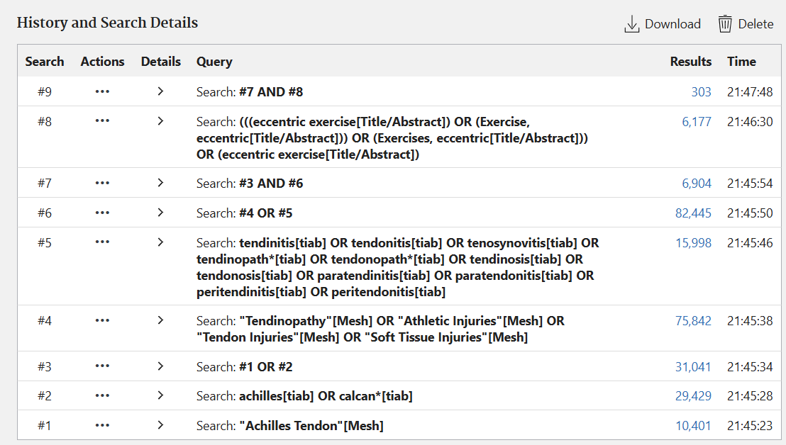
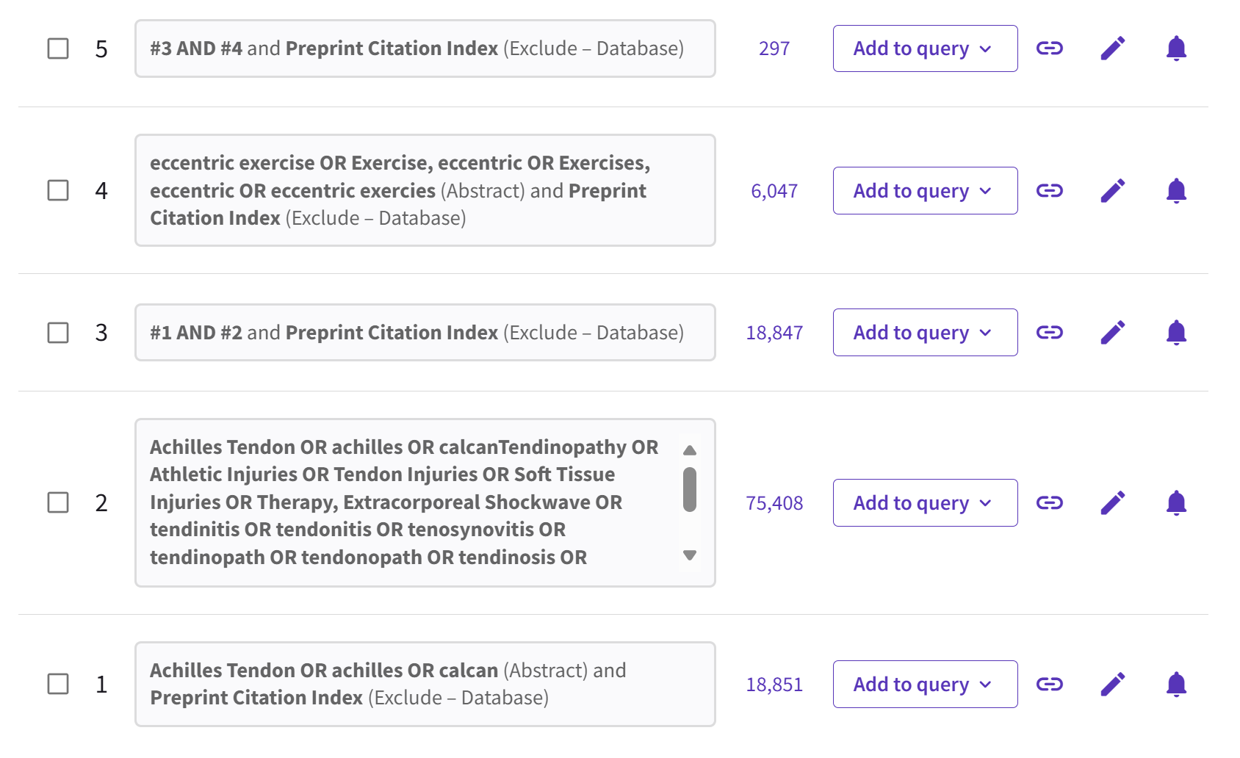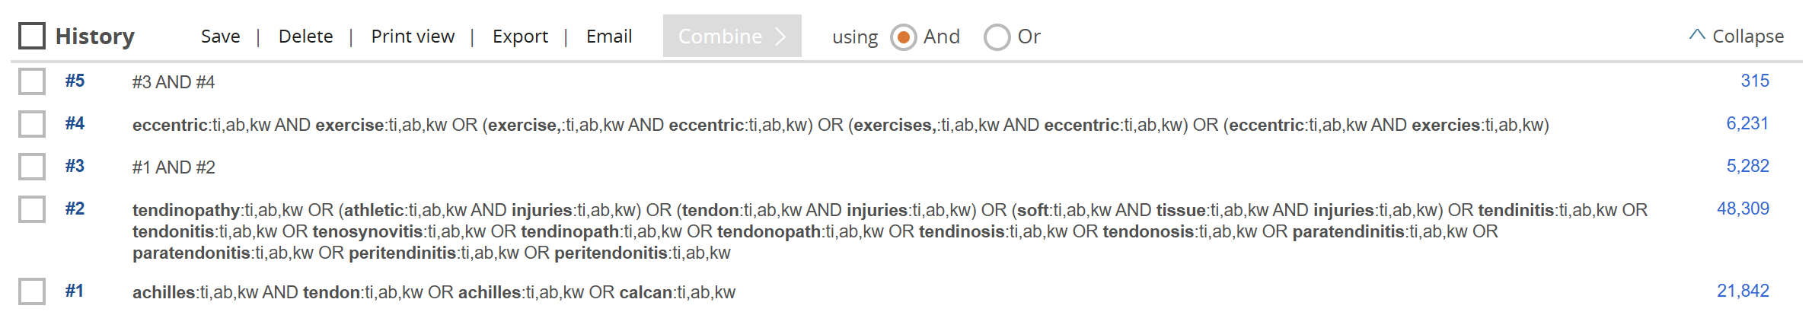
B
C
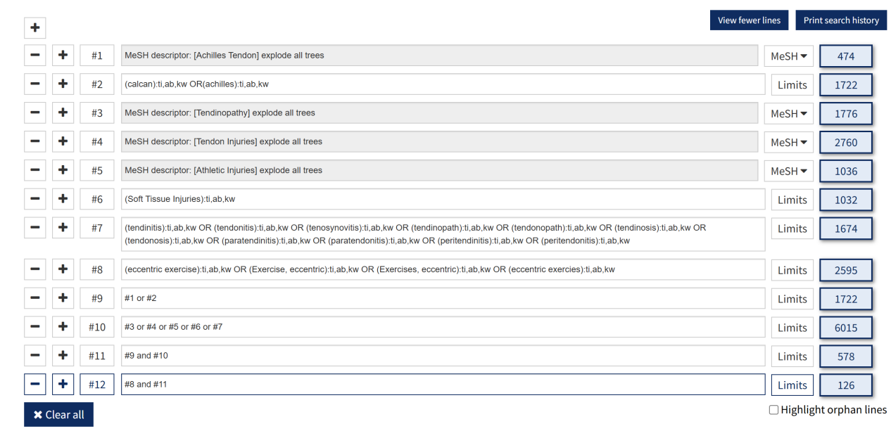
D

Supplemental Figure 2
Heterogeneous examination of pain indicators, (A) conducting heterogeneity assessment for all studies involving pain indicators; (B) conducting heterogeneity assessment for all studies involving VAS pain indicators; (C) conducting heterogeneity assessment for all studies involving NRS pain indicators.
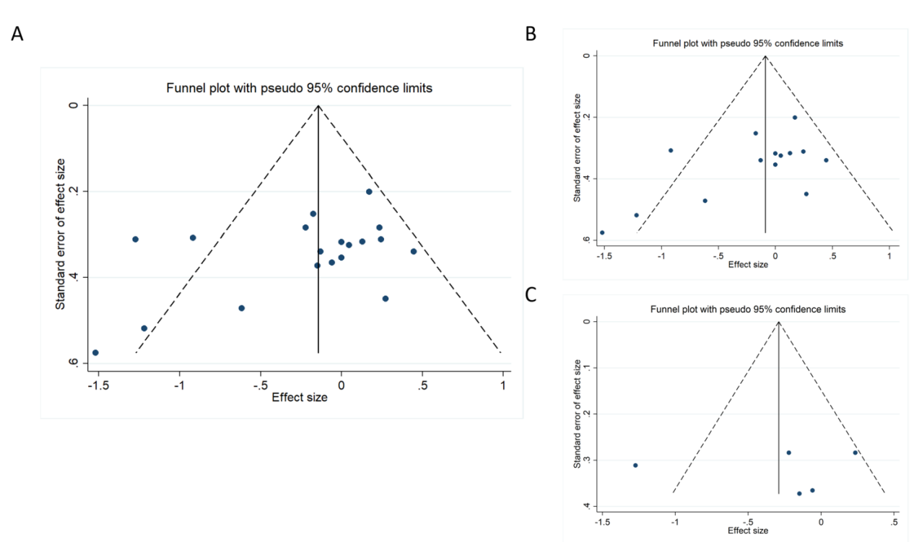
Supplemental Figure 3
Heterogeneous examination of ultrasound diagnostic indicators, (A) conducting heterogeneity assessment for all studies involving ultrasound diagnostic indicators; (B) conducting heterogeneity assessment for all studies involving vascularity; (C) conducting heterogeneity assessment for all studies involving anteroposterior thickness indicators.

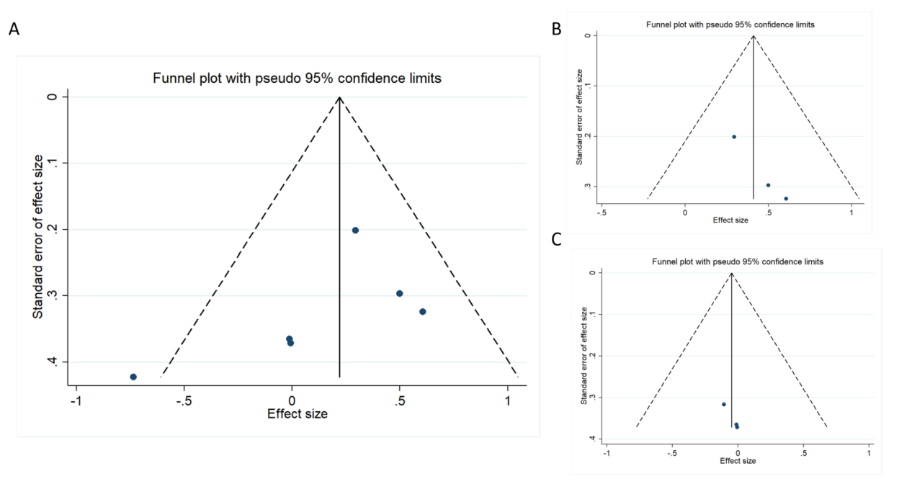

Supplemental Figure 4
Heterogeneous examination of functional indicators, (A) conducting heterogeneity assessment for all studies involving functional indicators; (B) conducting heterogeneity assessment for all studies involving VISA-A functional indicators.
