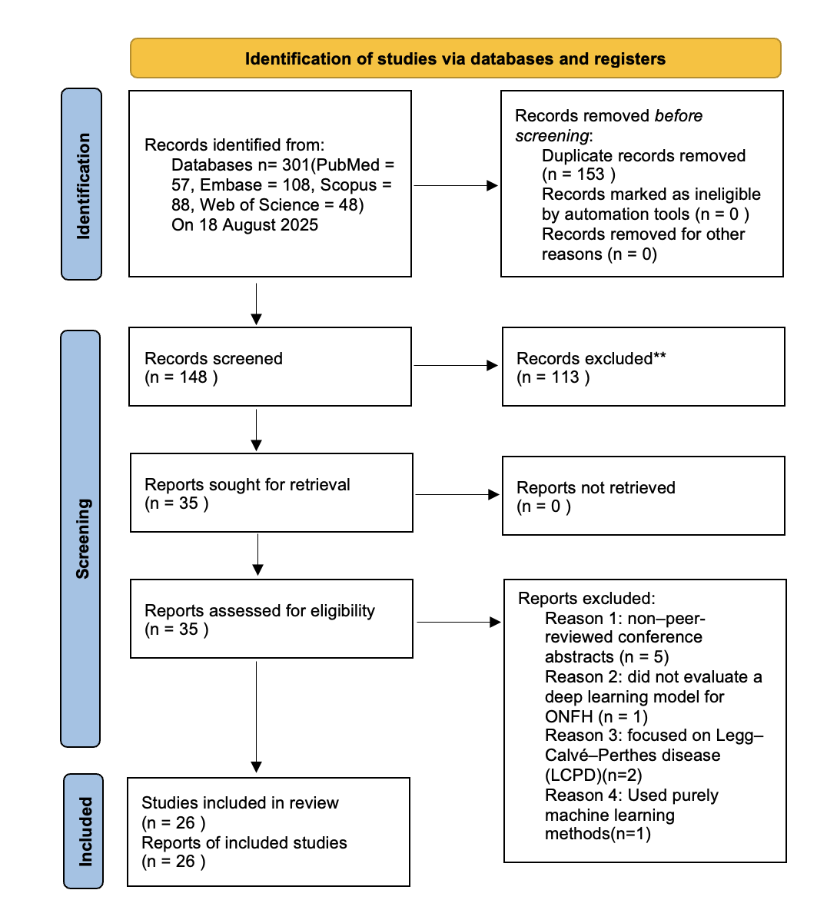
Figure 1 PRISMA flow diagram of study selection[1]

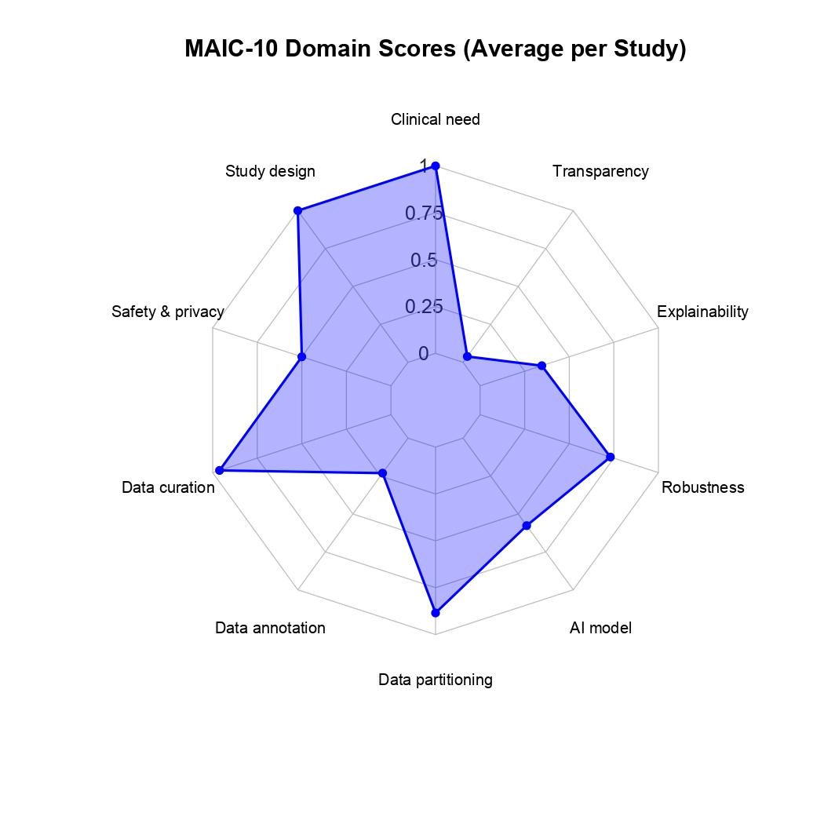
Figure 2 MAIC-10 per domain averages

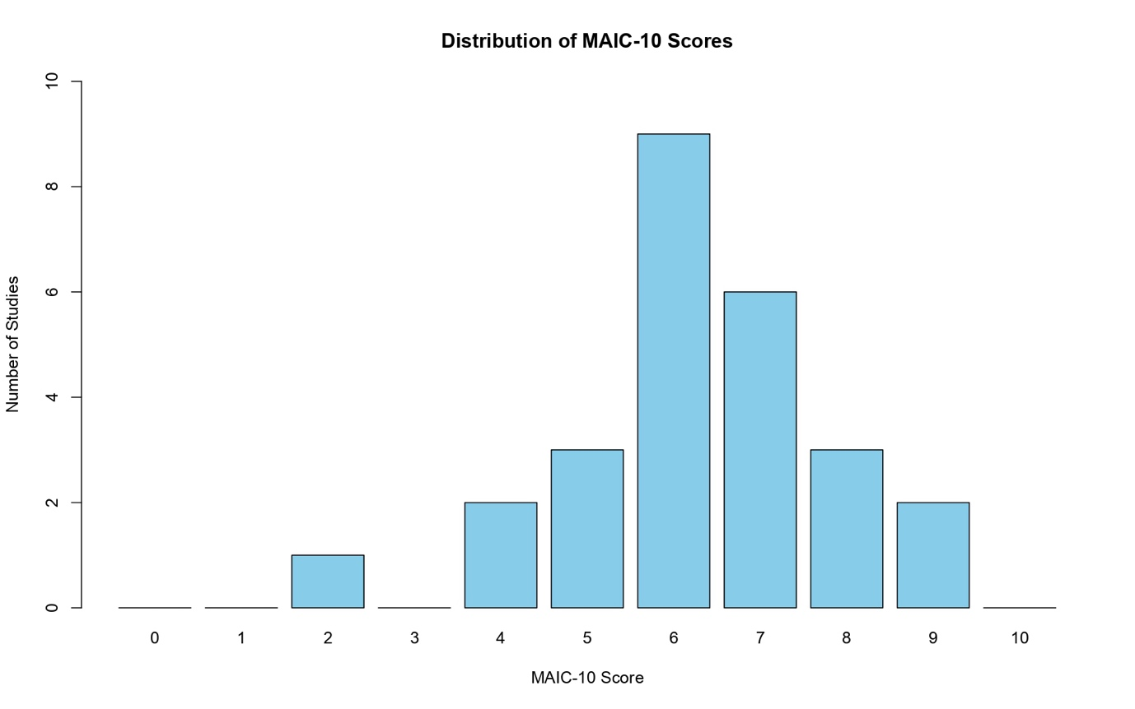
Figure 3 Total Must AI Criteria-10 score distribution

