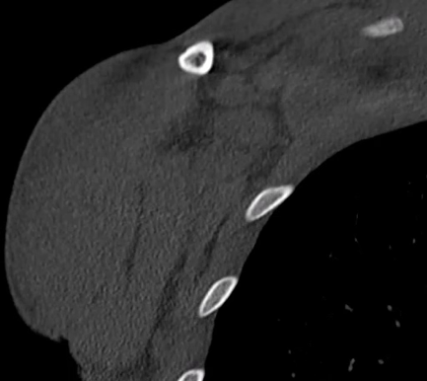
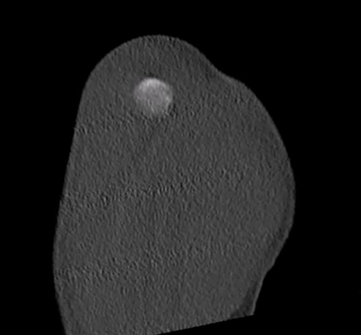
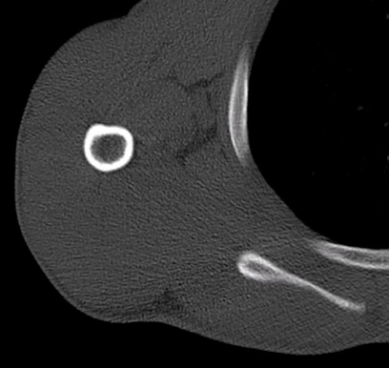
Video Legends:

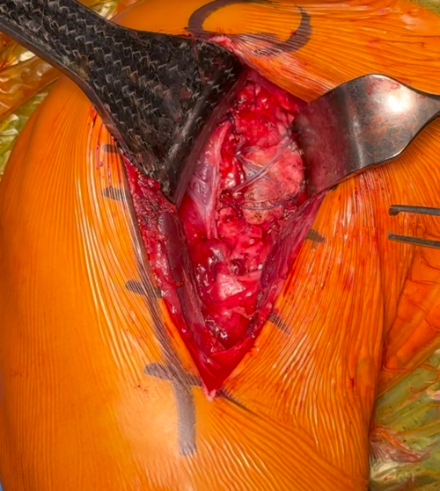
Video 1 : CT imaging of a 19-year-old male with a lesser tuberosity avulsion fracture, showing the coronal (A), axial (B) and sagittal (C) CT views.
Video 2: Double-row refixation of the lesser tuberosity

