Supplementary Material 1

Search Strategies

Cochrane Central Register of Controlled Trials
#1 MeSH descriptor: [Arthroplasty, Replacement, Knee] explode all trees
#2 (Arthroplasties, RepArthroplasties, Replacement, Knee OR Arthroplasty, Knee Replacement OR Knee Replacement Arthroplasties OR Knee Replacement Arthroplasty OR Replacement Arthroplasties, Knee OR Knee Arthroplasty, Total OR Arthroplasty, Total Knee OR Total Knee Arthroplasty OR Replacement, Total Knee OR Total Knee Replacement OR Knee Replacement, Total OR Knee Arthroplasty OR Arthroplasty, Knee OR Arthroplasties, Knee Replacement OR Replacement Arthroplasty, Kneelacement, Knee):ti,ab,kw (Word variations have been searched)
#3 MeSH descriptor: [Virtual Reality] explode all trees
#4 MeSH descriptor: [Virtual Reality Exposure Therapy] explode all trees
#5 (Reality, Virtual OR Virtual Reality, Educational OR Educational Virtual Realities OR Educational Virtual Reality OR Reality, Educational Virtual OR Virtual Realities, Educational OR Virtual Reality, Instructional OR Instructional Virtual Realities OR Instructional Virtual Reality OR Realities, Instructional Virtual OR Reality, Instructional Virtual OR Virtual Realities, Instructional OR Virtual Reality Immersion Therapy OR Virtual Reality Therapy OR Reality Therapies, Virtual OR Reality Therapy, Virtual Therapies, Virtual Reality OR Therapy, Virtual Reality OR Virtual Reality Therapies OR Augmented Reality OR AR OR Mixed Reality OR MR OR Extended Reality OR XR):ti,ab,kw (Word variations have been searched)
#6 (game* OR computer game* OR videogame* OR video game* OR active game* OR serious game* OR Exergam* OR Interactive OR immersive OR Wii OR Kinect OR Xbox OR Playstation):ti,ab,kw (Word variations have been searched)
#7 #1 OR #2
#8 #3 OR #4 OR #5 OR #6
#9 #7 AND #8
Pubmed
#1 Arthroplasty, Replacement, Knee[MeSH Major Topic]
#2 Arthroplasties, Replacement, Knee OR Arthroplasty, Knee Replacement OR Knee Replacement Arthroplasties OR Knee Replacement Arthroplasty OR Replacement Arthroplasties, Knee OR Knee Arthroplasty, Total OR Arthroplasty, Total Knee OR Total Knee Arthroplasty OR Replacement, Total Knee OR Total Knee Replacement OR Knee Replacement, Total OR Knee Arthroplasty OR Arthroplasty, Knee OR Arthroplasties, Knee Replacement OR Replacement Arthroplasty, Knee
#3 #1 OR #2
#4 Virtual Reality[MeSH Major Topic]
#5 Virtual Reality Exposure Therapy[MeSH Major Topic]
#6 Reality, Virtual OR Virtual Reality, Educational OR Educational Virtual Realities OR Educational Virtual Reality OR Reality, Educational Virtual OR Virtual Realities, Educational OR Virtual Reality, Instructional OR Instructional Virtual Realities OR Instructional Virtual Reality OR Realities, Instructional Virtual OR Reality, Instructional Virtual OR Virtual Realities, Instructional OR Virtual Reality Immersion Therapy OR Virtual Reality Therapy OR Reality Therapies, Virtual OR Reality Therapy, Virtual Therapies, Virtual Reality OR Therapy, Virtual Reality OR Virtual Reality Therapies OR Augmented Reality OR AR OR Mixed Reality OR MR OR Extended Reality OR XR
#7 game(s) OR computer game(s) OR videogame(s) OR video game(s) OR active game(s) OR serious game(s) OR Exergam OR Interactive OR immersive OR Wii OR Kinect OR Xbox OR Playstation
#8 #4 OR #5 OR #6 OR #7
#9 #3 AND #8
#10 ((((((randomized controlled trial [pt]) OR (controlled clinical trial [pt])) OR (randomized [tiab])) OR (placebo [tiab])) OR (clinical trials as topic [mesh: noexp])) OR (randomly [tiab])) OR (trial [ti])
#11 animals [mh] NOT humans [mh]
#12 #10 NOT #11
#13 #9 AND #12
Web of science
#1 TI=(Arthroplasty, Replacement, Knee) OR AB=(Arthroplasty, Replacement, Knee) OR TI=(Arthroplasties, Replacement, Knee OR Arthroplasty, Knee Replacement OR Knee Replacement Arthroplasties OR Knee Replacement Arthroplasty OR Replacement Arthroplasties, Knee OR Knee Arthroplasty, Total OR Arthroplasty, Total Knee OR Total Knee Arthroplasty OR Replacement, Total Knee OR Total Knee Replacement OR Knee Replacement, Total OR Knee Arthroplasty OR Arthroplasty, Knee OR Arthroplasties, Knee Replacement OR Replacement Arthroplasty, Knee) OR AB=(Arthroplasties, Replacement, Knee OR Arthroplasty, Knee Replacement OR Knee Replacement Arthroplasties OR Knee Replacement Arthroplasty OR Replacement Arthroplasties, Knee OR Knee Arthroplasty, Total OR Arthroplasty, Total Knee OR Total Knee Arthroplasty OR Replacement, Total Knee OR Total Knee Replacement OR Knee Replacement, Total OR Knee Arthroplasty OR Arthroplasty, Knee OR Arthroplasties, Knee Replacement OR Replacement Arthroplasty, Knee)
#2 TI=(Virtual Reality) OR AB=(Virtual Reality) OR TI=(Virtual Reality Exposure Therapy) OR AB=(Virtual Reality Exposure Therapy) OR TI=(Reality, Virtual OR Virtual Reality, Educational OR Educational Virtual Realities OR Educational Virtual Reality OR Reality, Educational Virtual OR Virtual Realities, Educational OR Virtual Reality, Instructional OR Instructional Virtual Realities OR Instructional Virtual Reality OR Realities, Instructional Virtual OR Reality, Instructional Virtual OR Virtual Realities, Instructional OR Virtual Reality Immersion Therapy OR Virtual Reality Therapy OR Reality Therapies, Virtual OR Reality Therapy, Virtual Therapies, Virtual Reality OR Therapy, Virtual Reality OR Virtual Reality Therapies OR Augmented Reality OR AR OR Mixed Reality OR MR OR Extended Reality OR XR) OR AB=(Reality, Virtual OR Virtual Reality, Educational OR Educational Virtual Realities OR Educational Virtual Reality OR Reality, Educational Virtual OR Virtual Realities, Educational OR Virtual Reality, Instructional OR Instructional Virtual Realities OR Instructional Virtual Reality OR Realities, Instructional Virtual OR Reality, Instructional Virtual OR Virtual Realities, Instructional OR Virtual Reality Immersion Therapy OR Virtual Reality Therapy OR Reality Therapies, Virtual OR Reality Therapy, Virtual Therapies, Virtual Reality OR Therapy, Virtual Reality OR Virtual Reality Therapies OR Augmented Reality OR AR OR Mixed Reality OR MR OR Extended Reality OR XR) OR TI=(game* OR computer game* OR videogame* OR video game* OR active game* OR serious game* OR Exergam OR Interactive OR immersive OR Wii OR Kinect OR Xbox OR Playstation) OR AB=(game* OR computer game* OR videogame* OR video game* OR active game* OR serious game* OR Exergam OR Interactive OR immersive OR Wii OR Kinect OR Xbox OR Playstation)
#3 #1 AND #2
#4 (TS=(randomized controlled trial)) OR TS=(controlled clinical trial) OR (((TI=(randomized)) OR AB=(randomized)) OR TI=(randomly)) OR AB=(randomly)
#5 #3 AND #4
Database: Embase
#7. #1 AND #5 AND #6
#6. 'randomized controlled trial'/exp
#5. #2 OR #3 OR #4
#4. 'reality, virtual' OR 'virtual reality, educational' OR 'educational virtual realities' OR 'educational virtual reality' OR 'reality, educational virtual' OR 'virtual realities, educational' OR 'virtual reality, instructional' OR 'instructional virtual realities' OR 'instructional virtual reality' OR 'realities, instructional virtual' OR 'reality, instructional virtual' OR 'virtual realities, instructional' OR 'virtual reality immersion therapy' OR 'virtual reality therapy' OR 'reality therapies, virtual' OR 'reality therapy, virtual therapies, virtual reality' OR 'therapy, virtual reality' OR 'virtual reality therapies' OR 'augmented reality' OR 'AR' OR 'mixed reality' OR 'MR' OR 'extended reality' OR 'XR' OR 'game(s)' OR 'computer game(s)' OR 'videogame(s)' OR 'video game(s)' OR 'active game(s)' OR 'serious game(s)' OR 'exergam' OR 'interactive' OR 'immersive' OR 'wii' OR 'kinect' OR 'xbox' OR 'playstation'
#3. 'virtual reality exposure therapy'/exp
#2. 'virtual reality'/exp
#1. 'arthroplasty, replacement, knee'/exp OR 'arthroplasties, replacement, knee' OR 'arthroplasty, knee replacement' OR 'knee replacement arthroplasties' OR 'knee replacement arthroplasty' OR 'replacement arthroplasties, knee' OR 'knee arthroplasty, total' OR 'arthroplasty, total knee' OR 'total knee arthroplasty' OR 'replacement, total knee' OR 'total knee replacement' OR 'knee replacement, total' OR 'knee arthroplasty' OR 'arthroplasty, knee' OR 'arthroplasties, knee replacement' OR 'replacement arthroplasty, knee' OR 'arthroplasty, replacement, partial knee' OR 'unicompartmental knee arthroplasty' OR 'arthroplasty, unicompartmental knee' OR 'knee arthroplasty, unicompartmental' OR 'unicondylar knee arthroplasty' OR 'arthroplasty, unicondylarknee' OR 'knee arthroplasty, unicondylar' OR 'partial knee arthroplasty' OR 'arthroplasty, partial knee' OR 'knee arthroplasty, partial' OR 'unicondylar knee replacement' OR 'knee replacement, unicondylar' OR 'partial knee replacement' OR 'knee replacement, partial' OR
'unicompartmental knee replacement' OR 'knee replacement, unicompartmental' OR 'tka' OR 'tkr'

Supplementary Table 1: Sensitivity Analysis of Virtual Reality Interventions on Pain Outcomes (VAS and NPRS)
Subgroup (VAS) | Excluded Study | Pooled Effect Size (95% CI) | I² (%) | P-value
Within 2 weeks | None | -0.31 [-0.64, 0.01] | 53 | 0.1
 | Jin et al. 2018 | -0.15 [-0.39, 0.09] | 0 | 0.55
 | Gianola et al. 2020 | -0.31 [-0.77, 0.15] | 68 | 0.05
 | Fuchs et al. 2022 | -0.37 [-0.80, 0.06] | 68 | 0.05
 | Piqueras et al. 2013 | -0.44 [-0.80, -0.07] | 38 | 0.2
2 weeks to 3 months | None | -0.29 [-1.00, 0.42] | 75 | 0.05
 | Vibhuti et al. 2024 | -0.14 [-0.89, 0.62] | 83 | 0.02
 | Pournajaf et al. 2021 | -0.22 [-1.41, 0.96] | 67 | 0.08
 | Piqueras et al. 2013 | -0.62 [-1.11, -0.12] | 0 | 0.52
Subgroup (NPRS) | Excluded Study | Pooled Effect Size (95% CI) | I² (%) | P-value
Within 4 weeks | None | -1.25 [-2.14, -0.35] | 84 | 0.01
 | Güra et al. 2023 | -0.83 [-1.16, -0.50] | - | -
 | K Nishitha et al. 2024 | -1.75 [-2.40, -1.10] | - | -
4 to 12 weeks | K Nishitha et al. 2024 | -1.04 [-1.48, -0.59] | - | -
Note: VAS = Visual Analog Scale; NPRS = Numerical Pain Rating Scale; CI = Confidence Interval. "Conclusion Changed" indicates whether statistical significance was altered after excluding the specified study.

Supplementary Table 2: Sensitivity Analysis of Virtual Reality Interventions on Functional Outcomes (WOMAC and TUG)
Subgroup (WOMAC) | Excluded Study | Pooled Effect Size (95% CI) | I² (%) | P-value
Within 1 month | None | -1.68 [-2.83, -0.54] | - | -
 | K Nishitha et al. 2024 | -0.72 [-1.02, -0.42] | 91 | <0.01
 | Gianola et al. 2020 | -2.12 [-3.91, -0.33] | 0 | 0.9
 | Vibhuti et al. 2024 | -1.91 [-3.25, -0.58] | 93 | <0.01
 | Yoon et al. 2020 | -2.05 [-3.56, -0.55] | 93 | <0.01
 | Jin et al. 2018 | -2.17 [-3.91, -0.44] | 93 | <0.01
1 to 3 months | None | -2.20 [-4.07, -0.34] | 96 | <0.01
 | K Nishitha et al. 2024 | -0.46 [-1.05, 0.13] | 69 | 0.07
 | Jin et al. 2018 | -3.37 [-9.75, 3.01] | 98 | <0.01
 | Eichler et al. 2019 | -3.67 [-9.46, 2.12] | 97 | <0.01
3 to 6 months | None | -2.20 [-4.07, -0.34] | 92 | <0.01
 | K Nishitha et al. 2024 | -0.53 [-1.78, 0.72] | 91 | <0.01
 | Jin et al. 2018 | -1.26 [-4.01, 1.49] | 96 | <0.01
 | Fuchs et al. 2022 | -1.87 [-3.36, -0.37] | 85 | <0.01
Subgroup (TUG) | Excluded Study | Pooled Effect Size (95% CI) | I² (%) | P-value
Within 1 month | None | -1.54 [-2.54, -0.54] | 91 | <0.01
 | K Nishitha et al. 2024 | -1.04 [-1.90, -0.18] | 87 | <0.01
 | Güra et al. 2023 | -1.36 [-2.47, -0.25] | 93 | <0.01
 | Piqueras et al. 2013 | -1.62 [-3.12, -0.11] | 92 | <0.01
 | Yoon et al. 2020 | -1.86 [-3.08, -0.64] | 92 | <0.01
 | Pournajaf et al. 2021 | -1.92 [-3.06, -0.78] | 89 | <0.01
1 to 3 months | None | -1.62 [-3.39, 0.14] | 97 | <0.01
 | K Nishitha et al. 2024 | 0.27 [-0.23, 0.76] | 70 | 0.07
 | Eichler et al. 2019 | -3.03 [-10.06, 4.00] | 98 | <0.01
 | Piqueras et al. 2013 | -3.28 [-9.82, 3.26] | 98 | <0.01
Note: WOMAC = Western Ontario and McMaster Universities Osteoarthritis Index; TUG = Timed Up and Go test; CI = Confidence Interval.
Supplementary Table 3: Sensitivity Analysis of Virtual Reality Interventions on Range of Motion (ROM)
Subgroup | Excluded Study | Pooled Effect Size (95% CI) | I² (%) | P-value
Within 1 week | Jin et al. 2018 | 7.88 [5.16, 10.60] | - | -
1 to 2 weeks | None | 9.47 [-3.40, 22.33] | 98 | <0.01
 | Gianola et al. 2020 | 14.71 [0.38, 29.05] | 98 | <0.01
 | Jin et al. 2018 | 10.33 [-12.92, 33.57] | 98 | <0.01
 | K Nishitha et al. 2024 | 3.27 [-5.60, 12.13] | 85 | <0.01
2 to 4 weeks | None | 7.94 [5.86, 10.02] | 2 | 0.31
 | K Nishitha et al. 2024 | 9.50 [5.84, 13.16] | - | -
 | Güra et al. 2023 | 7.22 [4.75, 9.69] | - | -
4 to 12 weeks | K Nishitha et al. 2024 | 10.73 [8.31, 13.15] | - | -
Note: ROM = Range of Motion; CI = Confidence Interval. Negative values for I² indicate no heterogeneity.

Supplementary Figure 1
Sensitivity analysis of the VAS, NPRS, WOMAC, TUG test, ROM.
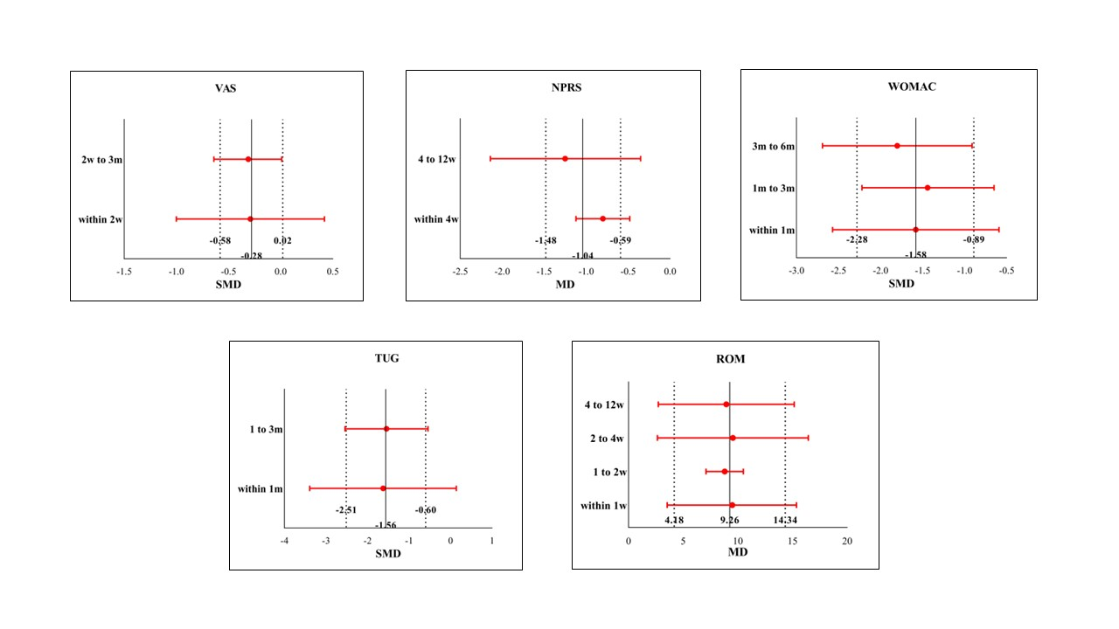
Note: VAS: Visual Analogue Scale; NPRS: numerical pain rating scale; WOMAC: Western Ontario and McMaster Universities Osteoarthritis Index; TUG: Timed Up and Go; ROM: Range of Movement.
Supplementary Figure 2
Funnel plot of the included trails to access publication bias on VAS; NPRS; WOMAC; TUG test; ROM.
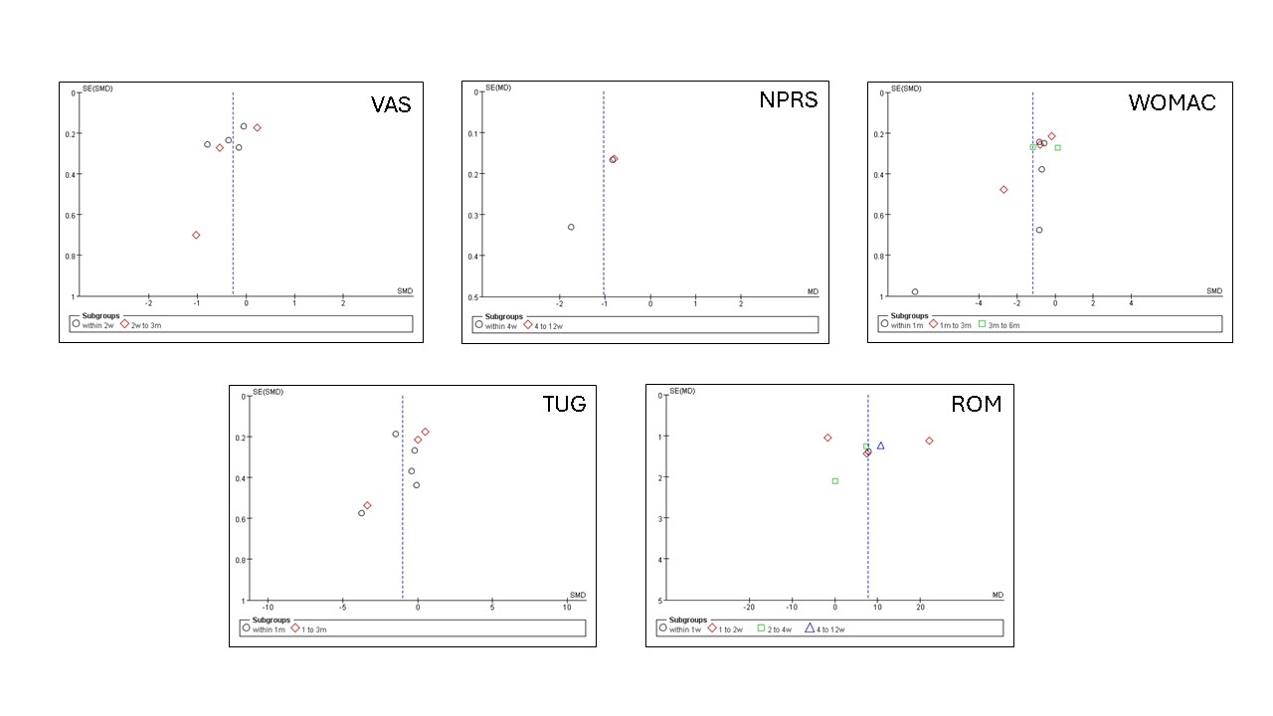
Note: VAS: Visual Analogue Scale; NPRS: numerical pain rating scale; WOMAC: Western Ontario and McMaster Universities Osteoarthritis Index; TUG: Timed Up and Go; ROM: Range of Movement.

