Visual Cognitive Neuromuscular Training Protocol:
Balance training exercises:
Modified single-leg deadlift with Visual Cues: Participants performed a single-leg deadlift while standing on the ACLR limb. To increase task difficulty and engage perceptual attention, several colored cones were arranged at equal distances corresponding to each athlete’s maximal reach in the single-leg stance. The therapist selected four colors (e.g., yellow, blue, red, and white) and called them out in random order. Upon hearing a color cue, the athlete reached toward the matching cone while maintaining balance on the support leg.
Single-Leg foam/BOSU-ball stance with horizontal rod: Athletes stood barefoot on a foam pad or BOSU ball on the ACLR limb, holding a lightweight rod at shoulder height with the elbow extended. They were instructed to keep the rod perfectly horizontal throughout the exercise, focusing on minimizing any tilt. This dual-task approach challenged both postural control and upper-body stabilization. (See Supplemental Figure 1)
Agility training exercises
Modified T-test with unanticipated cuts: From a central start line, the athlete sprinted 10 m forward to touch the first cone. Immediately before reaching that cone—while still sprinting—the therapist randomly shouted “left” or “right,” cueing an unanticipated 5 m lateral cut in the specified direction to touch the second cone. The athlete then performed a 10 m cut in the opposite lateral direction to reach the third cone, executed another 5 m cut back to the center to retouch the first cone, and finally sprinted 10 m back to the start. This sequence traced a “T” shape (see Supplemental Figure 1). Introducing an unexpected directional cue simulates the cognitive demands of sport and has been shown to increase the biomechanical risk factors for injury compared with anticipated cutting drills. Exercise 2: In ladder drills, athletes were asked to match the predetermined foot-placement patterns within the agility ladder framework.
Plyometric training exercises
Vertical jump with unanticipated single-leg landing: During the initial flight phase of the vertical jump, the trainer called out “left” or “right” to cue the athlete to land unilaterally on the left or right leg. Using spontaneous cuing creates an unanticipated landing scenario, which has previously been reported to increase hazardous biomechanical patterns associated with injury compared to anticipated landings.
Modified jump squat with cone-direction cues: Four cones were placed around the participant at 0°, 90°, 180°, and 270° and numbered 1–4. After each squat jump, the therapist rapidly called out a cone number, instructing the athlete to face that cone upon landing. To increase the cognitive challenge, additional cones were added or the rapidity of cuing was increased once the athlete had mastered the four primary directions (see Supplemental Figure 1).
Reaction training exercises
Single-Leg jump to aerial target, landing, and ball catch: The athlete stood on one leg, jumped forward, and at peak height touched an overhead target with the hand opposite the take-off leg (target set at 50 % of their maximal jump height). They then landed on the same leg and simultaneously caught a ball thrown at them.
Double-Leg jump with ball reaction and unanticipated cut: The athlete stood on both feet, performed a two-legged jump, landed on both feet, and tracked a ball thrown by the trainer to determine and execute an unanticipated cutting maneuver.
Single-Leg jump with 180° turn, aerial target touch, and ball catch: From a slight knee flexion stance on both feet, the athlete performed a single-leg jump with a 180° rotation in the air, touched an overhead target with the hand opposite the landing leg (target at 50 % maximal jump height), and caught a ball thrown by the trainer upon landing.

Supplemental Figure 1. Training exercises performed with visual perturbation.
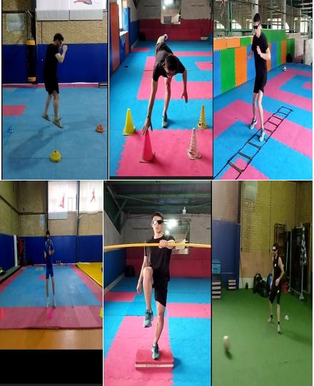

Supplemental Figure 2. Kinematics data Diagram.
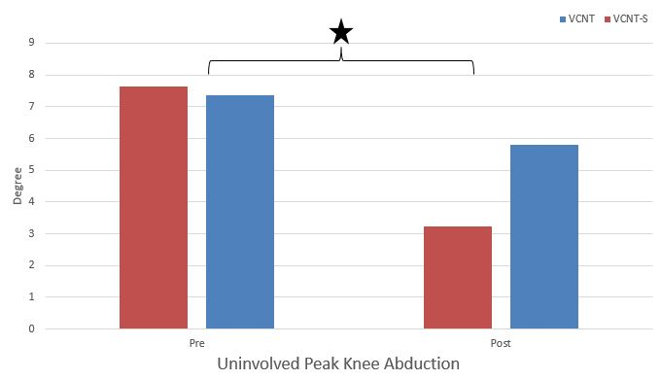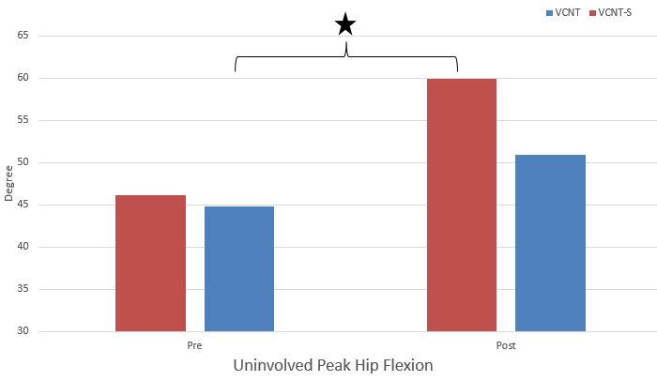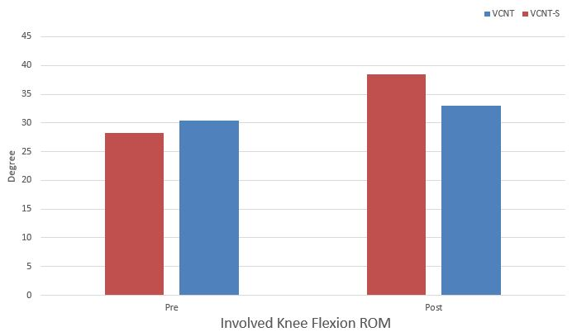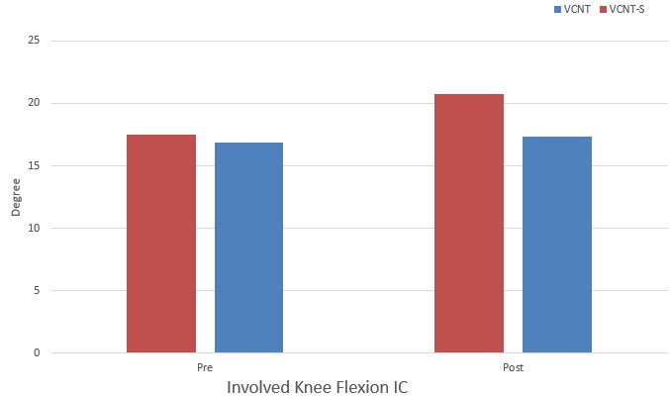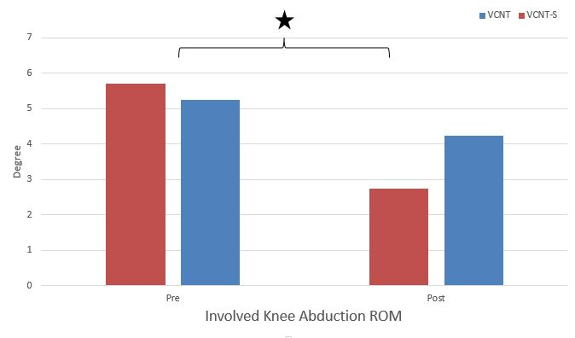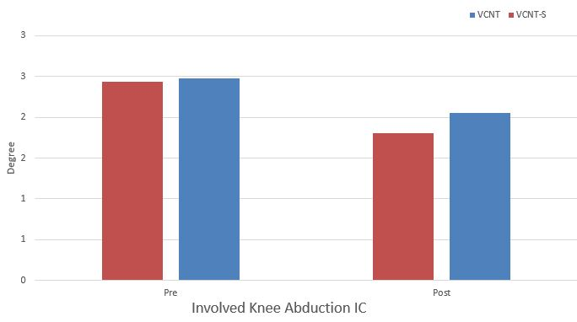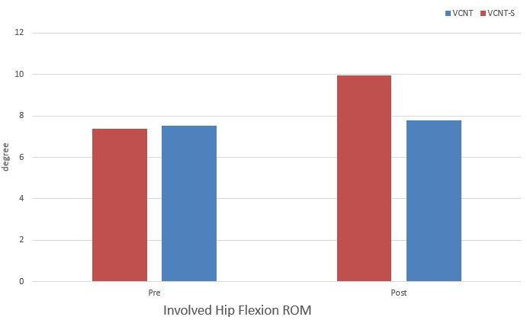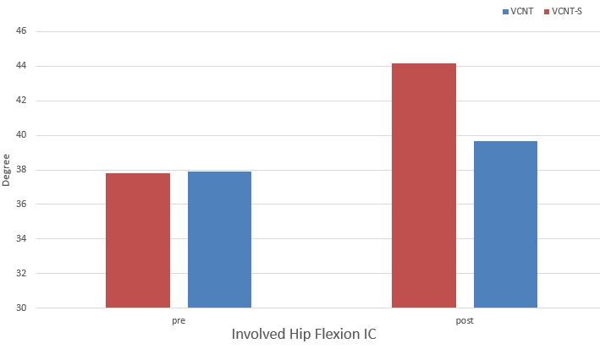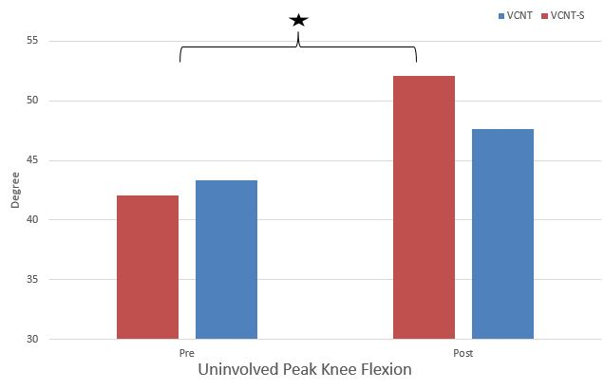
* Significant time * group interaction effect

Supplemental Figure 3. Kinetics data Diagram
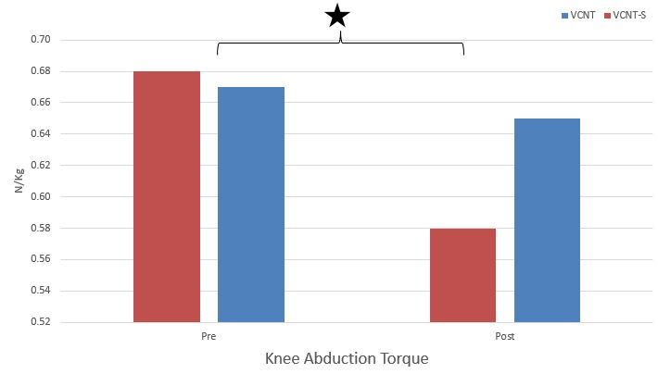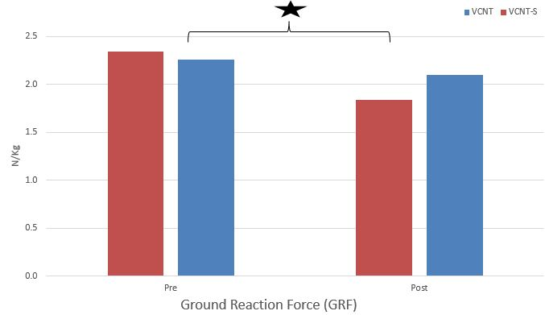
*: Significant time * group interaction effect

Supplemental Figure 4. Error Count Diagram.
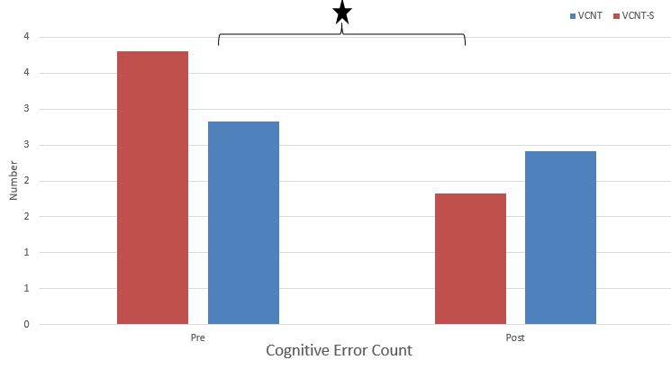
*: Significant time * group interaction effect

