Fig. S2. Theoretical normal distribution of the total clinical deficit score at the first and last visits.
The distribution of the total deficit score clearly shifted toward lower values at discharge, with a marked reduction in dispersion.
Fig. S2. Theoretical normal distribution and observed residuals
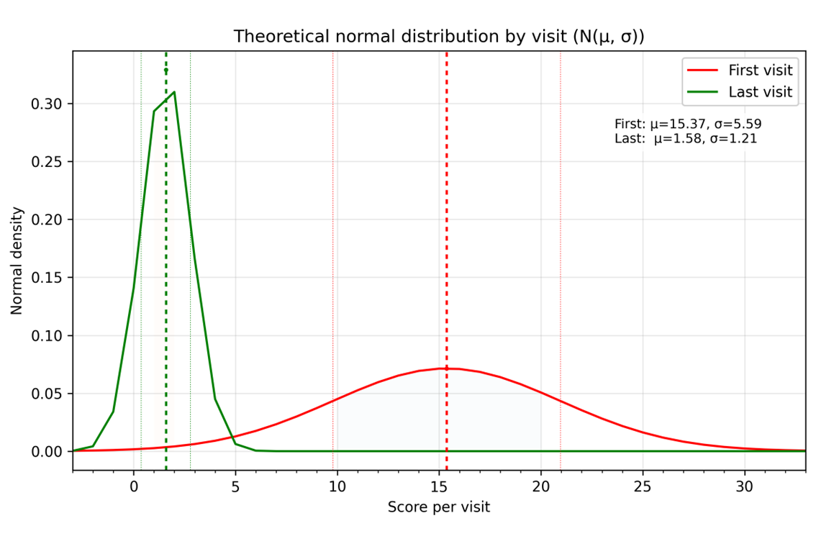
Theoretical normal distribution of the total clinical deficit score at the first and last visits. Normal density curves parameterized by the observed mean and standard deviation are shown for the first visit (red) and the last visit/discharge (green). The figure illustrates a marked shift towards lower scores and reduced dispersion at discharge (First: mu = 15.37. sd = 5.59; Last: mu = 1.58. sd = 1.21)

