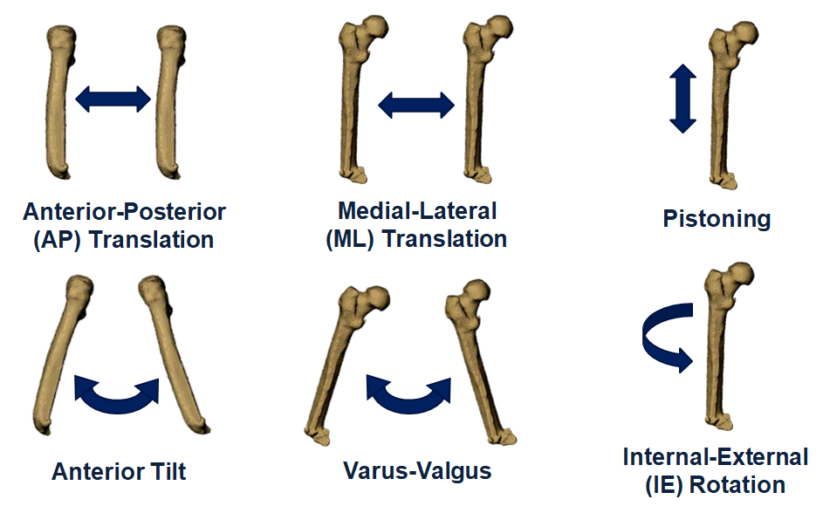
Figure 3. Six degree of freedom residual femur motion relative to the socket. The first row represents translations and the second row represents rotations. Positive directions for translations are anterior, lateral, and superior, respectively. Positive directions for rotations are anterior, varus, and internal rotation, respectively.

