Supplementary File 3

Figure I: Kinematic gait report for the operated leg of IG, CG and healthy reference data at six-month
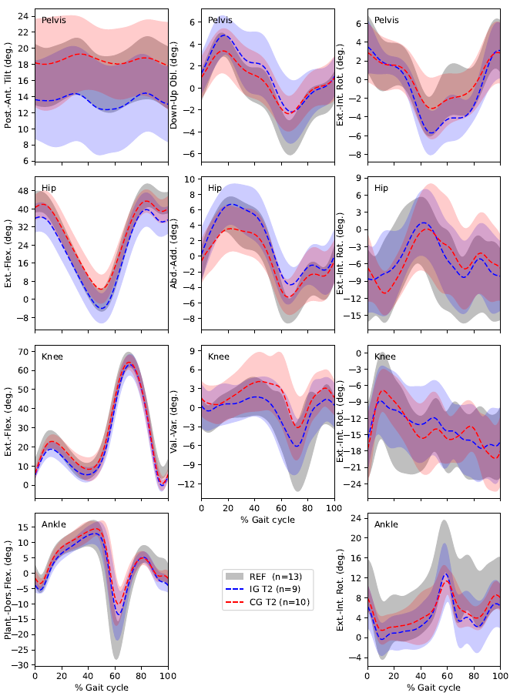
Parameters presented over 100% gait cycle for CG (red), IG (blue) and healthy reference (grey) with shadow indicating standard deviation from the mean.

Figure II: Kinetic gait report for the operated leg of IG, CG and healthy reference data at three-month
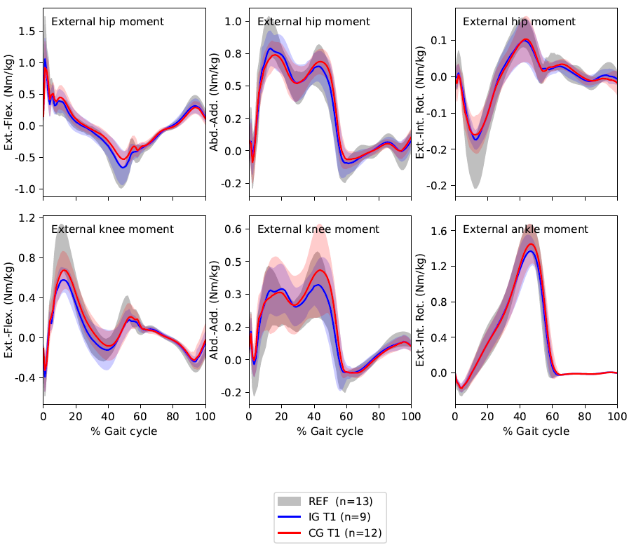
Parameters presented over 100% gait cycle for CG (red), IG (blue) and healthy reference (grey) with shadow indicating standard deviation from the mean.

Figure III: Kinetic gait report for the operated leg of IG, CG and healthy reference data at six-month
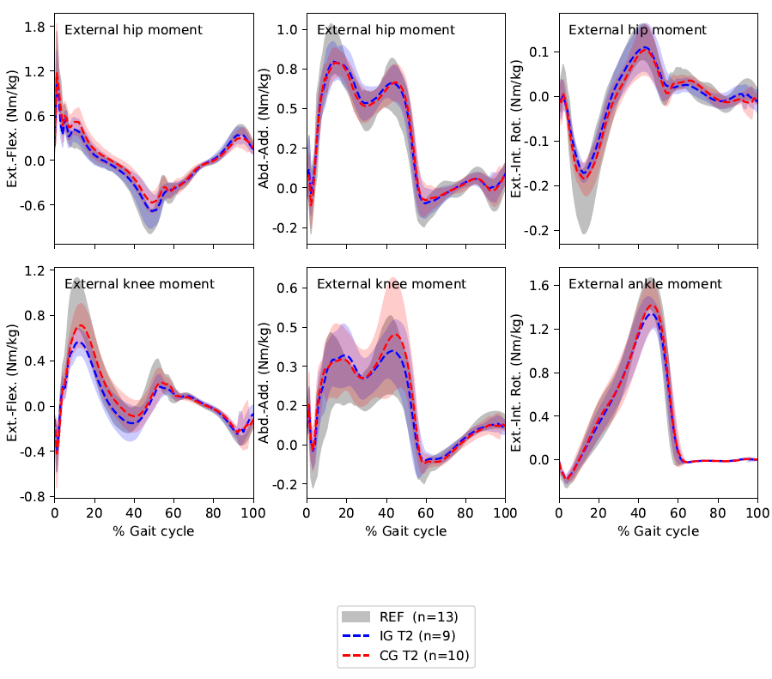
Parameters presented over 100% gait cycle for CG (red), IG (blue) and healthy reference (grey) with shadow indicating standard deviation from the mean.

