Supplementary Materials
Clinical Characteristics of the Reduced Bone Mineral Density Subgroup Among Adults With Type 2 Diabetes Mellitus: A Retrospective Cross-Sectional Study
These Supplementary Materials document endpoint reconstruction, data mapping, record-level quality control, bias-reduced model diagnostics, threshold and fixed-unit age sensitivity analyses, and repeated nested internal classification.
Supplementary Methods S1. Retrospective HIS extraction and endpoint reconstruction
The analytical dataset was reconstructed from exact source-column names in the orthopedic HIS export. The primary operational reduced-BMD subgroup was defined using the lowest T-score among the lumbar spine L1-L4, femoral neck, and total hip. Records with at least one site-specific T-score ≤ −1.0 were classified into the reduced-BMD subgroup, whereas records with T-scores > -1.0 at all three sites were classified as having normal BMD; the boundary sensitivity definition used < -1.0. Because menopausal status and Z-scores were unavailable, this rule was treated as an operational subgroup definition rather than a universal clinical diagnosis. The final research file contained sequential record identifiers but no stable patient-level hospital identifier. No exact duplicate row or duplicate composite clinical signature was found; nevertheless, repeated encounters from the same patient could not be definitively excluded. Duplicate-row checks, numeric coercion, allowed-value inspection, physiological-range review, missingness assessment, and cross-field consistency checks were performed. Values judged impossible were set to missing rather than corrected by inference. A source diagnosis field exactly matched the derived endpoint and was not used as independent validation.
Supplementary Methods S2. Jeffreys-prior bias-reduced logistic regression
Jeffreys-prior bias reduction was implemented with adjusted-score Fisher scoring and step halving. A model was considered converged only when the maximum absolute adjusted score and maximum parameter step were both <1 × 10−7. Profile-likelihood confidence intervals were obtained by constrained refitting. Linear-programming feasibility was used to assess complete separation, while sparse-cell near-separation was interpreted from event counts and uncertainty. The primary and strict-threshold analyses used identical model structures. The coefficient tables retain within-model standardization. Cross-sample age comparisons were performed separately on a common five-year scale because the age standard deviation differed between the full and age ≥50 samples.
Supplementary Methods S3. Fixed-unit age-restricted sensitivity analysis
All 26 primary events occurred in records aged ≥50 years. The restricted subset contained 273 records. The full-cohort age standard deviation was 9.9709 years and the restricted-sample standard deviation was 7.1991 years; consequently, the analysis-specific one-standard-deviation ORs of 5.39 and 3.29 are not directly comparable. When age was expressed per five years in both samples, the OR was 2.33 (95% profile-likelihood CI, 1.65-3.50) in the full cohort and 2.29 (95% CI, 1.60-3.47) in the age ≥50 subset. The female-sex OR in the restricted subset was 34.12 (95% CI, 8.22-317.67). The fixed age-sex classifier had a median repeated internal ROC AUC of 0.901 (range, 0.897-0.904), compared with 0.921 in the full cohort. Thus, restriction reduced discrimination because of narrower case mix, while the age association remained similar on a common scale.
Supplementary Methods S4. Repeated nested internal classification
Five stratified outer folds were repeated five times. Three-fold inner cross-validation selected hyperparameters. All imputation, standardization, and tuning occurred within training data. The fixed age-sex benchmark was an L2-regularized logistic model with C=1.0. Class-balanced fitting was used for penalized logistic regression and random forest but not for the benchmark, KNN, or Gaussian naive Bayes; therefore, calibration and Brier metrics were interpreted descriptively across model families. Pooled out-of-fold predictions were evaluated separately within each repeat. The main table reports the median and observed range across repeats, not confidence intervals.
Data and code availability
The de-identified record-level clinical data are not publicly available because they remain subject to institutional ethics and hospital data-governance requirements. Requests for data or analysis code may be directed to the corresponding author and will be considered on the basis of a scientifically appropriate proposal and approval by the relevant institutional authorities. Participant-level clinical data are not included in the Supplementary Materials.

SUPPLEMENTARY TABLES
Supplementary Table S1. Endpoint and data-quality audit
Audit item | Result
Analytical records | 329
Primary reduced-BMD events | 26
Strict-threshold events | 22
Primary-site T-score ≤ −2.5 records | 0
Female primary events | 25
Male primary events | 1
Primary events aged <50 years | 0
Lumbar-spine positive | 11
Femoral-neck positive | 16
Total-hip positive | 13
Positive at all three primary sites | 2
Radius-only positive | 5
Recorded diagnosis matched reconstructed endpoint | True
Missing BMI | 1
Missing diabetes duration | 16
Missing HbA1c | 11
Missing fasting plasma glucose | 1
Missing vitamin D | 2
Clarifying note: the primary-site T-score ≤ −2.5 count refers only to the retained lumbar-spine, femoral-neck, and total-hip fields and should not be interpreted as absence of clinically diagnosed osteoporosis. The recorded diagnosis exact match is a data-dictionary anomaly, not independent validation.

Supplementary Table S2. Previous-clean-file mapping audit
Previous label | Correct source field | Exact match | Correlation | Previous mean | Mapped raw mean
reduced_bmd | reduced_bmd | 1.000 | 1.000 | 0.08 | 0.08
age | age | 1.000 | 1.000 | 59.13 | 59.13
female | female | 1.000 | 1.000 | 0.38 | 0.38
height_cm | height_cm | 1.000 | 1.000 | 166.17 | 166.17
weight_kg | weight_kg | 1.000 | 1.000 | 69.77 | 69.77
bmi | bmi_raw | 1.000 | 1.000 | 25.81 | 25.81
duration | duration | 1.000 | 1.000 | 10.02 | 10.02
hba1c | hba1c | 0.000 | 0.880 | 16.82 | 8.28
fpg | fpg | 0.000 | −0.050 | 4.06 | 7.87
homa_ir | homa_ir | 1.000 | 1.000 | 3.33 | 3.33
grip | grip | 1.000 | 1.000 | 31.61 | 31.61
asmi | asmi | 1.000 | 1.000 | 8.25 | 8.25
sarco | sarco | 1.000 | 1.000 | 0.02 | 0.02
gait | gait | 1.000 | 1.000 | 1.00 | 1.00
tug | tug | 1.000 | 1.000 | 13.50 | 13.50
p1np | p1np | 1.000 | 1.000 | 42.81 | 42.81
balp | balp | 1.000 | 1.000 | 23.87 | 23.87
oc | oc | 1.000 | 1.000 | 23.68 | 23.68
bctx | bctx | 1.000 | 1.000 | 0.43 | 0.43
trap5b | trap5b | 1.000 | 1.000 | 3.79 | 3.79
frax_major | frax_major | 1.000 | 1.000 | 10.80 | 10.80
frax_hip | frax_hip | 1.000 | 1.000 | 3.37 | 3.37
sf36 | sf36 | 1.000 | 1.000 | 60.18 | 60.18
berg | berg | 1.000 | 1.000 | 48.95 | 48.95
fall_risk | fall_risk | 1.000 | 1.000 | 0.51 | 0.51
bisphosphonate | bisphosphonate | 1.000 | 1.000 | 0.14 | 0.14
vitd | vitd_25oh | 0.000 | 0.637 | 53.38 | 20.06
egfr | egfr | 1.000 | 1.000 | 100.45 | 100.45
cystatin_c | cystatin_c | 1.000 | 1.000 | 0.73 | 0.73
imt | imt | 1.000 | 1.000 | 0.99 | 0.99
tc | tc | 0.000 | −0.018 | 103.16 | 4.66
ldl | ldl | 0.000 | −0.014 | 2.31 | 2.50
hdl | hdl | 0.024 | 0.052 | 1.08 | 1.08
tg | tg | 0.000 | −0.082 | 4.08 | 2.28
smoking | smoking | 1.000 | 1.000 | 0.27 | 0.27
Clarifying note: this table is a source-column mapping audit, not a final post-QC descriptive table. The column labeled 'Mapped raw mean' reports the mean of the mapped source field before plausibility filtering. For BMI, the mapped raw mean was 25.81 kg/m²; after the impossible value of 209.78 kg/m² was set to missing, the analytical mean used in Table 1 was 25.25 kg/m².

Supplementary Table S3A. Complete primary-definition coefficient output
Model | Term | OR (95% profile CI) | P value | Events/N | Converged
Age + sex | age | 5.388 (2.713–12.153) | <0.0001 | 26/329 | True
Age + sex | female | 34.466 (8.291–321.113) | <0.0001 | 26/329 | True
Age + sex + ASMI | age | 5.476 (2.659–12.757) | <0.0001 | 26/329 | True
Age + sex + ASMI | female | 39.296 (6.061–474.106) | <0.0001 | 26/329 | True
Age + sex + ASMI | asmi | 1.117 (0.477–2.616) | 0.798 | 26/329 | True
Age + sex + grip strength | age | 5.417 (2.508–13.242) | <0.0001 | 26/329 | True
Age + sex + grip strength | female | 37.149 (4.231–564.381) | <0.001 | 26/329 | True
Age + sex + grip strength | grip | 1.066 (0.372–3.198) | 0.906 | 26/329 | True
Age + sex + cystatin C | age | 5.647 (2.485–14.690) | <0.0001 | 26/329 | True
Age + sex + cystatin C | female | 33.401 (8.059–310.701) | <0.0001 | 26/329 | True
Age + sex + cystatin C | cystatin_c | 0.931 (0.513–1.654) | 0.808 | 26/329 | True
Age + sex + eGFR | age | 5.192 (2.365–13.049) | <0.0001 | 26/329 | True
Age + sex + eGFR | female | 33.696 (8.126–313.518) | <0.0001 | 26/329 | True
Age + sex + eGFR | egfr | 0.970 (0.565–1.710) | 0.912 | 26/329 | True
Age + sex + carotid IMT | age | 8.371 (3.404–24.567) | <0.0001 | 26/329 | True
Age + sex + carotid IMT | female | 40.114 (9.358–380.927) | <0.0001 | 26/329 | True
Age + sex + carotid IMT | imt | 0.572 (0.280–1.120) | 0.104 | 26/329 | True
Age + sex + P1NP | age | 4.665 (2.199–11.165) | <0.0001 | 26/329 | True
Age + sex + P1NP | female | 21.205 (3.627–248.257) | <0.001 | 26/329 | True
Age + sex + P1NP | p1np | 1.319 (0.629–2.824) | 0.464 | 26/329 | True
Age + sex + β-CTX | age | 4.538 (2.188–10.484) | <0.0001 | 26/329 | True
Age + sex + β-CTX | female | 23.188 (5.021–225.810) | <0.0001 | 26/329 | True
Age + sex + β-CTX | bctx | 1.338 (0.897–2.022) | 0.154 | 26/329 | True
Age + sex + HbA1c | age | 5.125 (2.574–11.628) | <0.0001 | 24/318 | True
Age + sex + HbA1c | female | 31.752 (7.599–296.344) | <0.0001 | 24/318 | True
Age + sex + HbA1c | hba1c | 0.945 (0.519–1.637) | 0.846 | 24/318 | True
Age + sex + fasting glucose | age | 5.579 (2.726–13.089) | <0.0001 | 25/328 | True
Age + sex + fasting glucose | female | 36.123 (8.413–344.979) | <0.0001 | 25/328 | True
Age + sex + fasting glucose | fpg | 0.573 (0.294–1.017) | 0.057 | 25/328 | True
Interpretive note: coefficients in Supplementary Tables S3A-S3C are within-model standardized effects. Cross-sample age comparisons use the common five-year scale reported in Supplementary Methods S3.

Supplementary Table S3B. Model-level convergence and separation diagnostics
Analysis | Model | N | Events | Converged | Iterations | Penalized log likelihood | Maximum adjusted score | Final step | Separation assessment
Primary: T-score ≤ −1.0 | Age + sex | 329 | 26 | True | 12 | −50.9541 | 2.28e-09 | 8.09e-10 | No complete separation by LP; sparse male-event cell=1
Primary: T-score ≤ −1.0 | Age + sex + ASMI | 329 | 26 | True | 13 | −50.0733 | 1.07e-09 | 2.45e-10 | No complete separation by LP; sparse male-event cell=1
Primary: T-score ≤ −1.0 | Age + sex + grip strength | 329 | 26 | True | 12 | −50.3301 | 5.39e-09 | 2.74e-09 | No complete separation by LP; sparse male-event cell=1
Primary: T-score ≤ −1.0 | Age + sex + cystatin C | 329 | 26 | True | 12 | −49.7045 | 3.49e-09 | 1.63e-09 | No complete separation by LP; sparse male-event cell=1
Primary: T-score ≤ −1.0 | Age + sex + eGFR | 329 | 26 | True | 12 | −49.6832 | 8.67e-09 | 3.78e-09 | No complete separation by LP; sparse male-event cell=1
Primary: T-score ≤ −1.0 | Age + sex + carotid IMT | 329 | 26 | True | 13 | −48.5447 | 7.25e-10 | 3.94e-10 | No complete separation by LP; sparse male-event cell=1
Primary: T-score ≤ −1.0 | Age + sex + P1NP | 329 | 26 | True | 13 | −49.6941 | 2.33e-09 | 1.07e-09 | No complete separation by LP; sparse male-event cell=1
Primary: T-score ≤ −1.0 | Age + sex + β-CTX | 329 | 26 | True | 12 | −48.3785 | 2.44e-09 | 9.38e-10 | No complete separation by LP; sparse male-event cell=1
Primary: T-score ≤ −1.0 | Age + sex + HbA1c | 318 | 24 | True | 13 | −46.5831 | 1.69e-09 | 5.84e-10 | No complete separation by LP; sparse male-event cell=1
Primary: T-score ≤ −1.0 | Age + sex + fasting glucose | 328 | 25 | True | 13 | −47.2183 | 2.48e-09 | 1.78e-09 | No complete separation by LP; sparse male-event cell=1
Sensitivity: T-score < −1.0 | Age + sex | 329 | 22 | True | 12 | −47.0283 | 7.06e-09 | 2.66e-09 | No complete separation by LP; sparse male-event cell=1
Sensitivity: T-score < −1.0 | Age + sex + ASMI | 329 | 22 | True | 13 | −46.1569 | 4.60e-09 | 9.75e-10 | No complete separation by LP; sparse male-event cell=1
Sensitivity: T-score < −1.0 | Age + sex + grip strength | 329 | 22 | True | 13 | −46.2067 | 8.67e-10 | 4.39e-10 | No complete separation by LP; sparse male-event cell=1
Sensitivity: T-score < −1.0 | Age + sex + cystatin C | 329 | 22 | True | 13 | −45.8438 | 7.18e-10 | 3.46e-10 | No complete separation by LP; sparse male-event cell=1
Sensitivity: T-score < −1.0 | Age + sex + eGFR | 329 | 22 | True | 13 | −45.7974 | 1.68e-09 | 7.55e-10 | No complete separation by LP; sparse male-event cell=1
Sensitivity: T-score < −1.0 | Age + sex + carotid IMT | 329 | 22 | True | 13 | −44.5756 | 2.65e-09 | 1.54e-09 | No complete separation by LP; sparse male-event cell=1
Sensitivity: T-score < −1.0 | Age + sex + P1NP | 329 | 22 | True | 13 | −46.0639 | 7.29e-09 | 4.84e-09 | No complete separation by LP; sparse male-event cell=1
Sensitivity: T-score < −1.0 | Age + sex + β-CTX | 329 | 22 | True | 12 | −44.7467 | 8.04e-09 | 3.25e-09 | No complete separation by LP; sparse male-event cell=1
Sensitivity: T-score < −1.0 | Age + sex + HbA1c | 318 | 20 | True | 13 | −42.5453 | 5.69e-09 | 1.77e-09 | No complete separation by LP; sparse male-event cell=1
Sensitivity: T-score < −1.0 | Age + sex + fasting glucose | 328 | 21 | True | 13 | −44.5801 | 4.97e-09 | 2.80e-09 | No complete separation by LP; sparse male-event cell=1

Supplementary Table S3C. Strict-threshold sensitivity analysis
Model | Term | OR (95% profile CI) | P value | Events/N | Converged
Age + sex | age | 5.334 (2.582–12.729) | <0.0001 | 22/329 | True
Age + sex | female | 26.341 (6.294–245.631) | <0.0001 | 22/329 | True
Age + sex + ASMI | age | 5.495 (2.564–13.520) | <0.0001 | 22/329 | True
Age + sex + ASMI | female | 32.405 (4.790–402.029) | <0.001 | 22/329 | True
Age + sex + ASMI | asmi | 1.178 (0.485–2.877) | 0.716 | 22/329 | True
Age + sex + grip strength | age | 6.068 (2.646–16.127) | <0.0001 | 22/329 | True
Age + sex + grip strength | female | 48.915 (4.933–844.183) | <0.001 | 22/329 | True
Age + sex + grip strength | grip | 1.507 (0.492–5.055) | 0.479 | 22/329 | True
Age + sex + cystatin C | age | 5.160 (2.186–14.033) | <0.0001 | 22/329 | True
Age + sex + cystatin C | female | 26.106 (6.230–243.811) | <0.0001 | 22/329 | True
Age + sex + cystatin C | cystatin_c | 1.029 (0.556–1.868) | 0.927 | 22/329 | True
Age + sex + eGFR | age | 5.328 (2.309–14.307) | <0.0001 | 22/329 | True
Age + sex + eGFR | female | 25.998 (6.218–242.367) | <0.0001 | 22/329 | True
Age + sex + eGFR | egfr | 1.014 (0.582–1.856) | 0.961 | 22/329 | True
Age + sex + carotid IMT | age | 8.683 (3.332–27.644) | <0.0001 | 22/329 | True
Age + sex + carotid IMT | female | 31.071 (7.189–295.731) | <0.0001 | 22/329 | True
Age + sex + carotid IMT | imt | 0.543 (0.253–1.105) | 0.093 | 22/329 | True
Age + sex + P1NP | age | 5.081 (2.269–12.994) | <0.0001 | 22/329 | True
Age + sex + P1NP | female | 22.506 (3.498–287.199) | <0.001 | 22/329 | True
Age + sex + P1NP | p1np | 1.070 (0.491–2.342) | 0.864 | 22/329 | True
Age + sex + β-CTX | age | 4.555 (2.108–11.132) | <0.0001 | 22/329 | True
Age + sex + β-CTX | female | 18.443 (3.910–180.900) | <0.0001 | 22/329 | True
Age + sex + β-CTX | bctx | 1.296 (0.857–1.971) | 0.216 | 22/329 | True
Age + sex + HbA1c | age | 5.080 (2.442–12.296) | <0.0001 | 20/318 | True
Age + sex + HbA1c | female | 23.936 (5.686–223.371) | <0.0001 | 20/318 | True
Age + sex + HbA1c | hba1c | 1.039 (0.558–1.840) | 0.899 | 20/318 | True
Age + sex + fasting glucose | age | 5.138 (2.466–12.376) | <0.0001 | 21/328 | True
Age + sex + fasting glucose | female | 25.232 (5.989–236.509) | <0.0001 | 21/328 | True
Age + sex + fasting glucose | fpg | 0.763 (0.405–1.333) | 0.353 | 21/328 | True
Supplementary Table S3D. Fixed-unit age sensitivity analysis using a common five-year increment.
Analysis | Events/N | Age SD, years | Age OR per 5 years (95% profile CI) | Female OR (95% profile CI) | Median ROC AUC (range)
Full cohort | 26/329 | 9.9709 | 2.33 (1.65-3.50) | 34.47 (8.29-321.11) | 0.921 (0.915-0.923)
Age ≥50 subset | 26/273 | 7.1991 | 2.29 (1.60-3.47) | 34.12 (8.22-317.67) | 0.901 (0.897-0.904)
Age was expressed per a fixed five-year increment to permit direct comparison across samples with different age standard deviations. ROC AUC values are internally validated repeat-level summaries, not external-validation estimates or confidence intervals. Events/N reports the number of reduced-BMD events divided by the total number of records in the analysis.

Supplementary Table S4A. Model specification and tuning grid
Model | Features | Estimator | Inner tuning grid
Age + sex logistic benchmark | Age, sex | Logistic regression | C=1.0
Penalized logistic regression | 10-variable non-leakage set | L1/L2 logistic regression | C={0.1,1.0}; penalty={L1,L2}
Random forest | 10-variable non-leakage set | 100 trees; class balanced | max depth={3,None}; minimum leaf=5
K-nearest neighbors | 10-variable non-leakage set | Standardized KNN | neighbors={5,15,25}; weights={uniform,distance}
Gaussian naive Bayes | 10-variable non-leakage set | Gaussian naive Bayes | variance smoothing={1e-9,1e-7}

Supplementary Table S4B. Repeat-level internal performance summary
Model | ROC AUC | PR AUC | Brier | Brier skill | Calibration intercept | Calibration slope
Age + sex logistic benchmark | 0.921 (0.915–0.923) | 0.465 (0.427–0.512) | 0.052 (0.051–0.053) | 0.280 (0.278–0.294) | 0.348 (0.266–0.444) | 1.455 (1.413–1.521)
Penalized logistic regression | 0.902 (0.880–0.923) | 0.427 (0.381–0.459) | 0.147 (0.139–0.152) | −1.024 (−1.095 to −0.913) | −2.467 (−3.002 to −2.364) | 1.177 (0.839–1.724)
Random forest | 0.899 (0.872–0.901) | 0.423 (0.404–0.481) | 0.074 (0.072–0.082) | −0.019 (−0.129–0.010) | −1.368 (−1.470 to −1.215) | 0.883 (0.686–0.961)
K-nearest neighbors | 0.899 (0.887–0.904) | 0.435 (0.352–0.484) | 0.056 (0.054–0.057) | 0.237 (0.221–0.258) | −0.693 (−0.791 to −0.609) | 0.437 (0.327–0.446)
Gaussian naive Bayes | 0.874 (0.865–0.891) | 0.384 (0.316–0.474) | 0.149 (0.129–0.155) | −1.053 (−1.128 to −0.766) | −1.963 (−2.017 to −1.907) | 0.180 (0.156–0.221)

Supplementary Table S4C. Selected hyperparameter frequencies across outer folds
Model | Selected parameters | Selections
Age + sex logistic benchmark | {"m__C": 1.0} | 25
Gaussian naive Bayes | {"m__var_smoothing": 1e-09} | 25
K-nearest neighbors | {"m__n_neighbors": 15, "m__weights": "distance"} | 6
K-nearest neighbors | {"m__n_neighbors": 25, "m__weights": "distance"} | 14
K-nearest neighbors | {"m__n_neighbors": 25, "m__weights": "uniform"} | 4
K-nearest neighbors | {"m__n_neighbors": 5, "m__weights": "distance"} | 1
Penalized logistic regression | {"m__C": 0.1, "m__penalty": "l1"} | 17
Penalized logistic regression | {"m__C": 0.1, "m__penalty": "l2"} | 4
Penalized logistic regression | {"m__C": 1.0, "m__penalty": "l1"} | 3
Penalized logistic regression | {"m__C": 1.0, "m__penalty": "l2"} | 1
Random forest | {"m__max_depth": 3, "m__min_samples_leaf": 5} | 15
Random forest | {"m__max_depth": null, "m__min_samples_leaf": 5} | 10

SUPPLEMENTARY FIGURES
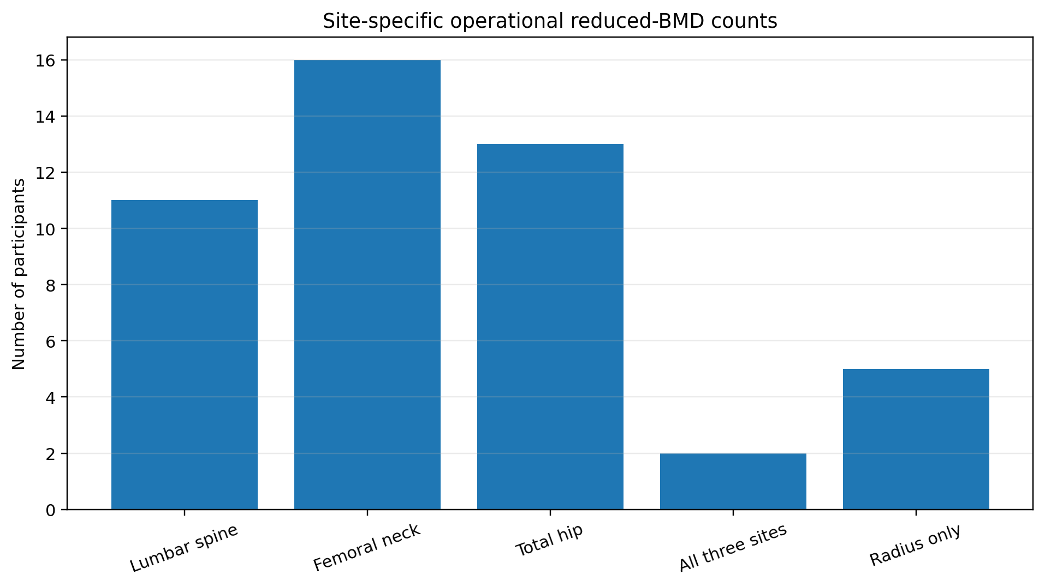
Supplementary Figure S1. Non-mutually exclusive site-specific counts contributing to the operational reduced-BMD subgroup.

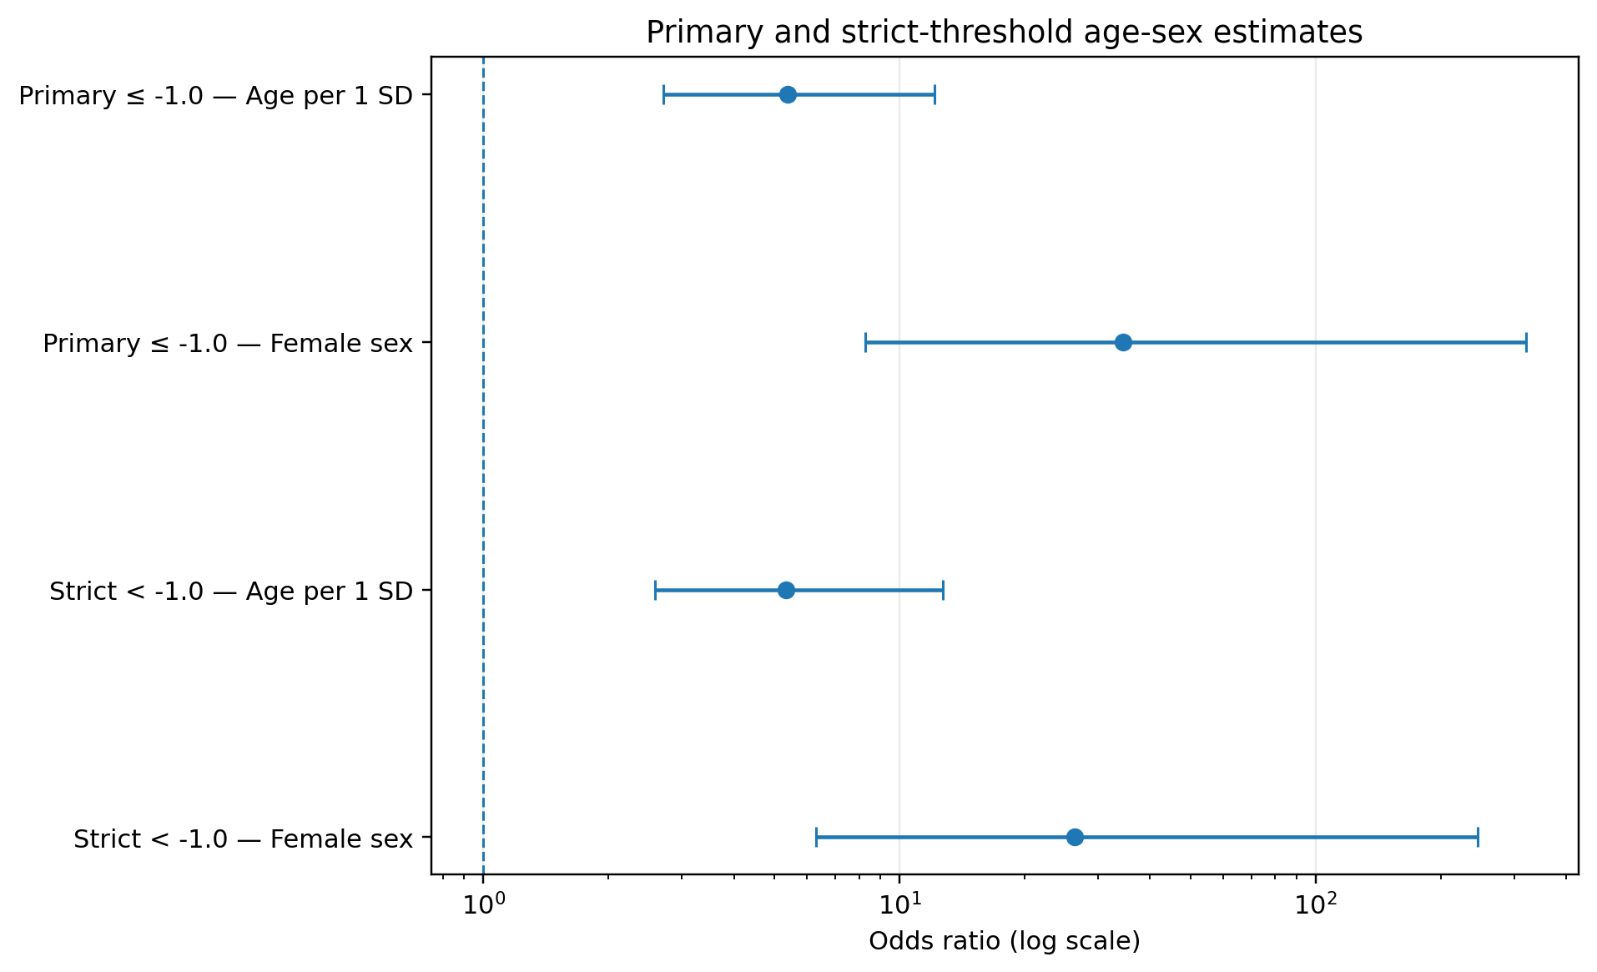
Supplementary Figure S2. Primary and strict-threshold age-sex bias-reduced estimates. The figure retains within-sample standardized estimates. The direct full-cohort versus age ≥50 comparison is reported on a common five-year scale in Supplementary Table S3D.

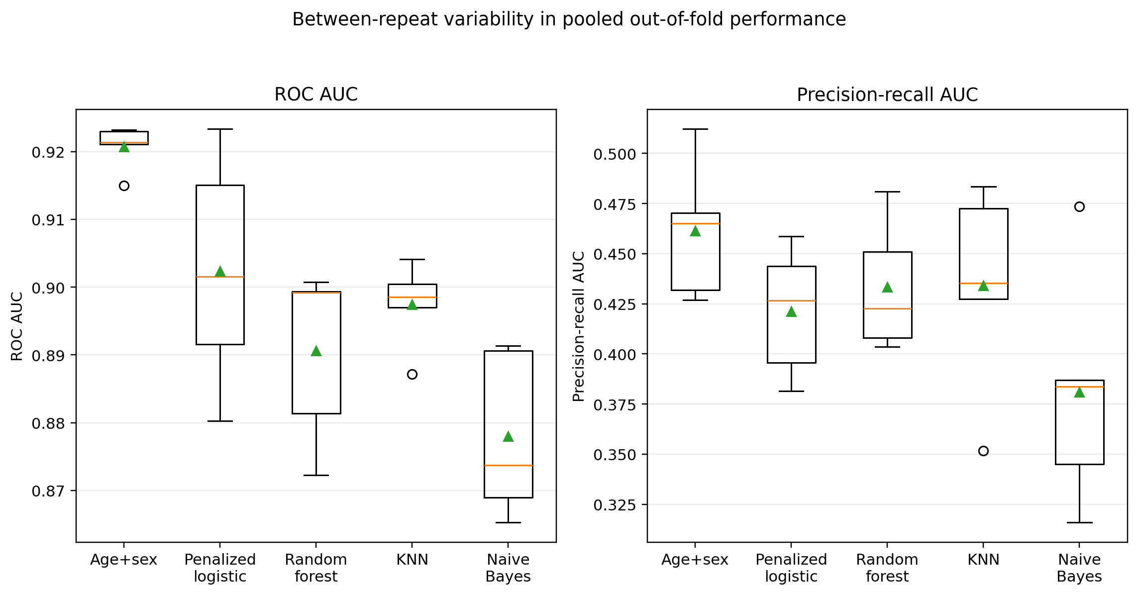
Supplementary Figure S3. Between-repeat variability in pooled out-of-fold ROC AUC and precision-recall AUC. Five repeat-level values are shown for each model; the display summarizes internal resampling variability and does not represent confidence intervals or external validation.

