SUPPLEMENTARY MATERIAL
Supplementary Table S1
Laboratory Results
Variable  Complement C3 mg/dL (SF), mean (SD)  Percentage in plasma, mean (SD)  >10% plasma, n (%)  Complement C4 mg/dL (SF), mean (SD)  Percentage in plasma, mean (SD)  >10% plasma, n (%)  Leukocytes/μL, mean (SD)  Proteins g/dL (SL), median (SD)  Complement C3 mg/dL (S), mean (SD)  Complement C4 mg/dL (S), mean (SD)  CRP mg/L (S), mean (SD)  ESR mm/h (S), mean (SD) | Value  25,9 (7,9)  18,6 (5,8)  29 (93,5)  6 (2,7)  20 (9)  26 (83,9)  228,2 (388)  2,31 (0,5)  133 (15,9)  27,2 (9,4)  5,2 (4,7)  15,4 (10,1)
CRP (C-reactive protein); ESR (erythrocyte sedimentation rate); SF (synovial fluid); S (serum); SD (standard deviation)

Supplementary Table S2
Relationships between ultrasound items and levels of C3 and C4 in synovial fluid
Variables | SF C3 Levels | SF C3 normalised | SF C4 Levels | SF C4 normalised
Osteophytes (M)
Grade 0 | 28 ± 6.9 | 6.71 ± 5.15 | 5.83 ± 1.65 | 1.34 ± 1.02
Grade 1 | 28.23 ± 9.99 | 3.53 ± 4.55 | 6.53 ± 2.94 | 0.84 ± 1.20
Grade 2 | 24.43 ± 8.09 | 3.78 ± 5.30 | 5.84 ± 3.41 | 0.67 ± 0.73
Grade 3  p-value  p-value (FDR) | 23.06 ± 3.31  0.487  0.731 | 4.92 ± 5.54  0.763  0.853 | 5.46 ± 2.11  0.861  0.861 | 1.05 ± 1.20  0.779  0.835
Osteophytes (M) (dichotomized)
Grades 0-1 | 28.19 ± 9.24 | 4.17 ± 4.67 | 6.39 ± 2.69 | 0.94 ± 1.15
Grades 2-3  p-value  p-value (FDR) | 23.74 ± 6.01  0.121  0.194 | 4.35 ± 5.27  0.919  0.919 | 5.65 ± 2.75  0.457  0.617 | 0.86 ± 0.98  0.827  0.835
Osteophytes (L)
Grade 0 | 34.20 ± 5.08 | 1.25 ± 0.12 | 8.57 ± 2.93 | 0.33 ± 0.17
Grade 1 | 28.17 ± 2.69 | 6.12 ± 5.54 | 6,58 ± 3.12 | 1.29 ± 1.20
Grade 2 | 23.97 ± 5.16 | 3.35 ± 4.01 | 5.56 ± 2.13 | 0.75 ± 0.98
Grade 3  p-value  p-value (FDR) | 19.68 ± 5.38  0.037*  0.098 | 3.62 ± 6.00  0.358  0.726 | 4.06 ± 1.10  0.099  0.594 | 0.65 ± 0.99  0.399  0.798
Osteophytes (L) (dichotomized)
Grades 0-1 | 29.37 ± 8.84 | 5.15 ± 5.30 | 6.98 ± 3.09 | 1.10 ± 1.14
Grades 2-3 | 22.63 ± 5.45 | 3.44 ± 4.51 | 5.45 ± 1.97 | 0.72 ± 0.95
p-value  p-value (FDR) | 0.015*  0.090 | 0.340  0.726 | 0.050*  0.300 | 0.321  0.798
Meniscal extrusion (M)
Grade 0 | 26.79 ± 9.55 | 5.10 ± 4.95 | 5.61 ± 2.50 | 1.14 ± 1.25
Grade 1  p-value  p-value (FDR) | 24.93 ± 5.96  0.524  0.731 | 3.37 ± 4.87  0.336  0.726 | 6.43 ± 2.93  0.411  0.617 | 0.65 ± 0.74  0.198  0.798
Meniscal extrusion (L)
Grade 0 | 28.65 ± 9.79 | 5.19 ± 1.26 | 6.52 ± 2.90 | 0.94 ± 0.98
Grade 1  p-value  p-value (FDR) | 5.34 ± 1.43  0.031*  0.093 | 4.69 ± 1.25  0.618  0.853 | 5.39± 2.39  0.252  0.504 | 0.86 ± 1.17  0.835  0.835
Cartilage degradation (M)
Grades 0-1 | 26.18 ± 8.90 | 3.70 ± 4.48 | 5.85 ± 2.54 | 0.77 ± 0.99
Grades 2-3  p-value  p-value (FDR) | 25.30 ± 5.80  0.779  0.779 | 5.45 ± 1.82  0.363  0.726 | 6.33 ± 3.14  0.653 | 1.16 ± 1.15  0.344  0.798
Cartilage degradation (L)
Grades 0-1 | 28.11 ± 7.44 | 4.40 ± 5.16 | 6.48 ± 2.73 | 0.97 ± 1.20
Grades 2-3  p-value  p-value (FDR) | 22.39 ± 7.71  0.049*  0.098 | 4.05 ± 4.69  0.853  0.853 | 5.26 ± 2.59  0.226  0.504 | 0.79 ± 0.79  0.652  0.835
M (medial); L (lateral); FDR (p-value after false discovery rate correction); SF C3 and C4 normalised (values of complement levels normalised to total synovial fluid proteins)

Supplementary Table S3
Greyscale synovitis grade, ultrasound findings and Kellgren–Lawrence grade
Variables | Grade 0 or 1 | Grade 2 | p-value
Sex
Women | 14 (82.4%) | 10 (71.4%)
Male | 3 (17.6%) | 4 (28.6%) | 0.770
X-Ray Grade
Grade 1 | 5 (29.4%) | 0 (0%)
Grade 2 | 8 (47.1%) | 5 (35.7%)
Grade 3 | 2 (11.8%) | 6 (42.9%)
Grade 4 | 2 (11.8%) | 3 (21.4%) | 0.021
X-Ray Grade (dichotomized)
Grade 1-2 | 13 (76.5%) | 5 (37.5%)
Grade 3-4 | 4 (23.5%) | 9 (64.3%) | 0.022  OR: 5.85 (1.22-27.99)  p = 0,033 (adjusted)
Lequesne
Severe disability | 1 (6.3%) | 1 (7.1%)
Very severe disability | 4 (25%) | 3 (21.4%)
Extreme disability | 11 (68.8%) | 10 (71.4%) | 0.937
PD-synovitis
No | 17 (100%) | 11 (78.6%)
Yes | 0 (0%) | 3 (21.4%) | 0.048
Osteophytes (M)
Grade 0 | 3 (17.6%) | 0 (0%)
Grade 1 | 9 (52.9%) | 3 (21.4%)
Grade 2 | 3 (17.6%) | 5 (35.7%)
Grade 3 | 2 (11.8%) | 6 (42.9%) | 0.006
Osteophytes (M) (dichotomized)
Grade 0-1 | 12 (70.6%) | 3 (21.4%) | 0.006
Grade 2-3 | 5 (29.4%) | 11 (78.6%) | OR: 8.80 (1.69-45.76)  p = 0.018 (adjusted)
Osteophytes (L)
Grade 0 | 3 (17.6%) | 0 (0%)
Grade 1 | 7 (41.2%) | 5 (35.7%)
Grade 2 | 6 (35.3%) | 5 (35.7%)
Grade 3 | 1 (5.9%) | 4 (28.6%) | 0.047  p = 0.047 (adjusted)
Meniscal extrusion (M)
Grade 0 | 10 (58.8%) | 6 (42.9%)
Grade 1 | 7 (41.2%) | 8 (57.1%) | 0.376
Meniscal extrusion (L)
Grade 0 | 12 (70.6%) | 5 (35.7%)
Grade 1 | 5 (29.4%) | 9 (64.3%) | 0.052
Cartilage degradation (M) (dichotomized)
Grade 0-2 | 12 (70.6%) | 9 (64.3%)
Grade 2-3 | 5 (29.4%) | 5 (35.7%) | 1
Cartilage degradation (L) (dichotomized)
Grade 0-1 | 9 (52.9%) | 10 (71.4%)
Grade 2-3 | 8 (47.1%) | 4 (28.6%) | 0.293
PD-synovitis (Power-Doppler synovitis); M (medial); L (lateral)

Supplementary Table S4
Complete SPSS outputs of the exploratory multivariable linear regression analyses.
Dependent variable: Synovial fluid C3 concentration (mg/dL).

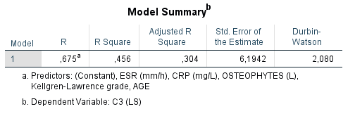
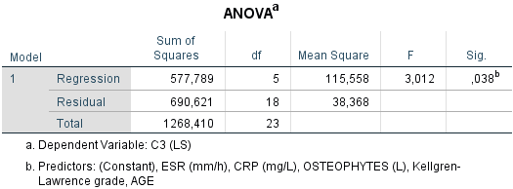
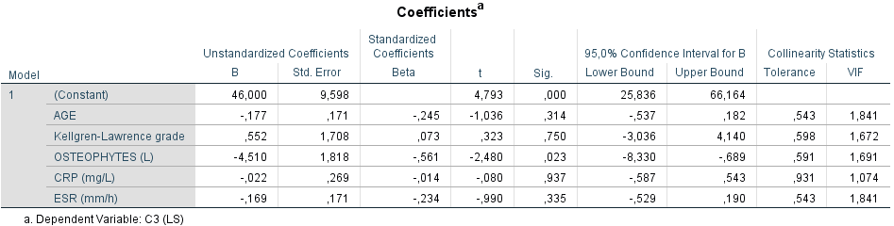

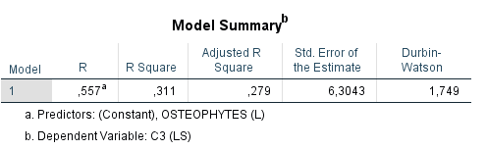
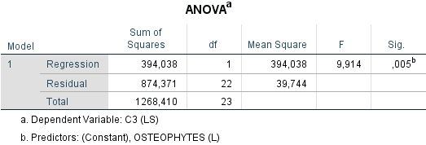
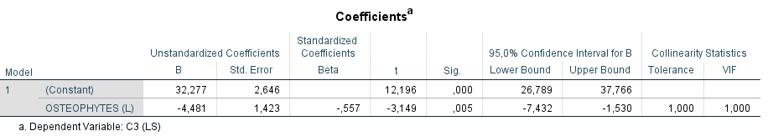

Supplementary Table S5
Complete SPSS outputs of the exploratory binary logistic regression analyses.
Dependent variable: GS-synovitis (grade 2 vs grades 0–1).

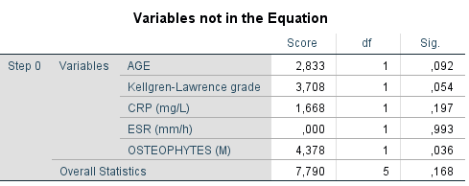
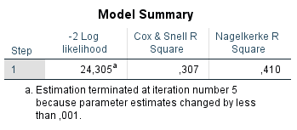
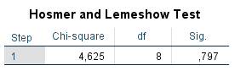
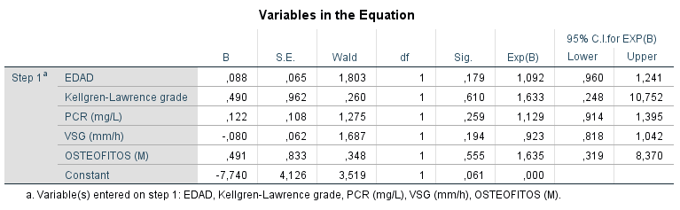

Final forward stepwise model
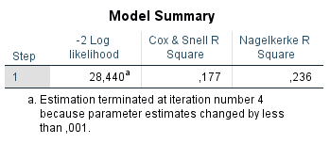
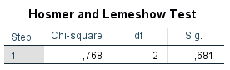
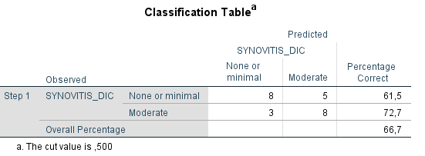
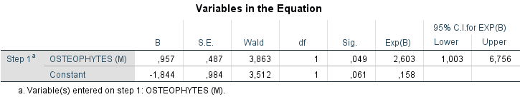

Supplementary Fig S1
Association between pain scores and inflammatory biomarkers, synovitis, and radiographic severity
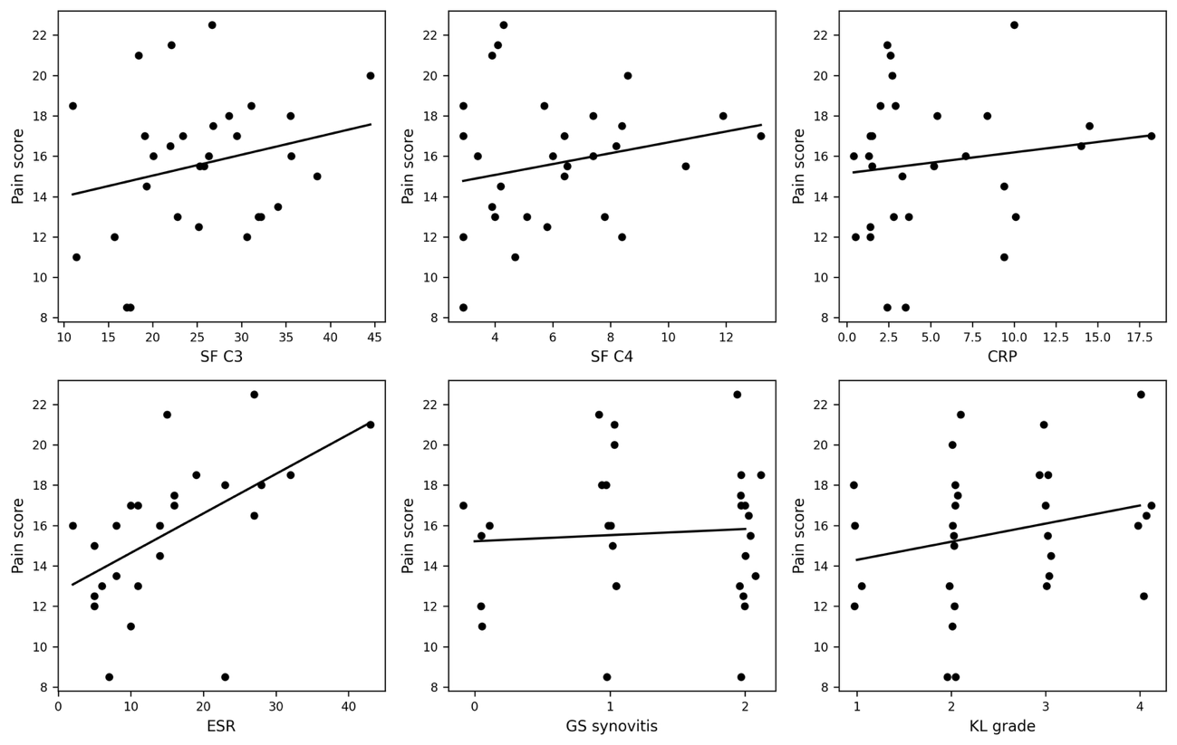
Scatter plots showing the relationship between pain scores and synovial fluid C3, synovial fluid C4, C-reactive protein (CRP), erythrocyte sedimentation rate (ESR), grey-scale (GS) synovitis grade, and Kellgren–Lawrence (KL) grade. Each dot represents an individual patient. Solid lines represent fitted linear trend lines.

