Supplementary Figure S1. Relationship between serum albumin and gluteus medius muscle area and distribution of AGMI according to one-year survival status.
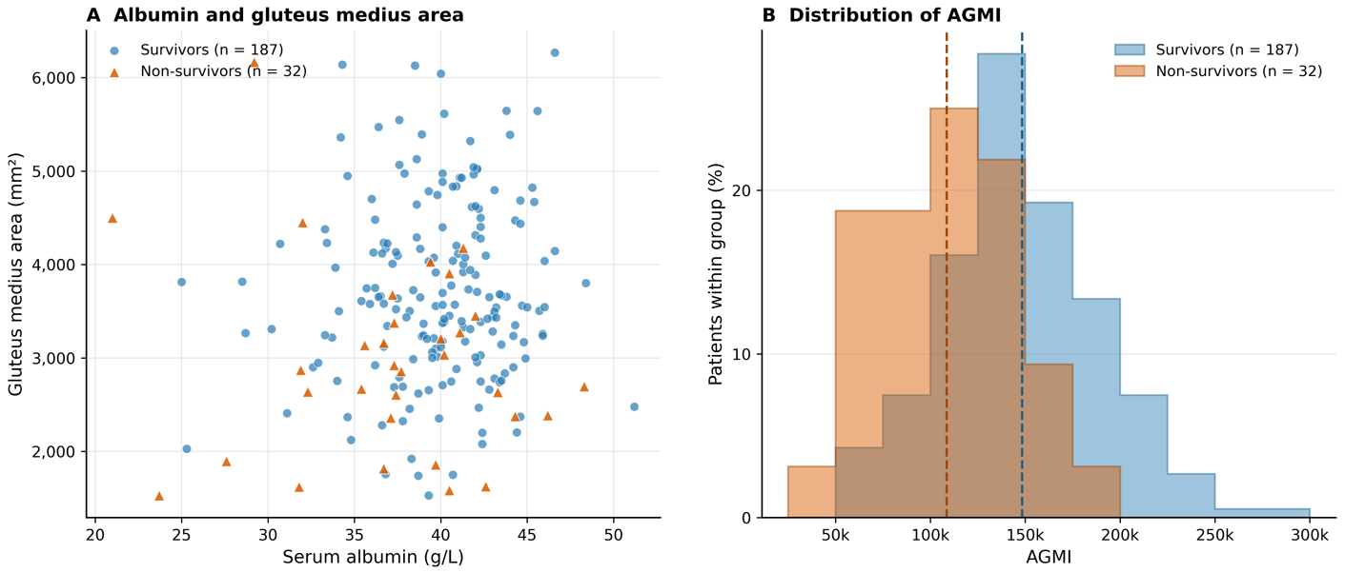
Panel A shows the relationship between serum albumin and gluteus medius muscle area, with patients distinguished according to one-year survival status. Panel B shows the distributions of AGMI among survivors and non-survivors using common histogram bin boundaries. Percentages were calculated within each survival group to account for the unequal group sizes. Dashed vertical lines indicate the group-specific mean AGMI values. AGMI: Albumin–Gluteus Medius Index.

