Article title: Semi-quantitative Bone Bruise Ratio as Predictors of High-Grade Lateral Meniscal Injury in ACL Ruptures with Kissing Contusion：A Multicenter Retrospective Cohort Study
Author names: Yang Peng, Jin Tang, Jiaxing Chen, Yuan Li, Juncai Xu, Xu Peng, Pei Zhao
Affiliations of the corresponding author:
Department of Orthopaedics, Sports Injury Division, Fujian Medical University Union Hospital, Fuzhou, China.
e-mail address of the corresponding author: zpawl@163.com

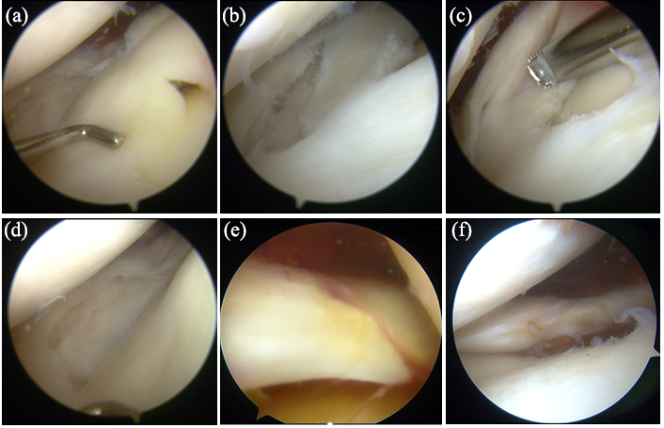
Figure S1. Representative arthroscopic findings for high-grade lateral meniscus injury. (a) Radial tear of the posterior horn of the meniscus. (b) Longitudinal tear of the lateral meniscus body. (c) Longitudinal tear and delamination tear of the posterior horn of the meniscus. (d) Delamination tear of the lateral meniscus body. (e) Oblique tear of the lateral meniscus posterior root. (f) Posterior root injury of the lateral meniscus.

