Appendix: Alternative descriptions of the classification scheme

The classification scheme depicted in Figure 2 can also be described in the following manner:

- “New”, if all disc levels were classified as “normal” in the recumbent position and there was at least one disc level classified as “appeared” in the upright position.
- “Broader”, if there was at least one disc level classified as “abnormal” in the recumbent position and there was at least one disc level classified as “appeared” and no disc level classified as “disappeared” in the upright position.
- “Stay normal”, if all disc levels were classified as “normal” in the recumbent position and no disc level was classified as “appeared” in the upright position.
- “Stay abnormal”, if there was at least one disc level classified as “abnormal” in the recumbent position, and all disc levels were classified as “unchanged” in the upright position.
- “Mixed A/D”, if there was at least one disc level classified as “appeared” and at least one disc level classified as “disappeared” in the upright position.
- “Worsened”, if there was at least one disc level classified as “worsened” and no disc level was classified as “appeared”, ”disappeared”, or ”improved”.
- “Improved”, if there was at least one disc level classified as “improved” and no disc level was classified as “appeared”, ”disappeared or ”worsened”.
- “Mixed W/I”, if there was at least one disc level classified as “improved” and at least one disc level classified as “worsened” and no disc level was classified as “appeared”, or ”disappeared”.
- “More narrow”, if there was no disc level classified as “appeared” and at least one disc level classified as “disappeared” in the upright position, and at least one disc level classified as “abnormal” in the recumbent position was not classified as “disappeared”.
- “Vanished”, if there was at least one disc level classified as “abnormal” in the recumbent position, and all these disc levels were judged as “disappeared” in the upright position and no disc level was classified as “appeared” in the upright position.

Note that in this classification, “appeared” and “disappeared” overrules “worsened” and “improved”: As soon as at least one disc level is classified as “appeared” and “disappeared”, it does not matter whether there are also disc levels with “worsened” or “improved”. In particular, if one disc level is classified as “disappeared” and another as “worsened”, this does not result in a “mixed”.
The classification system can also be expressed by the following algorithm:

IF all disc levels are classified as “normal” in the recumbent position
THEN
IF any disc level classified as “appeared” in the upright position
THEN classify as “New”
ELSE classify as “Stay normal”
ELSE
IF any disc level is classified as “appeared” or “disappeared”
THEN
IF any disc level is classified as “appeared”
and any disc level classified as “disappeared”
THEN classify as “Mixed A/D”
ELSE
IF any disc level is classified as “appeared”
THEN classify as “Broader”
ELSE
IF abnormal findings all disappeared,
THEN classify as “Vanished”
ELSE classify as “More Narrow”
ELSE
If any disc level is classified as “improved” or “worsened”
THEN
IF any disc level is classified as “worsened”
and any disc level classified as “improved”
THEN classify as “Mixed W/I”
ELSE
IF any disc level is classified as “improved”
THEN classify as “Improved”
ELSE is classify as “Worsened”
ELSE classify “Stay abnormal”

Supplementary table 1: MRI sequence parameters.
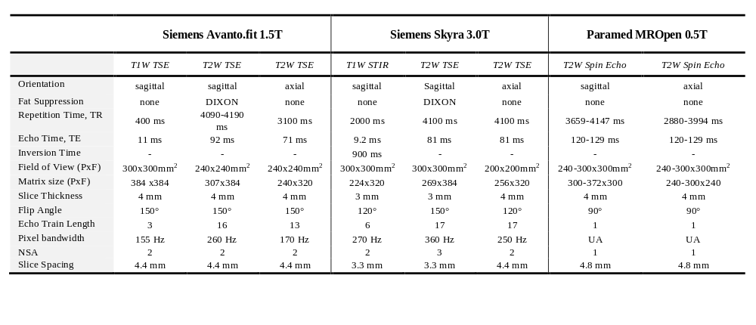
Abbreviations: STIR = Short TI Inversion Recovery, TSE = turbo spin echo, PxF = phase encoding direction x frequency encoding direction,
UA = un-available, NSA = number of signal averages.

Supplementary Figure 1: The frequency of the lumbar MRI findings in the recumbent position pooled over the three disc levels and stratified by participant group. 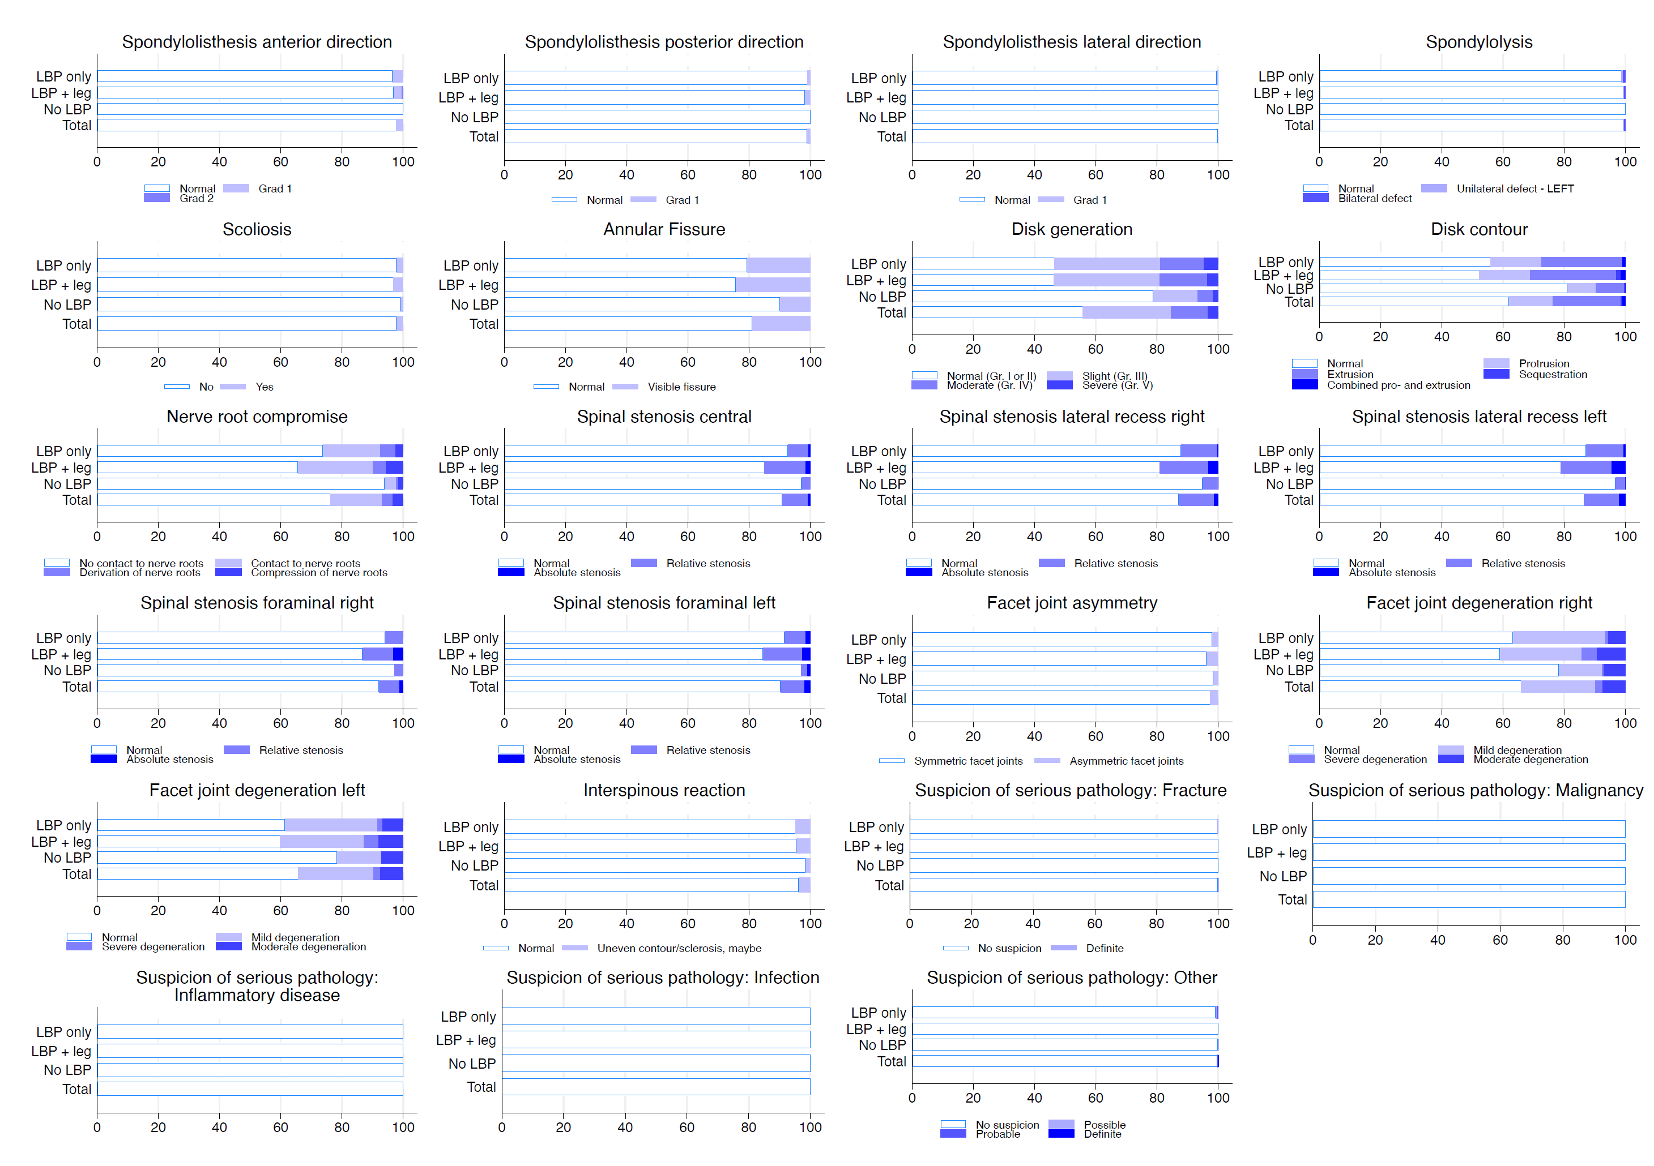

Supplementary Table 2: The frequency (%) of the single diagnostic findings in the recumbent MRI stratified by disc level and participant group.

 | Group | Finding |  | Disc level | Normal | Grade 1 | Grade 2
 | Only back | Spondylolisthesis | Anterior | L3/L4 | 97.1 | 2.9 | 0.0
 |  |  |  | L4/L5 | 98.6 | 1.4 | 0.0
 |  |  |  | L5/S1 | 94.3 | 5.7 | 0.0
 | Back + leg |  |  | L3/L4 | 97.8 | 2.2 | 0.0
 |  |  |  | L4/L5 | 95.9 | 4.1 | 0.0
 |  |  |  | L5/S1 | 97.4 | 1.5 | 1.1
 | No/LBP |  |  | L3/L4 | 100.0 | 0.0 | 0.0
 |  |  |  | L4/L5 | 100.0 | 0.0 | 0.0
 |  |  |  | L5/S1 | 100.0 | 0.0 | 0.0
 | Total |  |  | L3/L4 | 98.2 | 1.8 | 0.0
 |  |  |  | L4/L5 | 97.9 | 2.1 | 0.0
 |  |  |  | L5/S1 | 97.2 | 2.4 | 0.4
 | Only back |  | Retro | L3/L4 | 100.0 | 0.0 | 0.0
 |  |  |  | L4/L5 | 98.1 | 1.9 | 0.0
 |  |  |  | L5/S1 | 99.0 | 1.0 | 0.0
 | Back + leg |  |  | L3/L4 | 98.9 | 1.1 | 0.0
 |  |  |  | L4/L5 | 97.4 | 2.6 | 0.0
 |  |  |  | L5/S1 | 98.5 | 1.5 | 0.0
 | No-LBP |  |  | L3/L4 | 100.0 | 0.0 | 0.0
 |  |  |  | L4/L5 | 100.0 | 0.0 | 0.0
 |  |  |  | L5/S1 | 100.0 | 0.0 | 0.0
 | Total |  |  | L3/L4 | 99.6 | 0.4 | 0.0
 |  |  |  | L4/L5 | 98.4 | 1.6 | 0.0
 |  |  |  | L5/S1 | 99.1 | 0.9 | 0.0
 | Only back |  | Lateral | L3/L4 | 100.0 | 0.0 | 0.0
 |  |  |  | L4/L5 | 98.6 | 1.4 | 0.0
 |  |  |  | L5/S1 | 100.0 | 0.0 | 0.0
 | Back + leg |  |  | L3/L4 | 100.0 | 0.0 | 0.0
 |  |  |  | L4/L5 | 100.0 | 0.0 | 0.0
 |  |  |  | L5/S1 | 100.0 | 0.0 | 0.0
 | No-LBP |  |  | L3/L4 | 100.0 | 0.0 | 0.0
 |  |  |  | L4/L5 | 100.0 | 0.0 | 0.0
 |  |  |  | L5/S1 | 100.0 | 0.0 | 0.0
 | Total |  |  | L3/L4 | 100.0 | 0.0 | 0.0
 |  |  |  | L4/L5 | 99.6 | 0.4 | 0.0
 |  |  |  | L5/S1 | 100.0 | 0.0 | 0.0
 | Group | Finding |  | Disc level | Normal | Unilateral | Bilateral
 | Only back | Lysis/arcus defect |  | L3/L4 | 100.0 | 0.0 | 0.0
 |  |  |  | L4/L5 | 100.0 | 0.0 | 0.0
 |  |  |  | L5/S1 | 96.2 | 1.4 | 2.4
 | Back + leg |  |  | L3/L4 | 100.0 | 0.0 | 0.0
 |  |  |  | L4/L5 | 100.0 | 0.0 | 0.0
 |  |  |  | L5/S1 | 97.8 | 1.1 | 1.1
 | No-LBP |  |  | L3/L4 | 100.0 | 0.0 | 0.0
 |  |  |  | L4/L5 | 100.0 | 0.0 | 0.0
 |  |  |  | L5/S1 | 100.0 | 0.0 | 0.0
 | Total |  |  | L3/L4 | 100.0 | 0.0 | 0.0
 |  |  |  | L4/L5 | 100.0 | 0.0 | 0.0
 |  |  |  | L5/S1 | 97.9 | 0.9 | 1.2
 | Group | Finding |  | Disc level | No | Yes
 | Only back | Scoliosis | Sinistro | Col. Lumb. | 94.3 | 5.7
 |  |  | Dextro | Col. Lumb. | 100.0 | 0.0
 |  |  | Rotation | Col. Lumb. | 99.5 | 0.5
 | Back + leg |  | Sinistro | Col. Lumb. | 94.8 | 5.2
 |  |  | Dextro | Col. Lumb. | 96.7 | 3.3
 |  |  | Rotation | Col. Lumb. | 99.3 | 0.7
 | No-LBP |  | Sinistro | Col. Lumb. | 98.9 | 1.1
 |  |  | Dextro | Col. Lumb. | 98.4 | 1.6
 |  |  | Rotation | Col. Lumb. | 100.0 | 0.0
 | Total |  | Sinistro | Col. Lumb. | 95.8 | 4.2
 |  |  | Dextro | Col. Lumb. | 98.2 | 1.8
 |  |  | Rotation | Col. Lumb. | 99.6 | 0.4
 | Group | Finding |  | Disc level | No | Yes
 | Only back | Annular fissure |  | L3/L4 | 86.7 | 13.3
 |  |  |  | L4/L5 | 76.7 | 23.3
 |  |  |  | L5/S1 | 75.7 | 24.3
 | Back + leg |  |  | L3/L4 | 88.5 | 11.5
 |  |  |  | L4/L5 | 68.9 | 31.1
 |  |  |  | L5/S1 | 71.1 | 28.9
 | No-LBP |  |  | L3/L4 | 98.9 | 1.1
 |  |  |  | L4/L5 | 84.7 | 15.3
 |  |  |  | L5/S1 | 86.8 | 13.2
 | Total |  |  | L3/L4 | 90.9 | 9.1
 |  |  |  | L4/L5 | 75.8 | 24.2
 |  |  |  | L5/S1 | 77.0 | 23.0
 | Group | Finding |  | Disc level | Gr. I/ II | Gr. III | Gr. IV | Gr. V
 | Only back | Disc degeneration |  | L3/L4 | 64.8 | 30.5 | 4.8 | 0.0
 |  |  |  | L4/L5 | 38.1 | 40.0 | 17.6 | 4.3
 |  |  |  | L5/S1 | 39.0 | 31.4 | 20.0 | 9.5
 | Back + leg |  |  | L3/L4 | 60.3 | 29.2 | 9.7 | 0.7
 |  |  |  | L4/L5 | 39.7 | 37.1 | 21.3 | 1.9
 |  |  |  | L5/S1 | 40.4 | 37.5 | 14.2 | 7.9
 | No-LBP |  |  | L3/L4 | 93.7 | 5.3 | 1.1 | 0.0
 |  |  |  | L4/L5 | 72.0 | 22.2 | 5.8 | 0.0
 |  |  |  | L5/S1 | 70.9 | 15.9 | 7.9 | 5.3
 | Total |  |  | L3/L4 | 71.2 | 22.8 | 5.7 | 0.3
 |  |  |  | L4/L5 | 48.3 | 33.8 | 15.8 | 2.1
 |  |  |  | L5/S1 | 48.6 | 29.4 | 14.3 | 7.7
 | Group | Finding |  | Disc level | Normal | Protrusion | Extrusion | Seq. | Comb.
 | Only back | Disc contour |  | L3/L4 | 79.4 | 10.3 | 9.8 | 0.0 | 0.5
 |  |  |  | L4/L5 | 46.6 | 20.6 | 30.9 | 0.0 | 2.0
 |  |  |  | L5/S1 | 43.9 | 18.1 | 37.5 | 0.0 | 0.5
 | Back + leg |  |  | L3/L4 | 76.1 | 9.4 | 13.3 | 0.0 | 1.2
 |  |  |  | L4/L5 | 42.9 | 18.6 | 35.7 | 2.0 | 0.8
 |  |  |  | L5/S1 | 40.0 | 21.6 | 33.3 | 2.7 | 2.4
 | No-LBP |  |  | L3/L4 | 95.2 | 0.5 | 4.2 | 0.0 | 0.0
 |  |  |  | L4/L5 | 78.8 | 14.8 | 6.3 | 0.0 | 0.0
 |  |  |  | L5/S1 | 69.0 | 12.4 | 17.5 | 0.5 | 0.5
 | Total |  |  | L3/L4 | 82.7 | 7.1 | 9.6 | 0.0 | 0.6
 |  |  |  | L4/L5 | 54.6 | 18.1 | 25.6 | 0.8 | 0.9
 |  |  |  | L5/S1 | 49.7 | 17.8 | 30.0 | 1.2 | 1.2
 | Group | Finding |  | Disc level | No contact | Contact | Derivation | compr.
 | Only back | Nerve comprom. |  | L3/L4 | 91.9 | 6.7 | 1.4 | 0.0
 |  |  |  | L4/L5 | 61.9 | 29.0 | 6.2 | 2.9
 |  |  |  | L5/S1 | 68.6 | 19.5 | 7.6 | 4.3
 | Back + leg |  |  | L3/L4 | 83.0 | 13.7 | 2.6 | 0.7
 |  |  |  | L4/L5 | 51.9 | 33.3 | 7.8 | 7.0
 |  |  |  | L5/S1 | 63.3 | 25.6 | 2.2 | 8.9
 | No-LBP |  |  | L3/L4 | 98.4 | 1.6 | 0.0 | 0.0
 |  |  |  | L4/L5 | 92.1 | 4.2 | 1.1 | 2.6
 |  |  |  | L5/S1 | 91.3 | 5.6 | 1.1 | 2.1
 | Total |  |  | L3/L4 | 90.1 | 8.1 | 1.5 | 0.3
 |  |  |  | L4/L5 | 66.4 | 23.8 | 5.4 | 4.5
 |  |  |  | L5/S1 | 72.9 | 18.0 | 3.6 | 5.5
 | Group | Finding |  | Disc level | Normal | Relative stenosis | Absolute stenosis
Only back |  | Stenosis | Central | L3/L4 | 95.2 | 3.4 | 1.4
 |  |  |  | L4/L5 | 87.4 | 12.1 | 0.5
 |  |  |  | L5/S1 | 95.7 | 4.3 | 0.0
 | Back + leg |  |  | L3/L4 | 89.3 | 9.6 | 1.1
 |  |  |  | L4/L5 | 74.4 | 22.2 | 3.3
 |  |  |  | L5/S1 | 92.2 | 7.4 | 0.4
 | No-LBP |  |  | L3/L4 | 100.0 | 0.0 | 0.0
 |  |  |  | L4/L5 | 93.7 | 6.3 | 0.0
 |  |  |  | L5/S1 | 97.9 | 2.1 | 0.0
 | Total |  |  | L3/L4 | 94.1 | 5.0 | 0.9
 |  |  |  | L4/L5 | 83.9 | 14.6 | 1.5
 |  |  |  | L5/S1 | 94.9 | 5.0 | 0.2
Only back |  |  | Lat.right | L3/L4 | 95.7 | 4.3 | 0.0
 |  |  |  | L4/L5 | 83.6 | 15.9 | 0.5
 |  |  |  | L5/S1 | 85.0 | 14.5 | 0.5
 | Back + leg |  |  | L3/L4 | 88.5 | 10.0 | 1.5
 |  |  |  | L4/L5 | 68.9 | 23.3 | 7.8
 |  |  |  | L5/S1 | 86.7 | 13.3 | 0.0
 | No-LBP |  |  | L3/L4 | 100.0 | 0.0 | 0.0
 |  |  |  | L4/L5 | 90.5 | 9.0 | 0.5
 |  |  |  | L5/S1 | 94.2 | 5.8 | 0.0
 | Total |  |  | L3/L4 | 94.0 | 5.4 | 0.6
 |  |  |  | L4/L5 | 79.6 | 17.0 | 3.5
 |  |  |  | L5/S1 | 88.3 | 11.6 | 0.2
Only back |  |  | Lat.left | L3/L4 | 94.2 | 5.8 | 0.0
 |  |  |  | L4/L5 | 75.4 | 22.7 | 1.9
 |  |  |  | L5/S1 | 92.3 | 7.7 | 0.0
 | Back + leg |  |  | L3/L4 | 88.5 | 9.3 | 2.2
 |  |  |  | L4/L5 | 70.7 | 23.3 | 5.9
 |  |  |  | L5/S1 | 78.9 | 16.3 | 4.8
 | No-LBP |  |  | L3/L4 | 100.0 | 0.0 | 0.0
 |  |  |  | L4/L5 | 93.1 | 6.3 | 0.5
 |  |  |  | L5/S1 | 97.4 | 2.6 | 0.0
 | Total |  |  | L3/L4 | 93.5 | 5.6 | 0.9
 |  |  |  | L4/L5 | 78.5 | 18.3 | 3.2
 |  |  |  | L5/S1 | 88.3 | 9.8 | 2.0
Only back |  |  | Fora.right | L3/L4 | 98.6 | 1.4 | 0.0
 |  |  |  | L4/L5 | 91.8 | 8.2 | 0.0
 |  |  |  | L5/S1 | 92.3 | 7.7 | 0.0
 | Back + leg |  |  | L3/L4 | 93.3 | 6.7 | 0.0
 |  |  |  | L4/L5 | 85.6 | 10.7 | 3.7
 |  |  |  | L5/S1 | 82.4 | 12.0 | 5.6
 | No-LBP |  |  | L3/L4 | 99.5 | 0.5 | 0.0
 |  |  |  | L4/L5 | 96.3 | 3.7 | 0.0
 |  |  |  | L5/S1 | 95.8 | 4.2 | 0.0
 | Total |  |  | L3/L4 | 96.7 | 3.3 | 0.0
 |  |  |  | L4/L5 | 90.5 | 8.0 | 1.5
 |  |  |  | L5/S1 | 89.3 | 8.5 | 2.3
Only back |  |  | Fora.left | L3/L4 | 95.2 | 3.4 | 1.4
 |  |  |  | L4/L5 | 91.3 | 8.2 | 0.5
 |  |  |  | L5/S1 | 88.4 | 8.7 | 2.9
 | Back + leg |  |  | L3/L4 | 91.1 | 7.4 | 1.5
 |  |  |  | L4/L5 | 85.9 | 10.0 | 4.1
 |  |  |  | L5/S1 | 77.8 | 20.0 | 2.2
 | No-LBP |  |  | L3/L4 | 100.0 | 0.0 | 0.0
 |  |  |  | L4/L5 | 97.4 | 1.1 | 1.6
 |  |  |  | L5/S1 | 93.7 | 4.8 | 1.6
 | Total |  |  | L3/L4 | 94.9 | 4.1 | 1.1
 |  |  |  | L4/L5 | 90.8 | 6.9 | 2.3
 |  |  |  | L5/S1 | 85.6 | 12.2 | 2.3
 | Group | Finding |  | Disc level | Normal | Mild | Moderate | Severe
Only back |  | Facet morphology | Degen. right | L3/L4 | 73.8 | 24.3 | 2.0 | 0.0
 |  |  |  | L4/L5 | 58.6 | 35.0 | 4.9 | 1.5
 |  |  |  | L5/S1 | 59.1 | 30.1 | 9.8 | 1.0
 | Back + leg |  |  | L3/L4 | 66.7 | 23.6 | 7.5 | 2.2
 |  |  |  | L4/L5 | 55.8 | 27.0 | 10.5 | 6.7
 |  |  |  | L5/S1 | 56.4 | 28.8 | 9.2 | 5.6
 | No-LBP |  |  | L3/L4 | 88.4 | 9.5 | 2.1 | 0.0
 |  |  |  | L4/L5 | 73.0 | 15.3 | 10.6 | 1.1
 |  |  |  | L5/S1 | 73.5 | 17.5 | 8.5 | 0.5
 | Total |  |  | L3/L4 | 75.1 | 19.8 | 4.2 | 0.9
 |  |  |  | L4/L5 | 61.6 | 26.1 | 8.8 | 3.5
 |  |  |  | L5/S1 | 62.1 | 26.0 | 9.2 | 2.7
Only back |  |  | Degen. left | L3/L4 | 71.8 | 22.3 | 5.9 | 0.0
 |  |  |  | L4/L5 | 55.6 | 35.0 | 7.4 | 2.0
 |  |  |  | L5/S1 | 58.6 | 31.6 | 6.9 | 2.9
 | Back + leg |  |  | L3/L4 | 66.3 | 26.2 | 5.2 | 2.2
 |  |  |  | L4/L5 | 55.8 | 26.2 | 12.0 | 6.0
 |  |  |  | L5/S1 | 59.0 | 28.8 | 6.6 | 5.6
 | No-LBP |  |  | L3/L4 | 90.5 | 9.0 | 0.5 | 0.0
 |  |  |  | L4/L5 | 72.0 | 18.0 | 10.1 | 0.0
 |  |  |  | L5/S1 | 73.0 | 16.4 | 10.6 | 0.0
 | Total |  |  | L3/L4 | 74.9 | 20.1 | 4.1 | 0.9
 |  |  |  | L4/L5 | 60.4 | 26.6 | 10.0 | 3.0
 |  |  |  | L5/S1 | 62.9 | 26.1 | 7.8 | 3.2
 | Group | Finding |  | Disc level | No | Yes
Only back |  | Facet morphology | Asymmetry | L3/L4 | 98.5 | 1.5
 |  |  |  | L4/L5 | 98.5 | 1.5
 |  |  |  | L5/S1 | 97.1 | 2.9
 | Back + leg |  |  | L3/L4 | 97.4 | 2.6
 |  |  |  | L4/L5 | 95.9 | 4.1
 |  |  |  | L5/S1 | 95.5 | 4.5
 | No-LBP |  |  | L3/L4 | 99.5 | 0.5
 |  |  |  | L4/L5 | 97.9 | 2.1
 |  |  |  | L5/S1 | 97.9 | 2.1
 | Total |  |  | L3/L4 | 98.3 | 1.7
 |  |  |  | L4/L5 | 97.3 | 2.7
 |  |  |  | L5/S1 | 96.7 | 3.3
 | Group | Finding |  | Disc level | No | Yes
Only back |  | Interspinous reactive change |  | L3/L4 | 93.3 | 6.7
 |  |  |  | L4/L5 | 94.3 | 5.7
 |  |  |  | L5/S1 | 98.1 | 1.9
 | Back + leg |  |  | L3/L4 | 95.9 | 4.1
 |  |  |  | L4/L5 | 93.7 | 6.3
 |  |  |  | L5/S1 | 97.0 | 3.0
 | No-LBP |  |  | L3/L4 | 98.9 | 1.1
 |  |  |  | L4/L5 | 96.8 | 3.2
 |  |  |  | L5/S1 | 99.5 | 0.5
 | Total |  |  | L3/L4 | 96.0 | 4.0
 |  |  |  | L4/L5 | 94.8 | 5.2
 |  |  |  | L5/S1 | 98.1 | 1.9
 | Group | Finding |  | Disc level | No | Yes
Only back |  | Serious pathology | Fracture | L3/L4 | 100.0 | 0.0
 |  |  |  | L4/L5 | 99.5 | 0.5
 |  |  |  | L5/S1 | 100.0 | 0.0
 | Back + leg |  |  | L3/L4 | 100.0 | 0.0
 |  |  |  | L4/L5 | 100.0 | 0.0
 |  |  |  | L5/S1 | 100.0 | 0.0
 | No-LBP |  |  | L3/L4 | 100.0 | 0.0
 |  |  |  | L4/L5 | 100.0 | 0.0
 |  |  |  | L5/S1 | 100.0 | 0.0
 | Total |  |  | L3/L4 | 100.0 | 0.0
 |  |  |  | L4/L5 | 99.8 | 0.2
 |  |  |  | L5/S1 | 100.0 | 0.0
Only back |  |  | Malignancy | L3/L4 | 100.0 | 0.0
 |  |  |  | L4/L5 | 100.0 | 0.0
 |  |  |  | L5/S1 | 100.0 | 0.0
 | Back + leg |  |  | L3/L4 | 100.0 | 0.0
 |  |  |  | L4/L5 | 100.0 | 0.0
 |  |  |  | L5/S1 | 100.0 | 0.0
 | No-LBP |  |  | L3/L4 | 100.0 | 0.0
 |  |  |  | L4/L5 | 100.0 | 0.0
 |  |  |  | L5/S1 | 100.0 | 0.0
 | Total |  |  | L3/L4 | 100.0 | 0.0
 |  |  |  | L4/L5 | 100.0 | 0.0
 |  |  |  | L5/S1 | 100.0 | 0.0
Only back |  |  | Inflam. dis. | L3/L4 | 100.0 | 0.0
 |  |  |  | L4/L5 | 100.0 | 0.0
 |  |  |  | L5/S1 | 100.0 | 0.0
 | Back + leg |  |  | L3/L4 | 100.0 | 0.0
 |  |  |  | L4/L5 | 100.0 | 0.0
 |  |  |  | L5/S1 | 100.0 | 0.0
 | No-LBP |  |  | L3/L4 | 100.0 | 0.0
 |  |  |  | L4/L5 | 100.0 | 0.0
 |  |  |  | L5/S1 | 100.0 | 0.0
 | Total |  |  | L3/L4 | 100.0 | 0.0
 |  |  |  | L4/L5 | 100.0 | 0.0
 |  |  |  | L5/S1 | 100.0 | 0.0
Only back |  |  | Infection | L3/L4 | 100.0 | 0.0
 |  |  |  | L4/L5 | 100.0 | 0.0
 |  |  |  | L5/S1 | 100.0 | 0.0
 | Back + leg |  |  | L3/L4 | 100.0 | 0.0
 |  |  |  | L4/L5 | 100.0 | 0.0
 |  |  |  | L5/S1 | 100.0 | 0.0
 | No-LBP |  |  | L3/L4 | 100.0 | 0.0
 |  |  |  | L4/L5 | 100.0 | 0.0
 |  |  |  | L5/S1 | 100.0 | 0.0
 | Total |  |  | L3/L4 | 100.0 | 0.0
 |  |  |  | L4/L5 | 100.0 | 0.0
 |  |  |  | L5/S1 | 100.0 | 0.0
Only back |  |  | Other | L3/L4 | 100.0 | 0.0
 |  |  |  | L4/L5 | 100.0 | 0.0
 |  |  |  | L5/S1 | 100.0 | 0.0
 | Back + leg |  |  | L3/L4 | 100.0 | 0.0
 |  |  |  | L4/L5 | 100.0 | 0.0
 |  |  |  | L5/S1 | 100.0 | 0.0
 | No-LBP |  |  | L3/L4 | 100.0 | 0.0
 |  |  |  | L4/L5 | 100.0 | 0.0
 |  |  |  | L5/S1 | 100.0 | 0.0
 | Total |  |  | L3/L4 | 100.0 | 0.0
 |  |  |  | L4/L5 | 100.0 | 0.0
 |  |  |  | L5/S1 | 100.0 | 0.0

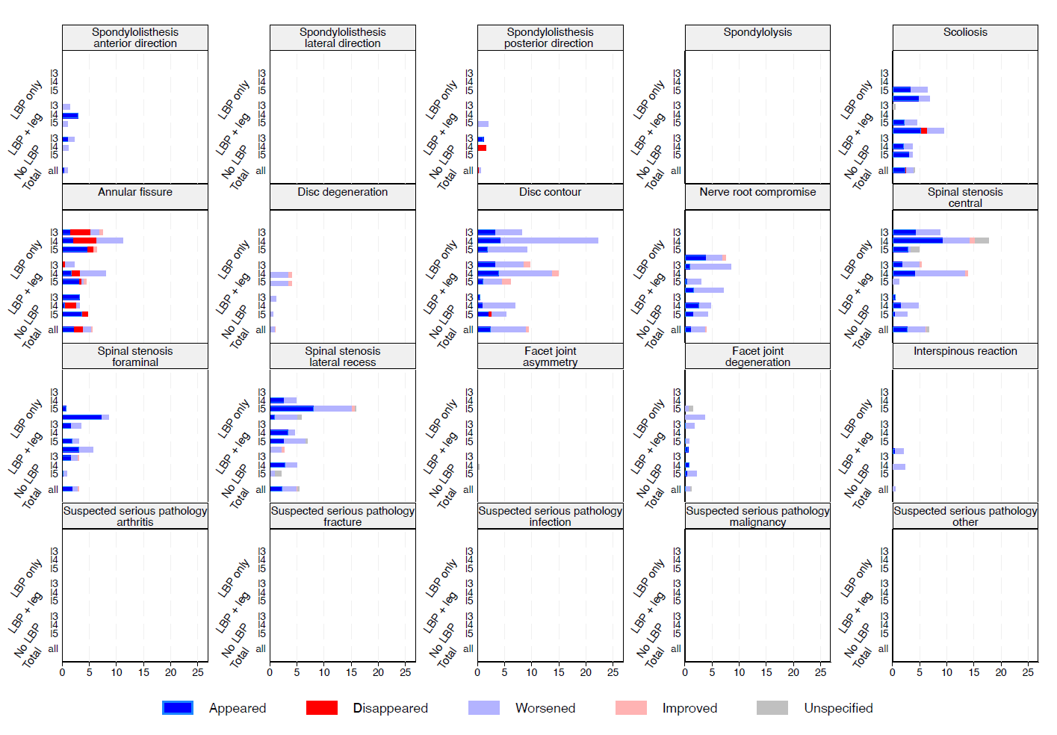
Supplementary Figure 2: The distribution of the differences identified stratified by participant group, disk level, and finding.
Supplementary figure 3A: The frequency of the different types of impact between the recumbent and upright positions for each disc level (L3, L4, and L5) across all MRI findings stratified by participant group.

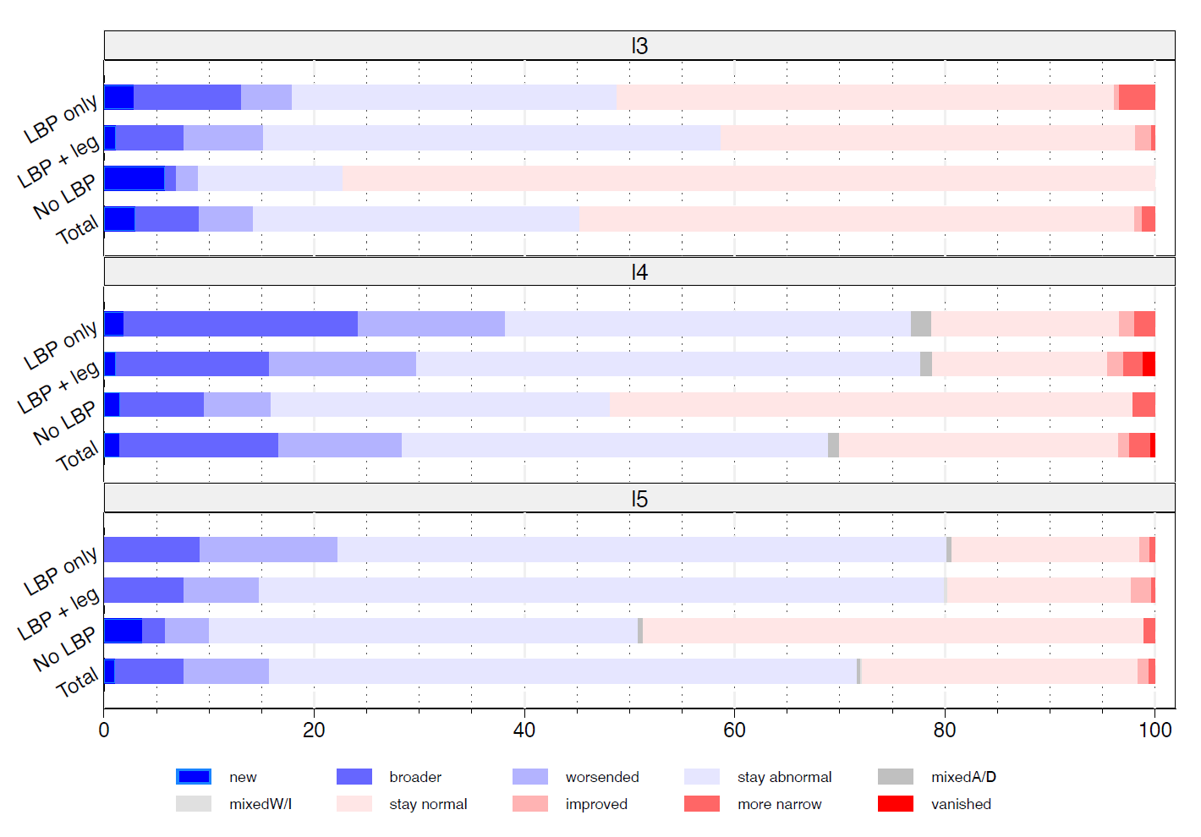

Supplementary figure 3B: The frequency of the different types of impact at the participant level when summarizing across all findings and across all disc levels stratified by participant group.

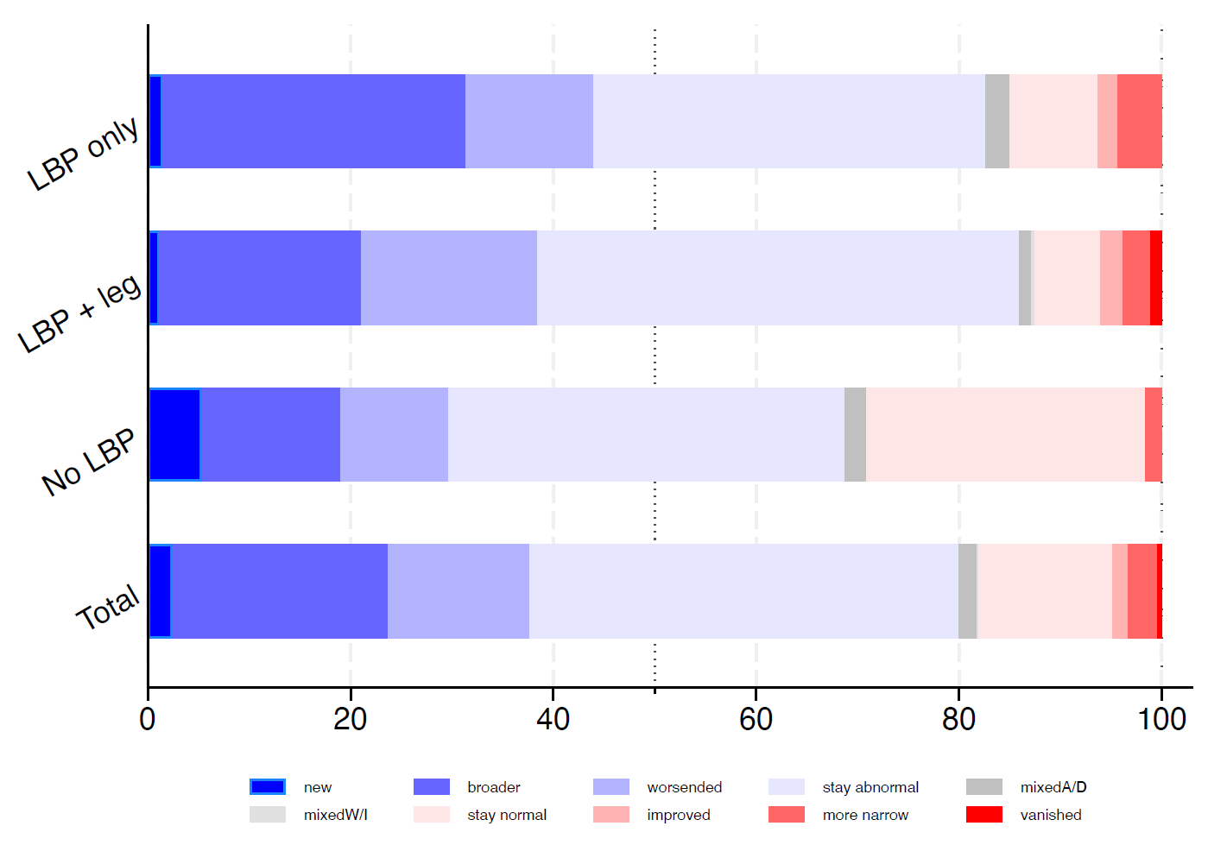

Supplementary Figure 4: The distribution of the number of findings with a difference in each participant stratified by the number of abnormal findings and the participant group.
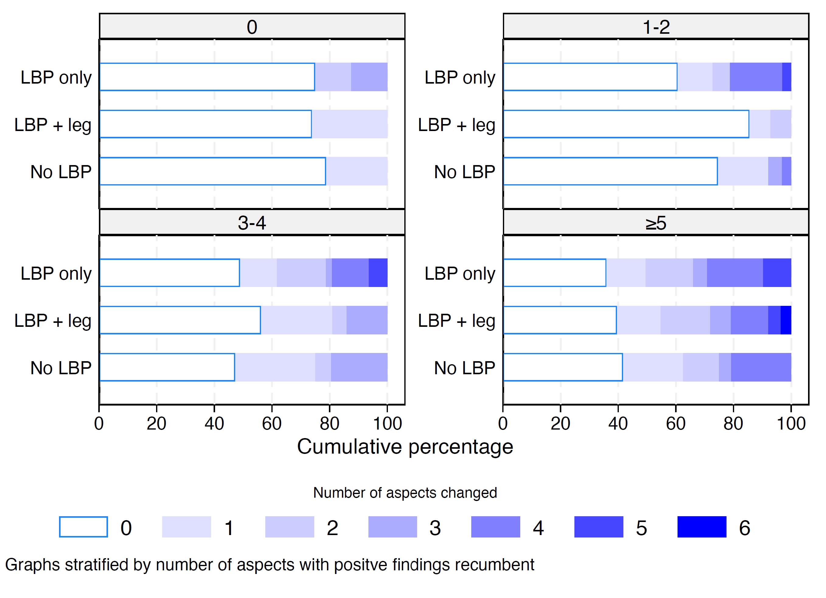

Supplementary figure 5: The distribution of the number of MRI-findings that differed between the upright position and the number of abnormal findings in the recumbent position stratified by the participant group. The area of the circles is proportional to the number of participants with the specific combination. The blue lines are regression lines fitted within each participant group.
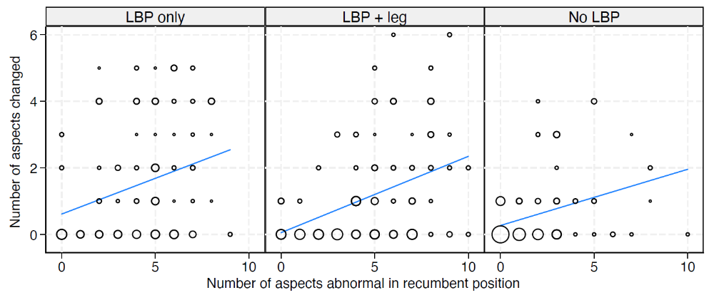

Supplementary Table 3: Frequencies of difference in the upright position at
disk level in this and a comparable study.
Findings | Frequency of differences
Spondylolisthesis: | Hansen et al. | Doktor et al.
anterior | 0.0% | 1.4%
posterior | 0.0% | 0.8%
Annular fissure (HIZ) | 0.9% | 6.3%
Disc contour | 0.0% | 11.5%
Nerve root compromise | 2.4% | 4.2%
Spinal stenosis:
central | 4.0% | 8.4%
foraminal | 8.0% | 4.1%

