A Multimodal Deep Learning Model for Classifying Early- versus Late-Stage Osteonecrosis of the Femoral Head on Biparametric MRI
Supplement Materials and Methods:
S1. Study Population
This was a single-center retrospective study that consecutively enrolled patients diagnosed with osteonecrosis of the femoral head (ONFH) at the Third Affiliated Hospital of Guangzhou University of Chinese Medicine between January 2018 and December 2023. Clinical and imaging data were collected for all patients. The inclusion criteria were as follows: (1) a definitive diagnosis of ONFH based on clinical manifestations and imaging examinations; (2) complete dual-sequence MRI data, including coronal short tau inversion recovery (STIR) and T1-weighted fast spin-echo (T1-FSE) sequences; and (3) comprehensive clinical records covering key variables such as etiology, sex, and age. Etiological classification was independently reviewed and determined by two investigators based on detailed medical history, medication records, and laboratory findings, and was categorized into the following five types: (1) Corticosteroid use: a clear history of systemic corticosteroid administration with a cumulative dose equivalent to prednisone ≥2000 mg (or equivalent doses of methylprednisolone, dexamethasone, etc.); (2) Alcohol abuse: average daily pure alcohol intake ≥80 g for a duration ≥5 years; (3) Hip trauma: a history of femoral neck fracture, hip dislocation, or severe hip injury with a clear temporal causal relationship to ONFH onset, and without the aforementioned two factors; (4) Combined multifactorial risk: coexistence of two or more of the above high-risk factors, or presence of other definite additive risk factors (e.g., long-term smoking combined with heavy alcohol consumption, gout combined with corticosteroid use, etc.); (5) No identified risk factor: no definite high-risk factor identified after detailed history inquiry and systematic laboratory work-up (including coagulation function, autoimmune antibodies, etc.). The exclusion criteria were: (1) concomitant hip joint infection, tumor, traumatic fracture, or other hip diseases that might affect the morphology of the femoral head or disease assessment; (2) prior hip surgery; (3) poor MRI image quality with severe motion or metal artifacts that precluded accurate evaluation of the femoral head region; and (4) availability of only a single MRI sequence.
All cases were staged according to the ARCO staging system, with independent interpretation by two experienced musculoskeletal radiologists; any disagreement was resolved through consensus. Based on clinical treatment stratification needs, the cases were further divided into an early-stage group (ARCO stages I–II, 266 hips) and a late-stage group (ARCO stages III–IV, 585 hips). To avoid data leakage, it was strictly ensured during the division that bilateral hip data from the same patient were assigned exclusively to the same data subset and were not split across the training and test sets. The training set was used for model development and parameter optimization, while the independent test set was used for final performance evaluation of the model.
The study was approved by the Institutional Review Board of the Third Affiliated Hospital of Guangzhou University of Chinese Medicine (Approval No. PJ-KY-20230919-001) and prospectively registered with the Chinese Clinical Trial Registry (ChiCTR2300075354). Given the retrospective nature of the study, the ethics committee waived the requirement for informed consent. All patient information was anonymized and de-identified, and the study was conducted in accordance.
S2. ARCO Staging and Endpoint Definition
All cases were staged independently by two radiologists with more than 10 years of experience in musculoskeletal imaging, in accordance with the 2019 revised ARCO staging system [19]. To maximize the accuracy and consistency of staging, the following quality control measures were implemented: (1) before independent reading, the two radiologists jointly reviewed and standardized the typical imaging manifestations and interpretation criteria for each ARCO stage, in order to eliminate discrepancies in the recognition of key signs (e.g., definition of the subchondral fracture line and measurement of collapse depth); (2) the interpretation for each patient was performed with reference to the complete clinical data (including symptoms, disease course, and follow‑up information) to compensate for the limitations of imaging alone; (3) in cases of disagreement between the two readers, a consensus was reached through discussion, and this consensus served as the reference standard for model training and evaluation.
ARCO staging was primarily determined based on imaging findings from coronal STIR and T1‑FSE sequences. The specific criteria were as follows: stage I – MRI shows a typical abnormal signal band around the necrotic area, but without significant morphological changes of the femoral head; stage II – MRI clearly delineates the necrotic area, while the femoral head contour remains intact and smooth, with no evidence of subchondral fracture or collapse; stage III – subchondral or necrotic‑area fracture is present; stage IV – secondary osteoarthritic changes are observed. In accordance with the clinical stratification objective of this study, ARCO stages I–II were defined as the early‑stage group and ARCO stages III–IV as the late‑stage group, which served as the binary endpoint for model development and performance evaluation. It should be noted that, from the perspective of clinical treatment strategy, although ARCO stages III and IV differ in the degree of collapse on imaging, they share the common feature of definite femoral head collapse, and both are generally recommended for total hip arthroplasty (THA) in clinical practice. Therefore, the binary classification of ARCO I–II versus III–IV was adopted in this study to distinguish, from a clinical decision‑making standpoint, between the two major patient populations: those suitable for hip‑preserving procedures and those recommended for arthroplasty.
S3. Model Architecture
In this study, seven diagnostic models were constructed, covering a unimodal clinical model, unimodal imaging models, and multimodal fusion models, to systematically evaluate the contribution of each information modality to ONFH staging. The core design of the model architecture comprises three levels: (1) imaging feature extraction, using DenseNet-121 to extract deep features from single-sequence and dual-sequence MRI; (2) cross-modal imaging interaction, designing a Bidirectional Interactive Attention (BIA) module to achieve multi-level feature fusion between STIR and T1-FSE sequences; and (3) imaging-clinical fusion, integrating structured clinical variables into imaging features via a Clinical-Aware Feature Modulation (CFM) module. In addition, early-fusion and late-fusion strategies were compared in terms of their performance on the ONFH staging task.
All imaging models took coronal MRI images as input. For each hip, three consecutive coronal slices covering the center of the femoral head were selected, resized to 224×224 pixels, and averaged pixel-wise to form the final sample, thereby balancing three-dimensional spatial information with computational efficiency. Model development was implemented with PyTorch (v1.9.0) and conducted on an NVIDIA RTX 4090 GPU (24 GB memory) for both training and inference.
S3.1 Unimodal Baseline Models
- Clinical model: This model used only structured clinical features as input, including age (continuous variable, normalized by Z-score), sex (binary, one-hot encoded), affected side (three categories, one-hot encoded), and etiology (five categories, one-hot encoded), concatenated into a 11-dimensional vector. The vector was mapped through a multilayer perceptron (MLP) to output a binary classification result, serving as a baseline to evaluate the independent discriminative ability of clinical parameters.
(2) Single-sequence imaging models (STIR model, T1-FSE model): These models took a single MRI sequence as input and employed a DenseNet-121 backbone pre-trained on ImageNet-1K for feature extraction. The DenseNet-121 architecture was used with its original layer configuration, consisting of 121 convolutional layers organized into four dense blocks, with dense connections enabling feature reuse and mitigating vanishing gradients. The input image was passed through the backbone to produce imaging feature vectors, which were then fed into a fully connected layer for binary classification. These models were used to assess the diagnostic value of each sequence individually.
S3.2 Biparametric MRI Imaging Fusion Model (bpMRI Model)
To achieve complementary information from the STIR and T1-FSE MRI sequences, we designed a Bidirectional Interactive Attention (BIA) module to capture inter-modal dependencies at multiple feature levels and construct a comprehensive imaging representation.
Specifically, images from the two sequences were separately fed into a shared-weight DenseNet-121 backbone to extract multi-level feature maps from each dense block. Subsequently, the BIA module performed interactive enhancement on the dual-sequence features at each level. The module comprised two embedding layers, four BIA blocks, and eight self-attention blocks (Supplement figure 1). The embedding layers converted feature maps from different modalities into tokens; within the BIA blocks, an attention-exchange mechanism computed bidirectional attention weights between tokens across imaging modalities, explicitly modelling the potential local interconnections between STIR and T1-FSE and generating jointly enhanced multimodal imaging representations. These enhanced representations were then passed through eight self-attention blocks for global context learning, outputting a comprehensive dual-sequence imaging feature vector, which was subsequently classified by the classifier to obtain the bpMRI model’s diagnostic result. This design allowed the model to exchange and enhance information between the two sequences at multiple feature levels, matching the oedema-activity information (STIR advantage) with structural-change information (T1-FSE advantage), mirroring the radiologist’s logic when interpreting both sequences together.
S3.3 Imaging-Clinical Multimodal Fusion Models (STIR-clinical, T1-clinical, and bpMRI-clinical Models)
Because imaging data and clinical data differ substantially in both dimensionality and physical meaning, simple concatenation or summation cannot effectively integrate them. Therefore, we developed a Clinical-Aware Feature Modulation (CFM) module that uses clinical information to selectively enhance or suppress multimodal image features, enabling contextual weighting of imaging findings based on clinical presentation.
The workflow of this module is as follows: (1) the 11-dimensional structured clinical feature vector is fed into a multilayer perceptron (MLP), which maps it to an intermediate representation with the same number of channels as the imaging features; (2) a Sigmoid activation function generates channel-wise modulation weights in the range (0, 1), indicating the importance of each imaging feature channel under the given clinical context; (3) these weights are element-wise multiplied with the comprehensive imaging features (the output of the BIA module of the bpMRI model) to dynamically enhance or suppress the imaging features; and (4) the modulated features are passed through a classifier to obtain the final diagnostic result. This design enables the model to adjust its attention to different imaging dimensions according to the patient’s etiology, age, and other individual characteristics, providing a direct and interpretable pathway for clinical data to influence the final decision.
S3.4 Early-Fusion vs. Late-Fusion Strategies
We systematically compared two strategies for multimodal information integration.
Modality interaction is performed at an early stage of feature extraction. For dual‑sequence imaging, STIR and T1‑FSE images are separately passed through a shared DenseNet‑121 backbone to extract multi‑level features, which are then immediately fused via the BIA module at each feature level; the jointly enhanced representation is subsequently fed into subsequent self‑attention layers. For imaging–clinical fusion, the clinical modulation weights are applied to the imaging features immediately after the BIA module output, and the modulated comprehensive features are directly classified. This strategy allows cross‑modal information to influence each other early in the forward pass.
Each modality independently completes feature extraction and representation learning, and information is integrated at the decision level. Specifically, the output probabilities from each single‑sequence model or each single‑sequence clinical model are combined via mean pooling or weighted voting to obtain the final classification result.
For the single‑sequence clinical models, we additionally investigated a simple intermediate fusion approach, where each modality is encoded independently and the resulting feature vectors are concatenated before the final classification layer. This serves as an additional baseline to compare against the early and late fusion schemes described above.
S3.5 Training Strategy and Overfitting Prevention
All models were trained with identical configurations to ensure controlled comparisons: the optimizer was stochastic gradient descent (SGD) with a momentum of 0.9 and a weight decay of 1×10⁻⁴. The initial learning rate was 0.00125, adjusted dynamically using a cosine annealing schedule with a minimum learning rate of 1×10⁻⁶. All models were trained for 500 epochs with a batch size of 16. To prevent overfitting, the following strategies were employed: (1) the DenseNet-121 backbone was initialized with pre-trained weights from ImageNet-1K, leveraging transfer learning to improve generalization on the relatively small dataset; (2) mild Gaussian noise (σ = 0.01) and random contrast adjustments (±10%) were applied to the input images as data augmentation during training; and (3) the train-test split was performed at the patient level, ensuring that both hips of the same patient were assigned to the same subset and never split across training and test sets. No validation set was used for early stopping or hyperparameter selection during the training process; all hyperparameters were fixed before training, and the final model was evaluated on the independent test set using the weights after all 500 epochs, thereby avoiding overfitting bias introduced by validation set tuning. All experiments used a fixed random seed (seed = 42) to ensure reproducibility.
S3.6 Statistical Analysis
All statistical analyses and visualizations were performed in R 4.4.0 (R Foundation for Statistical Computing, Vienna, Austria) and Python 3.7 (Python Software Foundation). Normally distributed continuous variables are presented as mean ± standard deviation, and categorical variables as frequencies (percentages). Comparisons of baseline clinical characteristics between the training and test cohorts, as well as between early-stage (ARCO I-II) and late-stage (ARCO III-IV) groups, were performed using independent-samples t-tests or χ² tests, as appropriate.
Model diagnostic performance was evaluated using the area under the receiver operating characteristic curve (AUC), accuracy, sensitivity, and specificity. 95% confidence intervals for these metrics were calculated using the bootstrap method with 1000 resampling iterations. Pairwise comparisons of AUCs between models were performed using the DeLong test, with a two-sided P < 0.05 considered statistically significant. To assess the risk of overfitting, we compared the performance on the training set against that on the test set for the optimal bpMRI-clinical model; a training-set AUC substantially higher than the test-set AUC (difference > 0.1) with non-overlapping confidence intervals was considered indicative of possible overfitting. The results are presented in Supplement Table 1.
S3.7 Model Explainability Analysis
Gradient-weighted Class Activation Mapping (Grad-CAM) was used to visualise the key imaging regions that drove the model’s decisions, qualitatively verifying whether the model focused on clinically relevant pathological signs such as the necrotic lesion, bone marrow oedema zone, and subchondral fracture line. Grad-CAM leverages gradient information to locate the spatial regions in the last convolutional layer that contributed most to the classification decision, generating a heatmap overlaid on the original MRI images to provide intuitive visual explanations for clinicians
Supplement Figure: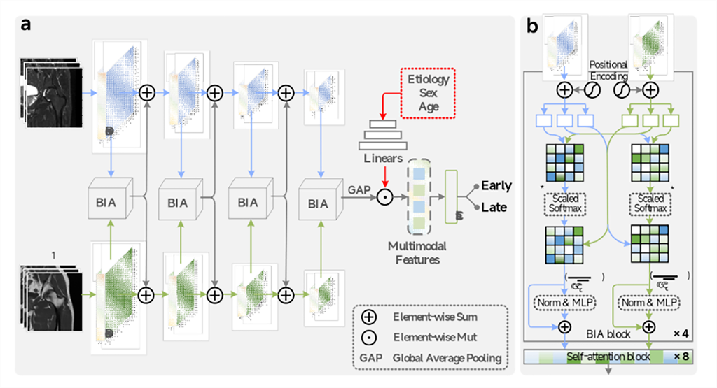
Supplement figure 1. The architecture of this proposed method. a. Diagnostic model b. BIA block
Supplement Table:
Supplement Table 1. Diagnostic performance of the bpMRI-clinical model with early fusion strategy for early- and late-stage ONFH in the train and test cohort.
 | AUC (95% CI) | Accuracy | Sensitivity (95% CI) | Specificity (95% CI)
Train | 0.951 (0.915-0.979) | 0.926 | 0.901 (0.837-0.957) | 0.953 (0.901-0.989)
Test | 0.944 (0.905-0.973) | 0.909 | 0.890 (0.822-0.953) | 0.929 (0.866-0.978)
AUC area under the curve, CI confidence interval

