Supplementary Material
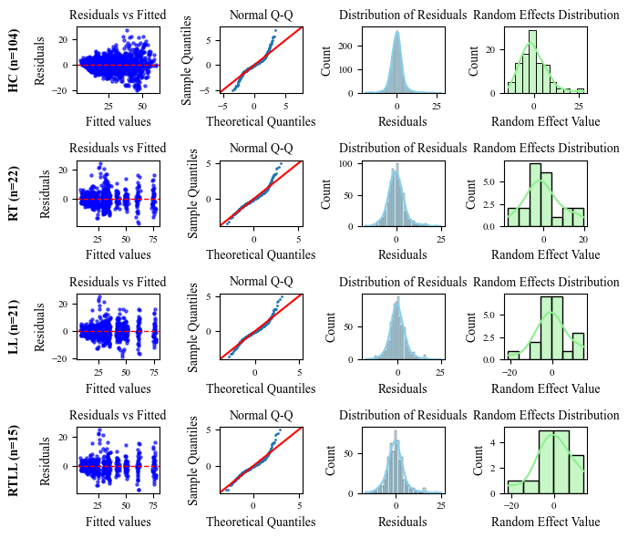
Figure. S1 Residual Diagnostic Plots of Linear Mixed-Effects Models for Four Subject Groups. Each row represents one group. Red dashed lines indicate reference lines (residuals=0 or theoretical normal distribution)

