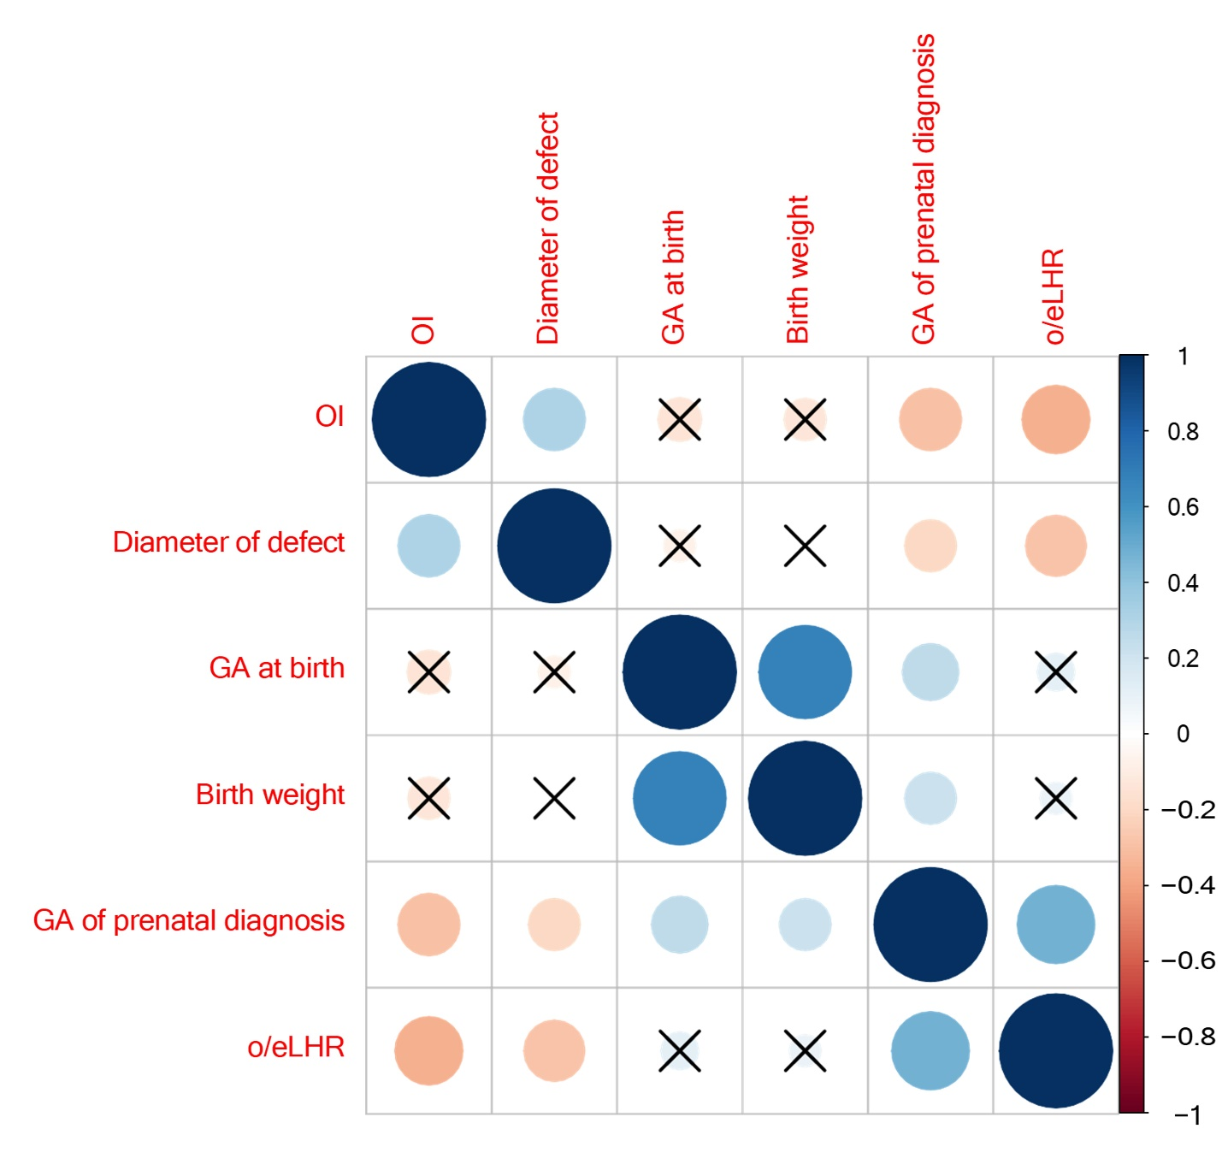
Figure S1. Correlation plot of continuous variables. The size of the circle represents the correlation coefficient between the two variables. Higher correlation coefficient has larger circle. The color of the circle represents positive or negative correlation. The blue circle represents a positive correlation and the orange circle represents a negative correlation.

