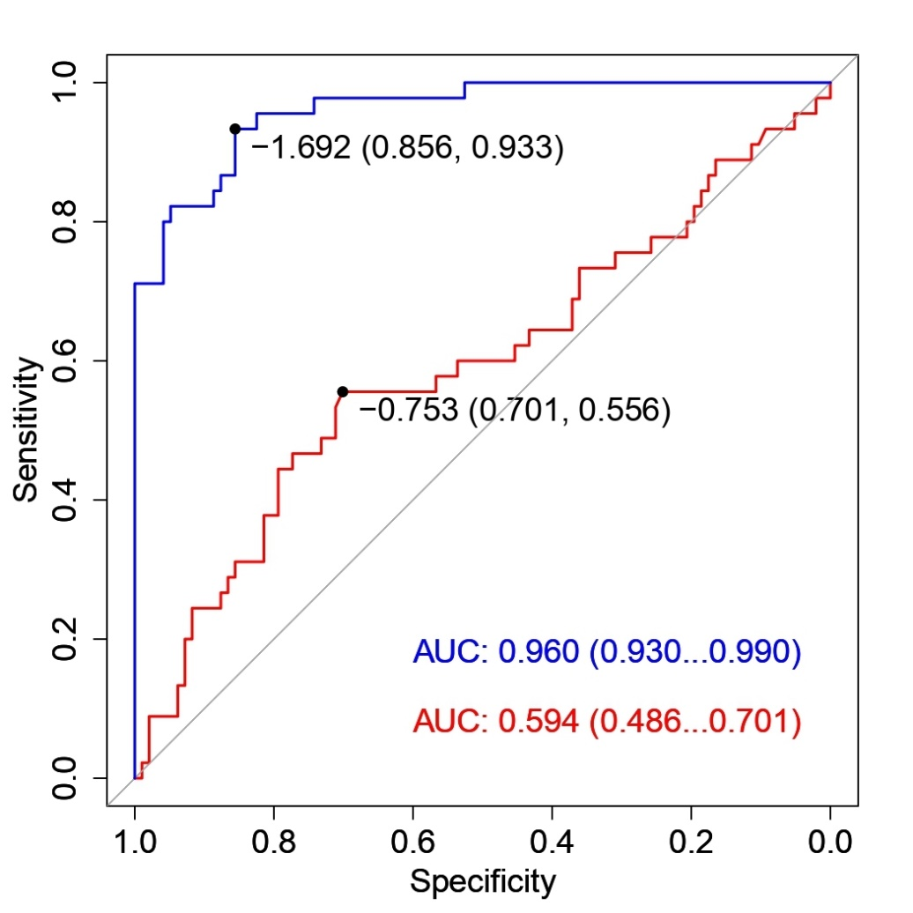
Figure S2. The area under the curve (AUC) of baseline model (red curve) and full mode (blue curve).

