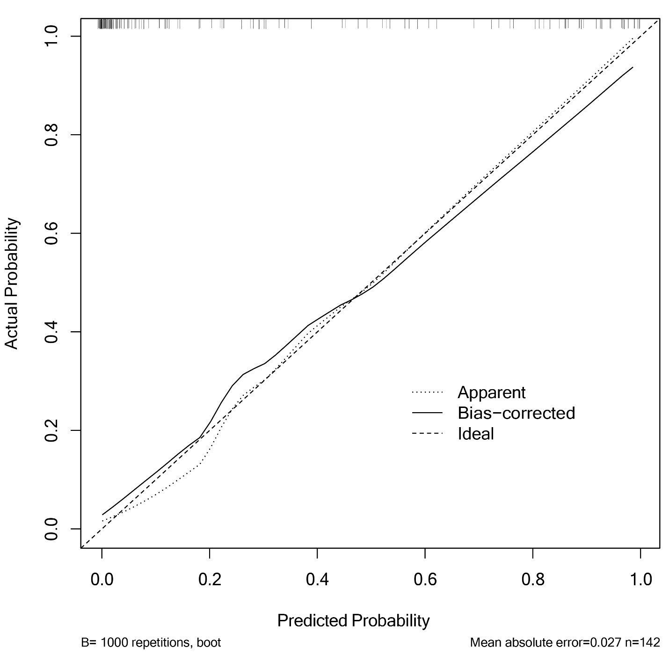

Figure S3. Calibration curve for the prediction nomogram for 1-month mortality in neonates with congenital diaphragmatic hernia. This curve can evaluate the performance of the nomogram and compare the predicted- and actual-probability of 1-month survival in neonates with congenital diaphragmatic hernia

