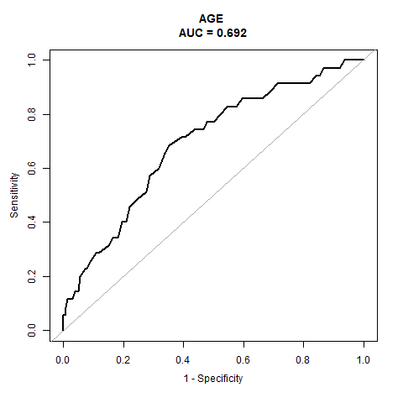
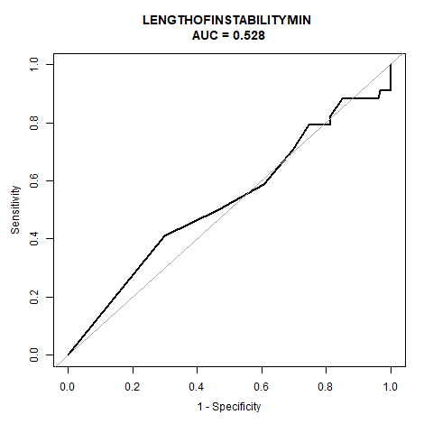
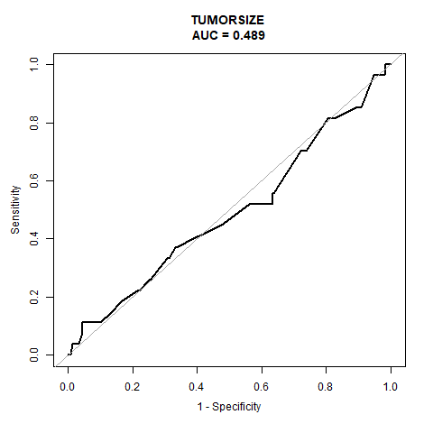
B
C
A

Figure S1. ROC curve analysis (A. ROC analysis for age yielded an AUC of 0.692 with a diagnostic threshold of 41.5 years; B. ROC analysis for tumor size yielded an AUC of 0.489 with a diagnostic threshold of 11.25 cm; C. ROC analysis for intraoperative instability minutes yielded an AUC of 0.628 with a diagnostic threshold of 12.5 minutes.)

