Appendix
Contents
- Appendix A.1: Search strategy.
- Appendix B.1: Study details of included cohort studies.
- Appendix C.1: Overall survival after curatively treated locoregional recurrent colon cancer.
- Appendix C.2: Disease-free survival after curatively treated locoregional recurrent colon cancer.

Appendix A.1: Search strategy.

Embase
((('large intestine tumor'/de OR 'large intestine cancer'/de OR 'large intestine carcinoma'/de OR 'colon carcinoma'/exp OR 'colon tumor'/exp OR 'colon cancer'/exp OR 'colon neuroendocrine tumor'/exp OR 'intestinal sarcoma'/de OR 'intestinal sarcoma'/de OR 'intestine cancer'/de OR 'intestine carcinoma'/de OR 'rectosigmoid cancer'/exp) AND ('tumor recurrence'/exp OR 'cancer recurrence'/exp)) OR (((recurren* OR relaps*) NEAR/6 (colon* OR intestin* OR sigmoid* OR rectosigmoid* OR appendi* OR bowel*) NEAR/6 (tumor* OR tumour* OR neoplas* OR cancer* OR carcinom* OR adenocarcinom* OR sarcoma* OR malignan*)) OR ((recurren* OR relaps*) NEAR/3 (colon* OR intestin* OR sigmoid* OR appendi* OR bowel*) NEAR/3 (tumor* OR tumour* OR neoplas* OR cancer* OR carcinom* OR adenocarcinom* OR sarcoma* OR malignan*))):ab,ti,kw) AND ('postoperative period'/exp OR (postoperat* OR post-operat* OR reoperat* OR re-operat* OR ((after) NEAR/3 (operat*)) OR ((surgic* OR surger* OR resect* OR excision* OR dissection* OR exenterat* OR intraoperat* OR intra-operat* OR manag* OR treatment* OR therap* OR diagnos* OR recognition* OR robotic* OR appendectom* OR ileo-caecectom* OR ileo-cecectom* OR ileocaecectom* OR ileocecectom* OR colectom* OR helicolectom* OR transversumresect* OR Hartman* OR sigmoidectom* OR rectosigmoidectom* OR segmentresect*) NEAR/6 (recurren* OR relaps*)) OR ((recurren* OR relaps*) NEAR/3 (colon* OR intestin* OR sigmoid* OR rectosigmoid* OR appendi* OR bowel*) NEAR/3 (tumor* OR tumour* OR neoplas* OR cancer* OR carcinom* OR adenocarcinom* OR sarcoma* OR malignan*))):ab,ti,kw) NOT ((animal/exp OR animal*:de OR nonhuman/de) NOT ('human'/exp)) NOT ([Conference Abstract]/lim OR [preprint]/lim)

Medline
(((exp Colonic Neoplasms/ OR Intestinal Neoplasms/) AND (Neoplasm Recurrence, Local/)) OR (((recurren* OR relaps*) ADJ6 (colon* OR intestin* OR sigmoid* OR appendi* OR bowel*) ADJ6 (tumor* OR tumour* OR neoplas* OR cancer* OR carcinom* OR adenocarcinom* OR sarcoma* OR malignan*)) OR ((recurren* OR relaps*) ADJ3 (colon* OR intestin* OR sigmoid* OR rectosigmoid* OR appendi* OR bowel*) ADJ3 (tumor* OR tumour* OR neoplas* OR cancer* OR carcinom* OR adenocarcinom* OR sarcoma* OR malignan*))).ab,ti,kf.) AND (Postoperative Period/ OR (postoperat* OR post-operat* OR reoperat* OR re-operat* OR ((after) ADJ3 (operat*)) OR ((surgic* OR surger* OR resect* OR excision* OR dissection* OR exenterat* OR intraoperat* OR intra-operat* OR manag* OR treatment* OR therap* OR diagnos* OR recognition* OR robotic* OR appendectom* OR ileo-caecectom* OR ileo-cecectom* OR ileocaecectom* OR ileocecectom* OR colectom* OR helicolectom* OR transversumresect* OR Hartman* OR sigmoidectom* OR rectosigmoidectom* OR segmentresect*) ADJ6 (recurren* OR relaps*)) OR ((recurren* OR relaps*) ADJ3 (colon* OR intestin* OR sigmoid* OR rectosigmoid* OR appendi* OR bowel*) ADJ3 (tumor* OR tumour* OR neoplas* OR cancer* OR carcinom* OR adenocarcinom* OR sarcoma* OR malignan*))).ab,ti,kf.) NOT (exp Animals/ NOT Humans/) NOT (news OR congres* OR abstract* OR book* OR chapter* OR dissertation abstract*).pt.

Cochrane
((((recurren* OR relaps*) NEAR/6 (colon* OR intestin* OR sigmoid* OR appendi* OR bowel*) NEAR/6 (tumor* OR tumour* OR neoplas* OR cancer* OR carcinom* OR adenocarcinom* OR sarcoma* OR malignan*)) OR ((recurren* OR relaps*) NEAR/3 (colon* OR intestin* OR sigmoid* OR rectosigmoid* OR appendi* OR bowel*) NEAR/3 (tumor* OR tumour* OR neoplas* OR cancer* OR carcinom* OR adenocarcinom* OR sarcoma* OR malignan*))):ab,ti,kw) AND ((postoperat* OR post NEXT/1 operat* OR reoperat* OR re NEXT/1 operat* OR ((after) NEAR/3 (operat*)) OR ((surgic* OR surger* OR resect* OR excision* OR dissection* OR exenterat* OR intraoperat* OR intra NEXT/1 operat* OR manag* OR treatment* OR therap* OR diagnos* OR recognition* OR robotic* OR appendectom* OR ileo NEXT/1 caecectom* OR ileo NEXT/1 cecectom* OR ileocaecectom* OR ileocecectom* OR colectom* OR helicolectom* OR transversumresect* OR Hartman* OR sigmoidectom* OR rectosigmoidectom* OR segmentresect*) NEAR/6 (recurren* OR relaps*)) OR ((recurren* OR relaps*) NEAR/3 (colon* OR intestin* OR sigmoid* OR rectosigmoid* OR appendi* OR bowel*) NEAR/3 (tumor* OR tumour* OR neoplas* OR cancer* OR carcinom* OR adenocarcinom* OR sarcoma* OR malignan*))):ab,ti,kw) NOT "conference abstract":pt

Web of Science
TS=(((((recurren* OR relaps*) NEAR/6 (colon* OR intestin* OR sigmoid* OR appendi* OR bowel*) NEAR/6 (tumor* OR tumour* OR neoplas* OR cancer* OR carcinom* OR adenocarcinom* OR sarcoma* OR malignan*)) OR ((recurren* OR relaps*) NEAR/3 (colon* OR intestin* OR sigmoid* OR rectosigmoid* OR appendi* OR bowel*) NEAR/3 (tumor* OR tumour* OR neoplas* OR cancer* OR carcinom* OR adenocarcinom* OR sarcoma* OR malignan*)))) AND ((postoperat* OR post-operat* OR reoperat* OR re-operat* OR ((after) NEAR/3 (operat*)) OR ((surgic* OR surger* OR resect* OR excision* OR dissection* OR exenterat* OR intraoperat* OR intra-operat* OR manag* OR treatment* OR therap* OR diagnos* OR recognition* OR robotic* OR appendectom* OR ileo-caecectom* OR ileo-cecectom* OR ileocaecectom* OR ileocecectom* OR colectom* OR helicolectom* OR transversumresect* OR Hartman* OR sigmoidectom* OR rectosigmoidectom* OR segmentresect*) NEAR/6 (recurren* OR relaps*)) OR ((recurren* OR relaps*) NEAR/3 (colon* OR intestin* OR sigmoid* OR rectosigmoid* OR appendi* OR bowel*) NEAR/3 (tumor* OR tumour* OR neoplas* OR cancer* OR carcinom* OR adenocarcinom* OR sarcoma* OR malignan*)))) NOT ((animal* OR rat OR rats OR mouse OR mice OR murine OR dog OR dogs OR canine OR cat OR cats OR feline OR rabbit OR cow OR cows OR bovine OR rodent* OR sheep OR ovine OR pig OR swine OR porcine OR veterinar* OR chick* OR zebrafish* OR baboon* OR nonhuman* OR primate* OR cattle* OR goose OR geese OR duck OR macaque* OR avian* OR bird* OR fish*) NOT (human* OR patient* OR women OR woman OR men OR man))) NOT DT=(Meeting Abstract OR Meeting Summary)

Google Scholar
“recurrence|recurrent|relapse colon|colonic|sigmoid|appendix|bowel tumor|tumour|neoplasm|cancer|carcinoma|adenocarcinoma|sarcoma|malignancy” postoperative|”post|after operative|surgery|surgical”

Appendix B.1: Study details of included cohort studies.

First author (year) | Country | Study design | Inclusion criteria | Exclusion criteria
Akgun 2018 | Turkey | Retrospective cohort | All patients who developed isolated LRCC | Stage 4 colon carcinoma, emergency cases, non-invasive tumors, and cases that underwent R2 resection or a palliative procedure
Akiyoshi 2011 | Japan | Retrospective cohort | All patients who underwent initial resection for LRCC following macroscopically curative resection of primary colon cancer | NR
Chesney 2021 | Canada | Retrospective cohort | Patients who underwent curative-intent resection for LRCC at three University of Toronto academic centers | Disseminated peritoneal surface disease (peritoneal carcinomatosis), hereditary cancer syndromes, or who were deemed to have unresectable distant metastases
Costi 2016 | Italy | Retrospective cohort | All patients undergoing colorectal resection for adenocarcinoma and ultimately developing an anastomotic recurrence | NR
Dumont 2012 | France | Retrospective cohort | All consecutive patients who underwent complete (R0) surgical resection of histologically confirmed locoregional recurence | Pelvic recurrences
Hallet 2014 | Canada | Retrospective cohort | Adults (18 years old) with a biopsy-proven diagnosis of recurrent colonic adenocarcinoma and with a potentially compromised radial margin based on CT scan and/or MRI; candidates for neo-adjuvant chemoradiotherapy | Patients with distant metastasis, previous radiation treatment, and primary tumours located below 15 cm from the anal verge, multifocal recurrences
Harji 2013 | UK | Retrospective cohort | All patients undergoing surgery for LRCC | Multifocal disease recurrence, greater sciatic notch extension, 360◦ encasement of the inferior vena cava, unresectable metastatic disease, and multiple co-morbidities
Huang 2024 | China | Retrospective cohort | All patients with pathologic stage I-III primary colon cancer cases diagnosed in China with R0 resection and complete follow-up information | Synchronous intestinal tumors, urgent or emergency surgery for any cause, neoadjuvant therapy, hereditary colon cancer, any type of cancer within 5 years prior to colon cancer surgery or postoperative death within 90 days
Jarrar 2020 | USA | Retrospective cohort | All patients who underwent a surgical resection with curative intent for LRCC | Stage 4 disease, patients treated with palliative intent or with unresectable disease at the time of first recurrence, patients with incomplete follow-up or follow-up less than one year.
Kogler 2014 | Austria | Retrospective cohort | All patients surgically treated for CRC at Innsbruck Medical University | NR

First author (year) | Country | Study design |  | Inclusion criteria |  | Exclusion criteria
Swartjes 2023 | Netherlands |  | Retrospective cohort |  | All patients with pathologic stage I-III primary colon cancer cases diagnosed in the Netherlands |  | Appendiceal tumors, neuro-endocrine tumors, pT0 tumors, and endoscopically resected tumors. If patients presented with more than one colonic tumor simultaneously, the tumor with the lowest stage was excluded
Wisselink 2020 | Netherlands |  | Retrospective cohort |  | All consecutive patients who underwent curative-intent surgery for unifocal LRCC at Amsterdam University Medical Center |  | Patients with evidence of distant metastases at time of diagnosis of the LRCC

Appendix B.1: Study details of included cohort studies.

First author (year published) | Definition of LRCC | Years of data retrieval | No. study subjects | Median follow-up time after LRCC resection (months)ª | Quality assessment (based on Newcastle-Ottawa Scale) | Quality Rating scheme for studies and other evidence
Akiyoshi (2011) | Anastomosis, mesentery/nodal, retroperitoneal or peritoneal | 1988-2007 | 45 | 51 | Good | 3
Akgun (2018) | Anastomotic, mesentery/nodal, retroperitoneal, abdominal wall, pelvis | 2003-2015 | 15 | 36.6ª | Poor | 3
Chesney (2021) | Anastomotic, nodal, peritoneal, retroperitoneal, abdominal wall, pelvis | 1993-2017 | 117 | 53^{b} | Good | 3
Costi (2016) | Anastomotic | 1988-2013 | 18 | 121ª | Poor | 3
Dumont (2012) | Tumor bed | 1988-2008 | 8 | 47^{c} | Poor | 3
Hallet (2014) | Not specifically described; recurrence involving adjacent organ or structures. | 2000-2010 | 15 | 54 | Poor | 3
Harji (2013) | Anastomotic, nodal, retroperitoneal, abdominal wall, pelvis | 2003-2011 | 42 | NR | Fair | 3
Huang (2024) | Anastomotic, mesentery/nodal, tumor bed | 2009-2019 | 139 | 62^{b} | Good | 3
Jarrar (2020) | Anastomotic, peritoneal, pelvis | 1999-2007 | 52 | 81ª | Good | 3
Kogler (2014) | Not specifically described; at the initial tumor site or in the area of tumor-associated lymphatic drainage or perianastomotic recurrences | 2000-2011 | 33 | NR | Poor | 3
Swartjes (2023) | Not specifically described; near the site of the primary tumor, in lymph nodes that would classify as regional lymph nodes, or both | 2015 (6 months) | 134 | 43.1^{b} | Good | 3
Wisselink (2020) | Anastomotic, mesentery, nodal, "local" | 2010-2017 | 17 | 20 | Good | 3
ª Mean in case median not reported
^{b} After primary resection in case median time after LRCC resection not reported
^{c} This included retroperitoneal lymph node recurrences as well

Appendix C.1: Overall survival after curatively treated locoregional recurrent colon cancer.

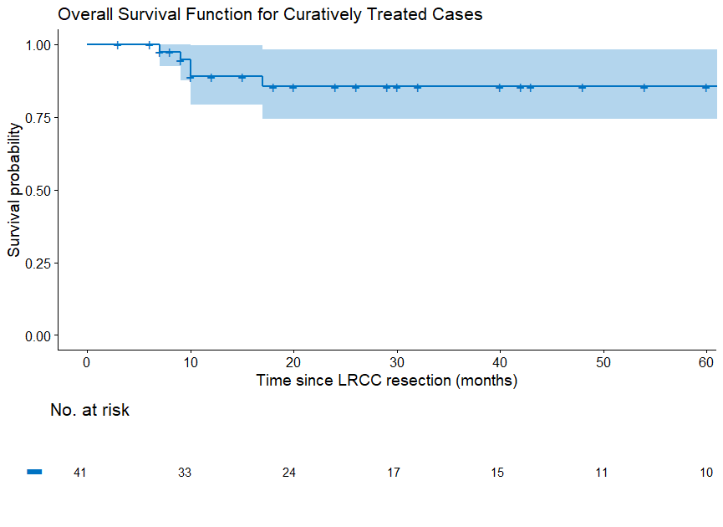

Appendix C.2: Disease-free survival after curatively treated locoregional recurrent colon cancer.

