Supplementary Figure 1. Subgroup analysis for postoperative bleeding based on administration time.
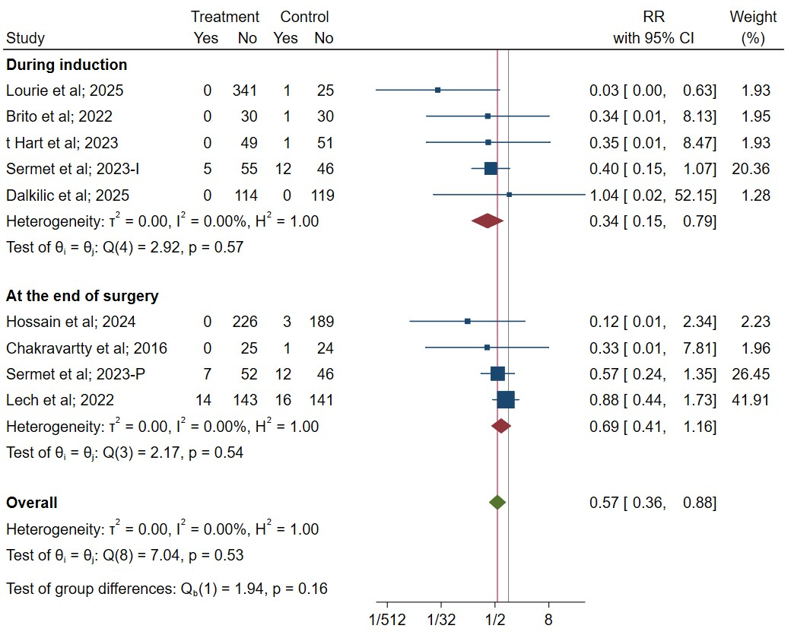

Supplementary Figure 2. Subgroup analysis for postoperative bleeding based on dose.
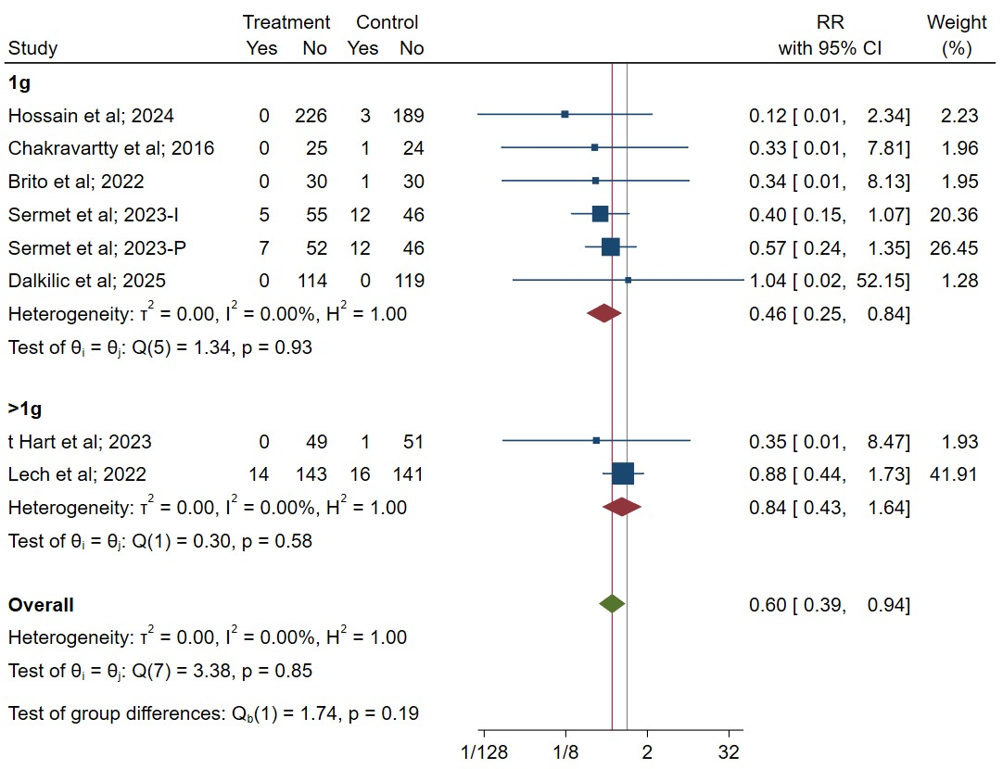

Supplementary Figure 3. Subgroup analysis for postoperative bleeding based on surgery type.
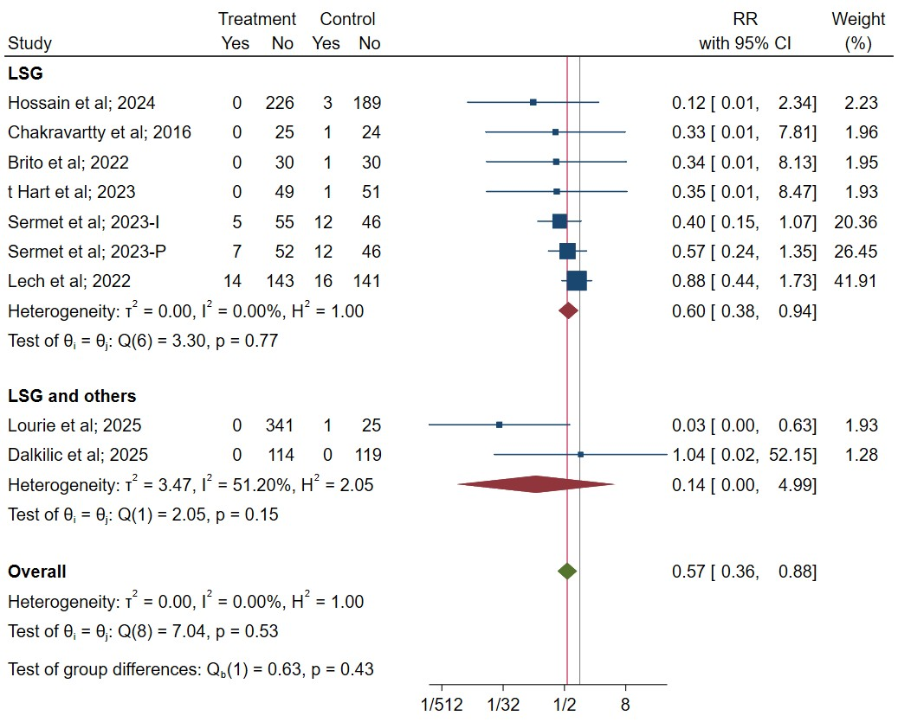

Supplementary Figure 4. Galbraith plot for the mean operative time.

Supplementary Figure 5. Sensitivity analysis of the outcomes: [A] rate of postoperative bleeding, [B] rate of perioperative blood transfusion, [C] rate of hematoma, [D] rate of reoperation, [E] mean operative time, [F] mean hospital stay, and [G] rate of thromboembolic event.

[A]
[B]

[C]
[D]
[E]

[F]
[G]

Supplementary Figure 6. Funnel plot for rate of thromboembolic event.

