Supplementary Figure 1. Quality of life before and after surgery assessed by WHOQOL-BREF. Higher scores indicate better outcomes in each domain. Higher scores indicate better quality of life in the respective domain. P < 0.05 was considered statistically significant. * indicates significant differences between pre- and postoperative scores.

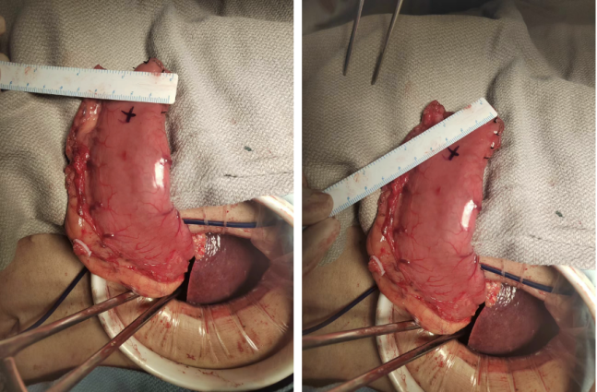
Supplementary Figure 2. The size of reconstructed artificial gastric fundus.

