Supplementary Material
Title: Intrabiliary injection of indocyanine green dye (ICG) versus intravenous injection for patients undergoing laparoscopic cholecystectomy for symptomatic gallbladder diseases: Systematic Review and Meta-Analysis
Mohamed Gamal¹, Sohieb Hedawy²*
Supplementary Content:
a. Tables: |  | Page
1 | Supplementary Table 1. Details of the search strategy | 2
2 | Supplementary Table 2. GRADE Summary of findings table | 3
b. Figure: |  | Page
1 | Supplementary Fig. 1 Subgroup analysis for: (A) CD visualization before dissection of Calot's triangle, (B) CD visualization after dissection of Calot's triangle, and (C) operative time. | 3

Supplementary Table 1. Details of the search strategy
Databases | Restrictions | Term | Number of items found
PubMed | Title and abstract | ("Laparoscopic Cholecystectomy" OR "Celioscopic Cholecystectomy" OR "LC")  AND  ("Indocyanine Green" OR "ICG" OR "ICG dye" OR "Indocyanine green dye" OR "ICG fluorescence" OR "Near-infrared fluorescent dye" OR "Indocyanine green dye" OR "ICG fluorophore" OR "NIR dye”) | 315
Scopus | Title, abstract, and keyword |  | 422
WOS | Topic |  | 360
Cochrane | Title, abstract, and keywords |  | 85
Total |  |  | 1182
PubMed: Public/Publisher MEDLINE database; WOS: Web of Science; Cochrane: Cochrane Central Register of Controlled Trials; Scopus: Elsevier's abstract and citation database.

Supplementary Table 2. GRADE Summary of findings table
Outcomes | Anticipated absolute effects* (95% CI) |  | Relative effect  (95% CI) | № of participants  (studies) | Certainty of the evidence  (GRADE)
Outcomes | Risk with Intravenous | Risk with Intrabiliary | Relative effect  (95% CI) | № of participants  (studies)
CD visualization before dissection | 683 per 1,000 | 629 per 1,000  (1,000 to 376) | RR 0.92  (0.55 to 1.54) | 119  (3 non-randomised studies) | ⨁◯◯◯  Very low^{a,b,c,d}
CD visualization after dissection | 850 per 1,000 | 927 per 1,000  (1,000 to 816) | RR 1.09  (0.96 to 1.24) | 119  (3 non-randomised studies) | ⨁◯◯◯  Very low^{a,c,d}
CBD visualization before dissection | 690 per 1,000 | 525 per 1,000  (746 to 373) | RR 0.76  (0.54 to 1.08) | 84  (2 non-randomised studies) | ⨁◯◯◯  Very low^{a,c,d}
CBD visualization after dissection | 905 per 1,000 | 932 per 1,000  (1,000 to 769) | RR 1.03  (0.85 to 1.25) | 84  (2 non-randomised studies) | ⨁◯◯◯  Very low^{a,c,d}
CHD visualization before dissection | 595 per 1,000 | 494 per 1,000  (726 to 339) | RR 0.83  (0.57 to 1.22) | 84  (2 non-randomised studies) | ⨁◯◯◯  Very low^{a,c,d}
CHD visualization after dissection | 905 per 1,000 | 751 per 1,000  (1,000 to 362) | RR 0.83  (0.40 to 1.70) | 84  (2 non-randomised studies) | ⨁◯◯◯  Very low^{a,b,c,d}
Liver visualization ( FLOURESENCE ) | 1,000 per 1,000 | 80 per 1,000  (210 to 30) | RR 0.08  (0.03 to 0.21) | 95  (2 non-randomised studies) | ⨁◯◯◯  Very low^{a,c}
a. Some studies have some concerns risk of bias; b. There is significant heterogeneity; c. small sample size; d. The confidence interval contains benefit and harm.

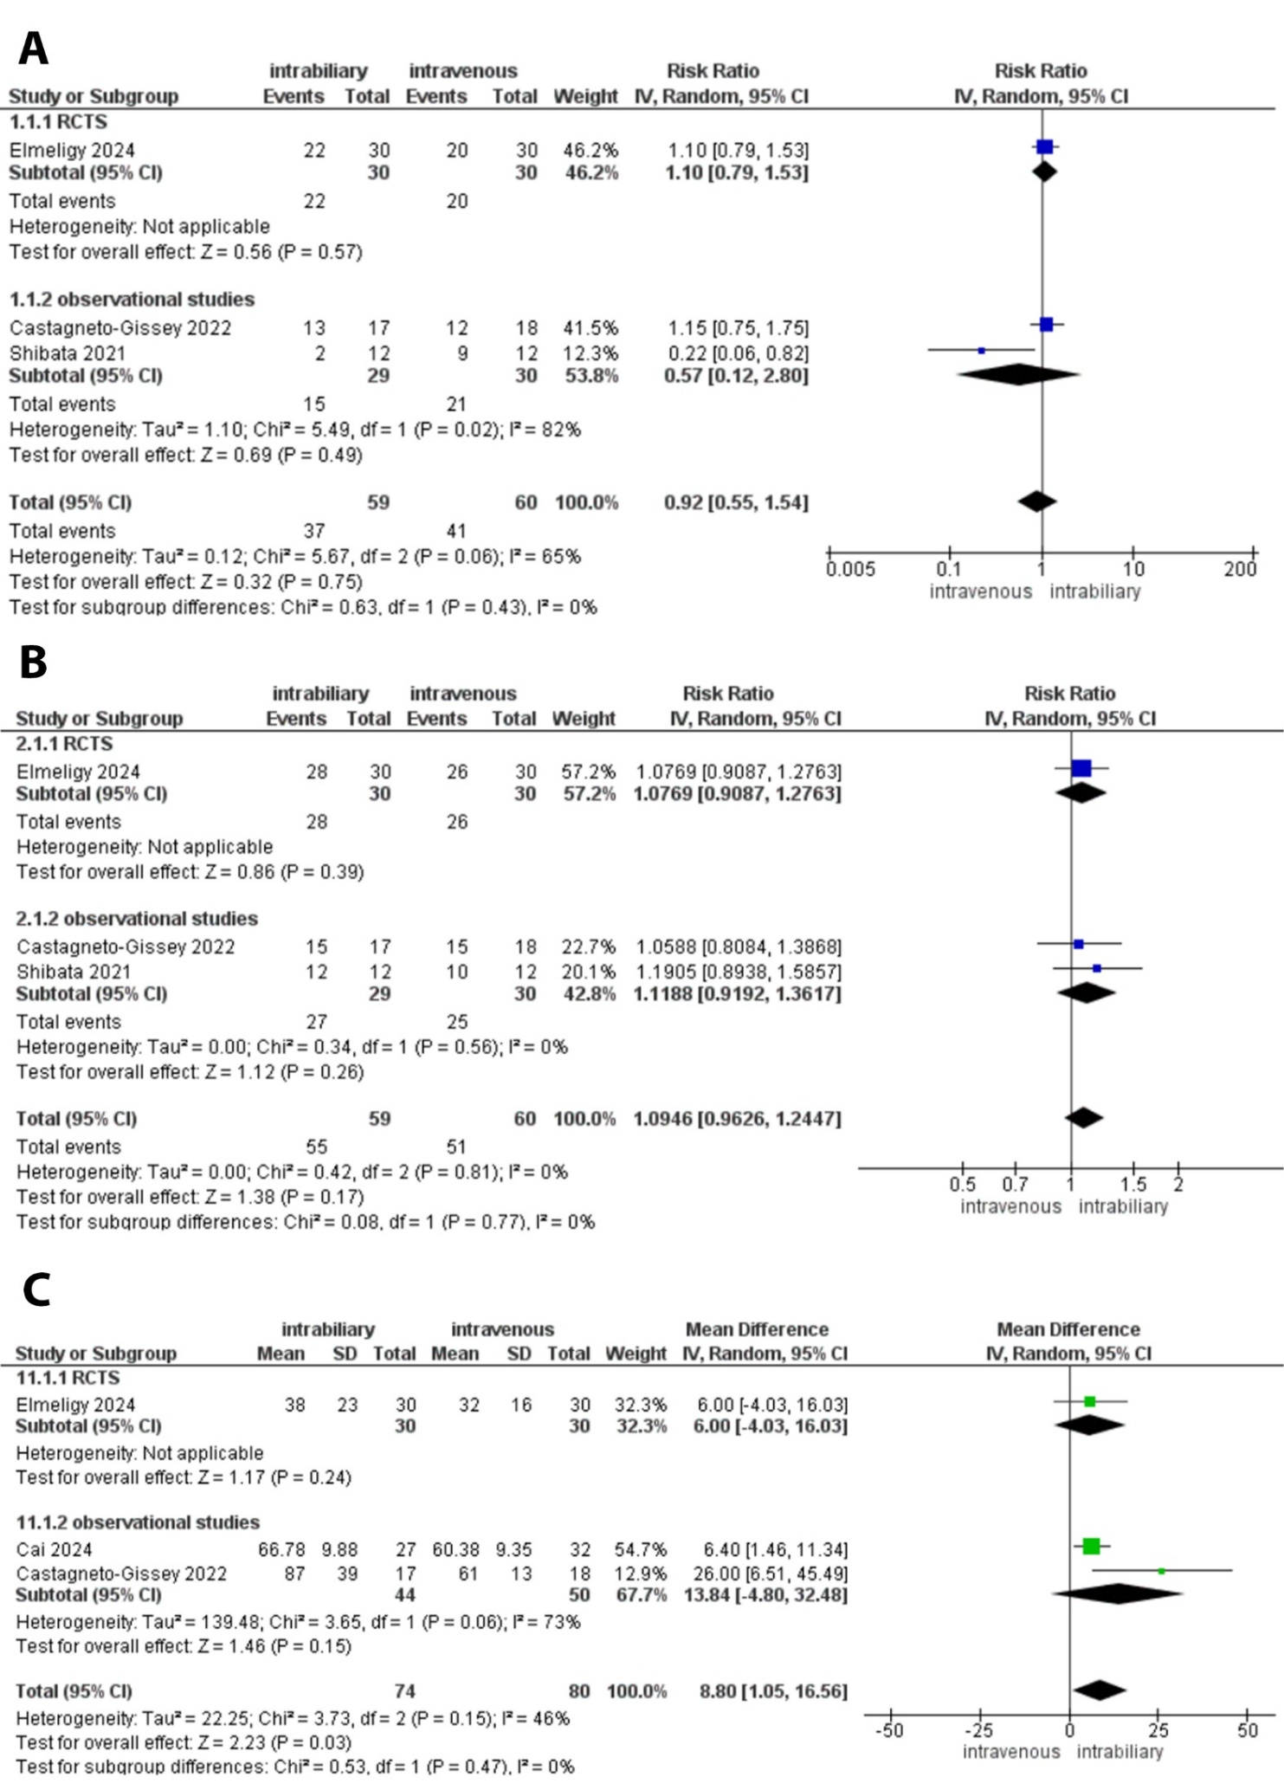

Supplementary Fig 1. Subgroup analysis for: (A) CD visualization before dissection of Calot's triangle, (B) CD visualization after dissection of Calot's triangle, and (C) operative time

