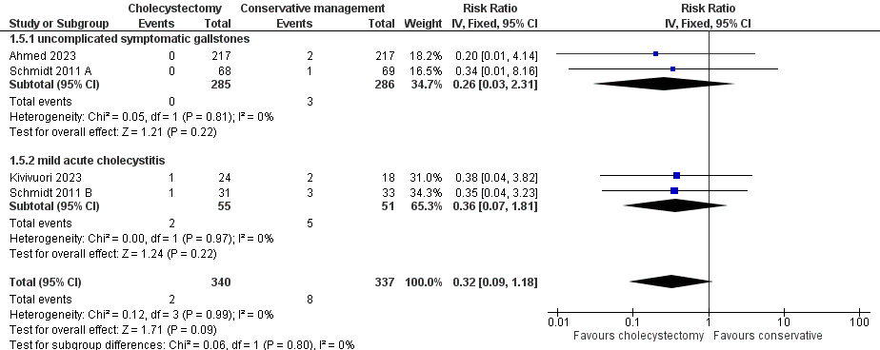

Supplementary Figure 1. This plot shows the comparison of common bile duct stones between the cholecystectomy group and the conservative management group.
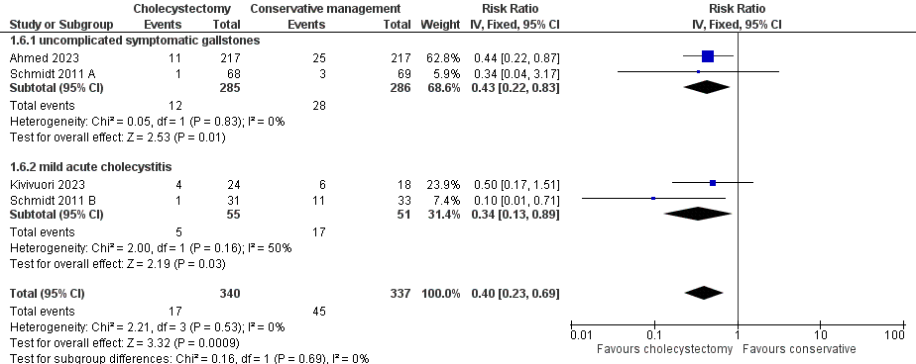

Supplementary Figure 2. This plot shows the comparison of overall gallstone-related complications between the cholecystectomy group and the conservative management group.

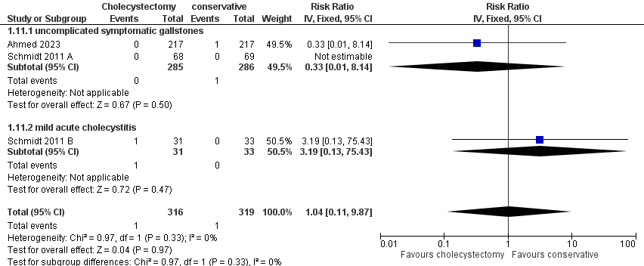

Supplementary Figure 3. This plot shows the comparison of bile duct injury between the cholecystectomy group and the conservative management group.

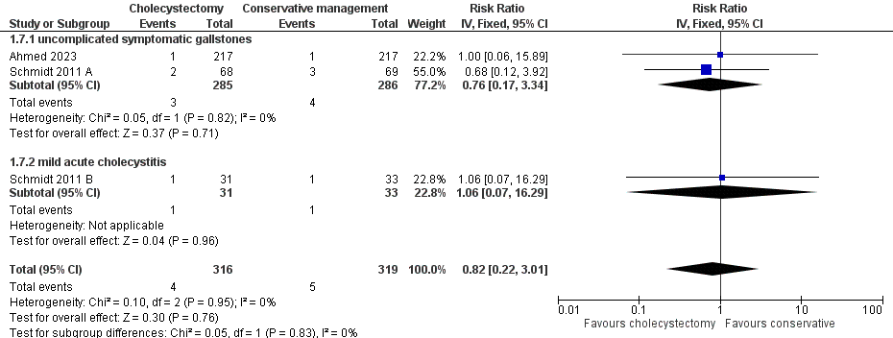
Supplementary Figure 4. This plot shows the comparison of intra-abdominal leakage between the cholecystectomy group and the conservative management group.
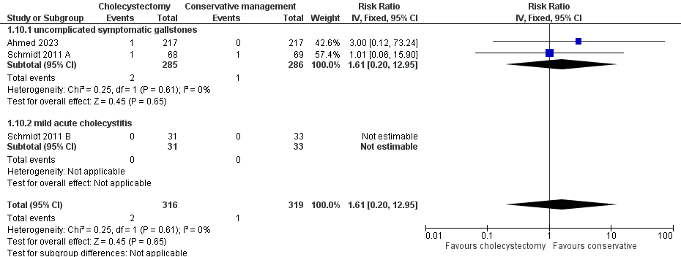
Supplementary Figure 5. This plot illustrates the comparison of wound infection between the cholecystectomy group and the conservative care group.
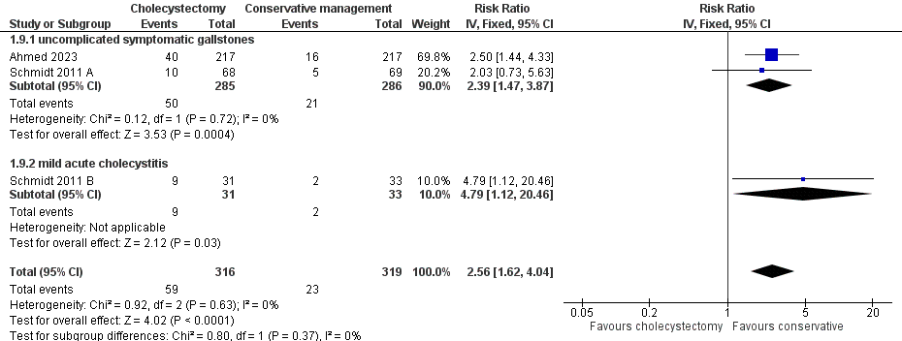
Supplementary Figure 6. This plot shows the comparison of overall surgery-related complications between the cholecystectomy group and the conservative care group.

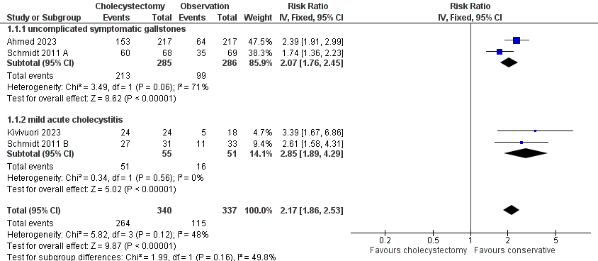
Supplementary Figure 7. This pilot illustrates the comparison of patients who underwent surgery in the cholecystectomy group with those in the conservative care group.
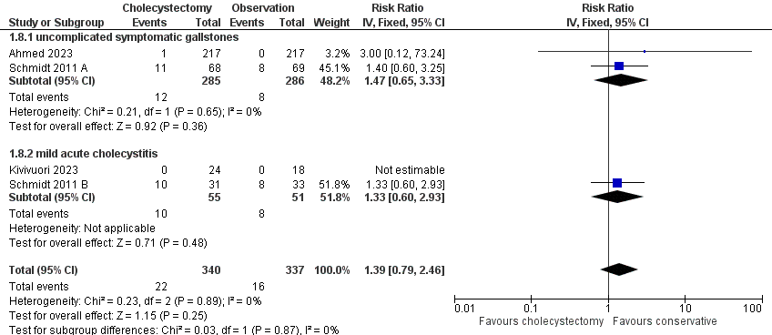
Supplementary Figure 8. This plot illustrates the comparison of mortality between the cholecystectomy group and the conservative care group.

