Supplementary Table 1. Literature search strategy.
Database | Search strategy | Literature quantity
Pubmed | ((((((colorectal neoplasm[MeSH Terms]) OR (colorectal cancer)) ) OR (colon cancer)) OR (rectal cancer))) AND (((((((natural orifice specimen extraction) OR (natural orifice specimen retrieval)) OR (transvaginal natural orifice specimen extraction)) OR (transvaginal specimen extraction)) OR (transvaginal specimen retrieval)))) | 302
EMBASE | #1 natural orifice specimen extraction  #2 natural orifice specimen retrieval  #3 transvaginal natural orifice specimen extraction  #4 transvaginal specimen extraction  #5 transvaginal specimen retrieval  #6 #1 OR #2 OR #3 OR #4 OR#5  #7 colorectal cancer  #8 rectal cancer  #9 colon cancer  #10 #7 OR #8 OR #9  #11 #6 AND #10 | 301
Web of Science | ((((ALL=(natural orifice specimen extraction)) OR ALL=(natural orifice specimen retrieval)) OR ALL=( transvaginal natural orifice specimen extraction)) OR ALL=(transvaginal specimen extraction)) OR ALL=(transvaginal specimen retrieval) AND ((ALL=(colorectal cancer)) OR ALL=(rectal cancer )) OR ALL=(colon cancer) | 314

Supplementary Table 2. Results of the meta-regression analysis.
 | β | 95% CI | SE | p-value
Hospital stay
Age | -0.10 | -0.44, 0.24 | 0.14 | 0.52
BMI | -0.46 | -1.08, 0.15 | 0.25 | 0.12
ASA I | 8.01 | -19.02, 35.05 | 9.74 | 0.45
ASA II | 4.03 | -7.36, 15.43 | 4.10 | 0.38
ASA III | -7.02 | -17.19, 3.15 | 3.66 | 0.13
T1 | -10.96 | -39.14, 17.22 | 8.86 | 0.30
T2 | -5.97 | -15.54, 3.60 | 3.01 | 0.14
T3 | 5.01 | -2.20, 12.23 | 2.27 | 0.11
Pain score
Age | -0.10 | -0.22, 0.02 | 0.05 | 0.09
BMI | -0.24 | -0.64, 0.16 | 0.16 | 0.19
ASA I | 1.39 | -13.19, 15.97 | 5.25 | 0.26
ASA II | -0.10 | -6.61, 6.40 | 2.34 | 0.96
ASA III | -0.22 | -7.59, 7.15 | 2.66 | 0.938
T1 | -3.96 | -29.57, 21.65 | 8.05 | 0.66
T2 | -2.61 | -11.94, 6.72 | 2.93 | 0.44
T3 | 2.31 | -5.59, 10.21 | 2.48 | 0.42

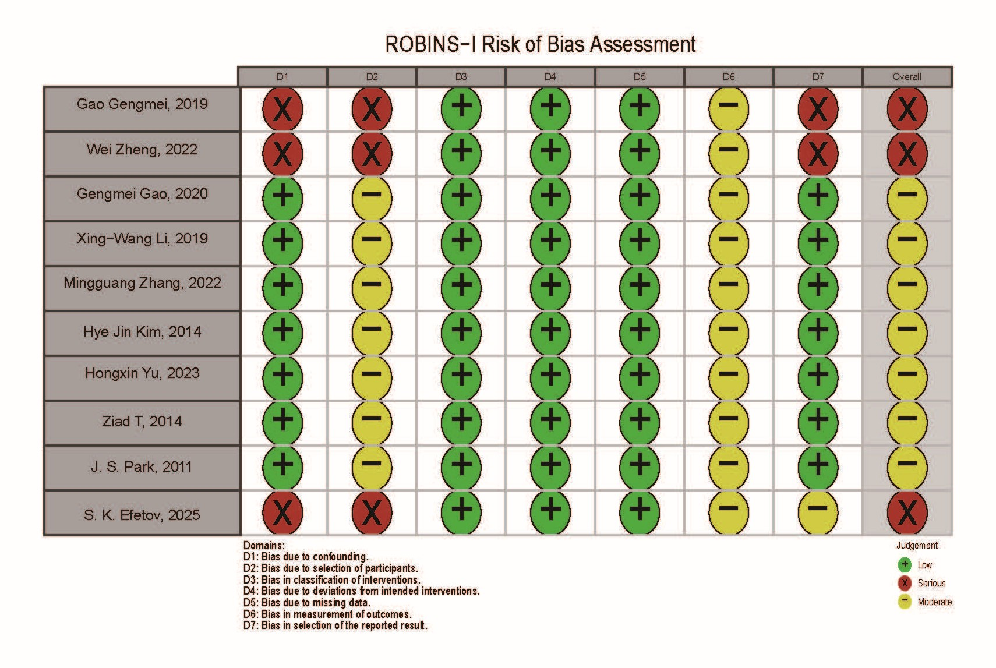
Supplementary Table 3. Risk of bias assessment for non-randomised studies (ROBINS-I).

Supplementary Table 4. GRADE evidence profile
Certainty assessment |  |  |  |  |  |  | № of patients |  | Effect |  | Certainty | Importance
№ of studies | Study design | Risk of bias | Inconsistency | Indirectness | Imprecision | Other considerations | TVSE | LAP | Relative  (95% CI) | Absolute  (95% CI) | Certainty | Importance
postoperative complications
10 | non-randomised studies | not serious | not serious | not serious | not serious | strong association | 39/375 (10.4%) | 99/438 (22.6%) | OR 0.45  (0.30 to 0.67) | 110 fewer per 1,000  (from 145 fewer to 62 fewer) | ⨁⨁⨁◯  Moderate | CRITICAL
Clavien–Dindo classification grades I–II complications
3 | non-randomised studies | not serious | not serious | not serious | not serious | none | 45/109 (41.3%) | 59/116 (50.9%) | OR 0.72  (0.44 to 1.18) | 82 fewer per 1,000  (from 196 fewer to 41 more) | ⨁⨁◯◯  Low | IMPORTANT
Clavien–Dindo classification grade III-IV complications
3 | non-randomised studies | not serious | not serious | not serious | not serious | none | 0/109 (0.0%) | 4/116 (3.4%) | OR 0.20  (0.02 to 1.74) | 27 fewer per 1,000  (from 34 fewer to 24 more) | ⨁⨁◯◯  Low | IMPORTANT
overall survival
5 | non-randomised studies | not serious | not serious | not serious | not serious | none | 244 participants | 286 participants | HR 0.76  (0.43 to 1.37)  [overall survival] | 22 fewer per 1,000  (from 52 fewer to 32 more) | ⨁⨁◯◯  Low | IMPORTANT
 |  |  |  |  |  |  | - | 9.4% | HR 0.76  (0.43 to 1.37)  [overall survival] | 22 fewer per 1,000  (from 52 fewer to 32 more) | ⨁⨁◯◯  Low | IMPORTANT
disease-free survival
5 | non-randomised studies | not serious | not serious | not serious | not serious | none | 250 participants | 296 participants | HR 1.22  (0.72 to 2.08)  [disease-free survival] | 18 more per 1,000  (from 24 fewer to 85 more) | ⨁⨁◯◯  Low | IMPORTANT
 |  |  |  |  |  |  | - | 8.7% | HR 1.22  (0.72 to 2.08)  [disease-free survival] | 18 more per 1,000  (from 24 fewer to 85 more) | ⨁⨁◯◯  Low | IMPORTANT

