Supplementary file 1. Detailed search strategies of occult breast cancer studies in three databases.
Pubmed/MEDLINE database (N=3572)
(("Neoplasms, Unknown Primary"[Mesh]) OR (((((((((((((((((((Occult Primary Neoplasms[Title/Abstract]) OR (Neoplasms, Occult Primary[Title/Abstract])) OR (Neoplasm, Occult Primary[Title/Abstract])) OR (Occult Primary Neoplasm[Title/Abstract])) OR (Primary Neoplasm, Occult[Title/Abstract])) OR (Primary Neoplasms, Occult[Title/Abstract])) OR (Unknown Primary Neoplasms[Title/Abstract])) OR (Neoplasm, Unknown Primary[Title/Abstract])) OR (Primary Neoplasm, Unknown[Title/Abstract])) OR (Primary Neoplasms, Unknown[Title/Abstract])) OR (Primary Neoplasms, Unknown[Title/Abstract])) OR (Unknown Primary Tumors[Title/Abstract])) OR (Primary Tumor, Unknown[Title/Abstract])) OR (Primary Tumors, Unknown[Title/Abstract])) OR (Tumor, Unknown Primary[Title/Abstract])) OR (Tumors, Unknown Primary[Title/Abstract])) OR (Unknown Primary Tumor[Title/Abstract])) OR (Neoplasm Metastasis, Unknown Primary[Title/Abstract])) OR (Unknown Primary Neoplasm Metastasis[Title/Abstract]))) AND ((("Breast Neoplasms"[Mesh] OR "Unilateral Breast Neoplasms"[Mesh] OR "Triple Negative Breast Neoplasms"[Mesh] OR "Inflammatory Breast Neoplasms"[Mesh]) OR ((((((((((((((((((((((((((((((((((((((((((((((((((((((((((((Breast Neoplasm, Unilateral[Title/Abstract]) OR (Breast Neoplasms, Unilateral[Title/Abstract])) OR (Unilateral Breast Cancer[Title/Abstract])) OR (Breast Cancer, Unilateral[Title/Abstract])) OR (Breast Cancers, Unilateral[Title/Abstract])) OR (Unilateral Breast Cancers[Title/Abstract])) OR (Right-Sided Breast Neoplasms[Title/Abstract])) OR (Breast Neoplasm, Right-Sided[Title/Abstract])) OR (Breast Neoplasms, Right-Sided[Title/Abstract])) OR (Right Sided Breast Neoplasms[Title/Abstract])) OR (Right-Sided Breast Neoplasm[Title/Abstract])) OR (Right-Sided Breast Cancer[Title/Abstract])) OR (Breast Cancer, Right-Sided[Title/Abstract])) OR (Breast Cancers, Right-Sided[Title/Abstract])) OR (Right-Sided Breast Cancers[Title/Abstract])) OR (Right Sided Breast Cancer[Title/Abstract])) OR (Right Sided Breast Neoplasm[Title/Abstract])) OR (Left-Sided Breast Neoplasms[Title/Abstract])) OR (Breast Neoplasm, Left-Sided[Title/Abstract])) OR (Breast Neoplasms, Left-Sided[Title/Abstract])) OR (Left-Sided Breast Neoplasm[Title/Abstract])) OR (Left Sided Breast Neoplasm[Title/Abstract])) OR (Left-Sided Breast Cancer[Title/Abstract])) OR (Breast Cancer, Left-Sided[Title/Abstract])) OR (Breast Cancers, Left-Sided[Title/Abstract])) OR (Left-Sided Breast Cancers[Title/Abstract])) OR (Left Sided Breast Neoplasms[Title/Abstract])) OR (Left Sided Breast Cancer[Title/Abstract])) OR (ER-Negative PR-Negative HER2-Negative Breast Neoplasms[Title/Abstract])) OR (ER Negative PR Negative HER2 Negative Breast Neoplasms[Title/Abstract])) OR (Triple-Negative Breast Cancer[Title/Abstract])) OR (Breast Cancer, Triple-Negative[Title/Abstract])) OR (Breast Cancers, Triple-Negative[Title/Abstract])) OR (Triple-Negative Breast Cancers[Title/Abstract])) OR (Triple-Negative Breast Neoplasm[Title/Abstract])) OR (Breast Neoplasm, Triple-Negative[Title/Abstract])) OR (Breast Neoplasms, Triple-Negative[Title/Abstract])) OR (Triple Negative Breast Neoplasm[Title/Abstract])) OR (Triple-Negative Breast Neoplasms[Title/Abstract])) OR (ER-Negative PR-Negative HER2-Negative Breast Cancer[Title/Abstract])) OR (ER Negative PR Negative HER2 Negative Breast Cancer[Title/Abstract])) OR (Triple Negative Breast Cancer[Title/Abstract])) OR (Breast Neoplasm, Inflammatory[Title/Abstract])) OR (Breast Neoplasms, Inflammatory[Title/Abstract])) OR (Inflammatory Breast Neoplasm[Title/Abstract])) OR (Neoplasm, Inflammatory Breast[Title/Abstract])) OR (Neoplasms, Inflammatory Breast[Title/Abstract])) OR (Inflammatory Breast Cancer (IBC[Title/Abstract]))) OR (Inflammatory Breast Carcinoma[Title/Abstract])) OR (Breast Carcinoma, Inflammatory[Title/Abstract])) OR (Breast Carcinomas, Inflammatory[Title/Abstract])) OR (Carcinoma, Inflammatory Breast[Title/Abstract])) OR (Carcinomas, Inflammatory Breast[Title/Abstract])) OR (Inflammatory Breast Carcinomas[Title/Abstract])) OR (Inflammatory Breast Cancer[Title/Abstract])) OR (Breast Cancer, Inflammatory[Title/Abstract])) OR (Breast Cancers, Inflammatory[Title/Abstract])) OR (Cancer, Inflammatory Breast[Title/Abstract])) OR (Cancers, Inflammatory Breast[Title/Abstract])) OR (Inflammatory Breast Cancers[Title/Abstract]))) OR (((((((((((((((((((((((((((((((((((((Breast Neoplasm[Title/Abstract]) OR (Neoplasm, Breast[Title/Abstract])) OR (Breast Tumors[Title/Abstract])) OR (Breast Tumor[Title/Abstract])) OR (Tumor, Breast[Title/Abstract])) OR (Tumors, Breast[Title/Abstract])) OR (Neoplasms, Breast[Title/Abstract])) OR (Breast Cancer[Title/Abstract])) OR (Cancer, Breast[Title/Abstract])) OR (Mammary Cancer[Title/Abstract])) OR (Cancer, Mammary[Title/Abstract])) OR (Cancers, Mammary[Title/Abstract])) OR (Mammary Cancers[Title/Abstract])) OR (Malignant Neoplasm of Breast[Title/Abstract])) OR (Breast Malignant Neoplasm[Title/Abstract])) OR (Breast Malignant Neoplasms[Title/Abstract])) OR (Malignant Tumor of Breast[Title/Abstract])) OR (Breast Malignant Tumor[Title/Abstract])) OR (Breast Malignant Tumors[Title/Abstract])) OR (Cancer of Breast[Title/Abstract])) OR (Cancer of the Breast[Title/Abstract])) OR (Mammary Carcinoma, Human[Title/Abstract])) OR (Carcinoma, Human Mammary[Title/Abstract])) OR (Carcinomas, Human Mammary[Title/Abstract])) OR (Human Mammary Carcinomas[Title/Abstract])) OR (Mammary Carcinomas, Human[Title/Abstract])) OR (Human Mammary Carcinoma[Title/Abstract])) OR (Mammary Neoplasms, Human[Title/Abstract])) OR (Human Mammary Neoplasm[Title/Abstract])) OR (Human Mammary Neoplasms[Title/Abstract])) OR (Neoplasm, Human Mammary[Title/Abstract])) OR (Neoplasms, Human Mammary[Title/Abstract])) OR (Mammary Neoplasm, Human[Title/Abstract])) OR (Breast Carcinoma[Title/Abstract])) OR (Breast Carcinomas[Title/Abstract])) OR (Carcinoma, Breast[Title/Abstract])) OR (Carcinomas, Breast[Title/Abstract]))) OR (“occult breast cancer” OR “occult breast carcinoma” OR “occult primary breast cancer” OR “occult breast neoplasm”)

Embase database (N=1873)
'occult breast cancer'/exp OR 'occult breast carcinoma':ab,ti OR 'occult primary breast cancer':ab,ti OR 'occult breast neoplasm':ab,ti OR (('occult cancer'/exp OR 'occult carcinoma':ab,ti OR 'occult cancer':ab,ti) AND ('breast cancer'/exp OR 'breast gland cancer':ab,ti OR 'breast gland neoplasm':ab,ti OR 'breast malignancies':ab,ti OR 'breast malignancy':ab,ti OR 'breast tumor malignant':ab,ti OR 'ca breast':ab,ti OR 'cancer in the mammary gland':ab,ti OR 'cancer of the breast':ab,ti OR 'cancer of the mammary gland':ab,ti OR 'cancer, breast':ab,ti OR 'malignancies of the breast':ab,ti OR 'malignancy of the breast':ab,ti OR 'malignant breast neoplasm':ab,ti OR 'malignant breast tumor':ab,ti OR 'malignant neoplasm of the breast':ab,ti OR 'malignant tumor of the breast':ab,ti OR 'mamma cancer':ab,ti OR 'mammary cancer':ab,ti OR 'mammary gland cancer':ab,ti OR 'mammary gland malignancy':ab,ti OR 'mammary malignancies':ab,ti OR 'mammary malignancy':ab,ti OR 'breast cancer':ab,ti))

Cochrane (N=462)
((MeSH descriptor: [Neoplasms, Unknown Primary] explode all trees) OR (Neoplasm Metastasis, Unknown Primary):ti,ab,kw OR (Unknown Primary Neoplasm Metastasis):ti,ab,kw OR (Neoplasm, Occult Primary):ti,ab,kw OR (Primary Neoplasms, Occult):ti,ab,kw OR (Primary Neoplasm, Occult):ti,ab,kw (Word variations have been searched) OR (Primary Neoplasm, Unknown):ti,ab,kw OR (Neoplasm, Unknown Primary):ti,ab,kw OR (Primary Neoplasms, Unknown):ti,ab,kw OR (Occult Primary Neoplasm):ti,ab,kw OR (Unknown Primary Neoplasm):ti,ab,kw (Word variations have been searched) OR (Unknown Primary Neoplasms):ti,ab,kw OR (Occult Primary Neoplasms):ti,ab,kw OR (Neoplasms, Occult Primary):ti,ab,kw OR (Primary Tumor, Unknown):ti,ab,kw OR (Unknown Primary Tumor):ti,ab,kw (Word variations have been searched) OR (Tumor, Unknown Primary):ti,ab,kw OR (Tumors, Unknown Primary):ti,ab,kw OR (Unknown Primary Tumors):ti,ab,kw OR (Primary Tumors, Unknown):ti,ab,kw (Word variations have been searched)) AND ((MeSH descriptor: [Breast Neoplasms] explode all trees OR (Human Mammary Carcinoma):ti,ab,kw OR (Carcinoma, Human Mammary):ti,ab,kw OR (Carcinomas, Human Mammary):ti,ab,kw OR (Mammary Carcinomas, Human):ti,ab,kw OR (Human Mammary Carcinomas):ti,ab,kw (Word variations have been searched) OR (Mammary Carcinoma, Human):ti,ab,kw OR (Mammary Neoplasm, Human):ti,ab,kw OR (Neoplasms, Human Mammary):ti,ab,kw OR (Human Mammary Neoplasm):ti,ab,kw OR (Human Mammary Neoplasms):ti,ab,kw (Word variations have been searched) OR (Mammary Neoplasms, Human):ti,ab,kw OR (Neoplasm, Human Mammary):ti,ab,kw OR (Breast Malignant Tumor):ti,ab,kw OR (Breast Cancer):ti,ab,kw OR (Cancer of the Breast):ti,ab,kw (Word variations have been searched) OR (Malignant Tumor of Breast):ti,ab,kw OR (Breast Malignant Neoplasms):ti,ab,kw OR (Cancers, Mammary):ti,ab,kw OR (Cancer of Breast):ti,ab,kw OR (Malignant Neoplasm of Breast):ti,ab,kw (Word variations have been searched) OR (Cancer, Mammary):ti,ab,kw OR (Breast Malignant Tumors):ti,ab,kw OR (Breast Malignant Neoplasm):ti,ab,kw OR (Mammary Cancers):ti,ab,kw OR (Mammary Cancer):ti,ab,kw (Word variations have been searched) OR (Cancer, Breast):ti,ab,kw OR (Neoplasm, Breast):ti,ab,kw OR (Breast Tumors):ti,ab,kw OR (Tumor, Breast):ti,ab,kw OR (Breast Tumor):ti,ab,kw (Word variations have been searched) OR (Tumors, Breast):ti,ab,kw OR (Neoplasms, Breast):ti,ab,kw OR (Breast Neoplasm):ti,ab,kw OR (Breast Carcinomas):ti,ab,kw OR (Carcinoma, Breast):ti,ab,kw (Word variations have been searched) OR (Carcinomas, Breast):ti,ab,kw OR (Breast Carcinoma):ti,ab,kw ) OR ((occult breast cancer):ti,ab,kw OR (occult breast carcinoma):ti,ab,kw OR (occult primary breast cancer):ti,ab,kw OR (occult breast neoplasm):ti,ab,kw (Word variations have been searched))

Supplementary file 2. Risk of bias assessment of included studies via JBI Critical Appraisal Checklist for Analytical Cross-Sectional Studies.
Study | Were the criteria for inclusion in the sample clearly defined? | Were the study subjects and the setting described in detail? | Was the exposure measured in a valid and reliable way? | Were objective, standard criteria used for measurement of the condition? | Were confounding factors identified? | Were strategies to deal with confounding factors stated? | Were the outcomes measured in a valid and reliable way? | Was appropriate statistical analysis used? | Score
Choi, et.al (2023) | 0 | 0 | 0 | 0 | 1 | 1 | 0 | 0 | 2
Van den Bruele, et.al (2021) | 0 | 0 | 1 | 0 | 1 | 1 | 0 | 0 | 3
Ouldamer, et.al (2018) | 0 | 0 | 1 | 0 | 1 | 1 | 0 | 0 | 3
Rueth, et.al (2015) | 0 | 0 | 0 | 0 | 1 | 1 | 0 | 0 | 2
Masinghe, et.al (2011) | 0 | 0 | 0 | 0 | 1 | 1 | 0 | 0 | 2
Hu,et.al (2010) | 0.5 | 0 | 0 | 0.5 | 1 | 1 | 0 | 0 | 3
Wang, et.al (2010) | 0 | 0 | 0 | 0 | 1 | 1 | 0 | 0 | 2
Zhao, et.al (2022) | 0 | 0 | 0 | 0 | 1 | 1 | 0 | 0 | 2
Sun, et.al (2014) | 0.5 | 0 | 0 | 0.5 | 1 | 1 | 0 | 0 | 3
Lu, et.al (2011) | 0.5 | 0 | 0 | 0.5 | 1 | 1 | 0 | 1 | 3
Hessler, et.al (2017) | 0 | 0 | 0 | 0 | 1 | 1 | 0 | 0 | 2
Vlastos，et.al (2001) | 0.5 | 0 | 0 | 0.5 | 1 | 1 | 0 | 0 | 3
Montagna，et.al (2011) | 0 | 0 | 0 | 0 | 1 | 1 | 0 | 0 | 2
Bertozzi, et.al (2015) | 0 | 0 | 1 | 0 | 0.5 | 0.5 | 0 | 0 | 2
Lloyd, et.al (2001) | 0.5 | 0 | 0 | 0.5 | 1 | 1 | 0 | 0 | 3
FOROUDI，et.al (2000) | 0 | 0 | 0 | 0 | 1 | 1 | 0 | 0 | 2
Matsuoka, et.al (2003) | 0 | 0 | 0 | 0 | 1 | 1 | 0 | 0 | 2
Shannon, et.al (2002) | 0 | 0 | 0 | 0 | 1 | 1 | 0 | 0 | 2
McCartan, et.al (2017) | 0 | 0 | 1 | 0 | 1 | 1 | 0 | 0 | 3
Kim, et.al (2020) | 0 | 0 | 1 | 0 | 1 | 1 | 0 | 0 | 3
Varadarajan, et.al (2006) | 0 | 0 | 0 | 0 | 1 | 1 | 0 | 1 | 2
Kim, et.al (2021) | 0 | 0 | 1 | 0 | 1 | 1 | 0 | 0 | 3
Hao, et.al (2014) | 0.5 | 0 | 0 | 0.5 | 1 | 1 | 0 | 0 | 3
Zhang, et.al (2022) | 0 | 0 | 0 | 0 | 1 | 1 | 0 | 0 | 2
Blanchard,et.al (2004) | 0.5 | 0 | 1 | 0.5 | 1 | 1 | 0 | 0 | 4
Baumrucker, et.al (2020) | 0 | 0 | 0 | 0 | 1 | 1 | 0 | 0 | 2
Johnso, et.al (2019) | 0 | 0 | 0 | 0 | 0.5 | 0.5 | 0 | 0 | 1
Barton,et.al (2011) | 0 | 0 | 0 | 0 | 1 | 1 | 0 | 0 | 2
SOHN, et.al (2014) | 0 | 0 | 0 | 0 | 0.5 | 0.5 | 0 | 0 | 1
Tsai, et.al (2020) | 0 | 0 | 0 | 0 | 0.5 | 0.5 | 0 | 0 | 1
If all eight items were satisfied the study was rated as a low risk of bias study. If at least one of the items was not ascertainable the study was rated as unclear risk of bias study. Alternately, if one of the items was not satisfied the study was rated as a high risk of bias study.

Supplementary file 3. Funnel plot of rate of different types of treatments for OBC patients. a. Mastectomy+ALND; b. Lumpectomy+ALND; c. ALND only; d. radiotherapy.
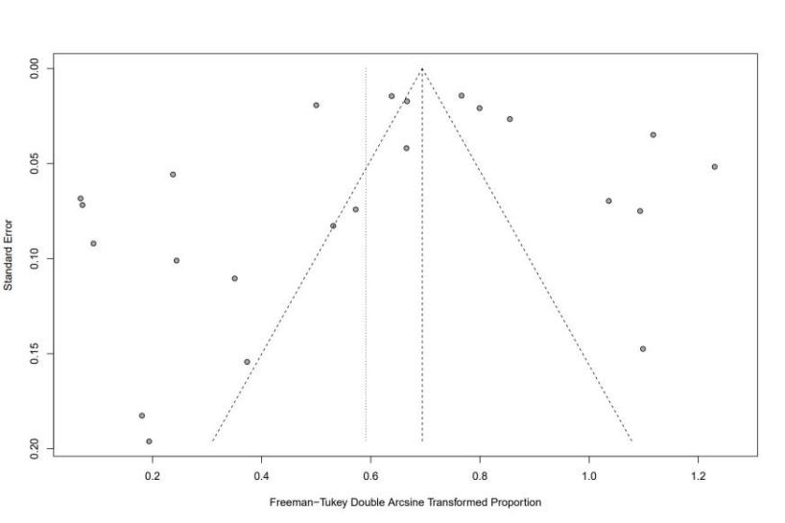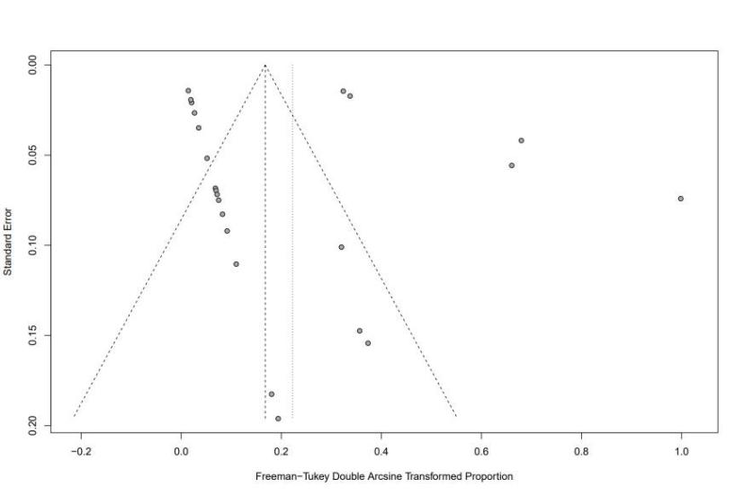
b
a
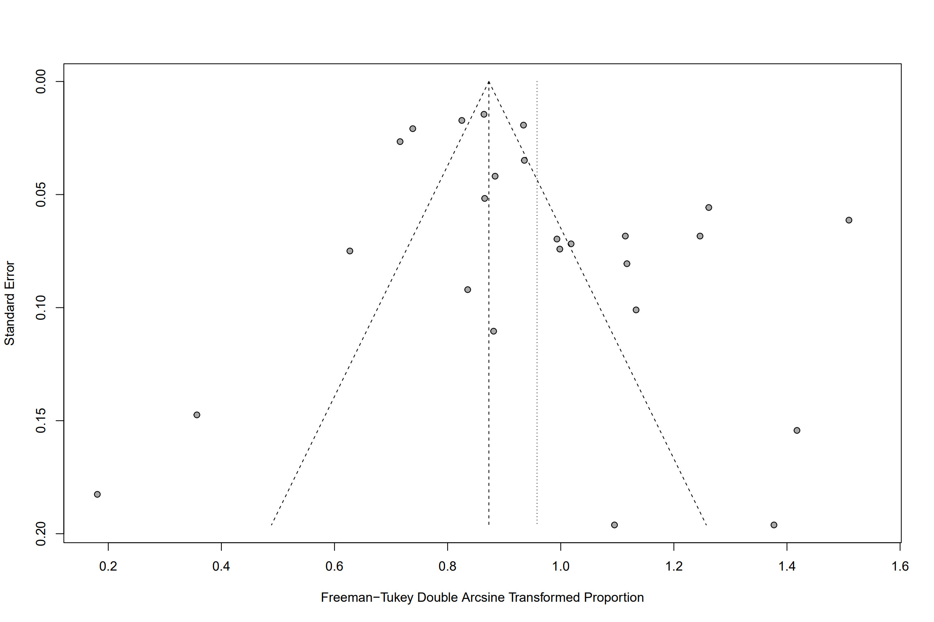
d
c
Supplementary file 4. Funnel plot of rate of OBC patients with lymph node stage N1 (a), N2 (b), and N3 (c), respectively.
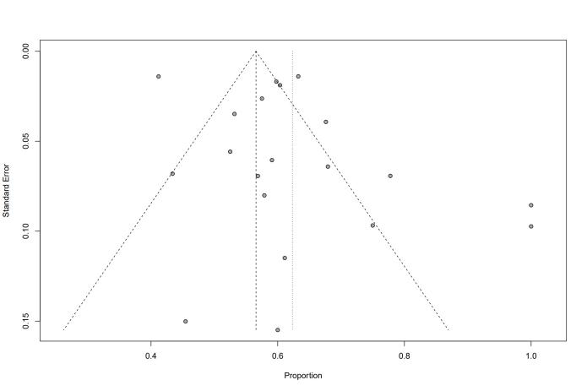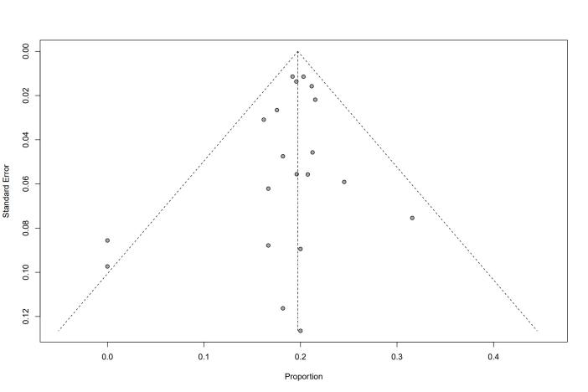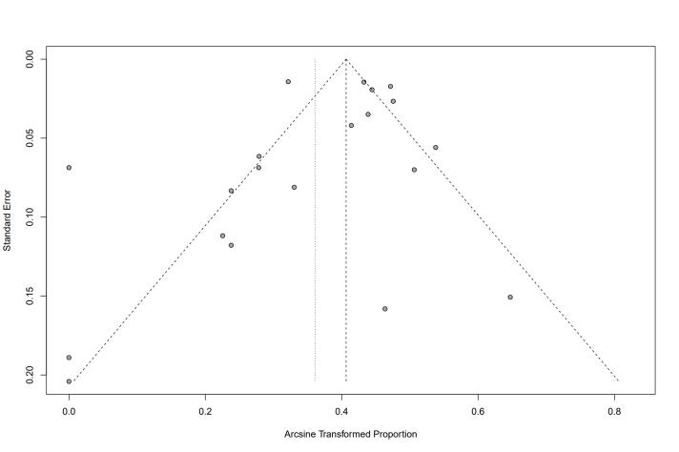
c
b
a

Supplementary file 5. Funnel plot of rate of OBC patients with ER-positive (a), PR-positive (b), HER-2 positive (c), and TNBC (d), respectively.
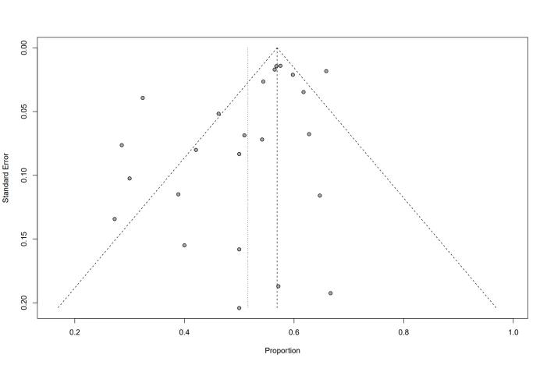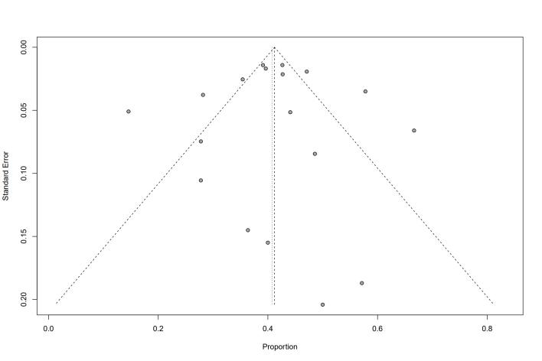
b
a
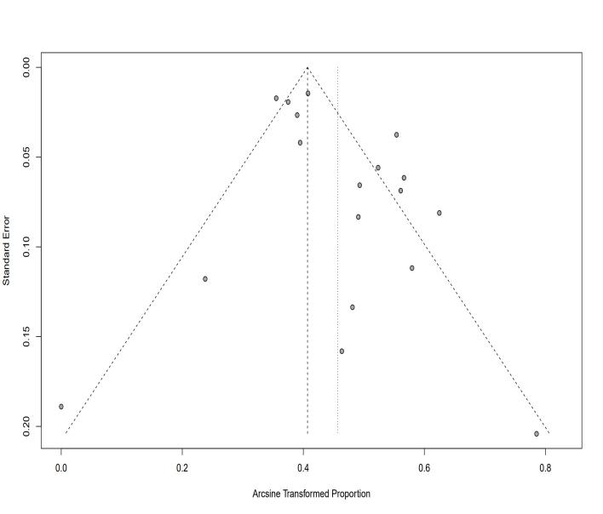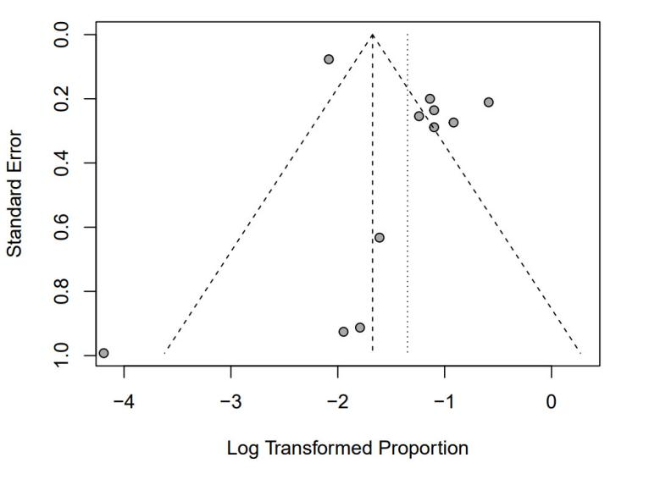
d
c
ER, Estrogen receptor; PR, Progesterone receptor; HER-2, Human epidermal growth factor receptor 2; TNBC, Triple-negative breast cancer

Supplementary file 6. Funnel plot of 5-year (a) and 8-year (b) overall survival of the whole cohort of OBC patients.
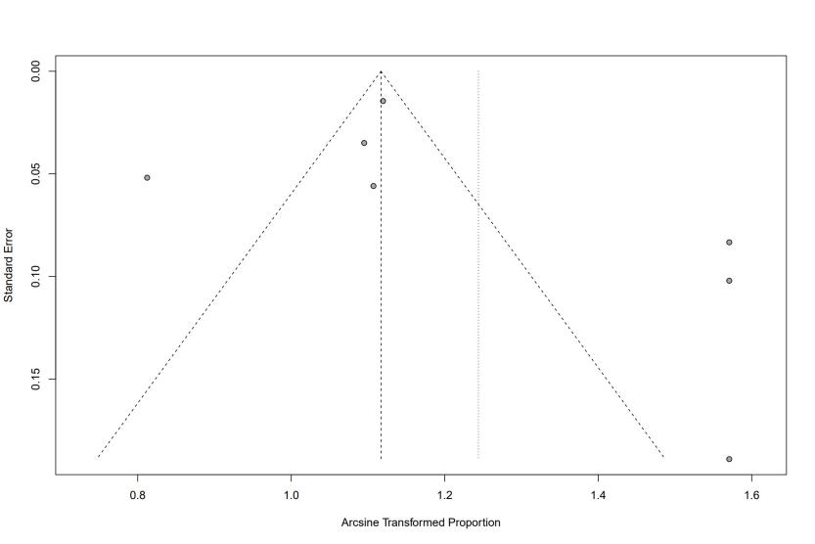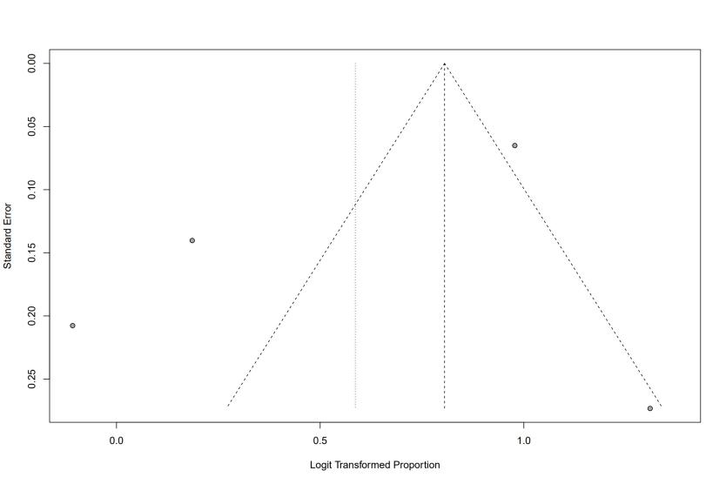
b
a

Supplementary file 7. Forest plot of hazard ratio of overall survival of occult breast cancer patients with lymph node stage N2-3 vs. Stage N1. 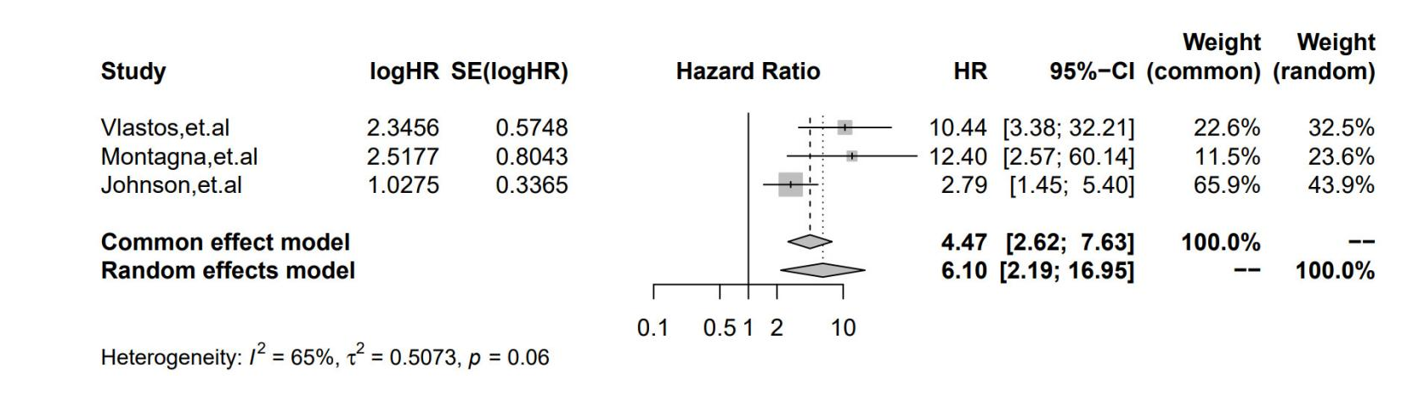

Supplementary file 8. Funnel plots of meta-analysis of hazard ratios between different surgical or non-surgical treatments across included studies Overall survival of occult breast cancer (OBC) patients receiving mastectomy vs. no mastectomy(a) ; Overall survival of patients receiving radiotherapy vs. no radiotherapy(b) ; Disease-free survival of patients receiving mastectomy vs. no mastectomy(c) ; Disease-free survival of patients receiving radiotherapy vs. no mastectomy(d).

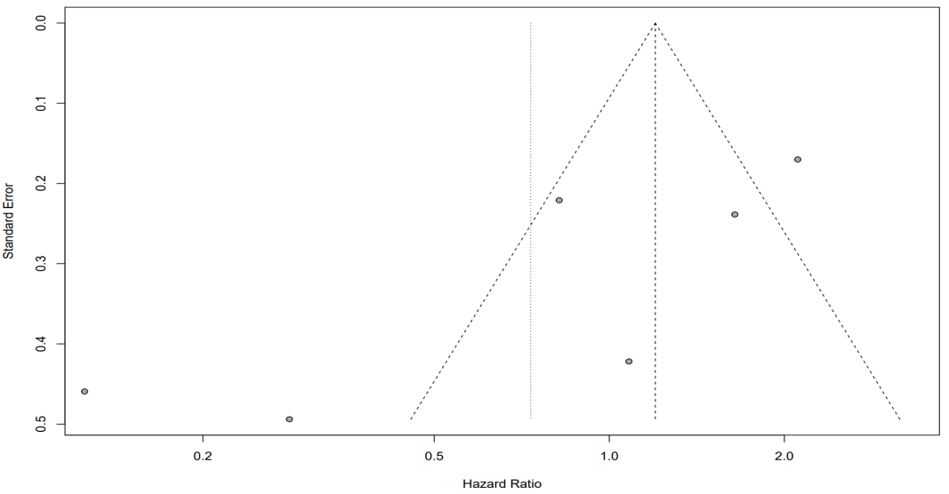
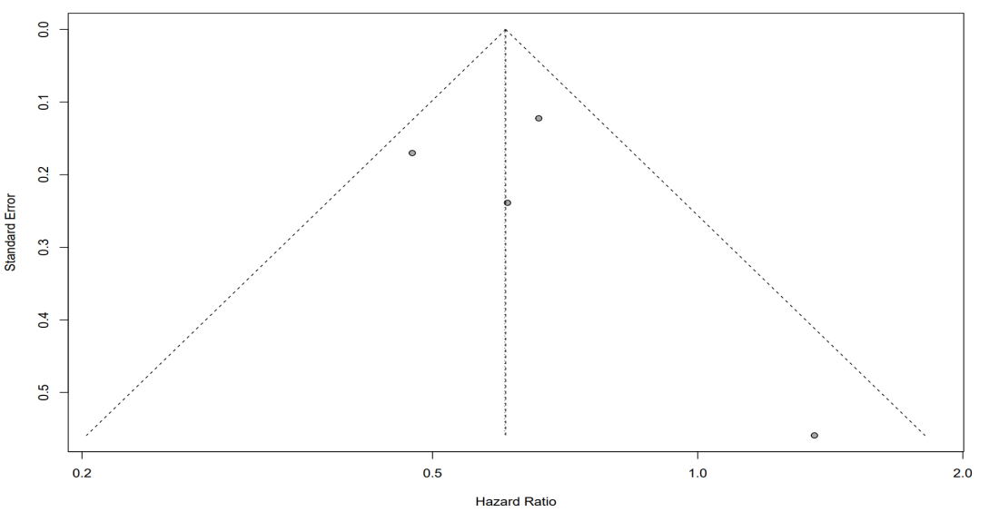
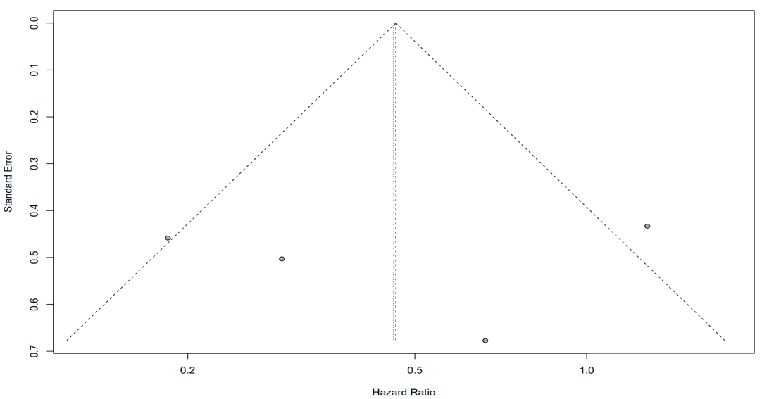
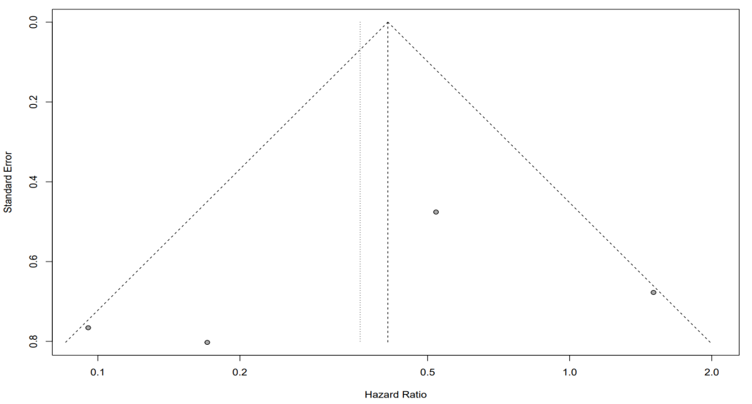
a
b
c
d

