Supplementary Figure 1. Change from baseline in nutritional parameters (entire cohort)
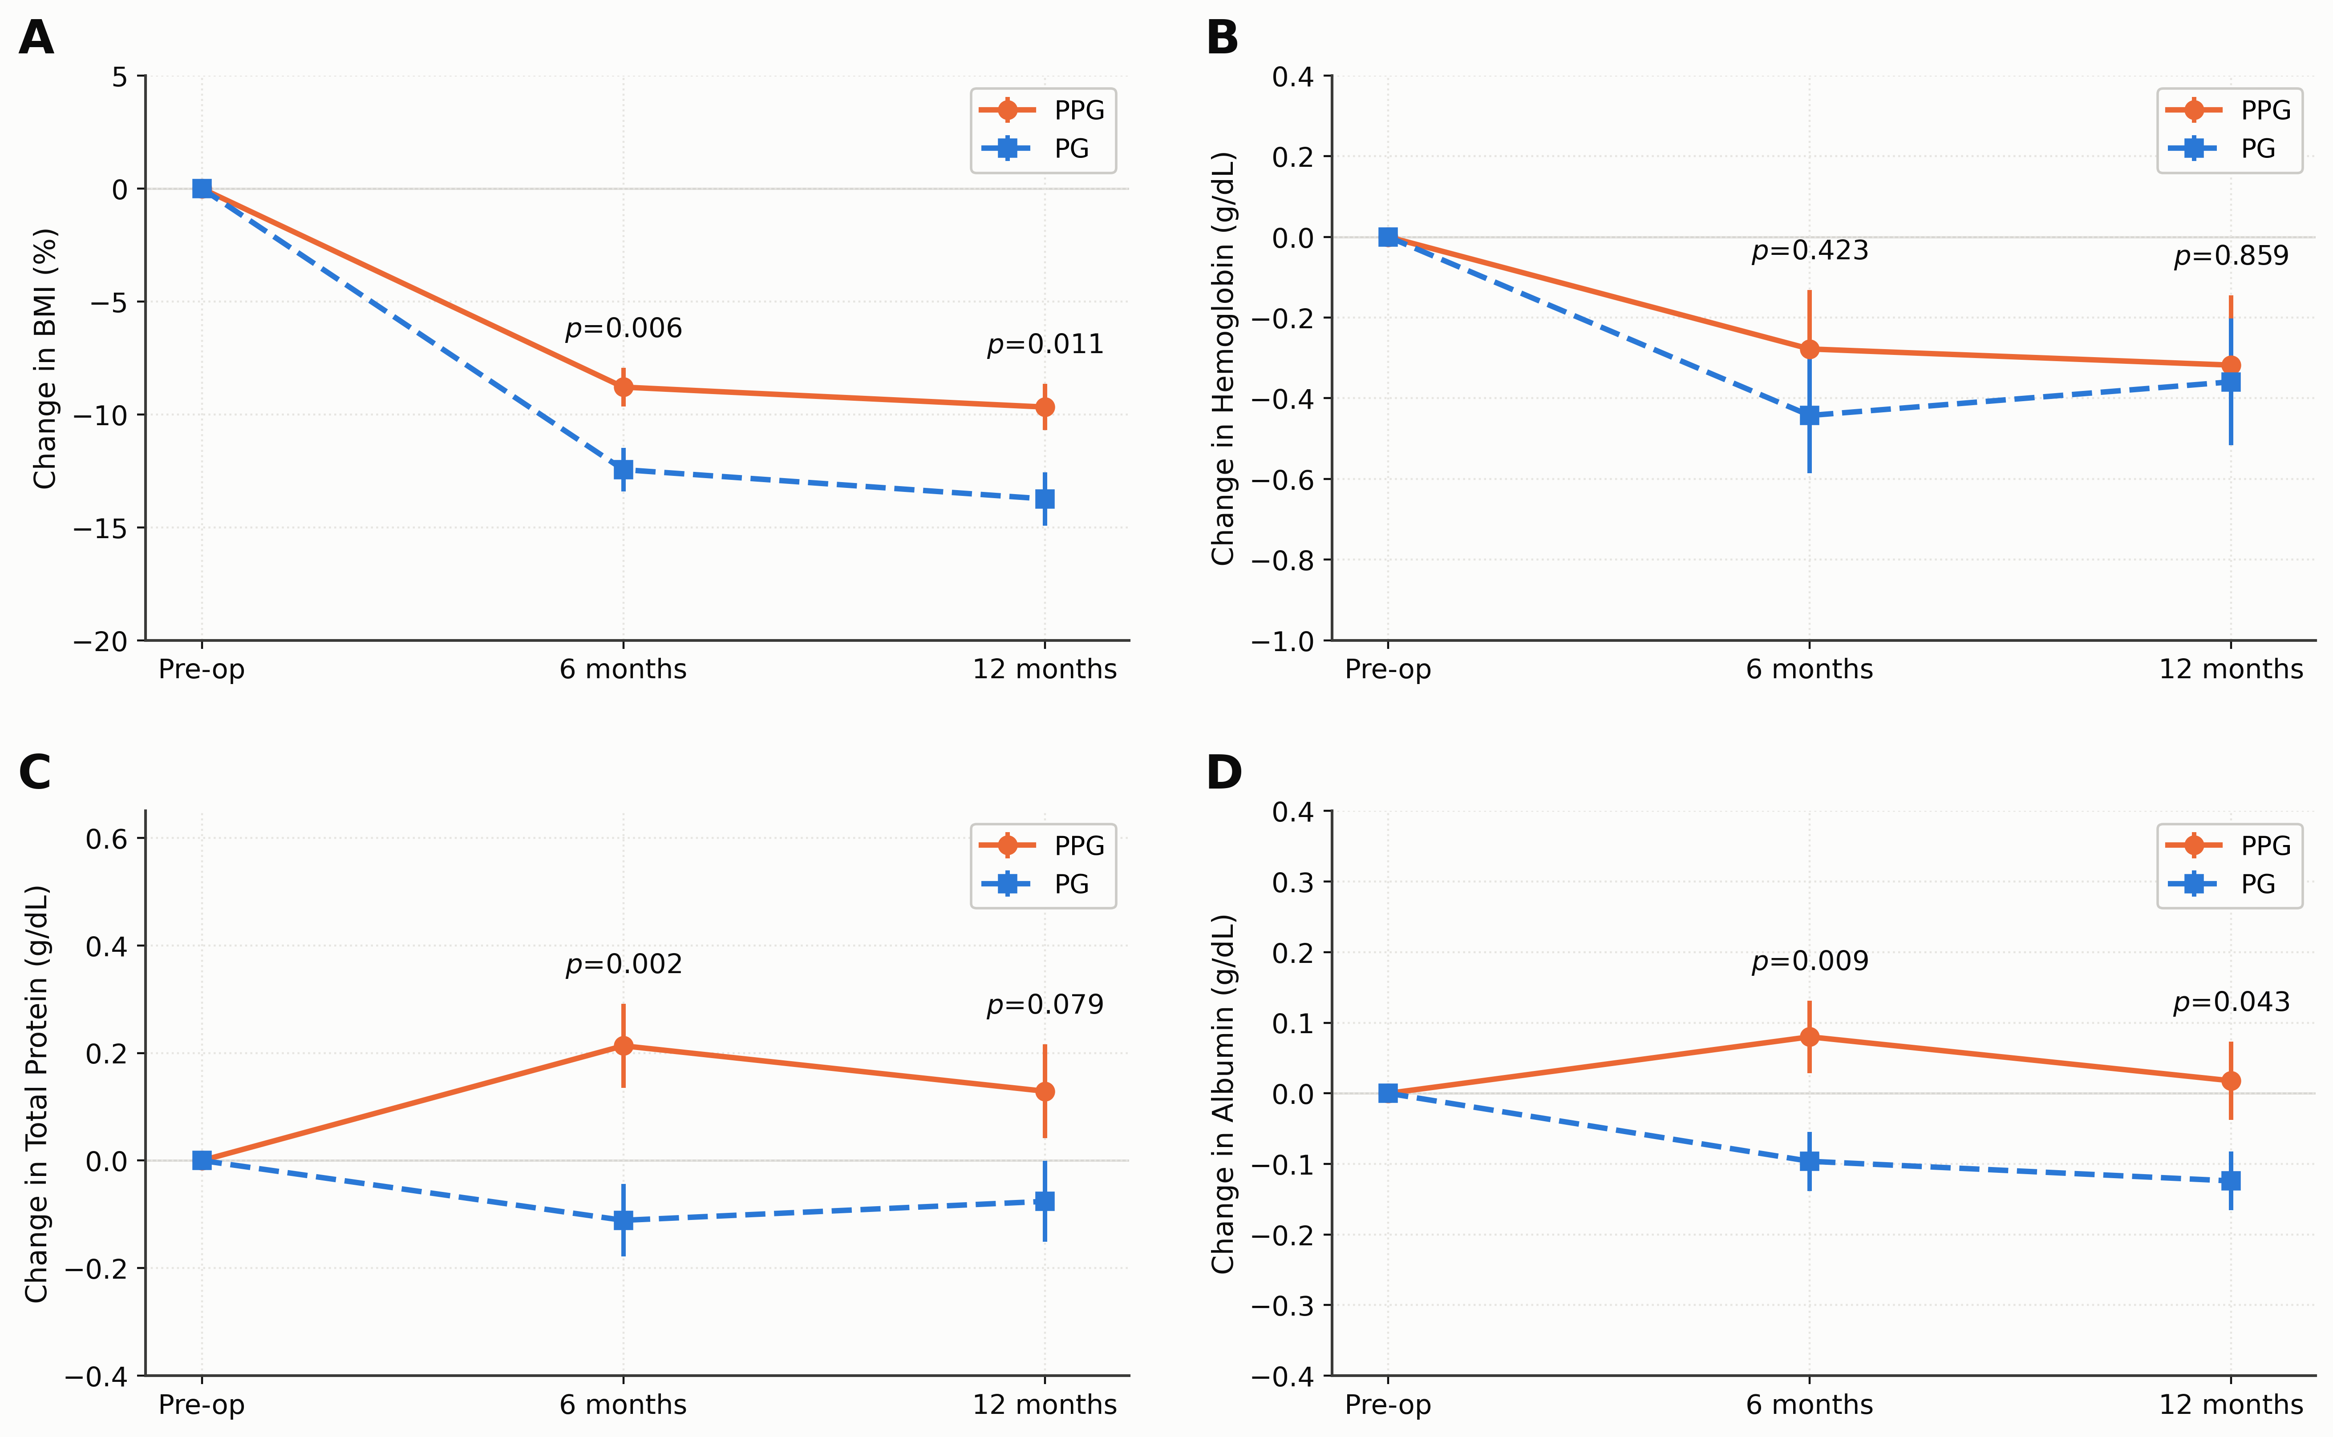
Supplementary Figure 2A. Love plot of standardized mean differences
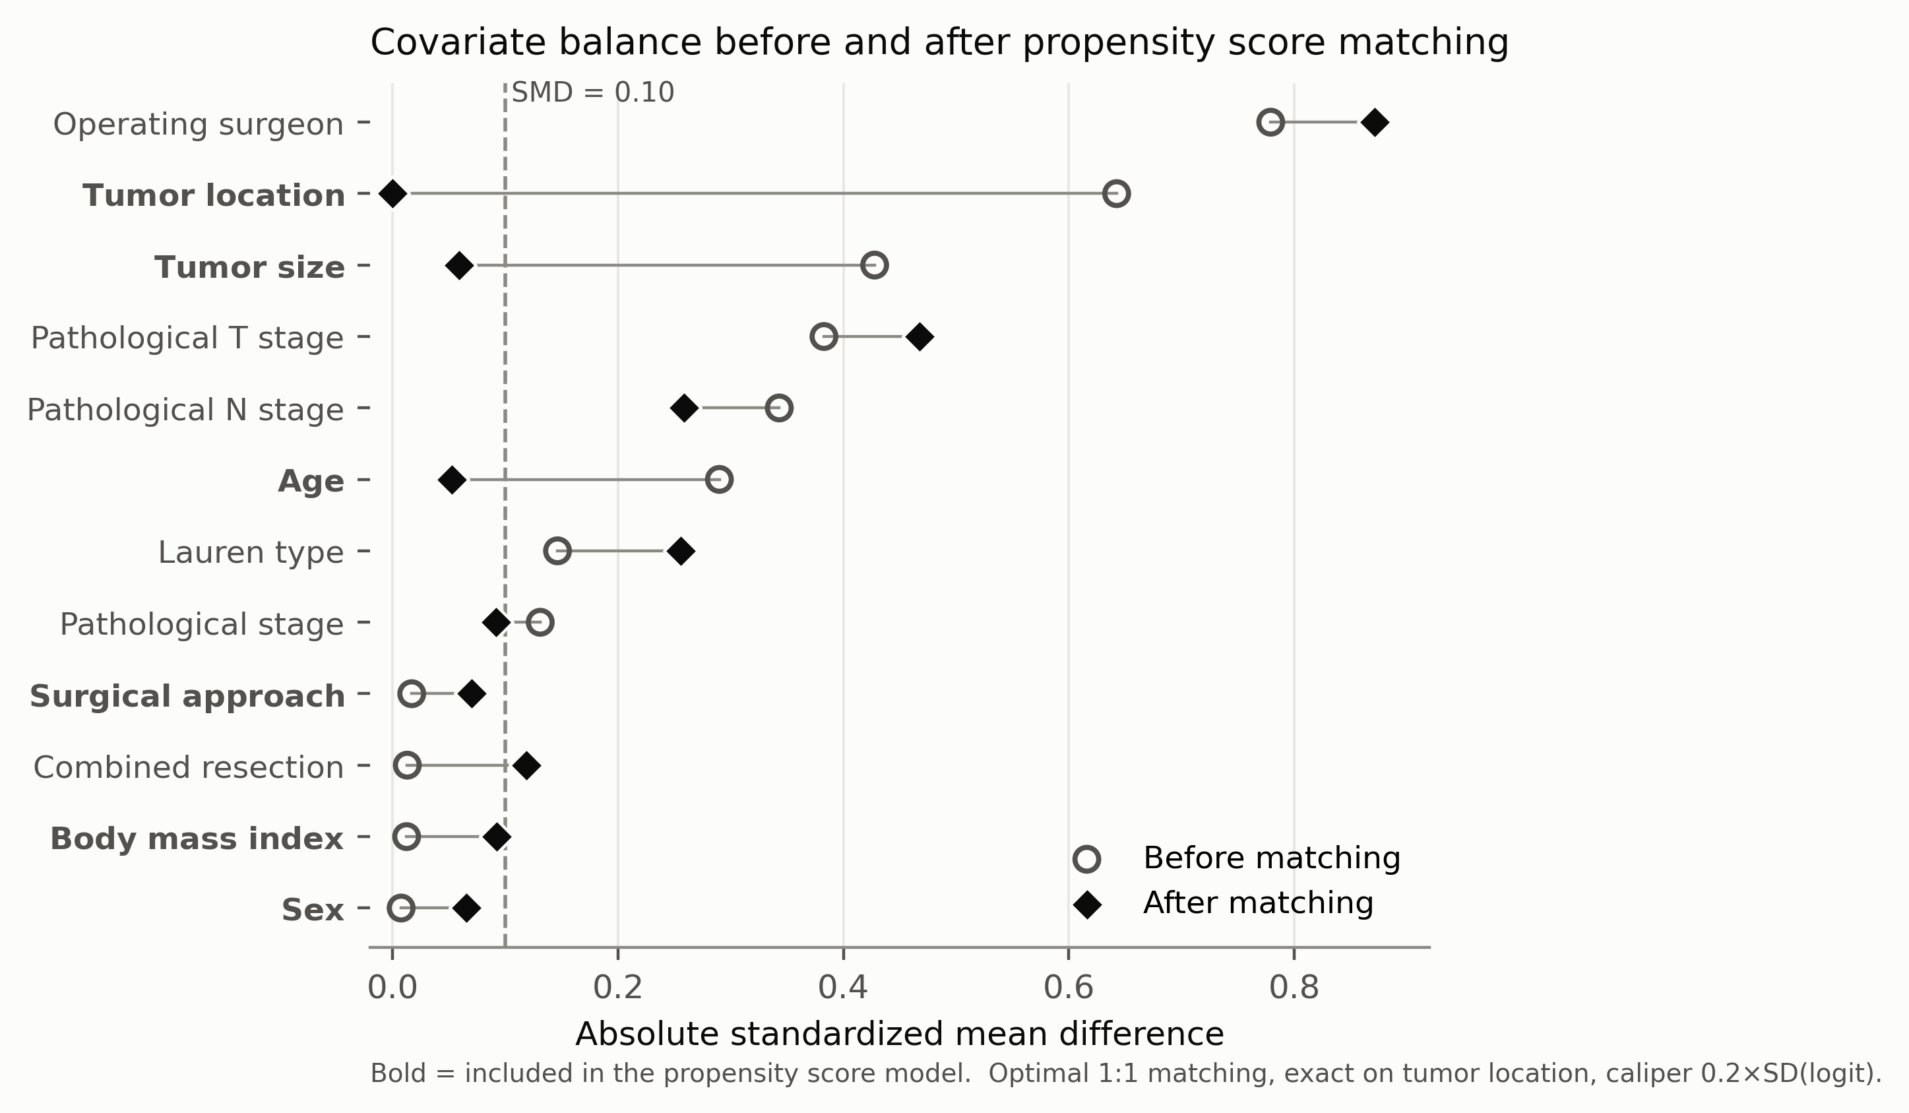
Supplementary Figure 2B. Propensity score distribution and common support
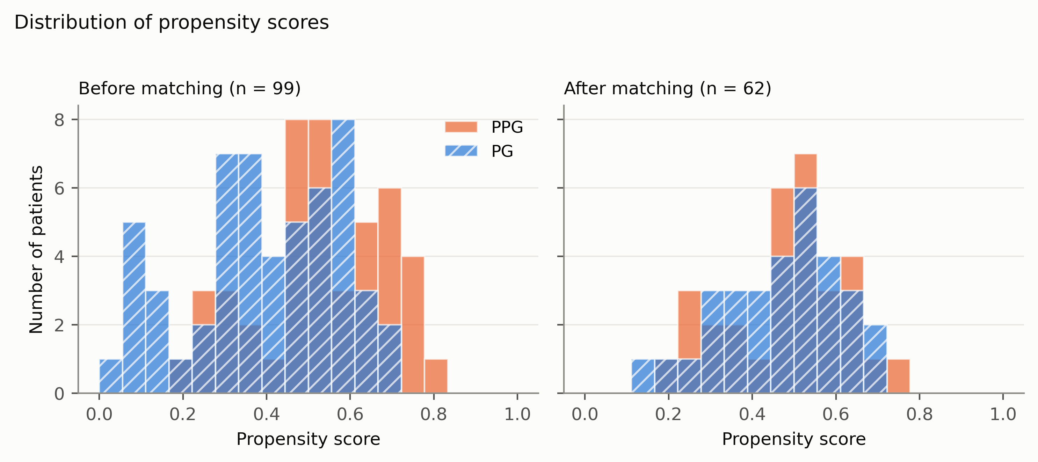
Supplementary Figure 2C. Matching diagram
