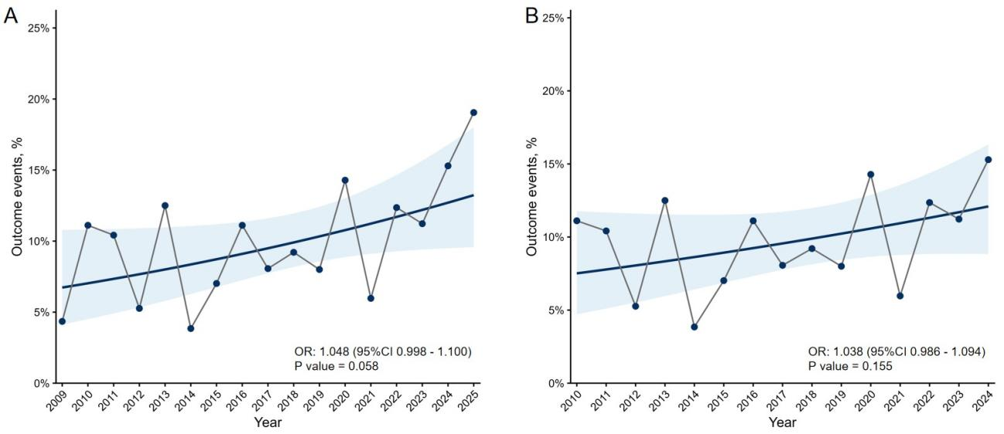
Figure S1. Annual trends in the incidence of the primary outcome during the study period. Observed annual proportions and trends estimated using logistic regression are presented for May 2009 to May 2025 (A) and January 2010 to December 2024 (B). OR, odds ratio.

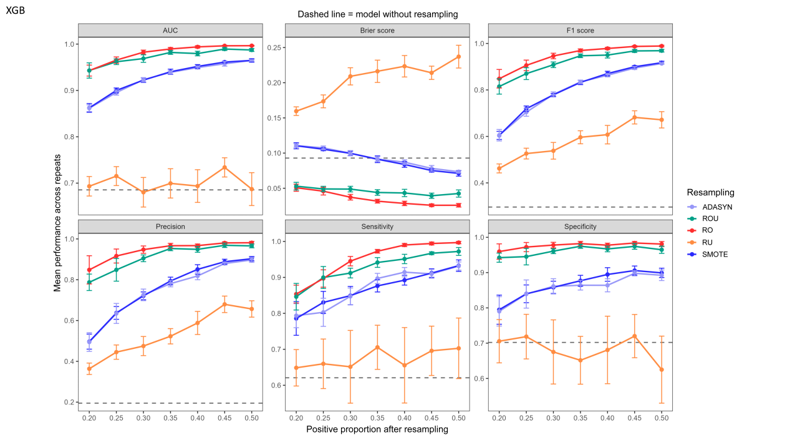
Figure S2. Selection of optimal resampling ratios for XGBoost with default hyperparameters. XGBoost, extreme gradient boosting; AUC, area under the receiver operating characteristic curve; SMOTE, synthetic minority over-sampling technique; ADASYN, adaptive synthetic sampling; ROU, random over-sampling combined with under-sampling; RO, random over-sampling; RU, random under-sampling.

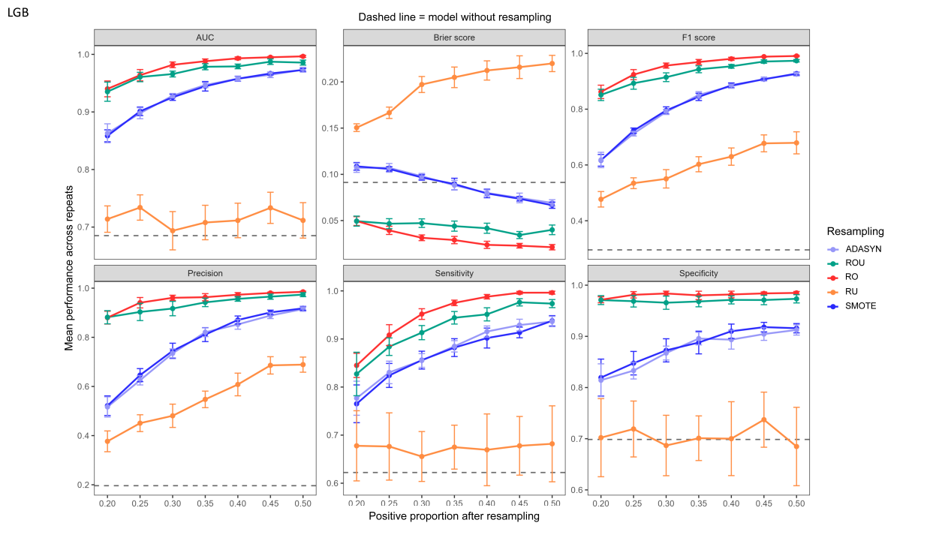
Figure S3. Selection of optimal resampling ratios for LightGBM with default hyperparameters. LightGBM, light gradient boosting machine; AUC, area under the receiver operating characteristic curve; SMOTE, synthetic minority over-sampling technique; ADASYN, adaptive synthetic sampling; ROU, random over-sampling combined with under-sampling; RO, random over-sampling; RU, random under-sampling.

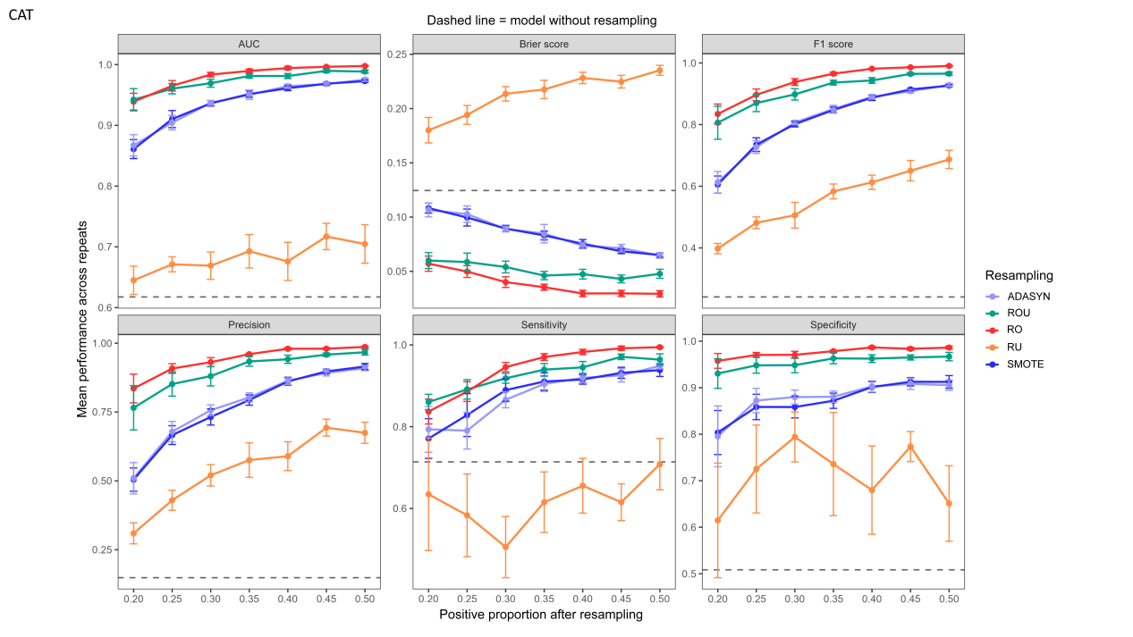
Figure S4. Selection of optimal resampling ratios for CatBoost with default hyperparameters. CatBoost, categorical boosting; AUC, area under the receiver operating characteristic curve; SMOTE, synthetic minority over-sampling technique; ADASYN, adaptive synthetic sampling; ROU, random over-sampling combined with under-sampling; RO, random over-sampling; RU, random under-sampling.

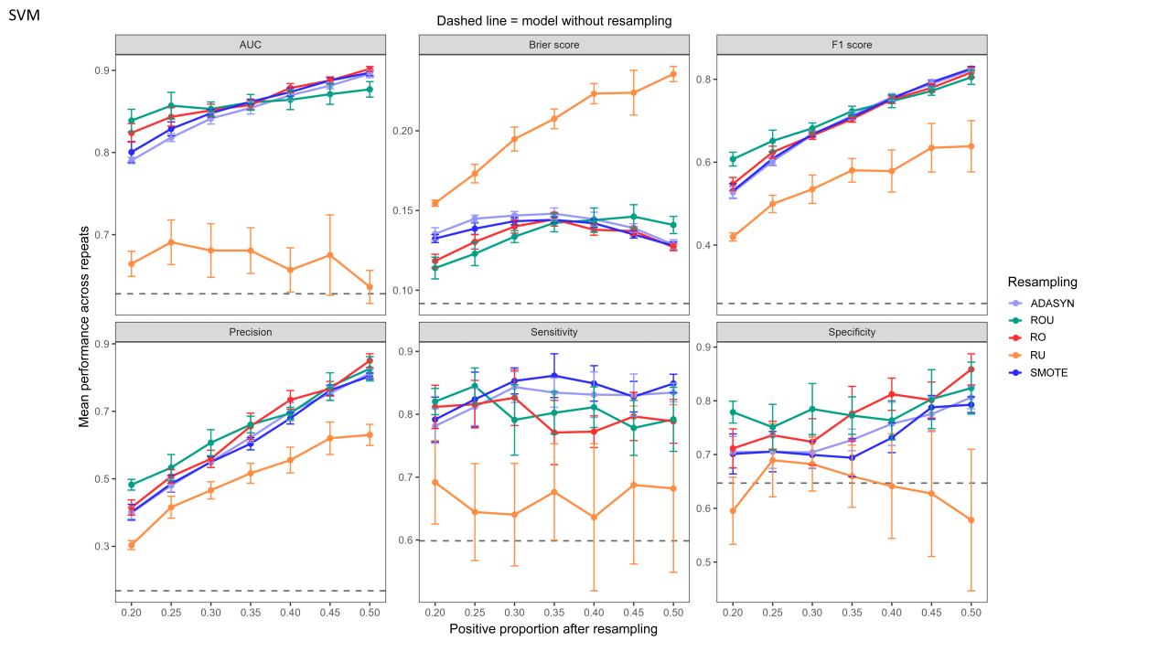
Figure S5. Selection of optimal resampling ratios for SVM with default hyperparameters. SVM, support vector machine; AUC, area under the receiver operating characteristic curve; SMOTE, synthetic minority over-sampling technique; ADASYN, adaptive synthetic sampling; ROU, random over-sampling combined with under-sampling; RO, random over-sampling; RU, random under-sampling.

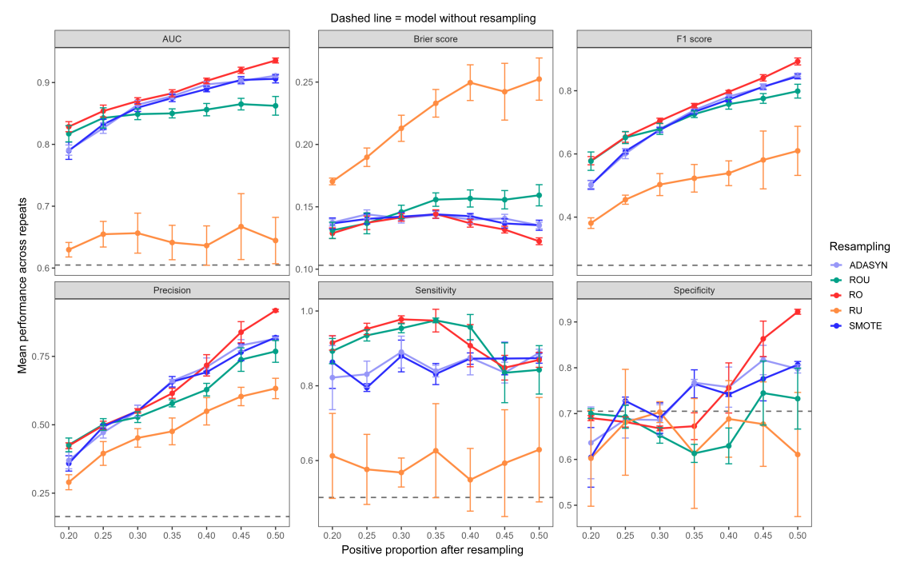
Figure S6. Selection of optimal resampling ratios for KNN with default hyperparameters. KNN, k-nearest neighbors; AUC, area under the receiver operating characteristic curve; SMOTE, synthetic minority over-sampling technique; ADASYN, adaptive synthetic sampling; ROU, random over-sampling combined with under-sampling; RO, random over-sampling; RU, random under-sampling.

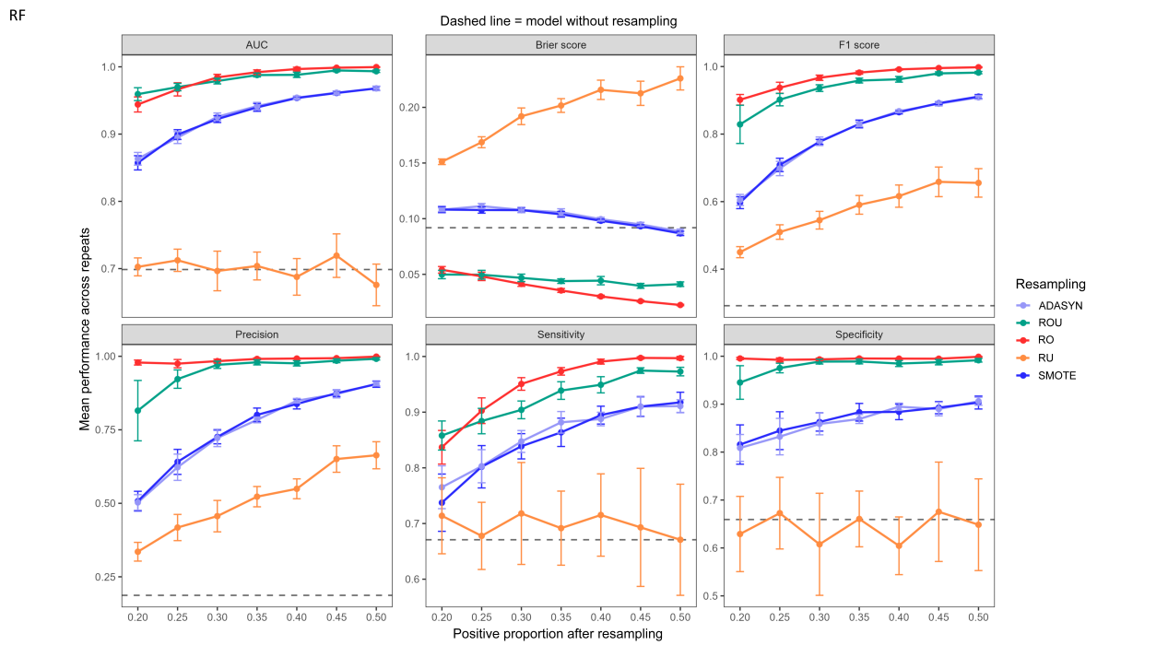
Figure S7. Selection of optimal resampling ratios for RF with default hyperparameters. RF, random forest; AUC, area under the receiver operating characteristic curve; SMOTE, synthetic minority over-sampling technique; ADASYN, adaptive synthetic sampling; ROU, random over-sampling combined with under-sampling; RO, random over-sampling; RU, random under-sampling.

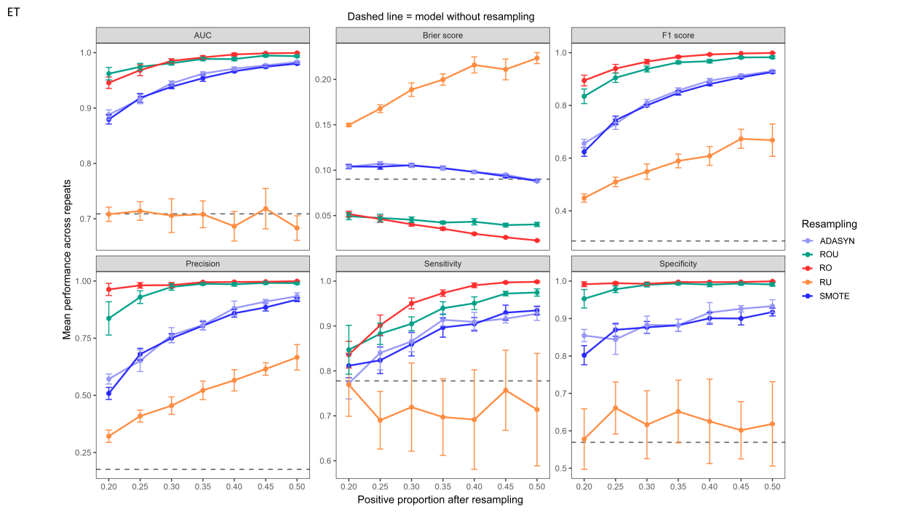
Figure S8. Selection of optimal resampling ratios for ET with default hyperparameters. ET, extra trees; AUC, area under the receiver operating characteristic curve; SMOTE, synthetic minority over-sampling technique; ADASYN, adaptive synthetic sampling; ROU, random over-sampling combined with under-sampling; RO, random over-sampling; RU, random under-sampling.

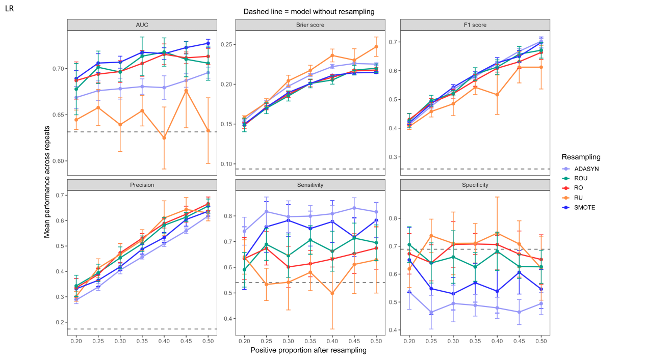
Figure S9. Selection of optimal resampling ratios for LR with default hyperparameters. LR, logistic regression; AUC, area under the receiver operating characteristic curve; SMOTE, synthetic minority over-sampling technique; ADASYN, adaptive synthetic sampling; ROU, random over-sampling combined with under-sampling; RO, random over-sampling; RU, random under-sampling.

Table S1. Definitions of major complications.
Major complication | Definition
Postoperative stroke | Any newly confirmed ischemic or hemorrhagic cerebrovascular event
Malignant arrhythmia | Any life-threatening arrhythmia requiring urgent intervention or high-grade atrioventricular block associated with hemodynamic instability
Prolonged mechanical ventilation | Mechanical ventilatory support exceeding 24 hours
AKI requiring dialysis | New-onset renal failure or worsening renal function requiring renal replacement therapy
Shock | Persistent circulatory failure with end-organ hypoperfusion requiring vasopressor or inotropic support despite adequate fluid resuscitation
MODS | Dysfunction of 2 or more organ systems, resulting in failure to maintain physiological homeostasis without intervention
AKI, acute kidney injury; MODS, multiple organ dysfunction syndrome.

Predictor | Overall (n = 992) | 30-day mortality or major complications |  | P value
Predictor | Overall (n = 992) | Controls (n = 892) | Cases (n = 100) | P value
TB [median (IQR), μmol/L] | 11.7 (8.3, 16.9) | 11.2 (8.1, 16.6) | 13.9 (10.7, 18.9) | < 0.001
NT-proBNP [median (IQR), ng/L] | 2146.0 (706.3, 5936.0) | 1884.0 (637.8, 5053.0) | 6333.0 (1931.0, 12844.0) | < 0.001
cTnT [median (IQR), ng/L] | 44.7 (14.6, 156.0) | 40.8 (13.6, 156.0) | 69.2 (25.1, 154.4) | 0.032
BMI [median (IQR), kg/m²] | 21.7 (19.6, 23.9) | 21.8 (19.6, 23.9) | 21.1 (19.1, 24.0) | 0.241
WBC [median (IQR), 10⁹/L] | 7.8 (6.2, 10.8) | 7.7 (6.1, 10.4) | 9.6 (6.9, 13.5) | < 0.001
PLT [median (IQR), 10⁹/L] | 149.0 (63.8, 227.0) | 148.5 (57.8, 228.2) | 154.5 (71.9, 212.2) | 0.444
eGFR [median (IQR), mL/min/1.73 m²] | 98.7 (75.0, 112.3) | 99.2 (76.4, 112.8) | 88.7 (54.3, 110.9) | 0.007
Age [median (IQR), years] | 47.9 (35.8, 57.0) | 47.4 (35.7, 56.9) | 48.6 (36.8, 58.0) | 0.291
Urea [median (IQR), mmol/L] | 5.5 (3.9, 7.8) | 5.4 (3.9, 7.6) | 6.6 (4.0, 11.5) | 0.003
CRP [median (IQR), mg/L] | 23.3 (7.3, 71.5) | 22.0 (6.6, 69.2) | 45.9 (17.1, 89.5) | < 0.001
Table S2. Ten key predictors for model development.
IQR, interquartile range; TB, total bilirubin; NT-proBNP, N-terminal pro-B-type natriuretic peptide; cTnT, cardiac troponin T; BMI, body mass index; WBC, white blood cell count; PLT, platelet count; eGFR, estimated glomerular filtration rate; CRP, C-reactive protein.

Table S3. Optimal resampling ratios and hyperparameters for XGBoost based on the training set (nrounds = 1000).
Model | over_ratio | p | eta | max_depth | min_child_weight | subsample | colsample_bytree | gamma | lambda | alpha
ORI | / | / | 0.05 | 4 | 4 | 0.85 | 1.00 | 0 | 2 | 0.5
WE | / | / | 0.03 | 4 | 4 | 0.70 | 0.85 | 1 | 2 | 0
SMOTE | 0.82 | / | 0.05 | 4 | 1 | 0.85 | 0.70 | 0 | 1 | 0
ADASYN | 0.82 | / | 0.05 | 4 | 1 | 0.85 | 1.00 | 0 | 2 | 0
RO | / | 0.30 | 0.03 | 4 | 2 | 0.85 | 0.70 | 0 | 2 | 0.5
RU | / | 0.25 | 0.03 | 4 | 4 | 0.85 | 1.00 | 0 | 1 | 0.5
ROU | / | 0.35 | 0.05 | 4 | 1 | 0.70 | 1.00 | 0 | 2 | 0
XGBoost, extreme gradient boosting; ORI, original training set; WE, weighting strategy; SMOTE, synthetic minority over-sampling technique; ADASYN, adaptive synthetic sampling; RO, random over-sampling; RU, random under-sampling; ROU, random over-sampling combined with under-sampling; “over_ratio”, the minority-to-majority frequency ratio after resampling for SMOTE and ADASYN; “p”, the target proportion of the minority class in the resampled data set for RO, RU, and ROU.
Table S4. Optimal resampling ratios and hyperparameters for LightGBM based on the training set (nrounds = 1000).
Model | over_ratio | p | learning_rate | num_leaves | max_depth | min_data_in_leaf | feature_fraction | bagging_fraction | bagging_freq | min_gain_to_split | lambda_l1 | lambda_l2
ORI | / | / | 0.02 | 31 | -1 | 40 | 0.85 | 0.70 | 1 | 0 | 0 | 1
WE | / | / | 0.05 | 31 | 5 | 20 | 0.70 | 0.70 | 1 | 0.05 | 0 | 3
SMOTE | 0.67 | / | 0.05 | 31 | -1 | 20 | 0.85 | 0.85 | 1 | 0 | 0 | 1
ADASYN | 0.67 | / | 0.05 | 31 | -1 | 20 | 0.70 | 0.85 | 1 | 0 | 0 | 1
RO | / | 0.30 | 0.05 | 31 | -1 | 20 | 0.85 | 0.85 | 1 | 0 | 0 | 1
RU | / | 0.25 | 0.05 | 15 | -1 | 20 | 0.85 | 0.70 | 1 | 0 | 0 | 3
ROU | / | 0.30 | 0.05 | 15 | 5 | 20 | 0.85 | 0.85 | 1 | 0 | 0.5 | 3
LightGBM, light gradient boosting machine; ORI, original training set; WE, weighting strategy; SMOTE, synthetic minority over-sampling technique; ADASYN, adaptive synthetic sampling; RO, random over-sampling; RU, random under-sampling; ROU, random over-sampling combined with under-sampling; “over_ratio”, the minority-to-majority frequency ratio after resampling for SMOTE and ADASYN; “p”, the target proportion of the minority class in the resampled data set for RO, RU, and ROU.
Table S5. Optimal resampling ratios and hyperparameters for CatBoost based on the training set (nrounds = 1000).
Model | over_ratio | p | learning_rate | depth | l2_leaf_reg | random_strength | bootstrap_type | subsample
ORI | / | / | 0.05 | 6 | 3 | 1 | Bernoulli | 0.85
WE | / | / | 0.05 | 4 | 3 | 1 | Bernoulli | 0.70
SMOTE | 0.67 | / | 0.05 | 6 | 3 | 1 | Bernoulli | 0.70
ADASYN | 0.67 | / | 0.05 | 6 | 5 | 1 | Bernoulli | 0.70
RO | / | 0.25 | 0.05 | 6 | 3 | 1 | Bernoulli | 0.85
RU | / | 0.20 | 0.05 | 6 | 5 | 2 | Bernoulli | 0.70
ROU | / | 0.30 | 0.02 | 6 | 5 | 1 | Bernoulli | 0.70
CatBoost, categorical boosting; ORI, original training set; WE, weighting strategy; SMOTE, synthetic minority over-sampling technique; ADASYN, adaptive synthetic sampling; RO, random over-sampling; RU, random under-sampling; ROU, random over-sampling combined with under-sampling; “over_ratio”, the minority-to-majority frequency ratio after resampling for SMOTE and ADASYN; “p”, the target proportion of the minority class in the resampled data set for RO, RU, and ROU.
Table S6. Optimal resampling ratios and hyperparameters for SVM based on the training set.
Model | over_ratio | p | kernel | cost | gamma_factor | scale
ORI | / | / | radial | 1 | 2 | TRUE
WE | / | / | radial | 0.50 | 0.50 | TRUE
SMOTE | 0.82 | / | radial | 4 | 2 | TRUE
ADASYN | 0.82 | / | radial | 4 | 2 | TRUE
RO | / | 0.30 | radial | 4 | 2 | TRUE
RU | / | 0.25 | radial | 1 | 2 | TRUE
ROU | / | 0.30 | radial | 4 | 2 | TRUE
SVM, support vector machine; ORI, original training set; WE, weighting strategy; SMOTE, synthetic minority over-sampling technique; ADASYN, adaptive synthetic sampling; RO, random over-sampling; RU, random under-sampling; ROU, random over-sampling combined with under-sampling; “over_ratio”, the minority-to-majority frequency ratio after resampling for SMOTE and ADASYN; “p”, the target proportion of the minority class in the resampled data set for RO, RU, and ROU.
Table S7. Optimal resampling ratios and hyperparameters for KNN based on the training set.
Model | over_ratio | p | k_neighbors | distance_weighted | algorithm
ORI | / | / | 15 | TRUE | kd_tree
WE | / | / | 15 | FALSE | kd_tree
SMOTE | 0.82 | / | 5 | TRUE | kd_tree
ADASYN | 0.82 | / | 9 | TRUE | kd_tree
RO | / | 0.35 | 15 | TRUE | kd_tree
RU | / | 0.25 | 15 | TRUE | kd_tree
ROU | / | 0.25 | 9 | TRUE | kd_tree
KNN, k-nearest neighbors; ORI, original training set; WE, weighting strategy; SMOTE, synthetic minority over-sampling technique; ADASYN, adaptive synthetic sampling; RO, random over-sampling; RU, random under-sampling; ROU, random over-sampling combined with under-sampling; “over_ratio”, the minority-to-majority frequency ratio after resampling for SMOTE and ADASYN; “p”, the target proportion of the minority class in the resampled data set for RO, RU, and ROU.
Table S8. Optimal resampling ratios and hyperparameters for RF based on the training set.
Model | over_ratio | p | ntree | mtry_ratio | nodesize
ORI | / | / | 750 | 0.20 | 1
WE | / | / | 1000 | 0.35 | 1
SMOTE | 0.82 | / | 750 | 0.20 | 1
ADASYN | 0.82 | / | 1000 | 0.20 | 1
RO | / | 0.25 | 1000 | 0.50 | 1
RU | / | 0.20 | 750 | 0.20 | 1
ROU | / | 0.25 | 750 | 0.35 | 1
RF, random forest; ORI, original training set; WE, weighting strategy; SMOTE, synthetic minority over-sampling technique; ADASYN, adaptive synthetic sampling; RO, random over-sampling; RU, random under-sampling; ROU, random over-sampling combined with under-sampling; “over_ratio”, the minority-to-majority frequency ratio after resampling for SMOTE and ADASYN; “p”, the target proportion of the minority class in the resampled data set for RO, RU, and ROU.
Table S9. Optimal resampling ratios and hyperparameters for ET based on the training set.
Model | over_ratio | p | num.trees | mtry_ratio | min.node.size | num.random.splits | sample.fraction | replace
ORI | / | / | 1000 | 0.35 | 3 | 1 | 0.632 | TRUE
WE | / | / | 500 | 0.2 | 3 | 1 | 0.632 | TRUE
SMOTE | 0.82 | / | 500 | 0.35 | 1 | 1 | 0.80 | TRUE
ADASYN | 0.67 | / | 750 | 0.35 | 1 | 1 | 0.80 | TRUE
RO | / | 0.30 | 1000 | 0.50 | 1 | 3 | 0.80 | TRUE
RU | / | 0.20 | 750 | 0.20 | 1 | 3 | 0.80 | TRUE
ROU | / | 0.25 | 1000 | 0.35 | 1 | 1 | 0.80 | TRUE
ET, extra trees; ORI, original training set; WE, weighting strategy; SMOTE, synthetic minority over-sampling technique; ADASYN, adaptive synthetic sampling; RO, random over-sampling; RU, random under-sampling; ROU, random over-sampling combined with under-sampling; “over_ratio”, the minority-to-majority frequency ratio after resampling for SMOTE and ADASYN; “p”, the target proportion of the minority class in the resampled data set for RO, RU, and ROU.

Table S10. Optimal resampling ratios and hyperparameters for LR based on the training set.
Model | over_ratio | p | maxit
ORI | / | / | 100
WE | / | / | 50
SMOTE | 0.82 | / | 200
ADASYN | 0.82 | / | 50
RO | / | 0.35 | 200
RU | / | 0.25 | 50
ROU | / | 0.35 | 50
LR, logistic regression; ORI, original training set; WE, weighting strategy; SMOTE, synthetic minority over-sampling technique; ADASYN, adaptive synthetic sampling; RO, random over-sampling; RU, random under-sampling; ROU, random over-sampling combined with under-sampling; “over_ratio”, the minority-to-majority frequency ratio after resampling for SMOTE and ADASYN; “p”, the target proportion of the minority class in the resampled data set for RO, RU, and ROU.

Table S11. Performance of the 56 candidate models based on OOF predictions in the training set.
Algorithm | Weighting / Resampling | AUC (95% CI) | Intercept (95% CI) | Slope (95% CI) | Brier score (95% CI)
XGBoost | ORI | 0.687 (0.620 - 0.753) | 0.018 (-0.231 - 0.268) | 0.946 (0.541 - 1.352) | 0.090 (0.086 - 0.093)
 | WE | 0.681 (0.613 - 0.749) | -1.729 (-1.979 - -1.479) | 0.869 (0.487 - 1.251) | 0.168 (0.159 - 0.177)
 | SMOTE | 0.956 (0.944 - 0.967) | -0.328 (-0.532 - -0.124) | 1.018 (0.899 - 1.137) | 0.081 (0.070 - 0.092)
 | ADASYN | 0.952 (0.941 - 0.964) | -0.303 (-0.496 - -0.110) | 1.114 (0.983 - 1.245) | 0.082 (0.071 - 0.093)
 | RO | 0.979 (0.969 - 0.989) | -0.235 (-0.456 - -0.014) | 1.763 (1.496 - 2.030) | 0.049 (0.041 - 0.057)
 | RU | 0.677 (0.610 - 0.745) | 0.023 (-0.262 - 0.307) | 0.643 (0.333 - 0.954) | 0.176 (0.161 - 0.191)
 | ROU | 0.965 (0.949 - 0.981) | -0.106 (-0.358 - 0.147) | 1.353 (1.156 - 1.551) | 0.057 (0.046 - 0.068)
LightGBM | ORI | 0.719 (0.655 - 0.783) | 0.006 (-0.239 - 0.251) | 2.444 (1.612 - 3.276) | 0.090 (0.088 - 0.091)
 | WE | 0.718 (0.663 - 0.774) | -1.188 (-1.445 - -0.931) | 0.779 (0.518 - 1.039) | 0.118 (0.108 - 0.126)
 | SMOTE | 0.948 (0.934 - 0.962) | -0.259 (-0.487 - -0.030) | 0.814 (0.718 - 0.911) | 0.082 (0.071 - 0.096)
 | ADASYN | 0.954 (0.943 - 0.966) | -0.230 (-0.437 - -0.023) | 1.072 (0.942 - 1.203) | 0.081 (0.071 - 0.092)
 | RO | 0.988 (0.979 - 0.993) | -0.561 (-0.845 - -0.277) | 1.460 (1.225 - 1.694) | 0.033 (0.025 - 0.042)
 | RU | 0.657 (0.585 - 0.729) | 0.002 (-0.279 - 0.284) | 0.484 (0.164 - 0.804) | 0.184 (0.169 - 0.199)
 | ROU | 0.954 (0.935 - 0.974) | 0.012 (-0.228 - 0.251) | 1.384 (1.180 - 1.587) | 0.065 (0.055 - 0.077)
CatBoost | ORI | 0.619 (0.558 - 0.680) | -0.944 (-1.200 - -0.688) | 0.345 (0.123 - 0.566) | 0.121 (0.113 - 0.129)
 | WE | 0.690 (0.622 - 0.757) | -2.005 (-2.251 - -1.759) | 1.597 (0.854 - 2.341) | 0.212 (0.206 - 0.218)
 | SMOTE | 0.957 (0.944 - 0.969) | -0.257 (-0.463 - -0.052) | 1.116 (0.981 - 1.251) | 0.076 (0.065 - 0.088)
 | ADASYN | 0.966 (0.956 - 0.976) | -0.273 (-0.470 - -0.077) | 1.384 (1.209 - 1.559) | 0.072 (0.062 - 0.082)
 | RO | 0.957 (0.940 - 0.974) | -0.095 (-0.346 - 0.156) | 1.367 (1.168 - 1.566) | 0.050 (0.041 - 0.060)
 | RU | 0.657 (0.588 - 0.726) | -0.132 (-0.401 - 0.136) | 0.737 (0.375 - 1.099) | 0.152 (0.142 - 0.162)
 | ROU | 0.968 (0.952 - 0.984) | -0.014 (-0.245 - 0.217) | 1.805 (1.522 - 2.087) | 0.057 (0.048 - 0.067)
SVM | ORI | 0.695 (0.633 - 0.758) | 0.008 (-0.242 - 0.257) | 1.082 (0.660 - 1.504) | 0.089 (0.085 - 0.093)
 | WE | 0.691 (0.628 - 0.755) | -0.023 (-0.272 - 0.226) | 1.021 (0.618 - 1.423) | 0.090 (0.087 - 0.093)
 | SMOTE | 0.962 (0.951 - 0.973) | 0.009 (-0.195 - 0.212) | 1.151 (1.020 - 1.282) | 0.069 (0.059 - 0.079)
 | ADASYN | 0.956 (0.944 - 0.967) | 0.064 (-0.138 - 0.266) | 1.075 (0.955 - 1.196) | 0.076 (0.065 - 0.086)
 | RO | 0.944 (0.928 - 0.960) | -0.042 (-0.261 - 0.178) | 1.118 (0.978 - 1.257) | 0.079 (0.067 - 0.091)
 | RU | 0.640 (0.570 - 0.710) | -0.031 (-0.302 - 0.240) | 0.629 (0.096 - 1.161) | 0.181 (0.173 - 0.191)
 | ROU | 0.956 (0.938 - 0.974) | 0.049 (-0.230 - 0.328) | 1.037 (0.890 - 1.184) | 0.067 (0.054 - 0.080)
KNN | ORI | 0.674 (0.607 - 0.741) | 0.272 (0.009 - 0.535) | 0.095 (0.043 - 0.148) | 0.091 (0.087 - 0.096)
 | WE | 0.669 (0.602 - 0.735) | -1.886 (-2.149 - -1.624) | 0.078 (0.034 - 0.122) | 0.192 (0.177 - 0.208)
 | SMOTE | 0.934 (0.920 - 0.949) | -1.484 (-1.692 - -1.276) | 0.266 (0.233 - 0.299) | 0.124 (0.112 - 0.138)
 | ADASYN | 0.921 (0.906 - 0.937) | -0.939 (-1.097 - -0.781) | 0.890 (0.764 - 1.016) | 0.137 (0.126 - 0.149)
 | RO | 0.979 (0.970 - 0.988) | -6.939 (-9.300 - -4.578) | 0.736 (0.594 - 0.879) | 0.072 (0.064 - 0.081)
 | RU | 0.686 (0.622 - 0.751) | 0.227 (-0.062 - 0.515) | 0.214 (0.061 - 0.368) | 0.176 (0.162 - 0.189)
 | ROU | 0.949 (0.925 - 0.973) | -0.688 (-1.154 - -0.222) | 0.276 (0.232 - 0.321) | 0.050 (0.038 - 0.062)
RF | ORI | 0.710 (0.651 - 0.770) | -0.091 (-0.349 - 0.168) | 0.685 (0.442 - 0.928) | 0.090 (0.084 - 0.095)
 | WE | 0.668 (0.610 - 0.726) | 0.185 (-0.077 - 0.447) | 0.447 (0.247 - 0.646) | 0.094 (0.089 - 0.099)
 | SMOTE | 0.963 (0.954 - 0.973) | -0.187 (-0.334 - -0.040) | 2.473 (2.173 - 2.774) | 0.094 (0.087 - 0.101)
 | ADASYN | 0.962 (0.952 - 0.971) | -0.178 (-0.322 - -0.035) | 2.597 (2.286 - 2.909) | 0.098 (0.091 - 0.106)
 | RO | 0.953 (0.931 - 0.974) | -0.630 (-0.866 - -0.394) | 1.671 (1.400 - 1.941) | 0.057 (0.049 - 0.065)
 | RU | 0.687 (0.624 - 0.750) | -0.044 (-0.318 - 0.231) | 0.743 (0.437 - 1.049) | 0.149 (0.138 - 0.160)
 | ROU | 0.962 (0.941 - 0.983) | -0.248 (-0.516 - 0.019) | 1.599 (1.323 - 1.875) | 0.046 (0.037 - 0.055)
ET | ORI | 0.726 (0.670 - 0.783) | -0.127 (-0.382 - 0.127) | 0.893 (0.600 - 1.185) | 0.089 (0.084 - 0.093)
 | WE | 0.722 (0.665 - 0.778) | -0.059 (-0.311 - 0.193) | 0.995 (0.661 - 1.328) | 0.088 (0.085 - 0.092)
 | SMOTE | 0.973 (0.966 - 0.980) | -0.264 (-0.406 - -0.122) | 3.290 (2.870 - 3.710) | 0.097 (0.091 - 0.103)
 | ADASYN | 0.967 (0.958 - 0.976) | -0.248 (-0.394 - -0.103) | 3.380 (2.930 - 3.829) | 0.104 (0.097 - 0.110)
 | RO | 0.988 (0.979 - 0.997) | -0.701 (-0.910 - -0.491) | 3.039 (2.448 - 3.630) | 0.049 (0.044 - 0.055)
 | RU | 0.699 (0.638 - 0.760) | -0.061 (-0.332 - 0.210) | 0.838 (0.492 - 1.185) | 0.149 (0.140 - 0.159)
 | ROU | 0.965 (0.946 - 0.983) | -0.225 (-0.472 - 0.022) | 1.926 (1.593 - 2.259) | 0.050 (0.042 - 0.059)
LR | ORI | 0.640 (0.572 - 0.708) | -0.035 (-0.291 - 0.222) | 0.460 (0.176 - 0.745) | 0.092 (0.086 - 0.099)
 | WE | 0.663 (0.596 - 0.729) | -2.194 (-2.454 - -1.933) | 0.430 (0.173 - 0.688) | 0.215 (0.204 - 0.228)
 | SMOTE | 0.722 (0.693 - 0.751) | -0.013 (-0.140 - 0.113) | 0.857 (0.696 - 1.018) | 0.215 (0.206 - 0.224)
 | ADASYN | 0.669 (0.638 - 0.700) | -0.011 (-0.134 - 0.112) | 0.705 (0.517 - 0.892) | 0.231 (0.222 - 0.239)
 | RO | 0.704 (0.670 - 0.738) | 0.005 (-0.138 - 0.147) | 0.818 (0.637 - 1.000) | 0.201 (0.192 - 0.212)
 | RU | 0.631 (0.558 - 0.703) | -0.041 (-0.324 - 0.242) | 0.521 (0.205 - 0.837) | 0.181 (0.165 - 0.197)
 | ROU | 0.732 (0.693 - 0.772) | -0.003 (-0.175 - 0.170) | 0.862 (0.668 - 1.055) | 0.191 (0.178 - 0.203)
OOF, out-of-fold; AUC, area under the receiver operating characteristic curve; CI, confidence interval; XGBoost, extreme gradient boosting; LightGBM, light gradient boosting machine; CatBoost, categorical boosting; SVM, support vector machine; KNN, k-nearest neighbors; RF, random forest; ET, extra trees; LR, logistic regression; ORI, original training set; WE, weighting strategy; SMOTE, synthetic minority over-sampling technique; ADASYN, adaptive synthetic sampling; RO, random over-sampling; RU, random under-sampling; ROU, random over-sampling combined with under-sampling.

Table S12. Performance of 13 candidate models selected based on OOF predictions in the training set.
Algorithm | Weighting / Resampling | Threshold | Sensitivity | Specificity | Accuracy | Precision
XGBoost | SMOTE | 0.514 | 0.919 | 0.875 | 0.880 | 0.460
 | ADASYN | 0.533 | 0.925 | 0.881 | 0.886 | 0.474
 | ROU | 0.458 | 0.928 | 0.945 | 0.943 | 0.661
LightGBM | SMOTE | 0.552 | 0.882 | 0.908 | 0.905 | 0.526
 | ADASYN | 0.352 | 0.949 | 0.846 | 0.857 | 0.416
 | ROU | 0.420 | 0.916 | 0.951 | 0.947 | 0.684
CatBoost | SMOTE | 0.515 | 0.911 | 0.904 | 0.905 | 0.523
 | ADASYN | 0.523 | 0.923 | 0.905 | 0.907 | 0.529
 | RO | 0.380 | 0.868 | 0.973 | 0.962 | 0.788
SVM | SMOTE | 0.512 | 0.915 | 0.907 | 0.908 | 0.532
 | ADASYN | 0.447 | 0.923 | 0.897 | 0.900 | 0.509
 | RO | 0.332 | 0.856 | 0.892 | 0.888 | 0.478
 | ROU | 0.239 | 0.911 | 0.894 | 0.896 | 0.499
OOF, out-of-fold; XGBoost, extreme gradient boosting; LightGBM, light gradient boosting machine; CatBoost, categorical boosting; SVM, support vector machine; SMOTE, synthetic minority over-sampling technique; ADASYN, adaptive synthetic sampling; RO, random over-sampling; ROU, random over-sampling combined with under-sampling.

