Figure S1- Characterization of the purified mAb. 6D6 with two concentrations (10 and 20 µg) were loaded on a 12.5% polyacrylamide gel under reduced conditions. After staining the gel with colloidal Coomassie Brilliant Blue G-250 and destaining, the image of the gel was captured with GS-800 Calibrated Densitometer (A; Bio-Rad). MW was determined using a protein marker (B; Thermo Scientific, 10 to 250 kDa).

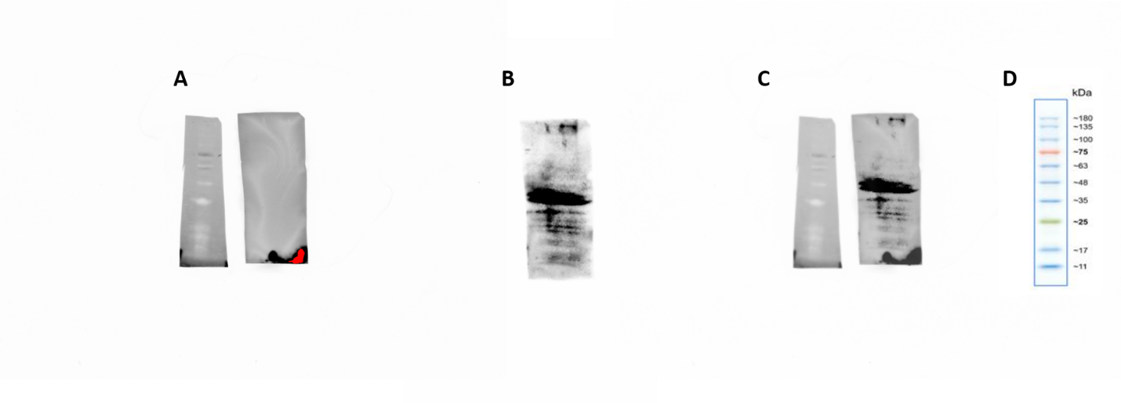
Figure S2- Characterization of the target antigen of 6D6 mAb. After transferring, membranes were cut before hybridization with the antibody. Images were captured with stain-free blot (A) and chemi (B) settings and then merged with Image Lab software version 6.1.0 (C, Bio-Rad). The MW of the target antigen was obtained using a pre-stained marker (D; Sinaclon, Cat.No. SL7011(PR911654)).

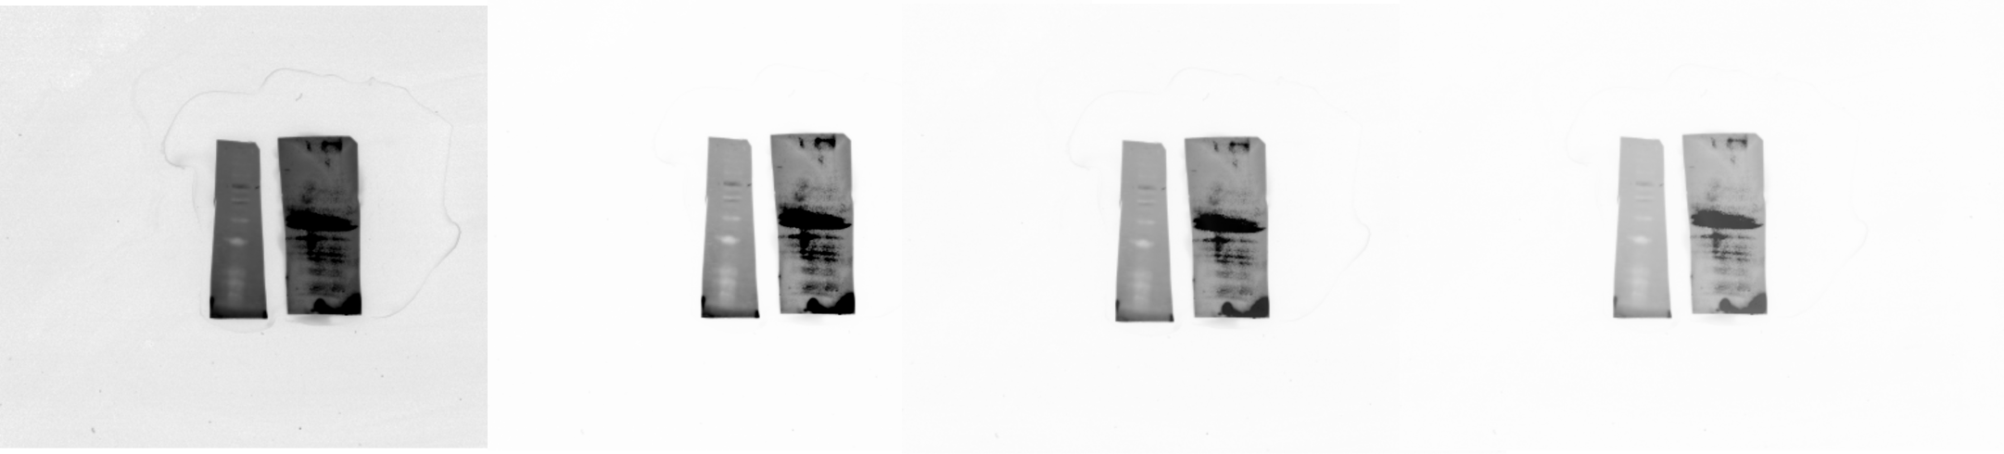
Figure S3- Multiple contrast percentages of the merged image (Figure 2B) with Image Lab software.

